**We are a professional**

* Young team of engineers that combine local knowledge, AI-powered predictive modelling and remote sensing to monitor what’s happening in forest regions.
* Team of valuable people that provides technical expertise and software-based solutions to environmental problems.

**About Us**

* Tech lovers and yet passionate about the environment the idea of Nkhalango monitoring system was born to aid forest owners in the sustainable management of their forests which involves a broad range of factors such as tree population and resilience against fire.
* We believe there is a better way to adapt, a more technological less invasive way where forests can be monitored using remote sensing rather than just traditional methods. We’re obsessively passionate about about it and our mission is to help forest owner’s achieve it. We focus on using AI and sensors to achieve tree population count and sensing of forest region changes respectively. It’s one of the least understood and least used technologies in Malawi, and we see that as an opportunity.
* **Got a forest? We help you manage it sustainably**

Ever heard about climate resolutions in context of tree planting, forest conservation and forest recreation that jumpstarted with fire but somehow its value or impact was not seen simply because no one managed the trees after planting them? How about planting tree species that was not suitable for that geographical location?

That’s exactly the problem we solve. If you have a forest or you are planning on having one , you deserve to manage it sustainably. We make sure you monitor the forest regions remotely and take action when necessary.

**Our Mission**

* NMS works on things that matter. The best technology that exists to provide remote sensing of forest, giving up to date data on tree population forest regions.
* Nkhalango Monitoring System exists to provide remote sensing of forest regions that allow forest owners to get up to date data on forest population and fire alerts
* Our aim is to provide climate technologies as a tool to enable communities to adapt to climate change, mostly in relation to forest conservation and forest recreation.

**Our plan**

* In the near future, remote sensing and Geographical Information System (GIS) could be used in environmental monitoring for land use/land cover analysis, habitat mapping and disaster management.

**Our Vision**

* To change the way, we think about saving the planet
* Bringing innovation to the fight against climate change

**Our objectives**

The general objective of this project is to build a forest monitoring system that analyses soil properties, calculates tree population, monitors forests regions, and gives user control access remotely.

To achieve the main objective, the **specific objectives** are accordingly to:

* Analyze soil properties to determine what tree species suits a particular geographical location;
* Count tree population for accurate record keeping;
* Asses the type of smoke and trigger an alarm for elevated carbon dioxide levels;
* Monitor high temperatures; and
* Alert forest monitoring control room when an alarm has been triggered.

**Team**

Founder: KasambalaCo-founder: Kaponda



Or

Founder: Kasambala cofounder: Kaponda

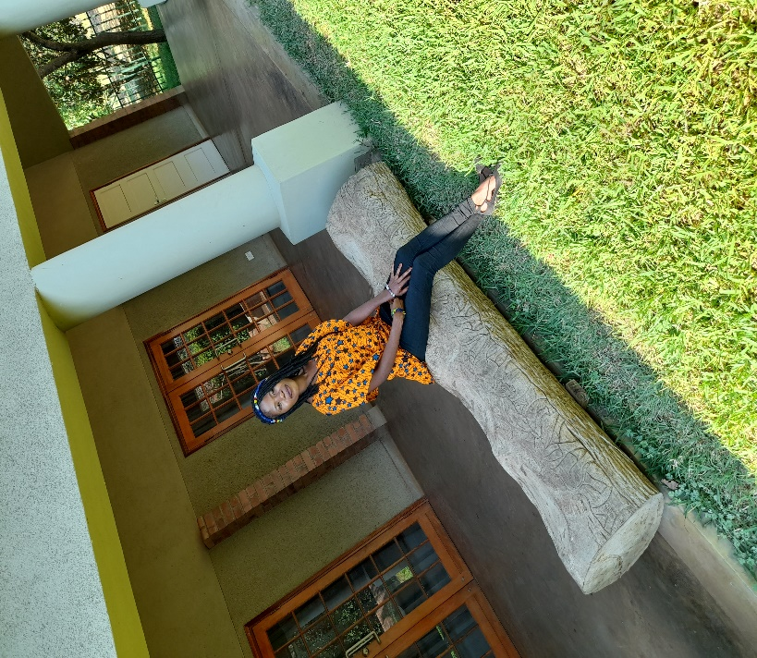

Contact us

Address

Phone number

+265(0)

Email

nkhalango@gmail.com