23705

Habimana Kenny Prince

SOFTWARE MODELING ASSIGNMENT

QUESTION 1: UNIVERSITY CASE STUDY.

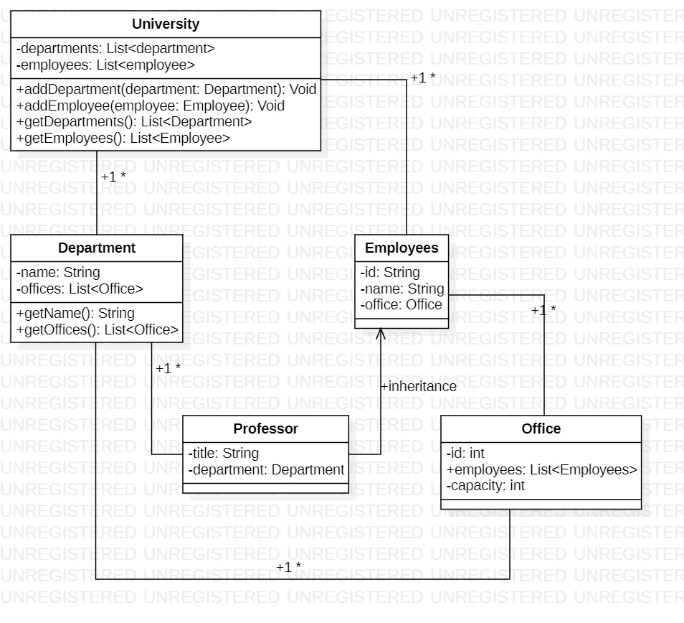

QUESTION 2: MOVIE THEATRE CASE STUDY.

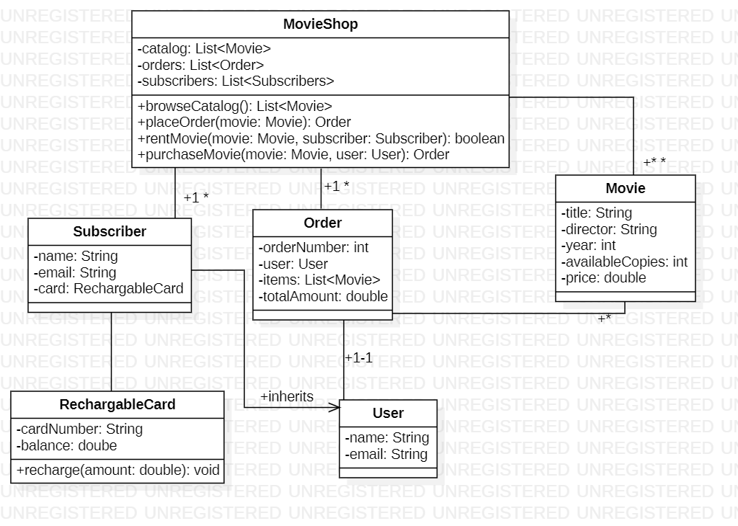

**NB: PLEASE NOTE THAT ON INHERITENCE I DIDN’T USE THE RIGHT SYMBOL DUE TO THE FACT THAT I COULDN’T FIND IT ON STAR UML WHICH I WAS USING.**

**KIND REGARDS,**