
Geldium Delinquency Prediction - Exploratory Data Analysis (EDA) Summary Report

1. Introduction
This report presents the Exploratory Data Analysis (EDA) of the Geldium delinquency prediction dataset, prepared for the Tata iQ analytics team as part of the forage simulation. Geldium, a consumer-credit lender, aims to predict which customer accounts will become delinquent so that proactive, loss-mitigating outreach can be prioritised. Before any predictive model is built, the data must be understood, its quality quantified, and its usability for modelling judged. The analysis covers 500 customer records and 19 variables from the delivered workbook (single sheet, 'Delinquency_prediction_dataset'), including demographic attributes, credit behaviour, account characteristics and a six-month payment history. Objectives were to: (1) profile structure and content, (2) measure data quality issues, (3) define a justified missing-data treatment, (4) explore relationships with the delinquency target, and (5) shortlist candidate risk indicators for later validation. The source file was preserved unchanged; all cleaning was applied to a separate working copy with a full transformation log. The dataset description guide (Updated_Dataset_Description_Guide.pdf) was not available, so variable definitions are inferred from column names and observed value ranges and should be confirmed with the data owner.

2. Dataset Overview
This section summarizes the dataset, including the number of records, key variables, and data types. It also highlights any anomalies, duplicates, or inconsistencies observed during the initial review.
Key dataset attributes:
- Number of records: 500 (no duplicate rows; 500 unique Customer_IDs)
- Key variables: Delinquent_Account (target, 1 = delinquent); credit behaviour: Credit_Score, Credit_Utilization, Missed_Payments, Month_1..Month_6 payment status; debt/exposure: Income, Loan_Balance, Debt_to_Income_Ratio; demographics/context: Age, Employment_Status, Location; account: Account_Tenure, Credit_Card_Type; Customer_ID (identifier)
- Data types: 8 numeric (Age, Income, Credit_Score, Credit_Utilization, Missed_Payments, Loan_Balance, Debt_to_Income_Ratio, Account_Tenure), 1 binary integer target (Delinquent_Account), 9 categorical (Employment_Status, Credit_Card_Type, Location, Month_1..6), 1 identifier (Customer_ID)
Headline metrics (Table 1):
Attribute | Value | Attribute | Value
Records x variables | 500 x 19 | Target base rate | 80/500 = 16.0% delinquent
Unique IDs / duplicates | 500 / 0 | Rows with >=1 missing value | 64 (12.8%)
Numeric / categorical vars | 9 (incl. target) / 9 | Columns with missing data | Income 7.8%, Loan_Balance 5.8%, Credit_Score 0.4%
Age (mean, range) | 46.3 yrs (18-74) | Income (median, range) | 107,658 (15,404-199,943)
Credit_Score (mean, range) | 577.7 (301-847) | Credit_Utilization (mean, range) | 0.49 (0.05-1.03)
IQR outliers detected | 0 of 8 numeric vars | Logical inconsistencies | Tenure>age-18: 81 rows; Missed_Payments vs months: 428 rows disagree
Table 1: Dataset structure and headline quality metrics (n = 500).
Significant inconsistencies and anomalies:
- Employment_Status contains 6 raw label variants ('EMP', 'employed', 'retired' etc.) that collapse to 4 categories; 245 rows required standardisation.
- Missed_Payments (0-6) contradicts the Month_1..6 payment history in 428 of 500 rows (agreement 14.4%, corr = 0.01) - two conflicting behavioural sources.
- Account_Tenure exceeds the plausible maximum for the customer's age in 81 rows (e.g., 18-year-olds with 12-18 years tenure).
- Debt_to_Income_Ratio cannot be reproduced from Loan_Balance / Income (corr = 0.05); its business formula must be confirmed.
- 4 records show Credit_Utilization slightly above 1.0 (max 1.026) - possible over-limit usage or a unit error; values were retained and flagged.
- No duplicate records, no negative or out-of-range values, no IQR outliers, and no sentinel values (e.g., 999/-1) were detected.

3. Missing Data Analysis
Identifying and addressing missing data is critical to ensuring model accuracy. This section outlines missing values in the dataset, the approach taken to handle them, and justifications for the chosen method.
Key missing data findings:
- Variables with missing values: Income - 39 records (7.8%); Loan_Balance - 29 records (5.8%); Credit_Score - 2 records (0.4%). All other 16 columns, including the target, are complete. In total 64 records (12.8%) miss at least one value and 6 records miss more than one. No blank or whitespace-only strings and no sentinel placeholders were found. Missingness is not related to the target (delinquency 17.2% in affected rows vs 15.8% in complete rows, Fisher p = 0.72), which is consistent with a missing-completely-at-random pattern.
- Missing data treatment: median imputation for Income, Loan_Balance and Credit_Score on the cleaned working copy, each accompanied by a binary missingness indicator (Income_Missing, Loan_Balance_Missing, Credit_Score_Missing). All three distributions are close to symmetric (skew 0.05-0.11), so medians are stable and here coincide closely with the means. No rows were deleted, no synthetic customers were generated, no missing delinquency labels were imputed (none exist), and missing payment history was never treated as successful payment. When modelling begins, imputation parameters must be re-fitted inside each training fold to avoid leakage.
Missing-data treatment summary:
Variable | Missing | Treatment | Rationale / limitation
Income | 39 (7.8%) | Median imputation + indicator | Near-symmetric (skew 0.05); understates variance; refit per fold
Loan_Balance | 29 (5.8%) | Median imputation + indicator | Near-symmetric (skew 0.11); same caveat
Credit_Score | 2 (0.4%) | Median imputation | Only 2 records; sensitivity check recommended
Target (Delinquent_Account) | 0 (0%) | None required | Complete; no label imputation attempted
Table 2: Missing-data treatment plan (applied to the cleaned working copy).
Remaining concerns: the missingness mechanism could not be confirmed without the source systems, and imputed values must not be treated as observed facts in downstream modelling.

4. Key Findings and Risk Indicators
This section identifies trends and patterns that may indicate risk factors for delinquency. Feature relationships and statistical correlations are explored to uncover insights relevant to predictive modeling.
Key findings:
- Correlations observed between key variables: none of the predictors correlates meaningfully with the delinquency target - all point-biserial correlations are |r| <= 0.05 (p > 0.33) and all univariate AUCs fall between 0.47 and 0.54 (chance level). Predictors are also mutually independent: every pairwise Pearson and Spearman correlation is |r| <= 0.10, which is unusual for real credit data and suggests the sample may be synthetic or the target randomly assigned. Group-level rates vary (e.g., debt-to-income >40%: 18.9% vs <20%: 9.8%; unemployed 19.4% vs retired 11.5%; Business cards 21.3% vs Platinum 11.8%), but no contrast is statistically significant (all two-proportion z-tests p > 0.05).
- Unexpected anomalies: (a) the target appears statistically independent of every recorded predictor, so a model built on this file would likely perform at chance - this must be clarified with the data owner before modelling; (b) Missed_Payments disagrees with the six monthly payment statuses in 428 of 500 rows, indicating two conflicting behavioural feeds; (c) the class imbalance (16.0% positive) means a naive 'never delinquent' classifier already achieves 84% accuracy; (d) 81 rows have an account tenure that is impossible given the customer's age.
Candidate risk indicators (descriptive screening only):
Rank | Indicator | Observed pattern | Key statistics
1 | Debt_to_Income_Ratio | Delinquency 18.9% in >40% band vs 9.8% in <20% band | r = 0.034 (p = 0.44); z-test p = 0.10
2 | Employment_Status | Unemployed 19.4% vs Retired 11.5% | chi2 p = 0.78; z-test p = 0.15
3 | Credit_Card_Type | Business 21.3% vs Platinum 11.8% | chi2 p = 0.35; z-test p = 0.10
4 | Location (fairness-sensitive) | Los Angeles 19.6% vs New York 12.0% | chi2 p = 0.66
5 | Age / Account_Tenure (protected/proxy) | 45-59 band highest (20.0%); tenure 10-14 lowest (10.8%) | r = 0.023 / -0.040 (p = 0.62 / 0.37)
Table 3: Ranked candidate risk indicators - none is statistically significant; definitive predictive importance requires model validation on a dataset with genuine outcome linkage.
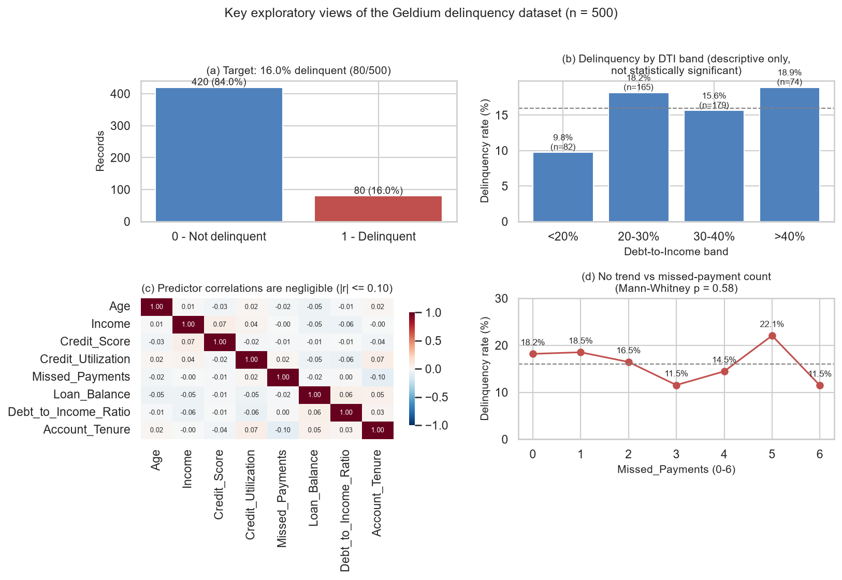
Figure 1: Key exploratory views - (a) target class imbalance, (b) delinquency rate by debt-to-income band (descriptive only, not significant), (c) negligible predictor correlations, and (d) no trend between missed-payment count and delinquency.

5. AI & GenAI Usage
A generative-AI coding assistant (LLM agent with Python execution - pandas, numpy, scipy, matplotlib/seaborn, openpyxl and python-docx) supported this analysis by drafting and running the profiling, statistical-testing and reporting code and by suggesting narrative summaries. Every number in this report was computed from the actual dataset by executed code; none was generated by the model. AI suggested candidate imputation strategies (median vs mean vs mode, missingness indicators), which the analyst verified against the observed distributions (skewness 0.05-0.11, near-identical mean/median) before adopting. AI did not generate synthetic data and did not modify the source file. Human validation consisted of re-running the statistics, cross-checking counts against the raw workbook, and reviewing the analysis for leakage, bias and unsupported claims - which is why this report explicitly states that no risk indicator is statistically validated.
Example AI prompts used:
- 'Summarise the dataset structure, missing values, anomalies and data quality risks; verify every figure against the file.'
- 'Recommend an appropriate missing-data treatment for each affected variable and justify it against the observed distribution.'
- 'Identify variables associated with delinquency, report the actual statistics, and flag anything that is not statistically significant.'
- 'Review the analysis for potential target leakage, selection bias and unsupported conclusions before finalising the report.'
AI-generated suggestions were used as hypotheses only; conclusions were retained only where the executed statistics supported them.

6. Conclusion & Next Steps
Overall, the Geldium dataset is structurally clean but not yet modelling-ready. Structure is sound: 500 unique customers, no duplicates, no invalid ranges, and a complete delinquency target (16.0% positive). Missingness is limited and treatable (Income 7.8%, Loan_Balance 5.8%, Credit_Score 0.4%), and a documented median-imputation-plus-indicator strategy has been applied to a separate cleaned copy. The blocking issues are analytical rather than cosmetic: no predictor shows a statistically significant relationship with delinquency, predictors are mutually independent, and Missed_Payments conflicts with the monthly payment history - together these suggest the target may not be genuinely linked to the behavioural fields. Recommended next steps: (1) resolve the critical quality issues at source (employment-label standardisation, tenure-age inconsistencies, the Missed_Payments vs monthly-history conflict, and the Debt_to_Income_Ratio definition); (2) confirm how the dataset and target were generated before investing in modelling; (3) apply the documented imputation strategy strictly inside training folds and keep the missingness indicators; (4) validate the five candidate risk indicators with proper train/test validation rather than relying on these descriptive screens; (5) in the modelling phase evaluate discrimination (PR-AUC given the 16% base rate), calibration, and fairness across Age, Location and Employment_Status, and monitor performance by segment.

