Practical No. 7 | Data Visualization Lab (TE7663)
Bringing R into Power BI: Regression and Time-Series Analytics on Adventure Works Sales Data
Symbiosis Institute of Technology, Pune | Department of AI & ML | Sem V | AY 2026-27 |
Name: Prince Kumar PRN: 24070126140

1. Introduction
Power BI is excellent for quick, interactive reporting, but it has limits when we want statistical modelling or fully customised charts. R fills this gap. Power BI can run R scripts inside visuals, so we can fit a model or draw a custom plot and still keep it connected to slicers and filters. In this practical, I connected R with Power BI and built an interactive dashboard on the Adventure Works sales data. It combines KPI cards, standard Power BI charts and R visuals, and uses linear regression and time-series analysis as the advanced analytics techniques.

2. Objective
- Configure R with Power BI Desktop and run R scripts successfully.
- Clean the data (missing values and duplicates) and generate descriptive statistics.
- Create at least 4 R visualizations and at least 4 Power BI visualizations.
- Implement one statistical technique (linear regression and time-series trend analysis).
- Build an interactive dashboard with 5 KPI cards, slicers, filters and drill-down.
- Interpret the results and write business insights.

3. Dataset and Tools
Dataset: Adventure Works sales data (2020 to 2022), using the tables Sales_2020_2022, Products, Product_Categories, Customers, Territories and Calendar.
Tools: Microsoft Power BI Desktop and R (base R graphics, no extra packages needed).
Measures used: Total Sales, Total Cost, Total Profit, Total Orders, Total Customers, Average Order Value, Profit Margin % and Monthly Sales (created with DAX in Practical 6).

4. Steps Performed

Step 1: R installation and configuration
- Download and install R from the CRAN website (cran.r-project.org).
- Open Power BI Desktop and go to File > Options and settings > Options > R scripting.
- Check that the R installation folder is detected under "Detected R home directories". If not, choose the folder manually.
- Select the R visual icon (R) in the Visualizations pane and click "Enable" when asked to allow script visuals.

Step 2: Import the dataset
I used Get data to load the Adventure Works tables into Power BI, built the relationships between the sales table and the product, customer, territory and calendar tables, and reused the DAX measures from the previous practical.

Step 3: Data cleaning
Cleaning was done at two levels. In Power Query, I checked column types and removed blank rows. In every R visual, the script removes duplicate rows with unique() and drops missing values with complete.cases(). Power BI also shows the message "Duplicate rows will be removed from the data" when an R visual is added, which confirms that duplicates are handled before the script runs.

Step 4: Run the R scripts
I added an R script visual from the Visualizations pane, dragged the required fields into Values, and wrote the R code in the R script editor. Power BI passes the selected fields to the script as a data frame called dataset. The screenshot below shows the R script editor in Power BI with the code for the monthly trend visual and the fields selected.
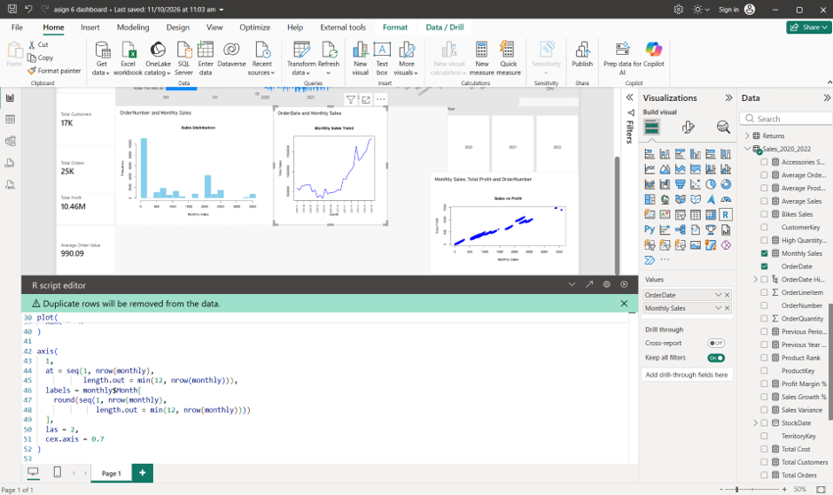
Figure 1: R script editor in Power BI Desktop (steps performed)

Step 5: Summary statistics
Descriptive statistics were generated to understand the spread and relationship of the data: minimum, quartiles, median, mean and maximum with summary(), spread with sd() and var(), the relationship between sales and profit with cor(), and a check for missing values.
# Descriptive statistics (run in an R script / RStudio)
sales <- dataset$`Monthly Sales`
summary(sales) # min, quartiles, median, mean, max
sd(sales) # standard deviation
var(sales) # variance
cor(dataset$`Monthly Sales`, dataset$`Total Profit`) # correlation
colSums(is.na(dataset)) # missing values per column

Step 6: R visualizations
Four R visuals were created. Each script first removes duplicates and missing values, then draws the chart with base R.
No. | R visual | Description
1 | Sales Distribution | Histogram of sales values (Fields: OrderNumber, Monthly Sales)
2 | Sales vs Profit | Scatter plot with linear regression line (Monthly Sales, Total Profit)
3 | Sales by Order Quantity | Scatter plot of order quantity against sales
4 | Monthly Sales Trend | Time-series line plot of monthly sales (OrderDate, Monthly Sales)

R visual 1: Sales Distribution
# Visual 1: Sales Distribution (Histogram)
# Fields: OrderNumber, Monthly Sales
dataset <- unique(dataset) # remove duplicate rows
dataset <- dataset[complete.cases(dataset), ] # remove missing values
sales <- dataset$`Monthly Sales`
hist(sales, breaks = 30, col = "skyblue", border = "white",
main = "Sales Distribution",
xlab = "Monthly Sales", ylab = "Frequency")

R visual 2: Sales vs Profit with regression line
# Visual 2: Sales vs Profit (Linear Regression)
# Fields: Monthly Sales, Total Profit, OrderNumber
dataset <- unique(dataset)
dataset <- dataset[complete.cases(dataset), ]
sales <- dataset$`Monthly Sales`
profit <- dataset$`Total Profit`

model <- lm(profit ~ sales) # fit regression model
r2 <- round(summary(model)$r.squared, 3)

plot(sales, profit, pch = 19, col = "blue",
main = "Sales vs Profit",
xlab = "Monthly Sales", ylab = "Total Profit",
sub = paste("Linear regression: R-squared =", r2))
abline(model, col = "red", lwd = 2) # regression line

R visual 3: Sales by Order Quantity
# Visual 3: Sales by Order Quantity (Scatter Plot)
# Fields: Monthly Sales, Sum of OrderQuantity, OrderDate
dataset <- unique(dataset)
dataset <- dataset[complete.cases(dataset), ]
plot(dataset$OrderQuantity, dataset$`Monthly Sales`,
pch = 19, col = "darkgreen",
main = "Sales by Order Quantity",
xlab = "Order Quantity", ylab = "Monthly Sales")

R visual 4: Monthly Sales Trend
# Visual 4: Monthly Sales Trend (Time Series)
# Fields: OrderDate, Monthly Sales
dataset <- unique(dataset)
dataset <- dataset[complete.cases(dataset), ]
dataset$OrderDate <- as.Date(dataset$OrderDate)
dataset$Month <- format(dataset$OrderDate, "%Y-%m")
monthly <- aggregate(`Monthly Sales` ~ Month, data = dataset, FUN = sum)
monthly <- monthly[order(monthly$Month), ]

plot(monthly$`Monthly Sales`, type = "l", col = "blue", lwd = 2,
xaxt = "n", main = "Monthly Sales Trend",
xlab = "Month", ylab = "Total Sales")
axis(1,
at = seq(1, nrow(monthly), length.out = min(12, nrow(monthly))),
labels = monthly$Month[
round(seq(1, nrow(monthly), length.out = min(12, nrow(monthly))))
],
las = 2, cex.axis = 0.7)

Step 7: Advanced analytics
Technique 1: Simple linear regression. The Sales vs Profit visual fits the model Profit = a + b × Sales using lm() and draws the fitted line over the scatter plot. The R-squared value is printed under the chart to show how much of the variation in profit is explained by sales. The points follow a clear upward straight-line pattern, so sales is a strong predictor of profit.
Technique 2: Time-series analysis. The Monthly Sales Trend visual aggregates sales by month and plots them in time order, which reveals the long-term trend. Sales rise steadily from 2020 to 2022 with a sharp increase in the last year.

Step 8: Interactive dashboard
The R visuals were placed next to standard Power BI visuals on one page. Because R visuals in Power BI are linked to the report, they refresh automatically when the user clicks the Year slicer or any chart element.
Power BI visual | Chart | Purpose
Total Sales by ProductName | Bar chart | Bar chart of top 10 products
Total Sales by OrderDate | Area chart | Area/line chart showing the sales trend
Total Sales by Region | Column chart | Column chart comparing regions
Total Sales by CategoryName | Bar chart | Bar chart comparing product categories

5. Output: Dashboard with KPI Cards
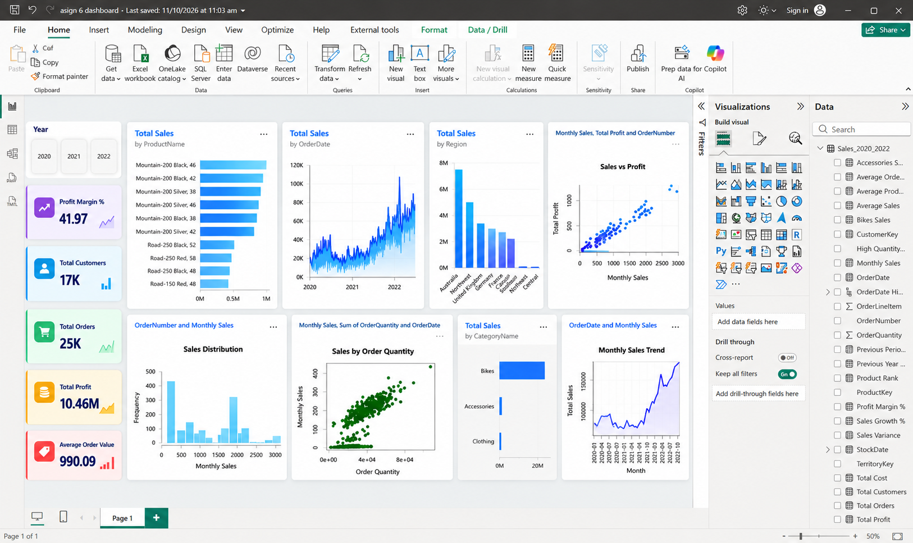
Figure 2: Interactive Power BI dashboard with KPI cards, Power BI visuals and R visuals
KPI card | Value | Meaning
Profit Margin % | 41.97 | Profit earned for every 100 of sales
Total Customers | 17K | Unique customers
Total Orders | 25K | Distinct orders placed
Total Profit | 10.46M | Total Sales minus Total Cost
Average Order Value | 990.09 | Revenue per order

Dashboard requirement checklist
Requirement | How it is met
5 KPI cards | Profit Margin %, Total Customers, Total Orders, Total Profit, Average Order Value
4 R visualizations | Sales Distribution, Sales vs Profit, Sales by Order Quantity, Monthly Sales Trend
4 Power BI visualizations | Sales by Product, Order Date, Region and Category
Interactive slicers | Year slicer (2020, 2021, 2022); all visuals respond to the selection
Filters | Filters pane for page-level and visual-level filters
Drill-down | Date hierarchy (Year > Quarter > Month > Day) and Category > Subcategory > Product
Professional layout | KPI cards on the left, Power BI visuals in the top row, R visuals in the bottom row

Task summary
No. | Task | What was done
1 | R Installation | R installed and the R home directory set in Power BI options
2 | Import Dataset | Adventure Works tables loaded into Power BI
3 | Data Cleaning | Duplicates and missing values removed (Power Query and R)
4 | R Script | R scripts executed successfully in R script visuals
5 | Summary Statistics | summary(), sd(), var() and cor() used
6 | Data Visualization | 4 R-based charts created
7 | Advanced Analytics | Linear regression (Profit ~ Sales) and time-series trend analysis
8 | Interactive Dashboard | R visuals combined with Power BI visuals, KPI cards and slicers
9 | Business Insights | Section 6
10 | Conclusion | Section 7

6. Business Insights

KPI overview
The business has earned a total profit of 10.46M with a profit margin of 41.97%. It served 17K customers through 25K orders, with an average order value of 990.09. This is a high order value, which is typical for a bicycle company.

Products, categories and regions
- The Mountain-200 models (Black and Silver, in several sizes) are the top sellers, each bringing close to 1M in sales. The Road-250 and Road-150 models are well below them.
- Bikes make up almost all of the sales. Accessories and Clothing are small by comparison.
- Australia is the strongest region, well ahead of the others. The Southeast, Northeast and Central regions contribute almost nothing.

Regression: Sales vs Profit
The scatter plot shows a strong, positive, almost linear relationship between sales and profit. When sales go up, profit goes up in proportion, which means profit margins are fairly stable across transactions. The regression line can therefore be used to estimate expected profit for a given sales amount.

Sales distribution
The histogram has two main peaks. A large group of orders falls at low sales values (accessories, clothing and low-priced items) and another group sits around the 2,000 mark (mid-range bikes). Very high-value sales are rare. The business therefore has a mix of many small purchases and a smaller number of expensive ones.

Order quantity and sales
Sales generally increase as order quantity increases, but a cluster of points stays close to zero sales even at higher quantities. These are low-priced items sold in volume, which add to quantity but contribute little to revenue.

Monthly trend
Monthly sales show a clear upward trend from 2020 through 2022, with the steepest growth in the second half of 2021 and during 2022. The business is expanding, and the trend suggests continued growth if conditions stay the same.

7. Conclusion
In this practical, I integrated R with Power BI and built an interactive dashboard that combines 5 KPI cards, 4 Power BI visuals and 4 R visuals, with a Year slicer, filters and drill-down. Linear regression showed a strong linear link between sales and profit, and the time-series plot showed steady growth in monthly sales. Overall, the analysis shows a growing, bike-driven business with a healthy 41.97% margin. Using R inside Power BI gives the report statistical depth and custom charts that standard visuals cannot provide, while keeping everything interactive.
Blog link: [Paste your published blog URL here]

