Kivy in python:-

Program code1:-

HELLO WORLD:-

import kivy

from kivy.app import App

from kivy.uix.label import Label

kivy.require('1.11.1')

class MyFirstKivyApp(App):

    def build(self):

        return Label(text ="Hello World !")

MyFirstKivyApp().run()

Output:-

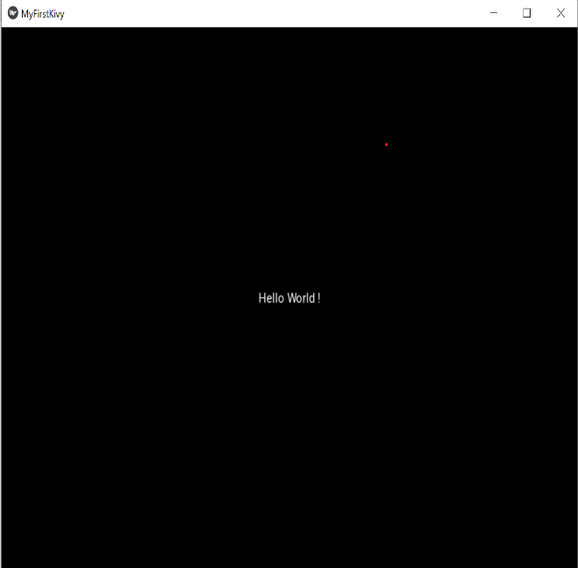

Programe 2:-

IMPORTING KIVY FILE .kv

Main file

import kivy

from kivy.app import App

kivy.require('1.11.1')

class kvfileApp(App):

    pass

kv = kvfileApp()

kv.run()

.kv file

Label:

text:

"PRINCE KUMAR"

markup: True

font_size: '64pt'

Output:-



LAYOUT:-

TYPES OF LAYOUT:-

Layouts are containers used to arrange widgets in a particular manner.

[AnchorLayout](https://kivy.org/doc/stable/api-kivy.uix.anchorlayout.html#module-kivy.uix.anchorlayout):

Widgets can be anchored to the ‘top’, ‘bottom’, ‘left’, ‘right’ or ‘center’.

[BoxLayout](https://kivy.org/doc/stable/api-kivy.uix.boxlayout.html#module-kivy.uix.boxlayout):

Widgets are arranged sequentially, in either a ‘vertical’ or a ‘horizontal’ orientation.

[FloatLayout](https://kivy.org/doc/stable/api-kivy.uix.floatlayout.html#module-kivy.uix.floatlayout):

Widgets are essentially unrestricted.

[RelativeLayout](https://kivy.org/doc/stable/api-kivy.uix.relativelayout.html#module-kivy.uix.relativelayout):

Child widgets are positioned relative to the layout.

[GridLayout](https://kivy.org/doc/stable/api-kivy.uix.gridlayout.html#module-kivy.uix.gridlayout):

Widgets are arranged in a grid defined by the *rows* and *cols* properties.

[PageLayout](https://kivy.org/doc/stable/api-kivy.uix.pagelayout.html#module-kivy.uix.pagelayout):

Used to create simple multi-page layouts, in a way that allows easy flipping from one page to another using borders.

[ScatterLayout](https://kivy.org/doc/stable/api-kivy.uix.scatterlayout.html#module-kivy.uix.scatterlayout):

Widgets are positioned similarly to a RelativeLayout, but they can be translated, rotated and scaled.

[StackLayout](https://kivy.org/doc/stable/api-kivy.uix.stacklayout.html#module-kivy.uix.stacklayout):

Widgets are stacked in a *lr-tb* (left to right then top to bottom) or *tb-lr* order.

Diagram:-

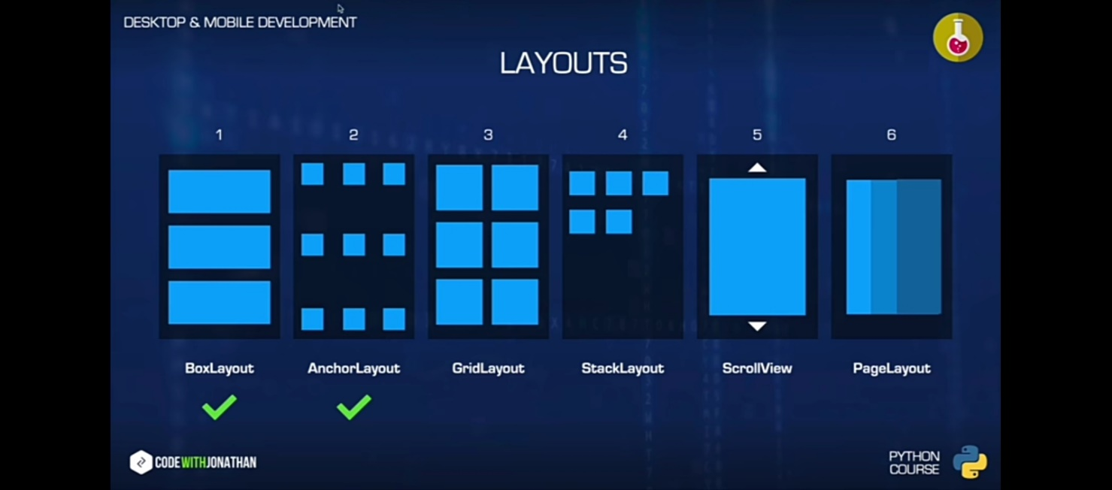

LAYOUT PROGRAME:-

Programe code:-

from kivy.app import App

from kivy.uix.boxlayout import BoxLayout

from kivy.uix.anchorlayout import AnchorLayout

from kivy.uix.gridlayout  import GridLayout

from kivy.uix.stacklayout import StackLayout

from kivy.uix.scrollview import ScrollView

from kivy.uix.pagelayout import PageLayout

from kivy.uix.button import Button

from kivy.uix.widget import Widget

class ScrLayout(ScrollView):

    pass

class StckLayout(StackLayout):

    def __init__(self, **kwargs):

        super().__init__(**kwargs)

        b=Button(text="Z",size_hint=(.5,.5))

        self.add_widget(b)

    pass

class GrdLayout(GridLayout):

    pass

class AnrLayout(AnchorLayout):

    pass

class BxLayout(BoxLayout):

    pass

class mainwidget(Widget):

    pass

class princeapp(App):

    pass

princeapp().run()

.Kv file:-

PgLayout:

<PgLayout@PageLayout>

StckLayout:

GrdLayout:

AnrLayout:

BxLayout:

mainwidget:

<ScrLayout@ScrollView>

StckLayout:

size_hint:1,None

height:12000

<StckLayout>

#left-right top-bottom

orientation:"rl-tb"

padding:("40dp","40dp","40dp","40dp")

spacing:"20dp","20dp"

Button:

text:"A"

size_hint:.5,.5

Button:

text:"B"

size_hint:.5,.5

Button:

text:"C"

size_hint:.5,.5

Button:

text:"D"

size_hint:.5,.5

Button:

text:"E"

size_hint:.5,.5

Button:

text:"F"

size_hint:.5,.5

Button:

text:"G"

size_hint:.5,.5

Button:

text:"H"

size_hint:.5,.5

Button:

text:"I"

size_hint:.5,.5

Button:

text:"J"

size_hint:.5,.5

Button:

text:"K"

size_hint:.5,.5

<GrdLayout>

# requires rows and cols

cols:3

rows:3

Button:

text:"A"

size_hint:.5,1

BxLayout:

Button:

text:"C"

Button:

text:"D"

size_hint:.5,1

Button:

text:"E"

AnrLayout:

Button:

text:"G"

size_hint:.5,1

Button:

text:"H"

Button:

text:"I"

<AnrLayout>:

anchor_x:"center"

# right,left,center

anchor_y:"top"

# top,bottom,center

BoxLayout:

size_hint:.2,.2

Button:

text:"A"

Button:

text:"B"

<BxLayout>

orientation:"horizontal"

Button:

text:"A"

size_hint:None,None

width:"100dp"

height:"68dp"

pos_hint:{"x":.1}

BoxLayout:

orientation:"vertical"

spacing:"10dp"

Button:

text:"B1"

Button:

text:"B2"

Button:

text:"B3"

Button:

text:"B4"

Button:

text:"C"

size_hint:None,None

width:"100dp"

height:"70dp"

pos_hint:{"center_x":.7}

# for horizontal we use top and down insted of right and left

<mainwidget>

Button:

text: "Hello1"

size:"400dp","200dp"

pos:"100dp","200dp"

color: 0,0,1,1

Label:

text: "Hello2"

size:"100dp","80dp"

pos:"40dp","80dp"

color: 1,0,0,1

Box Layout:-

Main file:-

class BxLayout(BoxLayout):

    pass

.kv file:-

<BxLayout>

orientation:"horizontal"

Button:

text:"A"

size_hint:None,None

width:"100dp"

height:"68dp"

pos_hint:{"x":.1}

BoxLayout:

orientation:"vertical"

spacing:"10dp"

Button:

text:"B1"

Button:

text:"B2"

Button:

text:"B3"

Button:

text:"B4"

Button:

text:"C"

size_hint:None,None

width:"100dp"

height:"70dp"

pos_hint:{"center_x":.7}

# for horizontal we use top and down insted of right and left

Anchor layout:-

class AnrLayout(AnchorLayout):

    pass

.kvfile:-

<AnrLayout>:

anchor_x:"center"

# right,left,center

anchor_y:"top"

# top,bottom,center

BoxLayout:

size_hint:.2,.2

Button:

text:"A"

Button:

text:"B"

Grid layout:-

class GrdLayout(GridLayout):

    pass

.kvfile:-

<GrdLayout>

# requires rows and cols

cols:3

rows:3

Button:

text:"A"

size_hint:.5,1

BxLayout:

Button:

text:"C"

Button:

text:"D"

size_hint:.5,1

Button:

text:"E"

AnrLayout:

Button:

text:"G"

size_hint:.5,1

Button:

text:"H"

Button:

text:"I"

Stack Layout:-

class StckLayout(StackLayout):

   def __init__(self, **kwargs):

        super().__init__(**kwargs)

        b=Button(text="Z",size_hint=(.5,.5))

        self.add_widget(b)

.kv file:-

<StckLayout>

#left-right top-bottom

orientation:"rl-tb"

padding:("40dp","40dp","40dp","40dp")

spacing:"20dp","20dp"

Button:

text:"A"

size_hint:.5,.5

Button:

text:"B"

size_hint:.5,.5

Button:

text:"C"

size_hint:.5,.5

Button:

text:"D"

size_hint:.5,.5

Button:

text:"E"

size_hint:.5,.5

Button:

text:"F"

size_hint:.5,.5

Button:

text:"G"

size_hint:.5,.5

Scroll layout:-

class ScrLayout(ScrollView):

    pass

.kvfile:-

<ScrLayout>

StckLayout:

size_hint:1,None

height:12000

Page Layout:-

class PgLayout(PageLayout):

    pass

.kvfile:-

<PgLayout>

StckLayout:

GrdLayout:

AnrLayout:

BxLayout:

mainwidget:

WIDGETS PROPERTIES:-

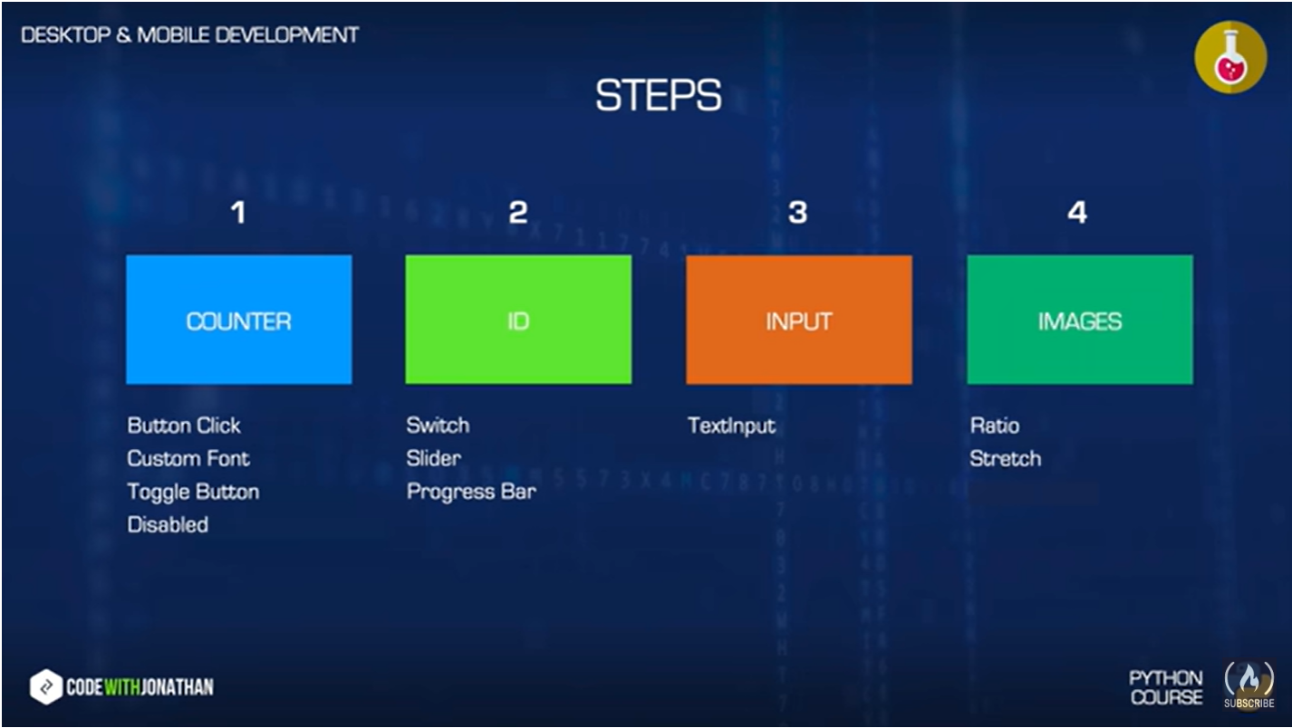

Programe code:-

class WidgetsExample(GridLayout):

    count=1

    count_enabled=BooleanProperty(False)

    my_text=StringProperty("1")

    slider_value_txt=StringProperty("Value")

    def on_button_click(self):

        print("Button clicked")

        if self.count_enabled:

            self.count+=1

            self.my_text=str(self.count)

    def on_toggle_button_state(self,widget):

        print("toggle state:"+ widget.state)

        if widget.state=="normal":

            widget.text="OFF"

            self.count_enabled=False

        else:

            widget.text="ON"

            self.count_enabled=True

    def on_switch_active(self,widget):

        print("Switch" + str(widget.active))

    def on_slider_value(self,widget):

        print("Slider:"+ str(int(widget.value)))

        self.slider_value_txt=str(int(widget.value))

.Kv file:-

WidgetsExample:

<WidgetsExample>

cols:3

ToggleButton:

text:"OFF"

on_state: root.on_toggle_button_state(self)

size_hint:None,1

width:"100dp"

Button:

text:"Count"

on_press: root.on_button_click()

disabled: not root.count_enabled

Label:

text: root.my_text

font_size:"80dp"

color:1,.5,1,1

Switch:

on_active:root.on_switch_active(self)

size_hint:None,1

width:"100dp"

Slider:

min:0

max:100

value:50

on_value:root.on_slider_value(self)

orientation:"vertical"

Label:

text:root.slider_value_txt

font_size:"80dp"

Output:-

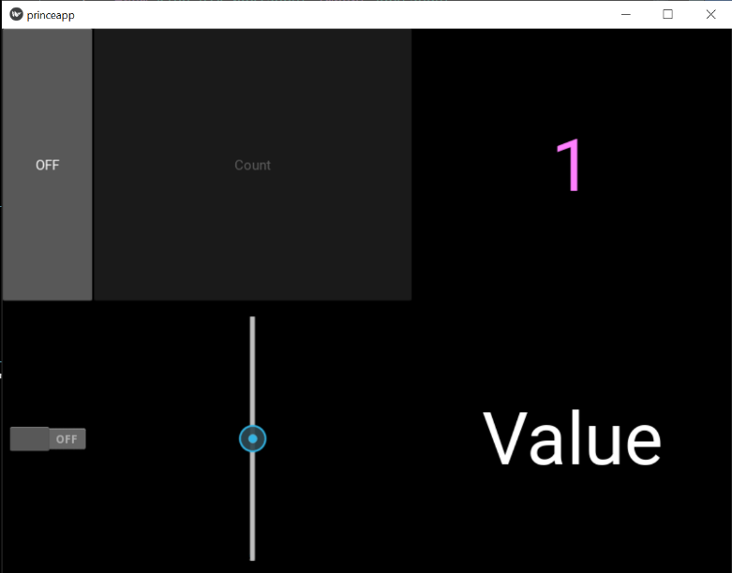

Button,toggle,Disabled:-

Programe code:-

class WidgetsExample(GridLayout):

    count=1

    count_enabled=BooleanProperty(False)

    my_text=StringProperty("1")

    slider_value_txt=StringProperty("Value")

    def on_button_click(self):

        print("Button clicked")

        if self.count_enabled:

            self.count+=1

            self.my_text=str(self.count)

    def on_toggle_button_state(self,widget):

        print("toggle state:"+ widget.state)

        if widget.state=="normal":

            widget.text="OFF"

            self.count_enabled=False

        else:

            widget.text="ON"

            self.count_enabled=True

.kv file:-

WidgetsExample:

<WidgetsExample>

cols:3

ToggleButton:

text:"OFF"

on_state: root.on_toggle_button_state(self)

size_hint:None,1

width:"100dp"

Button:

text:"Count"

on_press: root.on_button_click()

disabled: not root.count_enabled

Label:

text: root.my_text

font_size:"80dp"

color:1,.5,1,1

Output:-

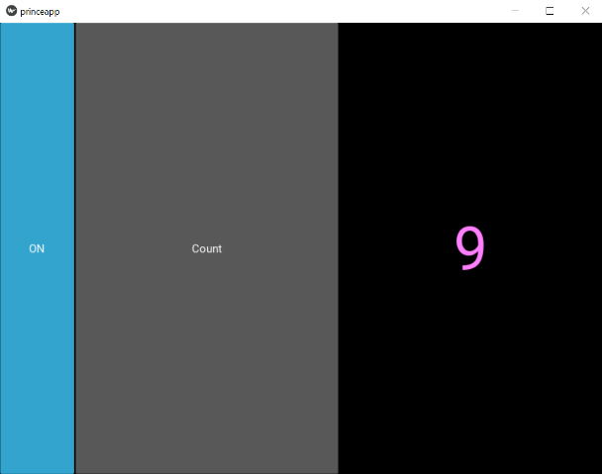

Switch,Slider,Progress:-

def on_switch_active(self,widget):

        print("Switch" + str(widget.active))

    def on_slider_value(self,widget):

        print("Slider:"+ str(int(widget.value)))

        self.slider_value_txt=str(int(widget.value))

.Kv File:-

Switch:

id:my_switch

on_active: root.on_switch_active(self)

size_hint:None,1

width:"100dp"

active:False

Slider:

min:0

max:100

value:50

on_value: root.on_slider_value(self)

orientation:"vertical"

disabled: not my_switch.active

Label:

text: root.slider_value_txt

font_size:"80dp"

output:-

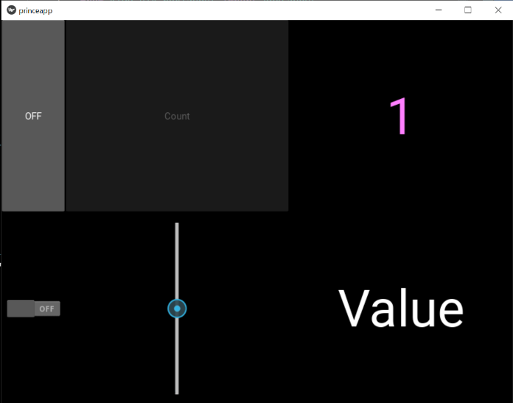

Adding progress bar:-

from kivy.app import App

from kivy.uix.boxlayout import BoxLayout

from kivy.uix.anchorlayout import AnchorLayout

from kivy.properties import StringProperty, BooleanProperty

from kivy.uix.gridlayout  import GridLayout

from kivy.uix.stacklayout import StackLayout

from kivy.uix.scrollview import ScrollView

from kivy.uix.pagelayout import PageLayout

from kivy.uix.button import Button

from kivy.uix.widget import Widget

class WidgetsExample(GridLayout):

    count=1

    count_enabled=BooleanProperty(False)

    my_text=StringProperty("1")

    slider_value_txt=StringProperty("Value")

    def on_button_click(self):

        print("Button clicked")

        if self.count_enabled:

            self.count+=1

            self.my_text=str(self.count)

    def on_toggle_button_state(self,widget):

        print("toggle state:"+ widget.state)

        if widget.state=="normal":

            widget.text="OFF"

            self.count_enabled=False

        else:

            widget.text="ON"

            self.count_enabled=True

    def on_switch_active(self,widget):

        print("Switch" + str(widget.active))

    #def on_slider_value(self,widget):

        #print("Slider:"+ str(int(widget.value)))

        #self.slider_value_txt=str(int(widget.value))

class ScrLayout(ScrollView):

    pass

class PgLayout(PageLayout):

    pass

class StckLayout(StackLayout):

   def __init__(self, **kwargs):

        super().__init__(**kwargs)

        b=Button(text="Z",size_hint=(.5,.5))

        self.add_widget(b)

class GrdLayout(GridLayout):

    pass

class AnrLayout(AnchorLayout):

    pass

class BxLayout(BoxLayout):

    pass

class mainwidget(Widget):

    pass

class princeapp(App):

    pass

princeapp().run()

.Kv file:-

WidgetsExample:

<WidgetsExample>

cols:3

ToggleButton:

text:"OFF"

on_state: root.on_toggle_button_state(self)

size_hint:None,1

width:"100dp"

Button:

text:"Count"

on_press: root.on_button_click()

disabled: not root.count_enabled

Label:

text: root.my_text

font_size:"80dp"

color:1,.5,1,1

Switch:

id:my_switch

on_active: root.on_switch_active(self)

size_hint:None,1

width:"100dp"

active:False

Slider:

id:my_slider

min:0

max:100

value:50

#on_value: root.on_slider_value(self)

orientation:"vertical"

disabled: not my_switch.active

BoxLayout:

orientation:"vertical"

Label:

text: str(int(my_slider.value))

font_size:"80dp"

ProgressBar:

max:100

value:my_slider.value

Output:-

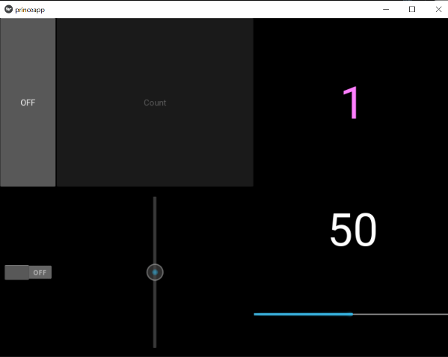

TextInput:-

Syntax:- TextInput:

def on_text_validate(self,widget):

        self.text_input_str=widget.text

.Kv file:-

TextInput:

id:my_text_input

size_hint:None,1

width:"100dp"

text:"Prince"

multiline:False

on_text_validate:root.on_text_validate(self)

Label:

text:"Your Name is "+my_text_input.text

Output:

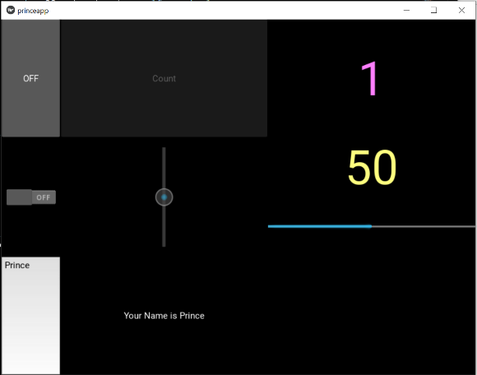

Image:-

.Kv class file:

ImageExample:

<ImageExample@GridLayout>

cols:3

Image:

source:"pri2.jpg"

Image:

source:"pri1.jpg"

Image:

source:"pri1.jpg"

Output:-

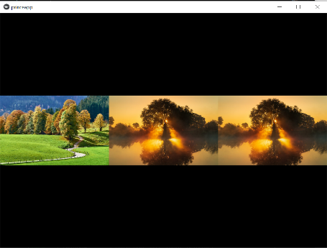

Strechabel,ratio

.Kv file:

ImageExample:

<ImageExample@GridLayout>

cols:3

Image:

source:"pri2.jpg"

Image:

source:"pri1.jpg"

allow_stretch:True

Image:

source:"pri1.jpg"

allow_stretch:True

keep_ratio:False

Output:

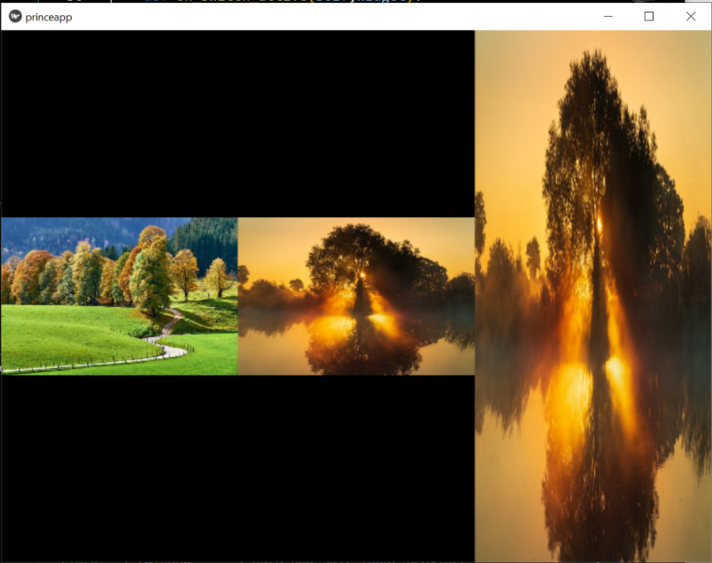

Canvas:

Line,ellipse,rectangle:

class CanvasExample(Widget):

    pass

.Kv file:-

CanvasExample:

<CanvasExample>

canvas:

Rectangle:

pos:self.center_x-s/2,self.center_y-s/2

size:s,s

Ellipse:

pos:200,500

size:s,s/2

Line:

points:(0,0,self.width/4,100,self.width/2,0,self.width+3/4,100,self.width,0)

width:2

output:-

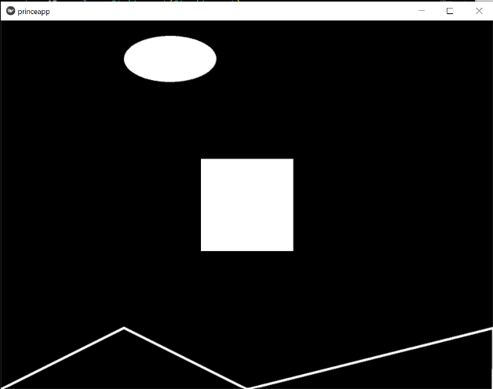

Line property:

class CanvasExample1(Widget):

    pass

.Kv file:

CanvasExample1:

<CanvasExample1>

canvas:

Line:

points:(0,self.height/2,self.width,self.height/2)

width:2

Line:

points:(self.width/2,0,self.width/2,self.height)

width:2

Output:

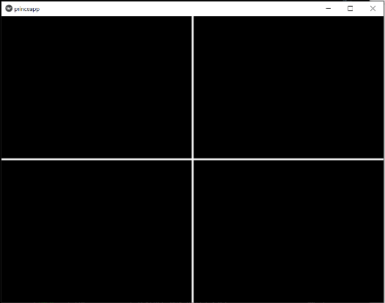

Circle,rectangle,eclipse using line property:

class CanvasExample3(Widget):

    pass

.Kv file:

CanvasExample3:

<CanvasExample3>

canvas:

Color:

rgba:1,0,0,.5

Line:

circle:(200,200,100)# center_x,center_y,radius

width:2

Line:

ellipse:(500,300,100,200)# center_x,center_y,radius_x,radius_y

width:4

Color:

rgba:0,0,.5,1

Line:

rectangle:(800,100,300,200)# x,y,m,n

width:2

Output:

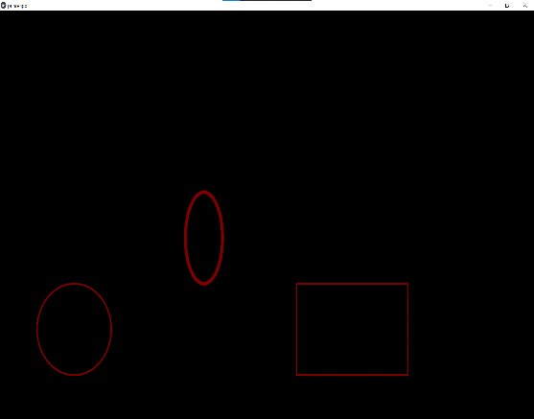

Color property in shape

class CanvasExample3(Widget):

    pass

.Kv file:

CanvasExample3:

<CanvasExample3>

canvas:

Color:

rgba:1,0,0,.5

Line:

circle:(200,200,100)# center_x,center_y,radius

width:2

Line:

ellipse:(500,300,100,200)# center_x,center_y,radius_x,radius_y

width:4

Color:

rgba:0,0,1,1

Line:

rectangle:(800,100,300,200)# x,y,m,n

width:2

Color:

rgba:0,1,0,1

Rectangle:

pos:self.center_x-s/2,self.center_y-s/2

size:s,s

output:

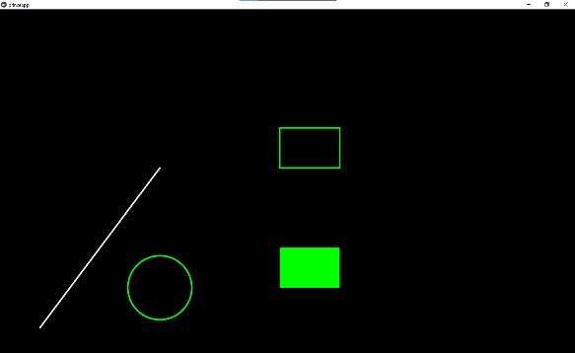

Use of animation inside code:

class CanvasExample4(Widget):

    def __init__(self, **kwargs):

        super().__init__(**kwargs)

        with self.canvas:

            Line(points=(100,100,400,500),width=2)

            Color(0,1,0)

            Line(circle=(400,200,80),width=2)

            Line(rectangle=(700,500,150,100),width=2)

            self.r=Rectangle(pos=(700,200),size=(150,100))

.Kv file:

CanvasExample4:

<CanvasExample4>

Output:

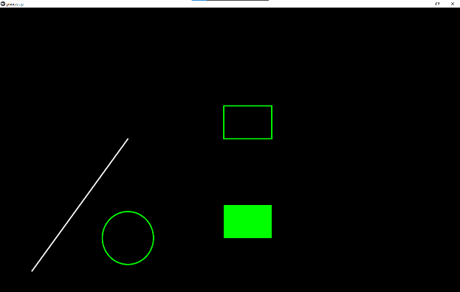

Use of postion property:

class CanvasExample4(Widget):

    def __init__(self, **kwargs):

        super().__init__(**kwargs)

        with self.canvas:

            Line(points=(100,100,400,500),width=2)

            Color(0,1,0)

            Line(circle=(400,200,80),width=2)

            Line(rectangle=(700,500,150,100),width=2)

            self.r=Rectangle(pos=(700,200),size=(150,100))

    def on_button_a_click(self):

        self.r.pos=(100,100)

.Kv file:

CanvasExample4:

<CanvasExample4>

Button:

pos:100,400

text:"A"

on_press:root.on_button_a_click()

Output:-

Initial: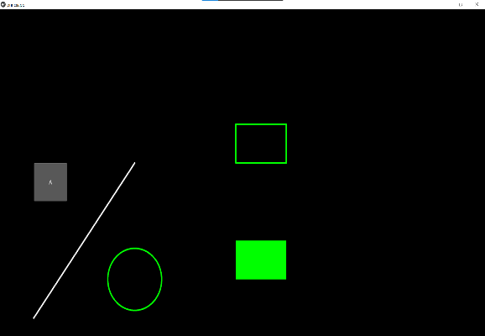 final: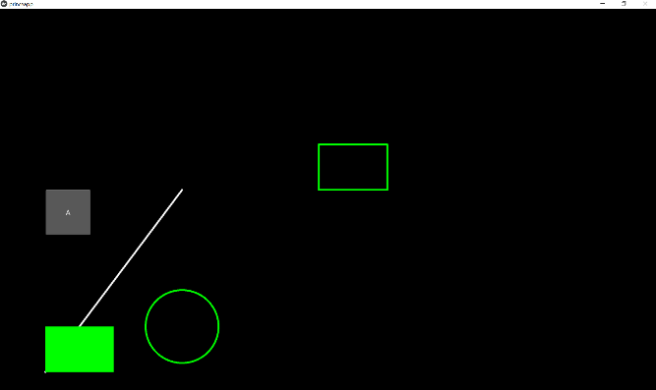

File that we have imported in this file:

from kivy.app import App

from kivy.uix.boxlayout import BoxLayout

from kivy.uix.anchorlayout import AnchorLayout

from kivy.properties import StringProperty, BooleanProperty

from kivy.uix.gridlayout  import GridLayout

from kivy.uix.stacklayout import StackLayout

from kivy.uix.scrollview import ScrollView

from kivy.uix.pagelayout import PageLayout

from kivy.metrics import dp

from kivy.graphics.context_instructions import Color

from kivy.graphics.vertex_instructions import Line

from kivy.graphics.vertex_instructions import Rectangle

from kivy.uix.button import Button

from kivy.uix.widget import Widget

Increment of values:

class CanvasExample4(Widget):

    def __init__(self, **kwargs):

        super().__init__(**kwargs)

        with self.canvas:

            Line(points=(100,100,400,500),width=2)

            Color(0,1,0)

            Line(circle=(400,200,80),width=2)

            Line(rectangle=(700,500,150,100),width=2)

            self.r=Rectangle(pos=(700,200),size=(150,100))

    def on_button_a_click(self):

        x,y=self.r.pos

        x+=dp(10)

        self.r.pos=(x,y)

.Kv file:

CanvasExample4:

<CanvasExample4>

Button:

pos:100,400

text:"A"

on_press:root.on_button_a_click()

output:

Initial: final:

Using clock inside Moving Shape:

class CanvasExample5(Widget):

    def __init__(self, **kwargs):

        super().__init__(**kwargs)

        self.ball_size=dp(50)

        self.vx=dp(3)

        self.vy=dp(3)

        with self.canvas:

            self.ball=Ellipse(pos=self.center,size=(self.ball_size,self.ball_size))

        Clock.schedule_interval(self.update,0.2)

    def on_size(self,*args):

        self.ball.pos=(self.center_x-self.ball_size/2,self.center_y-self.ball_size/2)

    def update(self,dt):

        #print("update")

        x,y=self.ball.pos

        x+=self.vx

        y+=self.vy

        self.ball.pos=(x,y)

        if y+self.ball_size>self.height:

            y=self.height-self.ball_size

            self.vy=-self.vy

        if x+self.ball_size>self.width:

            x=self.width-self.ball_size

            self.vx=-self.vx

        if y<0:

            y=0

            self.vy=-self.vy

        if x<0:

            x=0

            self.vx=-self.vx

.Kv file:

CanvasExample5:

<CanvasExample5>

Output:

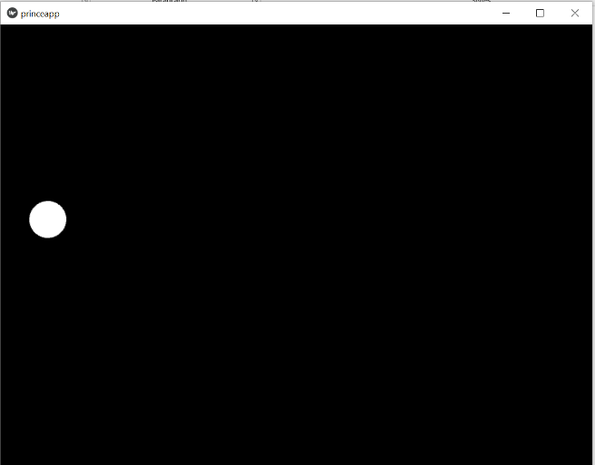

Use of before and after key:

class CanvasExample6(Widget):

    pass

.Kv file:

CanvasExample6:

<CanvasExample6>

Button:

canvas.before:

Rectangle:

text:"A"

pos:100,100

Output:

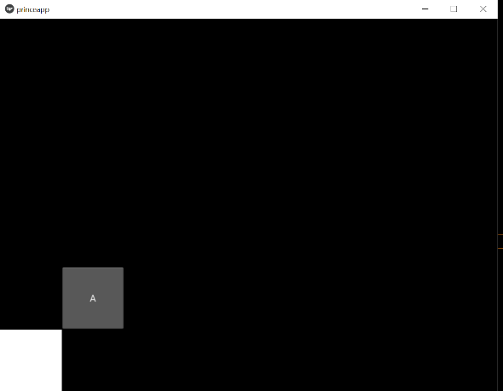

Nested,Boxlayout,canavs:

class CanvasExample6(Widget):

    pass

.kv file:

CanvasExample6:

<CanvasExample6>

BoxLayout

size:root.size

Widget:

canvas:

Rectangle:

size:self.size

Button:

text:"B"

Output:

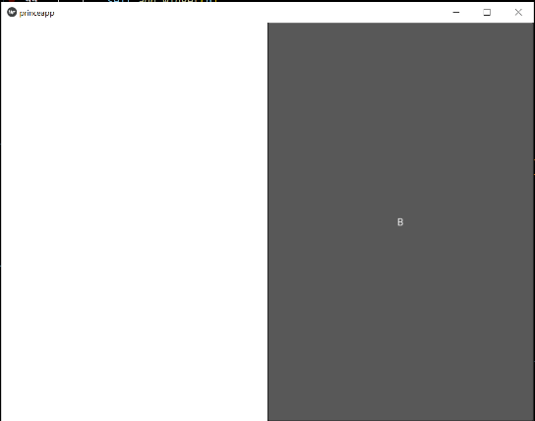

Use of positon in kivi:

class CanvasExample6(Widget):

    pass

.Kv file:

CanvasExample6:

<CanvasExample6>

BoxLayout

size:root.size

Widget:

canvas:

Color:

rgb:0,1,0

Rectangle:

size:self.size

Widget:

canvas:

Color:

rgb:0,0,1

Rectangle:

size:self.size

pos:self.pos

output:-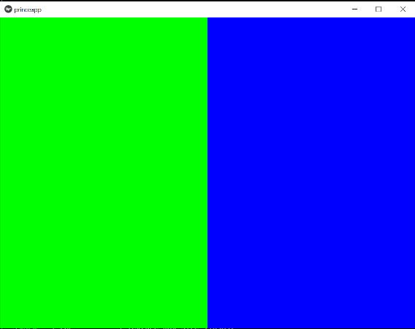

relavtiveLayout:

.Kv file:

CanvasExample6:

<CanvasExample6>

BoxLayout

size:root.size

Widget:

canvas:

Color:

rgb:0,1,0

Rectangle:

size:self.size

RelativeLayout:

canvas:

Color:

rgb:0,0,1

Rectangle:

size:self.size

output:- :-

Project 1:(create a France flage:)

class CanvasExample6(Widget):

    pass

.Kv file:

CanvasExample6:

<CanvasExample6>

BoxLayout

size:root.size

Widget:

canvas:

Color:

rgb:1,0,0

Rectangle:

size:self.size

RelativeLayout:

canvas:

Color:

rgb:1,1,1

Rectangle:

size:self.size

RelativeLayout:

canvas:

Color:

rgb:0,0,1

Rectangle:

size:self.size

Output:

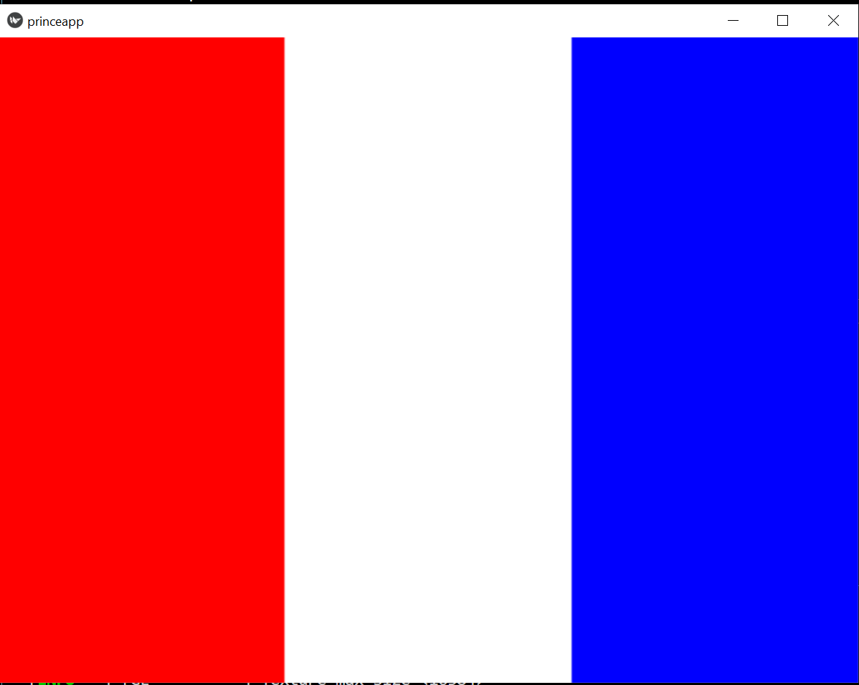

Co-oridinates in :

from kivy.app import App

from kivy.uix.widget import Widget

from kivy.properties import NumericProperty

class Mainwidget(Widget):

    x=NumericProperty(0)

    y=NumericProperty(0)

    def __init__(self, **kwargs):

        super(Mainwidget,self).__init__(**kwargs)

        print("INIT W:"+ str(self.width) + "W:" + str(self.height))

    def on_parent(self,widget,parent):

        print("ON PARENT W:" + str(self.width) + "W:" + str(self.height))

    def on_size(self,*args):

        print("ON SIZE W:"+ str(self.width)+"H:"+ str(self.height))

        self.x=self.width/2

        self.y=self.height*0.75

    def on_x(self,widget,value):

        print("PX:"+ str(value))

    def on_y(self,widget,value):

        print("PY:"+ str(value))

class GalaxyApp(App):

    pass

GalaxyApp().run()

.KV file:

Mainwidget

OUTPUT:

ON SIZE W:697H:600

PX:348.5

ON SIZE W:698H:600

PX:349.0

[INFO ] [Base ] Leaving application in progress...

ON PARENT W:698W:600

using kivy file use of co-oridenet:

from kivy.app import App

from kivy.uix.widget import Widget

from kivy.properties import NumericProperty

class Mainwidget(Widget):

    x=NumericProperty(0)

    y=NumericProperty(0)

    def __init__(self, **kwargs):

        super(Mainwidget,self).__init__(**kwargs)

        print("INIT W:"+ str(self.width) + "W:" + str(self.height))

    def on_parent(self,widget,parent):

        print("ON PARENT W:" + str(self.width) + "W:" + str(self.height))

    def on_size(self,*args):

        print("ON SIZE W:"+ str(self.width)+"H:"+ str(self.height))

        self.x=self.width/2

        self.y=self.height*0.75

    def on_x(self,widget,value):

        print("PX:"+ str(value))

    def on_y(self,widget,value):

        print("PY:"+ str(value))

class GalaxyApp(App):

    pass

GalaxyApp().run()

.KV file:

Mainwidget

OUTPUT:

ON SIZE W:697H:600

PX:348.5

ON SIZE W:698H:600

PX:349.0

[INFO ] [Base ] Leaving application in progress...

ON PARENT W:698W:600

Constructing vertical points:

from kivy.app import App

from kivy.uix.widget import Widget

from kivy.properties import NumericProperty

from kivy.graphics.context_instructions import Color

from kivy.graphics.vertex_instructions import Line

class Mainwidget(Widget):

    x=NumericProperty(0)

    y=NumericProperty(0)

    V_NB_LINES=7

    V_LINES_SPACING=0.1

    vertical_lines=[]

    def __init__(self, **kwargs):

        super(Mainwidget,self).__init__(**kwargs)

        #print("INIT W:"+ str(self.width) + "W:" + str(self.height))

        self.init_vertical_lines()

    def on_parent(self,widget,parent):

       # print("ON PARENT W:" + str(self.width) + "W:" + str(self.height))

       pass

    def on_size(self,*args):

       # print("ON SIZE W:"+ str(self.width)+"H:"+ str(self.height))

       # self.x=self.width/2

       # self.y=self.height*0.75

       self.update_vertical_lines()

       pass

    def on_x(self,widget,value):

        # print("PX:"+ str(value))

        pass

    def on_y(self,widget,value):

        # print("PY:"+ str(value))

        pass

    def init_vertical_lines(self):

        with self.canvas:

            Color(1,1,1)

            #self.line=Line(points=[100,0,100,0])

            for i in range(0,self.V_NB_LINES):

                self.vertical_lines.append(Line())

    def update_vertical_lines(self):

        central_line_x=int(self.width/2)

        spacing=self.V_LINES_SPACING*self.width

        offset=-int(self.V_NB_LINES/2)

        for i in range(0,self.V_NB_LINES):

            line_x=int(central_line_x+offset*spacing)

            self.vertical_lines[i].points=[line_x,0,line_x,self.height]

            offset+=1

        #self.line.points=[center_x,0,center_x,100]

class GalaxyApp(App):

    pass

GalaxyApp().run()

Output:

