BRAND GUIDELINES | AGSR SONIPAT

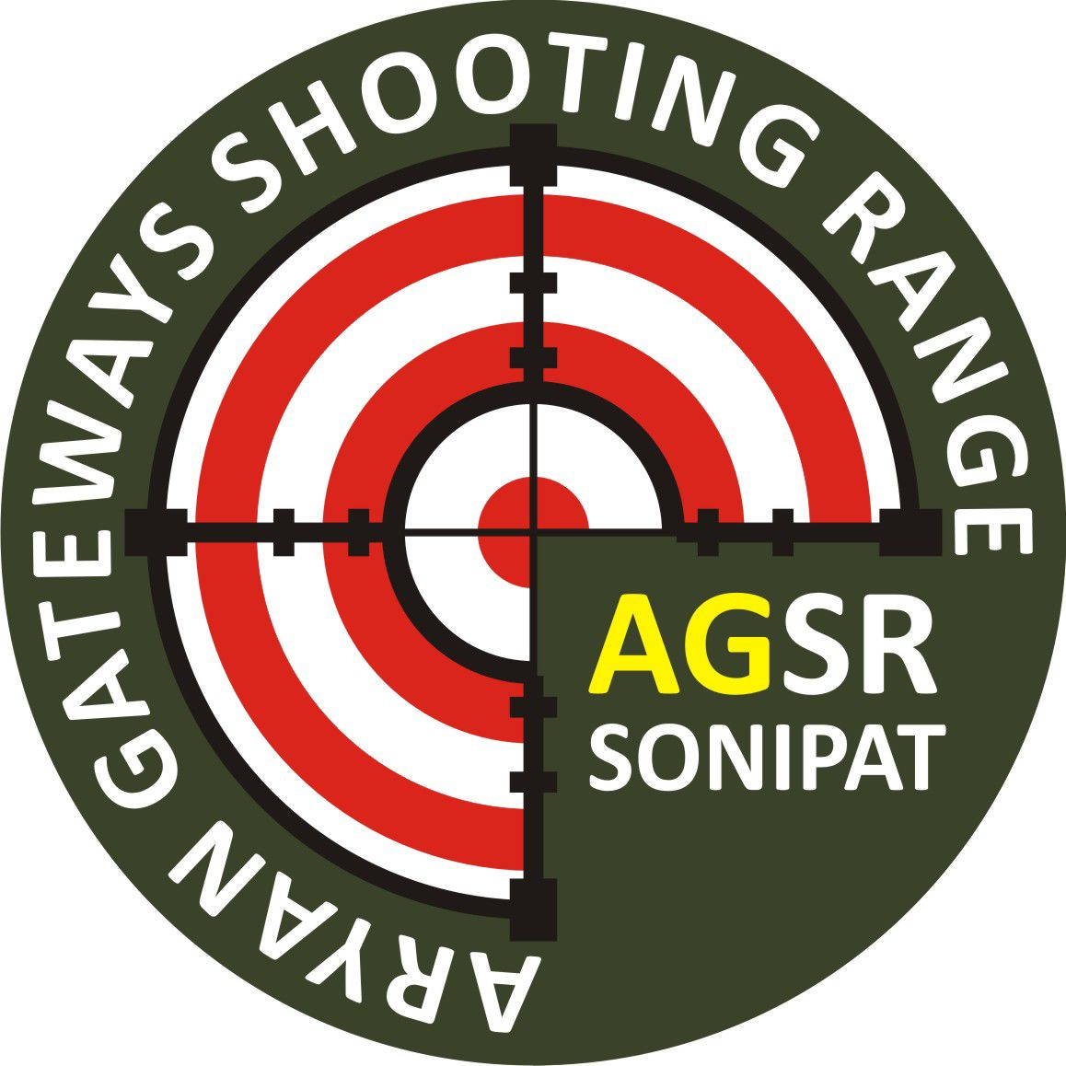 | ARYAN GATEWAYS  SHOOTING RANGE  AGSR SONIPAT  Visual Identity Guide · Version 1.0 · 2026

01 / LOGO
 | Primary Logo  Clear space: Equal to the "A" width on all sides  Min size (digital): 40px diameter  Min size (print): 15mm diameter  Backgrounds: White, light grey, or dark olive  File formats: PNG · SVG · EPS  Do not stretch · recolour · rotate · add effects

02 / COLOUR PALETTE
Olive Green | Shooting Red | Gold | Near Black | White
#3D5A2A  Primary brand | #E63322  CTAs & energy | #F5C518  Awards & highlights | #141414  Backgrounds & text | #FFFFFF  Text on dark

03 / TYPOGRAPHY
Oswald  Headings, Navigation & Buttons  AaBbCc 123  Used for all headings (H1–H3), navigation links, CTA buttons, and section labels. Always bold or semi-bold. Uppercase for navigation and buttons.  Download: fonts.google.com/specimen/Oswald | Inter  Body Text & UI  AaBbCc 123  Used for all body paragraphs, captions, form labels, and supporting text. 400 weight for body, 600 weight for emphasis.  Download: fonts.google.com/specimen/Inter | Bebas Neue  Large Display Numbers  0123456789  Used exclusively for large statistics and distance badges (10m, 25m, 50m). Numbers only — never for prose or headings.  Download: fonts.google.com/specimen/Bebas+Neue

04 / QUICK REFERENCE
Website  www.agsrsonipat.in  agsr.sonipat@gmail.com  +91 93065 21724 | Affiliations  NRAI — National Rifle Association  Haryana Rifle Association  ISSF Standard | Tagline  "Aim with Purpose.  Shoot with Perfection."  — Primary brand tagline

Aryan Gateways Shooting Range, Sonipat · Brand Guidelines v1.0 · 2026

