PROJECT REPORT
ON
VIRTUAL PAINTER
USING PYTHON AND MEDIAPIPE

Submitted By:
UNNIKRISHNAN P
Roll No: 31

Submitted To:
Faculty Name: Mr Shivlok Singh, Dy Dir, NIELIT

Course / Program: Essentials of AI (Upskilling)
Institute Name: National Institute of Electronics and Telecommunication
Session: 2025–2026

CERTIFICATE
This is to certify that the project report entitled “Virtual Painter using Python and MediaPipe” submitted by Unnikrishnan P is a bonafide work carried out under my guidance and supervision in partial fulfillment of the requirements for the completion of the course/training. The work embodied in this project has not been submitted elsewhere for any degree or diploma.

Project Guide Signature: ____________________
HOD / Faculty Signature: ____________________
Date: ____________________

DECLARATION
I hereby declare that the project report entitled “Virtual Painter using Python and MediaPipe” is an original work carried out by me under the guidance of my mentor/faculty. This project has not been submitted previously for any academic award or certification.

Name: Unnikrishnan P
Signature: ____________________
Date: ____________________

ACKNOWLEDGEMENT
I would like to express my sincere gratitude to my project guide, faculty members, and institute for their continuous guidance and support during the development of this project. Their valuable suggestions and encouragement helped me complete this work successfully.
I also thank my friends and family for their motivation and support throughout the project.
Unnikrishnan P

ABSTRACT
The project titled “Virtual Painter using Python and MediaPipe” focuses on
real-time hand gesture recognition to enable touchless drawing using a webcam. The system is developed using Python, where OpenCV is utilized for video capture and image processing, and MediaPipe is employed for accurate hand landmark detection.
The application detects and tracks hand movements by identifying key points such as fingertips and joints. Based on these tracked landmarks, the system allows users to draw on a virtual canvas by moving their fingers in the air. The detected landmarks are also visually represented on the video frame for better interaction and feedback.
This project highlights the practical implementation of computer vision and machine learning techniques in developing gesture-based interfaces. Furthermore, the system can be extended to various advanced applications, including gesture control systems, virtual mouse operations, sign language recognition, gaming, and improved human-computer interaction.

TABLE OF CONTENTS
1. Introduction
2. Objectives
3. Problem Statement
4. Proposed System
5. Tools and Technologies Used
6. System Requirements
7. Methodology
8. Code Explanation
9. Implementation
10. Results and Output
11. Advantages
12. Limitations
13. Applications
14. Future Scope
15. Conclusion

1. INTRODUCTION
With the rapid advancement of Artificial Intelligence (AI) and computer vision, machines are increasingly capable of understanding human gestures and movements. Hand tracking is a significant technology in this domain, enabling computers to detect and interpret hand motions in real time.
In modern applications such as gesture-based drawing, virtual control systems, augmented reality, and touchless interfaces, hand tracking provides a natural and intuitive way for users to interact with digital systems without physical contact. This is especially useful in environments where traditional input devices like a mouse or touchscreen are not convenient.
This project, titled “Virtual Painter using Python and MediaPipe,” focuses on developing a real-time gesture-based drawing system. The application is implemented using Python, with OpenCV handling video capture and image processing, and MediaPipe enabling accurate hand landmark detection.
The system uses a webcam to capture live video, detect hand movements, and track key points such as fingertips. Based on these movements, users can draw on a virtual canvas in the air. This project demonstrates a practical application of computer vision and serves as a foundation for more advanced gesture-controlled systems.

2. OBJECTIVES
The main objectives of this project are:
• To capture real-time video input using a webcam through OpenCV.
• To detect and track human hand movements in the video stream using MediaPipe.
• To identify and analyze hand landmarks such as fingertips for gesture recognition.
• To implement a gesture-based drawing system that allows users to draw on a virtual canvas.
• To provide functionalities such as color selection, erasing, and clearing the canvas using hand gestures.
• To visualize the drawing output in real time based on finger movements.
• To understand and apply computer vision concepts using Python.
• To develop a foundation for advanced applications like virtual painting, gesture control, and touchless human-computer interaction systems.
3. PROBLEM STATEMENT
Traditional computer interaction systems primarily depend on physical input devices such as a mouse, keyboard, or touch screen. While effective, these methods may not always be convenient, intuitive, or suitable in environments where touchless interaction is preferred.
To address this limitation, there is a growing need for intelligent systems that enable natural, gesture-based interaction between humans and computers. This project, “Virtual Painter using Python and MediaPipe,” aims to meet this need by developing a real-time, touchless drawing application using computer vision techniques.
By leveraging OpenCV for video processing and MediaPipe for accurate hand detection, the system tracks finger movements and allows users to draw on a virtual canvas without physical contact. This approach enhances user interaction by making it more intuitive, efficient, and engaging

5. PROPOSED SYSTEM
The proposed system is a real-time virtual painting application that uses a webcam to track hand movements. It processes live video frames to detect the user’s hand and identifies key landmarks using MediaPipe. With OpenCV, it enables drawing on a virtual canvas.
6. TOOLS AND TECHNOLOGIES USED
The following tools and technologies were used in this project:
- Programming Language: Python
- Libraries Used: OpenCV, MediaPipe
- Development Platform: VS Code
- Hardware: Laptop / PC, Webcam

7. SYSTEM REQUIREMENTS
This project requires both hardware and software support for smooth execution.
- Hardware Requirements: Intel i3 / i5 / i7 processor or equivalent
- Minimum 4GB RAM
- Webcam
- Laptop / Desktop
- Software Requirements: Windows 10 / 11 / Linux
- Python 3.x
- OpenCV library
- MediaPipe library
- Code editor (VS Code / PyCharm)

8. METHODOLOGY
The project follows a structured approach to capture, process, and interpret hand gestures for real-time virtual drawing.
- Step 1: Video Capture
Capture live video from the webcam using OpenCV.
- Step 2: Frame Conversion (BGR to RGB)
Convert each frame into RGB format for processing with MediaPipe.
- Step 3: Hand Detection
Detect the presence of a hand in each video frame.
- Step 4: Landmark Detection
Identify key hand landmarks such as fingertips and joints.
- Step 5: Gesture Recognition
Interpret finger positions to switch between drawing, selection, and erasing modes.
- Step 6: Drawing on Canvas
Track finger movement to draw on a virtual canvas in real time.
- Step 7: Display Output
Show the final output with hand tracking and drawing overlay on the screen.
- Step 8: Exit Condition
Terminate the application using a key press (e.g., ‘q’ key).

9. WORKING PRINCIPLE
The system operates on the principles of computer vision, hand tracking, and gesture recognition. A webcam continuously captures live video frames, which are processed using MediaPipe to detect and track the user’s hand in real time.
Once the hand is detected, the system identifies 21 key landmarks, including fingertips and joints. These landmarks are analyzed to determine finger positions and gestures. Based on the movement of the index finger, the system enables drawing on a virtual canvas, while specific gestures are used to switch between drawing, color selection, and erasing modes.
The processed output is displayed using OpenCV, providing a smooth and interactive virtual painting experience without physical contact.

10. CODE EXPLANATION
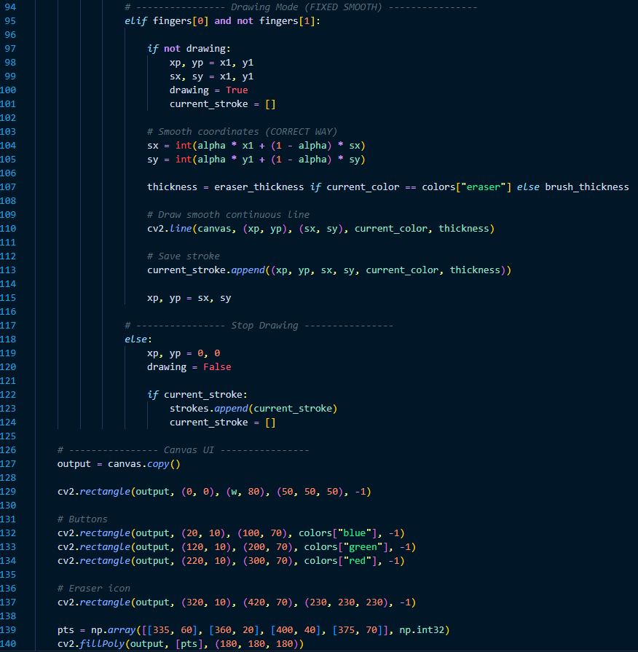
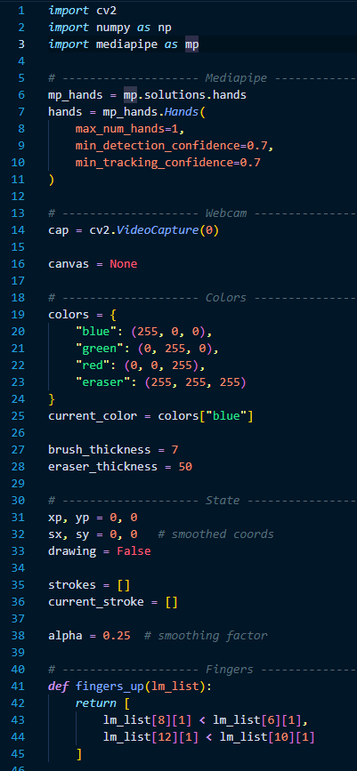
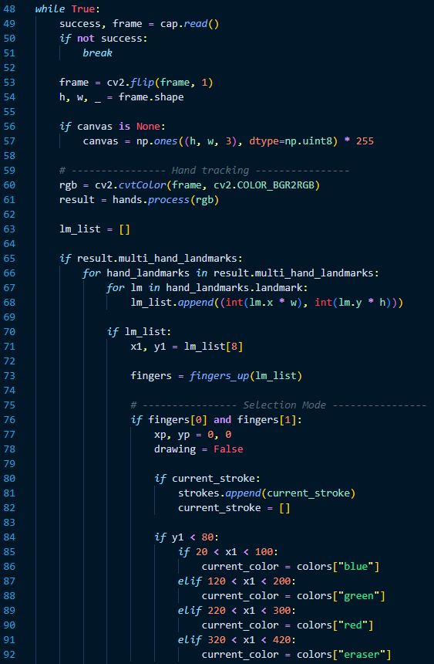
The following Python code is used in this project:
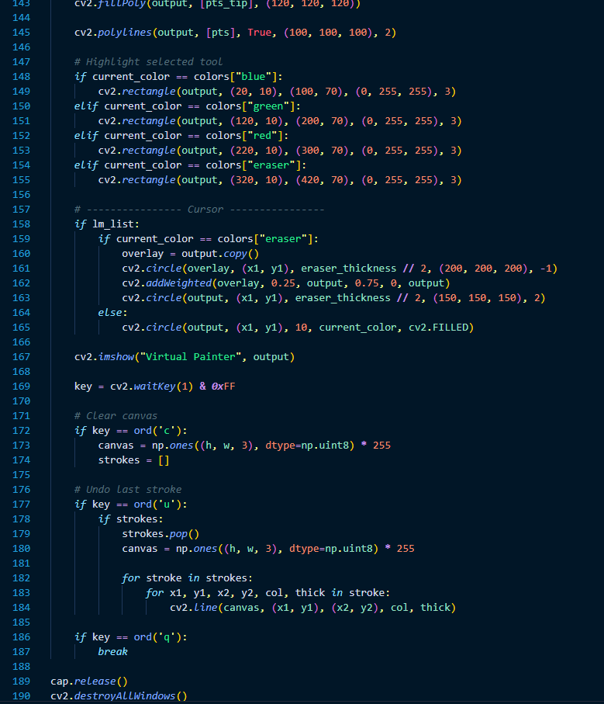

- import cv2: Imports the OpenCV library for webcam capture and image display.
- import mediapipe as mp: Imports MediaPipe for hand detection and tracking.
- cap = cv2.VideoCapture(0): Starts the default webcam.
- hands = mp.solutions.hands.Hands(): Initializes the MediaPipe Hands model.
- draw = mp.solutions.drawing_utils: Loads utilities to draw landmarks and connections.
- img_rgb = cv2.cvtColor(img, cv2.COLOR_BGR2RGB): Converts image from BGR to RGB.
- result = hands.process(img_rgb): Processes the image to detect hand landmarks.
- draw.draw_landmarks(...): Draws the hand landmarks and their connections.
- cv2.imshow(...): Displays the processed output.
- cv2.waitKey(1) == ord('q'): Exits the program when 'q' is pressed.

11. IMPLEMENTATION
The implementation of the project was done in Python using a simple and effective structure.
- Install required libraries using pip.
- Write the Python code in a code editor.
- Run the code and allow webcam access.
- Show hand in front of camera.
- Observe hand gestures on the display screen.
- Use the Index finger for painting and use two fingers for selecting colours

12. RESULTS AND OUTPUT
The project was tested successfully on a PC webcam. The system was able to detect the hand in real time, identify hand gestures accurately, and draw/paint using the index finger on the white canvas.
When the user lifts index finger the drawing will start. Showing the palm stops drawing to enable the user to shift from one place to another on the canvas without painting/drawing. User can select colours by lifting two fingers and also use eraser for any corrections required.

13. ADVANTAGES
This system provides several practical benefits for real-time, touchless drawing and human-computer interaction:
- Enables real-time virtual painting using hand gestures.
- Simple and easy to implement using Python libraries.
- Does not require any special hardware, only a standard webcam.
- Provides an intuitive and interactive drawing experience.
- Supports multiple features such as drawing, color selection, and erasing through gestures.
- Can be extended for advanced applications like gesture-controlled interfaces and AI-based creative tools.
- Enhances touchless interaction between humans and computers.

14. LIMITATIONS
Despite being effective for real-time virtual painting, the system has certain limitations:
- The accuracy of hand detection may decrease in poor lighting conditions or noisy backgrounds.
- Performance depends on the quality and resolution of the webcam used.
- The system may face difficulty in handling fast or complex hand movements.
- Gesture recognition is limited to basic actions such as drawing, color selection, and erasing; advanced gesture classification is not included.
- Continuous hand visibility is required; occlusion or moving the hand out of frame may interrupt drawing.

15. APPLICATIONS
This project has several practical applications in the field of gesture-based drawing and human-computer interaction:
- Virtual painting and digital sketching applications
- Touchless drawing systems for interactive interfaces
- Educational tools for teaching drawing and creativity
- Creative design platforms for basic sketching and ideation
- Gesture-based control systems in multimedia applications
- Interactive kiosks and smart display systems
- Foundation for advanced AR/VR drawing environments
- Research and development in computer vision and HCI systems

16. FUTURE SCOPE
The project can be further enhanced to develop more advanced and intelligent virtual interaction systems:
- Adding advanced drawing features such as shapes (circle, rectangle, etc.) and text tools
- Implementing undo and redo functionality for better user control
- Integrating AI-based drawing prediction and sketch enhancement
- Developing multi-hand support for collaborative drawing
- Adding gesture-based tool switching for improved usability
- Saving and exporting drawings in different file formats and cloud storage
- Expanding into AR/VR-based virtual painting environments
- Building a full-featured digital whiteboard for education and presentations

17. CONCLUSION
The project successfully demonstrates the implementation of a real-time virtual painting system using computer vision techniques. By combining Python, OpenCV, and MediaPipe, the system effectively tracks hand movements and enables users to draw on a virtual canvas using simple gestures.
The project provides a practical and interactive way to understand gesture-based human-computer interaction. It is simple to use, efficient in real-time performance, and helps in learning core concepts of computer vision and AI applications. Overall, the Virtual Painter system serves as a strong foundation for developing more advanced touchless and AI-based creative applications in the future.

