**Power management test system presentation**

**Purpose:** In order to design most efficient power management test system, we are proposing to use following test equipment, N6705B and architecture.

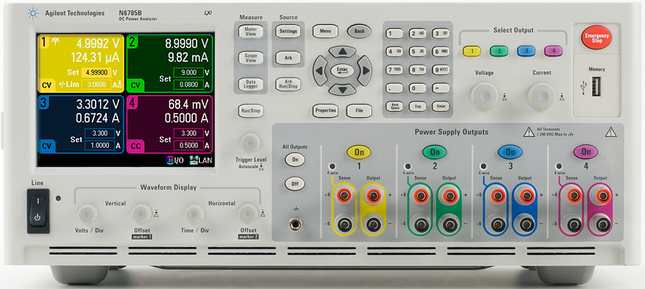

**Comparison:**

|  |  |  |
| --- | --- | --- |
|  | **Agilent DC Power Analyzer N6705B** | **NI Analog Power Modular**  **NI9215,9227** |
| **Sample rate** | 50kHz/ch | *NI 9215* 100 kHz/ch,  *NI 9227* 50 kHz/ch, |
| **Resolution** | 18bit | NI 9215 16bit  NI 9227 24bit |
| **Voltmeter accuracy** | Up to 0.025% + 50 µV, | 0.02% |
| **Ammeter accuracy** | Up to 0.025% + 8 nA, | 0.02% |
| **Programming Language** | SCPI commands & Python | LabView. |
| **Connectivity Interface** | GPIB, USB & LAN | USB only |
| **Useful features** | 🡪Easy to use R&D tool for sourcing and measuring DC voltage and current into the DUT  🡪Integrates capabilities of up to 4 Power Supplies, DMM, Scope, Arb and Data Logger |  |
| **Price** | $7486 | NI 9227🡪$3321  NI 9215🡪$570  NI 9263🡪$438  NI 9174🡪$777  Total:$5106 |

# Test Architecture:

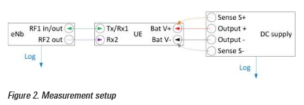

USB Circuit

Figure 1 – Measurement Setup

**4-Wire Sense Connections (Charge and Discharge):**

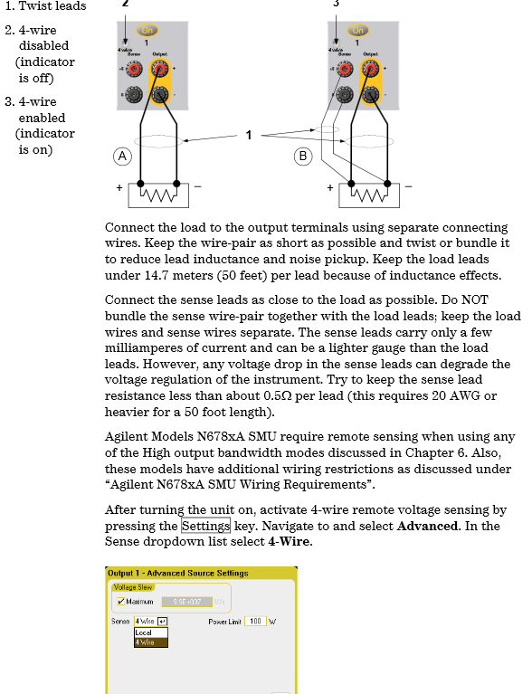

.

**Testcases using litepoint:**

**Frequency Perspective:**

|  |  |  |  |  |
| --- | --- | --- | --- | --- |
| **BT** | **Sweep** | **Bandwidth** | **Frequency(Mhz)** | **Date Rate(Mbps)** |
| BDR | Tx | 1MHz | 2402 | 1 |
| EDR | Rx | 2MHz | 2403 | 3 |
| BTLE |  |  | 2404 | 24 |
|  |  |  | 2405 |  |
|  |  |  | 2406 |  |
|  |  |  | 2407 |  |
|  |  |  | … … … |  |
|  |  |  | 2481 |  |

**Tx/Rx Power Perspective:**

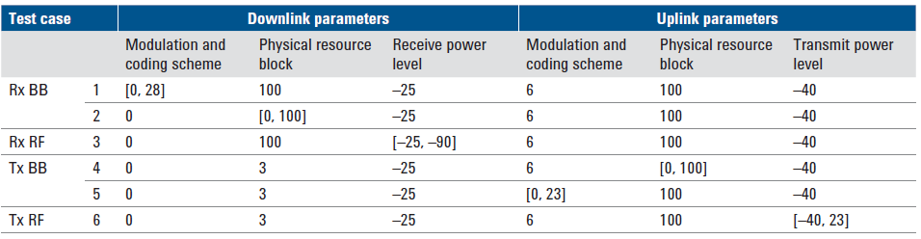

**Device’s power consumption model**

The major power consumption parts in CSR board are radio modem. The model includes functions of UL and DL power and data rate. UL transmit power and DL data rate determines the overall power consumption, while UL data rate and DL receive power have smaller impact.

