Prince Mathew Web Development Final

1. Description of My Web Application

My Web Application is a Note Taking App, it is called whatnote. It can create, edit, delete Note. The User can register, login. Create, edit, delete, Last Login Date, Date Created profile. Create, edit, delete Note. The app is finished. In the future I want to add functionalities such as add photos and videos to Notes.

1. Indicate any bugs or issues

No bugs or issues

1. List of all technologies

front-end Back end

html Node

CSS Javascript

Javascript SQL

Express

1. Include a screenshot of your finished ERD

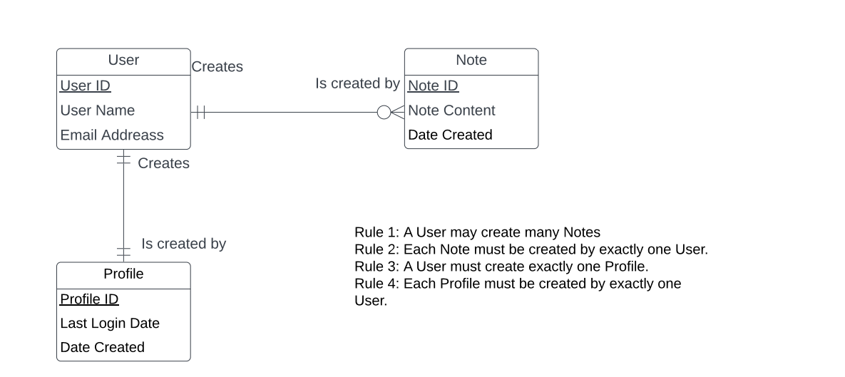

**ENTITIES**

**USER**

Username and Password used to login and register, in sql table

**Note**

Notes Content to Create, Edit, Delete Note, in sql table

**Profile**

Create, edit, delete , Last Login Date, Date Created profile, in sql table.

5. Indicate how someone who downloads My project can use it.

hosted on localhost on port 80

npm install to download dependencies, using the command node index.js to run it, and setting up the environment variables for the database.

.env

MYSQL_USERNAME = "root"

MYSQL_PSWD = "Marymatha1#"

MYSQL_HOST = "localhost"

MYSQL_DB = "db_whatenote"

1. Include screenshots of how your website

