Practical - 3
Practical Title: Responsive UI Design using CSS Grid, Flexbox, and Bootstrap/Tailwind

Problem Definition: Design responsive layouts for Home, About, Registration, Dashboard, and Events pages using CSS Grid and Flexbox. Optional to use CSS

framework such as Bootstrap or Tailwind. Ensure mobile-first

responsiveness.

A. Theory
1. How does the layout adapt for mobile, tablet, and desktop screens?
ANSWER:
- On mobile phones, the content is displayed in a single column so it is easy to read and scroll.
- On tablets, the content is arranged in two or more columns depending on the available space.
- On desktop computers, the layout uses multiple columns and a wider screen to display more content at the same time.
This is achieved using CSS Grid which help the webpage look good on all devices.

2. Which layout technique is used and why?
ANSWER:
For this practical, CSS Grid is used.
CSS Grid is used to create the overall page layout with rows and columns. It is suitable for dashboards and page sections more effectively.
These techniques help create a clean, responsive, and user-friendly website.

3. Are typography, spacing, colors, and contrast readable?
ANSWER:
Yes. Simple and clear fonts are used.
Enough spacing is provided between headings, paragraphs, buttons, and images.
Colors are chosen carefully to provide good contrast between the background and text and to look the website as a professional one as it is StudentHubPortal.

4. Is the framework used consistently without unnecessary inline CSS?
ANSWER:
Yes. The website uses external CSS files and framework consistently.

Implementation/ Output/Result

Evidence of Work (Screenshots):
Figure 1.1: Login Page of StudentHub Portal using HTML and CSS
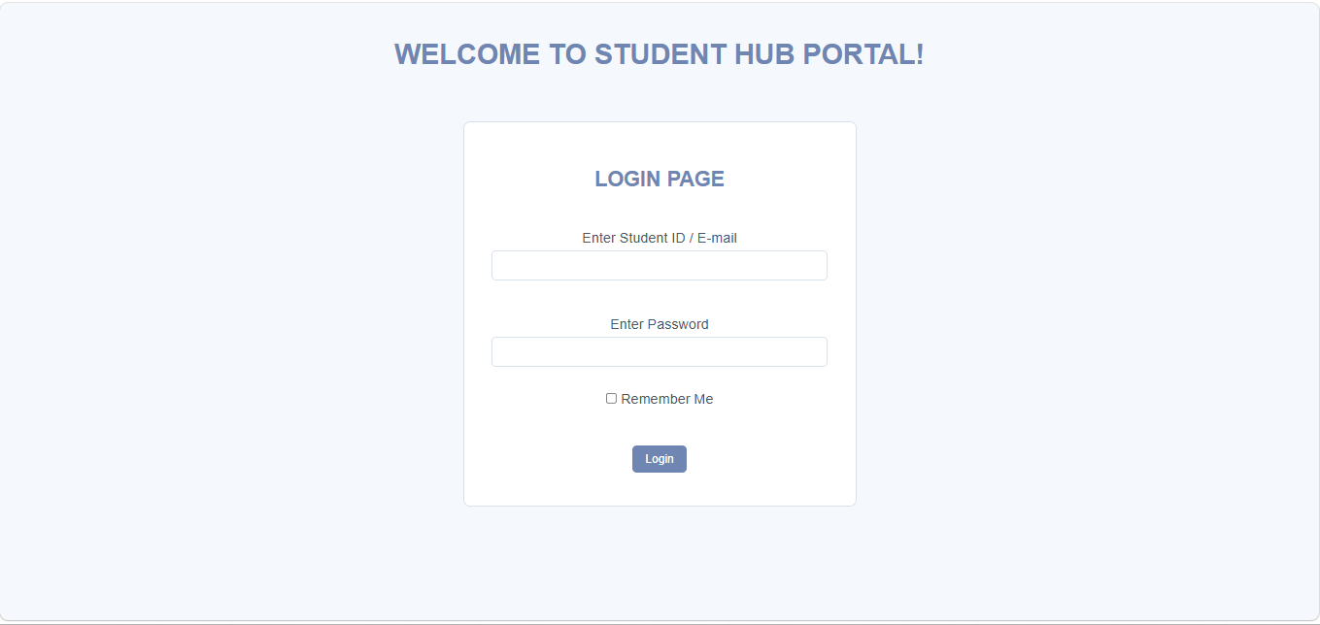
Figure 1.2: Student Dashboard Page of StudentHub Portal using HTML and CSS

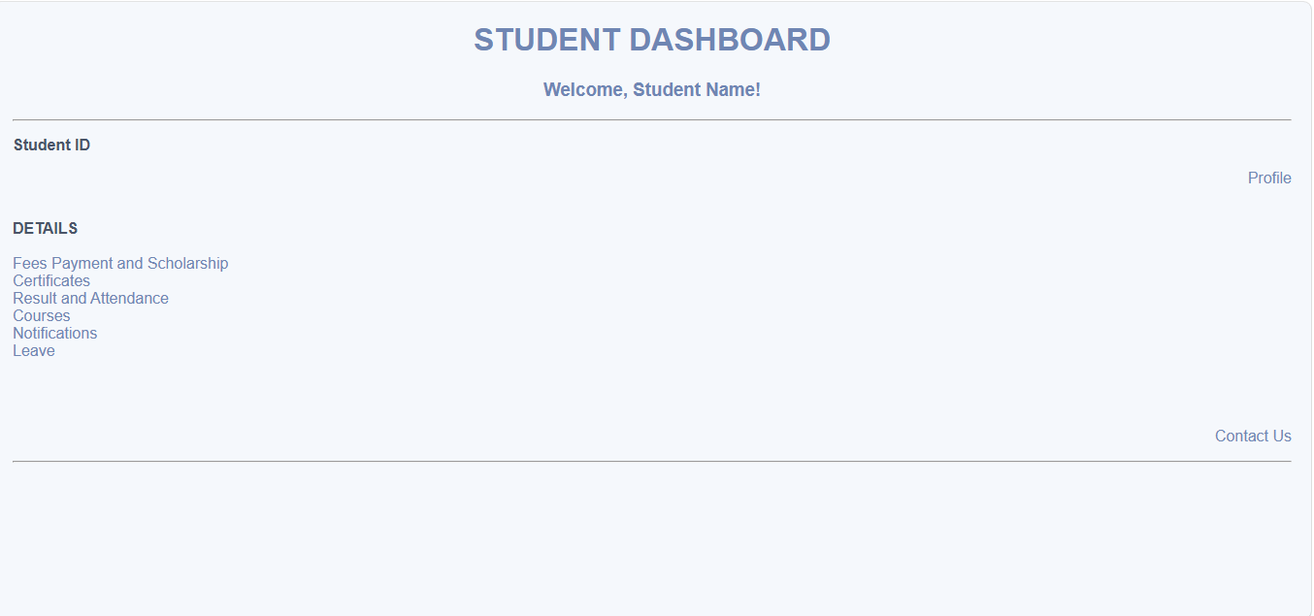

Figure 1.3: Fees payment & Scholarship Page of StudentHub Portal using HTML and CSS
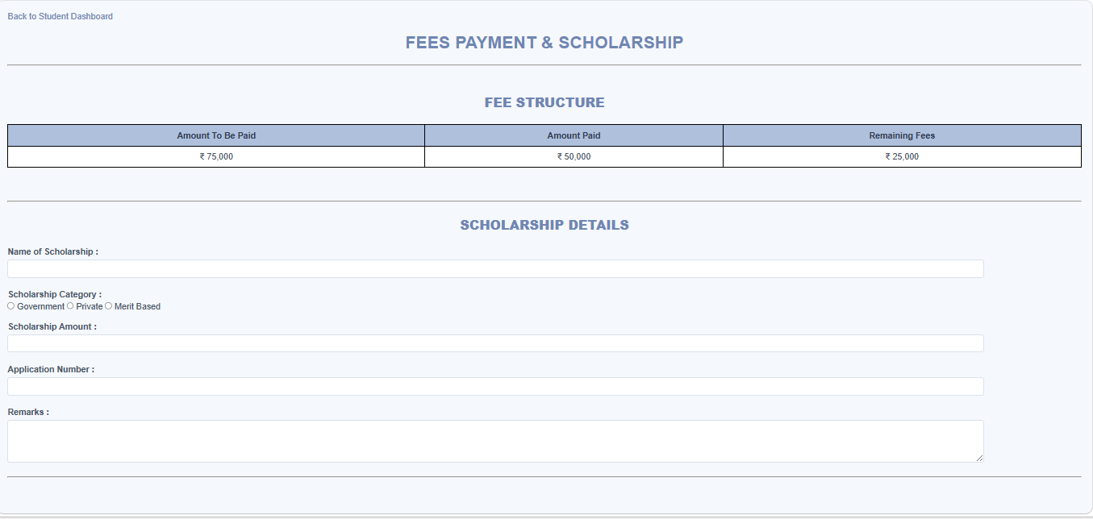

Figure 1.4: Certificates Page of StudentHub Portal using HTML and CSS.
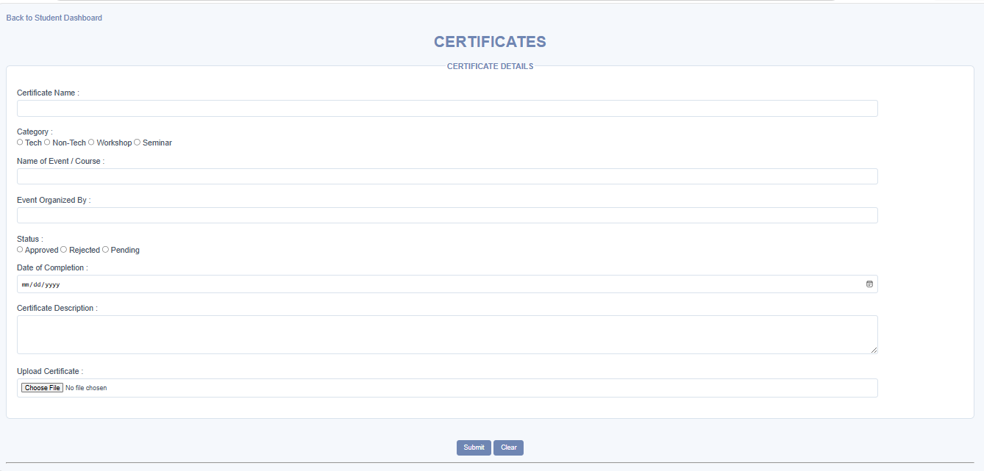

Figure 1.5: Result & Attendance Page of StudentHub Portal using HTML and CSS

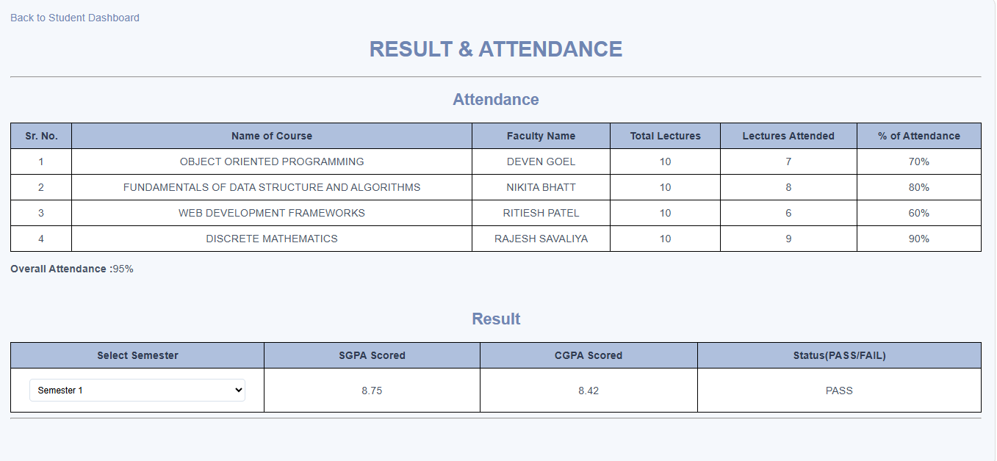

Figure 1.6: Course Page of StudentHub Portal using HTML and CSS
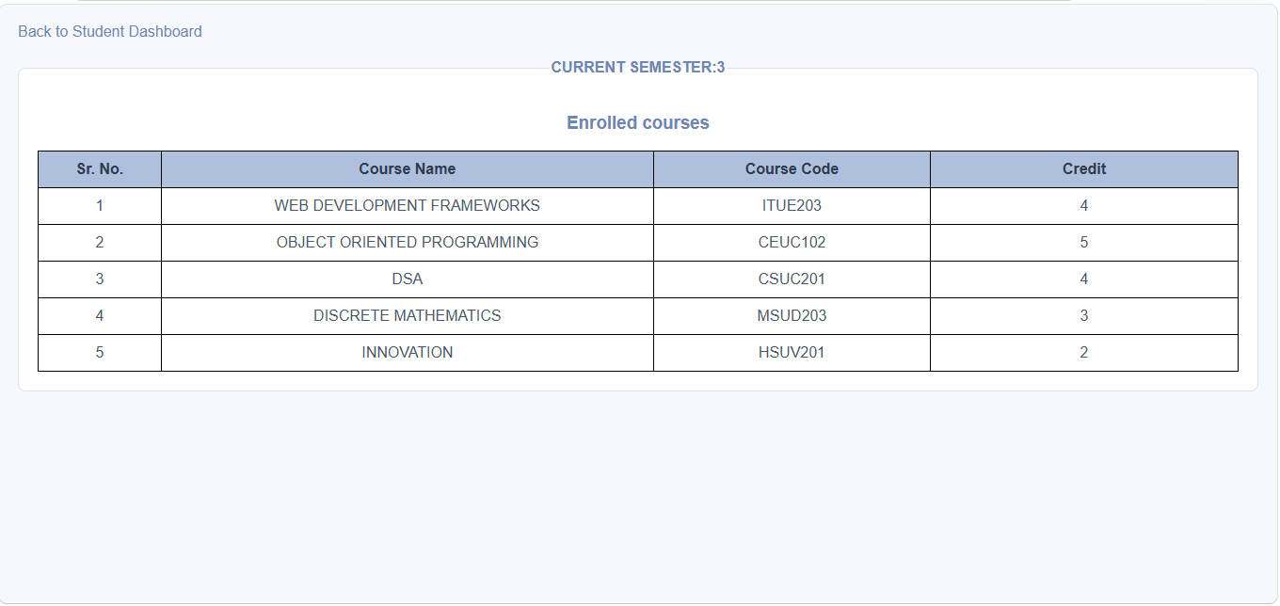

Figure 1.7: Notification Page of StudentHub Portal using HTML and CSS
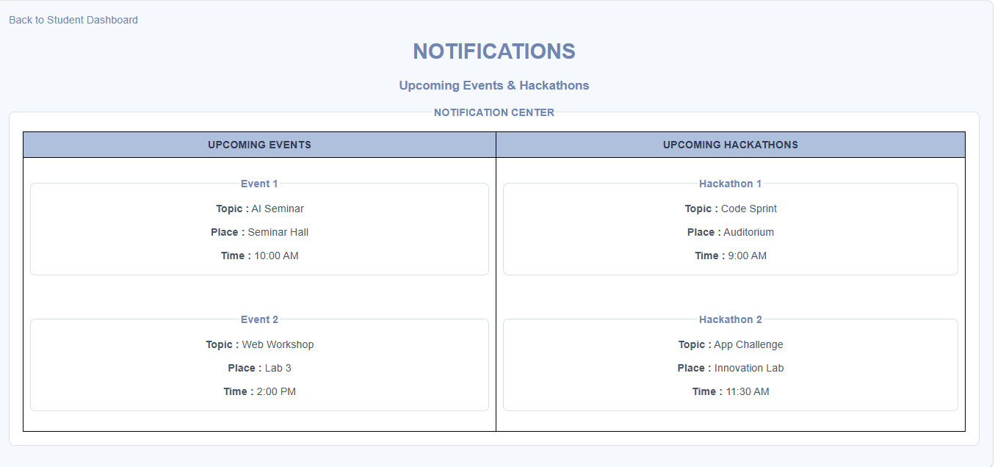

Figure 1.8: Leave Page of StudentHub Portal using HTML and CSS
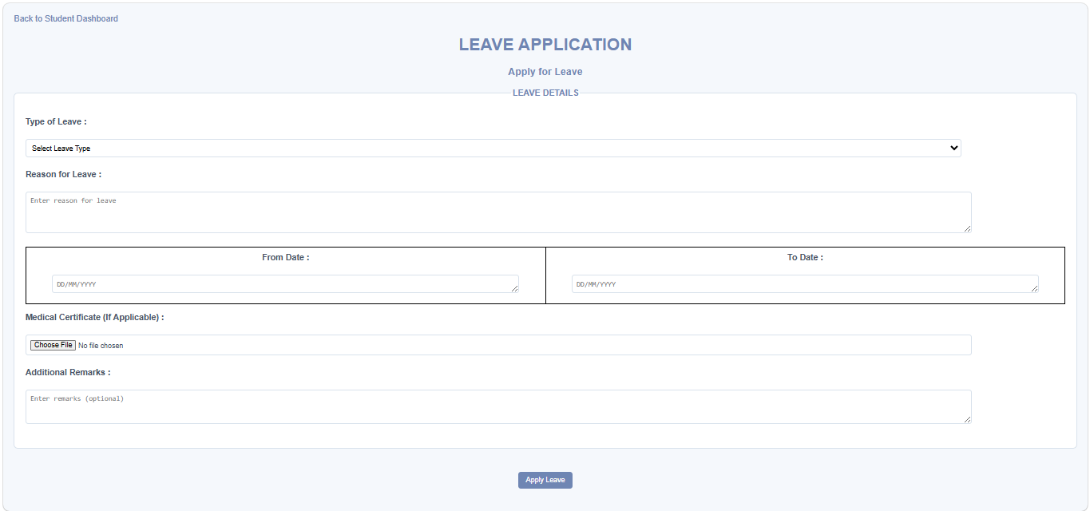

Figure 1.9: Student Profile Page of StudentHub Portal using HTML and CSS

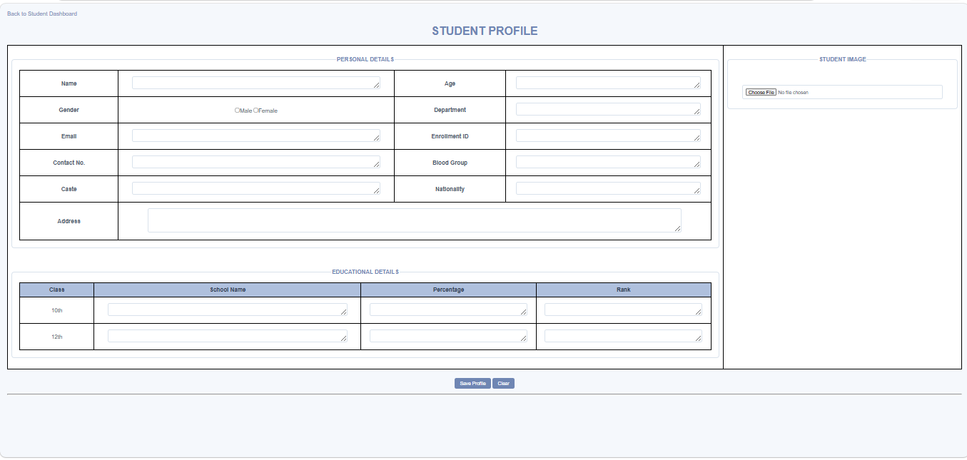

Figure 1.10: Contact Us Page of StudentHub Portal using HTML and CSS.
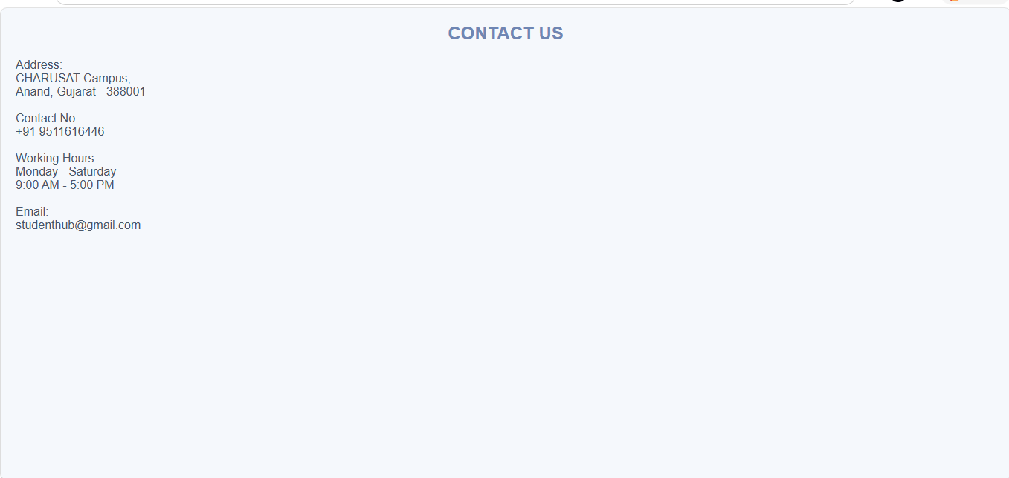

GitHub Repository Link:
https://github.com/princemerja2/WDF/tree/main/Practical-3

Challenges Faced:
- Making the website for different screen sizes such as mobile, tablet, and desktop.
- Choosing suitable font sizes, colors, and contrast for better readability.
- Maintaining consistent spacing, alignment, and sizing of elements across pages so that user can see it without difficulty.
- Ensuring images resize correctly without breaking the layout.
- Making the website look more professional as this is STUDENTHUBPORTAL.

Firstly, after using Flexbox I was not able to get that “Remember Me” and the checkbox in the same align horizontal line. 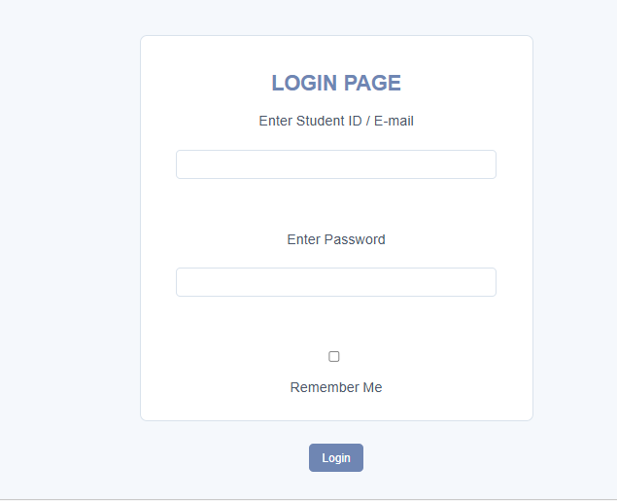
But then I get to know about “Block” feature that does this.

F.Learning Outcomes:
- Improve skills in designing user-friendly web pages that means according to the user we have to put color, fonts and all the aspects.
- To implement external CSS.
- To understand what a “style” does to a website.
- How to improve website readability by choosing appropriate fonts, colors, and contrast.
- To make all the webpages look alike same thus that impacts more efficiently to the user.
- How to build a clean and user-friendly interface with proper spacing and alignment.

Faculty Remarks:

