Index
Sr No | Question | Starts Page | Ends Page
1 | Q1.Build a CNN model to classify a person's gender (Male/Female) | 3 | 6
2 | Q2. Develop a CNN model to classify fashion items into categories such | 7 | 10
3 | Q3.Build a CNN model to identify food items from images. | 11 | 15
4 | Q4.Develop a CNN model to classify computer hardware components | 16 | 21
5 | Q5.Build a CNN model to detect whether a medical scan contains a tumor | 22 | 26
6 | Q6. Develop a CNN model to classify fruits such as Apple,Banana,Orange and Mango. | 27 | 32
7 | Q7.Build a CNN model to classify animal images such as Cat, Dog, Horse, | 33 | 37
8 | Q8.Develop a CNN model to classify vehicles such as Car, Bus, Bike, and | 38 | 43
9 | Q9.Build a CNN model to identify plant diseases from leaf images. | 44 | 49
10 | Q10.Create a unique Streamlit web application for any of the above or | 50 | 56
11 | Q11.Build an Artificial Neural Network (ANN) model to predict whether a | 57 | 58
12 | Q12.Develop an ANN model to predict whether a patient is diabetic or non- | 59 | 60
13 | Q13.Build a Convolutional Neural Network (CNN) model using the MNIST | 61 | 66
14 | Q14.Create a CNN model that detects whether a person is wearing a face | 67 | 72
15 | Q15.Build a CNN model to recognize human facial emotions such as Happy, Sad, | 73 | 78

Q1.Build a CNN model to classify a person's gender (Male/Female)from facial images.

import tensorflow as tf
import numpy as np
from tensorflow import keras
import matplotlib.pyplot as plt
from tensorflow.keras import layers
from google.colab import drive

drive.mount('/content/drive')
print("Drive Mounted Successfylly...")

train_dataset = tf.keras.utils.image_dataset_from_directory(
"/content/drive/MyDrive/Gender",
validation_split=0.2,
subset = "training",
seed = 10,
image_size = (128,128),
batch_size = 4
)

testing_dataset = tf.keras.utils.image_dataset_from_directory(
"/content/drive/MyDrive/Gender",
validation_split=0.2,
subset="validation",
seed=10,
image_size=(128,128),
batch_size = 4
)

for images , labels in testing_dataset.take(1):
plt.figure(figsize=(10,10))

for i in range(4):
plt.subplot(4,4,i+1)
plt.xticks([])
plt.yticks([])
plt.imshow(images[i].numpy().astype("uint8"))
plt.title(testing_dataset.class_names[labels[i].numpy()])
plt.show()

model = keras.Sequential([

layers.Rescaling(1./255,input_shape=(128,128,3)),

layers.Conv2D(16,(3,3),activation="relu"),
layers.MaxPooling2D(),
layers.Conv2D(32,(3,3),activation="relu"),
layers.MaxPooling2D(),

layers.Flatten(),
layers.Dense(30,activation="relu"),
layers.Dense(len(testing_dataset.class_names),activation="softmax")
])
print("Model Trained Successfullly...")

model.compile(
optimizer = "adam",
loss = "SparseCategoricalCrossentropy",
metrics = ["accuracy"]
)
print("Model Compiled Successfylly.....")

model.fit(testing_dataset,validation_data=testing_dataset,epochs=10)
print("Model Trained Successfully...")

img = keras.utils.load_img(
"/content/Female.jpg",
target_size = (128,128)
)

plt.figure(figsize=(4,4))
plt.imshow(img)
plt.axis("off")
plt.show()
img_array = keras.utils.img_to_array(img)
img_array = tf.expand_dims(img_array,0)

prediction = model.predict(img_array)
predicted_img = testing_dataset.class_names[np.argmax(prediction)]
print("Prediction : - ",predicted_img)
print(np.argmax(prediction))
print("Evaluating the model...")
loss, accuracy = model.evaluate(testing_dataset)
print(f"Test Loss: {loss:.4f}")
print(f"Test Accuracy: {accuracy:.4f}")

Output : -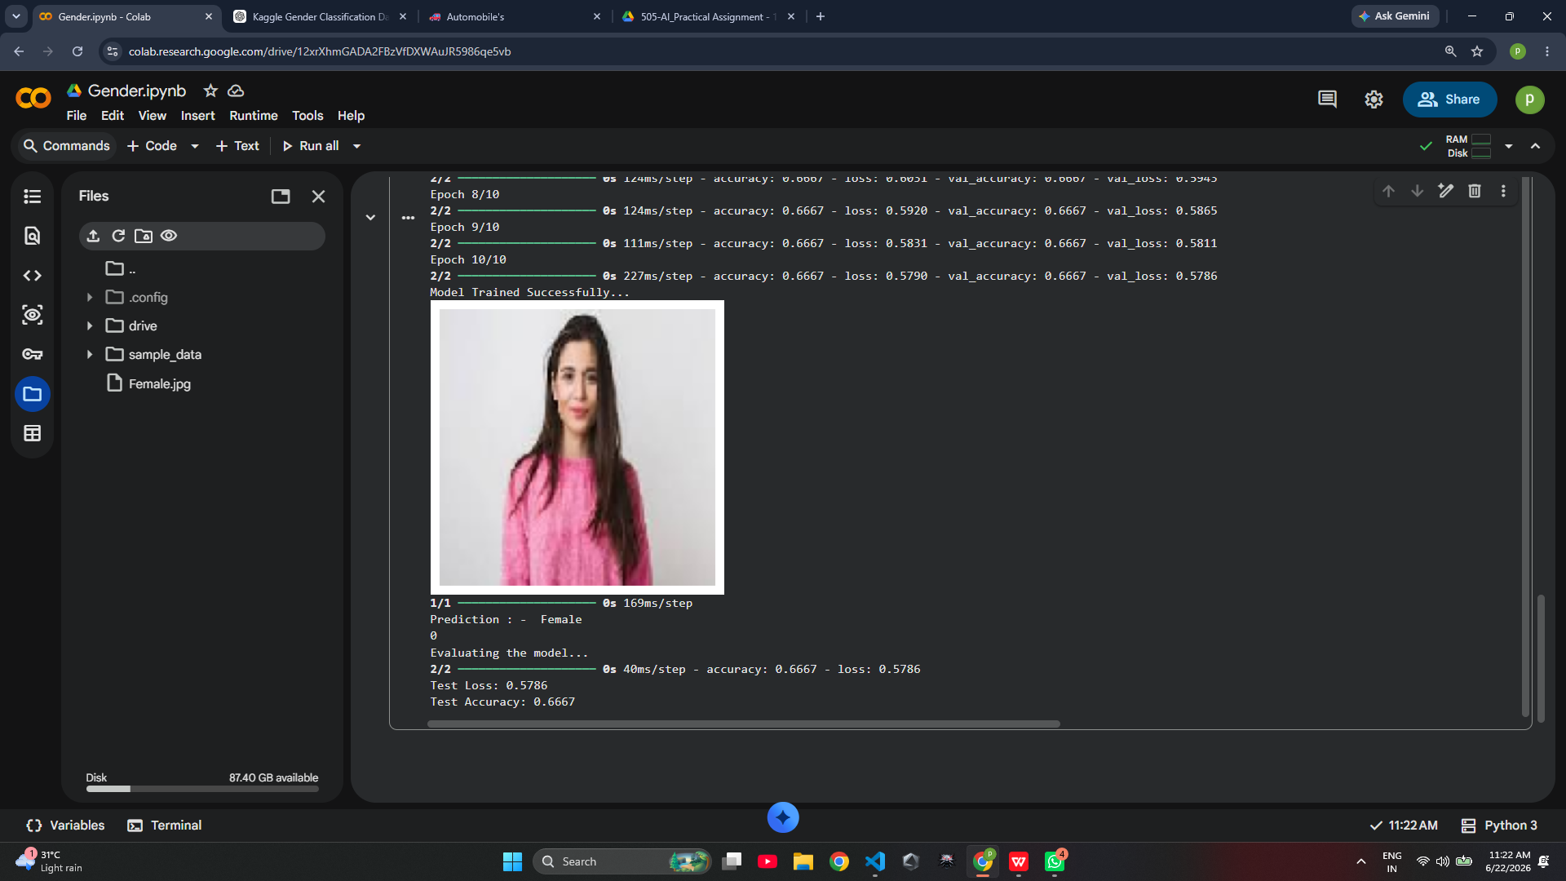Q2. Develop a CNN model to classify fashion items into categories suchas Shirt, T-Shirt, Dress, Shoes, and Bag.

import tensorflow as tf
from tensorflow import keras
from tensorflow.keras import layers
import matplotlib.pyplot as plt
import numpy as np

(x_train, y_train), (x_test, y_test) = tf.keras.datasets.fashion_mnist.load_data()

class_names = [ "T-shirt/top","Trouser","Pullover","Dress","Coat","Sandal","Shirt","Sneaker","Bag","Ankle boot"]

plt.figure(figsize=(10,10))

for i in range(10):
plt.subplot(5,5,i+1)
plt.xticks([])
plt.yticks([])
plt.imshow(x_train[i], cmap="gray")
plt.title(class_names[y_train[i]])

plt.show()
data_augmentaion = keras.Sequential([

layers.RandomFlip("horizontal"),
layers.RandomRotation(0.1),
layers.RandomZoom(0.1)

])

model = tf.keras.Sequential([

data_augmentaion,
layers.Rescaling(1./255),

layers.Conv2D(16,3,activation="relu"),
layers.MaxPooling2D(),

layers.Conv2D(32,3,activation="relu"),
layers.MaxPooling2D(),

layers.Flatten(),

layers.Dense(128,activation="relu"),
layers.Dense(len(class_names),activation="softmax")
])
print("Model Created Successfully")

model.compile(
optimizer="adam",
loss="SparseCategoricalCrossentropy",
metrics=["accuracy"]
)

print("Compiled Successfully")

# history = model.fit(
# x_train,
# y_train,
# epochs=10,
# validation_data=(x_test,y_test)
# )

# model.save("fashion.keras")
model = tf.keras.models.load_model("fashion.keras")
# print("Model Trained Successfully")

img = tf.keras.utils.load_img(
"/content/shirt.jpg",
color_mode="grayscale",
target_size=(28,28)
)

plt.imshow(img, cmap="gray")
plt.axis("off")
plt.show()

img_array = tf.keras.utils.img_to_array(img)
img_array = np.expand_dims(img_array, axis=0)

prediction = model.predict(img_array)
predicted_class = np.argmax(prediction[0])
print("\nPredicted Class :", class_names[predicted_class])
Output : -
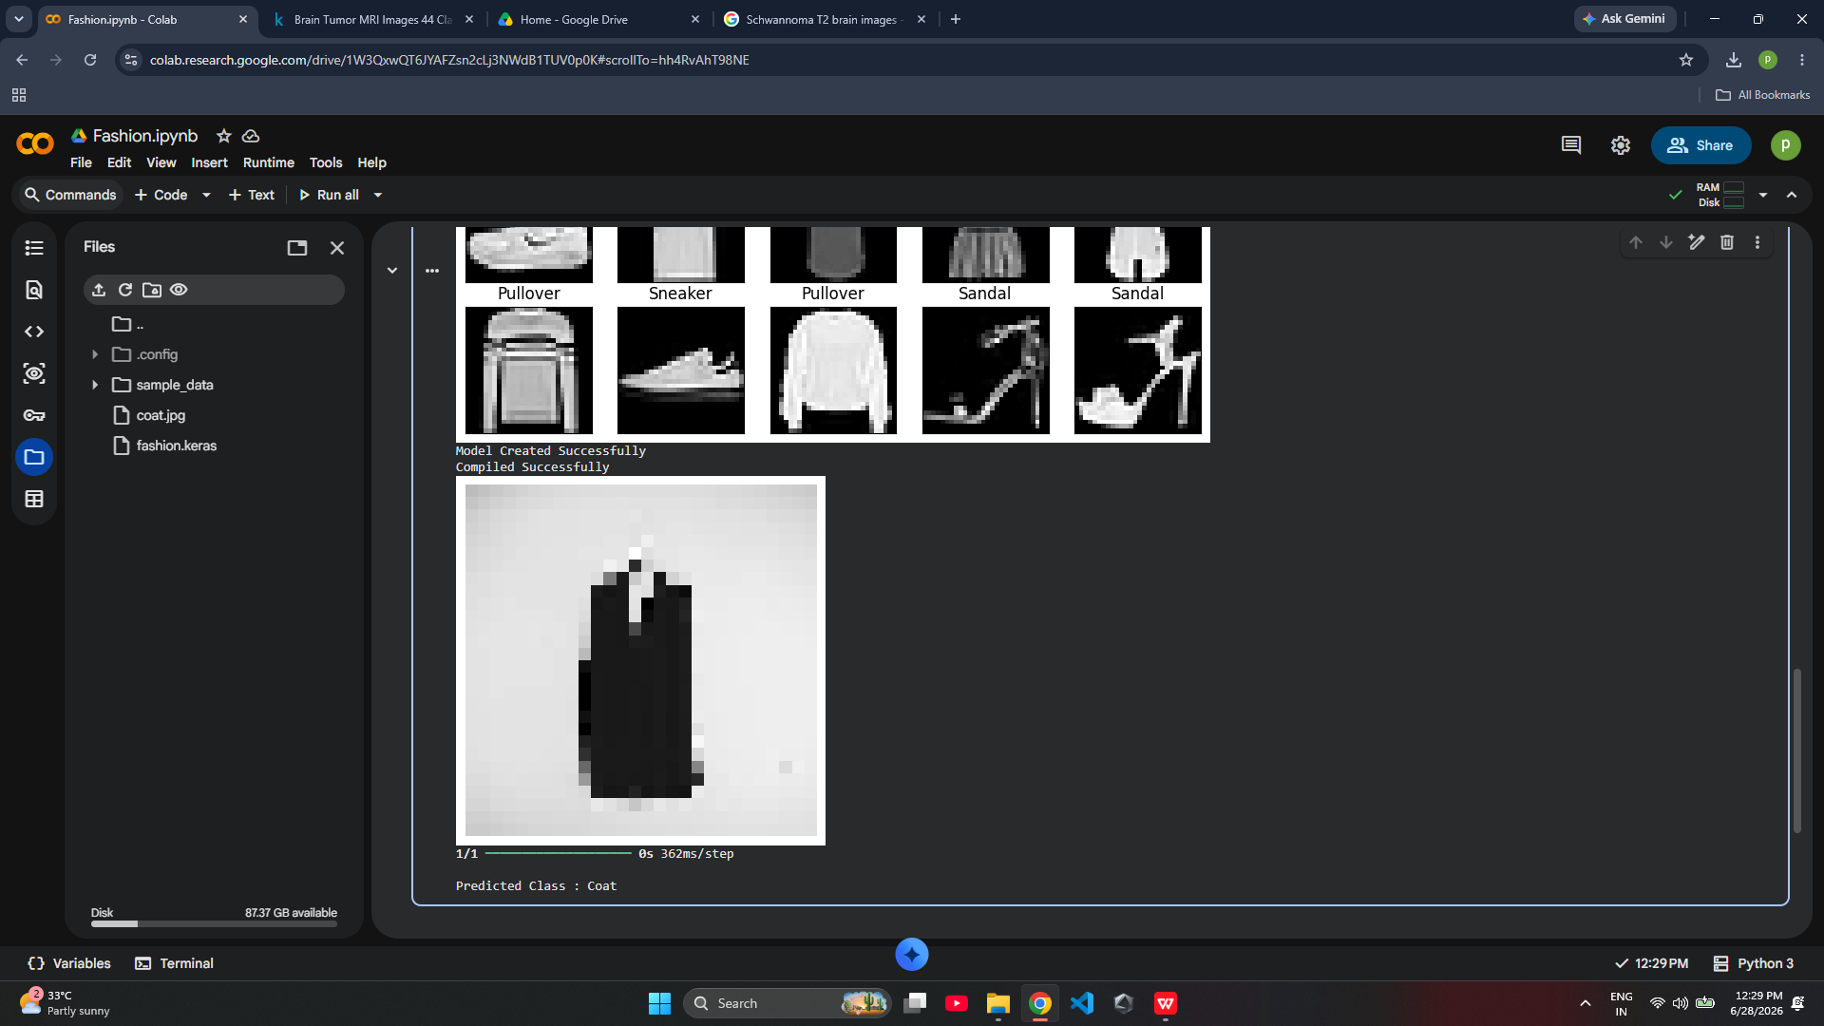

Q3.Build a CNN model to identify food items from images.
import tensorflow as tf
import kagglehub
from tensorflow import keras
from tensorflow.keras import layers
import matplotlib.pyplot as plt
import numpy as np
import os

kaggle_dataset = kagglehub.dataset_download(
"l33tc0d3r/indian-food-classification"
)
print("Dataset Downloaded Successfully...")

path = os.path.join(kaggle_dataset,"Food Classification")

train_dataset = tf.keras.utils.image_dataset_from_directory(
path,
validation_split = 0.2,
subset = "training",
seed=10,
image_size = (128,128),
batch_size = 50
)
val_dataset = tf.keras.utils.image_dataset_from_directory(
path,
validation_split = 0.2,
subset = "validation",
seed=10,
image_size = (128,128),
batch_size = 100
)

for images , labels in val_dataset.take(1):
plt.figure(figsize=(10,10))

for i in range(4):
plt.subplot(4,4,i+1)
plt.xticks([])
plt.yticks([])
plt.imshow(images[i].numpy().astype("uint8"))
plt.title(val_dataset.class_names[labels[i]])
plt.show()

model = keras.Sequential([

layers.Rescaling(1./255,input_shape=(128,128,3)),

layers.Conv2D(16,(4,4),activation="relu"),
layers.MaxPooling2D((2,2)),

layers.Conv2D(32,(4,4),activation="relu"),
layers.MaxPooling2D((2,2)),

layers.Conv2D(64,(4,4),activation="relu"),
layers.MaxPooling2D((2,2)),

layers.Conv2D(128,(4,4),activation="relu"),
layers.MaxPooling2D((2,2)),

layers.Conv2D(256,(4,4),activation="relu"),
layers.MaxPooling2D((2,2)),

layers.Flatten(),

layers.Dense(128,activation="relu"),
layers.Dense(len(train_dataset.class_names),activation="softmax")

])

print("Model Created Successfully.....")

model.compile(
optimizer = "adam",
loss = "SparseCategoricalCrossentropy",
metrics = ["accuracy"]
)

print("Model Compiled Successfully.....")

early_stop = tf.keras.callbacks.EarlyStopping(
monitor="val_accuracy",
patience=5,
restore_best_weights=True
)

model.fit(train_dataset,validation_data = val_dataset,epochs=40,callbacks=[early_stop,checkpoint])
print("Model Trained Successfully....")

model.save("Food_model.keras")
model = tf.keras.models.load_model("Food_model.keras")

img = keras.utils.load_img(
"/content/jalebi.jpg",
target_size = (128,128)
)

plt.figure(figsize=(5,5))
plt.imshow(img)
plt.axis("off")
plt.show()

img_array = tf.keras.utils.img_to_array(img)
img_array = tf.expand_dims(img_array,0)

prediction = model.predict(img_array)
predicted_Food = val_dataset.class_names[np.argmax(prediction)]

print("Prediction : - " , predicted_Food)
Output : -
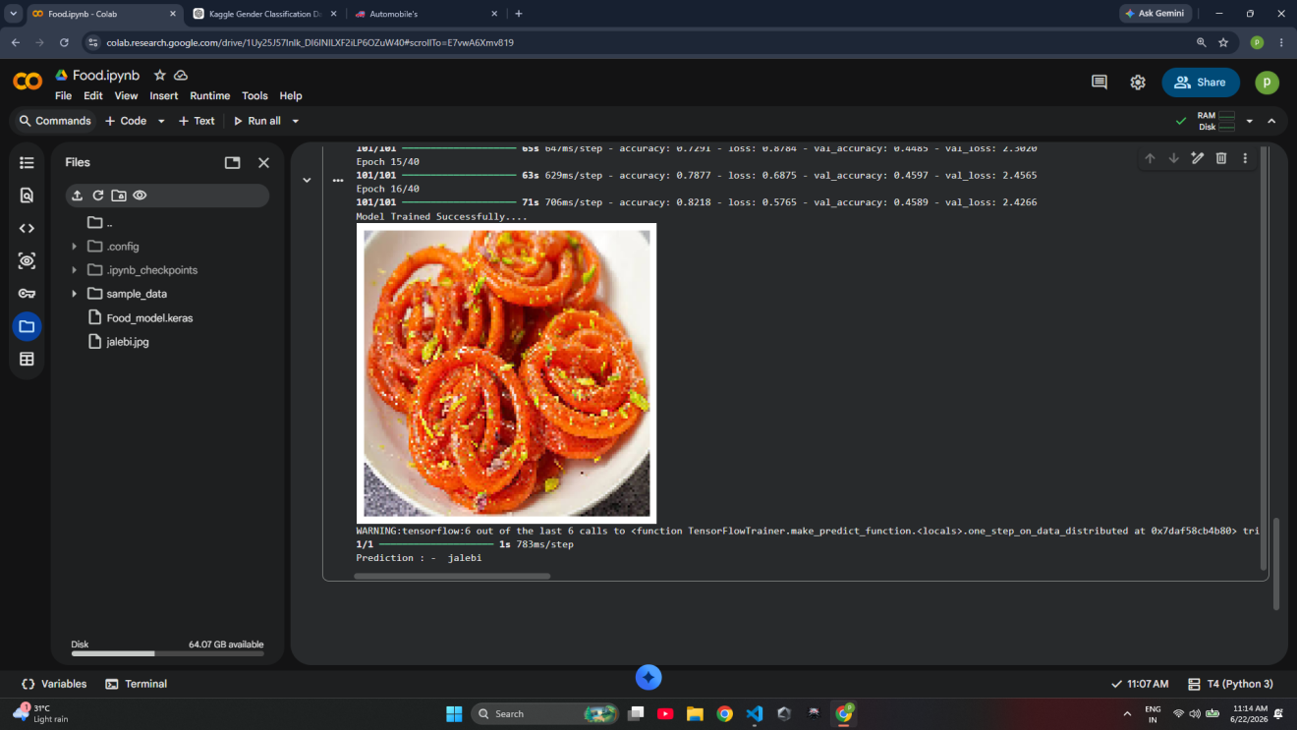
Q4.Develop a CNN model to classify computer hardware componentssuch as Keyboard, Mouse, Monitor, CPU, and Printer.

import tensorflow as tf
import kagglehub
from tensorflow import keras
from tensorflow.keras import layers
import matplotlib.pyplot as plt
import numpy as np
import os

kaggle_dataset = kagglehub.dataset_download(
"asaniczka/pc-parts-images-dataset-classification"
)

print("Dataset Downloaded Successfully...")

path = os.path.join(kaggle_dataset, "pc_parts")

train_dataset = tf.keras.utils.image_dataset_from_directory(
path,
validation_split=0.2,
subset="training",
seed=100,
image_size=(128, 128),
batch_size=64
)

val_dataset = tf.keras.utils.image_dataset_from_directory(
path,
validation_split=0.2,
subset="validation",
seed=100,
image_size=(128, 128),
batch_size=64
)

print(train_dataset.class_names)

plt.figure(figsize=(8, 8))

for images, labels in train_dataset.take(1):
for i in range(4):
plt.subplot(2, 2, i + 1)
plt.imshow(images[i].numpy().astype("uint8"))
plt.title(train_dataset.class_names[labels[i]])
plt.axis("off")

plt.show()

data_augmentation = keras.Sequential([
layers.RandomFlip("horizontal"),
layers.RandomRotation(0.1),
layers.RandomZoom(0.1)
])

model = keras.Sequential([

data_augmentation,

layers.Rescaling(1./255),

layers.Conv2D(16, (4,4), activation="relu"),
layers.MaxPooling2D(),

layers.Conv2D(32, (4,4), activation="relu"),
layers.MaxPooling2D(),

layers.Conv2D(64, (4,4), activation="relu"),
layers.MaxPooling2D(),

layers.Conv2D(128, (4,4), activation="relu"),
layers.MaxPooling2D(),

layers.Conv2D(256, (4,4), activation="relu"),
layers.MaxPooling2D(),

layers.Flatten(),

layers.Dense(128, activation="relu"),

layers.Dense(len(train_dataset.class_names), activation="softmax")
])

print("Model Created Successfully")

model.compile(
optimizer="adam",
loss="SparseCategoricalCrossentropy",
metrics=["accuracy"]
)

print("Model Compiled Successfully")

early_stop = tf.keras.callbacks.EarlyStopping(
monitor="val_loss",
patience=5,
restore_best_weights=True
)

# history = model.fit(
# train_dataset,
# validation_data=val_dataset,
# epochs=15,
# callbacks=[early_stop]
# )

# model.save("computer_parts.keras")
# print("Model Saved Sccessfully....")

model = tf.keras.models.load_model("computer_parts.keras")

img = tf.keras.utils.load_img(
"/content/casr.png",
target_size=(128,128)
)

plt.figure(figsize=(8,8))
plt.imshow(img)
plt.axis("off")
plt.show()

img_array = tf.keras.utils.img_to_array(img)
img_array = tf.expand_dims(img_array,0)

prediction = model.predict(img_array)
predicted_part = val_dataset.class_names[np.argmax(prediction[0])]
print("Prediction : - ",predicted_part)
Output : - 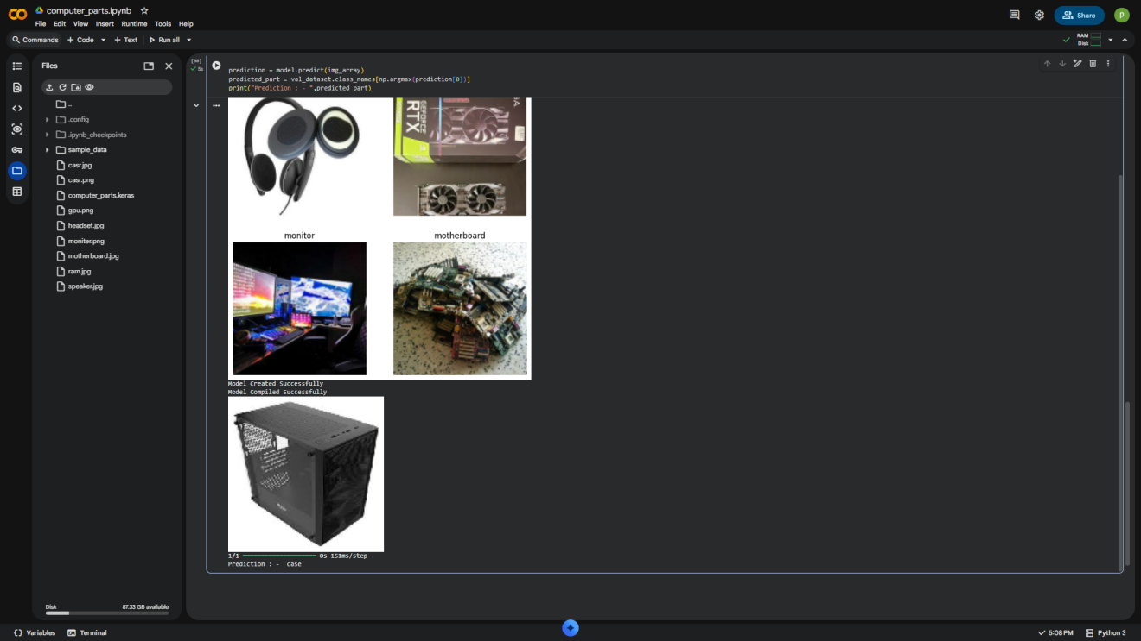

Q5.Build a CNN model to detect whether a medical scan contains a tumor or not.

from matplotlib.cbook import flatten
import tensorflow as tf
from tensorflow import keras
from tensorflow.keras import layers
import matplotlib.pyplot as plt
import os
import numpy as np
import kagglehub

kaggle_dataset = kagglehub.dataset_download("fernando2rad/brain-tumor-mri-images-44c")

train_dataset = tf.keras.utils.image_dataset_from_directory(
kaggle_dataset,
validation_split = 0.2,
subset = "training",
seed = 100,
image_size = (128,128),
batch_size = 64
)

val_dataset = tf.keras.utils.image_dataset_from_directory(
kaggle_dataset,
validation_split = 0.2,
subset = "validation",
seed = 100,
image_size = (128,128),
batch_size = 64
)

print(train_dataset.class_names)

for images , label in train_dataset.take(1):
for i in range(4):
plt.subplot(2,2,i+1)
plt.imshow(images[i].numpy().astype("uint8"))
plt.axis("off")
plt.title(train_dataset.class_names[label[i]])
plt.show()

data_augmentation = keras.Sequential([
layers.RandomFlip("horizontal"),
layers.RandomRotation(0.1),
layers.RandomZoom(0.1)

])

model = keras.Sequential([

data_augmentation,
layers.Rescaling(1./255),

layers.Conv2D(16,(3,3),activation="relu"),
layers.MaxPooling2D(),

layers.Conv2D(32,(3,3),activation="relu"),
layers.MaxPooling2D(),

layers.Conv2D(64,(3,3),activation="relu"),
layers.MaxPooling2D(),

layers.Conv2D(128,(3,3),activation="relu"),
layers.MaxPooling2D(),

layers.Flatten(),

layers.Dense(128,activation="relu"),
layers.Dense(len(train_dataset.class_names),activation = "softmax")
])
print("Model Created Successfully....")

model.compile(
optimizer='adam',
loss='sparse_categorical_crossentropy',
metrics=['accuracy']
)

early_stop = tf.keras.callbacks.EarlyStopping(
monitor = "val_loss",
patience = 5,
restore_best_weights = True
)

# model.fit(train_dataset,validation_data=val_dataset,callbacks=[early_stop],epochs=15)
# print("Model Trained Successfully...")

# model.save("Breain_tumor.keras")
# print("Model Saved Successfully...")

model = tf.keras.models.load_model("brain_tumor.keras")

img = keras.utils.load_img(
"/content/tumor.jpg",
target_size = (128,128)
)
plt.figure(figsize=(2,2))
plt.imshow(img)
plt.axis("off")
plt.show()

img_array = tf.keras.utils.img_to_array(img)
img_array = tf.expand_dims(img_array,0)

prediction = model.predict(img_array)
predicted_class = val_dataset.class_names[np.argmax(prediction[0])]
print("Prediction : - " , predicted_class)

OutPut :-
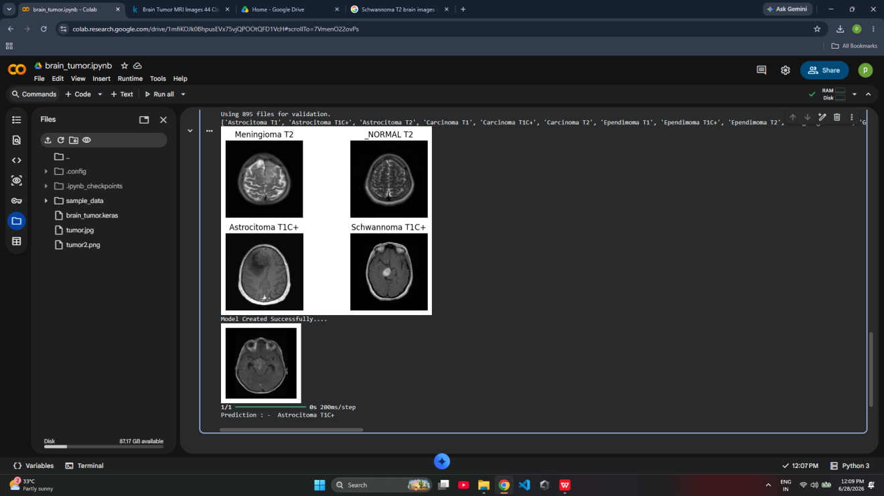

Q6. Develop a CNN model to classify fruits such as Apple,Banana,Orange and Mango.
import tensorflow as tf
import kagglehub
from tensorflow import keras
from tensorflow.keras import layers
import matplotlib.pyplot as plt
import numpy as np
import os

kaggle_dataset = kagglehub.dataset_download(
"karimabdulnabi/fruit-classification10-class"
)

print("Dataset Downloaded Successfully...")

path = os.path.join(kaggle_dataset, "MY_data", "train")

train_dataset = tf.keras.utils.image_dataset_from_directory(
path,
validation_split=0.2,
subset="training",
seed=100,
image_size=(128, 128),
batch_size=64
)

val_dataset = tf.keras.utils.image_dataset_from_directory(
path,
validation_split=0.2,
subset="validation",
seed=100,
image_size=(128, 128),
batch_size=64
)

print("\nClasses:")
print(train_dataset.class_names)

plt.figure(figsize=(8, 8))

for images, labels in train_dataset.take(1):
for i in range(4):
plt.subplot(2, 2, i + 1)
plt.imshow(images[i].numpy().astype("uint8"))
plt.title(train_dataset.class_names[labels[i]])
plt.axis("off")

plt.show()
data_augmentation = keras.Sequential([
layers.RandomFlip("horizontal"),
layers.RandomRotation(0.1),
layers.RandomZoom(0.1)
])

model = keras.Sequential([

data_augmentation,

layers.Rescaling(1./255),

layers.Conv2D(16, (4,4), activation="relu"),
layers.MaxPooling2D(),

layers.Conv2D(32, (4,4), activation="relu"),
layers.MaxPooling2D(),

layers.Conv2D(64, (4,4), activation="relu"),
layers.MaxPooling2D(),

layers.Conv2D(128, (4,4), activation="relu"),
layers.MaxPooling2D(),

layers.Conv2D(256, (4,4), activation="relu"),
layers.MaxPooling2D(),

layers.Flatten(),

layers.Dense(128, activation="relu"),

layers.Dense(len(train_dataset.class_names), activation="softmax")
])

print("Model Created Successfully")

model.compile(
optimizer="adam",
loss="SparseCategoricalCrossentropy",
metrics=["accuracy"]
)

print("Model Compiled Successfully")

early_stop = tf.keras.callbacks.EarlyStopping(
monitor="val_loss",
patience=5,
restore_best_weights=True
)

history = model.fit(
train_dataset,
validation_data=val_dataset,
epochs=15,
callbacks=[early_stop]
)

# model.save("Fruit_model.keras")
# print("Model Saved Successfully")

model = tf.keras.models.load_model("Fruit_model.keras")
print("Model Loaded Successfully")

img = keras.utils.load_img(
"/content/strawberries.jpg",
target_size=(128,128)
)

plt.imshow(img)
plt.axis("off")
plt.show()

img_array = keras.utils.img_to_array(img)
img_array = tf.expand_dims(img_array, 0)
prediction = model.predict(img_array)

score = tf.nn.softmax(prediction[0])
predicted_index = np.argmax(score)
print("\nPrediction :", train_dataset.class_names[predicted_index])

Output : -
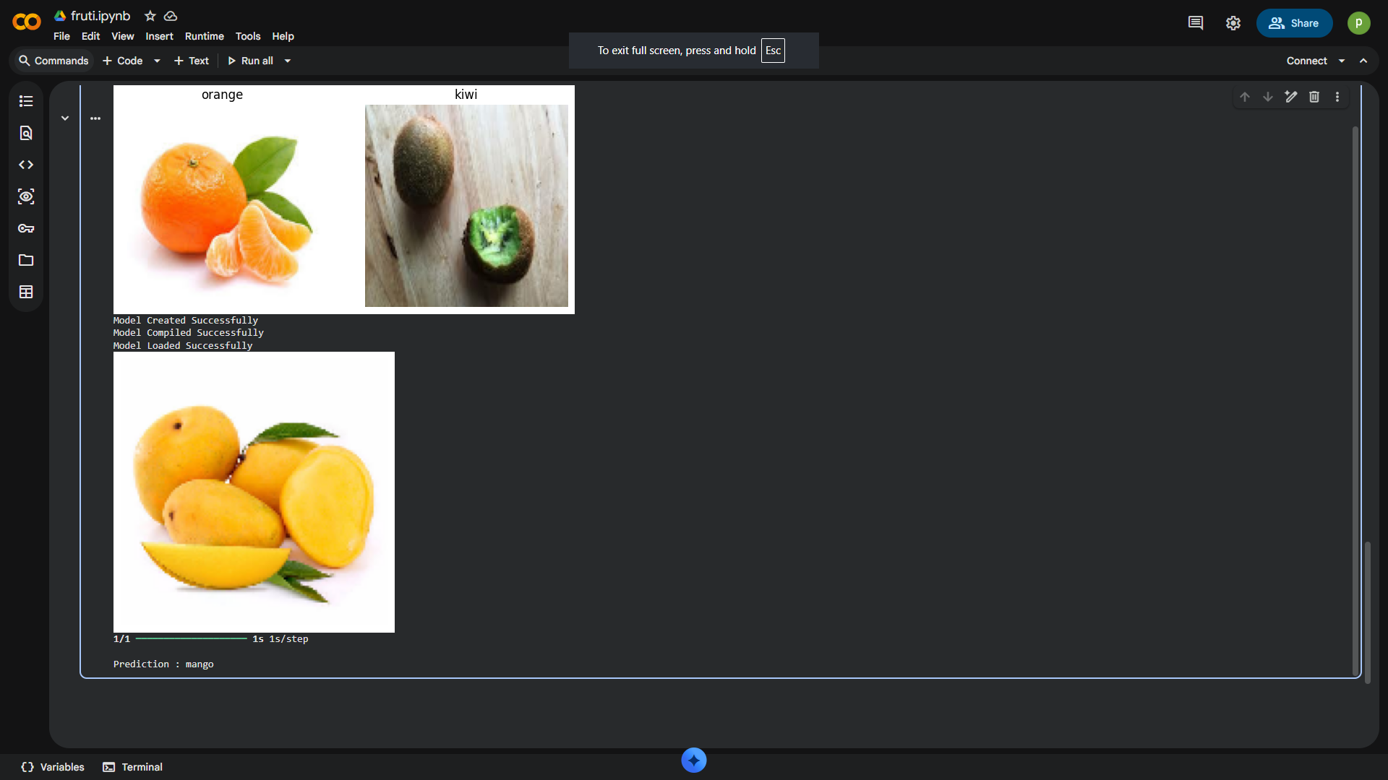

Q7.Build a CNN model to classify animal images such as Cat, Dog, Horse,and Elephant.

import tensorflow as tf
from tensorflow import keras
from tensorflow.keras import layers
from tensorflow.keras.applications import MobileNetV2
import matplotlib.pyplot as plt
import kagglehub
from google.colab import drive
import os
import numpy as np

drive.mount("/content/drive")

kaggle_dataset = kagglehub.dataset_download("antoreepjana/animals-detection-images-dataset")
print("Dataset Downloaded Successfully....")

path = os.path.join(kaggle_dataset,"train")

train_dataset = tf.keras.utils.image_dataset_from_directory(
path,
validation_split = 0.2,
subset = "training",
seed=100,
image_size=(128,128),
batch_size=72
)

val_dataset = tf.keras.utils.image_dataset_from_directory(
path,
validation_split=0.2,
subset="validation",
seed=100,
image_size=(128,128),
batch_size=72
)

print(train_dataset.class_names)

for images , label in train_dataset.take(1):
for i in range(4):
plt.subplot(2,2,i+1)
plt.axis("off")
plt.imshow(images[i].numpy().astype("uint8"))
plt.title(train_dataset.class_names[label[i]])
plt.show()
MNV2 = MobileNetV2(
weights="imagenet",
include_top=False,
input_shape=(128,128,3)
)

MNV2.trainable = True

data_augmentation = keras.Sequential([
layers.RandomFlip("horizontal"),
layers.RandomRotation(0.1),
layers.RandomZoom(0.1)

])

model = keras.Sequential([
data_augmentation,
layers.Rescaling(1./255),
MNV2,

layers.GlobalAveragePooling2D(),

layers.Dense(128,activation="relu"),
layers.Dropout(0.3),
layers.Dense(len(train_dataset.class_names),activation="softmax")
])

print("Model Created Successfully....")

early_stop = tf.keras.callbacks.EarlyStopping(
monitor = "val_loss",
patience = 5,
restore_best_weights = True
)

model.compile(
tf.keras.optimizers.Adam(),
tf.keras.losses.SparseCategoricalCrossentropy(),
metrics=["accuracy"]
)

model.fit(train_dataset,validation_data=val_dataset,epochs=10,callbacks=[early_stop])
print("Model Trained Successfully....")

model.save("/content/drive/MyDrive/Model/animals.keras")
print("Model Saves Successfully....")

model = tf.keras.models.load_model("/content/drive/MyDrive/Model/animals.keras")
print("Model Loaded Successfully....")
img = tf.keras.utils.load_img(
"/content/spider.jpg",
target_size=(128,128)
)
plt.figure(figsize=(2,2))
plt.imshow(img)
plt.axis("off")
plt.show()
img_array = tf.keras.utils.img_to_array(img)
img_array = tf.expand_dims(img_array,0)
prediction = model.predict(img_array)
predicted_animal = train_dataset.class_names[np.argmax(prediction[0])]
print("Prediction : - ",predicted_animal)
Output :-
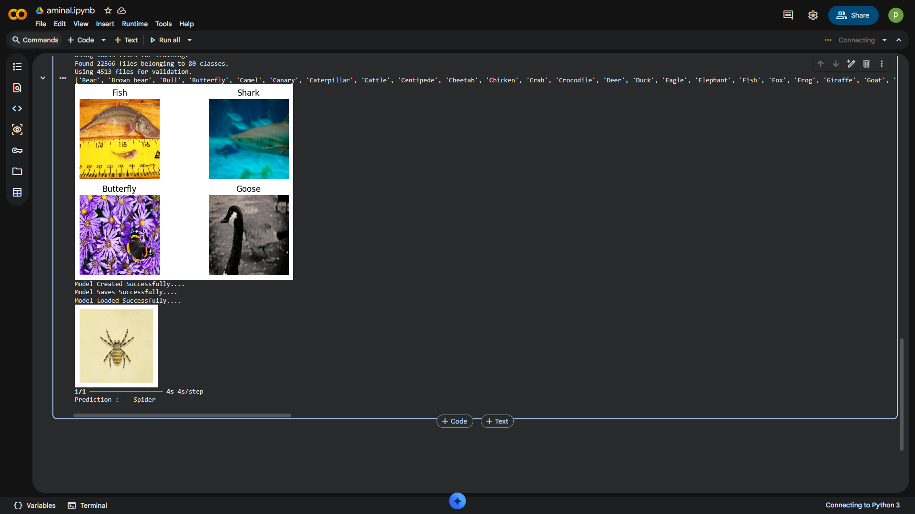

Q8.Develop a CNN model to classify vehicles such as Car, Bus, Bike, and Truck.

import tensorflow as tf
import kagglehub
from tensorflow import keras
from tensorflow.keras import layers
from tensorflow.keras.applications import MobileNetV2
import matplotlib.pyplot as plt
import numpy as np
import os
from google.colab import drive
drive.mount('/content/drive')

kaggle_dataset = kagglehub.dataset_download(
"mohamedmaher5/vehicle-classification"
)
print("Dataset Downloaded Successfully...")
path = os.path.join(kaggle_dataset, "Vehicles")
train_dataset = tf.keras.utils.image_dataset_from_directory(
path,
validation_split=0.2,
subset="training",
seed=100,
image_size=(128, 128),
batch_size=64
)

val_dataset = tf.keras.utils.image_dataset_from_directory(
path,
validation_split=0.2,
subset="validation",
seed=100,
image_size=(128, 128),
batch_size=64
)
print(train_dataset.class_names)
plt.figure(figsize=(8, 8))
for images, labels in train_dataset.take(1):
for i in range(4):
plt.subplot(2, 2, i + 1)
plt.imshow(images[i].numpy().astype("uint8"))
plt.title(train_dataset.class_names[labels[i]])
plt.axis("off")
plt.show()

data_augmentation = keras.Sequential([
layers.RandomFlip("horizontal"),
layers.RandomRotation(0.1),
layers.RandomZoom(0.1)
])

MNV2 = MobileNetV2(
weights="imagenet",
include_top=False,
input_shape=(128,128,3)
)

MNV2.trainable = False
model = keras.Sequential([

data_augmentation,
layers.Rescaling(1./255),

MNV2,
layers.GlobalAveragePooling2D(),
layers.Dense(128,activation="relu"),
layers.Dropout(0.3),
layers.Dense(len(train_dataset.class_names),activation="softmax")

])

print("Model Created Successfully")

model.compile(
optimizer="adam",
loss="SparseCategoricalCrossentropy",
metrics=["accuracy"]
)

print("Model Compiled Successfully")

early_stop = tf.keras.callbacks.EarlyStopping(
monitor="val_loss",
patience=5,
restore_best_weights=True
)

# history = model.fit(
# train_dataset,
# validation_data=val_dataset,
# epochs=15,
# callbacks=[early_stop]
# )

# model.save("/content/drive/MyDrive/Model/Fruit_model.keras")
# print("Model Saved Successfully")

model = tf.keras.models.load_model("/content/drive/MyDrive/Model/Fruit_model.keras")
print("Model Loaded Successfully")

img = keras.utils.load_img(
"/content/auto.png",
target_size=(128,128)
)

plt.imshow(img)
plt.axis("off")
plt.show()

img_array = keras.utils.img_to_array(img)
img_array = tf.expand_dims(img_array, 0)

prediction = model.predict(img_array)
score = tf.nn.softmax(prediction[0])
predicted_index = np.argmax(score)
print("\nPrediction :", train_dataset.class_names[predicted_index])

Output :-
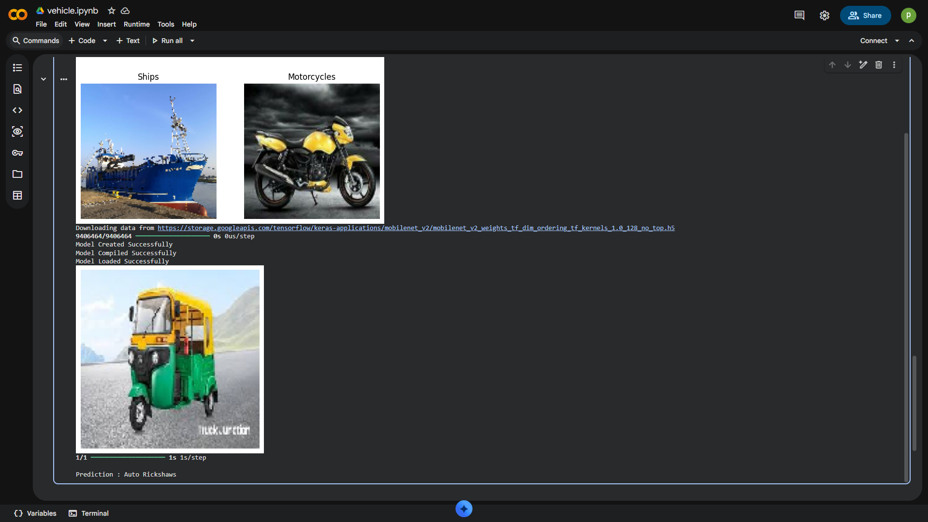

Q9.Build a CNN model to identify plant diseases from leaf images.

import tensorflow as tf
import kagglehub
from tensorflow import keras
from tensorflow.keras import layers
from tensorflow.keras.applications import MobileNetV2
import matplotlib.pyplot as plt
import numpy as np
import os
from google.colab import drive
drive.mount('/content/drive')

kaggle_dataset = kagglehub.dataset_download(
"karagwaanntreasure/plant-disease-detection"
)

print("Dataset Downloaded Successfully...")

path = os.path.join(kaggle_dataset, "Dataset")

train_dataset = tf.keras.utils.image_dataset_from_directory(
path,
validation_split=0.4,
subset="training",
seed=100,
image_size=(128, 128),
batch_size=82
)

val_dataset = tf.keras.utils.image_dataset_from_directory(
path,
validation_split=0.4,
subset="validation",
seed=100,
image_size=(128, 128),
batch_size=82
)

print(train_dataset.class_names)

plt.figure(figsize=(8, 8))

for images, labels in train_dataset.take(1):
for i in range(4):
plt.subplot(2, 2, i + 1)
plt.imshow(images[i].numpy().astype("uint8"))
plt.title(train_dataset.class_names[labels[i]])
plt.axis("off")

plt.show()

data_augmentation = keras.Sequential([
layers.RandomFlip("horizontal"),
layers.RandomRotation(0.1),
layers.RandomZoom(0.1)
])

MNV2 = MobileNetV2(
weights="imagenet",
include_top=False,
input_shape=(128,128,3)
)

MNV2.trainable = False

model = keras.Sequential([

data_augmentation,
layers.Rescaling(1./255),
MNV2,
layers.GlobalAveragePooling2D(),

layers.Dense(128,activation="relu"),
layers.Dropout(0.3),
layers.Dense(len(train_dataset.class_names),activation="softmax")

])

print("Model Created Successfully")

model.compile(
optimizer="adam",
loss="SparseCategoricalCrossentropy",
metrics=["accuracy"]
)

print("Model Compiled Successfully")

early_stop = tf.keras.callbacks.EarlyStopping(
monitor="val_loss",
patience=5,
restore_best_weights=True
)

# history = model.fit(
# train_dataset,
# validation_data=val_dataset,
# epochs=10,
# callbacks=[early_stop]
# )
# print("Model Trained Successfully...")

model.save("/content/drive/MyDrive/Model/plant_model.keras")
print("Model Saved Successfully")

model = tf.keras.models.load_model("/content/drive/MyDrive/Model/plant_model.keras")
print("Model Loaded Successfully")

img = keras.utils.load_img(
"/content/tomatolate.jpg",
target_size=(128,128)
)

plt.imshow(img)
plt.axis("off")
plt.show()
img_array = keras.utils.img_to_array(img)
img_array = tf.expand_dims(img_array, 0)

prediction = model.predict(img_array)
score = tf.nn.softmax(prediction[0])
predicted_index = np.argmax(score)
print("\nPrediction :", train_dataset.class_names[predicted_index])

Output : -

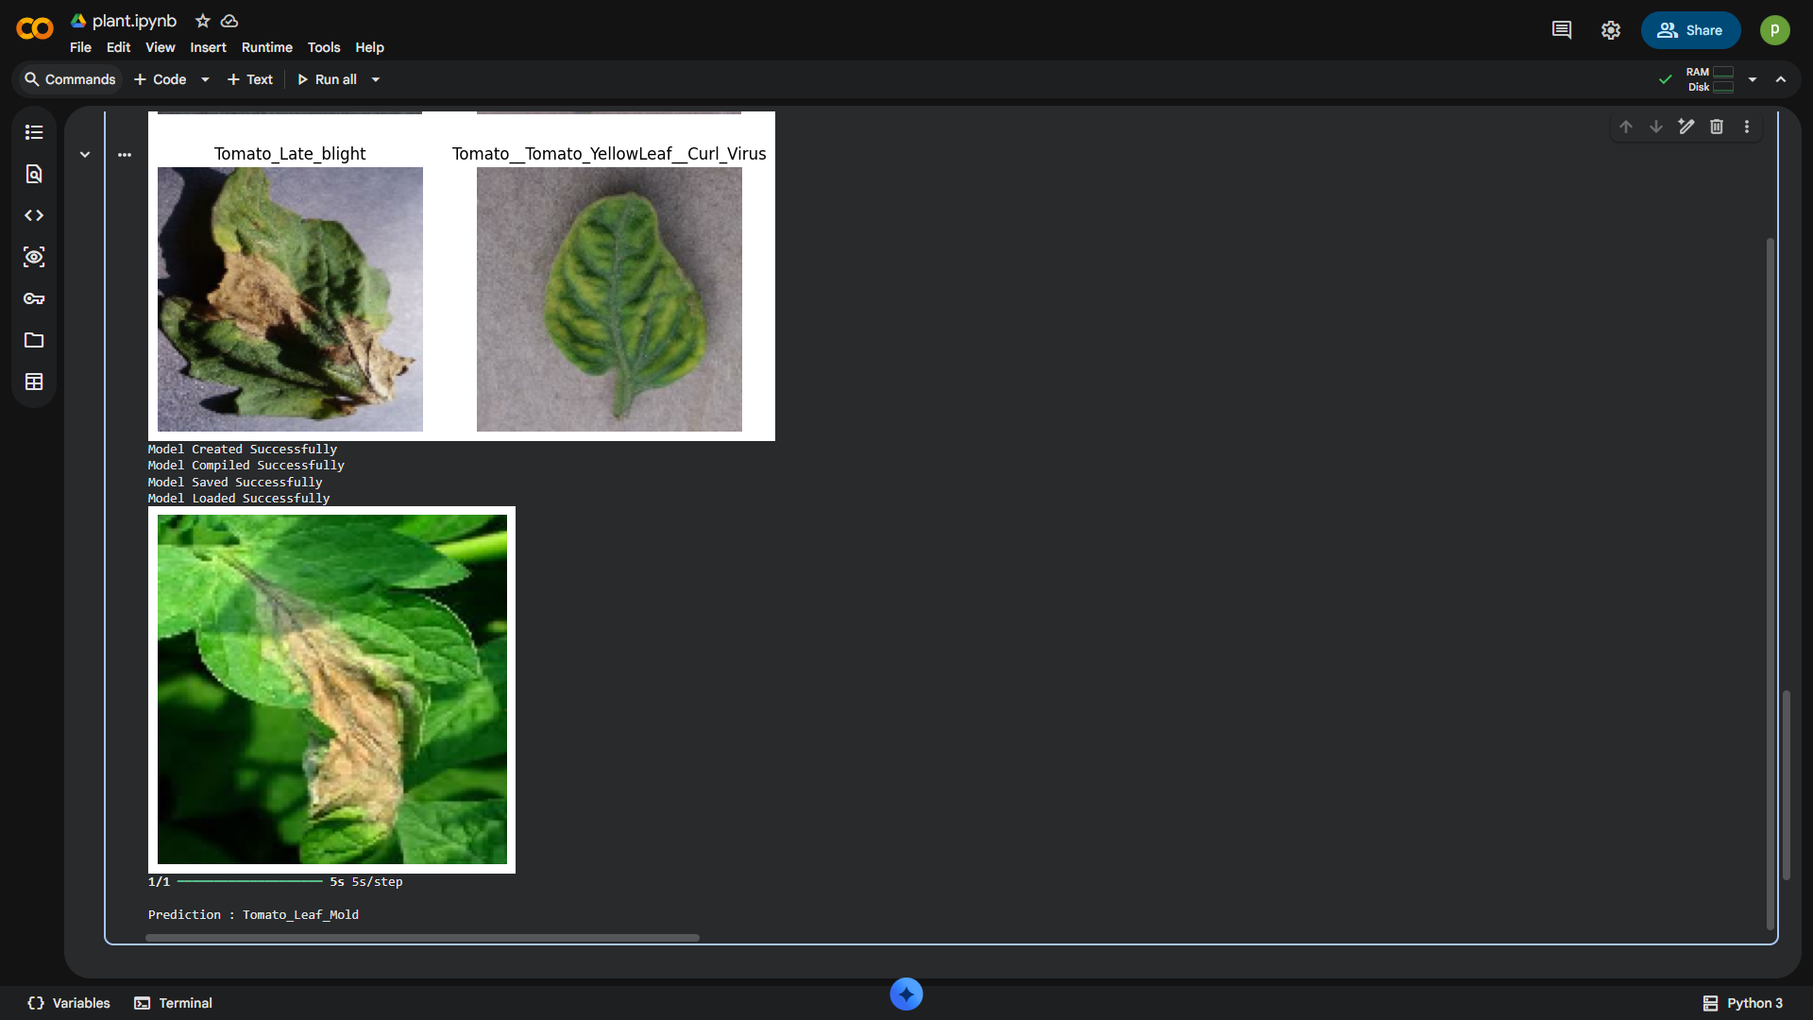

Q10.Create a unique Streamlit web application for any of the above or selected trained CNN models.

Colab :-
import tensorflow as tf
import kagglehub
from tensorflow import keras
from tensorflow.keras import layers
import matplotlib.pyplot as plt
import numpy as np
import os

kaggle_dataset = kagglehub.dataset_download(
"karimabdulnabi/fruit-classification10-class"
)

print("Dataset Downloaded Successfully...")

path = os.path.join(kaggle_dataset, "MY_data", "train")

train_dataset = tf.keras.utils.image_dataset_from_directory(
path,
validation_split=0.2,
subset="training",
seed=100,
image_size=(128, 128),
batch_size=64
)

val_dataset = tf.keras.utils.image_dataset_from_directory(
path,
validation_split=0.2,
subset="validation",
seed=100,
image_size=(128, 128),
batch_size=64
)

print("\nClasses:")
print(train_dataset.class_names)

plt.figure(figsize=(8, 8))

for images, labels in train_dataset.take(1):
for i in range(4):
plt.subplot(2, 2, i + 1)
plt.imshow(images[i].numpy().astype("uint8"))
plt.title(train_dataset.class_names[labels[i]])
plt.axis("off")

plt.show()

data_augmentation = keras.Sequential([
layers.RandomFlip("horizontal"),
layers.RandomRotation(0.1),
layers.RandomZoom(0.1)
])

model = keras.Sequential([
data_augmentation,
layers.Rescaling(1./255),
layers.Conv2D(16, (4,4), activation="relu"),
layers.MaxPooling2D(),

layers.Conv2D(32, (4,4), activation="relu"),
layers.MaxPooling2D(),
layers.Conv2D(64, (4,4), activation="relu"),
layers.MaxPooling2D(),

layers.Conv2D(128, (4,4), activation="relu"),
layers.MaxPooling2D(),

layers.Conv2D(256, (4,4), activation="relu"),
layers.MaxPooling2D(),
layers.Flatten(),
layers.Dense(128, activation="relu"),
layers.Dense(len(train_dataset.class_names), activation="softmax")
])

print("Model Created Successfully")
model.compile(
optimizer="adam",
loss="SparseCategoricalCrossentropy",
metrics=["accuracy"]
)

print("Model Compiled Successfully")
early_stop = tf.keras.callbacks.EarlyStopping(
monitor="val_loss",
patience=5,
restore_best_weights=True
)

history = model.fit(
train_dataset,
validation_data=val_dataset,
epochs=15,
callbacks=[early_stop]
)

# model.save("Fruit_model.keras")
# print("Model Saved Successfully")

model = tf.keras.models.load_model("Fruit_model.keras")
print("Model Loaded Successfully")

img = keras.utils.load_img(
"/content/strawberries.jpg",
target_size=(128,128)
)
plt.imshow(img)
plt.axis("off")
plt.show()

img_array = keras.utils.img_to_array(img)
img_array = tf.expand_dims(img_array, 0)
prediction = model.predict(img_array)

score = tf.nn.softmax(prediction[0])
predicted_index = np.argmax(score)
print("\nPrediction :", train_dataset.class_names[predicted_index])

VS CODE :-
import streamlit as st
from PIL import Image
import numpy as np
import tensorflow as tf
from tensorflow import keras

st.title("Hello World")

model = tf.keras.models.load_model(
"vehicle.keras",
compile=False
)

file = st.file_uploader(
"Upload an Image",
type=["jpg", "jpeg", "png"]
)

if file:
img = Image.open(file).convert("RGB")

st.image(img, caption="Uploaded Image", width=200)

img = img.resize((224, 224))
img_array = tf.keras.utils.img_to_array(img)
img_tensor = np.expand_dims(img_array, axis=0)

predictions = model.predict(img_tensor)
predicted_class = [np.argmax(predictions)]
confidence = np.max(predictions) * 100

st.success(
f"Predicted Class: {predicted_class} ({confidence:.2f}% confidence)"
)

Q11.Build an Artificial Neural Network (ANN) model to predict whether a student will Pass or Fail based on attendance, internal marks.

data = [("Ram", 30, 25),("Shyam", 15, 20),("Mohan", 35, 30),("Ravi", 10, 15),("Sita", 40,20),
("Amit", 25, 15),
("Priya", 45, 20)
]

w1 = 1
w2 = 1
b = 0

for name, x, y in data:

z = w1 * x + w2 * y + b

print("Name :", name)
print("Hours :", x)
print("Attendance :", y)
print("Output :", z)

if z >= 50:
print(name, "is PASS")
else:
print(name, "is FAIL")
print()

Output : - 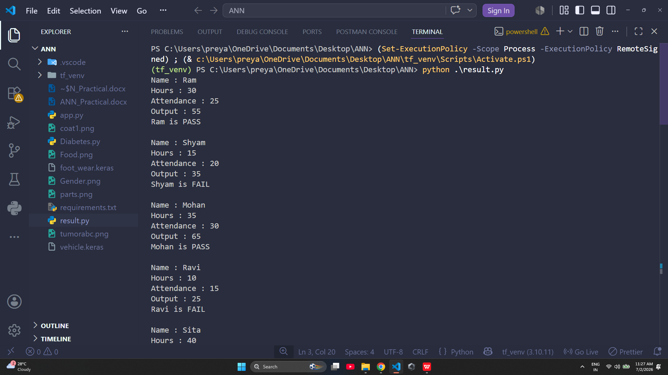

Q12.Develop an ANN model to predict whether a patient is diabetic or non-diabetic using medical attributes such as glucose level, blood pressure, BMI, insulin level, and age.

data = [
("Ram", 180, 80, 32, 150, 45),
("Shyam", 90, 70, 22, 80, 25),
("Mohan", 160, 85, 35, 200, 50),
("Ravi", 100, 75, 24, 90, 30),
("Sita", 190, 95, 38, 220, 55)
]

w1 = 1
w2 = 1
w3 = 1
w4 = 1
w5 = 1

b = 0

for name, glucose, bp, bmi, insulin, age in data:

z = (w1 * glucose) + (w2 * bp) + (w3 * bmi) + (w4 * insulin) + (w5 * age) + b

print("Name :", name)
print("Glucose :", glucose)
print("Blood Pressure :", bp)
print("BMI :", bmi)
print("Insulin :", insulin)
print("Age :", age)
print("Output :", z)

if z >= 350:
print(name, "is DIABETIC")
else:
print(name, "is NON-DIABETIC")
print()
Output : - 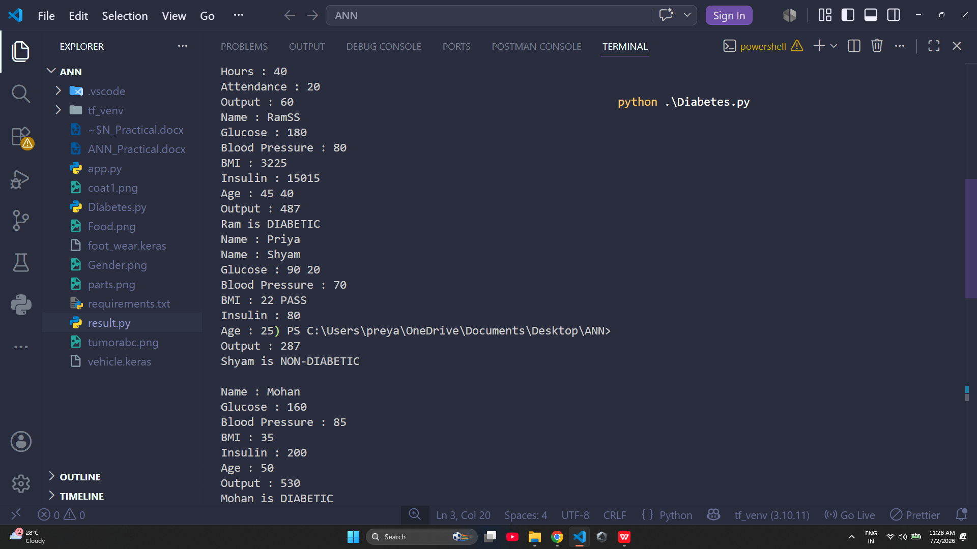

Q13.Build a Convolutional Neural Network (CNN) model using the MNIST dataset to recognize handwritten digits (0–9).

import tensorflow as tf
import kagglehub
from tensorflow import keras
from tensorflow.keras import layers
from tensorflow.keras.applications import MobileNetV2
import matplotlib.pyplot as plt
import numpy as np
import os
from google.colab import drive
drive.mount('/content/drive')

kaggle_dataset = kagglehub.dataset_download(
"olafkrastovski/handwritten-digits-0-9"
)

print("Dataset Downloaded Successfully...")

train_dataset = tf.keras.utils.image_dataset_from_directory(
kaggle_dataset,
validation_split=0.3,
subset="training",
seed=100,
image_size=(128, 128),
batch_size=82
)

val_dataset = tf.keras.utils.image_dataset_from_directory(
kaggle_dataset,
validation_split=0.3,
subset="validation",
seed=100,
image_size=(128, 128),
batch_size=82
)

print(train_dataset.class_names)

plt.figure(figsize=(8, 8))

for images, labels in train_dataset.take(1):
for i in range(4):
plt.subplot(2, 2, i + 1)
plt.imshow(images[i].numpy().astype("uint8"))
plt.title(train_dataset.class_names[labels[i]])
plt.axis("off")

plt.show()

data_augmentation = keras.Sequential([
layers.RandomFlip("horizontal"),
layers.RandomRotation(0.1),
layers.RandomZoom(0.1)
])

MNV2 = MobileNetV2(
weights="imagenet",
include_top=False,
input_shape=(128,128,3)
)

MNV2.trainable = False

model = keras.Sequential([

data_augmentation,
layers.Rescaling(1./255),
MNV2,

layers.GlobalAveragePooling2D(),

layers.Dense(128,activation="relu"),
layers.Dropout(0.3),
layers.Dense(len(train_dataset.class_names),activation="softmax")

])

print("Model Created Successfully")

model.compile(
optimizer="adam",
loss="SparseCategoricalCrossentropy",
metrics=["accuracy"]
)

print("Model Compiled Successfully")

early_stop = tf.keras.callbacks.EarlyStopping(
monitor="val_loss",
patience=5,
restore_best_weights=True
)

# history = model.fit(
# train_dataset,
# validation_data=val_dataset,
# epochs=10,
# callbacks=[early_stop]
# )
# print("Model Trained Successfully...")

# model.save("/content/drive/MyDrive/Model/handwriting_model.keras")
# print("Model Saved Successfully")

model = tf.keras.models.load_model("/content/drive/MyDrive/Model/handwriting_model.keras")
print("Model Loaded Successfully")

img = keras.utils.load_img(
"/content/two.jpg",
target_size=(128,128)
)

plt.imshow(img)
plt.axis("off")
plt.show()

img_array = keras.utils.img_to_array(img)
img_array = tf.expand_dims(img_array, 0)

prediction = model.predict(img_array)
score = tf.np.softmax(prediction[0])
predicted_index = np.argmax(score)
print("\nPrediction :", train_dataset.class_names[predicted_index])

Output : -
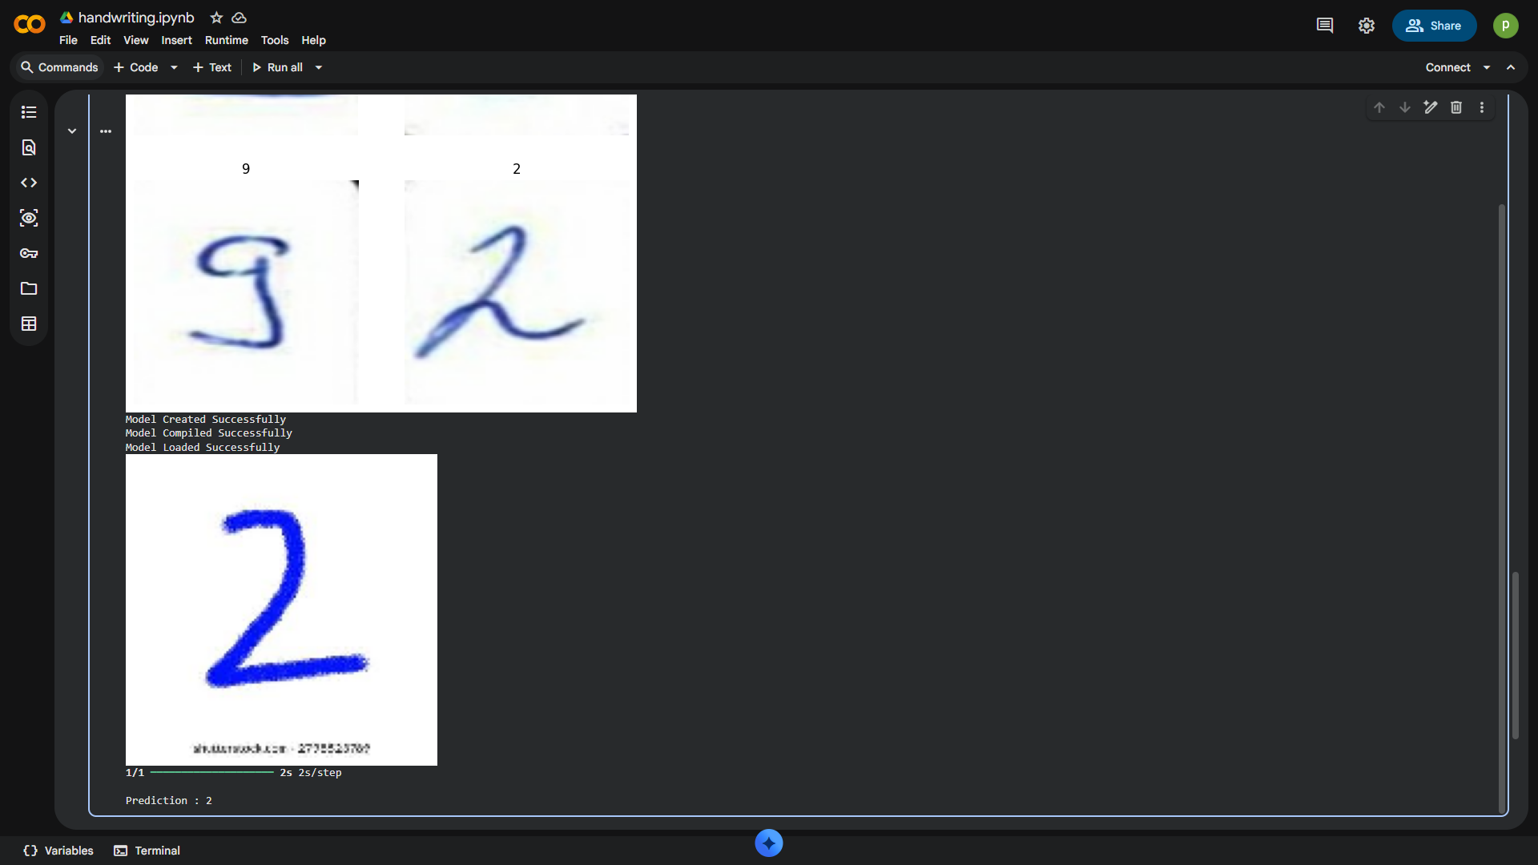

Q14.Create a CNN model that detects whether a person is wearing a face mask or not from facial images.

import tensorflow as tf
import kagglehub
from tensorflow import keras
from tensorflow.keras import layers
from tensorflow.keras.applications import MobileNetV2
import matplotlib.pyplot as plt
import numpy as np
import os
from google.colab import drive
drive.mount('/content/drive')

kaggle_dataset = kagglehub.dataset_download(
"sumansid/facemask-dataset"
)

print("Dataset Downloaded Successfully...")

train_dataset = tf.keras.utils.image_dataset_from_directory(
kaggle_dataset,
validation_split=0.4,
subset="training",
seed=100,
image_size=(128, 128),
batch_size=64
)

val_dataset = tf.keras.utils.image_dataset_from_directory(
kaggle_dataset,
validation_split=0.4,
subset="validation",
seed=100,
image_size=(128, 128),
batch_size=64
)

print(train_dataset.class_names)

plt.figure(figsize=(8, 8))

for images, labels in train_dataset.take(1):
for i in range(4):
plt.subplot(2, 2, i + 1)
plt.imshow(images[i].numpy().astype("uint8"))
plt.title(train_dataset.class_names[labels[i]])
plt.axis("off")

plt.show()

data_augmentation = keras.Sequential([
layers.RandomFlip("horizontal"),
layers.RandomRotation(0.1),
layers.RandomZoom(0.1)
])

MNV2 = MobileNetV2(
weights="imagenet",
include_top=False,
input_shape=(128,128,3)
)

MNV2.trainable = False
model = keras.Sequential([
data_augmentation,
layers.Rescaling(1./255),
MNV2,
layers.GlobalAveragePooling2D(),

layers.Dense(128,activation="relu"),
layers.Dropout(0.3),
layers.Dense(len(train_dataset.class_names),activation="softmax")

])

print("Model Created Successfully")

model.compile(
optimizer="adam",
loss="SparseCategoricalCrossentropy",
metrics=["accuracy"]
)

print("Model Compiled Successfully")

early_stop = tf.keras.callbacks.EarlyStopping(
monitor="val_loss",
patience=5,
restore_best_weights=True
)

# history = model.fit(
# train_dataset,
# validation_data=val_dataset,
# epochs=3,
# callbacks=[early_stop]
# )
# print("Model Trained Successfully...")

# model.save("/content/drive/MyDrive/Model/Facemask_model.keras")
# print("Model Saved Successfully")

model = tf.keras.models.load_model("/content/drive/MyDrive/Model/Facemask_model.keras")
print("Model Loaded Successfully")

img = keras.utils.load_img(
"/content/nomask.png",
target_size=(128,128)
)

plt.imshow(img)
plt.axis("off")
plt.show()
img_array = keras.utils.img_to_array(img)
img_array = tf.expand_dims(img_array, 0)

prediction = model.predict(img_array)
score = tf.nn.softmax(prediction[0])
predicted_index = np.argmax(score)
print("\nPrediction :", train_dataset.class_names[predicted_index])

Output : -
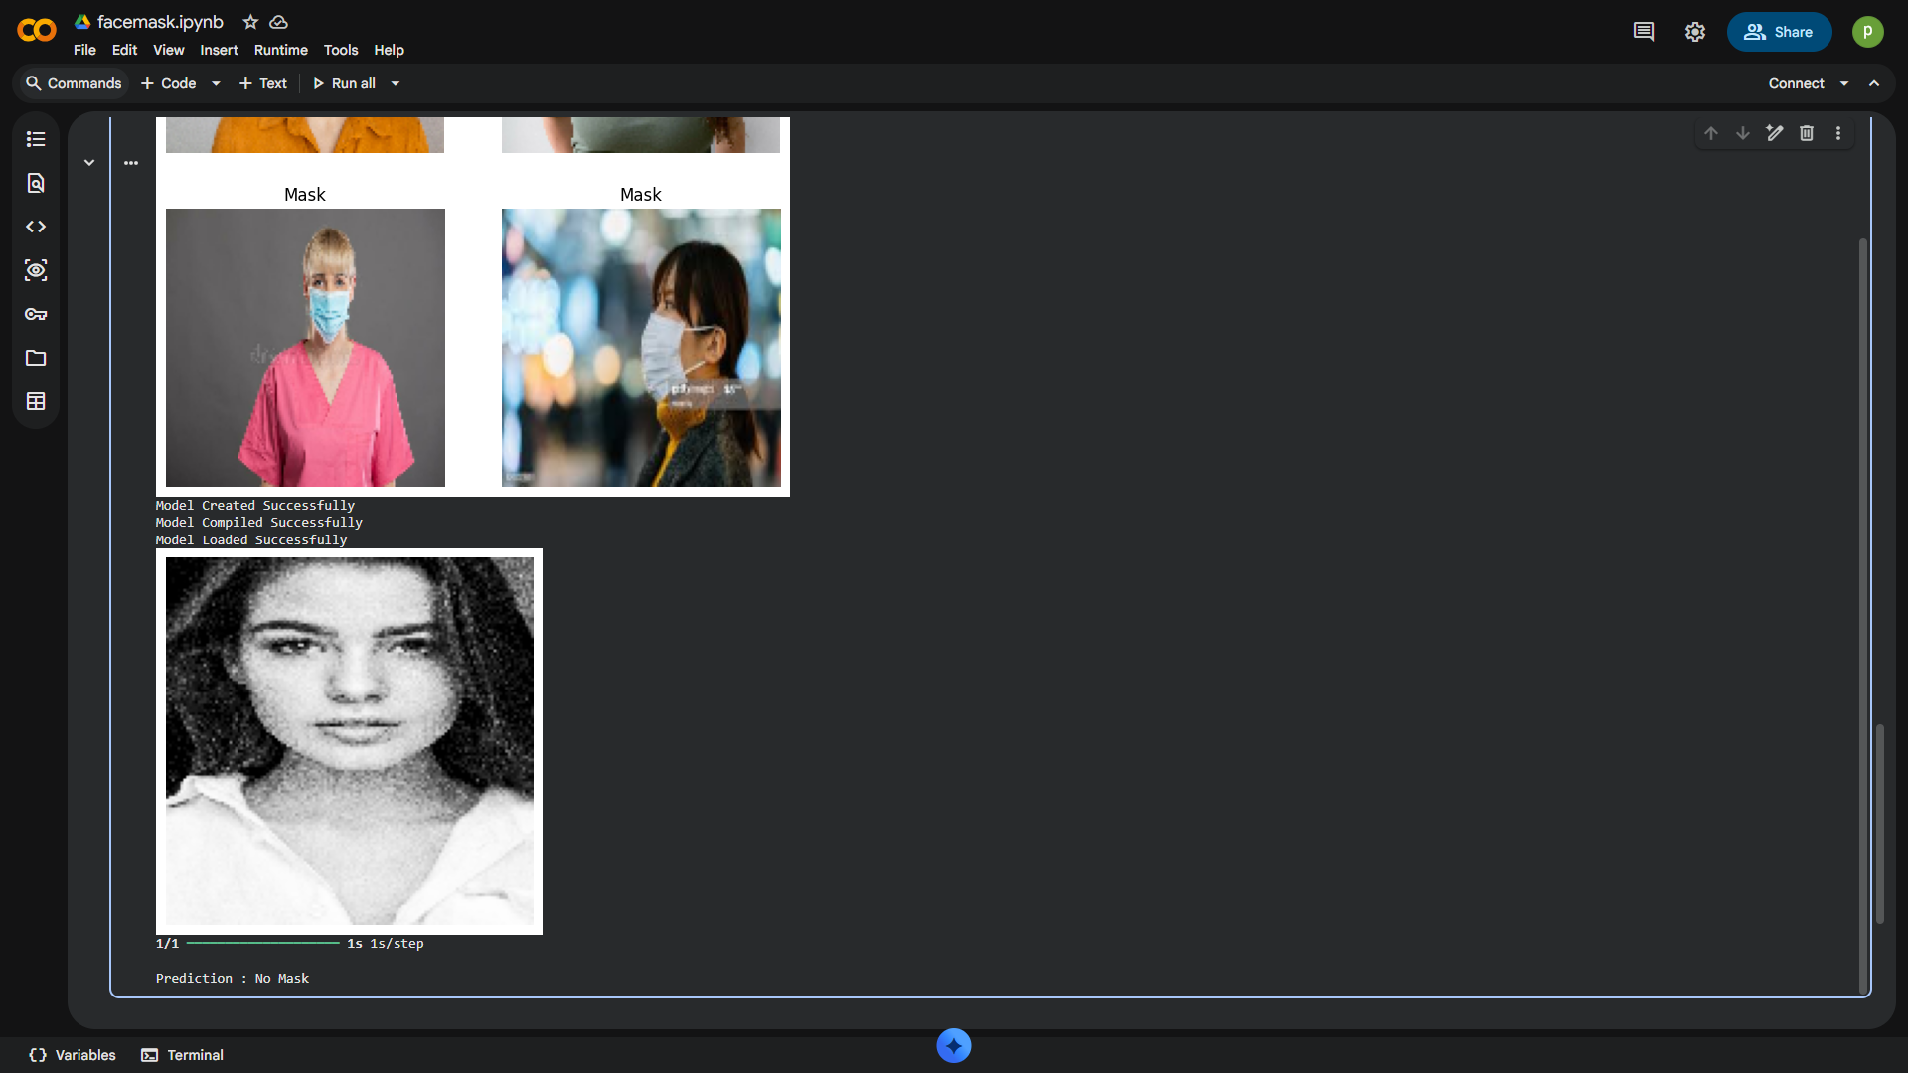

Q15.Build a CNN model to recognize human facial emotions such as Happy, Sad, Angry, Fear, Surprise, and Neutral from facial images.

ANS =>
import tensorflow as tf
import kagglehub
from tensorflow import keras
from tensorflow.keras import layers
from tensorflow.keras.applications import MobileNetV2
import matplotlib.pyplot as plt
import numpy as np
import os
from google.colab import drive
drive.mount('/content/drive')

kaggle_dataset = kagglehub.dataset_download(
"ananthu017/emotion-detection-fer"
)

print("Dataset Downloaded Successfully...")

path = os.path.join(kaggle_dataset,"train")

train_dataset = tf.keras.utils.image_dataset_from_directory(
path,
validation_split=0.4,
subset="training",
seed=100,
image_size=(128, 128),
batch_size=64
)

val_dataset = tf.keras.utils.image_dataset_from_directory(
path,
validation_split=0.4,
subset="validation",
seed=100,
image_size=(128, 128),
batch_size=64
)

print(train_dataset.class_names)

plt.figure(figsize=(8, 8))

for images, labels in train_dataset.take(1):
for i in range(4):
plt.subplot(2, 2, i + 1)
plt.imshow(images[i].numpy().astype("uint8"))
plt.title(train_dataset.class_names[labels[i]])
plt.axis("off")

plt.show()

data_augmentation = keras.Sequential([
layers.RandomFlip("horizontal"),
layers.RandomRotation(0.1),
layers.RandomZoom(0.1)
])

MNV2 = MobileNetV2(
weights="imagenet",
include_top=False,
input_shape=(128,128,3)
)

MNV2.trainable = False

model = keras.Sequential([

data_augmentation,
layers.Rescaling(1./255),
MNV2,

layers.GlobalAveragePooling2D(),

layers.Dense(128,activation="relu"),
layers.Dropout(0.3),
layers.Dense(len(train_dataset.class_names),activation="softmax")

])

print("Model Created Successfully")

model.compile(
optimizer="adam",
loss="SparseCategoricalCrossentropy",
metrics=["accuracy"]
)

print("Model Compiled Successfully")

early_stop = tf.keras.callbacks.EarlyStopping(
monitor="val_loss",
patience=5,
restore_best_weights=True
)

# history = model.fit(
# train_dataset,
# validation_data=val_dataset,
# epochs=10,
# callbacks=[early_stop]
# )
# print("Model Trained Successfully...")

model.save("/content/drive/MyDrive/Model/emotions_model.keras.keras")
print("Model Saved Successfully")

model = tf.keras.models.load_model("/content/drive/MyDrive/Model/emotions_model.keras.keras")
print("Model Loaded Successfully")

img = keras.utils.load_img(
"/content/neutral.jpg",
target_size=(128,128)
)

plt.imshow(img)
plt.axis("off")
plt.show()

img_array = keras.utils.img_to_array(img)
img_array = tf.expand_dims(img_array, 0)

prediction = model.predict(img_array)
score = tf.nn.softmax(prediction[0])
predicted_index = np.argmax(score)
print("\nPrediction :", train_dataset.class_names[predicted_index])

Output