Accelerometer Implementation:
During the implementation, we’ve went through following stages:
1-) Training the model using the WISDM data
2-) Testing the trained model on Python, generation of configuration files for the STM32F746G board.
3-) Implementing the model on the board and testing the model on the board.

1-) Training the model using the WISDM data:
We’ve used the functions provided in the Github repo of the book to generate the header files. During the parsing we’ve encountered a parser error thus we added on_bad_lines=”skip” argument to the parser.
Expected values in create_feature() function were expecting wrong column names, thus we standardized it.
Bayes Classifier’s predict function was not returning a label, but discrete class labels instead. We applied argmax over the class dimension to convert each probability vector into a single predicted class label, and then using these labels when computing the confusion matrix.
After these changes, we were able to generate configuration header and source files.

2-) Testing the trained model on Pyton, Generating Configuration Files:
In training.py, we trained the model and in the meantime, we added an extra part to create a feature array for testing both in Python and in microcontroller. With this feature array, we see how the model predicts on Python, also which class should be retrieved from the features generated. This will be used to monitor the MCU’s outputs and compare.
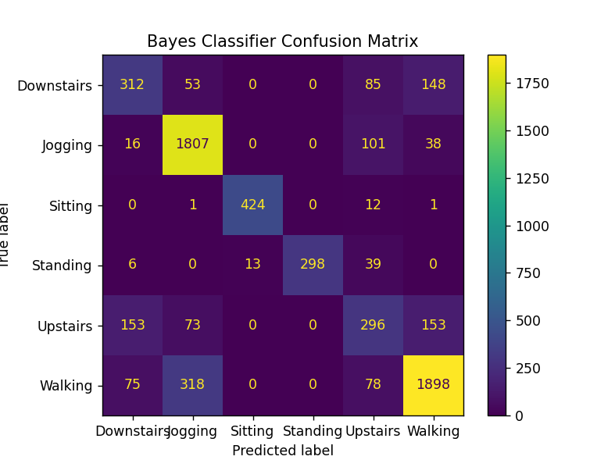
After these steps, we plot the true and predicted labels using matplotlib library. The output can be seen below:
3-) Implementing the model on the board:
To implement the model on the board, we’ve used MBED Studio’s blinky example in order to get the UART and Serial libraries. We modified the main file as follows:
We defined sample labels that are hardcoded in CLASS_NAMES array. Also, we’ve used the example features that were generated in the training.py file. In the main function, we used the bayes_har_predict() funciton in order to get a prediction which will be talked about next. After the prediction, the result was printed the terminal via the UART interface.
Custom inference function was implemented in bayes_har_inference() to reproduce the Gaussian likelihood calculation using the exported model parameters, which is located in bayes_har_config files. The output of the sample features from the board and the Python function are given below:

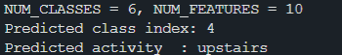
From the board:
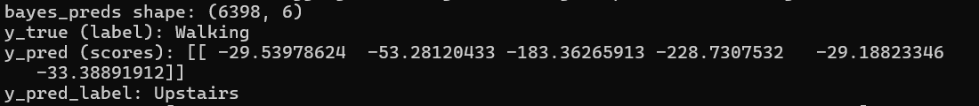
From the Python code. You can see the model made a wrong prediction.

