Keyword Spotting From Audio Signals Implementation:
During the implementation, we’ve went through following stages:
1-) Training the model using the WISDM data, generation of configuration files for the STM32F746G board.
2-) Testing the trained model on Python
3-) Implementing the model on the board and testing the model on the board.

1-) Training the model using the WISDM data:
We used the audio data that was provided in order to train our kNN model to recognize the number that was being said. To train our classifier, we used mfcc_func() to extract MFCC feature vectors from the raw audio recordings. It applies windowing, performs the FFT, computes Mel filterbank energies, and finally produces a fixed-length MFCC vector for each audio sample. These features are then used for both training and inference. In the main script, We loaded all WAV recordings, split them into training and test sets, and generate their MFCC features using mfcc_func. After that, We trained a kNN classifier, evaluate it on the test set, visualize the confusion matrix, and exported the trained model to C code using sklearn2c.
During these steps we’ve overcame the following problems:
First, the MFCC function failed because the input list contained tuples while the function expected a string path. This produced a TypeError. We fixed this by unpacking the tuple inside the loop and reconstructing the full path using os.path.join().
The original MFCC function also incorrectly returned only the last extracted MFCC vector instead of the full feature matrix; this was corrected by returning mfcc_features instead of mfcc_feature.
Once MFCC extraction worked, the confusion matrix step produced the error “Classification metrics can’t handle a mix of multiclass and continuous-multioutput targets.” From our research we understood that sklearn2c.KNNClassifier.predict() returns a 2-D output of shape instead of class labels. Applying argmax(axis=1) converted these outputs into 1-D integer class predictions, resolving the mismatch.

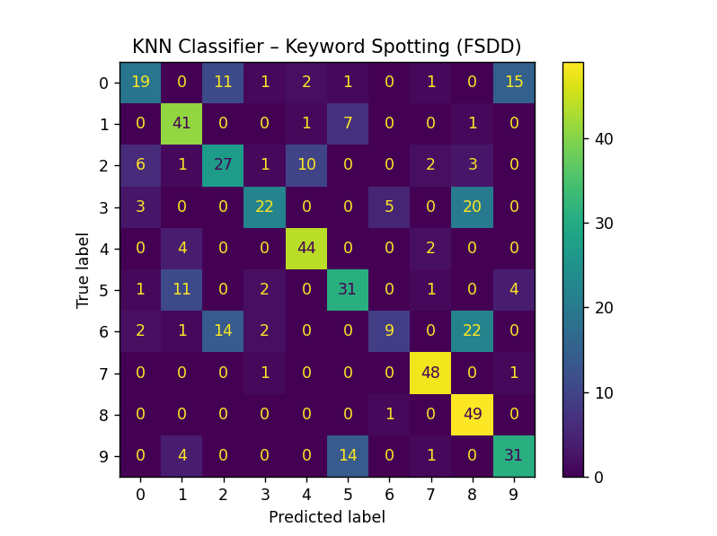

2-) Testing the trained model on Python.
We restored to using a simple prediction code, where from the main script we extracted a joblib file, which contained our trained model. We hardcoded a feature sample and let our classifier predict the hardcoded sample. You can see the prediction below, which is 6.

3-) Implementing the model on the board and testing the model on the board.
We implemented the complete kNN inference logic directly on the microcontroller. The MFCC training data, class labels, and model parameters were generated on the Python side using sklearn2c and imported into the C environment. The inference module computes the squared Euclidean distance between the input MFCC feature vector and every training sample. After identifying these neighbors, the algorithm counts their class votes and determines the final prediction by selecting the class with the highest vote.

