O P JINDAL UNIVERSITY
RAIGARH, CHHATTISGARH

DEPARTMENT OF COMPUTER SCIENCE AND ENGINEERING
MINOR PROJECT REPORT
Project Title
Alpha X1: A Privacy-Preserving Browser Agent with On-Device Vision and Redaction
Submitted in partial fulfilment of the requirements for the Minor Project
Submitted by | [Student name(s)]
Roll / Enrollment Number | [Enter number(s)]
Programme / Semester / Section | [Enter details]
Academic Session | [20__–__]
Project Supervisor | [Name and designation]
Department of Computer Science and Engineering
O P Jindal University, Raigarh, Chhattisgarh

Certificate
This is to certify that the Minor Project Report entitled “Alpha X1: A Privacy-Preserving Browser Agent with On-Device Vision and Redaction” is a bona fide work carried out by [Student Name(s)], Roll/Enrollment No(s). [________], of [Programme/Semester], Department of Computer Science and Engineering, O P Jindal University, Raigarh, Chhattisgarh, under my supervision during the academic session [20__–__].

Project Supervisor: ___________________________ Date: ______________
Head of Department: __________________________ Date: ______________

Declaration
We declare that the work presented in this report entitled “Alpha X1: A Privacy-Preserving Browser Agent with On-Device Vision and Redaction” is our own work completed under the guidance of [Supervisor Name]. It has not been submitted, in whole or in part, for any other academic award. All sources used have been appropriately acknowledged.

Student Signature(s): __________________________ Date: ______________

Acknowledgement
We express our sincere gratitude to our project supervisor, [Supervisor Name], for continuous guidance, constructive feedback and encouragement throughout this project. We are thankful to the Head of the Department and the faculty of the Department of Computer Science and Engineering, O P Jindal University, Raigarh, for providing the academic environment and resources needed to complete this work.
We also acknowledge the open-source communities behind FastAPI, React, Vite, ONNX Runtime, Tesseract, OpenCV’s YuNet and Ultralytics YOLO, whose tools made an on-device privacy pipeline practical, and our team members and friends for their support and testing help.

Abstract
Browser agents driven by large language models (LLMs) can read a web page and act on it — filling forms, clicking, navigating — but doing so normally means sending the raw page, and often a full screenshot, to a cloud provider. Such pages routinely contain passwords, payment details, national identifiers, contact information and faces, so the convenience of cloud reasoning comes at a direct privacy cost.
This project presents Alpha X1 (Privacy Vision Agent), a Chrome extension (Manifest V3) paired with a FastAPI gateway that follows the principle see locally, protect locally, reason in the cloud, validate locally, act locally. A local pipeline combines DOM field rules, a checksum-aware regular-expression engine (Luhn, Verhoeff), Tesseract.js OCR, a YuNet face detector and a YOLO11n visual model running through ONNX Runtime Web. A fusion engine merges the findings and fails closed on high-risk types; a redactor replaces text with semantic tokens and blurs or blacks out image regions. A privacy gate verifies the sanitized context before anything is transmitted. The cloud model (Claude, OpenAI or a local Ollama model) receives only sanitized data and returns a structured action, which is validated twice — on the server and by a local security policy with a user-confirmation gate for dangerous actions — before the extension executes it.
The system is implemented in about 17,500 lines of TypeScript and Python and is verified by 358 automated tests (336 extension, 22 backend), all passing, with type-checking and continuous integration on every push. The report describes the design, implementation, testing and honest limitations of the system and outlines future work.
Keywords: privacy-preserving AI, browser agent, PII redaction, on-device vision, LLM security, Chrome extension

Table of Contents
Chapter 1: Introduction 6
1.1 Background 6
1.2 Problem Statement 6
1.3 Aim and Objectives 6
1.4 Scope of the Project 7
1.5 Motivation and Significance 7
1.6 Organization of the Report 7
Chapter 2: Literature Review / Existing System 8
2.1 Review of Related Work 8
2.2 Existing System and Limitations 8
2.3 Research / Development Gap 9
Chapter 3: Requirements and System Analysis 10
3.1 Functional Requirements 10
3.2 Non-functional Requirements 10
3.3 Hardware and Software Requirements 11
3.4 Feasibility Analysis 11
3.5 Use Cases / User Requirements 11
Chapter 4: Proposed Methodology and System Design 12
4.1 Proposed Approach 12
4.2 System Architecture 12
4.3 Module Description 13
4.4 Algorithm / Workflow 14
4.5 Database / Data Design 15
4.6 UI / Interface Design 15
Chapter 5: Implementation 16
5.1 Development Environment 16
5.2 Implementation of Modules 16
5.3 Key Code / Configuration 17
5.4 Challenges and Solutions 18
Chapter 6: Testing and Results 19
6.1 Testing Strategy 19
6.2 Test Cases and Results 19
6.3 Results / Screenshots 20
6.4 Evaluation and Discussion 22
Chapter 7: Conclusion and Future Scope 23
7.1 Conclusion 23
7.2 Limitations 23
7.3 Future Enhancements 23
References 25
Appendices 25
Supervisor Evaluation / Approval 27

List of Figures
Figure 4.1: System architecture showing local and cloud trust zones 12
Figure 4.2: End-to-end workflow of the Alpha X1 agent loop 14
Figure 6.1: Extension popup showing page analysis and backend/session status 21
Figure 6.2: Synthetic demo login page used for privacy evaluation 21

List of Tables
Table 2.1: Summary of related work and identified gaps 8
Table 3.1: Hardware and software requirements 11
Table 4.1: System modules, functions and outputs 13
Table 4.2: Sensitive-data categories recognised by the detection layer 13
Table 5.1: Development environment and technologies 16
Table 5.2: Action protocol and risk classification 17
Table 5.3: Representative challenges and how they were addressed 18
Table 6.1: Automated test summary by component 19
Table 6.2: Representative PII-detection test cases 20
Table 6.3: Representative action-security test cases 20
Table 6.4: Outcomes against objectives 22

List of Abbreviations
Abbreviation | Full form
API | Application Programming Interface
CI | Continuous Integration
CSS | Cascading Style Sheets
CVV | Card Verification Value
DOM | Document Object Model
IoU | Intersection over Union
LLM | Large Language Model
NMS | Non-Maximum Suppression
OCR | Optical Character Recognition
ONNX | Open Neural Network Exchange
PAN | Permanent Account Number (India)
PII | Personally Identifiable Information
UPI | Unified Payments Interface
WASM | WebAssembly

Chapter 1: Introduction

1.1 Background
Large language models have made it possible to build browser agents: software that is given a goal in natural language (“log in and download my statement”), observes a web page, decides on the next step and carries it out by clicking, typing, scrolling or navigating. Commercial offerings and research prototypes of this kind generally observe the page through the DOM, through screenshots, or both, and send that observation to a cloud-hosted model [1], [2].
The pages an agent is useful on are precisely the pages that hold sensitive information: banking and payment forms, e-mail inboxes, government and identity portals, HR and health systems. Passwords, card numbers, Aadhaar and PAN-style identifiers, UPI addresses, phone numbers, postal addresses and photographs of people all appear on screen. Regulations such as India’s Digital Personal Data Protection Act, 2023 [3] and the wider security community’s guidance on LLM applications [4] make clear that this data must be handled with care.
Alpha X1 explores a different split of responsibilities. Perception and protection happen on the user’s device; only a sanitized description of the page ever reaches the cloud model; and every action the model proposes is checked locally before it is executed.

1.2 Problem Statement
Existing LLM browser agents forward raw page content and unredacted screenshots to a third-party service. A user who wants automation therefore has to trust that service with every credential, identifier and face visible in the tab. At the same time, an agent that executes whatever the model returns is exposed to mistakes and to prompt-injection from page content [4]. There is a need for an agent architecture that (a) keeps raw sensitive data on the device, (b) still gives the model enough sanitized context to act usefully, and (c) treats the model’s output as untrusted until it has been validated.

1.3 Aim and Objectives
Aim: To design and implement a browser agent that performs LLM-driven web automation while detecting and removing sensitive information locally, so that the cloud model sees only sanitized context and all proposed actions are validated before execution.
Objectives:
- Build a Chrome Manifest V3 extension that captures the DOM and a screenshot of the active tab and executes browser actions.
- Implement a fully local detection layer combining DOM rules, regular-expression/checksum matching, OCR, face detection and a general visual model.
- Fuse detector outputs and redact text, form fields and image regions in a fail-closed manner, with a privacy gate that blocks transmission when verification fails.
- Develop a FastAPI gateway that manages WebSocket sessions and routes sanitized context to interchangeable reasoning providers (Claude, OpenAI, Ollama) using a strict action protocol.
- Enforce layered action security: server-side validation, a local risk-based policy, user confirmation for dangerous actions, a kill switch and session time-outs.
- Verify the system with an automated test suite and continuous integration, and provide an evaluation harness for detection accuracy.

1.4 Scope of the Project
The project covers the end-to-end prototype: the extension (capture, local privacy pipeline, side-panel and popup UI, action executor, security layer), the backend gateway and provider adapters, a synthetic demo site and an evaluation framework. The intended users are individuals who want to automate web tasks without exposing private data to a cloud model, and developers researching privacy-preserving agents.
Assumptions and boundaries. The target browser is Chromium-based (Manifest V3). Detection is designed for English-language pages and for common Indian and international identifier formats. The project does not claim to verify that a detected identifier is genuine — it recognises its shape — and it does not guarantee perfect detection; it is a risk-reduction layer. Operation at production scale (multi-user hosting, persistent storage, authentication of users) is outside the scope of this minor project.

1.5 Motivation and Significance
Privacy is the main obstacle to using AI agents on real accounts. By proving that useful automation can be achieved with on-device sanitization, the project demonstrates a practical pattern that individuals, small organizations and regulated sectors can adopt. It also exercises a broad range of computer-science skills — browser extension engineering, computer vision inference in WebAssembly, real-time protocols, secure design and software testing — in a single integrated system.

1.6 Organization of the Report
- Chapter 2 reviews related work and identifies the gap the project addresses.
- Chapter 3 states the functional and non-functional requirements, platform needs, feasibility and use cases.
- Chapter 4 presents the methodology, architecture, modules, workflow, data design and interface design.
- Chapter 5 describes the implementation, key code and the challenges met.
- Chapter 6 reports the testing strategy, test cases, results and discussion.
- Chapter 7 concludes, lists limitations and suggests future enhancements.

Chapter 2: Literature Review / Existing System

2.1 Review of Related Work
The related work falls into three groups: LLM agents that operate user interfaces, PII-detection and anonymization tooling, and the model and OCR components that make local detection feasible. Table 2.1 summarizes the most relevant items.
Table 2.1: Summary of related work and identified gaps
Author / Year | Work / Approach | Key Findings | Limitation / Research Gap
Anthropic, 2024 [1] | Computer-use capability: model views screenshots and issues mouse/keyboard actions | LLMs can operate general GUIs from pixels alone | Screenshots and page content are sent to the cloud unredacted; no local privacy stage
OpenAI, 2025 [2] | Operator: browsing agent that observes pages and acts on them | Shows commercial viability of web agents; confirmation for sensitive steps | Cloud-side perception of raw pages; privacy relies on provider policy
Microsoft Presidio [5] | Open-source PII detection and anonymization for text and images | Mature recognizers and anonymizers; extensible | A general library, not integrated into a browser agent loop or action validation
Smith, 2007 [6] | Tesseract OCR engine | Open-source, accurate text recognition; now available in WebAssembly | Needs careful local packaging so no assets are fetched from a CDN
Wu et al., 2023 [7] | YuNet lightweight face detector | Millisecond-level face detection suitable for CPU/edge use | Detects faces only; no notion of documents or screens
Ultralytics / Lin et al., 2024 / 2014 [8], [9] | YOLO11 object detector trained on COCO | Fast general object detection, exportable to ONNX | Generic classes (person, laptop, phone, tv, book) must be mapped to privacy risks
OWASP, 2023 [4] | Top 10 risks for LLM applications | Identifies prompt injection and excessive agency as key risks | Gives guidance only; agents need concrete action validation and confirmation

2.2 Existing System and Limitations
Current cloud browser agents follow an “observe raw, reason in cloud” design. Their limitations, as they relate to this project, are:
- Raw data exposure: passwords typed or displayed, card numbers, identity numbers and faces in screenshots are transmitted to the provider.
- Single point of trust: protection depends entirely on a vendor’s retention and access policies, which the user cannot verify.
- Unchecked actions: the model’s output is executed directly; malicious page text can steer the agent (prompt injection), and navigation to dangerous schemes or local addresses is not systematically blocked.
- Limited auditability: the user rarely sees exactly what was sent, nor can they stop a runaway loop with a reliable kill switch.
General PII tools such as Presidio address detection but are not designed for in-browser, real-time use, do not combine DOM semantics with visual detectors, and do not govern what the agent may do next.

2.3 Research / Development Gap
What is missing is an integrated, on-device system that (i) detects sensitive content across DOM, text, images and faces, (ii) redacts it before any network transmission and proves the context is clean via a gate, (iii) lets the cloud model act on the sanitized view, and (iv) validates and confirms the resulting actions. Alpha X1 addresses this gap as a working, tested prototype that also exposes an “outbound data viewer” so the user can inspect exactly what leaves the device.

Chapter 3: Requirements and System Analysis

3.1 Functional Requirements
- FR1 – Page capture: capture the active tab’s DOM structure (interactive elements with stable local identifiers) and a screenshot.
- FR2 – Sensitive-data detection: detect sensitive items in form fields (by type, autocomplete, name, label), in text (e-mail, phone, card, Aadhaar-like, PAN-like, UPI, IP address), in images through OCR, and faces and document-like objects in screenshots.
- FR3 – Fusion and redaction: merge duplicate findings, apply a fail-closed risk policy, and redact text with semantic tokens, mask field values, and blur or black out image regions.
- FR4 – Privacy gate: block transmission when verification fails or high-risk findings remain unresolved; let the user review findings and the outbound payload.
- FR5 – Cloud reasoning: send only the sanitized context and task over a WebSocket session to the backend, which obtains the next action from a selectable provider (Claude, OpenAI or Ollama).
- FR6 – Action protocol: support the actions click, type, select, scroll, wait, navigate and finish in a strict structured format.
- FR7 – Action validation: validate every action on the server and again in the extension against a risk policy; require explicit user confirmation for dangerous actions.
- FR8 – Agent loop: execute actions, report results back, maintain a bounded action history and warn after repeated consecutive failures.
- FR9 – Safety controls: provide a kill switch, idle-session time-out and reconnection with heartbeat.
- FR10 – Evaluation: measure detection precision/recall, redaction, resource use and latency using synthetic data.

3.2 Non-functional Requirements
- Security and privacy: raw sensitive values never leave local memory; logs are scrubbed of secrets by a privacy-safe logger; no local-processing component may fetch assets from a CDN.
- Reliability: the system fails closed — if detection is uncertain on a high-risk type, it redacts; if the gate cannot verify, it blocks; if no confirmation arrives within the time-out, the action is denied.
- Performance: detection stages are timed individually and run asynchronously with time-outs so a stalled model cannot hang the UI.
- Usability: a popup for quick status and a side panel that shows detections, the sanitized context, the cloud decision and the execution status.
- Maintainability and portability: typed TypeScript and Python, modular detectors behind interfaces, provider abstraction, and CI on every push.
- Extensibility: new PII rules are registered in a rule registry without changing the engine.

3.3 Hardware and Software Requirements
Table 3.1: Hardware and software requirements
Item | Minimum | Recommended
Processor | Dual-core 64-bit CPU | Quad-core or better (WebAssembly inference)
Memory | 4 GB RAM | 8 GB RAM or more
Storage | 1 GB free (including model files) | 2 GB free
Browser | Chromium-based browser with Manifest V3 and Side Panel support | Latest stable Google Chrome
Backend runtime | Python 3.12 | Python 3.12 with virtual environment
Extension build | Node.js 20 and npm | Node.js 20 LTS
Network | Needed only for the cloud provider API | Not needed with a local Ollama model
Accounts / keys | API key for Claude or OpenAI (or a local Ollama install) | —

3.4 Feasibility Analysis
Technical feasibility. All components rely on mature open-source technology: Chrome extension APIs, React, ONNX Runtime Web, Tesseract.js, FastAPI and standard LLM APIs. The prototype demonstrates that inference for face and object detection and OCR runs on the user’s device through WebAssembly.
Operational feasibility. The user installs an unpacked extension and runs a local backend with a single command; the interface shows what was detected and what will be sent, which keeps the user in control.
Schedule and economic feasibility. The work was developed incrementally over about three weeks of repository activity (9–30 September 2026) using free tools. The only running cost is the optional cloud API usage, which can be eliminated by using a local Ollama model.

3.5 Use Cases / User Requirements
The primary actor is the end user who delegates a browsing task; secondary actors are the cloud reasoning provider and the web page being automated.
- UC1 – Run a task safely: the user enters a task; the extension captures and sanitizes the page, the user reviews the outbound data, and the agent proceeds step by step.
- UC2 – Review detections: the user inspects overlays, the list of findings and the sanitized context before anything is sent.
- UC3 – Approve a dangerous action: for navigate or finish the user is asked to approve or reject within 60 seconds.
- UC4 – Stop immediately: the user triggers the kill switch to terminate the loop.
- UC5 – Evaluate: a developer runs the benchmark to obtain detection metrics on synthetic data.

Chapter 4: Proposed Methodology and System Design

4.1 Proposed Approach
The approach is a five-stage trust pipeline: SEE LOCALLY → PROTECT LOCALLY → REASON IN CLOUD → VALIDATE LOCALLY → ACT LOCALLY. The central design decision is that the cloud model is a reasoner over sanitized data, never a perceiver of raw data. Three principles guide the design:
- Redact the value, keep the structure. The model must still understand the page, so output reads “Email: [EMAIL]” rather than “[REDACTED PAGE]”.
- Fail closed. When the system is uncertain about a high-risk type (password, card, CVV, Aadhaar-like, PAN-like, account number, face) it redacts rather than lets the value through.
- Never trust the model. Every returned action is untrusted input that must pass validation and, if dangerous, human confirmation.

4.2 System Architecture
The system has two deployable parts: the browser extension (the local trust zone) and the FastAPI gateway (the boundary to the cloud zone). Figure 4.1 shows the components and the one-way flow of sanitized data.
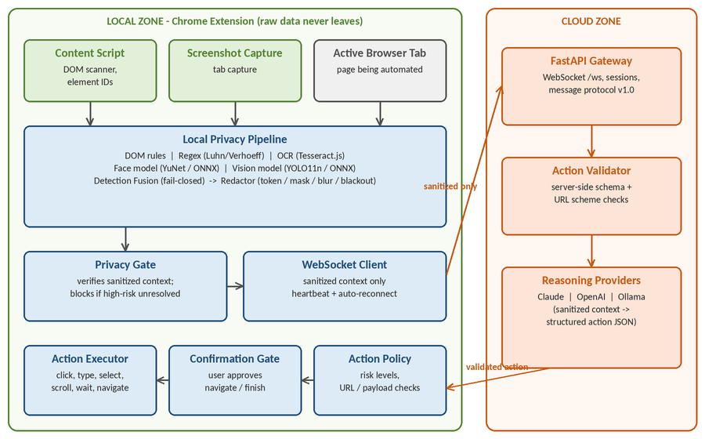
Figure 4.1: System architecture showing local and cloud trust zones
The content script and screenshot helper feed the local privacy pipeline; its output is checked by the privacy gate and sent through a WebSocket client to the gateway. The gateway validates and forwards the sanitized context to the selected reasoning provider and returns a validated structured action, which passes through the local action policy and confirmation gate before the executor performs it in the tab.

4.3 Module Description
Table 4.1: System modules, functions and outputs
Module | Description / Function | Expected Output
DOM scanner / content script | Walks the page, records interactive elements with local IDs, labels and field metadata | Element list for the agent and for DOM-rule detection
DOM rules detector | Classifies fields from autocomplete tokens, input type, name/id/label keywords | Findings with confidence 1.0 for semantic fields
Regex detector | Rule registry for e-mail, phone, card (Luhn), Aadhaar-like (Verhoeff), PAN-like, UPI, IPv4/IPv6 | Text-span findings
OCR (Tesseract.js) | Reads text baked into images/canvas; digit-recovery pass for numeric identifiers; assets loaded locally | Text with boxes, fed to the regex engine
Face detector (YuNet) | ONNX face model with greedy NMS; detects faces without identifying them | Face bounding boxes
Vision model (YOLO11n) | COCO objects mapped to privacy classes (person, book, laptop, cell phone, tv) | Document/face-like regions
Detection fusion | Groups findings by element, text-span overlap or IoU > 0.5; ranks sources; fail-closed policy | One normalized finding list
Redactor | Token replacement for text, masking of fields, blur or blackout of image regions | Sanitized text and screenshot
Privacy gate / outbound validator | Decides safe/blocked/idle; re-validates the outgoing payload independently of the UI | Gate state and send permission
Backend gateway | FastAPI app, WebSocket endpoint, sessions, heartbeat, protocol v1.0 | Validated actions for the extension
Providers | Claude, OpenAI and Ollama adapters behind one BaseProvider interface | Structured ActionResponse
Action policy & confirmation gate | Risk levels, payload and URL checks, user approval for dangerous actions | Allow / deny decision
Action executor | Performs click, type, select, scroll, wait, navigate and finish in the tab | Action result reported to backend
Security utilities | Kill switch, session manager, privacy-safe logger | Safe termination and scrubbed logs
Evaluation framework | Synthetic datasets, privacy and visual evaluators, metrics collector, benchmark runner | Precision/recall/F1 and resource metrics

Table 4.2: Sensitive-data categories recognised by the detection layer
Category | Detected by | Default redaction
Password, card CVV | DOM rules (field semantics) | Mask field value
Credit card number, card expiry | DOM rules, regex (Luhn), OCR | Token [CREDIT_CARD] / [CARD_EXPIRY]
E-mail, phone, person name, address | DOM rules, regex, OCR | Tokens [EMAIL], [PHONE], [PERSON], [ADDRESS]
Aadhaar-like, PAN-like, UPI ID, account number | DOM rules, regex (Verhoeff for Aadhaar shape), OCR | Tokens such as [AADHAAR_LIKE_ID]
IP address (v4/v6), other sensitive IDs | Regex, OCR | Tokens [IP_ADDRESS], [REDACTED]
Faces | YuNet face model, YOLO person class | Blur
Documents / screens | YOLO classes (book, laptop, cell phone, tv) | Blackout

Type names such as AADHAAR_LIKE_ID and PAN_LIKE_ID are deliberate: pattern matching identifies the shape of an identifier, never its real-world validity.

4.4 Algorithm / Workflow
Figure 4.2 shows the agent loop. Each iteration runs the six steps below until the model returns finish, the kill switch is activated or the session times out.
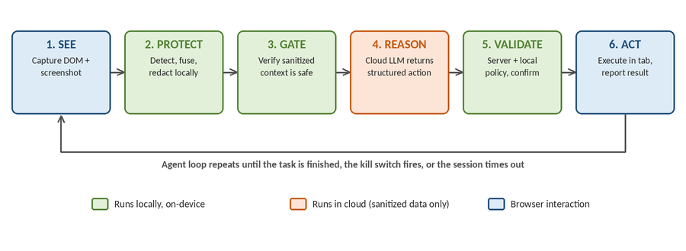
Figure 4.2: End-to-end workflow of the Alpha X1 agent loop
Pseudocode of one iteration:
loop:
if killSwitch.active or session.expired: stop
dom, shot <- capture(activeTab)
raw <- DOMrules(dom) + Regex(texts) + OCR(images)
+ Face(shot) + Vision(shot)
findings <- Fusion(raw) # merge, rank, fail-closed
clean <- Redact(dom, shot, findings)
if not PrivacyGate(clean, findings): block; ask user; continue
action <- Backend.reason(clean, task, history) # cloud
ok, why <- ServerValidator(action)
verdict <- ActionPolicy(action) # SAFE/MODERATE/DANGEROUS/BLOCKED
if verdict.requiresConfirmation and not user.confirm(60s): deny
result <- Executor.run(action)
Backend.report(result) # bounded history, failure count
if action == finish: stop

Fusion rules. Two findings merge when they share an element ID, have overlapping text spans or overlapping boxes (IoU > 0.5). The merged finding keeps the type of the higher-ranked source (DOM > regex > OCR/face > vision), the maximum confidence, and records any disagreement. Low-confidence findings are dropped unless they are high-risk types, which are promoted to “redact anyway”.

4.5 Database / Data Design
The prototype deliberately uses no persistent database: raw sensitive values are kept only in local memory and are never serialized out. The key data structures are:
- `PrivacyFinding` — type, source, confidence, optional bbox, elementId, textSpan, local-only rawValue, replacement, strategy and detail. A toWireFinding function strips rawValue before anything leaves the extension.
- `MessageEnvelope` (protocol v1.0) — session_id, message_id, type (context, action, action_result, error, heartbeat, page_changed), timestamp and a payload dictionary, validated with Pydantic.
- `SessionData` (backend, in memory) — creation time, last heartbeat, message counters, a history of at most 20 action results, a consecutive-failure counter and pending actions. Sessions idle for more than five minutes are considered stale.
- `ActionResponse` — action_type, target_id, value, option, direction, amount, duration_ms, url, confidence, reason.

4.6 UI / Interface Design
The extension offers two surfaces. The popup (Figure 6.1) gives quick access to page information, DOM analysis, screenshot capture and backend/session status. The side panel is the main workspace and is built from React components such as the processing pipeline view, detection overlay and list, sanitized-context viewer, split original/redacted screenshot view, privacy gate, outbound-data viewer, cloud decision, action validation, pending-action confirmation, execution status, session timeline and metrics panel. The design goal is transparency: the user can see what was found, what will be sent and what the agent intends to do.

Chapter 5: Implementation

5.1 Development Environment
Table 5.1: Development environment and technologies
Category | Technology | Purpose
Languages | TypeScript 5.3 (extension), Python 3.12 (backend) | Type-safe extension code; async backend
Extension framework | Chrome Manifest V3, React 18, Vite 5, lucide-react | Service worker, content script, popup and side panel
Local ML / vision | onnxruntime-web 1.19, Tesseract.js 7, YuNet (ONNX), YOLO11n (ONNX) | On-device OCR, face and object detection
Backend | FastAPI 0.104, Uvicorn, websockets 12, Pydantic 2 | Gateway, WebSocket sessions, schema validation
Cloud providers | anthropic SDK, openai SDK, httpx (Ollama) | Reasoning adapters
Testing | Vitest 1 + jsdom (extension), pytest 7 (backend) | Automated unit/integration tests
Quality tools | ESLint, tsc --noEmit, GitHub Actions CI | Lint, type-check, test and build on each push/PR
Version control | Git and GitHub (repository princeraj2572/alpha-x1) | 83 commits across 9–30 Sep 2026

The repository is organized as privacy-vision-agent/ with backend/, extension/ and demo-site/ directories; the extension source is split into privacy/, security/, executor/, communication/, background/, evaluation/, scanner/, capture/ and ui/. It contains roughly 17,500 lines of TypeScript, TSX and Python.

5.2 Implementation of Modules

Local privacy pipeline
PrivacyPipeline orchestrates the detectors, each of which is optional and individually timed: DOM rules, regex over supplied text blocks, OCR, face detection and vision detection, followed by fusion and redaction. Each detector sits behind an interface (for example OcrEngine, FaceModel) so that a stub can replace a model in tests and a model that fails to load degrades gracefully instead of crashing the pipeline. The pipeline returns the fused findings, visual regions, the redacted screenshot and text, a safe-to-log report and per-stage timings.

Detection engines
The DOM-rule detector classifies each field using, in order, the standardized autocomplete token, the input type and finally keyword heuristics over name, id, placeholder and label. The regex engine is a registry of PiiRule objects with optional validators; card candidates must pass the Luhn checksum and Aadhaar-like candidates the Verhoeff checksum, which sharply reduces false positives such as order numbers and version strings. OCR uses Tesseract.js with every asset (worker, WebAssembly core, language data) loaded from extension-local URLs, because the library’s default of fetching from a public CDN would contradict the project’s premise. Face and vision models run through ONNX Runtime Web with execution-provider fallback.

Fusion, redaction and the privacy gate
The fusion engine implements the rules of Section 4.4. The redactor applies text spans right-to-left so offsets remain valid, masks DOM values, and blurs or blacks out pixel regions. The privacy gate is a set of pure functions: the UI renders its result, but the transport layer independently re-validates the sanitized context before sending, so safety never depends on the UI.

Backend gateway and providers
The FastAPI application exposes health and status endpoints and a WebSocket endpoint that accepts envelopes, tracks sessions, sends heartbeats and relays validated actions. ReasoningService lazily creates the provider selected by the AI_PROVIDER environment variable (Claude by default, OpenAI or Ollama). All providers implement BaseProvider.reason() and return a common ActionResponse. Session state records recent action results and warns the extension after three consecutive failures.

Action security
Actions are classified by ActionPolicyValidator as in Table 5.2. The server-side ActionValidator enforces required fields and allowed URL schemes independently, so a compromised or confused extension, or a bad model response, is caught at either layer.
Table 5.2: Action protocol and risk classification
Action | Risk level | Key checks
click, scroll, wait | SAFE | target_id or direction required; scroll amount must be numeric and ≤ 1000; wait 100–10,000 ms
type, select | MODERATE | Value must be a string; suspicious script content rejected
navigate | DANGEROUS (confirmation required) | URL required; blocks javascript:, data:, file://, about:, blob:; blocks localhost/127.0.0.1/0.0.0.0; malformed URLs rejected
finish | DANGEROUS (confirmation required) | User must approve completion
Any action | BLOCKED if invalid | Unknown type or payload larger than 10 KB is blocked

Dangerous actions are held by the ConfirmationGate, which returns a promise that resolves only when the user answers (or denies automatically after 60 seconds). The KillSwitch can stop the loop at any time and notifies subscribers; the SessionManager enforces a ten-minute idle time-out and bounded reconnection attempts; SafeLogger redacts secrets such as passwords, tokens, cookies and API keys from log data.

5.3 Key Code / Configuration
The following excerpts show two central mechanisms. First, the Luhn checksum used to reduce false positives on card-like numbers:
export function luhnValid(value: string): boolean {
const digits = value.replace(/\D/g, '');
if (digits.length < 12 || digits.length > 19) return false;
let sum = 0, double = false;
for (let i = digits.length - 1; i >= 0; i--) {
let d = digits.charCodeAt(i) - 48;
if (double) { d *= 2; if (d > 9) d -= 9; }
sum += d; double = !double;
}
return sum % 10 === 0;
}

Second, the fail-closed set of high-risk types that fusion and the privacy gate treat conservatively:
export const HIGH_RISK_TYPES: ReadonlySet<PrivacyType> = new Set([
PrivacyType.PASSWORD, PrivacyType.CREDIT_CARD, PrivacyType.CARD_CVV,
PrivacyType.AADHAAR_LIKE_ID, PrivacyType.PAN_LIKE_ID,
PrivacyType.ACCOUNT_NUMBER, PrivacyType.FACE,
]);

Configuration is supplied through a .env file (copied from .env.example): AI_PROVIDER (anthropic, openai or ollama), the corresponding API key and model, the backend URLs and the log level. Real credentials are never committed. Complete source is available in the project repository.

5.4 Challenges and Solutions
Table 5.3: Representative challenges and how they were addressed
Challenge | Solution
Cloud model must act on elements it cannot see raw; click/type/select actions were not resolving to real elements | Introduced stable local target_id values and fixed the resolution so each action targets the intended element
Confirmation was computed and displayed but did not actually pause execution | Added a dedicated ConfirmationGate that blocks until the user decides or a time-out occurs, with unit tests
An unauthenticated reasoning endpoint and a popup “Ask Agent” button could bypass the privacy pipeline | Removed both so the only route to the cloud is the sanitized, gated WebSocket flow
Tesseract and ONNX defaults fetch assets from CDNs, violating the local-only principle | Packaged assets inside the extension and passed explicit local URLs
Models unavailable in tests (browser-only runtime) risked fake “pass” results | Evaluators report measured: false when a model cannot run instead of fabricating a score
Idle-session time-out existed but was not enforced; duplicate handlers and reconnect-after-disconnect bugs in the WebSocket client | Wired the session manager into the agent loop and fixed handler registration and disconnect() behaviour
Dead or orphaned code (old vision engine, unused privacy service, placeholder dashboard) increased the attack surface | Removed unused modules and consolidated evaluation onto one maintained dataset

Chapter 6: Testing and Results

6.1 Testing Strategy
Testing combines automated unit and integration tests, static checks and continuous integration:
- Unit tests for every detector, fusion, redaction, security module, state store and loader (Vitest with jsdom for the extension; pytest for the backend).
- Integration tests for the pipeline orchestrator and for the WebSocket action flow (session, validation, history and failure handling).
- Dataset-driven tests using a synthetic, privacy-safe dataset of 21 text cases and 19 form-field cases, including negatives that must not trigger (order numbers, version strings, promo codes).
- Static checks: tsc --noEmit and ESLint for the extension.
- Continuous integration: a GitHub Actions workflow runs type-check, lint, tests and the production build for the extension, and pytest for the backend, on every push and pull request.
Only synthetic and industry-standard test values are used (for example the card test numbers 4111 1111 1111 1111 and 5555 5555 5555 4444, and reserved example.invalid domains); no real personal data appears in the repository.

6.2 Test Cases and Results
The full automated suite was executed for this report on the project’s main code base. All 358 tests passed and the TypeScript type-check completed without errors. Table 6.1 summarizes the results by component.
Table 6.1: Automated test summary by component
Component | Test files | Tests | Result
Privacy detection (regex, DOM rules, detector facade, fusion, redactor, OCR, face, vision, pipeline, async utils) | 12 | 131 | All passed
Security (action policy, kill switch, safe logger, session manager) | 4 | 72 | All passed
Executor, confirmation gate and WebSocket client | 3 | 25 | All passed
UI state (store, messaging, privacy gate, outbound validator, loaders, pipeline runner) | 8 | 63 | All passed
DOM scanner | 1 | 23 | All passed
Evaluation framework | 3 | 22 | All passed
Extension total | 31 | 336 | All passed
Backend (providers, sessions, WebSocket action flow) | 5 | 22 | All passed
Overall | 36 | 358 | All passed

Representative functional test cases are listed in Tables 6.2 and 6.3. Expected and actual outputs agree in every case listed.
Table 6.2: Representative PII-detection test cases
Input | Expected output | Actual | Status
“Card on file 4111 1111 1111 1111” | CREDIT_CARD detected | CREDIT_CARD | Pass
“Aadhaar 2338 5972 6560” (Verhoeff-valid, synthetic) | AADHAAR_LIKE_ID detected | AADHAAR_LIKE_ID | Pass
“PAN: ABCDE1234F” | PAN_LIKE_ID detected | PAN_LIKE_ID | Pass
“Send to testuser@oksbi” | UPI_ID detected | UPI_ID | Pass
Combined text with name, e-mail, phone and card | EMAIL, PHONE, CREDIT_CARD | All three found | Pass
“Version 4.11.2024 of the doc” | No finding | No finding | Pass
“Order #100200300 shipped” | No finding | No finding | Pass
Field type=password, autocomplete=new-password | PASSWORD | PASSWORD | Pass
Field autocomplete=cc-csc | CARD_CVV | CARD_CVV | Pass
Field name search, placeholder “Search products” | Not sensitive | Not sensitive | Pass

Table 6.3: Representative action-security test cases
Input | Expected output | Actual | Status
navigate with an https URL | Valid, DANGEROUS, confirmation required | As expected | Pass
navigate with javascript: URL (any letter case) | Rejected as BLOCKED | Rejected | Pass
navigate with malformed URL | Rejected without throwing | Rejected | Pass
Unknown action type | BLOCKED (not defaulted to SAFE) | BLOCKED | Pass
Payload larger than 10 KB | Rejected | Rejected | Pass
scroll with amount over 1000 | Rejected | Rejected | Pass
finish action | DANGEROUS, confirmation required | As expected | Pass
Confirmation not answered within time-out | Denied automatically | Denied | Pass
Backend: consecutive action failures reach threshold | Warning raised to extension | Warning raised | Pass

6.3 Results / Screenshots
Figure 6.1 shows the extension popup running against a page, with page information, DOM analysis, screenshot capture and backend/session status. Figure 6.2 shows the bundled demo login page, a synthetic page with credential and personal-information fields used for development and privacy evaluation.
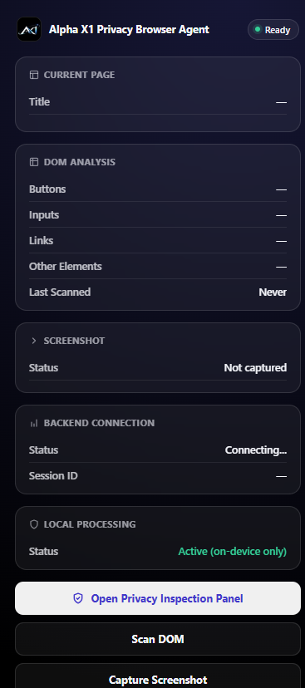
Figure 6.1: Extension popup showing page analysis and backend/session status
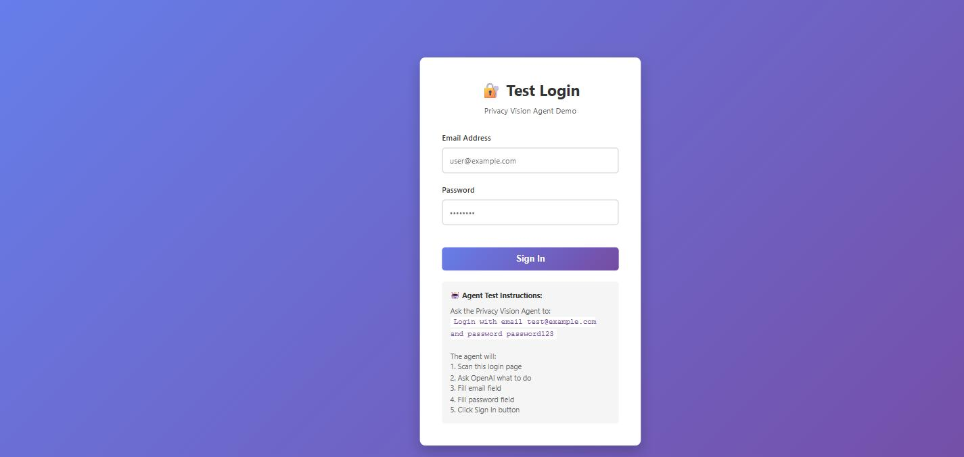
Figure 6.2: Synthetic demo login page used for privacy evaluation

6.4 Evaluation and Discussion
Table 6.4: Outcomes against objectives
Objective | Outcome
Capture DOM and screenshot; execute actions | Achieved: content script, screenshot helper and executor implemented and unit-tested
Local multi-detector privacy layer | Achieved: DOM, regex, OCR, face and vision detectors with graceful fallback
Fusion, fail-closed redaction, privacy gate | Achieved: implemented and tested; gate re-validated at the transport layer
Gateway with interchangeable providers | Achieved: Claude, OpenAI and Ollama adapters behind one interface
Layered action security | Achieved: server validation, local policy, confirmation gate, kill switch, session time-out
Testing and CI | Achieved: 358 tests passing; CI runs type-check, lint, tests and build

Discussion and honest limitations of the evaluation. The automated tests show that each component behaves as specified on synthetic data. They do not establish detection accuracy on real-world pages. In particular, the ONNX face and object models and Tesseract’s WebAssembly runtime are browser-only and are not exercised under Node-based tests, so visual-detection accuracy is reported as not measured by the evaluators in that environment rather than given a made-up score. A real precision/recall figure for the visual detectors requires the labelled fixture images, which are intentionally not bundled for licensing and privacy reasons and are fetched on demand with npm run fetch:visual-fixtures. We therefore report test status, not accuracy percentages, and recommend a measured browser-based evaluation as future work.

Chapter 7: Conclusion and Future Scope

7.1 Conclusion
This project set out to show that an LLM browser agent can be useful without being given raw sensitive data. Alpha X1 realises the “see locally, protect locally, reason in cloud, validate locally, act locally” design as a working prototype: a Manifest V3 extension with a multi-detector, fail-closed privacy pipeline and an inspectable privacy gate, a FastAPI gateway with interchangeable cloud providers, and a layered action-security model with user confirmation, a kill switch and session controls. The system is covered by 358 passing automated tests and continuous integration, and its development history documents several security-relevant fixes (such as removing paths that bypassed the privacy pipeline).
The main contribution is the integration: the individual techniques (regex with checksums, OCR, face and object detection, schema validation) are known, but combining them so that sanitization is enforced before transmission and action validation after reasoning, with the user able to see both, is what makes the agent safer to use on real accounts.

7.2 Limitations
- Detection is probabilistic and rule-based; novel identifier formats, handwritten or heavily distorted text, and unusual layouts can be missed. Detection is tuned for English and common Indian and international formats.
- Identifier checks establish shape and checksum validity only, not that a number is real or belongs to anyone.
- The face and vision models and OCR assets are not bundled in the repository and must be provided locally; accuracy on real pages has not yet been measured systematically.
- The vision model uses generic COCO classes mapped to privacy classes, which is coarse (for example any “laptop” is treated as a potential document).
- Backend sessions are held in memory in a single process; there is no user authentication, persistence or horizontal scaling.
- Redacted context can still reveal structure and the user’s task to the cloud provider; the system protects values, not the fact of using a service.
- The extension requests broad host permissions (<all_urls>) because it must operate on arbitrary pages.

7.3 Future Enhancements
- Run a browser-based benchmark on labelled real-world screenshots and publish precision/recall per category, including latency and memory on typical laptops.
- Train or fine-tune a purpose-built detector for document types (ID cards, bank statements) instead of mapping generic COCO classes.
- Add stronger prompt-injection defences, such as separating page text from instructions and allow-listing domains per task.
- Support more languages and identifier formats, and user-defined redaction rules.
- Add authentication, persistent encrypted audit logs and multi-user deployment to the backend; support fully offline reasoning with a local model by default, and ship a packaged extension build with a model-download onboarding flow.

References
Note: all sources below were consulted for the concepts used in this report. Please verify page numbers and URLs against the originals before submission.
[1] Anthropic, “Introducing computer use, a new Claude 3.5 Sonnet, and Claude 3.5 Haiku,” Anthropic News, Oct. 2024. [Online]. Available: https://www.anthropic.com/news/3-5-models-and-computer-use
[2] OpenAI, “Introducing Operator,” OpenAI, Jan. 2025. [Online]. Available: https://openai.com/index/introducing-operator/
[3] Government of India, “The Digital Personal Data Protection Act, 2023,” Ministry of Electronics and Information Technology, 2023.
[4] OWASP Foundation, “OWASP Top 10 for Large Language Model Applications,” 2023. [Online]. Available: https://owasp.org/www-project-top-10-for-large-language-model-applications/
[5] Microsoft, “Presidio: Data Protection and De-identification SDK,” GitHub. [Online]. Available: https://github.com/microsoft/presidio
[6] R. Smith, “An Overview of the Tesseract OCR Engine,” in Proc. 9th Int. Conf. Document Analysis and Recognition (ICDAR), 2007, pp. 629–633.
[7] W. Wu, H. Peng and S. Yu, “YuNet: A Tiny Millisecond-level Face Detector,” Machine Intelligence Research, vol. 20, pp. 656–665, 2023.
[8] Ultralytics, “YOLO11 Documentation,” 2024. [Online]. Available: https://docs.ultralytics.com
[9] T.-Y. Lin et al., “Microsoft COCO: Common Objects in Context,” in Proc. European Conf. Computer Vision (ECCV), 2014, pp. 740–755.
[10] J. Verhoeff, “Error Detecting Decimal Codes,” Mathematical Centre Tract 29, Mathematisch Centrum, Amsterdam, 1969.
[11] H. P. Luhn, “Computer for Verifying Numbers,” U.S. Patent 2 950 048, Aug. 23, 1960.
[12] I. Fette and A. Melnikov, “The WebSocket Protocol,” RFC 6455, IETF, Dec. 2011.
[13] Google, “Chrome Extensions – Manifest V3,” Chrome for Developers. [Online]. Available: https://developer.chrome.com/docs/extensions/mv3/
[14] S. Ramírez, “FastAPI Documentation.” [Online]. Available: https://fastapi.tiangolo.com
[15] Microsoft, “ONNX Runtime Web,” ONNX Runtime Documentation. [Online]. Available: https://onnxruntime.ai/docs/tutorials/web/
[16] Prince Raj, “alpha-x1: Privacy Vision Agent,” GitHub repository. [Online]. Available: https://github.com/princeraj2572/alpha-x1

Appendices

Appendix A: User Manual
Backend
cd privacy-vision-agent/backend
pip install -r requirements.txt
cp ../.env.example ../.env # add your API key and choose AI_PROVIDER
uvicorn app.main:app --reload

Extension
cd privacy-vision-agent/extension
npm install
npm run build # then load the dist folder via chrome://extensions
# (enable Developer mode -> Load unpacked)

Demo site and tests
cd privacy-vision-agent/demo-site && python -m http.server 8000
cd privacy-vision-agent/extension && npx vitest run
cd privacy-vision-agent/backend && python -m pytest -v

Open the demo page at http://localhost:8000, click the extension icon to open the popup, open the side panel, enter a task and review the detections, the sanitized context and the outbound data before approving each step. Use the kill switch to stop the agent at any time.

Appendix B: Additional Results / Screenshots
Supplementary screenshots (side panel with detection overlay, split original/redacted view and outbound-data viewer) can be added here from a live run of the extension. [Insert screenshots]

Appendix C: Selected Code / Supporting Documents
Full source code, CI configuration (.github/workflows/ci.yml) and test suites are available in the GitHub repository: https://github.com/princeraj2572/alpha-x1.

Supervisor Evaluation / Approval
Supervisor's remarks | [For supervisor use]
Recommendation | ☐ Accepted ☐ Accepted with corrections ☐ Resubmission required
Supervisor signature / date | [Signature and date]
HoD signature / date | [Signature and date, if required]

