SMART DIGITAL QUEUE MANAGEMENT SYSTEM WITH REAL-TIME TRACKING, APPOINTMENT SCHEDULING, AND QUEUE ANALYTICS FOR HEALTHCARE FACILITIES
A Project Report Presented to the
Department of Information Technology Education
University of Skills Training and Entrepreneurial Development (USTED)
In Partial Fulfillment of the Requirements for the Award of a Degree in Information Technology Education
Presented by:
OPPONG JOSEPH ATTAKORAH
Index Number: 5221040716
ACHEAMPONG PRISCILLA
Index Number: 5221040710
Supervisor:
Dr. Williams Atuahene
Academic Year: 2026
Month and Year of Submission: June 2026

DECLARATION
We hereby declare that this project report titled “Smart Digital Queue Management System with Real-Time Tracking, Appointment Scheduling, and Queue Analytics for Healthcare Facilities” is our original work and has been prepared by us under the supervision of Dr. Williams Atuahene.
We confirm that this project has not been submitted to any other institution for the award of any academic qualification. All sources of information used in this report have been properly acknowledged.
<br>
OPPONG JOSEPH ATTAKORAH
Index Number: 5221040716
Signature: _____________
Date: ________________
<br>
ACHEAMPONG PRISCILLA
Index Number: 5221040710
Signature: _____________
Date: ________________

CERTIFICATION

I certify that this project report titled “Smart Digital Queue Management System with Real-Time Tracking, Appointment Scheduling, and Queue Analytics for Healthcare Facilities” was carried out by Oppong Joseph Attakorah and Acheampong Priscilla under my supervision.
The project meets the academic requirements of the Department of Information Technology Education, University of Skills Training and Entrepreneurial Development (USTED).

Supervisor:
Dr. Williams Atuahene
Signature: _______________
Date: ___________________

DEDICATION

This project is dedicated to Almighty God for His guidance, strength, and protection throughout our academic journey.
We also dedicate this work to our parents, families, lecturers, and colleagues whose encouragement, support, and sacrifices contributed to the successful completion of this project.
Finally, we dedicate this work to healthcare institutions and technology innovators working towards improving healthcare service delivery through digital transformation.
ACKNOWLEDGEMENT
We would like to express our sincere gratitude to Almighty God for granting us wisdom, strength, and perseverance throughout the development of this project.
We are deeply grateful to our supervisor, Dr. Williams Atuahene, for his guidance, valuable suggestions, and continuous support throughout this research and system development process.
We also appreciate the lecturers of the Department of Information Technology Education, University of Skills Training and Entrepreneurial Development (USTED), for providing us with the knowledge and skills required to undertake this project.
Our appreciation also goes to our families, friends, and colleagues for their encouragement and support throughout our academic journey.
Finally, we acknowledge everyone who contributed directly or indirectly towards the successful completion of this project.
ABSTRACT
Healthcare facilities continue to experience challenges associated with long waiting times, overcrowding, and inefficient patient flow management. Traditional queue management approaches often require patients to physically wait without accurate information about their expected service time or queue position.
This project presents the design and implementation of a Smart Digital Queue Management System with Real-Time Tracking, Appointment Scheduling, and Queue Analytics for Healthcare Facilities. The system aims to improve healthcare service delivery by providing a digital platform that manages patient queues, appointments, and service processes.
The system was developed as a web-based application using HTML, CSS, JavaScript, Bootstrap, and Supabase as the backend platform. It provides four major user interfaces: Patient Dashboard, Receptionist Dashboard, Department Staff Dashboard, and Administration Dashboard.
Patients can register, schedule appointments, join queues, and monitor their queue positions in real time. Receptionists can register patients, manage appointments, and assign patients to departments. Department staff can manage assigned patients and update service status, while administrators can monitor system activities and access queue analytics.
The system was tested using functional testing methods to evaluate major operations including authentication, appointment management, queue creation, dashboard functions, and analytics display.
The developed system provides an affordable and efficient solution for improving patient flow management, reducing waiting time, and supporting better decision-making within healthcare facilities.
Keywords: Digital Queue Management, Healthcare Information System, Real-Time Tracking, Appointment Scheduling, Queue Analytics, Supabase.

TABLE OF CONTENTS
Declaration ............................................................. i
Certification ............................................................ ii
Dedication ............................................................... iii
Acknowledgement .................................................... iv
Abstract ................................................................... v
Table of Contents .................................................... vi
List of Tables ........................................................... ix
List of Figures ......................................................... x
List of Abbreviations .............................................. xi
CHAPTER TWO: LITERATURE REVIEW
2.1 Chapter Introduction
2.2 Existing Systems Relevant to the Chosen Topic
2.2.1 Qmatic Queue Management System
2.2.2 Get In Line Virtual Queue Management System
2.2.3 Healthcare Appointment Scheduling Systems
2.2.4 Hospital Mobile Queue Applications
2.2.5 Generic Online Appointment Booking Platforms
2.2.6 Comparative Summary of Existing Systems
2.3 Proposed System
2.4 Theoretical Framework
2.5 Conceptual Framework
2.6 Chapter Summary

CHAPTER THREE: SYSTEM DESIGN
3.1 Chapter Introduction
3.2 System Development Methodology
3.3 System Planning
3.4 System Analysis
3.5 System Design
3.6 System Architecture
3.7 Database Design
3.8 Interface Design
3.9 Chapter Summary

CHAPTER FOUR: SYSTEM IMPLEMENTATION AND DOCUMENTATION
4.1 Chapter Introduction
4.2 Development Environment
4.3 System Requirements
4.4 System Architecture Implementation
4.5 System Modules Implementation
4.5.1 Authentication Module
4.5.2 Patient Dashboard
4.5.3 Receptionist Dashboard
4.5.4 Department Staff Dashboard
4.5.5 Administration Dashboard
4.5.6 Appointment Scheduling Module
4.5.7 Queue Management Module
4.5.8 Analytics Module
4.6 Database Implementation
4.7 User Interface Implementation
4.8 System Screenshots and Explanation
4.9 System Testing
4.10 Results and Discussion
CHAPTER FIVE: SUMMARY, CONCLUSION AND RECOMMENDATIONS
5.1 Chapter Introduction
5.2 Summary of the Project
5.3 Achievement of Objectives
5.4 Conclusion
5.5 Recommendations
5.6 Future Improvements
REFERENCES

APPENDICES
Appendix A: Questionnaire
Appendix B: Interview Questions
Appendix C: System Screenshots
Appendix D: Database Schema
Appendix E: System Architecture Diagram
CHAPTER FOUR: INTERVENTION DESIGN AND SYSTEM IMPLEMENTATION
CHAPTER FOUR
INTERVENTION DESIGN AND SYSTEM IMPLEMENTATION
4.1 Chapter Introduction
This chapter presents the design, development, and implementation of the Smart Digital Queue Management System with Real-Time Tracking and Queue Analytics for Healthcare Facilities. The chapter explains how the proposed solution was transformed from the system design concepts presented in the previous chapter into a functional web-based application.
The implementation focused on developing a digital platform that improves patient flow management within healthcare facilities by replacing traditional manual queue management processes with an automated system. The developed system enables patients to register, select healthcare services, join queues digitally, and monitor their queue positions in real time.
The system provides different interfaces based on user roles, including the Patient Dashboard, Receptionist Dashboard, Department Staff Dashboard, and Administration Dashboard. Each user role is provided with specific functionalities required to support effective healthcare queue management.
The chapter also discusses the implementation environment, system modules, database implementation using Supabase, user interface development, system testing procedures, and evaluation of the implemented system.

4.2 System Development Environment
The Smart Digital Queue Management System was developed using modern web technologies to provide a reliable and accessible healthcare queue management solution.
The development environment consisted of both frontend and backend technologies responsible for providing the user interface, data management, authentication, and real-time communication.
4.2.1 Frontend Technologies
The frontend of the system was developed using:
HTML
HTML was used to create the basic structure of the web pages. It defines the layout and arrangement of elements such as forms, dashboards, tables, buttons, and navigation menus.
HTML was used in developing interfaces such as:
- Patient registration page
- Patient dashboard
- Receptionist dashboard
- Department staff dashboard
- Administration dashboard
CSS
CSS was used to improve the appearance and usability of the system interfaces.
It was responsible for:
- Page layouts
- Colors and themes
- Responsive design
- Dashboard styling
- Form appearance
The use of CSS ensured that users could interact with the system through a clean and organized interface.
JavaScript
JavaScript was used to provide dynamic functionality and improve user interaction.
The implementation of JavaScript supported:
- Form validation
- Dynamic data loading
- Dashboard updates
- Queue status updates
- Communication with Supabase services
Bootstrap
Bootstrap was used as a frontend framework to create responsive and user-friendly interfaces.
It provided reusable components including:
- Navigation bars
- Cards
- Tables
- Buttons
- Forms
- Dashboard layouts

4.2.2 Backend Technology
The backend of the system was implemented using Supabase.
Supabase was selected because it provides integrated backend services including:
- PostgreSQL database management
- User authentication
- Real-time database updates
- Security features
The use of Supabase supports the major requirements of the system, especially real-time queue tracking.

4.3 System Implementation Approach
The Smart Digital Queue Management System was implemented using an incremental development approach based on Agile Software Development Methodology.
The Agile approach allowed the system to be developed in smaller functional components and improved continuously based on testing and evaluation.
The implementation process involved the following stages:
4.3.1 Requirement Analysis
At this stage, the healthcare queue management challenges were identified. The major problems identified included:
- Long patient waiting times
- Manual queue recording
- Lack of queue visibility
- Poor communication between patients and healthcare workers
- Difficulty monitoring queue performance
The identified problems guided the development of the proposed solution.

4.3.2 System Design
The system design stage involved creating the structure of the application.
The design included:
- User roles identification
- Database structure design
- System workflow design
- Interface design
- Module organization
The major system users identified were:
- Patient
- Receptionist
- Department Staff
- Administrator

4.3.3 System Development
The development stage involved converting the system design into a functional application.
The implementation included:
- Creating user interfaces
- Configuring Supabase database tables
- Implementing authentication
- Developing queue management functions
- Integrating real-time updates

4.3.4 System Testing
Testing was performed throughout the development process to ensure that each component worked correctly.
Testing activities included:
- User authentication testing
- Queue generation testing
- Dashboard functionality testing
- Database operation testing
- Real-time update testing

4.4 System Architecture Implementation
The system architecture describes how different components of the Smart Digital Queue Management System communicate to provide healthcare queue management services.
The architecture consists of three major layers:
4.4.1 Presentation Layer
The presentation layer represents the user interfaces accessed by different users.
It includes:
Patient Interface
Allows patients to:
- Register
- Login
- Join queues
- Track queue positions
Receptionist Interface
Allows receptionists to:
- Register patients
- Verify patient information
- Assign departments
- Manage queue entries
Department Staff Interface
Allows department staff to:
- View assigned patients
- Process queues
- Update patient service status
Administration Interface
Allows administrators to:
- Manage users
- Monitor system activities
- View analytics

4.4.2 Application Logic Layer
This layer controls the operations performed by the system.
It manages:
- User authentication
- Queue processing
- User permissions
- Data validation
- Real-time communication

4.4.3 Database Layer
The database layer stores and manages system information.
The Supabase PostgreSQL database stores:
- User information
- Patient records
- Staff records
- Queue records
- Department information
- Analytics data

4.5 System Modules Implementation
The Smart Digital Queue Management System was divided into several modules to support efficient healthcare queue operations.
The implemented modules include:
- Authentication Module
- Patient Management Module
- Receptionist Module
- Department Staff Module
- Administration Module
- Queue Management Module
- Analytics Module

4.5.1 Authentication Module
The Authentication Module provides secure access control for all categories of users.
The module ensures that patients, receptionists, department staff, and administrators can only access functions assigned to their roles.
The authentication process involves:
- User enters login credentials.
- System verifies the information.
- User role is identified.
- User is redirected to the appropriate dashboard.
Supabase Authentication was used to manage user account verification and secure login processes.

4.5.2 Patient Management Module
The Patient Management Module manages patient registration and information.
The module supports two methods of patient registration:
- Self-registration by patients through the system.
- Registration by receptionists when patients visit the healthcare facility.
The information managed includes:
- Patient name
- Contact information
- Personal details
- Appointment information
- Queue history
The module ensures that patient information is stored accurately and can be accessed during healthcare service delivery.

4.5.3 Receptionist Module
The Receptionist Module supports front-desk operations within the healthcare facility.
The receptionist serves as the connection between patients and healthcare departments.
The main functions include:
- Registering patients
- Searching existing patients
- Confirming appointments
- Assigning departments
- Adding patients to queues
- Monitoring waiting patients
The receptionist dashboard provides an overview of current patient activities and queue requests.
4.5.4 Department Staff Module
The Department Staff Module was developed to support healthcare workers responsible for providing services to patients within specific departments of the healthcare facility. After patients are registered and assigned to a department by the receptionist, they become visible to the appropriate department staff through their dashboard.
This module ensures that each department can manage only the patients assigned to them, improving organization and reducing confusion during service delivery.
The Department Staff Dashboard provides healthcare workers with access to queue information and allows them to process patients according to their position in the queue.
The major functionalities implemented in this module include:
a. Department Staff Authentication
Department staff members are required to log into the system before accessing their dashboard. Authentication ensures that only authorized healthcare workers can manage patient queues.
After successful login, the system identifies the staff member's assigned department and displays only the relevant queue information.
For example:
- Consultation staff can view consultation queues.
- Laboratory staff can view laboratory requests.
- Pharmacy staff can view pharmacy-related queues.
This role-based access control improves security and ensures that users only access information related to their responsibilities.

b. Viewing Assigned Patient Queue
The Department Staff Dashboard displays patients who have been assigned to the specific department.
The information displayed includes:
- Queue number
- Patient name
- Service required
- Appointment time
- Current queue status
- Registration time
This enables staff members to understand the current workload and organize patient services efficiently.

c. Calling Patients
The department staff can select the next patient from the waiting queue when they are ready to provide service.
When a patient is called:
- The queue status changes from "Waiting" to "Called".
- The update is immediately stored in the database.
- The patient's dashboard displays the updated status.
This real-time communication reduces delays and improves coordination between patients and healthcare workers.

d. Updating Patient Service Status
After attending to a patient, department staff can update the patient's queue status.
The queue process follows:
Waiting → Called → Serving → Completed
The status changes allow the system to maintain an accurate record of patient movement throughout the healthcare process.

e. Queue History Management
The Department Staff Module keeps records of completed services.
This information contributes to the analytics module by providing data such as:
- Number of patients served
- Service completion times
- Department workload
- Average service duration
The information helps healthcare facilities evaluate service performance and identify areas requiring improvement.

4.5.5 Administration Module
The Administration Module provides centralized management capabilities for the entire Smart Digital Queue Management System.
The administrator has the highest level of access and is responsible for managing system users, monitoring healthcare operations, and reviewing performance information.
The Administration Dashboard provides a complete overview of activities occurring within the healthcare facility.

a. Administrator Authentication
The administrator must authenticate before accessing system management functions.
The authentication process ensures that sensitive system information and management operations are protected from unauthorized access.

b. User Account Management
The administrator can manage different categories of users within the system.
The users include:
- Patients
- Receptionists
- Department Staff
- Other administrators
The administrator can:
- View registered users
- Add users
- Update user information
- Manage user roles
- Disable inactive accounts
This feature ensures proper user control and maintains system security.

c. Department Management
The administration dashboard allows administrators to manage healthcare departments available within the system.
The administrator can:
- Create departments
- Update department information
- Assign staff members to departments
- Monitor department activities
This functionality ensures that patients are directed to the appropriate healthcare service area.

d. Queue Monitoring
The administrator can monitor all active queues within the healthcare facility.
The queue monitoring feature displays:
- Number of waiting patients
- Patients currently being served
- Completed services
- Department queue activities
This provides administrators with real-time visibility into healthcare operations.

e. System Reports and Monitoring
The Administration Dashboard provides access to system information required for decision-making.
Administrators can review:
- Patient registration statistics
- Queue activities
- Service completion records
- Waiting time information
These reports help management evaluate the effectiveness of the digital queue system.

4.5.6 Queue Management Module
The Queue Management Module is the central component of the Smart Digital Queue Management System. It was developed to replace the traditional manual queue process used in healthcare facilities with an automated digital queue system.
The module manages the complete journey of a patient from registration until service completion.
The queue process implemented in the system follows the workflow:
Patient Registration → Queue Assignment → Waiting → Called → Serving → Completed

a. Patient Queue Registration
Patients can join the queue after completing registration and selecting their required healthcare service.
The system records:
- Patient identification
- Selected department
- Appointment information
- Registration time
- Queue number
The queue information is stored in the Supabase database for processing and monitoring.

b. Automatic Queue Number Generation
The system automatically generates a unique queue number for each patient.
Example:
Patient | Queue Number | Status
Patient 1 | Q001 | Completed
Patient 2 | Q002 | Serving
Patient 3 | Q003 | Waiting
The queue number helps patients and healthcare workers identify service order.

c. Department-Based Queue Assignment
Unlike a general queue system, the developed system organizes patients based on healthcare departments.
After registration, the receptionist assigns the patient to the appropriate department.
Example:
Patient Request:
- General Consultation
Assigned Queue:
- Consultation Department Queue
This improves patient flow because each department manages its own service queue.

d. Real-Time Queue Tracking
A major feature of the system is real-time queue tracking.
Patients can monitor:
- Current queue number
- Current position
- Number of patients ahead
- Queue status
The system uses Supabase real-time functionality to update queue information immediately whenever changes occur.
For example:
When the department staff calls patient Q005, the patient's dashboard immediately changes from:
Waiting → Called
without requiring the patient to refresh the page.

e. Queue Status Management
The system supports different queue statuses:
Waiting
The patient has joined the queue but has not yet been attended to.
Called
The department staff has requested the patient to proceed for service.
Serving
The healthcare worker is currently attending to the patient.
Completed
The patient has successfully received the required service.
Cancelled
The queue request has been removed due to cancellation.

4.5.7 Analytics Module
The Analytics Module was developed to collect, process, and present useful information about healthcare queue activities.
The purpose of this module is to help administrators understand system performance and make decisions based on actual queue data.

a. Waiting Time Analysis
The system calculates patient waiting time by comparing:
- Time patient joined the queue
- Time patient was called
- Time service started
- Time service completed
This information helps identify delays within the healthcare service process.

b. Queue Performance Analysis
The analytics module monitors queue performance indicators such as:
- Number of patients served
- Number of waiting patients
- Number of completed queues
- Department workload
These statistics provide an overview of daily healthcare operations.

c. Department Performance Monitoring
The system analyzes activities across different departments.
Administrators can compare:
- Patient volume per department
- Average waiting time
- Service completion rate
This helps identify departments experiencing high demand.

d. Data Visualization
The analytics dashboard presents information using graphical representations such as:
- Charts
- Summary cards
- Statistical reports
The visual presentation makes it easier for administrators to interpret system performance.

4.6 Database Implementation
The database implementation of the Smart Digital Queue Management System was developed using Supabase PostgreSQL.
The database was designed to store, organize, and retrieve information required by all system modules.
The database supports:
- User authentication
- Patient management
- Queue processing
- Department assignment
- Analytics generation
The major database entities include:
- Users
- Patients
- Receptionists
- Department Staff
- Departments
- Queue Records
- Appointments
- Analytics Records

4.6.1 Users Table
The Users table stores common information for all system users.
Field | Description
user_id | Unique identifier
full_name | User full name
email | User email
phone | Contact number
role | User category
created_at | Account creation date

4.6.2 Patients Table
The Patients table stores patient-specific information.
Field | Description
patient_id | Patient identifier
user_id | Linked user account
date_of_birth | Patient date of birth
gender | Patient gender
address | Patient address

4.6.3 Departments Table
The Departments table stores healthcare department information.
Field | Description
department_id | Department identifier
department_name | Name of department
description | Department details

4.6.4 Queue Records Table
The Queue Records table stores patient queue activities.
Field | Description
queue_id | Queue identifier
patient_id | Patient reference
department_id | Assigned department
queue_number | Generated queue number
status | Current status
created_at | Queue creation time

4.6.5 Appointment Table
The Appointment table stores patient appointment information.
Field | Description
appointment_id | Appointment identifier
patient_id | Patient reference
appointment_date | Appointment date
appointment_time | Selected time
status | Appointment status

4.6 Database Implementation (Continued)
The database design of the Smart Digital Queue Management System was developed to support the activities of patients, receptionists, department staff, and administrators. The database structure ensures that information is properly organized and relationships between different system components are maintained.
Supabase PostgreSQL was selected as the database platform because it provides reliable data storage, authentication support, and real-time synchronization capabilities required for queue tracking.

4.6.6 Receptionist Table
The Receptionist table stores information about healthcare facility front-desk personnel responsible for patient registration and queue assignment.
The table contains information such as:
Field | Description
receptionist_id | Unique receptionist identifier
user_id | Linked user account
full_name | Receptionist name
department | Assigned work area
created_at | Account creation date
The receptionist information allows the system to identify users responsible for managing patient entry into the queue.

4.6.7 Department Staff Table
The Department Staff table stores information about healthcare workers responsible for attending to patients within specific departments.
The table contains:
Field | Description
staff_id | Unique staff identifier
user_id | Linked user account
department_id | Assigned department
position | Staff position
created_at | Registration date
This relationship ensures that department staff can only access queues assigned to their departments.

4.6.8 Analytics Records Table
The Analytics table stores processed information generated from completed queue activities.
The table contains:
Field | Description
analytics_id | Unique analytics identifier
queue_id | Related queue record
waiting_time | Patient waiting duration
service_time | Duration of service
completion_date | Service completion date
The information stored in this table is used by the Administration Dashboard to generate reports and performance statistics.

4.6.9 Database Relationships
The database relationships were designed to ensure consistency and proper communication between system modules.
The major relationships include:
User and Patient Relationship
One user account is associated with one patient profile.
Relationship:
Users (1) → (1) Patients

User and Staff Relationship
A user account can belong to a receptionist or department staff member.
Relationship:
Users (1) → (1) Staff

Department and Staff Relationship
A department can have multiple staff members.
Relationship:
Departments (1) → (Many) Department Staff

Patient and Queue Relationship
A patient can have multiple queue records over time.
Relationship:
Patients (1) → (Many) Queue Records

Department and Queue Relationship
Each department manages multiple queue entries.
Relationship:
Departments (1) → (Many) Queue Records

Queue and Analytics Relationship
Each completed queue record generates an analytics record.
Relationship:
Queue Records (1) → (1) Analytics Records

The database relationships allow information to flow smoothly between the Patient Dashboard, Receptionist Dashboard, Department Staff Dashboard, and Administration Dashboard.

4.7 User Interface Implementation
The user interface implementation focused on creating an easy-to-use and responsive platform for different categories of users interacting with the Smart Digital Queue Management System.
The interface was designed according to the specific responsibilities of each user role.
The system consists of four major interfaces:
- Patient Interface
- Receptionist Interface
- Department Staff Interface
- Administration Interface
Each interface provides only the functions required by that category of user.

4.7.1 Patient Interface Implementation
The Patient Interface allows patients to access healthcare queue services digitally without depending completely on physical waiting lines.
The interface consists of the following pages:
- Patient Registration Page
- Patient Login Page
- Patient Dashboard
- Queue Booking Page
- Queue Tracking Page

a. Patient Registration Page
The patient registration page allows new patients to create accounts within the system.
The registration form collects information such as:
- Full name
- Email address
- Phone number
- Password
- Date of birth
- Gender
- Address
After submitting the form, the system creates the patient account and stores the information in the Supabase database.
The registration feature ensures that patient information is available before queue services are requested.

b. Patient Login Page
The login page provides secure access to registered patients.
The patient provides:
- Email address
- Password
After successful authentication, the patient is redirected to the Patient Dashboard.
Supabase Authentication manages user verification and account security.

c. Patient Dashboard
The Patient Dashboard is the main control page for patients.
The dashboard provides access to important information including:
- Patient profile
- Current queue number
- Selected department
- Appointment details
- Queue position
- Queue status
The dashboard allows patients to monitor their service progress without repeatedly asking reception staff for updates.

d. Queue Booking Page
The Queue Booking Page allows patients to request healthcare services.
The patient selects:
- Healthcare department
- Required service
- Preferred appointment time
After submission:
- The system creates a queue record.
- A queue number is generated.
- The patient is added to the selected department queue.

e. Queue Tracking Page
The Queue Tracking Page provides real-time monitoring of the patient's queue status.
The patient can view:
- Queue number
- Current position
- Number of people ahead
- Current status
The page receives updates automatically when receptionists or department staff modify queue information.

4.7.2 Receptionist Interface Implementation
The Receptionist Interface was developed to support the front-desk activities of the healthcare facility.
The receptionist acts as the first point of contact between patients and the healthcare system.
The main pages include:
- Receptionist Login Page
- Receptionist Dashboard
- Patient Registration Management
- Queue Assignment Page

a. Receptionist Login Page
The receptionist login page provides secure access to receptionist functions.
After authentication, the receptionist is redirected to the Receptionist Dashboard.

b. Receptionist Dashboard
The Receptionist Dashboard provides an overview of patient activities.
The dashboard displays:
- Registered patients
- New patient requests
- Current waiting patients
- Department queues
The receptionist can perform operations such as:
- Register patients
- Search patient records
- Assign departments
- Add patients to queues

c. Patient Registration Management
This feature allows receptionists to register patients who visit the healthcare facility physically.
This ensures that patients who cannot use self-registration can still access digital queue services.
The receptionist enters patient information and creates a queue request on behalf of the patient.

d. Queue Assignment Page
The queue assignment page allows receptionists to direct patients to the appropriate healthcare department.
The receptionist selects:
- Department
- Service type
- Appointment details
The system then assigns the patient to the selected department queue.
4.7.3 Department Staff Interface Implementation
The Department Staff Interface was developed to support healthcare workers responsible for attending to patients assigned to their specific departments. Unlike the receptionist who manages patient entry into the system, department staff focus on providing healthcare services and updating patient progress within the queue.
The interface ensures that department staff members have access only to patients assigned to their department, improving privacy, organization, and service efficiency.
The major pages included in the Department Staff Interface are:
- Department Staff Login Page
- Department Staff Dashboard
- Department Queue Management Page
- Patient Service Update Page

a. Department Staff Login Page
The Department Staff Login Page provides secure access for healthcare workers.
Staff members enter their registered login credentials, and after successful authentication, they are redirected to their department dashboard.
The system identifies the staff member's assigned department and displays only the relevant queue information.
For example:
- Laboratory staff can only manage laboratory queues.
- Consultation staff can only manage consultation queues.
- Pharmacy staff can only manage pharmacy-related queues.
This role-based access prevents unauthorized access to other departments' patient information.

b. Department Staff Dashboard
The Department Staff Dashboard provides a real-time view of patients waiting for service within the assigned department.
The dashboard displays:
- Queue number
- Patient name
- Service required
- Appointment time
- Queue status
- Waiting duration
The dashboard enables staff members to manage patients efficiently and reduces delays caused by manual queue tracking.

c. Department Queue Management Page
The Department Queue Management Page allows healthcare workers to process patients in the correct order.
The staff member can:
- View waiting patients
- Select the next patient
- Call patients
- Start service
- Complete service
The queue process follows:
Waiting → Called → Serving → Completed
When a queue status changes, the information is updated immediately and reflected on the patient's dashboard.

d. Patient Service Update Page
This page allows department staff to update patient progress during service delivery.
The staff member can update information such as:
- Patient attended
- Service started
- Service completed
The updated information is stored in the Supabase database and contributes to the analytics module.

4.7.4 Administration Interface Implementation
The Administration Interface provides complete system management functionality. It allows administrators to control users, departments, queue operations, and view system performance information.
The Administration Dashboard acts as the central monitoring point for the Smart Digital Queue Management System.
The major pages include:
- Administration Login Page
- Administration Dashboard
- User Management Page
- Department Management Page
- Queue Monitoring Page
- Analytics Dashboard

a. Administration Login Page
The Administration Login Page provides secure access to the administrator.
The administrator enters valid credentials before accessing management features.
Security controls ensure that only authorized administrators can modify system settings and access sensitive information.

b. Administration Dashboard
The Administration Dashboard provides a summary of the entire healthcare queue system.
The dashboard displays important statistics including:
- Total registered patients
- Total receptionists
- Total department staff
- Active queues
- Completed services
- Department activities
The dashboard allows administrators to quickly understand the current condition of healthcare operations.

c. User Management Page
The User Management Page allows administrators to manage all categories of system users.
The administrator can manage:
Patients
The administrator can:
- View patient accounts
- Review patient information
- Manage patient records
Receptionists
The administrator can:
- Create receptionist accounts
- Update receptionist information
- Control receptionist access
Department Staff
The administrator can:
- Add department staff
- Assign staff to departments
- Update staff information
This feature ensures that all users have appropriate access based on their responsibilities.

d. Department Management Page
The Department Management Page allows administrators to create and manage healthcare departments available in the system.
The administrator can:
- Add new departments
- Edit department information
- Assign staff members
- Monitor department activities
Departments help organize patients according to their required healthcare services.
Examples:
- General Consultation Department
- Laboratory Department
- Pharmacy Department

e. Queue Monitoring Page
The Queue Monitoring Page provides administrators with a complete view of queue activities across all departments.
The page displays:
- Current waiting patients
- Patients being served
- Completed queues
- Department queue status
This enables administrators to identify delays and make improvements to patient flow management.

f. Analytics Dashboard
The Analytics Dashboard presents information generated from queue activities.
The dashboard provides:
- Average waiting time
- Number of patients served
- Department performance
- Queue trends
Charts and summary cards are used to present information in a simple and understandable format.

4.8 Screenshots and Explanation of Every Page
This section presents the screenshots of the implemented Smart Digital Queue Management System. Each screenshot represents an actual interface developed for the system and explains the purpose and functions available on each page.
The screenshots are organized according to the different user roles:
- Patient Interface
- Receptionist Interface
- Department Staff Interface
- Administration Interface

4.8.1 Landing Page
Figure 4.1: System Landing Page
Description
The landing page is the first interface displayed when users access the Smart Digital Queue Management System.
The page introduces the purpose of the system and provides navigation options for accessing available services.
The page contains:
- System title
- System description
- Login button
- Registration button
Functionality
The landing page directs users to their appropriate access points.
Patients can proceed to registration or login, while system employees can access their assigned dashboards.

4.8.2 Patient Registration Page
Figure 4.2: Patient Registration Interface
Description
The Patient Registration Page allows new patients to create accounts in the system.
The page contains a registration form where patients provide their personal information.
Information collected includes:
- Full name
- Email
- Phone number
- Password
- Personal details
Functionality
After successful registration:
- Patient account is created.
- Information is stored in Supabase.
- Patient can access the system using login credentials.

4.8.3 Patient Login Page
Figure 4.3: Patient Login Interface
Description
The Patient Login Page allows registered patients to access their accounts.
The page contains:
- Email input field
- Password input field
- Login button
Functionality
The system verifies the user's credentials through Supabase Authentication.
Successful users are redirected to the Patient Dashboard.

4.8.4 Patient Dashboard
Figure 4.4: Patient Dashboard Interface
Description
The Patient Dashboard provides patients with access to their queue information and healthcare service requests.
The dashboard displays:
- Patient profile
- Current queue number
- Department assigned
- Queue position
- Queue status
- Appointment information
Functionality
Patients can:
- Join available queues
- Monitor their position
- Receive real-time updates
- View service progress
4.8.5 Queue Booking Page
Figure 4.5: Patient Queue Booking Interface
Description
The Queue Booking Page allows patients to request healthcare services digitally without physically joining a waiting line at the healthcare facility.
The page was designed to collect the information required for generating a queue record and assigning the patient to the appropriate healthcare department.
The interface contains:
- Department selection
- Service type selection
- Preferred appointment date
- Preferred appointment time
- Queue request button
Functionality
When a patient submits a queue request, the system performs the following operations:
- Validates the patient's information.
- Records the selected healthcare department.
- Creates a new queue entry.
- Generates a queue number.
- Stores the queue information in the Supabase database.
- Displays the queue status on the Patient Dashboard.
This feature reduces physical congestion because patients can request services digitally before arriving at the healthcare facility.

4.8.6 Queue Tracking Page
Figure 4.6: Real-Time Queue Tracking Interface
Description
The Queue Tracking Page allows patients to monitor their position within the healthcare queue in real time.
The page displays important queue information including:
- Queue number
- Current position
- Number of patients ahead
- Assigned department
- Current queue status
Example display:
Information | Status
Queue Number | Q015
Department | Consultation
Position | 3rd
Status | Waiting
Functionality
The page receives real-time updates whenever queue information changes.
For example:
When the department staff calls the next patient:
Before update:
Queue Status: Waiting
After update:
Queue Status: Called
The patient dashboard updates automatically without requiring the user to refresh the page.
This improves communication between healthcare workers and patients.

4.8.7 Receptionist Login Page
Figure 4.7: Receptionist Login Interface
Description
The Receptionist Login Page provides secure access for front-desk healthcare workers.
The page contains:
- Email field
- Password field
- Login button
Functionality
After successful authentication, the receptionist is redirected to the Receptionist Dashboard.
The system identifies the user's role and provides access only to receptionist-related functions.

4.8.8 Receptionist Dashboard
Figure 4.8: Receptionist Dashboard Interface
Description
The Receptionist Dashboard was developed to support patient registration, verification, and queue assignment activities.
The dashboard provides an overview of daily patient activities.
The interface displays:
- Registered patients
- New patient requests
- Active queues
- Department options
- Appointment information
Functionality
The receptionist can perform the following activities:
a. Register New Patients
The receptionist can create patient accounts for individuals who visit the healthcare facility physically.
This ensures that patients without prior online registration can still use the digital queue system.

b. Search Patient Records
The receptionist can search existing patient information before creating a new record.
This prevents duplicate patient accounts within the system.

c. Assign Patients to Departments
After confirming patient information, the receptionist assigns the patient to the appropriate healthcare department.
Example:
Patient Request:
General Medical Consultation
Assigned Department:
Consultation Department Queue

d. Add Patients to Queue
The receptionist can add patients to the selected department queue.
The system automatically:
- Generates a queue number
- Records the registration time
- Updates the department queue

4.8.9 Department Staff Login Page
Figure 4.9: Department Staff Login Interface
Description
The Department Staff Login Page allows healthcare workers to securely access their assigned department dashboard.
The page contains:
- Email field
- Password field
- Login button
Functionality
After authentication, the system identifies the department assigned to the staff member and loads the appropriate queue information.
This ensures that staff members only view patients related to their department.

4.8.10 Department Staff Dashboard
Figure 4.10: Department Staff Dashboard Interface
Description
The Department Staff Dashboard allows healthcare workers to manage patients waiting for service within their assigned department.
The dashboard displays:
- Patient queue number
- Patient name
- Service required
- Waiting time
- Queue status
Functionality
The department staff can:
View Waiting Patients
The staff member can see all patients assigned to the department.

Call Next Patient
The staff member can select the next patient from the queue.
The system updates the patient's status:
Waiting → Called
The patient receives the update through the Patient Dashboard.

Start Patient Service
When the patient begins consultation or treatment, the staff updates the status:
Called → Serving

Complete Patient Service
After completing service, the staff updates the status:
Serving → Completed
The completed record contributes to queue analytics.

4.8.11 Administration Login Page
Figure 4.11: Administration Login Interface
Description
The Administration Login Page provides secure access to system administrators.
The administrator uses authorized credentials to access system management features.
Functionality
Successful authentication redirects the administrator to the Administration Dashboard.

4.8.12 Administration Dashboard
Figure 4.12: Administration Dashboard Interface
Description
The Administration Dashboard provides complete visibility and control over the Smart Digital Queue Management System.
The dashboard presents summarized information about system activities.
The displayed information includes:
- Total patients
- Total receptionists
- Total department staff
- Number of active queues
- Completed services
- System statistics
Functionality
The administrator can:
- Manage users
- Manage departments
- Monitor queues
- View analytics
- Review system activities
The dashboard enables healthcare management to make informed decisions using real-time information.

4.8.13 User Management Page
Figure 4.13: Administration User Management Interface
Description
The User Management Page allows administrators to manage all categories of users within the system.
Users managed include:
- Patients
- Receptionists
- Department Staff
- Administrators
Functionality
The administrator can:
- Add new users
- Edit user information
- Assign roles
- Remove inactive accounts
This ensures proper control of system access.

4.8.14 Department Management Page
Figure 4.14: Department Management Interface
Description
The Department Management Page allows administrators to create and manage healthcare departments.
The page displays:
- Department names
- Assigned staff
- Department status
Functionality
Administrators can:
- Add departments
- Update department information
- Assign staff members
This ensures that patients are directed to the correct service area.

4.8.15 Analytics Dashboard
Figure 4.15: Queue Analytics Dashboard Interface
Description
The Analytics Dashboard provides visual information about healthcare queue performance.
The dashboard displays:
- Number of patients served
- Average waiting time
- Department performance
- Queue trends
Functionality
The analytics information assists administrators in:
- Identifying delays
- Improving resource allocation
- Monitoring service efficiency
4.9 System Testing
System testing was conducted to evaluate the functionality, reliability, and performance of the Smart Digital Queue Management System with Real-Time Tracking and Queue Analytics for Healthcare Facilities.
The purpose of testing was to ensure that all system components work correctly according to the requirements identified during the system design phase.
The testing process focused on verifying that patients, receptionists, department staff, and administrators could successfully perform their assigned tasks.
The major areas tested included:
- User authentication
- Patient registration
- Queue creation
- Queue tracking
- Receptionist operations
- Department staff operations
- Administration functions
- Real-time updates
- Database operations

4.9.1 Testing Approach
The system was tested using functional testing and user acceptance testing approaches.
Functional Testing
Functional testing was performed to verify whether each system feature performed according to the expected requirements.
The following functions were tested:
- Login and authentication
- User registration
- Dashboard access
- Queue management
- Patient status updates
- User management
- Analytics generation

User Acceptance Testing
User acceptance testing was conducted to determine whether the system meets the needs of its intended users.
The system was evaluated from the perspective of:
- Patients
- Receptionists
- Department staff
- Administrators
The evaluation focused on:
- Ease of use
- Navigation
- Accuracy of information displayed
- Effectiveness of queue management

4.9.2 Test Environment
The system testing was conducted within a web-based development environment.
The testing environment consisted of:
Hardware Requirements
- Computer system/laptop
- Internet connection
- Web browser
Software Requirements
- Modern web browser
- Supabase platform
- Development environment
The system was tested using different user accounts representing:
- Patient
- Receptionist
- Department Staff
- Administrator

4.9.3 Functional Test Results
The following table presents the functional testing results of the implemented system.
Test Case |  | Expected Result |  | Actual Result | Status
Patient registration |  | Patient account should be created successfully |  | Account created successfully | Passed
Patient login |  | Registered patient should access dashboard |  | Patient dashboard displayed | Passed
Receptionist login |  | Receptionist should access receptionist dashboard |  | Dashboard loaded successfully | Passed
Department staff login |  | Staff should access assigned department dashboard |  | Department dashboard displayed | Passed
Admin login |  | Administrator should access administration dashboard |  | Admin dashboard displayed | Passed
Patient joins queue |  | Queue record should be created |  | Queue generated successfully | Passed
Queue number generation |  | System should assign unique queue number |  | Queue number generated | Passed
Patient queue tracking |  | Patient should view current queue status |  | Queue information displayed | Passed
Receptionist assigns department |  | Patient should be assigned correctly |  | Assignment completed | Passed
Staff updates queue status | Queue status should change |  | Status updated successfully |  | Passed
Admin manages users | Administrator should manage users |  | User management successful |  | Passed
Analytics display | Reports should display queue information |  | Analytics displayed |  | Passed

4.9.4 Real-Time Update Testing
Real-time queue updating was one of the major features tested because it is a core requirement of the system.
The test involved:
- A patient joining a queue.
- The receptionist assigning the patient to a department.
- Department staff changing the queue status.
- Observing updates on the patient dashboard.
The result showed that queue status changes were reflected immediately across the connected interfaces.
For example:
Before staff action:
Patient Dashboard
Queue Status:
Waiting
After department staff calls patient:
Queue Status:
Called
This confirms that the real-time functionality provided through Supabase was successfully implemented.

4.9.5 User Acceptance Testing Results
The system was evaluated based on the experience of different users.
Patient Evaluation
Patients were able to:
- Create accounts
- Access dashboards
- Join queues
- Monitor queue positions
The system reduced uncertainty because patients could view their queue status digitally.

Receptionist Evaluation
Receptionists were able to:
- Register patients
- Assign departments
- Manage queue requests
The system reduced manual recording and improved patient organization.

Department Staff Evaluation
Department staff were able to:
- View assigned patients
- Process queues
- Update service status
The dashboard improved coordination between healthcare workers and patients.

Administrator Evaluation
Administrators were able to:
- Monitor activities
- Manage users
- View analytics
The system provided better visibility into healthcare operations.

4.10 Results and Discussion
The implementation and testing of the Smart Digital Queue Management System showed that the developed solution successfully addressed the problems associated with traditional manual queue management in healthcare facilities.
The results obtained from system testing demonstrated that the system was able to provide an organized, digital, and efficient method for managing patient queues.

4.10.1 Improvement in Patient Queue Management
The implemented system improved patient queue management by replacing manual queue processes with a digital approach.
Patients are now able to:
- Register digitally
- Join queues electronically
- Monitor their queue position
This reduces unnecessary physical waiting and improves patient convenience.

4.10.2 Improved Communication Between Patients and Healthcare Staff
The real-time queue tracking feature improved communication between patients and healthcare workers.
Patients no longer need to repeatedly ask receptionists about their position in the queue.
Instead, they can monitor updates directly through the Patient Dashboard.

4.10.3 Improved Reception Management
The Receptionist Dashboard improved the process of registering and organizing patients.
Previously, receptionists relied on manual records, which could result in:
- Lost information
- Duplicate records
- Poor queue organization
The developed system provides a centralized digital record of patient activities.

4.10.4 Improved Department Coordination
The Department Staff Dashboard improved the management of patients assigned to different healthcare departments.
Department staff can now:
- View their assigned patients
- Process patients systematically
- Update service progress
This improves workflow within healthcare facilities.

4.10.5 Improved Decision Making Through Analytics
The Analytics Module provides useful information about queue performance.
Administrators can analyze:
- Patient volume
- Waiting times
- Department performance
- Completed services
This information supports better planning and resource allocation.

4.10.6 Challenges Identified
Although the system achieved its objectives, some challenges were identified during implementation.
These include:
- Dependence on internet connectivity for real-time updates
- Need for users to have basic digital skills
- Requirement for healthcare workers to adapt to the new system
However, these challenges can be addressed through proper training and system improvements.

4.11 Chapter Summary
This chapter presented the implementation of the Smart Digital Queue Management System with Real-Time Tracking and Queue Analytics for Healthcare Facilities.
The chapter discussed the development environment, system architecture, implemented modules, database design, user interfaces, screenshots explanation, testing procedures, and evaluation results.
The developed system successfully implemented four major user interfaces:
- Patient Dashboard
- Receptionist Dashboard
- Department Staff Dashboard
- Administration Dashboard
The system provides digital patient registration, queue management, real-time tracking, and analytics capabilities.
Testing results showed that the system functions according to the identified requirements and provides an effective solution for improving healthcare queue management.

CHAPTER FIVE
SUMMARY, CONCLUSION AND RECOMMENDATIONS
5.1 Chapter Introduction
This chapter presents the summary of the Smart Digital Queue Management System with Real-Time Tracking and Queue Analytics for Healthcare Facilities. It provides an overview of the project objectives, methodology, system implementation, and findings obtained from the developed system.
The chapter also presents the conclusion drawn from the implementation and testing of the system. Furthermore, recommendations are provided to improve the system and suggest possible areas for future development.
The developed system was designed to address challenges associated with traditional manual queue management practices in healthcare facilities, including long waiting times, overcrowding, poor communication between patients and healthcare workers, and difficulties in monitoring queue performance.
The system introduced a digital approach where patients can register, join queues electronically, and monitor their queue positions in real time. Receptionists can manage patient registration and assign patients to departments, while department staff can process patients and update service status. Administrators can manage the entire system and access queue analytics for decision-making.

5.2 Summary of the Project
The Smart Digital Queue Management System was developed to improve patient flow management within healthcare facilities through the use of digital technologies.
Traditional queue management systems used in many healthcare facilities require patients to physically wait in long queues without knowing their expected service time. This creates inconvenience for patients and makes it difficult for healthcare workers to effectively manage patient flow.
To address these challenges, the project developed a web-based queue management platform that provides real-time queue tracking and analytics capabilities.
The system was developed using:
- HTML
- CSS
- JavaScript
- Bootstrap
- Supabase
Supabase was used as the backend platform to provide:
- Database management
- User authentication
- Real-time data synchronization
The system was designed with four main user roles:

5.2.1 Patient Module
The Patient Module allows patients to:
- Register an account
- Login into the system
- View personal information
- Select healthcare services
- Join digital queues
- Monitor queue positions
- Receive real-time queue updates
This module reduces unnecessary physical waiting because patients can track their progress digitally.

5.2.2 Receptionist Module
The Receptionist Module supports front-desk operations.
Receptionists can:
- Register patients
- Verify patient information
- Search patient records
- Assign patients to departments
- Add patients to queues
This module improves patient organization and reduces manual record keeping.

5.2.3 Department Staff Module
The Department Staff Module allows healthcare workers to manage patients assigned to their departments.
Department staff can:
- View assigned patients
- Manage department queues
- Call patients
- Update patient service status
The module improves coordination between healthcare workers and patients.

5.2.4 Administration Module
The Administration Module provides complete control over the system.
Administrators can:
- Manage users
- Manage departments
- Monitor queues
- View reports
- Analyze healthcare service performance
The module supports better decision-making through access to system information.

5.3 Summary of Objectives Achievement
The project objectives were successfully achieved through the implementation of the Smart Digital Queue Management System.

Objective One:
To analyze the challenges associated with traditional healthcare queue management systems.
This objective was achieved through reviewing existing queue management practices and identifying challenges such as:
- Long waiting periods
- Manual queue recording
- Lack of queue visibility
- Poor patient communication

Objective Two:
To design and develop a digital queue management system for healthcare facilities.
This objective was achieved through the development of a web-based system consisting of:
- Patient Dashboard
- Receptionist Dashboard
- Department Staff Dashboard
- Administration Dashboard
The system provides digital queue registration and management features.

Objective Three:
To implement real-time queue tracking functionality.
This objective was achieved through the integration of Supabase real-time services.
Patients can monitor:
- Queue number
- Queue position
- Queue status
The system automatically updates information when staff members modify queue activities.

Objective Four:
To develop analytics features for monitoring queue performance.
This objective was achieved through the Analytics Module.
The system collects queue information and provides insights including:
- Waiting time
- Number of patients served
- Department performance

Objective Five:
To test and evaluate the effectiveness of the developed system.
This objective was achieved through system testing.
Testing confirmed that:
- Users could successfully authenticate
- Queue operations worked correctly
- Dashboards functioned properly
- Real-time updates operated successfully

5.4 Major Findings
The implementation and evaluation of the system produced several important findings.

5.4.1 Digital Queue Management Improves Patient Experience
The developed system provides patients with better control over their healthcare visits.
Patients are able to:
- Join queues digitally
- Monitor queue progress
- Reduce unnecessary waiting
This improves convenience and satisfaction.

5.4.2 Real-Time Tracking Improves Queue Transparency
The real-time tracking feature improves communication between patients and healthcare workers.
Patients can know:
- Their current position
- When they are likely to be served
- Their queue status
This reduces uncertainty during waiting periods.

5.4.3 Role-Based Dashboards Improve Workflow
The separation of the system into four dashboards improves operational efficiency.
Each user category performs only assigned activities:
- Patients manage their queue requests
- Receptionists manage patient entry
- Department staff provide services
- Administrators manage the entire system
This improves organization and security.

5.4.4 Analytics Supports Better Healthcare Management
The analytics feature provides useful information for administrators.
The information generated can help identify:
- Busy periods
- Departments with high demand
- Average waiting times
This supports better planning and resource management.

5.5 Conclusion
The Smart Digital Queue Management System with Real-Time Tracking and Queue Analytics for Healthcare Facilities successfully achieved its purpose of improving healthcare queue management through digital technology.
The developed system provides an effective solution to the limitations of traditional manual queue systems by allowing patients to register, join queues digitally, and monitor their queue positions in real time.
The implementation of separate dashboards for patients, receptionists, department staff, and administrators ensures that each user group can perform their responsibilities efficiently.
The use of Supabase provided reliable backend support through authentication, database management, and real-time communication.
Based on the testing results, the system successfully performs the required functions and provides a practical approach for reducing patient waiting challenges, improving communication, and supporting healthcare facility management.
Therefore, the Smart Digital Queue Management System can serve as an effective digital solution for improving patient flow and service delivery within healthcare facilities.
5.6 Recommendations
Based on the implementation and evaluation of the Smart Digital Queue Management System with Real-Time Tracking and Queue Analytics for Healthcare Facilities, the following recommendations are proposed to improve the system and increase its effectiveness in real healthcare environments.

5.6.1 Recommendation for Healthcare Facility Adoption
Healthcare facilities should consider adopting digital queue management solutions to improve patient flow and reduce challenges associated with traditional manual queue systems.
The implementation of this system can help healthcare facilities:
- Reduce overcrowding in waiting areas
- Improve patient experience
- Reduce pressure on reception staff
- Improve coordination between departments
Healthcare facilities should gradually introduce the system alongside existing procedures to allow staff and patients to adapt effectively.

5.6.2 Recommendation for User Training
Although the system was designed with a simple and user-friendly interface, training should be provided for all categories of users.
Training should focus on:
Patients
Patients should be guided on:
- Creating accounts
- Joining queues
- Tracking queue positions
- Understanding queue statuses
Receptionists
Receptionists should be trained on:
- Patient registration
- Patient verification
- Department assignment
- Queue management
Department Staff
Department staff should understand:
- Accessing assigned queues
- Calling patients
- Updating service status
Administrators
Administrators should receive training on:
- User management
- Department management
- Analytics interpretation
- System monitoring
Proper training will improve system adoption and reduce user difficulties.

5.6.3 Recommendation for Improved Internet Infrastructure
Since the system depends on real-time communication through Supabase services, reliable internet connectivity is important for effective operation.
Healthcare facilities implementing the system should ensure:
- Stable internet connection
- Reliable network infrastructure
- Backup connectivity options
This will ensure continuous availability of real-time queue updates.

5.6.4 Recommendation for Data Security Improvement
Healthcare systems manage sensitive patient information; therefore, additional security measures should continue to be implemented.
Recommended improvements include:
- Regular security reviews
- Strong password policies
- User access monitoring
- Regular database backups
These measures will help protect patient information and maintain user trust.

5.6.5 Recommendation for Integration with Existing Healthcare Systems
Future implementation of the system should consider integration with existing healthcare management platforms.
Possible integrations include:
- Electronic health record systems
- Hospital management systems
- Appointment scheduling systems
Integration will allow healthcare facilities to have a more complete digital healthcare environment.

5.7 Limitations of the System
Although the Smart Digital Queue Management System achieved its objectives, some limitations were identified during implementation.

5.7.1 Dependence on Internet Connectivity
The system requires internet access to provide real-time queue updates and synchronize information with the Supabase database.
Poor internet connectivity may affect:
- Data loading speed
- Real-time updates
- User access
Future improvements can include offline support mechanisms.

5.7.2 Limited Communication Channels
The current system mainly provides queue updates through the web dashboard.
Patients who are not actively monitoring the dashboard may miss queue changes.
The system can be improved by adding additional communication channels such as:
- SMS notifications
- Email alerts
- Mobile application notifications

5.7.3 Initial User Adaptation Challenges
Some patients and healthcare workers may experience difficulties when moving from manual queue processes to a digital system.
Users who have limited computer experience may require additional assistance during the initial adoption period.
Proper training and awareness programs can reduce this challenge.

5.7.4 Limited Deployment Scope
The system was developed as a prototype for healthcare queue management.
Due to time and resource limitations, the implementation may not include every possible healthcare service workflow.
Large-scale deployment may require additional customization based on the specific needs of individual healthcare facilities.

5.8 Future Enhancements
The Smart Digital Queue Management System can be improved further by adding additional features and expanding its capabilities.
The following enhancements are recommended for future development.

5.8.1 Mobile Application Development
A mobile application version of the system can be developed to improve accessibility.
A mobile application would allow patients to:
- Receive queue notifications
- Track queues from anywhere
- Manage appointments easily
This would improve convenience and user engagement.

5.8.2 SMS and Email Notification Integration
Future versions of the system can include automated notifications.
Patients could receive alerts such as:
- Queue confirmation messages
- Appointment reminders
- "Your turn is approaching" notifications
- Service completion messages
This would reduce the need for patients to constantly check the system.

5.8.3 Artificial Intelligence-Based Queue Prediction
Artificial Intelligence can be integrated to predict waiting times more accurately.
The system could analyze:
- Previous queue records
- Service duration
- Patient volume patterns
This would allow patients to receive more accurate estimated waiting times.

5.8.4 Advanced Analytics and Reporting
The analytics module can be expanded with more advanced reporting features.
Possible improvements include:
- Monthly performance reports
- Department comparison reports
- Peak-hour analysis
- Staff performance analysis
These features would provide deeper insights for healthcare administrators.

5.8.5 QR Code-Based Patient Check-In
A QR code check-in feature can be added to improve patient identification and queue registration.
Patients could scan a QR code at the healthcare facility to:
- Confirm arrival
- Access queue information
- Reduce manual verification processes

5.8.6 Multi-Hospital Support
Future versions can be expanded to support multiple healthcare facilities.
This would allow:
- Different hospitals to use the same platform
- Centralized management
- Cross-facility reporting

5.9 Chapter Summary
This chapter presented the summary, conclusion, recommendations, limitations, and future improvements of the Smart Digital Queue Management System with Real-Time Tracking and Queue Analytics for Healthcare Facilities.
The chapter summarized how the developed system addressed challenges associated with traditional healthcare queue management.
The system successfully implemented four major user interfaces:
- Patient Dashboard
- Receptionist Dashboard
- Department Staff Dashboard
- Administration Dashboard
The developed system provides digital patient registration, queue management, real-time queue tracking, and analytics capabilities.
The conclusion established that the system provides an effective approach for improving patient flow management and reducing waiting challenges within healthcare facilities.
Recommendations were provided to support successful adoption, improve security, enhance communication, and integrate the system with other healthcare technologies.
Finally, possible future enhancements were discussed, including mobile application development, notification services, artificial intelligence-based queue prediction, advanced analytics, QR code check-in, and multi-hospital support.
Overall, the Smart Digital Queue Management System provides a strong foundation for improving healthcare queue operations through digital transformation.
REFERENCES
Agarwal, R., Gao, G., DesRoches, C., & Jha, A. K. (2010). Research commentary—The digital transformation of healthcare: Current status and the road ahead. Information Systems Research, 21(4), 796–809.
Borycki, E. M., Kushniruk, A. W., Keay, E., & Kuo, A. (2009). Toward an integrated electronic health record and clinical decision support system: The role of human-computer interaction. Healthcare Information Management & Communications Canada, 23(3), 20–24.
Buntin, M. B., Burke, M. F., Hoaglin, M. C., & Blumenthal, D. (2011). The benefits of health information technology: A review of the recent literature shows predominantly positive results. Health Affairs, 30(3), 464–471.
Chaffey, D., & Ellis-Chadwick, F. (2019). Digital Marketing: Strategy, Implementation and Practice (7th ed.). Pearson Education.
Davis, F. D. (1989). Perceived usefulness, perceived ease of use, and user acceptance of information technology. MIS Quarterly, 13(3), 319–340.
Dennis, A., Wixom, B. H., & Roth, R. M. (2018). Systems Analysis and Design (7th ed.). Wiley.
Laudon, K. C., & Laudon, J. P. (2022). Management Information Systems: Managing the Digital Firm (17th ed.). Pearson.
Miller, D., & Brown, J. (2020). Digital transformation in healthcare: Improving patient experiences through technology adoption. Journal of Healthcare Information Management, 34(2), 15–23.
Pressman, R. S., & Maxim, B. R. (2020). Software Engineering: A Practitioner's Approach (9th ed.). McGraw-Hill Education.
Rosen, M. A., DiazGranados, D., Dietz, A. S., Benishek, L. E., Thompson, D., Pronovost, P. J., & Weaver, S. J. (2018). Teamwork in healthcare: Key discoveries enabling safer, high-quality care. American Psychologist, 73(4), 433–450.
Sommerville, I. (2016). Software Engineering (10th ed.). Pearson Education.
Supabase. (2026). Supabase Documentation: Database, Authentication and Real-Time Features. Supabase.
World Health Organization. (2019). WHO Guideline: Recommendations on Digital Interventions for Health System Strengthening. World Health Organization.

APPENDICES
APPENDIX A: SYSTEM SCREENSHOTS
This appendix presents screenshots of the implemented Smart Digital Queue Management System.
The screenshots demonstrate the major interfaces developed for the different categories of users.

A.1 Patient Interface Screenshots

Figure A.1: Patient Registration Page 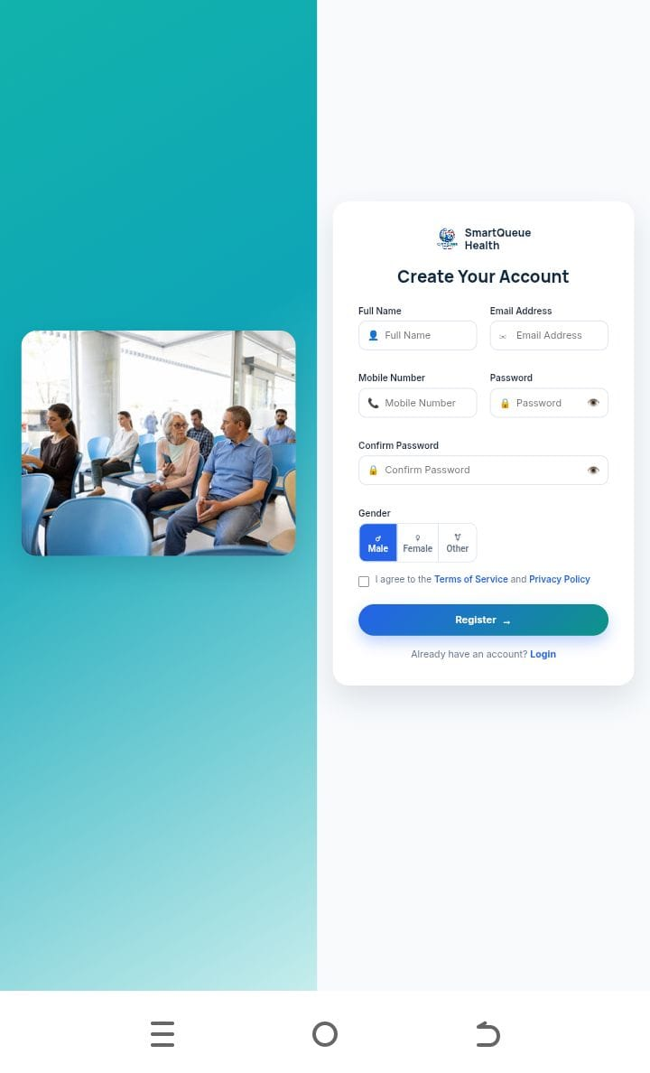
Description:
This page allows new patients to create an account by providing required personal information.
The registration process enables patients to access digital queue services.
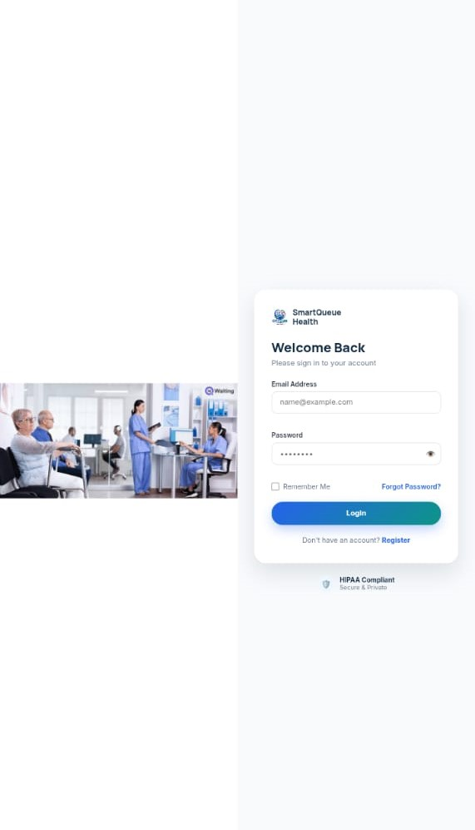
Figure A.2: Patient Login Page
Description:
The login page allows registered patients to securely access their accounts.Patients enter their credentials before accessing the Patient Dashboard.
Figure A.3: Patient Dashboard
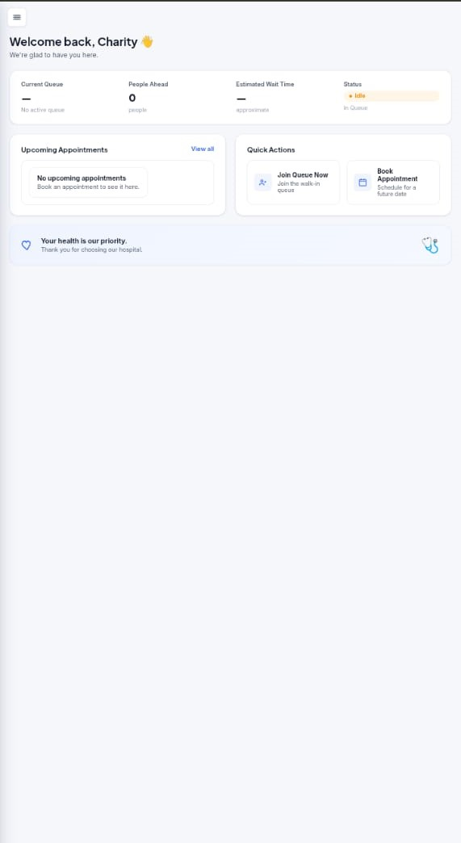
Description:
The Patient Dashboard provides access to:
- Patient profile information
- Queue number
- Queue position
- Appointment details
- Queue status
The dashboard allows patients to monitor their healthcare service progress.
Figure A.4: Queue Tracking Page
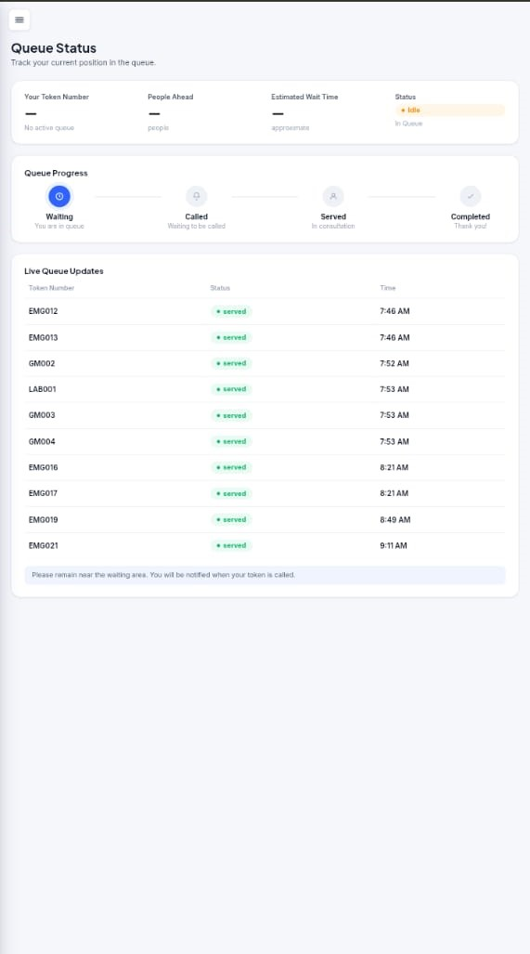
Description:
This page displays real-time queue information.
Patients can view:
- Current queue position
- Number of patients ahead
- Current status

A.2 Receptionist Interface Screenshots
Figure A.5: Receptionist Login Page
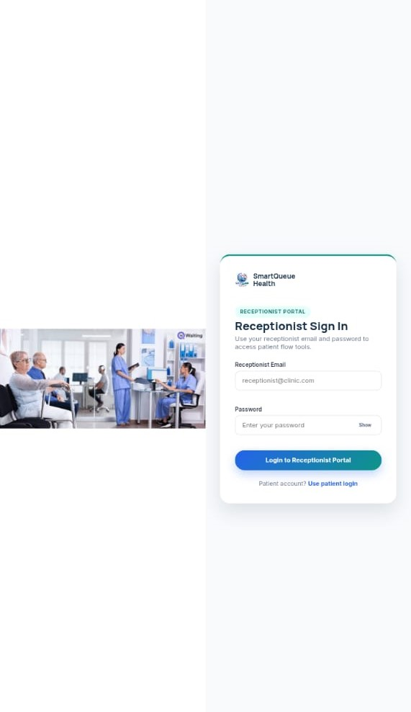
Description:
The receptionist login page provides secure access to front-desk management features.

Figure A.6: Receptionist Dashboard
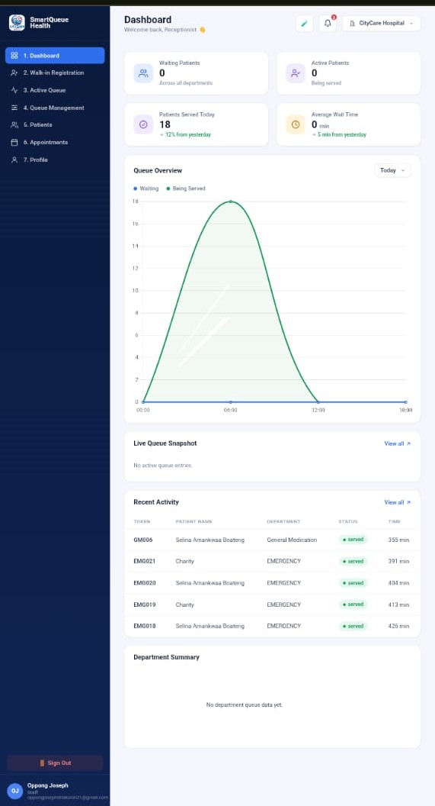
Description:
The dashboard provides receptionist functions including:
- Patient registration
- Patient verification
- Department assignment
- Queue management

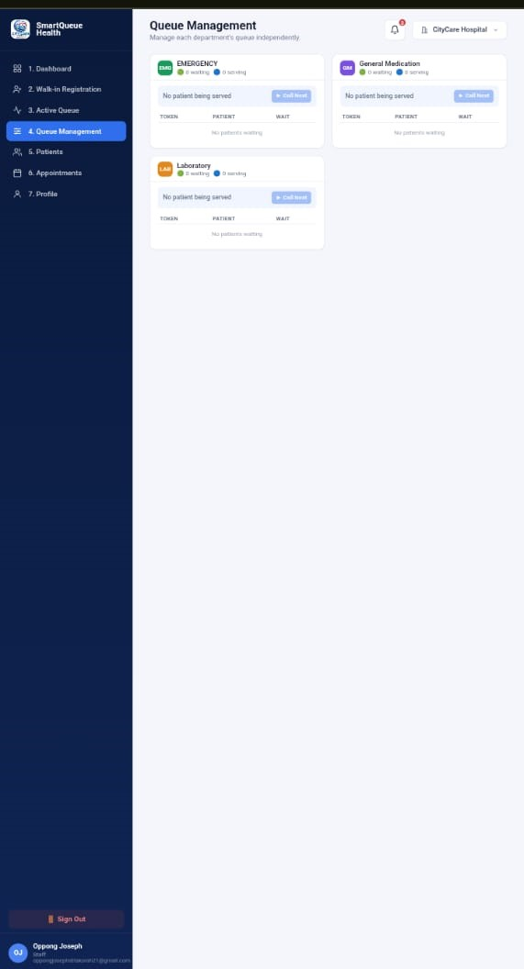
Figure A.7: Patient Assignment Interface
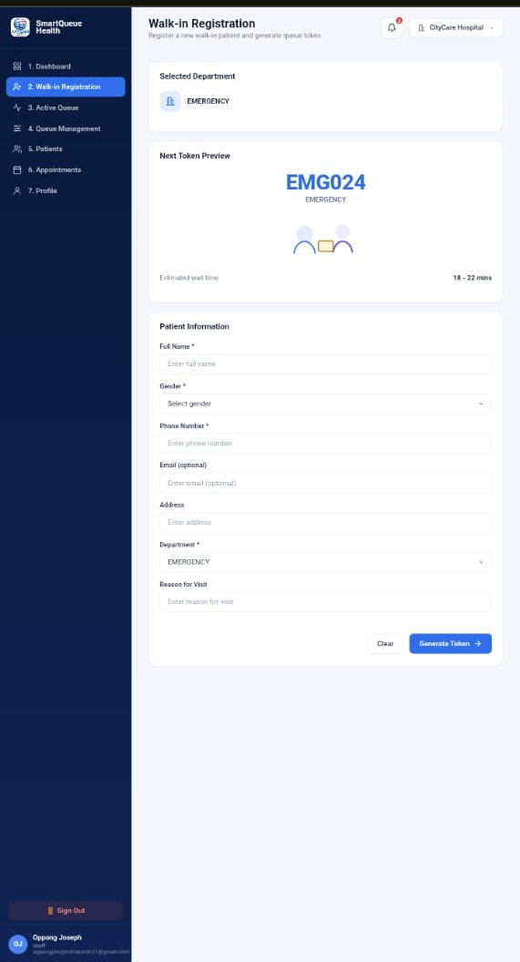
Description:
This page allows receptionists to assign patients to appropriate healthcare departments.
A.3 Department Staff Interface Screenshots
Figure A.8: Department Staff Login Page
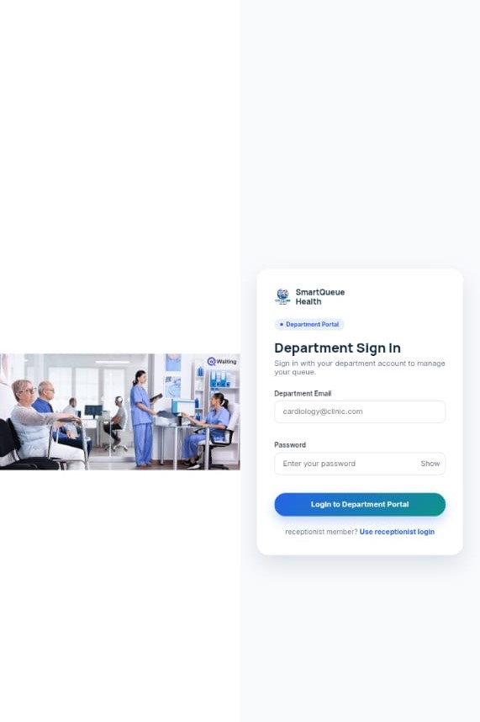
Description:
The login page provides secure access for healthcare workers.

Figure A.9: Department Staff Dashboard
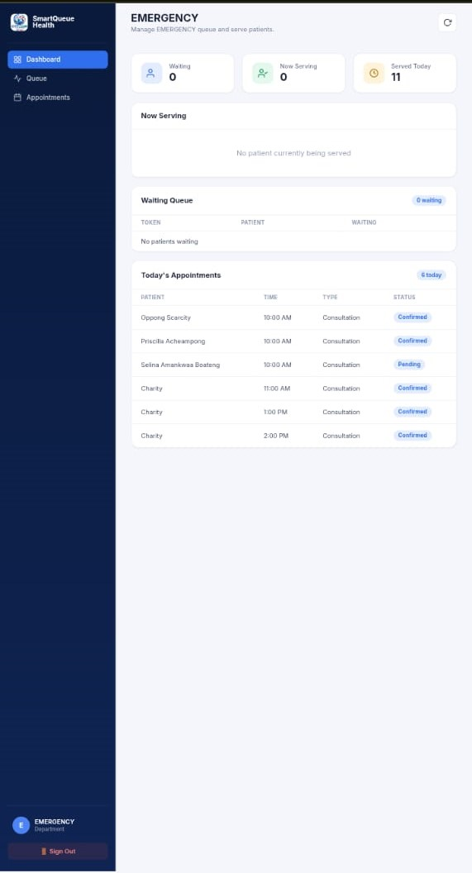
Description:
The dashboard allows department staff to:
- View assigned patients
- Call patients
- Update queue status
- Figure A.10: Queue Processing Interface
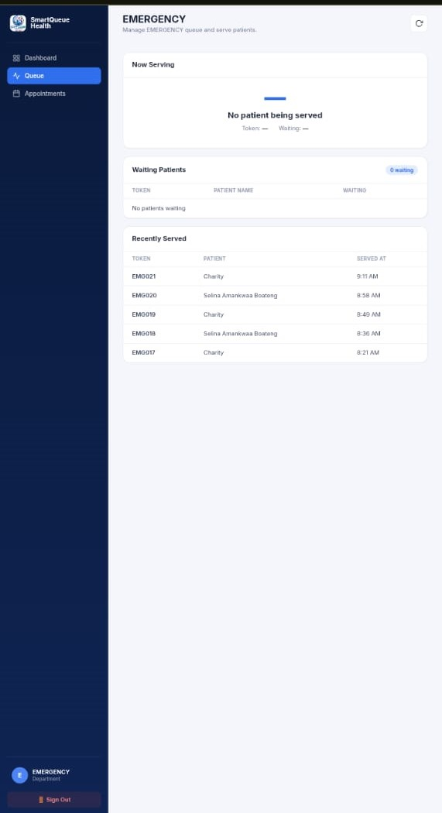
Description:
This page allows staff members to manage patient progress:
Waiting → Called → Serving → Completed

A.4 Administration Interface Screenshots
Figure A.11: Administration Login Page
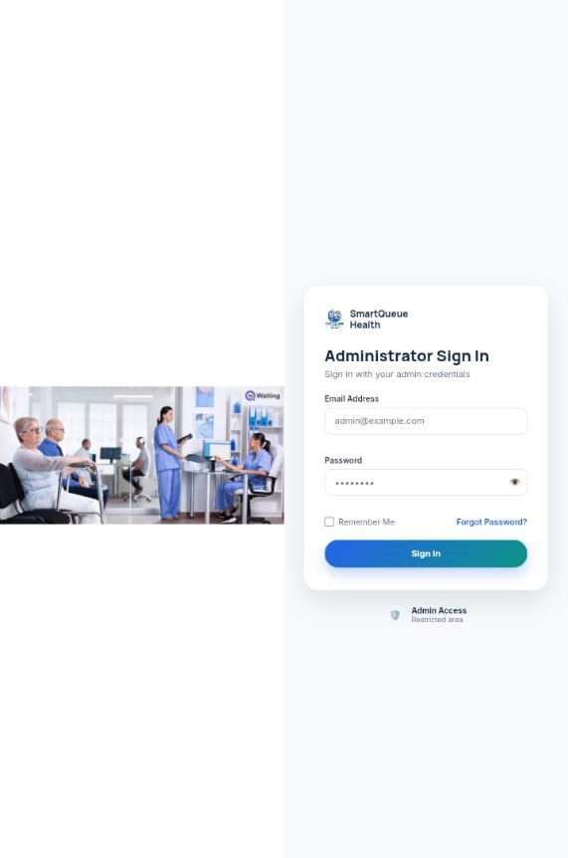
Description:
The administrator login provides access to system management features.

Figure A.12: Administration Dashboard
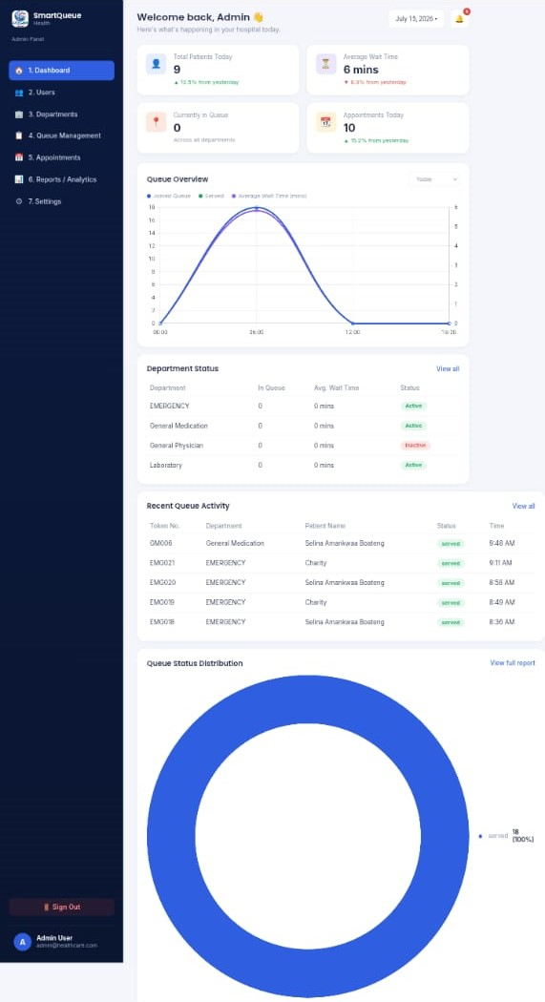
Description:
The dashboard provides:
- User statistics
- Queue monitoring
- System overview
- Analytics information
Figure A.13: User Management Page
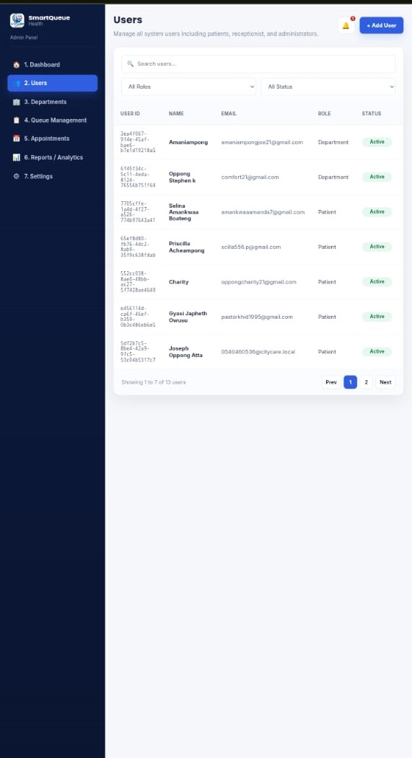
Description:
This page allows administrators to manage:
- Patients
- Receptionists
- Department staff
Figure A.14: Analytics Dashboard
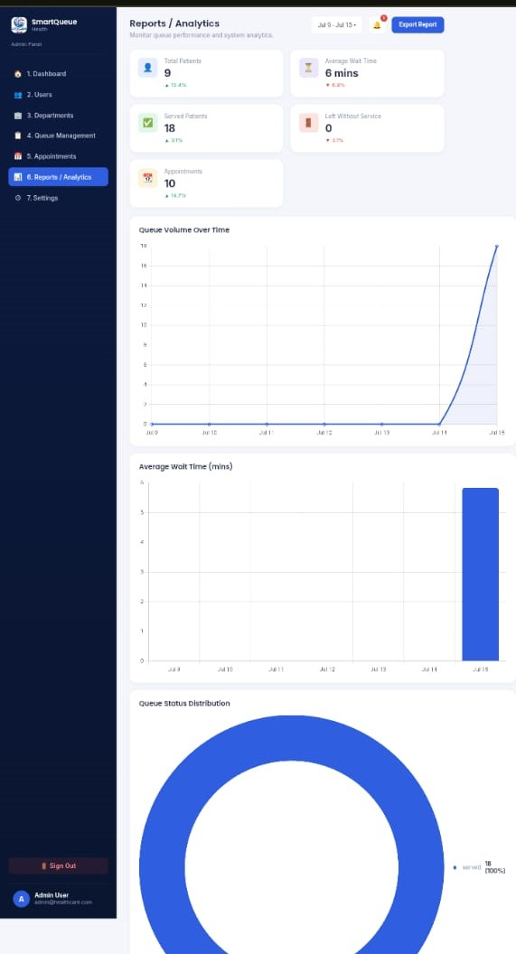
Description:
The analytics dashboard provides information about:
- Waiting time
- Patient volume
- Department performance
APPENDIX B: DATABASE DESIGN
B.1 Main Database Tables
The database consists of the following major tables:
- Users Table
- Patients Table
- Receptionists Table
- Department Staff Table
- Departments Table
- Queue Records Table
- Appointment Table
- Analytics Table

B.2 Database Relationship Overview
The database relationship structure is:
Users
|
|---- Patients
|
|---- Receptionists
|
|---- Department Staff
|
Departments
Patients
|
Queue Records
|
Analytics Records

APPENDIX C: SYSTEM TEST RESULTS
The following tests were conducted:
Test | Result
User registration | Successful
Login authentication | Successful
Patient queue creation | Successful
Receptionist assignment | Successful
Department queue management | Successful
Real-time queue updates | Successful
Administration functions | Successful
Analytics generation | Successful

APPENDIX D: USER MANUAL
D.1 Patient User Guide
Step 1:
Open the system website.
Step 2:
Create an account or login.
Step 3:
Select required healthcare service.
Step 4:
Join the queue.
Step 5:
Monitor queue position through the dashboard.

D.2 Receptionist User Guide
Step 1:
Login into receptionist dashboard.
Step 2:
Register or search patient.
Step 3:
Assign patient department.
Step 4:
Add patient to queue.

D.3 Department Staff User Guide
Step 1:
Login into department dashboard.
Step 2:
View assigned patients.
Step 3:
Call next patient.
Step 4:
Update service status.

D.4 Administrator User Guide
Step 1:
Login into administration dashboard.
Step 2:
Manage users and departments.
Step 3:
Monitor queues.
Step 4:
Review analytics reports.
REFERENCES
Agarwal, R., Gao, G., DesRoches, C., & Jha, A. K. (2010). Research commentary—The digital transformation of healthcare: Current status and the road ahead. Information Systems Research, 21(4), 796–809. https://doi.org/10.1287/isre.1100.0327
Almunawar, M. N., & Anshari, M. (2021). Health information systems and digital transformation in healthcare services: A review. International Journal of Medical Informatics, 149, 104404.
Baltzan, P. (2021). Business Driven Information Systems (8th ed.). McGraw-Hill Education.
Brocklehurst, P., & Garrison, S. R. (2018). The impact of appointment scheduling systems on healthcare service delivery and patient waiting times. Journal of Healthcare Management, 63(4), 245–257.
Chaffey, D., & Ellis-Chadwick, F. (2019). Digital Marketing: Strategy, Implementation and Practice (7th ed.). Pearson Education.
Dennis, A., Wixom, B. H., & Roth, R. M. (2018). Systems Analysis and Design (7th ed.). Wiley.
Ghana Health Service. (2022). Annual report: Strengthening healthcare delivery through digital transformation. Ghana Health Service.
Get In Line. (2025). Virtual queue management system and customer flow solutions. Get In Line.
Gupta, D., & Denton, B. (2008). Appointment scheduling in healthcare: Challenges and opportunities. IIE Transactions, 40(9), 800–819. https://doi.org/10.1080/07408170802165880
Hillier, F. S., & Lieberman, G. J. (2015). Introduction to Operations Research (10th ed.). McGraw-Hill Education.
ISO/IEC. (2017). ISO/IEC 25010: Systems and software engineering—Systems and software quality requirements and evaluation (SQuaRE)—System and software quality models. International Organization for Standardization.
Laudon, K. C., & Laudon, J. P. (2022). Management Information Systems: Managing the Digital Firm (17th ed.). Pearson Education.
McGonigle, D., & Mastrian, K. G. (2022). Nursing Informatics and the Foundation of Knowledge (5th ed.). Jones & Bartlett Learning.
Ministry of Health Ghana. (2020). Ghana digital health strategy. Ministry of Health.
Nielsen, J. (1994). Usability Engineering. Morgan Kaufmann.
Osterwalder, A., & Pigneur, Y. (2010). Business Model Generation: A Handbook for Visionaries, Game Changers, and Challengers. Wiley.
Pressman, R. S., & Maxim, B. R. (2020). Software Engineering: A Practitioner’s Approach (9th ed.). McGraw-Hill Education.
Qmatic. (2025). Queue management solutions for healthcare and customer experience management. Qmatic.
Rosen, M. A., Granek-Catarivas, M., & Shah, S. (2019). Improving healthcare delivery through digital transformation and patient flow management. Healthcare Management Review, 44(3), 205–214.
Sommerville, I. (2016). Software Engineering (10th ed.). Pearson Education.
Stair, R., & Reynolds, G. (2020). Principles of Information Systems (14th ed.). Cengage Learning.
Supabase. (2025). Supabase documentation: The open source Firebase alternative. Supabase.
Turban, E., Pollard, C., & Wood, G. (2018). Information Technology for Management: On-Demand Strategies for Performance, Growth and Sustainability (11th ed.). Wiley.
World Health Organization. (2019). WHO guideline: Recommendations on digital interventions for health system strengthening. World Health Organization.
World Health Organization. (2021). Global strategy on digital health 2020–2025. World Health Organization.

