Implementation of NOT, AND and OR Gates Using Only NAND Gates
Boolean Expressions • Schematic Diagrams • HDL Expression• Simulator Output• Boolean Expression

Aim :
Implement NOT, AND, OR gates using only NAND gates in HDL. Drawthe logic diagram for each and write the Boolean expression. Run the provided test scripts and capture the simulation output.

1.AND gate using NAND gate:

Boolean Expression:
Y=[(A.B)’]’=A.B

HDL Expression:
CHIP And {
IN a, b;
OUT out;

PARTS:
Nand(a=a , b=b , out=x);
Nand(a=x ,b=x ,out=out);

Schematic Diagram:
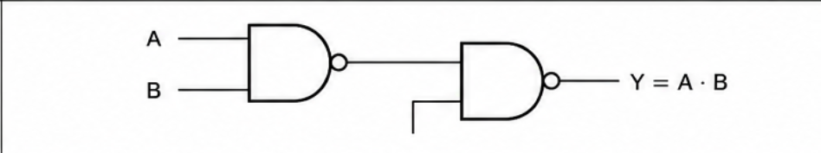

Stimulator Output:

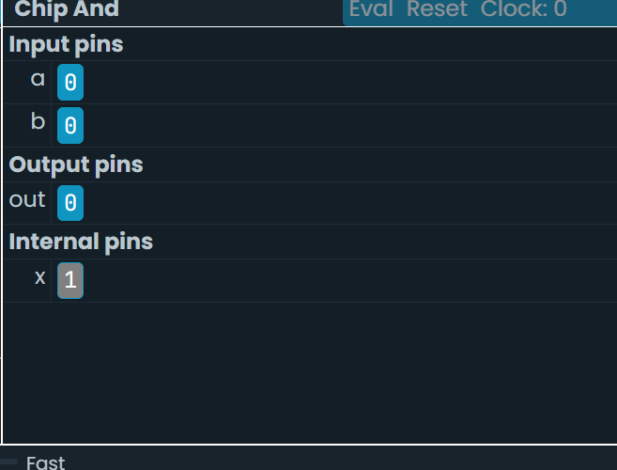

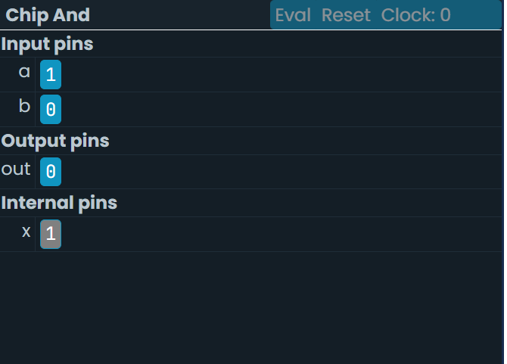
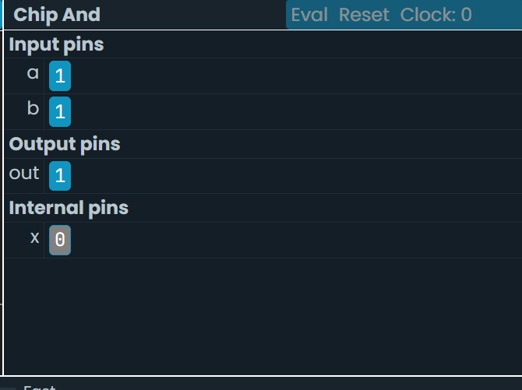

2.OR gate using NAND gate:

Boolean Expression:
Y=[A’.B’]’=A+B

HDL Expression:
CHIP Or {
IN a, b;
OUT out;

PARTS:
Nand(a=a ,b=a ,out=x);
Nand(a=b b=b ,out=y);
Nand(a=x ,b=y,out=out);

Schematic Diagram:
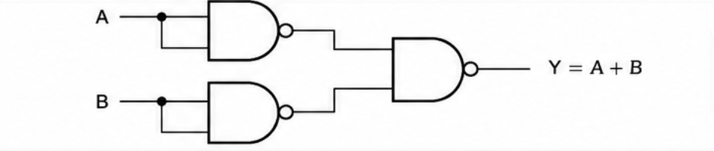

Stimulator Output:
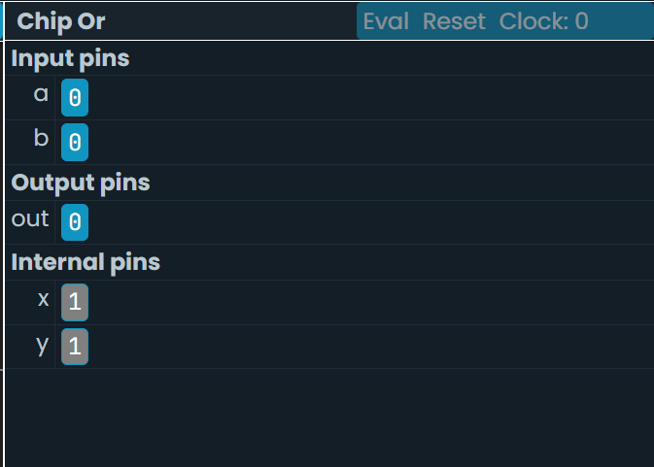

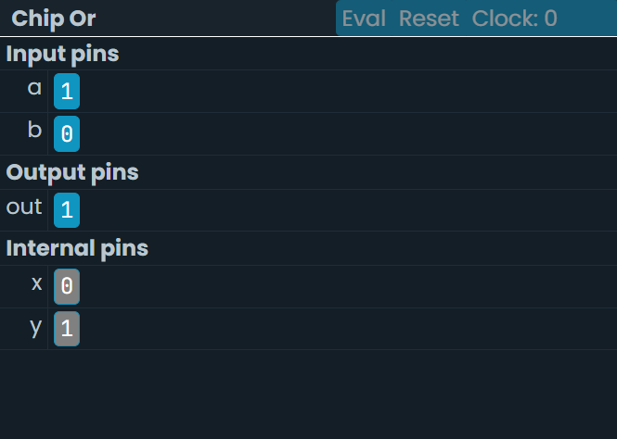

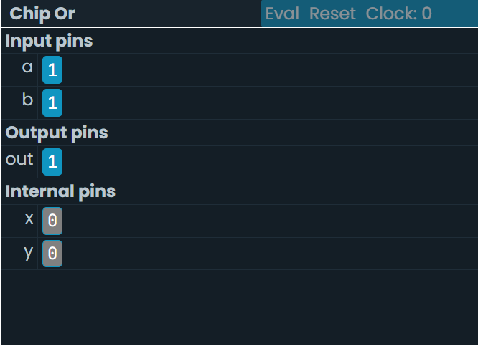

3.NOT gate using NAND gate:

Boolean Expression:
Y=(A.A)’=A’

HDL Expression:
CHIP Not {

IN a;
OUT out;

PARTS:
Nand(a=a, b=a, out=out);

}

Schematic Diagram:


Stimulator Output:
