1. Introduction

2. Identifiers

o Rules to define java identifiers:

3. Reserved words

o Reserved words for data types: (8)

o Reserved words for flow control:(11)

o Keywords for modifiers:(11)

o Keywords for exception handling:(6)

o Class related keywords:(6)

o Object related keywords:(4)

o Void return type keyword

o Unused keywords

o Reserved literals

o Enum

o Conclusions

4. Data types

o Integral data types

▪ Byte

▪ Short

▪ Int

▪ long

o Floating Point Data types

o boolean data type

o Char data type

o Java is pure object oriented programming or not ?

o Summary of java primitive data type

5. Literals

o Integral Literals

o Floating Point Literals

o Boolean literals

o Char literals

o String literals

o 1.7 Version enhansements with respect to Literals

▪ Binary Literals

▪ Usage of _ (underscore)symbol in numeric literals

**Identifier :**

A name in java program is called identifier. It may be class name, method name, variable name and label name.

Example:

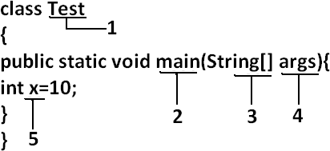

Rules to define java identifiers:

Rule 1: The only allowed characters in java identifiers are:

1) a to z

2) A to Z

3) 0 to 9

4) _ (underscore)

5) $

Rule 2: If we are using any other character we will get compile time error. Example:

1) total_number valid

2) Total# invalid

Rule 3: identifiers are not allowed to starts with digit. Example:

1) ABC123 valid

2) 123ABC invalid

Rule 4: java identifiers are case sensitive up course java language itself treated as case sensitive language.

Example:

class Test{ int number=10; int Number=20;

int NUMBER=20; we can differentiate with case. int NuMbEr=30;

}

Rule 5: There is no length limit for java identifiers but it is not recommended to take more than 15 lengths.

Rule 6: We can't use reserved words as identifiers. Example:

int if=10; invalid

Rule 7: All predefined java class names and interface names we use as identifiers.

Example 1:

class Test

{

public static void main(String[] args){ int String=10; System.out.println(String);

}}

Output:

10

Example 2:

class Test

{

public static void main(String[] args){ int Runnable=10; System.out.println(Runnable);

}}

Output:

10

Note:-Even though it is legal to use class names and interface names as identifiers but it is not a good programming practice.

Which of the following are valid java identifiers?

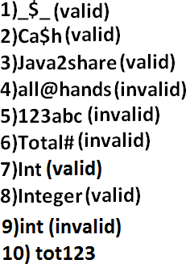

**Reserved words:**

In java some identifiers are reserved to associate some functionality or meaning such type of reserved identifiers are called reserved words.

Diagram:

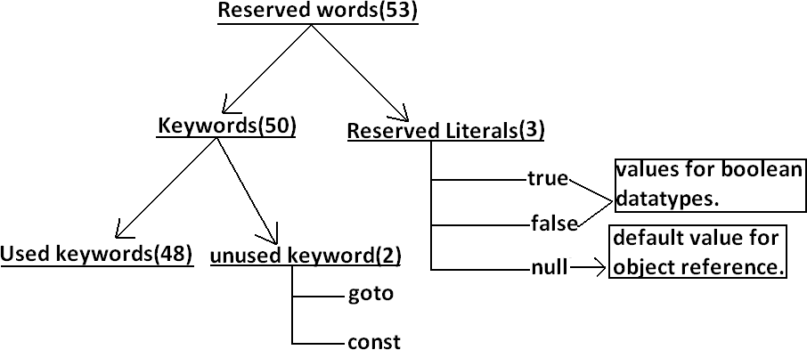

Reserved words for data types: (8)

1) byte

2) short

3) int

4) long

5) float

6) double

7) char

8) boolean

Reserved words for flow control:(11)

1) if

2) else

3) switch

4) case

5) default

6) for

7) do

8) while

9) break

10) continue

11) return

Keywords for modifiers:(11)

1) public

2) private

3) protected

4) static

5) final

6) abstract

7) synchronized

8) native

9) strictfp(1.2 version)

10) transient

11) volatile

Keywords for exception handling:(6)

1) try

2) catch

3) finally

4) throw

5) throws

6) assert(1.4 version)

Class related keywords:(6)

1) class

2) package

3) import

4) extends

5) implements

6) interface

Object related keywords:(4)

1) new

2) instanceof

3) super

4) this

Void return type keyword:

If a method won't return anything compulsory that method should be declared with the void return type in java but it is optional in C++.

1) void

Unused keywords:

goto: Create several problems in old languages and hence it is banned in java. Const: Use final instead of this.

By mistake if we are using these keywords in our program we will get compile time error.

Reserved literals:

1) true values for boolean data type.

2) false

3) null----------------- default value for object reference.

Enum:

This keyword introduced in 1.5v to define a group of named constants

Example:

enum Beer

{

KF, RC, KO, FO;

}

Conclusions :

1. All reserved words in java contain only lowercase alphabet symbols.

2. New keywords in java are:

3. strictfp --1.2v

4. assert v

5. enum v

6. In java we have only new keyword but not delete because destruction of useless objects is the responsibility of Garbage Collection.

7. instanceof but not instanceOf

8. strictfp but not strictFp

9. const but not Constant

10. syncronized but not syncronize

11. extends but not extend

12. implements but not implement

13. import but not imports

14. int but not Int

15.

Which of the following list contains only java reserved words ?

1. final, finally, finalize (invalid) //here finalize is a method in Object class.

2. throw, throws, thrown(invalid) //thrown is not available in java

3. break, continue, return, exit(invalid) //exit is not reserved keyword

4. goto, constant(invalid) //here constant is not reserved keyword

5. byte, short, Integer, long(invalid) //here Integer is a wrapper class

6. extends, implements, imports(invalid) //imports keyword is not available in java

7. finalize, synchronized(invalid) //finalize is a method in Object class

8. instanceof, sizeOf(invalid) //sizeOf is not reserved keyword

9. new, delete(invalid) //delete is not a keyword

10. None of the above(valid)

Which of the following are valid java keywords?

1. public(valid)

2. static(valid)

3. void(valid)

4. main(invalid)

5. String(invalid)

6. args(invalid)

**Data types:**

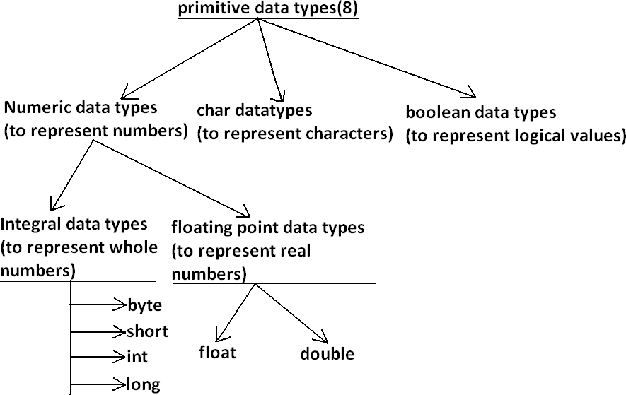

Every variable has a type, every expression has a type and all types are strictly define more over every assignment should be checked by the compiler by the type compatibility hence java language is considered as strongly typed programming language.

Java is pure object oriented programming or not?

Java is not considered as pure object oriented programming language because several oops features (like multiple inheritance, operator overloading) are not supported by java moreover we are depending on primitive data types which are non objects.

Diagram:

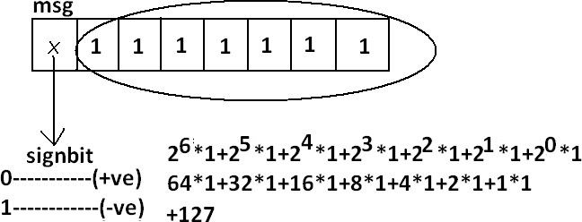

Except Boolean and char all remaining data types are considered as signed data types because we can represent both "+ve" and"-ve" numbers.

Integral data types : Byte:

Size: 1byte (8bits) Maxvalue: +127 Minvalue:-128

Range:-128to 127[-27 to 27-1]

• The most significant bit acts as sign bit. "0" means "+ve" number and "1" means "–ve" number.

• "+ve" numbers will be represented directly in the memory whereas "–ve" numbers will be represented in 2's complement form.

Example:

byte b=10;

byte b2=130;//C.E:possible loss of precision

found : int required : byte

byte b=10.5;//C.E:possible loss of precision byte b=true;//C.E:incompatible types

byte b="ashok";//C.E:incompatible types

found : java.lang.String required : byte

byte data type is best suitable if we are handling data in terms of streams either from the file or from the network.

**Short:**

The most rarely used data type in java is short.

Size: 2 bytes

Range: -32768 to 32767(-215 to 215-1)

Example:

short s=130;

short s=32768;//C.E:possible loss of precision short s=true;//C.E:incompatible types

Short data type is best suitable for 16 bit processors like 8086 but these processors are completely outdated and hence the corresponding short data type is also out data type.

**Int:**

This is most commonly used data type in java.

Size: 4 bytes

Range:-2147483648 to 2147483647 (-231 to 231-1)

Example:

int i=130;

int i=10.5;//C.E:possible loss of precision int i=true;//C.E:incompatible types

**long:**

Whenever int is not enough to hold big values then we should go for long data type. Example:

To hold the no. Of characters present in a big file int may not enough hence the return type of length() method is long.

long l=f.length();//f is a file Size: 8 bytes

Range:-263 to 263-1

Note: All the above data types (byte, short, int and long) can be used to represent whole numbers. If we want to represent real numbers then we should go for floating point data types.

Floating Point Data types:

|  |  |
| --- | --- |
| **Float** | **double** |
| **If we want to 5 to 6 decimal places of accuracy then we should go for float.** | **If we want to 14 to 15 decimal places of accuracy then we should go for double.** |
| **Size:4 bytes.** | **Size:8 bytes.** |
| **Range:-3.4e38 to 3.4e38.** | **-1.7e308 to1.7e308.** |
| **float follows single precision.** | **double follows double precision.** |

**boolean data type:**

Size: Not applicable (virtual machine dependent)

Range: Not applicable but allowed values are true or false.

Which of the following boolean declarations are valid? Example 1:

boolean b=true;

boolean b=True;//C.E:cannot find symbol Boolean

b="True";//C.E:incompatible types Boolean

b=0;//C.E:incompatible types Example 2:

Char data type:

In old languages like C & C++ are ASCII code based the no.Of ASCII code characters are < 256 to represent these 256 characters 8 - bits enough hence char size in old languages 1 byte.

In java we are allowed to use any worldwide alphabets character and java is Unicode based and no.Of unicode characters are > 256 and <= 65536 to represent all these characters one byte is not enough compulsory we should go for 2 bytes.

Size: 2 bytes

Range: 0 to 65535

Example:

char ch1=97;

char ch2=65536;//C.E:possible loss of precision

Summary of java primitive data type:

|  |  |  |  |  |
| --- | --- | --- | --- | --- |
| **data type** | **Size** | **Range** | **Corresponding Wrapper class** | **Default value** |
| **byte** | **1 byte** | **-27 to 27-1(-128 to 127)** | **Byte** | **0** |
| **short** | **2 bytes** | **-215 to 215-1 (-32768 to**  **32767)** | **Short** | **0** |
| **int** | **4 bytes** | **-231 to 231-1 (-2147483648**  **to 2147483647)** | **Integer** | **0** |
| **long** | **8 bytes** | **-263 to 263-1** | **Long** | **0** |
| **float** | **4 bytes** | **-3.4e38 to 3.4e38** | **Float** | **0.0** |
| **double** | **8 bytes** | **-1.7e308 to 1.7e308** | **Double** | **0.0** |
| **boolean** | **Not applicable** | **Not applicable(but allowed values true|false)** | **Boolean** | **false** |
| **char** | **2 bytes** | **0 to 65535** | **Character** | **0(represents blank space)** |

The default value for the object references is "null".

**Literals:**

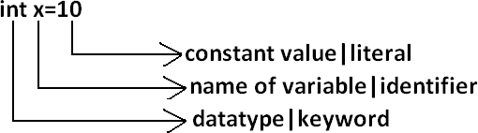

Any constant value which can be assigned to the variable is called literal. Example:

**Integral Literals:**

For the integral data types (byte, short, int and long) we can specify literal value in the following ways.

1) Decimal literals: Allowed digits are 0 to 9. Example: int x=10;

2) Octal literals: Allowed digits are 0 to 7. Literal value should be prefixed with zero. Example: int x=010;

3) Hexa Decimal literals:

• The allowed digits are 0 to 9, A to Z.

• For the extra digits we can use both upper case and lower case characters.

• This is one of very few areas where java is not case sensitive.

• Literal value should be prefixed with ox(or)oX. Example: int x=0x10;

These are the only possible ways to specify integral literal. Which of the following are valid declarations?

1. int x=0777; //(valid)

2. int x=0786; //C.E:integer number too large: 0786(invalid)

3. int x=0xFACE; (valid)

4. int x=0xbeef; (valid)

5. int x=0xBeer; //C.E:';' expected(invalid) //:int x=0xBeer; ^// ^

6. int x=0xabb2cd;(valid)

Example:

int x=10; int y=010; int z=0x10;

System.out.println(x+"----"+y+"----"+z); //10----8 16

By default every integral literal is int type but we can specify explicitly as long type by suffixing with small "l" (or) capital "L".

Example:

int x=10;(valid) long l=10L;(valid) long l=10;(valid)

int x=10l;//C.E:possible loss of precision(invalid) found : long

required : int

There is no direct way to specify byte and short literals explicitly. But whenever we are assigning integral literal to the byte variables and its value within the range of byte compiler automatically treats as byte literal. Similarly short literal also.

Example:

byte b=127;(valid)

byte b=130;//C.E:possible loss of precision(invalid) short s=32767;(valid)

short s=32768;//C.E:possible loss of precision(invalid)

**Floating Point Literals:**

Floating point literal is by default double type but we can specify explicitly as float type by suffixing with f or F.

Example:

float f=123.456;//C.E:possible loss of precision(invalid) float f=123.456f;(valid)

double d=123.456;(valid)

We can specify explicitly floating point literal as double type by suffixing with d or D.

Example:

double d=123.456D;

We can specify floating point literal only in decimal form and we can't specify in octal and hexadecimal forms.

Example:

double d=123.456;(valid)

double d=0123.456;(valid) //it is treated as decimal value but not octal double d=0x123.456;//C.E:malformed floating point literal(invalid)

Which of the following floating point declarations are valid?

1. float f=123.456; //C.E:possible loss of precision(invalid)

2. float f=123.456D; //C.E:possible loss of precision(invalid)

3. double d=0x123.456; //C.E:malformed floating point literal(invalid)

4. double d=0xFace; (valid)

5. double d=0xBeef; (valid)

We can assign integral literal directly to the floating point data types and that integral literal can be specified in decimal , octal and Hexa decimal form also.

Example:

double d=0xBeef; System.out.println(d);//48879.0

But we can't assign floating point literal directly to the integral types.

Example:

int x=10.0;//C.E:possible loss of precision

We can specify floating point literal even in exponential form also(significant notation).

Example:

double d=10e2;//==>10*102(valid)

System.out.println(d);//1000.0

float f=10e2;//C.E:possible loss of precision(invalid) float f=10e2F;(valid)

**Boolean literals:**

The only allowed values for the boolean type are true (or) false where case is important. i.e., lower case

Example:

1. boolean b=true;(valid)

2. boolean b=0;//C.E:incompatible types(invalid)

3. boolean b=True;//C.E:cannot find symbol(invalid)

4. boolean b="true";//C.E:incompatible types(invalid)

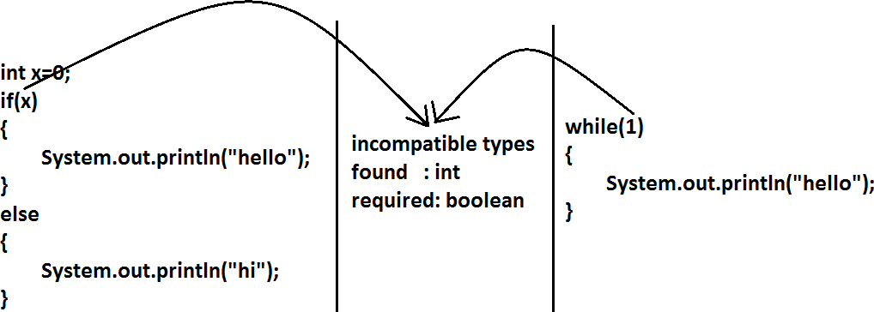

**Char literals:**

1) A char literal can be represented as single character within single quotes.

Example:

1. char ch='a';(valid)

2. char ch=a;//C.E:cannot find symbol(invalid)

3. char ch="a";//C.E:incompatible types(invalid)

4. char ch='ab';//C.E:unclosed character literal(invalid)

2) We can specify a char literal as integral literal which represents Unicode of that character.

We can specify that integral literal either in decimal or octal or hexadecimal form but allowed values range is 0 to 65535.

Example:

1. char ch=97; (valid)

2. char ch=0xFace; (valid) System.out.println(ch); //?

3. char ch=65536; //C.E: possible loss of precision(invalid)

3) We can represent a char literal by Unicode representation which is nothing but ‘\uxxxx' (4 digit hexa-decimal number) .

Example:

1. char ch='\ubeef'; 2. char ch1='\u0061';

System.out.println(ch1); //a

3. char ch2=\u0062; //C.E:cannot find symbol

4. char ch3='\iface'; //C.E:illegal escape character

5. Every escape character in java acts as a char literal.

Example:

1) char ch='\n'; //(valid)

2) char ch='\l'; //C.E:illegal escape character(invalid)

|  |  |
| --- | --- |
| **Escape Character** | **Description** |
|  |  |
| **\n** | **New line** |
|  |  |
| **\t** | **Horizontal tab** |
|  |  |
| **\r** | **Carriage return** |
|  |  |
| **\f** | **Form feed** |
|  |  |
| **\b** | **Back space character** |
|  |  |
| **\'** | **Single quote** |
|  |  |
| **\"** | **Double quote** |
|  |  |
| **\\** | **Back space** |
|  |  |

Which of the following char declarations are valid?

1. char ch=a; //C.E:cannot find symbol(invalid)

2. char ch='ab'; //C.E:unclosed character literal(invalid)

3. char ch=65536; //C.E:possible loss of precision(invalid)

4. char ch=\uface; //C.E:illegal character: \64206(invalid)

5. char ch='/n'; //C.E:unclosed character literal(invalid)

6. none of the above. (valid)

**String literals:**

Any sequence of characters with in double quotes is treated as String literal. Example:

String s="Ashok"; (valid)

1.7 Version enhansements with respect to Literals :

The following 2 are enhansements

1. Binary Literals

2. Usage of '_' in Numeric Literals

**Binary Literals :**

For the integral data types untill 1.6v we can specified literal value in the following ways

1. Decimal

2. Octal

3. Hexa decimal

But from 1.7v onwards we can specified literal value in binary form also. The allowed digits are 0 to 1.

Literal value should be prefixed with Ob or OB .

int x = 0b111; System.out.println(x); // 7

Usage of _ symbol in numeric literals :

From 1.7v onwards we can use underscore(_) symbol in numeric literals.

double d = 123456.789; //valid

double d = 1_23_456.7_8_9; //valid double d = 123_456.7_8_9; //valid

The main advantage of this approach is readability of the code will be improved At the time of compilation ' _ ' symbols will be removed automatically , hence after compilation the above lines will become double d = 123456.789

We can use more than one underscore symbol also between the digits. Ex : double d = 1_23_ _456.789;

We should use underscore symbol only between the digits

double d=_1_23_456.7_8_9; //invalid double d=1_23_456.7_8_9_; //invalid double d=1_23_456_.7_8_9; //invalid double d='a';

System.out.println(d); //97 integral data types

float f=10L;

System.out.println(f); //10.0 floating-point data types

Diagram