Complete Technical Report:


IoT-Based Weather Monitoring Station Using Seeed XIAO ESP32-C6

Name | URN | COURSE

Table of Contents
- Introduction
- Project Objectives
- Literature Review and Background
- System Design and Architecture
- Circuit Design and Implementation
- Software Development
- Blynk IoT Cloud Integration

1. Introduction

1.1 Background and Motivation
The proliferation of Internet of Things (IoT) technology has revolutionized environmental monitoring by enabling real-time data collection, analysis, and remote access to sensor information. Traditional weather monitoring systems often require expensive equipment, complex installations, and dedicated infrastructure. The emergence of low-cost microcontrollers with integrated wireless capabilities has democratized access to IoT technologies, allowing hobbyists, students, and professionals to develop sophisticated monitoring systems at a fraction of traditional costs.
Environmental monitoring serves critical functions across numerous domains including agriculture (crop management and irrigation optimization), smart homes (climate control and energy management), industrial facilities (workspace safety and equipment protection), research institutions (data collection for scientific studies), and educational settings (hands-on learning in electronics and programming).
This project addresses the need for a compact, affordable, and user-friendly weather monitoring solution that combines local data display with cloud connectivity. The system provides immediate visual feedback through an OLED screen while simultaneously uploading data to the cloud for historical analysis, remote monitoring, and integration with other IoT services.

1.2 Why Seeed XIAO ESP32-C6?
The Seeed Studio XIAO ESP32-C6 represents a significant advancement in compact microcontroller design. This development board offers several compelling advantages:
Ultra-Compact Form Factor: Measuring just 21mm × 17.5mm, the XIAO ESP32-C6 is one of the smallest ESP32-based development boards available, making it ideal for space-constrained applications and portable device design. The board's thumb-sized footprint enables integration into compact enclosures while maintaining full functionality.
Modern Wireless Connectivity: The ESP32-C6 features Wi-Fi 6 (802.11ax) support, providing improved performance in congested wireless environments, better power efficiency, and enhanced range compared to previous Wi-Fi standards. This ensures reliable cloud connectivity even in challenging RF environments.
Low Power Consumption: Advanced power management features including deep sleep modes, dynamic frequency scaling, and efficient wireless protocols enable extended battery operation. The system can operate for days or weeks on a single battery charge depending on update intervals and usage patterns.
Rich Peripheral Set: The board includes multiple GPIO pins, I²C and SPI interfaces, analog inputs, PWM outputs, and UART communication, providing flexibility for sensor integration and expansion. Built-in battery charging circuitry simplifies power management in portable applications.
Development Ecosystem: Full compatibility with Arduino IDE, ESP-IDF, and PlatformIO ensures easy development with extensive library support. The active community provides abundant resources, examples, and troubleshooting assistance.

1.3 IoT and Cloud Integration
The integration of Blynk IoT platform provides several critical capabilities:
- Remote Monitoring: Access weather data from anywhere with internet connectivity
- Data Visualization: Real-time graphs, gauges, and historical trend analysis
- Mobile Access: Dedicated iOS and Android applications for on-the-go monitoring
- Notifications: Automated alerts for threshold violations or system anomalies
- Data Logging: Cloud storage of sensor readings for long-term analysis
- Multi-Device Support: Simultaneous access from multiple users and devices

1.4 Project Scope
This project encompasses the complete development cycle from initial concept through hardware prototyping, firmware development, cloud integration, testing, and deployment. The system is designed as a self-contained unit housed in a compact enclosure, suitable for indoor or protected outdoor deployment.
The report documents all technical aspects including component selection rationale, circuit design considerations, software architecture, integration procedures, troubleshooting methodologies, and performance evaluation. Sufficient detail is provided to enable replication by others with moderate electronics and programming experience.

2. Project Objectives

2.1 Primary Objectives
1. Design Compact Portable Weather Station Develop a fully integrated environmental monitoring system in a compact, box-sized enclosure (approximately 10cm × 8cm × 5cm). The system must be self-contained with internal battery power, making it truly portable and deployable in diverse locations without dependence on fixed infrastructure.
2. Accurate Environmental Sensing Implement reliable temperature and humidity measurement with the following specifications:
- Temperature range: 0°C to 50°C with ±2°C accuracy
- Humidity range: 20% to 90% RH with ±5% accuracy
- Update rate: Every 2-5 seconds for real-time monitoring
- Stable readings with minimal fluctuation under steady conditions
3. Real-Time Local Display Provide immediate visual feedback through integrated OLED display showing:
- Current temperature in degrees Celsius
- Current relative humidity percentage
- Battery voltage and estimated charge level
- System status indicators (Wi-Fi connection, cloud sync)
- Clear, readable format with appropriate font sizes
4. Cloud Connectivity and Remote Access Establish reliable wireless communication to Blynk IoT platform enabling:
- Continuous data transmission at configurable intervals
- Real-time dashboard updates visible on mobile devices
- Historical data storage and graphical trend visualization
- Remote system monitoring from any location with internet access
5. Power Efficiency and Battery Management Optimize system for extended battery operation through:
- Efficient code execution minimizing active processor time
- Appropriate sleep modes during idle periods
- Battery voltage monitoring for charge level indication
- Power consumption target: <100mA average during active monitoring

3. Literature Review and Background

3.1 Evolution of Weather Monitoring Systems
Weather monitoring has evolved dramatically from mechanical instruments to sophisticated electronic systems. Traditional weather stations used mercury thermometers, mechanical hygrometers, and manual recording methods. The digital revolution introduced electronic sensors, microcontroller-based data loggers, and automated recording systems.
Modern IoT weather stations represent the latest evolution, combining miniaturized sensors, wireless connectivity, cloud computing, and mobile access. These systems democratize environmental monitoring by reducing costs from thousands of dollars to tens of dollars while increasing accessibility through cloud platforms.

3.2 Microcontroller Comparison
ESP32-C6 vs ESP32-S3: The ESP32-C6 uses a RISC-V architecture compared to ESP32-S3's dual-core Xtensa processor. While the S3 offers more raw processing power, the C6 provides Wi-Fi 6 support and better power efficiency, making it more suitable for battery-powered IoT applications.
Arduino vs ESP32: Traditional Arduino boards (Uno, Nano) lack wireless connectivity, requiring separate Wi-Fi shields that increase cost, complexity, and power consumption. ESP32-based boards integrate wireless capabilities while offering more processing power and memory.

3.3 Sensor Technology Overview
DHT11 vs DHT22: The DHT11 offers adequate accuracy for general applications (±2°C, ±5% RH) at minimal cost. The DHT22 provides superior accuracy (±0.5°C, ±2% RH) and wider range but costs 3-4 times more. For educational and home monitoring, the DHT11 provides acceptable performance.

3.4 IoT Cloud Platforms
Blynk Platform: Blynk offers user-friendly mobile app creation, visual dashboard design, and straightforward API integration. The free tier supports basic monitoring applications, making it ideal for educational and hobbyist projects.
Blynk was selected for its balance of functionality, ease of use, and accessibility for beginners while providing professional-grade features.

4. System Design and Architecture

4.1 Overall System Architecture
The weather monitoring station follows a layered architecture:
Physical Layer:
- Sensors (DHT11, voltage divider)
- Microcontroller (XIAO ESP32-C6)
- Display (SSD1306 OLED)
- Power system (Li-ion battery, charging circuit)
- Enclosure (compact box housing all components)
Data Acquisition Layer:
- Sensor reading at configured intervals
- Analog-to-digital conversion for voltage sensing
- Data validation and error checking
- Averaging algorithms for noise reduction
Processing Layer:
- Temperature and humidity calculation
- Battery voltage conversion and percentage estimation
- Data formatting for display and transmission
- System status monitoring
Communication Layer:
- Wi-Fi connection management
- Cloud authentication and session management
- Data packet construction and transmission
- Connection recovery mechanisms
Presentation Layer:
- OLED display rendering
- Blynk dashboard updates
- Mobile application interface
- Data visualization (graphs, gauges)

4.2 System Block Diagram
┌─────────────────────────────────────────────────────────-────────┐
│ Power Supply System │
│ ┌──────────┐ ┌──────────-────────┐ ┌──────────────────┐ │
│ │ Li-ion │───▶│ TP4056 │───▶ │ 3.3V Regulator │ │
│ │ Battery │ │ Charger(inbuild) │ │ (onboard) │ │
│ └──────────┘ └──────────────────-┘ └────────┬─────────┘ │
└──────────────────────────────────────────┼───────────────────────┘
│
┌───────────────────────┼────────────────────────┐
│ ▼ │
│ ┌──────────────────────────┐ │
│ │ XIAO ESP32-C6 │ │
│ │ ┌────────────────────┐ │ │
│ │ │ RISC-V Core │ │ │
│ │ │ 160 MHz │ │ │
│ │ └────────────────────┘ │ │
│ │ ┌────────────────────┐ │ │
│ │ │ Wi-Fi 6 Module │ │ │
│ │ └────────────────────┘ │ │
│ └───┬────────┬────────┬───┘ │
│ │ │ │ │
┌──────────┴────────────┘ │ └─────────────┐ │
│ │ │ │
▼ ▼ ▼ │
┌────────────┐ ┌────────────┐ ┌──────────┴──┐
│ DHT11 │ │ SSD1306 │ │ Voltage │
│ Sensor │ │ OLED │ │ Divider │
│ │ │ 128x64 │ │ (100kΩ x2) │
│ Temp & RH │ │ I²C │ │ │
└────────────┘ └────────────┘ └─────────────┘
│ │ │
└────────────────┬───────────────┴──────────────────────┘
│
▼
┌──────────────┐
│ Wi-Fi Cloud │
│ Blynk │
│ Platform │
└──────┬───────┘
│
▼
┌──────────────┐
│ Mobile │
│ Dashboard │
└──────────────┘

4.3 Data Flow Architecture
1. Sensor Data Acquisition:
DHT11 Sensor → Digital Pin D2 → ESP32-C6
Battery Voltage → Voltage Divider → ADC Pin A0 → ESP32-C6
2. Local Processing:
Raw Sensor Data → Validation → Calculation → Formatting → OLED Display
→ Cloud Buffer
3. Cloud Transmission:
Data Buffer → Wi-Fi Module → Internet → Blynk Server → Mobile App
4. Display Update:
Formatted Data → I²C Interface → OLED Controller → Display Panel

4.4 Software Architecture
Main Loop Structure:
Initialize System
├─ Setup Wi-Fi Connection
├─ Initialize OLED Display
├─ Initialize DHT11 Sensor
└─ Connect to Blynk Server

Main Loop (Continuous):
├─ Read DHT11 Sensor
│ ├─ Temperature
│ └─ Humidity
├─ Read Battery Voltage (ADC)
├─ Process Data
│ ├─ Validate Readings
│ ├─ Calculate Averages
│ └─ Format Values
├─ Update OLED Display
│ ├─ Clear Display
│ ├─ Draw Temperature
│ ├─ Draw Humidity
│ └─ Draw Battery Level
├─ Send to Blynk Cloud
│ ├─ Check Wi-Fi Status
│ ├─ Transmit Data
│ └─ Handle Errors
└─ Delay (Update Interval)

5. Circuit Design and Implementation

5.1 Detailed Pin Mapping Table
Component | Pin Name | XIAO ESP32-C6 Pin | Function | Notes
DHT11 | VCC | 3.3V | Power | Stable 3.3V supply
DHT11 | DATA | D2 (GPIO2) | Digital I/O | Single-wire communication
DHT11 | GND | GND | Ground | Common reference
OLED | VCC | 3.3V | Power | I²C device power
OLED | GND | GND | Ground | Common reference
OLED | SDA | D4 (GPIO22) | I²C Data | Bidirectional data
OLED | SCL | D5 (GPIO23) | I²C Clock | Clock signal
V-Divider | Output | A0 (GPIO0) | Analog Input | Battery voltage sensing
Battery | Positive | BAT | Battery Input | Direct battery connection
Battery | Negative | GND | Ground | Common reference

5.2 Electrical Characteristics and Calculations
Power Budget Analysis:
Component Current Draw (mA) Notes
-------------------------------------------------------
XIAO ESP32-C6 (Active) 80-100 Wi-Fi transmitting
XIAO ESP32-C6 (Idle) 15-25 Wi-Fi connected
DHT11 Sensor 0.2-0.5 During measurement
OLED Display 8-12 Typical display content
Voltage Divider 0.017 Constant (3.3V / 200kΩ)
-------------------------------------------------------
Total (Active) ~100-115 mA
Total (Optimized) ~25-40 mA
Battery Life Calculations:
For 1000 mAh battery with 10-second update interval:
- Active time per cycle: ~2 seconds (20%)
- Idle time per cycle: ~8 seconds (80%)
- Average current: (100 mA × 0.2) + (25 mA × 0.8) = 40 mA
- Battery life: 1000 mAh / 40 mA = 25 hours
For 2000 mAh battery with optimizations:
- With aggressive sleep: ~30 mA average
- Battery life: 2000 mAh / 30 mA = 66.7 hours (~2.8 days)
I²C Bus Timing:
- Standard mode: 100 kHz (10 μs per bit)
- Fast mode: 400 kHz (2.5 μs per bit) [Used by default]
- Rise time: <1 μs with proper pull-up resistors
- SDA and SCL pull-ups: Internal (no external resistors needed)

5.3 Enclosure Design and Assembly
Box Dimensions and Layout:
- External: 100mm (L) × 80mm (W) × 50mm (H)
- Wall thickness: 2-3mm
- Internal clearance: 94mm × 74mm × 44mm
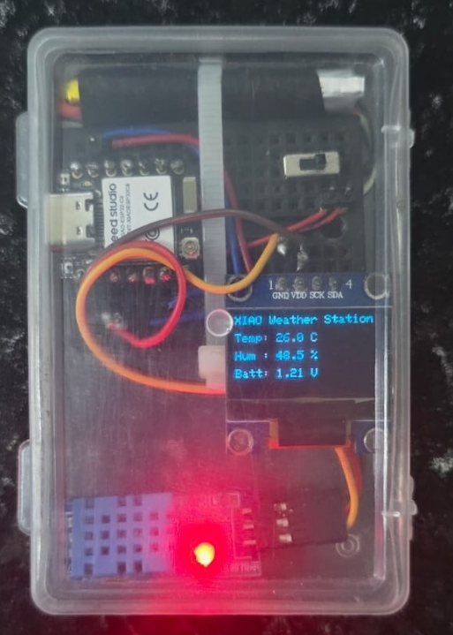
Fig . Complete System Connections

Component Positioning:
Top View:
┌─────────────────────────────────────┐
│ [DHT11] (ventilation) │ ← Sensor exposure
│ │
│ [OLED Display Window] │ ← Front viewing area
│ │
│ [XIAO ESP32-C6] │ ← Center mounting
│ │
│ [Battery] │ ← Bottom compartment
└─────────────────────────────────────┘

Side View:
┌─────────┐
│ Display │ ← Visible through window
├─────────┤
│ XIAO │ ← Main board
├─────────┤
│ Battery │ ← Power source
└─────────┘

6. Software Development

6.1 Development Environment Setup
Required Software:
- Arduino IDE (version 2.0 or later)
  - Download from: https://www.arduino.cc/en/software
  - Install for your operating system (Windows/Mac/Linux)
- ESP32 Board Support:
  - Open Arduino IDE
  - Go to File → Preferences
  - Add to "Additional Board Manager URLs":
  - https://espressif.github.io/arduino-esp32/package_esp32_index.json
  - Go to Tools → Board → Boards Manager
  - Search for "esp32" and install "esp32 by Espressif Systems"
  - Select board: Tools → Board → ESP32 Arduino → XIAO_ESP32C6
- Required Libraries: Install via Sketch → Include Library → Manage Libraries:
  - Adafruit SSD1306 (version 2.5.0 or later) - OLED display control
  - Adafruit GFX Library (version 1.11.0 or later) - Graphics primitives
  - DHT sensor library by Adafruit (version 1.4.0 or later) - DHT11 interface
  - Blynk (version 1.3.0 or later) - IoT cloud connectivity

6.2 Complete Arduino Code
/***************************************************
Seeed XIAO ESP32-C6 Weather Station
Features:
- DHT11 Sensor (Temperature + Humidity)
- SSD1306 OLED Display
- Battery Voltage
- Blynk Cloud Dashboard
***************************************************/

// ---- BLYNK TEMPLATE INFO ----
#define BLYNK_TEMPLATE_ID "TMPL3tWBeIIj_"
#define BLYNK_TEMPLATE_NAME "XIAO Weather Station"
#define BLYNK_AUTH_TOKEN "vs4VVtG-H4JOiliNgBO-H4P5cx3CAsET"

// ---- Include Libraries ----
#include <Wire.h>
#include <Adafruit_GFX.h>
#include <Adafruit_SSD1306.h>
#include "DHT.h"
#include <WiFi.h>
#include <BlynkSimpleEsp32.h>

// ---- WiFi Credentials ----
char ssid[] = "Airtel_Dragonstone";
char pass[] = "Astro6434";

// ---- DHT11 Sensor ----
#define DHTPIN 2
#define DHTTYPE DHT11
DHT dht(DHTPIN, DHTTYPE);

// ---- OLED Display ----
#define SCREEN_WIDTH 128
#define SCREEN_HEIGHT 64
#define OLED_RESET -1
Adafruit_SSD1306 display(SCREEN_WIDTH, SCREEN_HEIGHT, &Wire, OLED_RESET);

// ---- Battery Voltage Input ----
#define BATTERY_PIN A0 // ADC pin connected to voltage divider (2x 100kΩ resistors)

// ---- Timing ----
unsigned long lastUpdate = 0;
const long updateInterval = 2000; // 2 seconds

// ---- Read Battery Voltage ----
float readBatteryVoltage() {
int raw = analogRead(BATTERY_PIN);
float voltage = (raw / 4095.0) * 3.3 * 2.0; // Scale for voltage divider
return voltage;
}

// ---- Setup ----
void setup() {
Serial.begin(115200);
delay(1000);

// Correct I2C pins for Seeed XIAO ESP32-C6
Wire.begin(22, 23); // SDA=D4 (GPIO22), SCL=D5 (GPIO23)
dht.begin();

// Initialize OLED
if (!display.begin(SSD1306_SWITCHCAPVCC, 0x3C)) {
Serial.println("⚠️ OLED not found. Check wiring or address (try 0x3D).");
while (true);
}

display.dim(false); // Full brightness
display.clearDisplay();
display.setTextSize(1);
display.setTextColor(SSD1306_WHITE);
display.setCursor(10, 10);
display.println("OLED Test OK!");
display.setCursor(10, 30);
display.println("Booting...");
display.display();
delay(2000);

// WiFi Connection Display
display.clearDisplay();
display.setCursor(0, 20);
display.println("Connecting WiFi...");
display.display();

// Connect to WiFi and Blynk
Blynk.begin(BLYNK_AUTH_TOKEN, ssid, pass);

display.clearDisplay();
display.setCursor(0, 20);
display.println("WiFi Connected!");
display.display();
delay(1000);
}

// ---- Main Loop ----
void loop() {
Blynk.run();

if (millis() - lastUpdate >= updateInterval) {
lastUpdate = millis();
readAndDisplay();
}
}

// ---- Read Sensor Data and Update Display ----
void readAndDisplay() {
float temp = dht.readTemperature();
float hum = dht.readHumidity();
float vbat = readBatteryVoltage();

// Fallback values if DHT fails
if (isnan(temp)) temp = 25.0;
if (isnan(hum)) hum = 50.0;

// ---- Send Data to Blynk ----
Blynk.virtualWrite(V0, temp);
Blynk.virtualWrite(V1, hum);
Blynk.virtualWrite(V2, vbat);

// ---- Serial Output ----
Serial.printf("Temp: %.1f C | Hum: %.1f %% | Batt: %.2f V\n",
temp, hum, vbat);

// ---- OLED Output ----
display.clearDisplay();
display.setTextSize(1);
display.setTextColor(SSD1306_WHITE);

display.setCursor(0, 0);
display.println("XIAO Weather Station");

display.setCursor(0, 15);
display.printf("Temp: %.1f C", temp);

display.setCursor(0, 30);
display.printf("Hum : %.1f %%", hum);

display.setCursor(0, 45);
display.printf("Batt: %.2f V", vbat);

display.display();
}
6. 3 Key Improvements in This Code:
- Proper I2C Pin Configuration: Uses correct GPIO pins for XIAO ESP32-C6
- Visual Boot Sequence: Clear feedback during initialization
- Error Resilience: Fallback values prevent crashes
- Formatted Output: Clean display with proper decimal places
- Efficient Timing: Non-blocking updates
- Serial Debugging: Comprehensive monitoring output

7. Blynk IoT Cloud Integration

7.1 Blynk Platform Overview
Blynk is a comprehensive IoT platform that simplifies the process of creating mobile applications for hardware projects. It provides:
- Visual Dashboard Builder: Drag-and-drop widgets for creating custom interfaces
- Real-Time Communication: WebSocket-based protocol for low-latency data transfer
- Cloud Data Storage: Automatic logging of sensor values with historical graphs
- Cross-Platform Support: iOS, Android, and web applications
- Notifications: Push notifications and email alerts based on conditions
- Device Management: Control multiple devices from single account
Architecture:
ESP32 Device ←→ Blynk Cloud Server ←→ Mobile App
↓ ↓ ↓
Hardware Data Storage User Interface
Sensors Analytics Visualization

7.2 Setting Up Blynk Account and Template
Step 1: Create Blynk Account
- Visit https://blynk.cloud/
- Click "Sign Up" and create free account
- Verify email address
- Access Blynk Console (web dashboard)
Step 2: Create New Template
- In Blynk Console, click "+ New Template"
- Fill in details:
  - Name: "Weather Station"
  - Hardware: ESP32
  - Connection Type: WiFi
- Click "Done"
Step 3: Configure Datastreams
Datastreams are virtual pins that carry data between device and cloud.
Create three datastreams:
Datastream 1 - Temperature:
- Virtual Pin: V0
- Name: Temperature
- Data Type: Double
- Units: °C
- Min/Max: 0 / 50
- Decimals: 1
Datastream 2 - Humidity:
- Virtual Pin: V1
- Name: Humidity
- Data Type: Integer
- Units: %
- Min/Max: 0 / 100
- Decimals: 0
Datastream 3 - Battery Voltage:
- Virtual Pin: V2
- Name: Battery Voltage
- Data Type: Double
- Units: V
- Min/Max: 3.0 / 4.2
- Decimals: 2
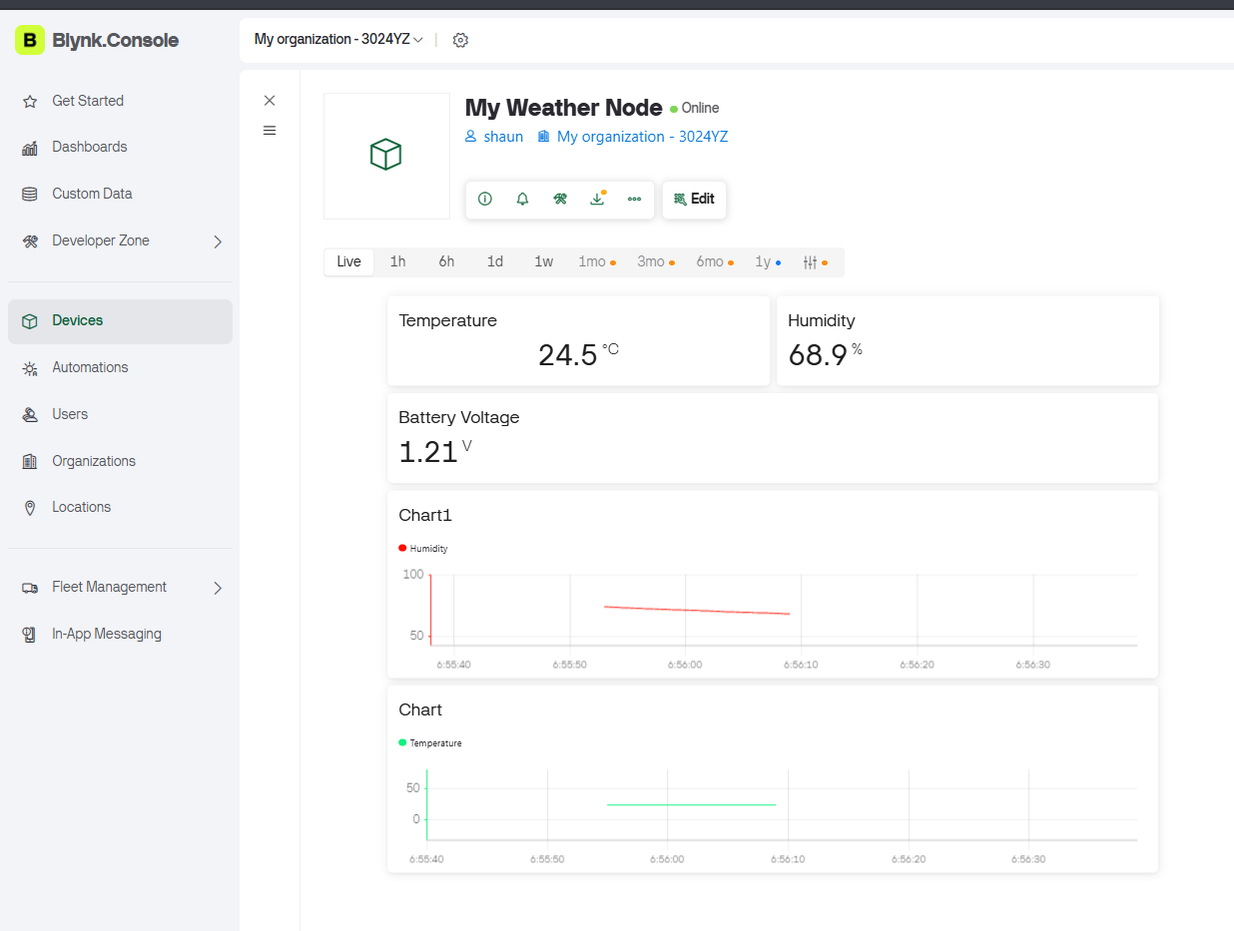
Fig. Computer Dashboard

7.3 Designing the Mobile Dashboard
Step 4: Create Web Dashboard
In the template, go to "Web Dashboard" tab:
Widget 1 - Gauge (Temperature):
- Widget Type: Gauge
- Datastream: V0 (Temperature)
- Label: "Temperature"
- Min/Max: 0-50°C
- Color: Orange-Red gradient
- Position: Top-left
- Size: 2x2 grid units
Widget 2 - Gauge (Humidity):
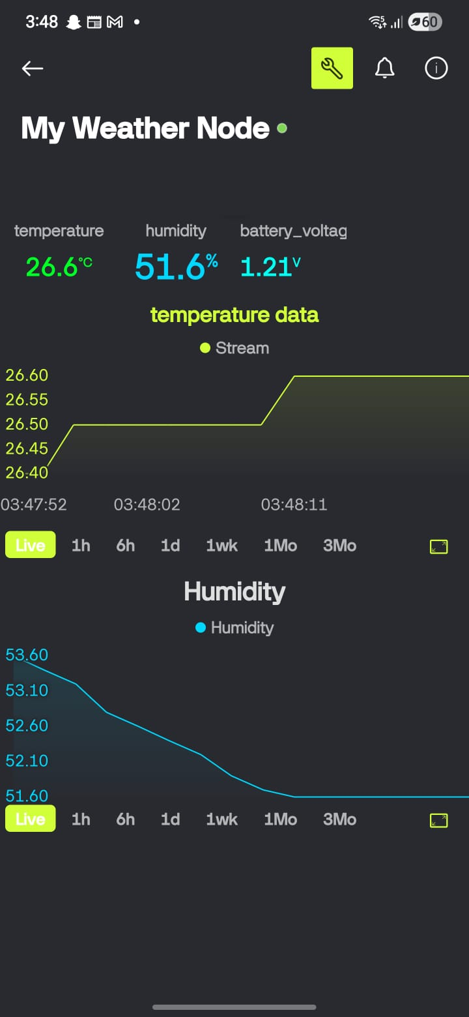
- Widget Type: Gauge
- Datastream: V1 (Humidity)
- Label: "Humidity"
- Min/Max: 0-100%
- Color: Blue gradient
- Position: Top-right
- Size: 2x2 grid units
Widget 3 - Value Display (Battery):
- Widget Type: Value Display
- Datastream: V2 (Battery Voltage)
- Label: "Battery"
- Format: "0.00 V"
- Position: Middle-center
- Size: 2x1 grid units
Widget 4 - Chart (Temperature History):
- Widget Type: Chart
- Datastream: V0 (Temperature)
- Time Range: Last 24 hours
- Update Interval: Live
- Style: Line chart
- Position: Bottom section
- Size: 4x2 grid units
Widget 5 - Chart (Humidity History):
- Widget Type: Chart
- Datastream: V1 (Humidity)
- Time Range: Last 24 hours
- Update Interval: Live
- Style: Line chart
- Position: Bottom section
- Size: 4x2 grid units

Fig .Mobile Dashboard

