REPORT

Table of Contents

**Introduction** 2

**1.Security** 2

**i. Security Protocols Implemented to Safeguard Network Communications** 2

**ii. Securing Communication Between Head Office and Branch Offices** 3

**2. Topology** 4

**3. Addressing Schemes** 4

**4. Network Testing** 5

**5. Reliability and Security** 7

**Conclusion** 7

Bibliography 8

Network Infrastructure Design for Rolling Storm Communications Ltd

# **Introduction**

The network infrastructure of Rolling Storm Communications Ltd has been thoughtfully constructed to promote security, efficiency, scalability, and reliability. This report discusses the main aspects of the network design, such as security protocols, topology options, IP addressing strategies, network testing, and overall reliability and security. By examining these elements, the network is equipped to meet the company’s operational requirements while assisting secure communication between the head office and its branch offices.

# **1.Security**

## **i. Security Protocols Implemented to Safeguard Network Communications**

To secure the network communications at Rolling Storm Communications Ltd., basic but effective security measures have been implemented on the routers and switches to control access and prevent unauthorized use. These include:

**Password Protection on Routers and Switches:** All the network devices, including the core routers and multilayer switches, have been secured with a **password** to prevent unauthorized access. The configured password is cisco, ensuring that only authorized personnel with the correct credentials can log in to the devices and make configuration changes.

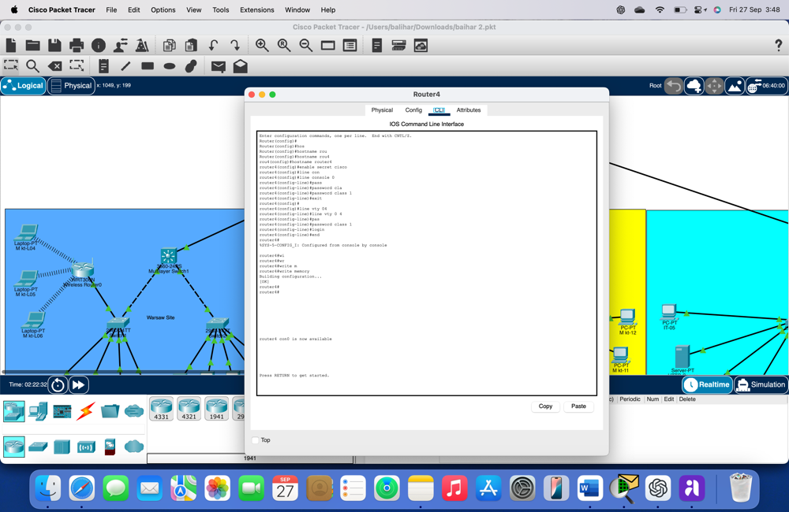

*figure1*

## **ii. Securing Communication Between Head Office and Branch Offices**

The communication between the head office (central hub) and the branch offices (Warsaw, London, and York) is protected primarily through the proper configuration of routing and access control:

**Secure Routing Configuration:** Access to the routing tables is protected by the same password-protection mechanisms implemented on the routers. This ensures that only authorized users can modify the routing tables, reducing the risk of misconfigurations that could compromise the network’s security.

**Segmentation via VLANs:** While the communication within branches is segmented through VLANs, this also adds a layer of security by isolating department traffic within each branch. Traffic from one VLAN (e.g., Marketing) is separated from another (e.g., IT), ensuring that sensitive data doesn’t inadvertently pass through networks it shouldn’t.

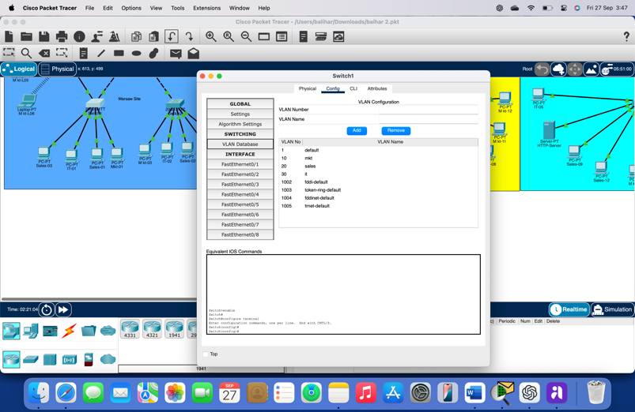

*Figure2*

# **2. Topology**

For Rolling Storm Communications Ltd., a **hybrid topology** combining elements of **star** and **mesh topology** was selected for the infrastructure design. This mixed topology offers the best of both worlds, providing the simplicity and centralization of a star topology with the resilience and redundancy of a mesh network. Here’s why this topology was chosen:

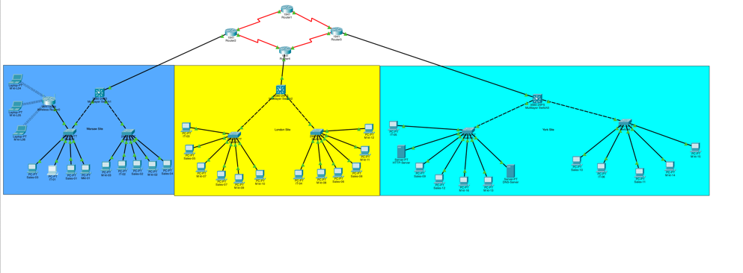

*Figure3*

* **Star Topology:** At the core of the network, a star configuration connects each branch office to the central head office. This ensures that communication between branch offices is routed through a central hub, simplifying management and ensuring efficient data flow.
* **Mesh Topology:** The mesh components provide direct, redundant links between critical nodes, particularly between routers at the head office and branches. This redundancy increases network resilience, allowing communication to continue even if a link fails.

(geeksforgeeks, 2024)

**ii. Enhancing Network Efficiency and Resilience**

* **Optimized Traffic Flow:** This topology approach ensures that network traffic is organized into layers. Local traffic within a branch (Warsaw, London, York) is handled by their respective switches, while inter-branch traffic flows to the central router. This leads to faster internal communications within each branch and smoother traffic handling between the sites.
* **Scalability:** The star and mesh design are easily scalable. As the company grows, new branches can be added by simply connecting them to the central hub (Router0), without disrupting existing traffic.
* **Resilience and Redundancy:** If a branch’s router (Router1, Router2, or Router3) or its connection fails, it does not impact other branches. Additionally, having **Router0** as the central router adds another layer of redundancy, ensuring the entire system can continue functioning without complete failure if one branch experiences issues.

(savemyexams, 2024)

# **3. Addressing Schemes**

**IP Addressing Scheme**

The IP addressing scheme for Rolling Storm Communications Ltd. has been designed to ensure efficient use of IP address space and clear segmentation between departments. The IP ranges have been carefully allocated for different departments to maintain logical separation of network traffic and facilitate easier network management.

The chosen IP range is from **205.168.7.0 to 205.168.7.167**, divided into distinct blocks for each department:

* **Marketing:** IP addresses **205.168.7.0 to 205.168.7.95** /27
* **Sales:** IP addresses **205.168.7.96 to 205.168.7.143** /28
* **IT:** IP addresses **205.168.7.144 to 205.168.7.167** /29

This method ensures that each department operates within its own subnet. Each subnet is capable of hosting the required number of devices while allowing for future scalability.

**Departmental VLANs:** The use of VLANs enhances the security and performance of the network by ensuring that traffic is contained within the relevant department. For example, devices in the Marketing VLAN (VLAN 10) cannot communicate directly with devices in the Sales VLAN (VLAN 20) or IT VLAN (VLAN 30) without routing through a Layer 3 device.

The VLAN assignments are as follows:

• **VLAN 10** – Marketing (IP Range: **205.168.7.0 – 205.168.7.95**)

• **VLAN 20** – Sales (IP Range: **205.168.7.96 – 205.168.7.143**)

• **VLAN 30** – IT (IP Range: **205.168.7.144 – 205.168.7.167**)

**Efficient IP Allocation and Future Scalability**

The current IP addressing scheme allows for efficient IP allocation while leaving room for future expansion. Each department is assigned a block of IP addresses, with Marketing having 94 addresses, Sales having 46 addresses, and IT having 22 addresses. This ensures there are sufficient IPs for the devices currently in use while providing room for future growth.

# **4. Network Testing**

**Results of Network Testing (Ping and Traceroute)**

**Network testing** was conducted using **ping** and **traceroute** commands to verify connectivity between all devices and branch offices.

• **Ping Results:** Pings between devices within the same VLAN, between VLANs, and across branch offices returned successful results, with low latency observed.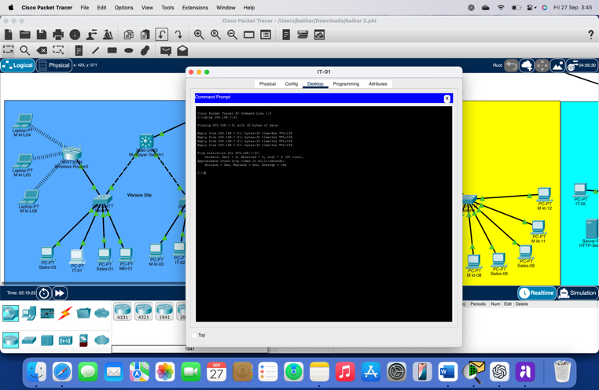

*Figure4*

• **Traceroute Results:** Traceroute was used to verify the path between head office and branch office routers. All traceroutes completed successfully, confirming that OSPF (Open Shortest Path First) routing was functioning as expected. The hop count was optimal, and there were no unexpected routing loops.

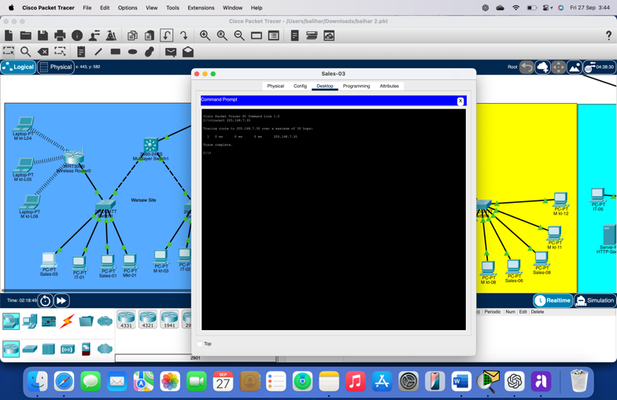

*Figure5*

**ii. Troubleshooting and Resolution of Connectivity Issues**

During testing, **connectivity issues** were identified between certain branch office routers due to misconfigured **OSPF settings**. The issue was resolved by:

• Ensuring consistent **area 0** configuration for all OSPF routers.

• Verifying that the correct **network statements** were applied to OSPF configuration on each router.

After these adjustments, all branches were able to communicate seamlessly.

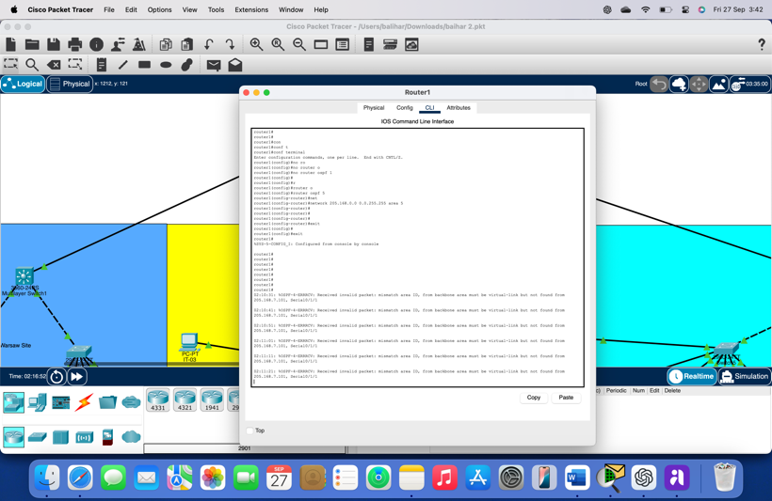

*Figure6*

# **5. Reliability and Security**

**Supporting Reliable and Secure Networking Infrastructure**

The network design for Rolling Storm Communications Ltd prioritizes both **reliability** and **security** through the following features:

• **OSPF Dynamic Routing:** OSPF provides fast convergence and optimal routing, ensuring that if a link fails, traffic is rerouted automatically.

• **VLAN Segmentation:** The use of VLANs within each branch ensures that network traffic is segmented based on department, improving both security and performance.

(Tanenbaum, 2021)

**ii. Benefits of Implemented Security Measures and Topology**

The security measures and topology provide several benefits:

• **Efficient Network Management:** The star and mesh topology, combined with centralized firewalls and routing, allows for easy management and monitoring of the entire network.

• **Scalability:** The chosen IP addressing scheme and topology make it easy to add new branches or departments without requiring major reconfiguration.

(stackexchange, 2017)

# **Conclusion**

The network infrastructure designed for Rolling Storm Communications Ltd is secure, efficient, scalable, and resilient. With strong security protocols, a reliable star and mesh topology, and a well-structured IP addressing scheme, the network is equipped to handle the company’s current and future needs. The combination of OSPF for dynamic routing and VLANs for traffic segregation ensures optimal performance and security across all branches.

# Bibliography

geeksforgeeks. (2024). *geeksforgeeks*. Retrieved from advantages-and-disadvantages-of-star-topology: https://www.geeksforgeeks.org/advantages-and-disadvantages-of-star-topology/

savemyexams. (2024). *savemyexams*. Retrieved from https://www.savemyexams.com/gcse/computer-science/ocr/22/revision-notes/3-computer-networks-connections-and-protocols/networks-and-topologies/star-and-mesh-networks/

stackexchange. (2017). Retrieved from stackexchange: https://security.stackexchange.com/questions/165935/what-is-a-more-secure-network-topology-star-or-mesh

Tanenbaum, A. S. (2021). Computer Networks, Global Edition. Pearson Education, Limited.