PROJECT SYNOPSIS
Create EC2 Instances in Public and Private Subnets and Test Connectivity
Project No. 6 · Computer Science & Engineering (CSE) — Cloud & DevOps
Branch / Stream: Computer Science & Engineering (CSE) — Cloud & DevOps
Group No.: Group 6
Group Leader: Prince (Roll No. 2415001181)
AWS Account ID: 638596943163

Group Members
# | Name | Roll No. | Role in the Project
1 | Prince | 2415001181 | Group Leader — EC2 instance deployment (public & private) and overall coordination
2 | Sohit Sharma | 2415001582 | Phase 1 — VPC creation and public/private subnet setup
3 | Mudit Chaudhary | 2415000995 | Phase 2 — Internet Gateway, route tables, and security group configuration
4 | Anshika Rai | 2415000261 | Phase 4 — Connectivity testing and verification (SSH & ping)

Introduction
Amazon Web Services (AWS) allows resources to be organized inside a Virtual Private Cloud (VPC), a logically isolated network that can be divided into subnets with different levels of internet exposure. This project sets up a custom VPC containing one public subnet and one private subnet, and deploys an EC2 instance in each. It demonstrates how AWS networking components — the Internet Gateway, route tables, and security groups — work together to expose one instance to the internet while keeping the other isolated, and how connectivity between the two can still be verified over their private IP addresses.

Aim / Objective
To launch one Amazon EC2 instance in a Public Subnet and another Amazon EC2 instance in a Private Subnet within the same VPC, and to verify network connectivity between them using their private IP addresses.

Scope of the Project
- Design and provision a custom VPC (10.0.0.0/16) with segmented public and private address spaces.
- Configure Internet Gateway access for the public subnet only, keeping the private subnet unreachable from the internet.
- Deploy and configure EC2 instances with appropriate security group rules for SSH and ICMP traffic.
- Validate the design empirically through live SSH access and ping-based connectivity testing.

Tools & Technologies Used
- Amazon VPC — custom network, public & private subnets, route tables
- Amazon EC2 — Amazon Linux instances in each subnet
- Internet Gateway — public internet access for the public subnet
- Security Groups — instance-level firewall rules (SSH, ICMP)
- SSH / EC2 Instance Connect — remote access and connectivity testing
- AWS Management Console — provisioning and verification

Methodology
The work was carried out in four sequential phases, each owned by a group member:
- Phase 1 — Sohit Sharma: Created the custom VPC (10.0.0.0/16) and the public (10.0.1.0/24) and private (10.0.2.0/24) subnets.
- Phase 2 — Mudit Chaudhary: Attached the Internet Gateway, configured the public and private route tables, and set up the security groups for SSH and ICMP access.
- Phase 3 — Prince (Group Leader): Launched the Public and Private EC2 instances with the correct subnet, IP assignment, and security group settings.
- Phase 4 — Anshika Rai: Connected to the public instance over SSH and confirmed connectivity to the private instance using ping over its private IP address.

Procedure / Implementation Steps
This section details the step-by-step implementation carried out on the AWS Management Console, along with supporting screenshots.

Step 1: Create and Verify the VPC
- Sign in to the AWS Management Console.
- Navigate to VPC.
- Create/select the custom VPC.
- VPC CIDR block: 10.0.0.0/16
- Verify that the VPC is available.
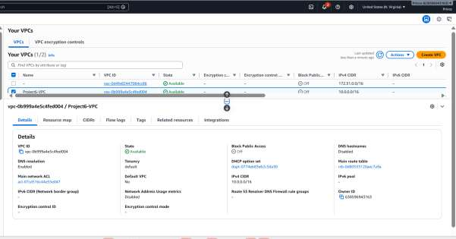
Fig 1: Project6-VPC created and available (CIDR 10.0.0.0/16)

Step 2: Create Public and Private Subnets
Public Subnet
- Navigate to VPC → Subnets.
- Create a subnet inside the custom VPC.
- Subnet Name: Project6-Public-Subnet
- IPv4 CIDR: 10.0.1.0/24
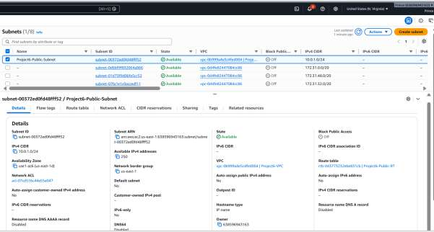
Fig 2: Project6-Public-Subnet details (10.0.1.0/24)
Private Subnet
- Create another subnet inside the same VPC.
- Subnet Name: Project6-Private-Subnet
- IPv4 CIDR: 10.0.2.0/24
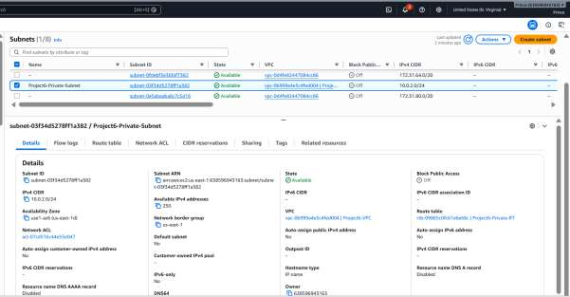
Fig 3: Project6-Private-Subnet details (10.0.2.0/24)

Step 3: Configure Internet Gateway and Route Table
- Navigate to VPC → Internet Gateways.
- Create an Internet Gateway named Project6-IGW.
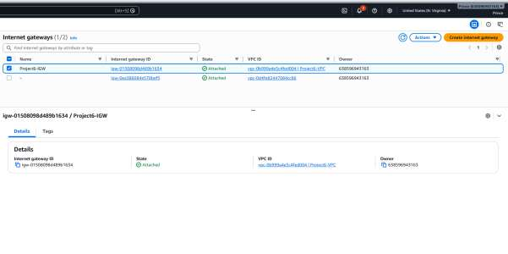
Fig 4: Project6-IGW created and attached to Project6-VPC
- Attach the Internet Gateway to the custom VPC.
- Create/select the Public Route Table.
- Add the following route — Destination: 0.0.0.0/0, Target: Internet Gateway.
- Associate the Public Subnet with the Public Route Table.
- Associate the Private Subnet with a separate Private Route Table.
- Do not add an Internet Gateway route to the Private Route Table.
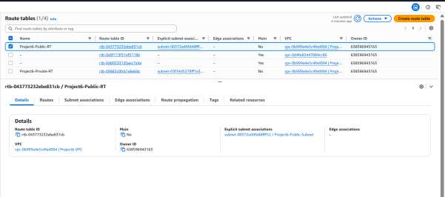
Fig 5: Project6-Public-RT route table
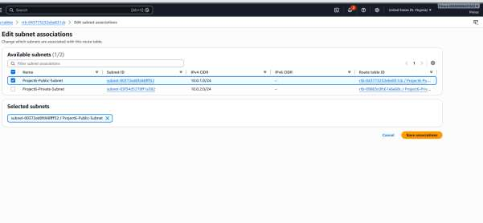
Fig 6: Associating Project6-Public-Subnet with the public route table
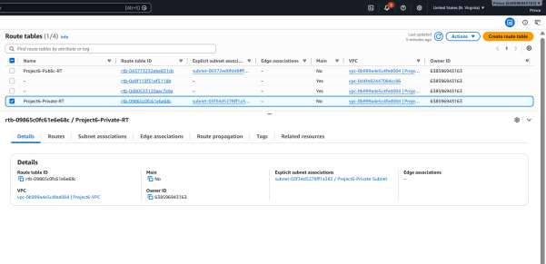
Fig 7: Project6-Private-RT route table
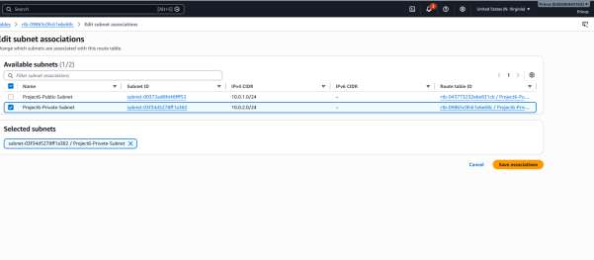
Fig 8: Associating Project6-Private-Subnet with the private route table

Step 4: Configure Security Groups
Public EC2 Security Group
- Allow — Type: SSH, Port: 22, Source: My IP
Private EC2 Security Group
- Allow — Type: All ICMP - IPv4, Source: 10.0.1.0/24
This allows the Public EC2 in the 10.0.1.0/24 subnet to send ping requests to the Private EC2. For SSH testing, SSH access can be restricted to the Public EC2/security group instead of opening SSH to the entire Internet.
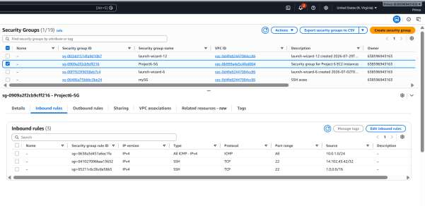
Fig 9: Project6-SG inbound rules (SSH and ICMP)

Step 5: Launch an EC2 Instance in the Public Subnet
- Navigate to EC2 → Instances, then click Launch Instance.
- Instance Name: Project6-Public-EC2
- AMI: Amazon Linux
- Instance Type: Select the available suitable instance type.
- Key Pair: Select the existing EC2 key pair.
- Network Settings — VPC: Project6-VPC, Subnet: Project6-Public-Subnet, Auto-assign Public IP: Enable, Security Group: Project6-Public-SG
- Launch the instance.
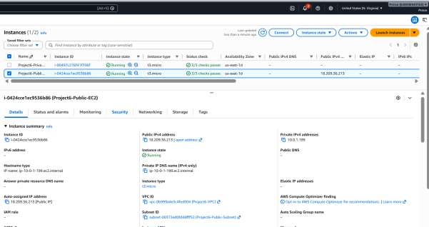
Fig 10: Project6-Public-EC2 launched and running with a public IPv4 address

Step 6: Launch an EC2 Instance in the Private Subnet
- Click Launch Instance again.
- Instance Name: Project6-Private-EC2
- AMI: Amazon Linux
- Instance Type: Select the suitable available instance type.
- Key Pair: Select the same key pair.
- Network Settings — VPC: Project6-VPC, Subnet: Project6-Private-Subnet, Auto-assign Public IP: Disable, Security Group: Project6-Private-SG
- Launch instance.
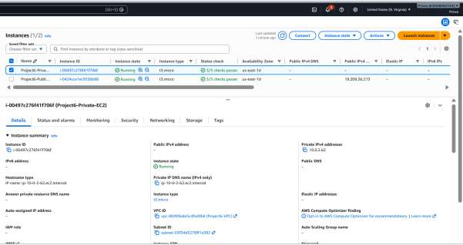
Fig 11: Project6-Private-EC2 instance summary (no public IPv4 address)

Step 7: Verify Both EC2 Instances
- Open EC2 → Instances.
- Verify that both instances are in the Running state.
- Note their Private IPv4 addresses.
- Verify that the Public EC2 has a Public IPv4 address.
- Verify that the Private EC2 does not have a Public IPv4 address.
For this project, our instances were:
- Public EC2 Private IP: 10.0.1.83
- Private EC2 Private IP: 10.0.2.62
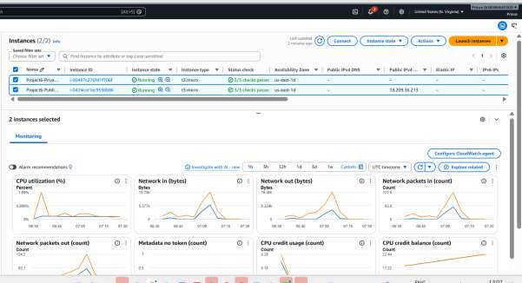
Fig 12: Both instances running, with monitoring metrics
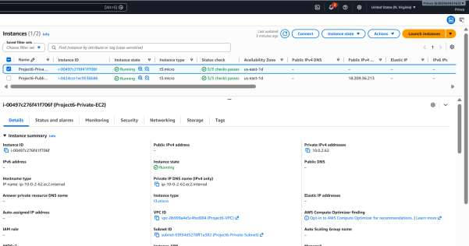
Fig 13: Private EC2 networking tab showing private IPv4 address (10.0.2.62)

Step 8: Connect to the Public EC2 Instance
- Connect to the Public EC2 using SSH or EC2 Instance Connect.
- For SSH, use the EC2 key pair.
- After successful login, the terminal displays the EC2 shell prompt.
Successful login confirms that the Public EC2 is reachable.
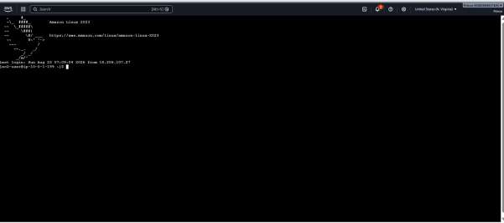
Fig 14: Successful SSH login to the Public EC2 instance

Step 9: Test Connectivity to the Private EC2
From the Public EC2 terminal, run: ping 10.0.2.62
The Private EC2 responded with messages similar to: 64 bytes from 10.0.2.62 (repeated for each ping).
This confirms that the Public EC2 can communicate with the Private EC2 using its Private IP address.
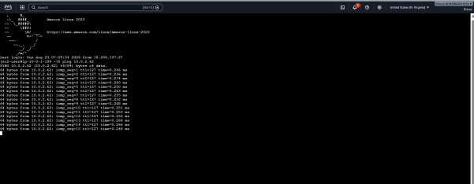
Fig 15: Successful ping replies from the Private EC2 (10.0.2.62)

Step 10: Verify Network Configuration
- Both EC2 instances are in the same VPC.
- Public EC2 is in the Public Subnet; Private EC2 is in the Private Subnet.
- Public EC2 has a Public IPv4 address; Private EC2 has no Public IPv4 address.
- Public Route Table has: 0.0.0.0/0 → Internet Gateway.
- Public EC2 can communicate with Private EC2 using its Private IP.
- Security Group allows ICMP between the required subnet/instances.
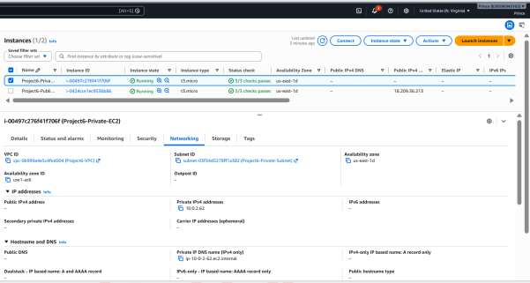
Fig 16: Public EC2 instance summary with public and private IPv4 addresses
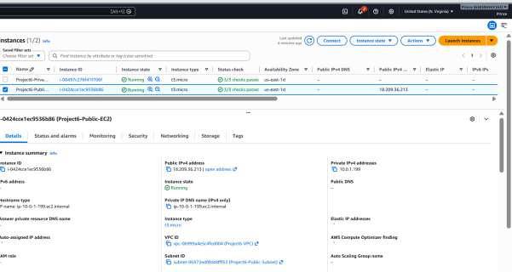
Fig 17: Public EC2 instance details (Project6-Public-EC2)
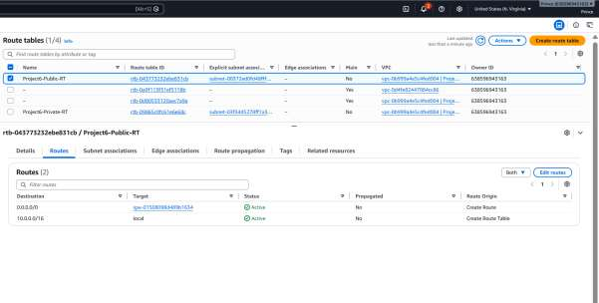
Fig 18: Project6-Public-RT routes — 0.0.0.0/0 → Internet Gateway
Result: The Public EC2 and Private EC2 instances were successfully launched in their respective subnets within the same VPC. The Public EC2 instance was successfully connected using SSH, and connectivity between the Public and Private EC2 instances was successfully verified using the Private IP address.

Expected Outcome
Both EC2 instances launch successfully in their respective subnets within the same VPC. The public instance is reachable from the internet via SSH, while the private instance remains inaccessible externally. Despite this isolation, the public instance is able to reach the private instance directly over its private IP address, confirming that intra-VPC routing and the configured security group rules work as intended.

Applications / Usage
This public–private subnet pattern is a foundational building block in real-world AWS architecture, and the skills practiced here carry directly into production scenarios such as:
- Three-tier web applications — public subnet hosts web/app servers; private subnet hosts the database, hidden from direct internet access.
- Bastion host architectures — a single hardened public instance is used as the only entry point into private resources, reducing the attack surface.
- Backend and internal services — application servers, caches, and internal APIs that should never be directly internet-reachable.
- A hands-on foundation for AWS networking concepts assessed in cloud certifications (e.g., AWS Certified Solutions Architect, AWS Certified Cloud Practitioner).

Limitations
- No NAT Gateway is configured, so the private instance has no outbound internet access at all (e.g., it cannot download OS updates or packages).
- The setup uses a single Availability Zone, so it is not resilient to an AZ-level outage.
- The public instance's SSH rule is scoped to "My IP"; it must be updated manually whenever that IP address changes.
- Only one instance is deployed per subnet — there is no load balancing or auto-scaling.
- Connectivity is validated only at the network layer (SSH login and ICMP ping); no application-layer testing is performed.
- All resources are provisioned manually through the AWS Console rather than as Infrastructure as Code, so the setup is not easily repeatable or version-controlled.

Future Scope
- Add a NAT Gateway to the private route table so the private instance can reach the internet outbound (e.g., for updates) without being reachable inbound.
- Extend the design across multiple Availability Zones for high availability.
- Introduce an Auto Scaling Group and an Application Load Balancer in front of the public subnet.
- Automate the entire setup using Infrastructure as Code (e.g., AWS CloudFormation or Terraform) for repeatability.
- Replace direct SSH bastion access with AWS Systems Manager Session Manager for keyless, auditable access.

Conclusion
This project demonstrates a practical, secure network design pattern used widely in production AWS environments: separating internet-facing and internal resources within a single VPC. By the end of the project, the group will have hands-on experience provisioning VPCs, subnets, route tables, security groups, and EC2 instances, and validating network connectivity between isolated resources — core skills for cloud and DevOps engineering.

