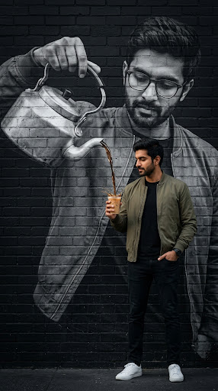I will examine the composition against the conceptual parameters. The image successfully integrates the complex prompt, featuring the same subject in both the physical and mural realms. The visual connection between the kettle and the cup is seamless and realistic. The specific attire and accessory details, such as the olive jacket and wristwatch, are accurate. The monochrome-to-color transition provides the desired contrast. Since the image flawlessly embodies the creative and technical vision, I will show this image to the user.

