ITEP 414 – System Administration and Maintenance
Enterprise Infrastructure Plan
for ABC Startup Solutions
Week 2 Portfolio Project — Individual Portfolio Project
Prepared for: Company Executive / IT Manager Review
Prepared by: Princess Anne B. Azucena, Junior System Administrator
Program: BS Information Technology
Date: August 15, 2026

Part 1 — Company Profile

Overview
Field | Details
Company Name | ABC Startup Solutions
Nature of Business | Software development and cloud-based business-application services (SaaS)
Company Vision | To become the region's most trusted software partner for small and medium enterprises by 2030.
Company Mission | To design, build, and support reliable, secure, and affordable digital solutions that help businesses grow.
Office Location | Unit 402, 4th Floor, Metro Business Tower, Brgy. San Isidro, Lipa City, Batangas, Philippines (fictional)
Founded | 2026
Total Employees | 20

Organizational Structure
ABC Startup Solutions operates on a flat, single-floor organizational structure typical of an early-stage startup. The Chief Executive Officer (CEO) oversees four department heads, each responsible for a functional unit: Information Technology, Human Resources, Finance, and Sales. The IT department additionally reports technical infrastructure matters to the Junior System Administrator, who manages day-to-day operations of the network and systems.
- Chief Executive Officer (CEO)
  - IT Manager → IT Department (Junior System Administrator, Developers, QA)
  - HR Manager → Human Resources Department
  - Finance Manager → Finance Department
  - Sales Manager → Sales Department

Employee Distribution
Department | Employees | Primary Function
Information Technology | 5 | Software development, QA, systems administration
Human Resources | 4 | Recruitment, employee relations, payroll coordination
Finance | 5 | Accounting, budgeting, invoicing, financial reporting
Sales | 6 | Client acquisition, account management, field sales
TOTAL | 20

Part 2 — Enterprise Hardware Inventory
The hardware inventory below equips all 20 employees with appropriate endpoint devices, supports server-based file/print/backup services, and provides basic power protection. Desktop computers are assigned to roles that are primarily desk-based (HR, Finance, and most of IT), while laptops are issued to roles that require mobility (Sales staff who visit clients, and IT staff who need to troubleshoot on-site).
Asset ID | Hardware | Qty | Department | Purpose
HW-001 | Desktop Computer (i5, 16GB RAM, 512GB SSD) | 3 | IT | Development and system administration workstations
HW-002 | Desktop Computer (i5, 8GB RAM, 256GB SSD) | 4 | HR | Daily HR tasks: records, payroll, communication
HW-003 | Desktop Computer (i5, 8GB RAM, 256GB SSD) | 5 | Finance | Accounting, spreadsheets, financial reporting
HW-004 | Laptop (i5, 16GB RAM, 512GB SSD) | 2 | IT | Mobile troubleshooting and on-site maintenance
HW-005 | Laptop (i5, 8GB RAM, 256GB SSD) | 6 | Sales | Field sales, client presentations, remote work
HW-006 | Monitor (24-inch IPS, dual-monitor for IT/Finance) | 16 | All (mostly IT/Finance) | Extended display for productivity-heavy roles
HW-007 | Rack Server (Xeon, 32GB RAM, RAID 1, 2×2TB HDD) | 1 | IT / Shared | Hosts file sharing, print server, internal apps, backups
HW-008 | Edge Router (Gigabit, dual-WAN capable) | 1 | IT / Shared | Internet gateway and inter-VLAN routing
HW-009 | 24-Port Managed Switch | 1 | IT / Shared | Core switch — VLAN segmentation for departments
HW-010 | 8-Port Unmanaged Switch (spare) | 1 | IT / Shared | Backup/expansion switch for future growth
HW-011 | Network Laser Printer (shared, duplex) | 4 | HR, Finance, Sales, IT | Shared departmental printing
HW-012 | UPS 2200VA (server rack) | 1 | IT / Shared | Power protection for server and core network gear
HW-013 | UPS 650VA (desktop clusters) | 4 | IT, HR, Finance, Sales | Surge protection and graceful shutdown per department
HW-014 | Wireless Access Point (WiFi 6, ceiling-mount) | 2 | IT / Shared | Wireless coverage across the single office floor
HW-015 | NAS Storage (4-bay, 8TB usable, RAID 5) | 1 | IT / Shared | Centralized shared storage and department backups
HW-016 | External Backup Drive (4TB, portable) | 2 | IT / Shared | Offsite/rotating backup copies for disaster recovery
Justification: Quantities match the 20-employee headcount exactly (12 desktops + 8 laptops = 20 endpoints), with a small surplus of monitors for roles requiring dual displays. One server, one core switch, and one router are sufficient for a single-floor, 20-person office, while a spare switch and dual UPS tiers protect against outages as the company scales.

Part 3 — Enterprise Software Inventory
Software | Version | License | Purpose
Windows 11 Pro | 23H2 | Volume Licensing (per device) | Primary desktop/laptop OS with domain-join, BitLocker, and remote management support
Ubuntu Server | 24.04 LTS | Free / Open Source | Server OS for file sharing, internal apps, and backup services
Microsoft 365 Office Apps | Current (cloud) | Subscription (Business Standard, per user) | Word, Excel, Outlook, Teams for daily productivity and communication
Visual Studio Code | 1.9x | Free / Open Source (MIT) | Primary code editor for the IT/development team
Git | 2.4x | Free / Open Source (GPL) | Source-code version control for all development work
GitHub Desktop | 3.x | Free | Simplified GUI for managing Git repositories
VirtualBox | 7.x | Free / Open Source (GPL) | Sandbox/testing environments and OS training labs
Google Chrome | Current | Free | Standard web browser for all staff
Microsoft Defender for Business | Current | Included with Microsoft 365 Business Premium | Endpoint antivirus, anti-malware, and threat protection
AnyDesk | Current | Free (Business tier for commercial helpdesk use) | Remote support and helpdesk troubleshooting
7-Zip | 23.x | Free / Open Source (LGPL) | File compression and archive management

Part 4 — Enterprise Network Inventory
Asset ID | Equipment | Qty | Specification | Purpose
NW-001 | ISP Modem | 1 | GPON Fiber ONT | Terminates the fiber internet connection from the ISP
NW-002 | Router | 1 | Gigabit, dual-WAN capable | Internet gateway, NAT, and inter-VLAN routing
NW-003 | Firewall (UTM) | 1 | Next-gen firewall, IDS/IPS | Perimeter security, traffic inspection, content filtering
NW-004 | Core Switch | 1 | 24-port managed, VLAN-capable | Central connectivity and department VLAN segmentation
NW-005 | Access Point | 2 | WiFi 6, ceiling-mount PoE | Wireless coverage for the office floor
NW-006 | Patch Panel | 1 | 24-port CAT6 | Organizes structured cabling terminations
NW-007 | CAT6 Cables | 40 | 305m box (bulk) + patch cords | Structured cabling to all desks and access points
NW-008 | RJ45 Connectors | 100 | CAT6-rated | Cable termination for wall jacks and patch cords

Part 5 — Enterprise Network Diagram
The diagram below represents the network topology designed for ABC Startup Solutions, showing traffic flow from the Internet through the ISP modem, edge router, and firewall, into a segmented core switch that connects each department (IT, HR, Finance, Sales), plus the server, wireless access point, and shared printer. This layout was modeled for reproduction in Draw.io and should be exported as both PNG and PDF for the GitHub submission.
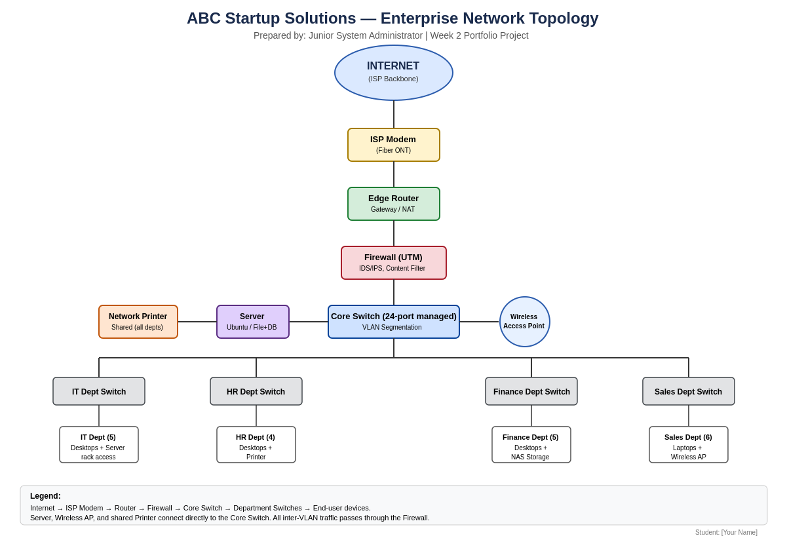
Design notes: Each department sits on its own switch/VLAN to contain broadcast traffic and simplify future access-control policies (e.g., restricting Sales from Finance file shares). The server, wireless AP, and shared network printer connect directly to the core switch so all departments can reach them without crossing department VLAN boundaries unnecessarily. All traffic entering or leaving the network passes through the firewall for inspection.

Part 6 — System Administration Roles

Helpdesk Technician
Responsibilities
- Provides first-line technical support to end users (hardware, software, account, and connectivity issues)
- Logs, tracks, and escalates tickets through a helpdesk/ticketing system
- Performs basic hardware setup, software installation, and account provisioning
Skills
- Strong troubleshooting and customer-service communication
- Working knowledge of Windows/macOS, Active Directory basics, and common office software
Common Tools
- Ticketing systems (e.g., Freshservice, Zendesk), AnyDesk/TeamViewer for remote support, Microsoft 365 admin basics
Certifications
- CompTIA A+, Microsoft 365 Certified: Fundamentals, ITIL Foundation

Network Administrator
Responsibilities
- Designs, configures, and maintains routers, switches, firewalls, and wireless infrastructure
- Monitors network performance, uptime, and security; manages VLANs and IP addressing
Skills
- Routing/switching (TCP/IP, VLANs, DHCP, DNS), firewall configuration, network monitoring
Common Tools
- Cisco/Ubiquiti/Mikrotik consoles, Wireshark, PRTG or Zabbix for monitoring, patch-panel/cabling tools
Certifications
- CCNA, CompTIA Network+, Fortinet NSE (for firewall-specific roles)

Linux System Administrator
Responsibilities
- Installs, configures, and maintains Linux servers (file, web, database, or application servers)
- Manages users/permissions, automates tasks via shell scripting, and applies security patches
Skills
- Linux command line, shell scripting (Bash), package management, service/daemon management (systemd)
Common Tools
- SSH, Bash/Python scripts, cron, systemctl, Ansible for configuration management
Certifications
- CompTIA Linux+, Red Hat Certified System Administrator (RHCSA), LPIC-1

Cloud Administrator
Responsibilities
- Provisions and manages cloud resources (compute, storage, networking) and monitors cost/usage
- Implements cloud backup, identity/access management, and cloud security policies
Skills
- Cloud platform administration (AWS/Azure/GCP), IAM, cost optimization, Infrastructure-as-Code basics
Common Tools
- AWS/Azure/GCP consoles, Terraform, CloudWatch/Azure Monitor, IAM policy editors
Certifications
- AWS Certified Cloud Practitioner/SysOps, Microsoft Certified: Azure Administrator Associate

How These Roles Work Together
Within ABC Startup Solutions, these four professionals form a layered support structure. The Helpdesk Technician acts as the first point of contact, resolving day-to-day user issues and escalating anything beyond basic troubleshooting. The Network Administrator ensures the underlying connectivity — routers, switches, firewall, and Wi-Fi — stays available and secure, which every other role depends on. The Linux System Administrator keeps the on-premises server (file sharing, internal applications, backups) running reliably and securely. As the company grows and adopts cloud services for scalability or disaster recovery, the Cloud Administrator extends the same principles of availability, security, and cost control into hosted environments. Together they cover the full stack — from a single user's laptop up to internet-facing infrastructure — communicating through shared documentation and escalation paths so that issues are resolved at the right level without duplicated effort.

Part 7 — Infrastructure Recommendations
Internet Provider
A business-grade fiber connection (minimum 100 Mbps symmetrical, with a Service Level Agreement guaranteeing uptime and support response times) is recommended over a residential plan. Business fiber offers static IP options, faster restoration times, and dedicated support — important once the company depends on email, cloud apps, and client-facing services daily.
Server Specifications
A single rack-mounted server with a multi-core Xeon or EPYC processor, 32GB ECC RAM, and RAID 1 storage (mirrored 2×2TB drives) is sufficient for the current 20-user load, covering file sharing, print services, and light internal application hosting. ECC memory and RAID mirroring protect against data corruption and single-disk failure, which is critical since this server underpins daily operations for all four departments.
Backup Strategy
A 3-2-1 backup strategy is recommended: at least three copies of data, stored on two different media types, with one copy kept offsite. In practice this means (1) production data on the server/NAS, (2) a nightly automated backup to the NAS or external backup drives, and (3) a periodic offsite or cloud copy (e.g., rotated external drives taken off-site weekly, or a low-cost cloud backup tier). Backups should be tested quarterly to confirm they can actually be restored.
Security Recommendations
- Deploy the UTM firewall with IDS/IPS enabled and default-deny inbound rules
- Segment departments into separate VLANs so a compromise in one department cannot immediately reach another
- Enable automatic OS and application patching on a defined schedule (e.g., patch Tuesday + 1 week testing window)
- Require multi-factor authentication (MFA) for email, cloud, and remote-access accounts
- Maintain an offboarding checklist to immediately revoke account access when staff leave
Antivirus
Microsoft Defender for Business is recommended since it is already bundled with Microsoft 365 Business Premium, provides centralized management through the Microsoft 365 Defender portal, and covers endpoint detection and response (EDR) in addition to traditional antivirus — avoiding the cost of a separate third-party suite.
Password Policy
- Minimum 12-character passwords combining upper/lowercase letters, numbers, and symbols
- Mandatory MFA on all accounts with access to email, file storage, or admin consoles
- No password reuse across the last 5 passwords; forced change only on suspected compromise (not arbitrary expiry, per current NIST guidance)
- Account lockout after 5 failed login attempts
Expansion Plan
The current design leaves headroom for growth: the 24-port core switch has spare ports, a backup 8-port switch is already stocked, and the router/firewall are both sized above the current 20-user load. As headcount grows toward 40–50 employees, the recommended next steps are to add a second access point for coverage, move to a dual-server setup (splitting file/print services from a dedicated backup server), and evaluate migrating backup and disaster-recovery to a cloud provider for offsite resilience.

Part 8 — Personal Reflection
Working through this Enterprise Infrastructure Plan for ABC Startup Solutions gave me a much clearer picture of what system administration actually involves before a single cable is plugged in. Going into the project, I assumed "infrastructure planning" mostly meant picking out hardware — deciding how many computers and routers to buy. What I learned instead is that planning starts with the business itself: how many people are in each department, what they do day to day, and how data needs to move between them. Only after mapping that out did the hardware, software, and network choices start to make sense, because every device I listed had to be justified against a real need rather than picked because it sounded impressive.
The most challenging part was designing the network diagram and inventory together so that they actually matched. It was easy to list equipment in isolation, but harder to make sure the switch port counts, VLAN structure, and department groupings in the diagram lined up exactly with the hardware and network inventories. I found myself going back and forth between the tables and the diagram several times, adjusting quantities so the whole plan told one consistent story instead of three disconnected documents. Writing the infrastructure recommendations also pushed me to think beyond "what works" toward "what's defensible" — for example, justifying a 3-2-1 backup strategy or a specific password policy meant researching why those standards exist, not just stating them.
This exercise made it obvious why planning has to come before deployment. Buying equipment first and figuring out the network later invites wasted spending, security gaps, and rework — a switch with too few ports, a server with no redundancy, or a network with no segmentation between departments are all mistakes that are expensive to fix after the fact but nearly free to avoid on paper. Planning is also what makes a system defensible to management: an IT Manager or executive can look at a documented plan with justified quantities and clear recommendations and trust that money is being spent deliberately, not guessed at.
Overall, this project moved me from thinking like someone who fixes computers to thinking like someone who designs systems for an organization's needs. Translating a company scenario into a full hardware, software, and network plan — and documenting it professionally enough to hand to an executive — is a skill I expect to use directly in future coursework and, eventually, as an entry-level System Administrator. It reinforced that attention to detail and clear documentation are not optional extras in this field; they are what separates a workable system from a fragile one.

