**Initializing Terraform**

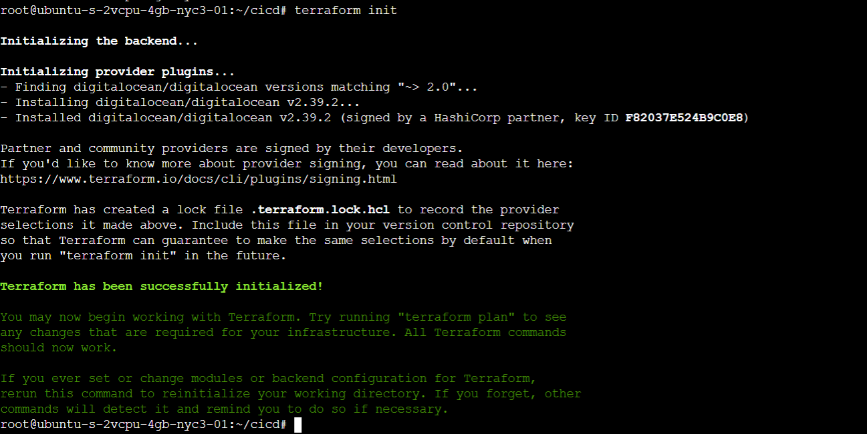

**Running the ansible playbook to create the tools for the implementation such as Jenkins SonarQube, Prometheus and Grafana**

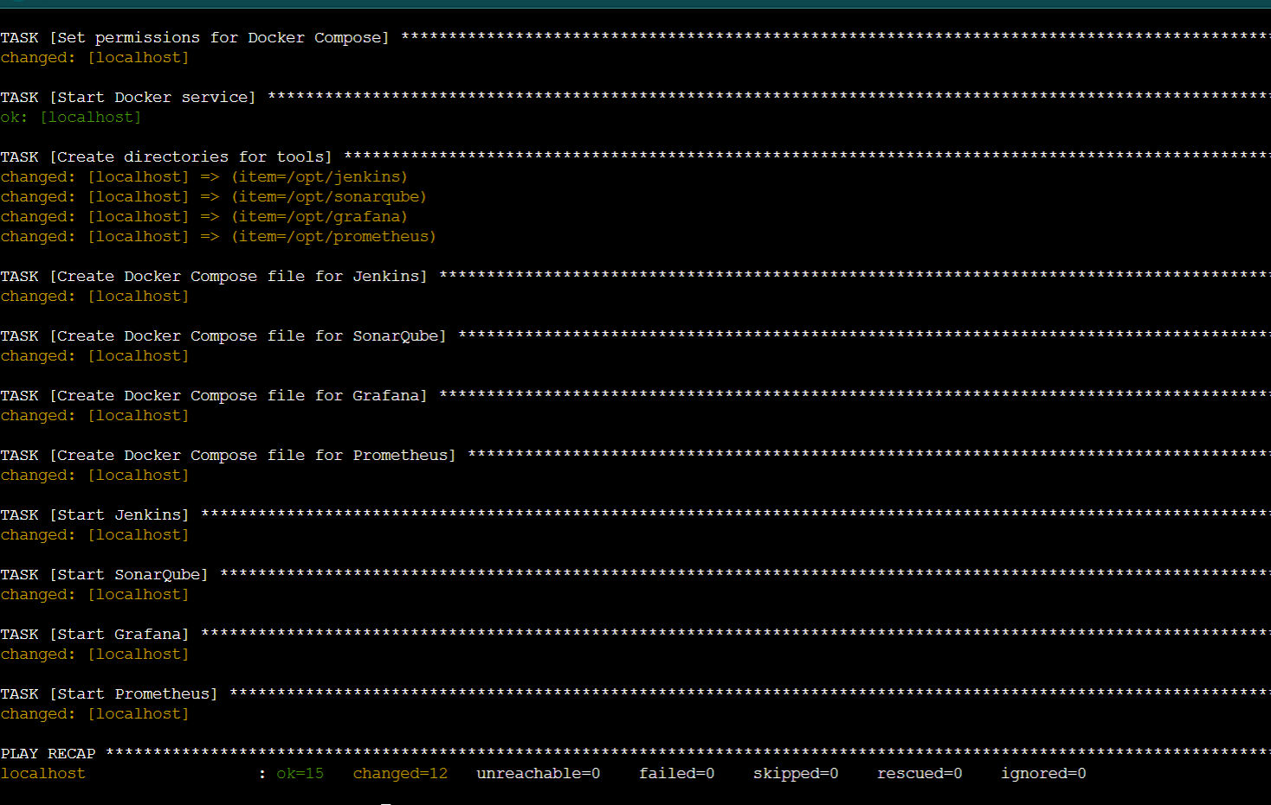

**Running containers after the ansible playbook ran successfully**

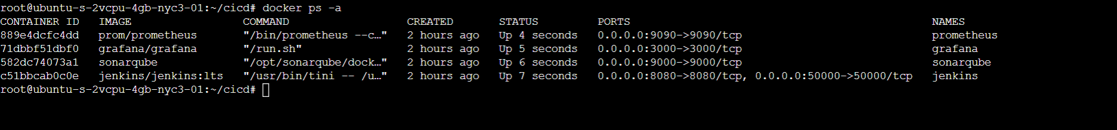

**Jenkins Setup**

**Unlocking the setup with the password provided by the Docker image**

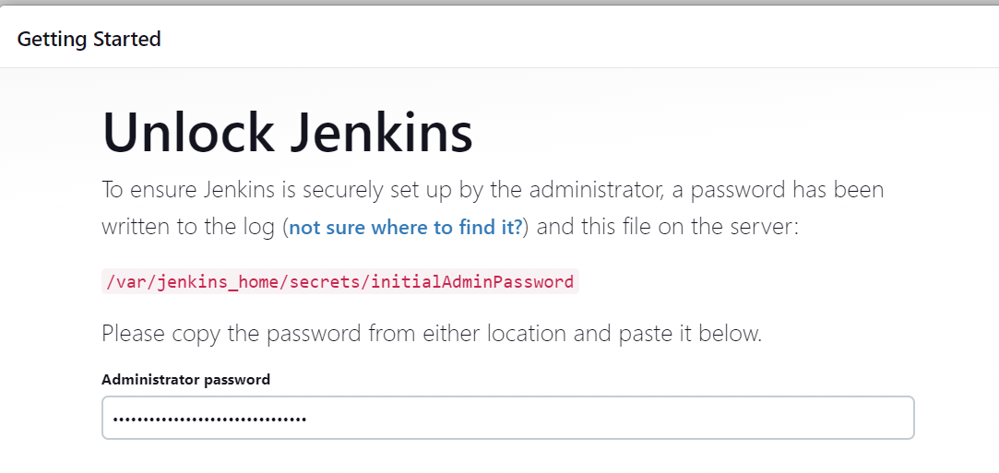

**Install the necessary plugins that Jenkins Suggests**

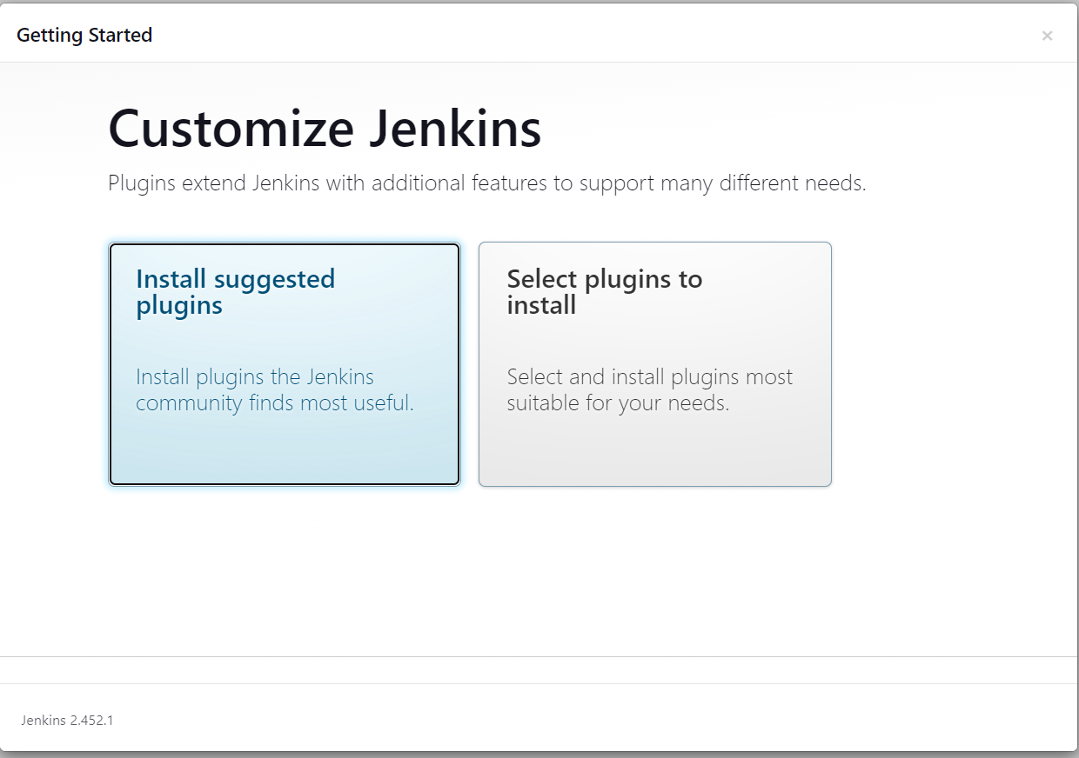

**Start the Jenkins installation**

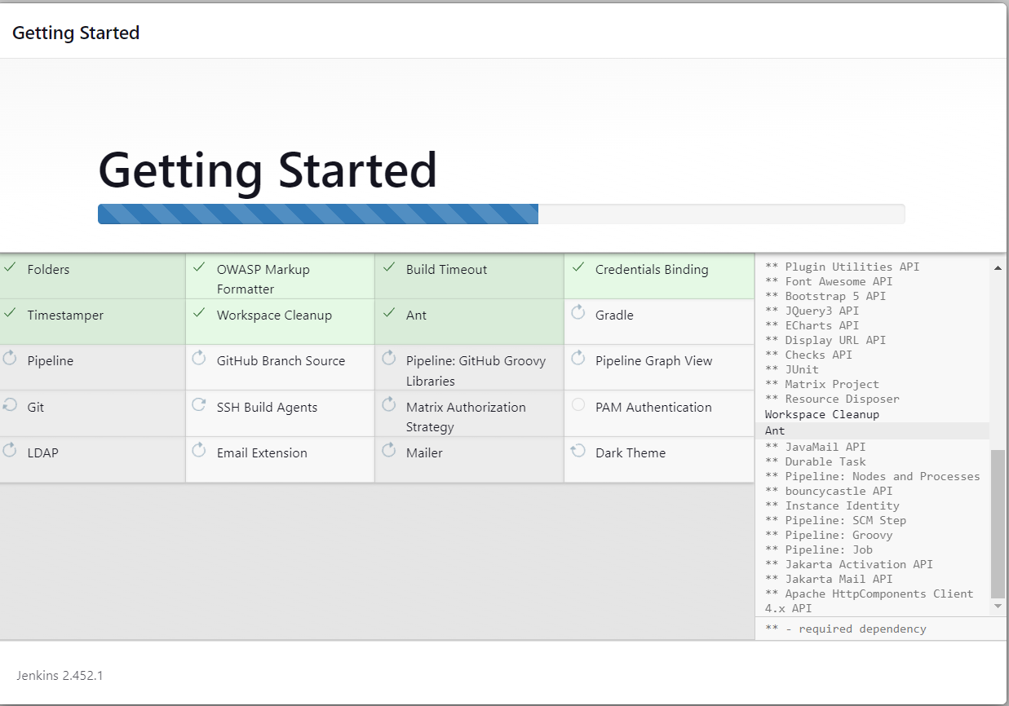

**Jenkins Installation completed**

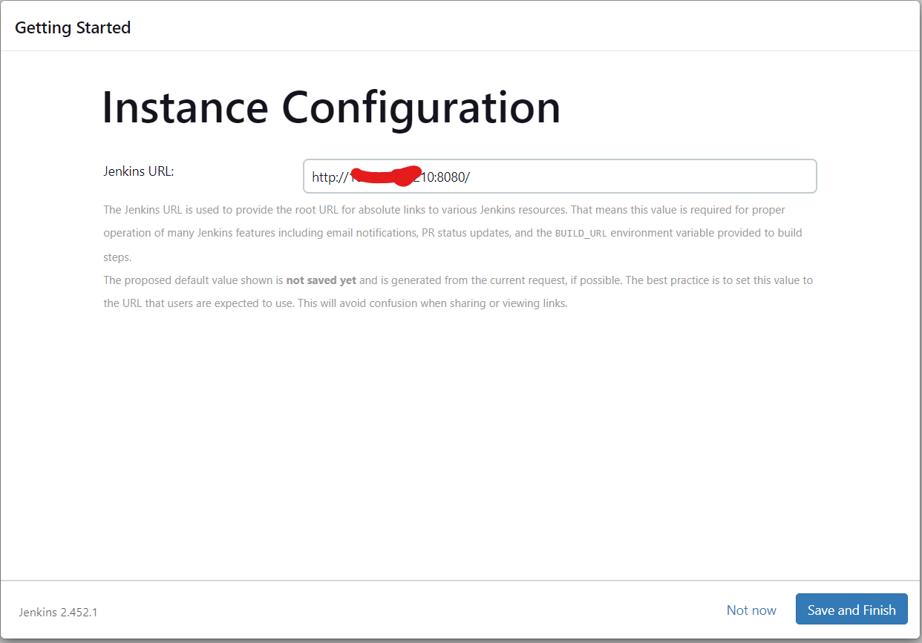

**Showing the installation of the required plugins that are needed to run the pipeline**

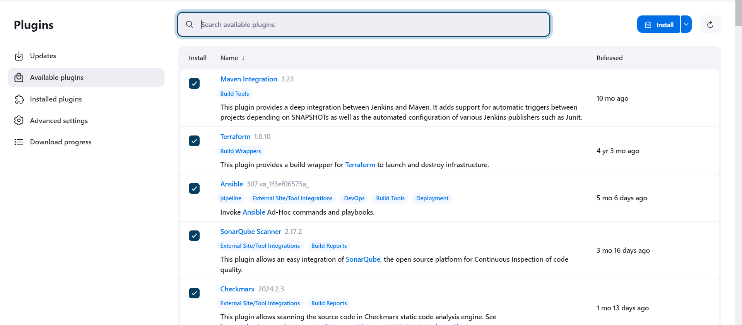



**Setting up the Maven tool**

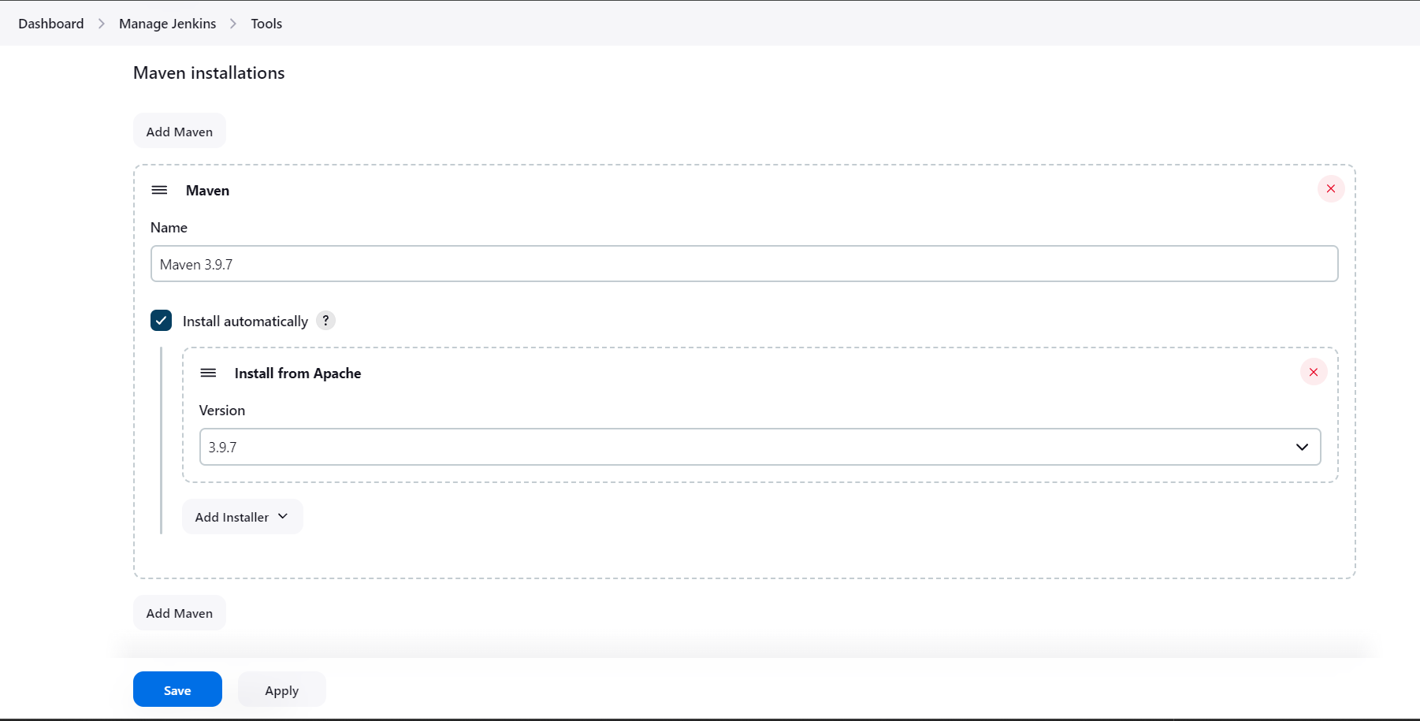

**Setting up the Ansible plugin**

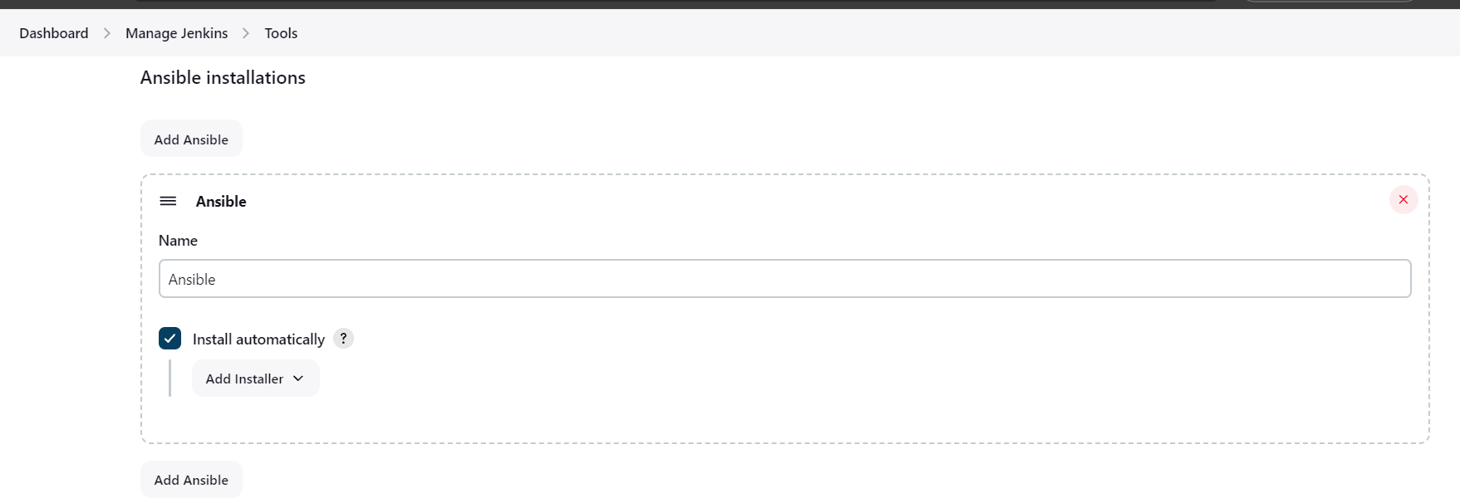

**Configuring the SonarQube plugin**

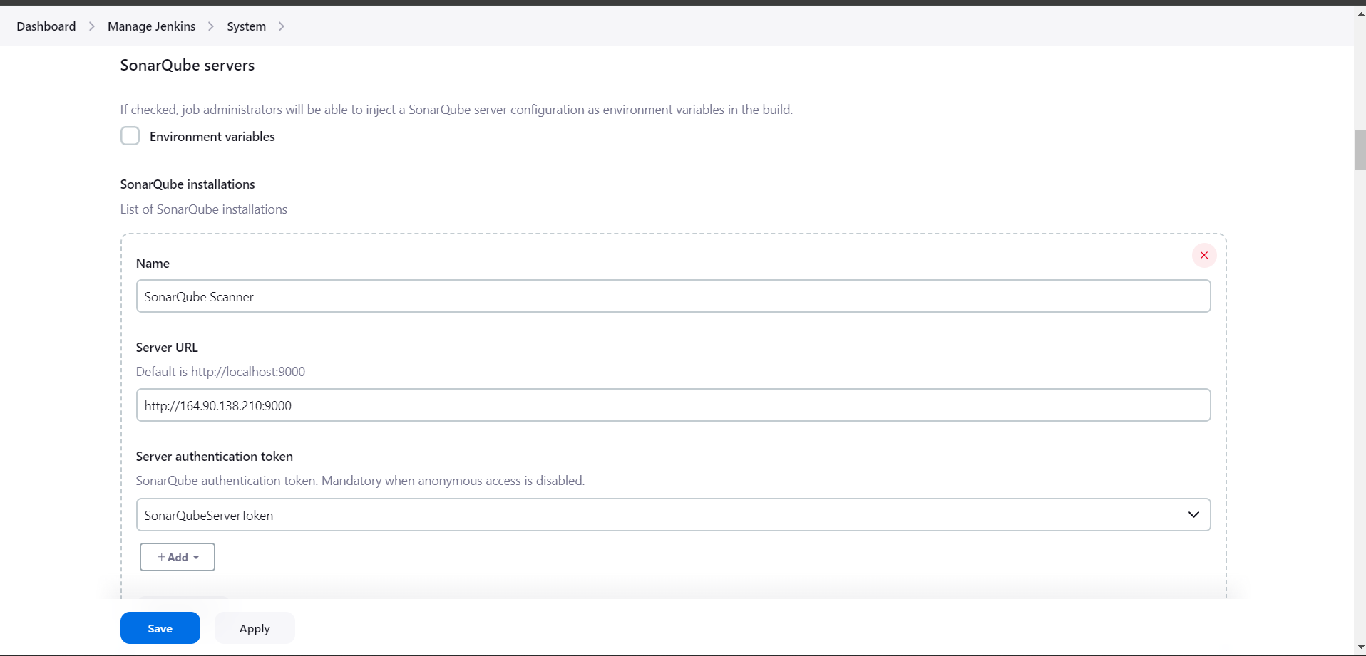

**Example of Pipeline**

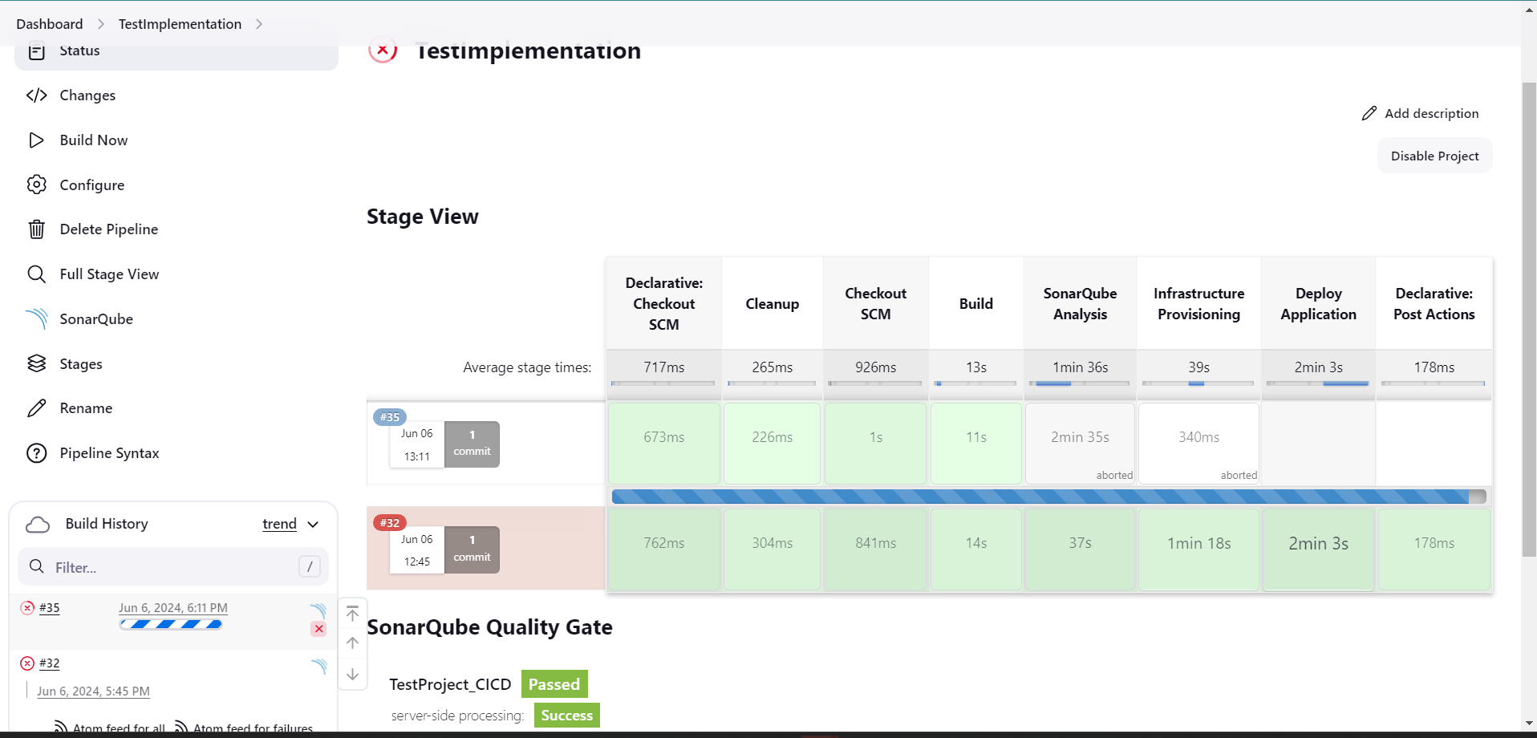

**Result of failed build**

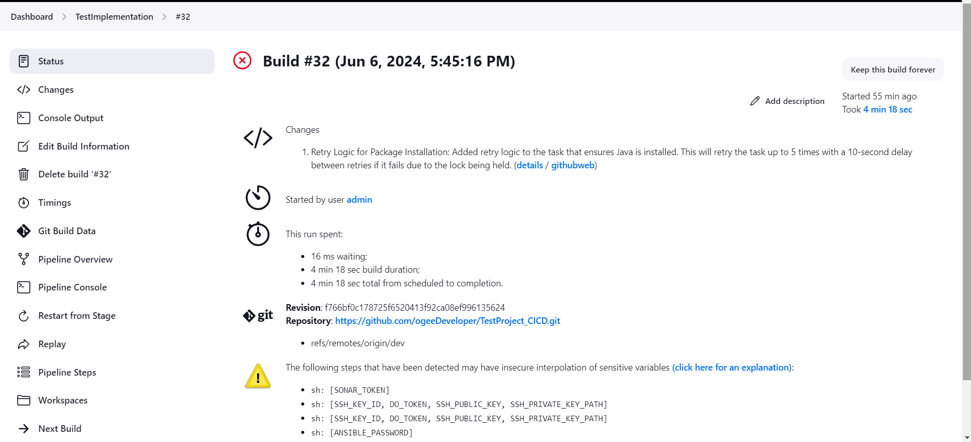

**Result of successful build**

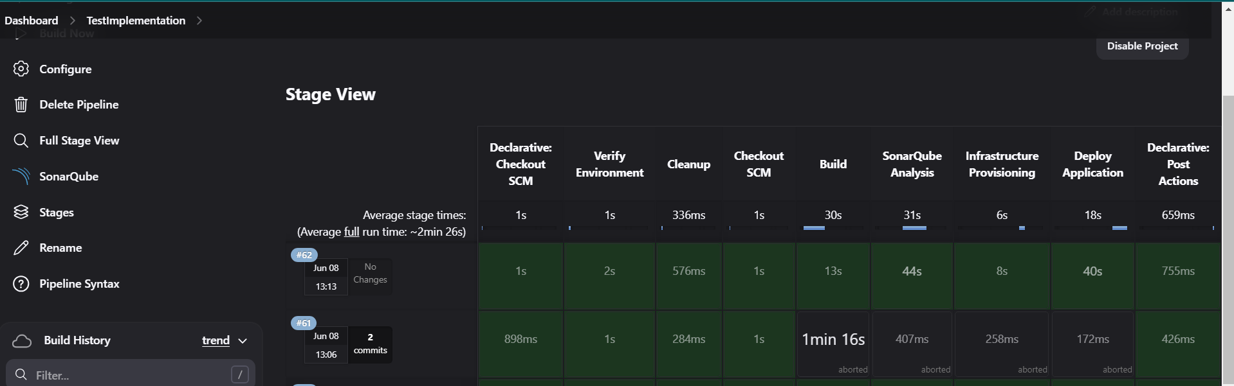

**Time taken for the Terraform to provision server**

