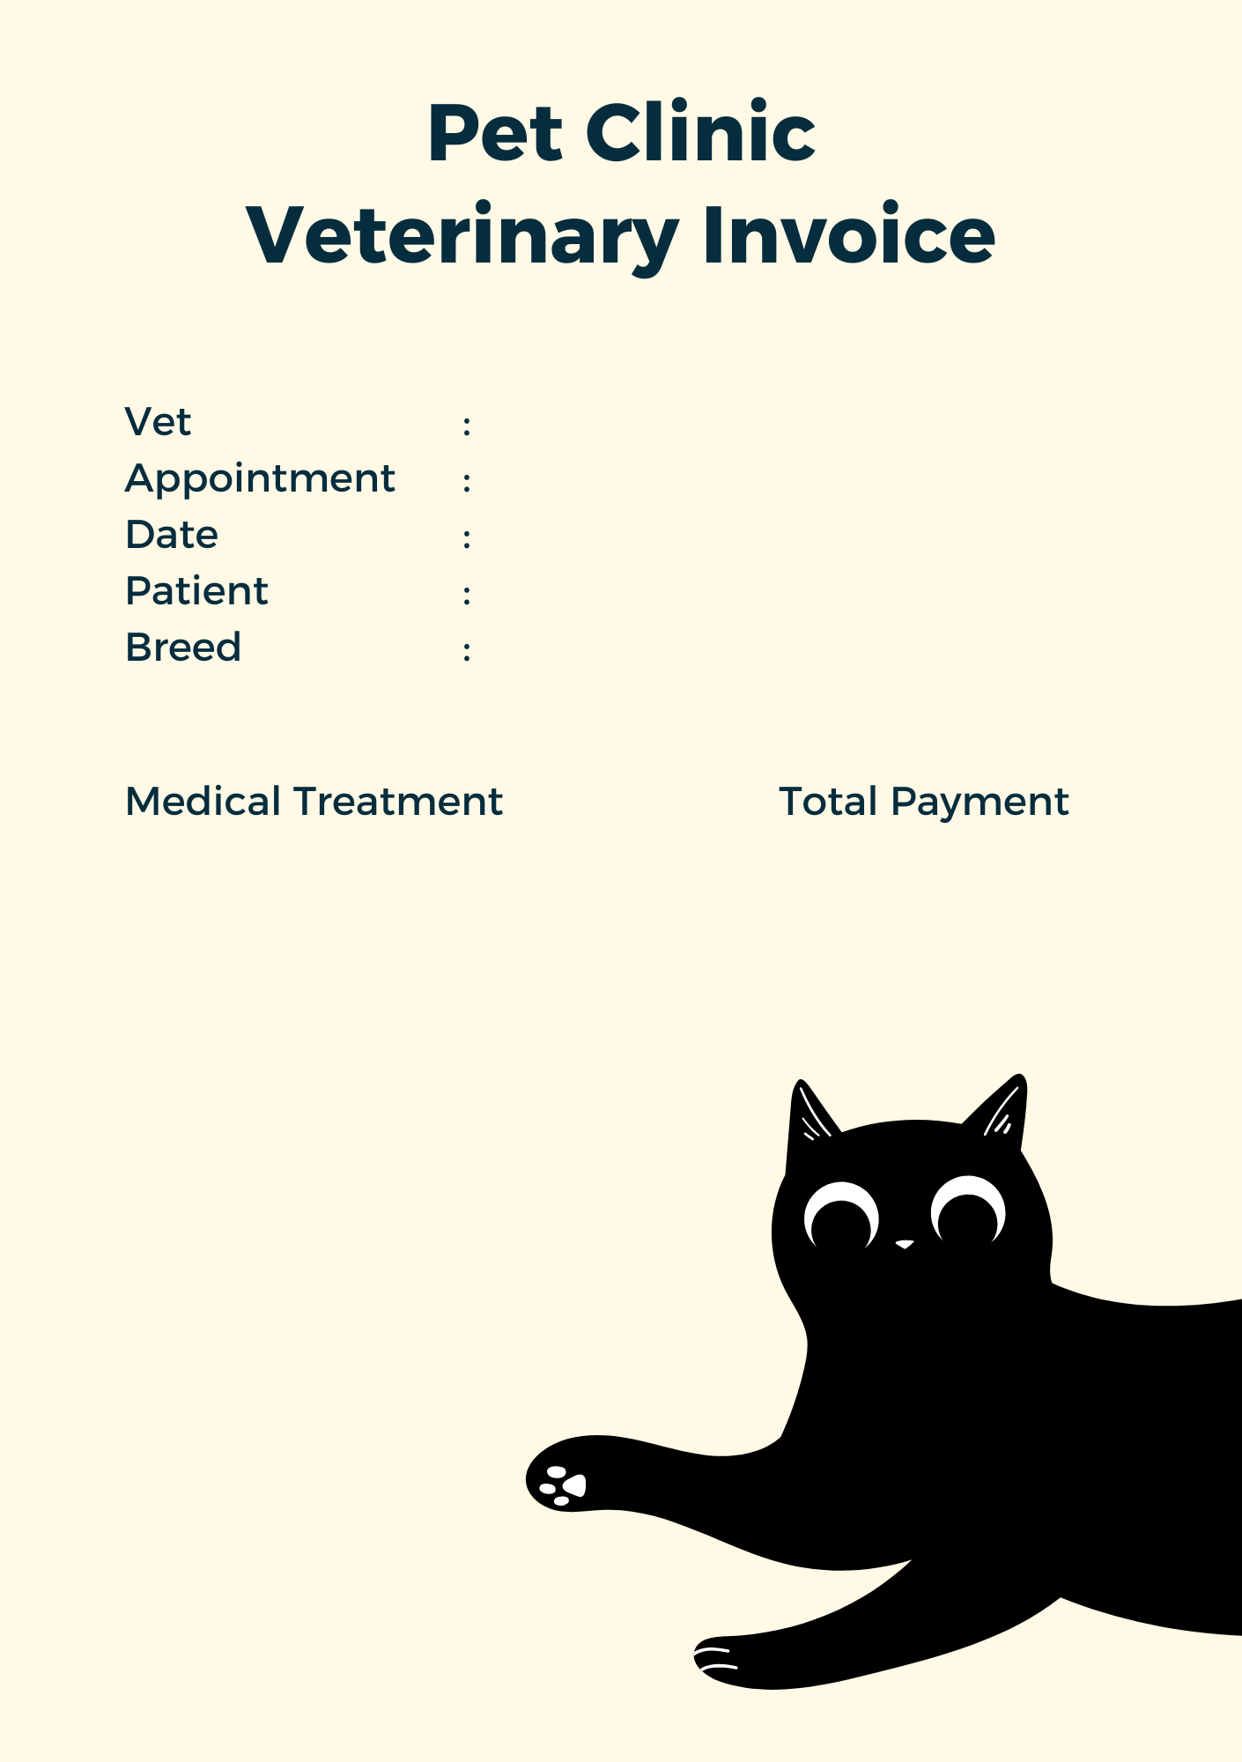

Vaccine

300000

Kitty

Zakiya

Persia

08/06/2024

Najwa