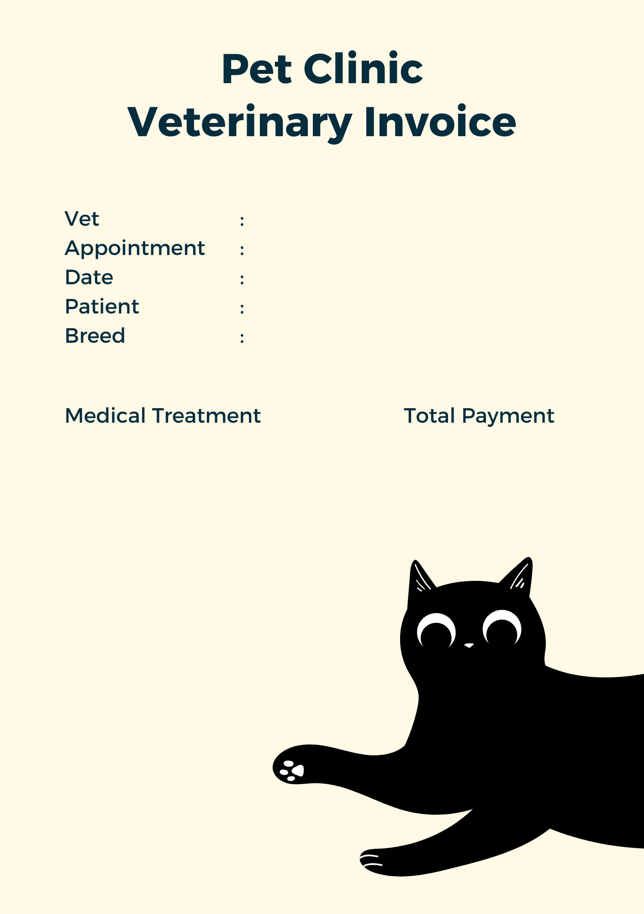

{{Medical_Treatment}}

{{Total_Payment}}

{{Patient}}

{{Appointment}}

{{Breed}}

{{Date}}

{{Vet}}