Date : 17-11-2019
Time : 9:00:34 pm

Number of driver:
- Driver 1 – yusuf sir

Position of phone : mounter
- Vertical
- Horizontal
- Tilt
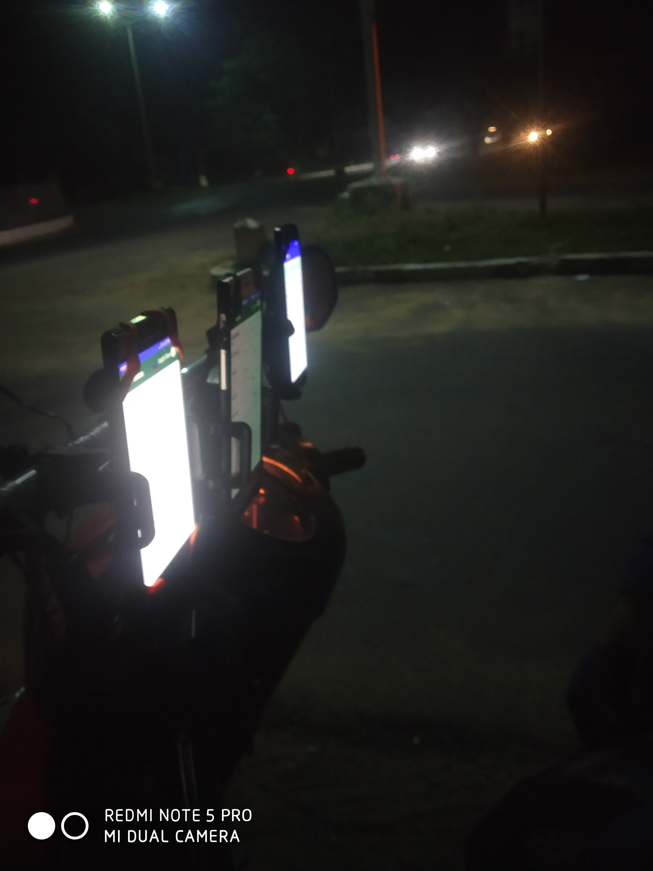
Picture of vertical position

Picture of horizontal position of phone
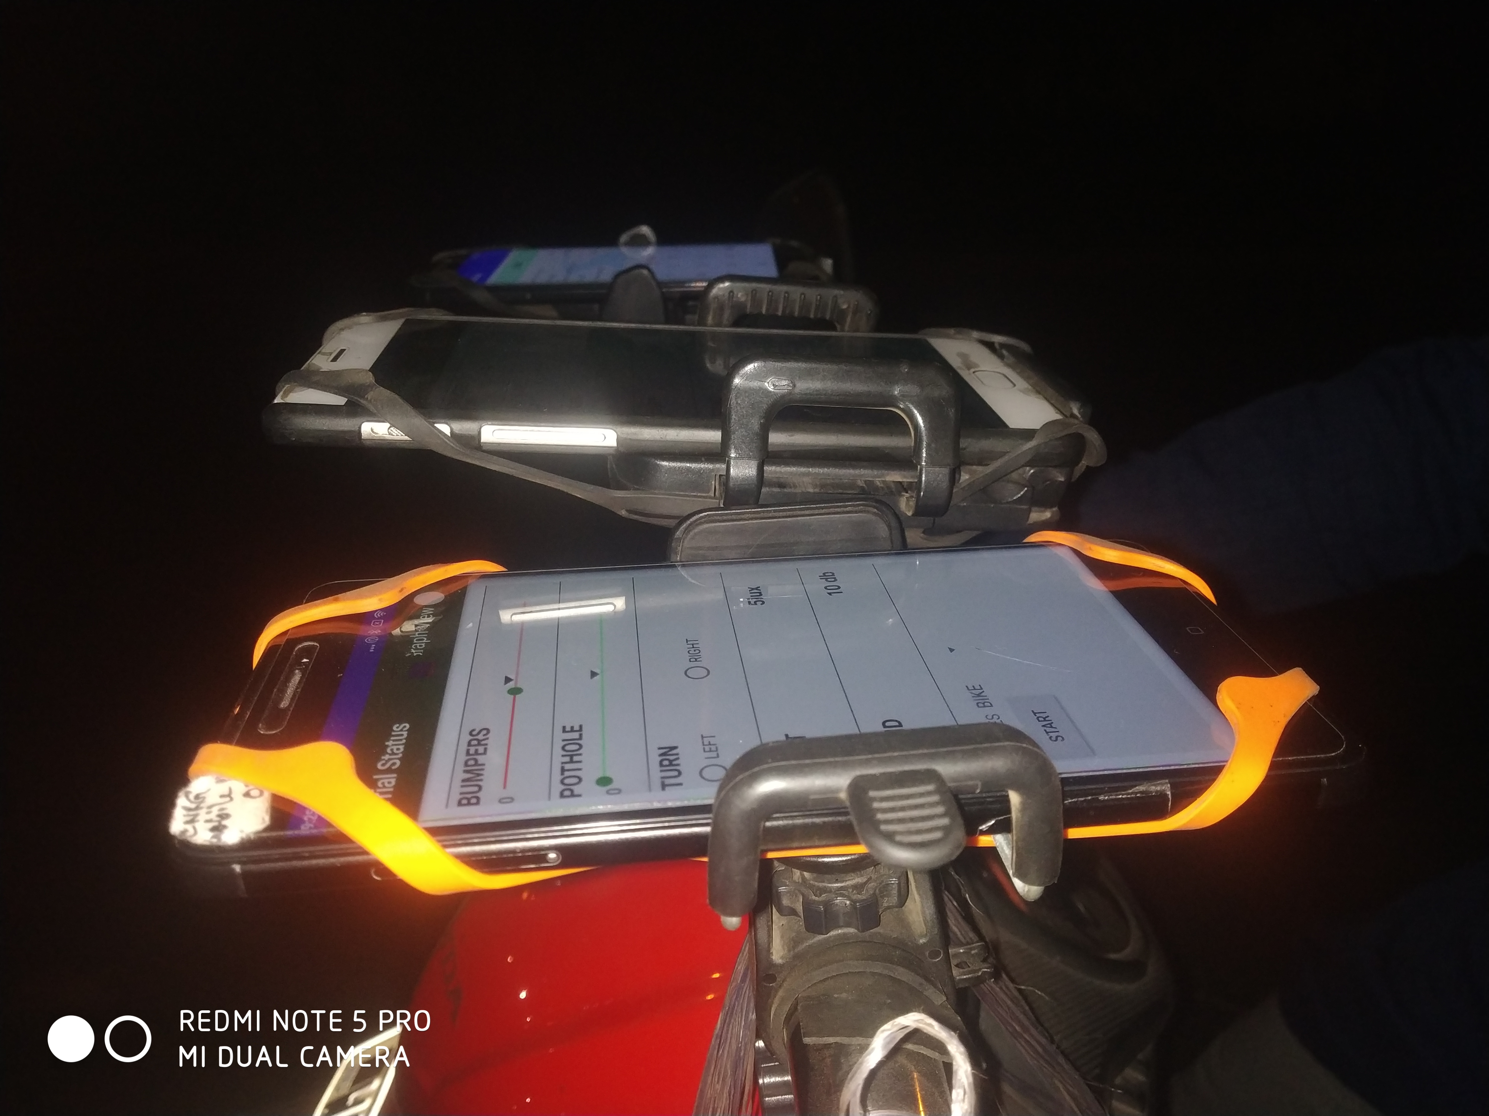

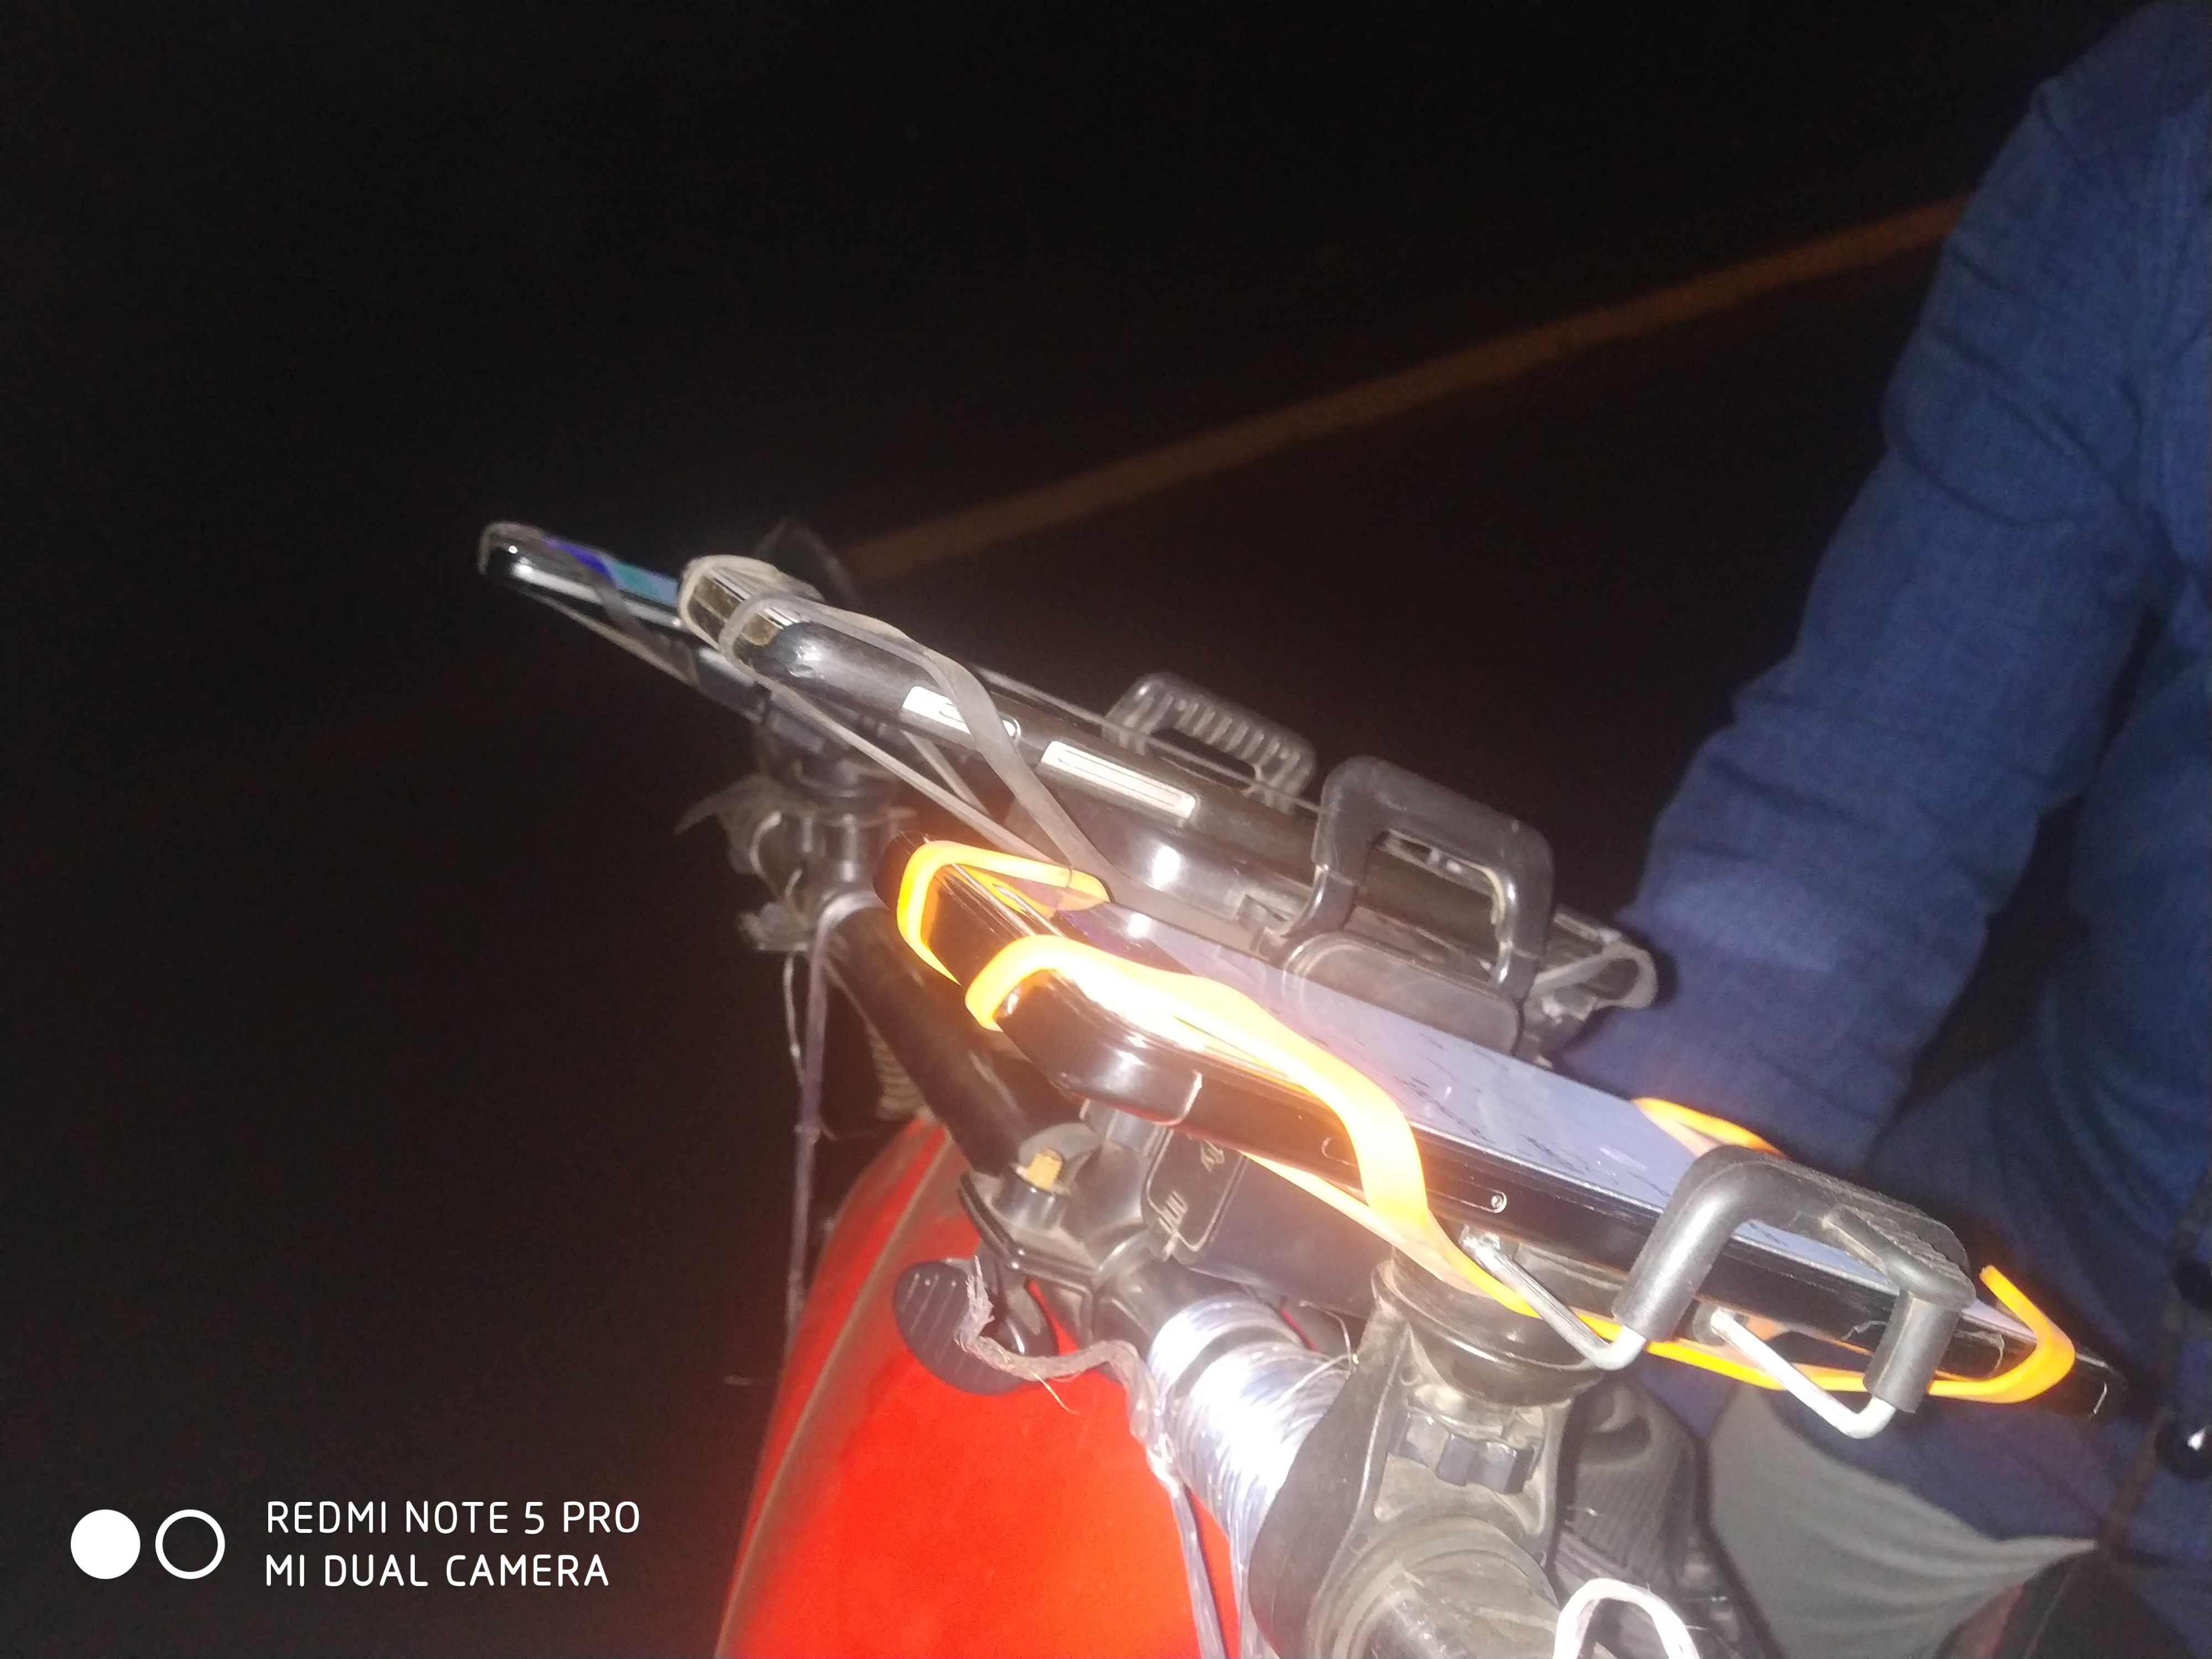
Picture of tilt position of phone

Vehicle type : 2 wheeler (scooty)

Number of phone : 2
- Redmi note4
- Oneplus3

Event type:
- Normal
- Break
- Speed breaker (there was 2 speed breaker)

Distance covered(for break and normal event): approx 1/2 km
Distance covered(for speed breaker event): approx 300 m

speed:
- low speed (less than 30)
- high speed (greater than 30)

Map:
For collecting data of break and normal event
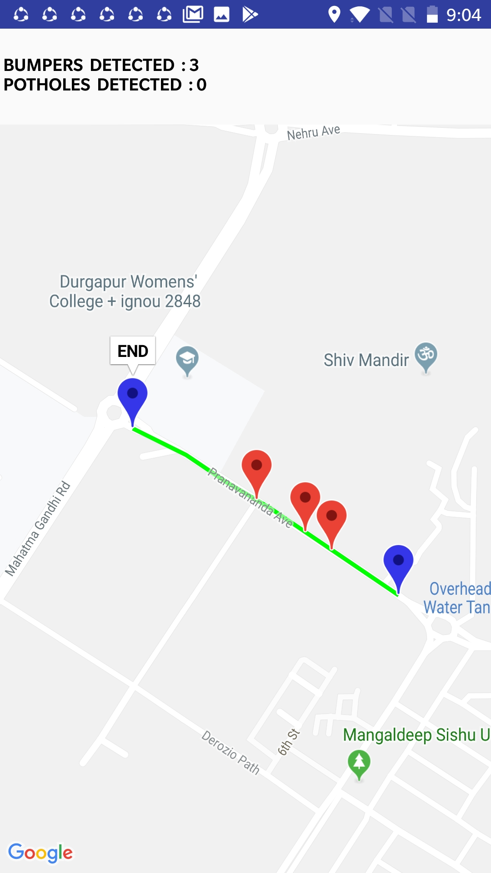

For collecting data of speed breaker event


