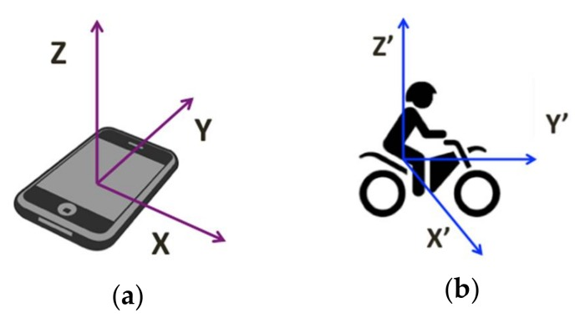
Phone type: one plus 3
Vehicle type: scooty
Position of phone: mounter

All turn is 90 degree.

In all the plot bellow blue line is actual data and red line is kalman filtered data of same data. And in all the plots we fixed the range of eery plot between -2 to 2

Left turn : (means we started vehice then after some time we took left turn and then after some time we stoped the vehicle)

Data sample 1:
GYROSCOPE Z axis (rad/s)
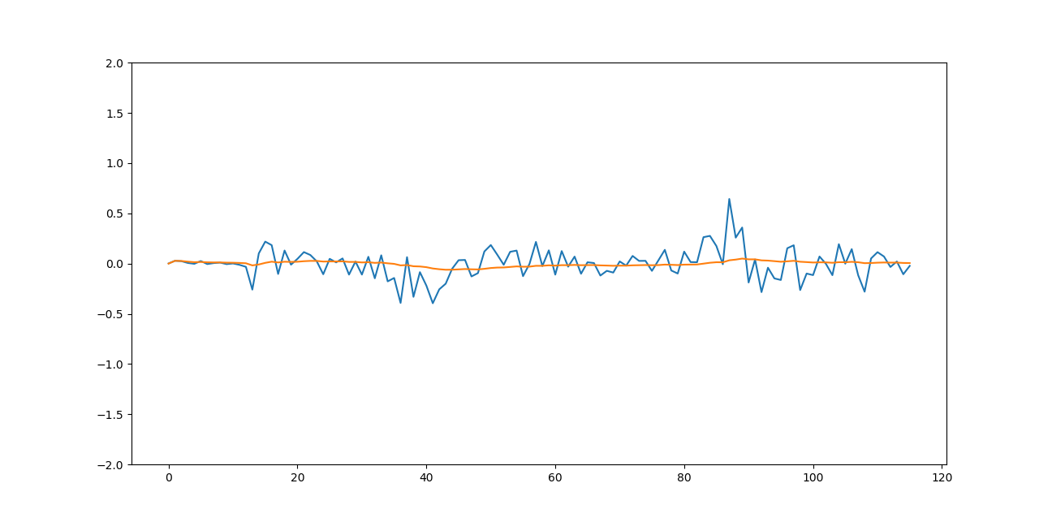
LINEAR ACCELERATION X axis(m/s²)
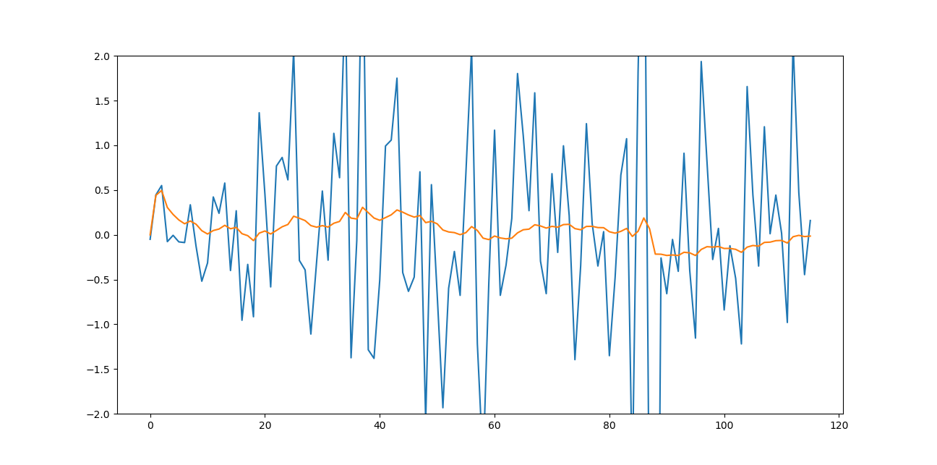
Data sample 2:

GYROSCOPE Z axis(rad/s)
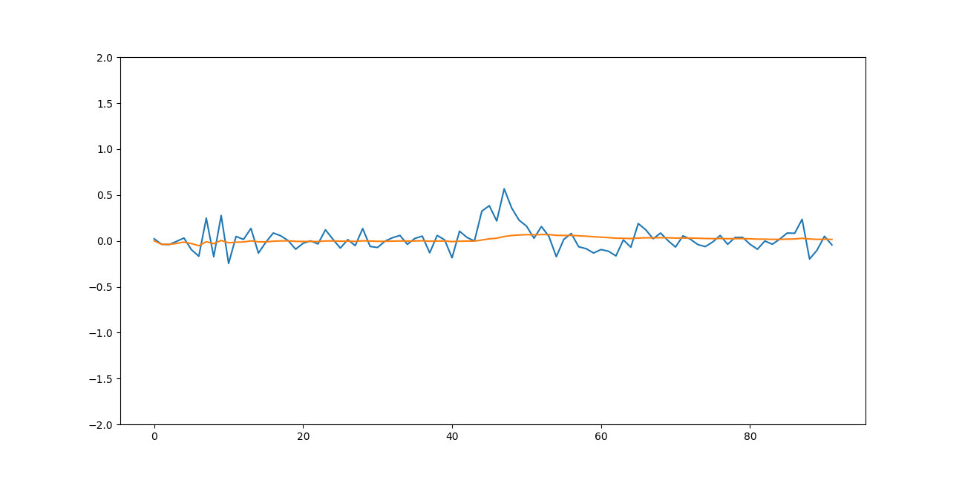

LINEAR ACCELERATION X axis(m/s²)
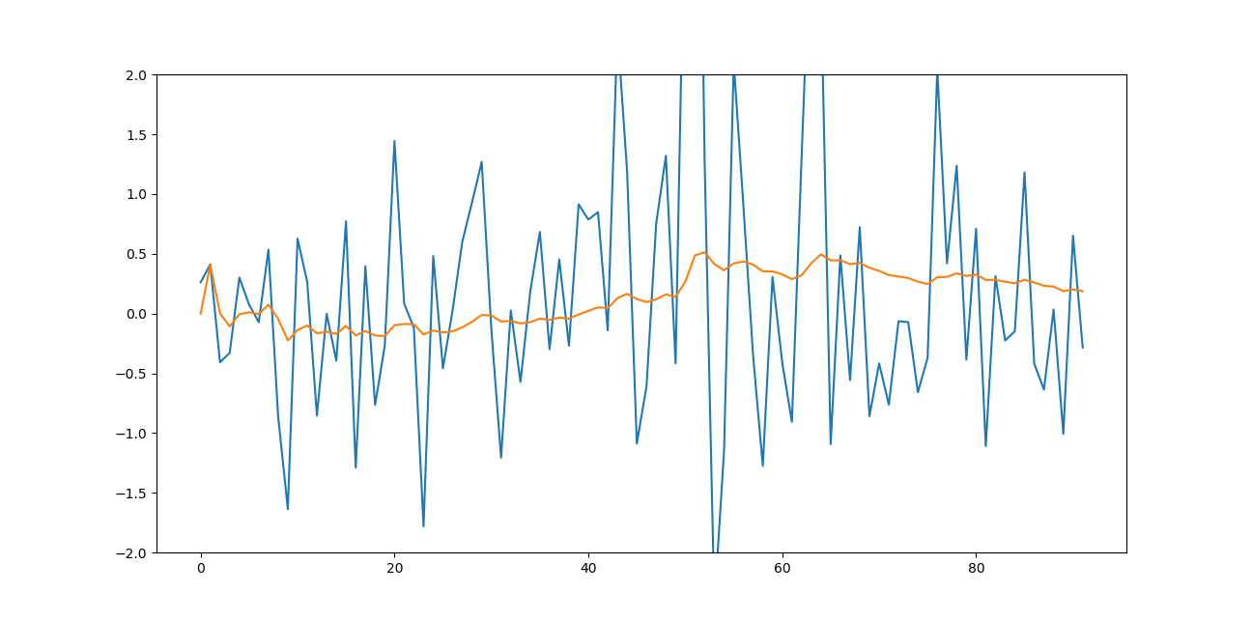
Left Left turn : (means we first took left turn then after some time again left turn )

GYROSCOPE Z axis(rad/s)
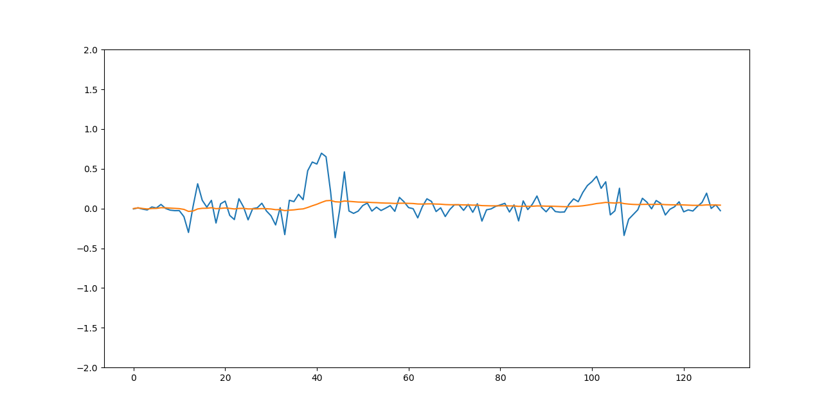
LINEAR ACCELERATION X axis(m/s²)
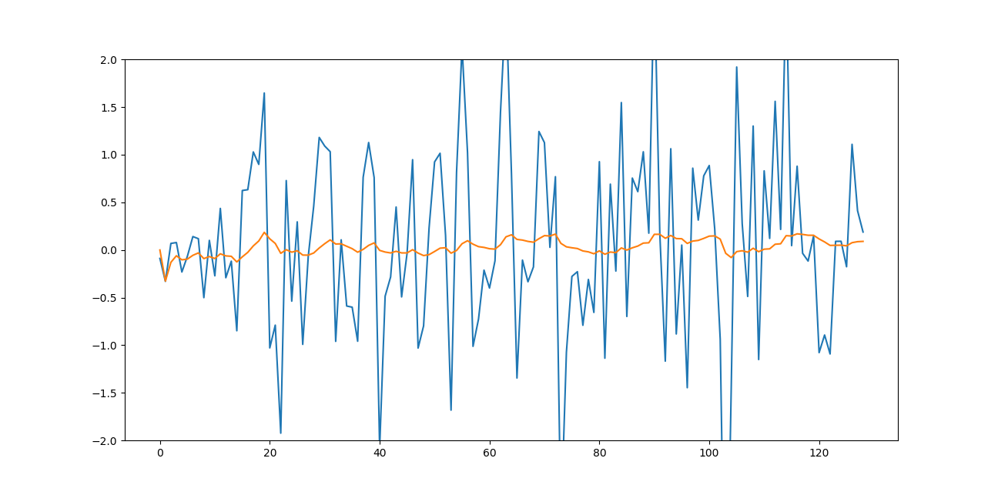
Left Right turn :(means we first took left turn then after some time took right turn )

GYROSCOPE Z axis(rad/s)
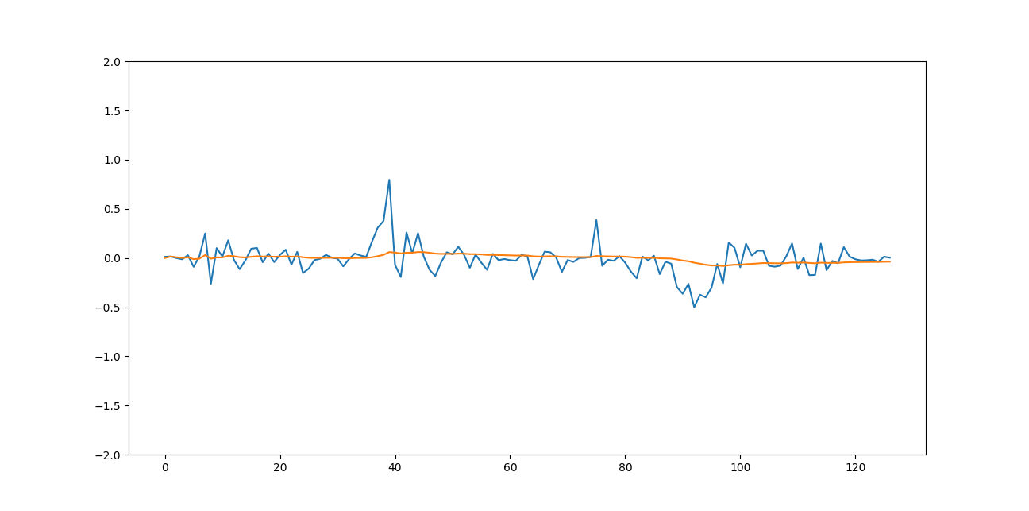
LINEAR ACCELERATION X axis(m/s²)
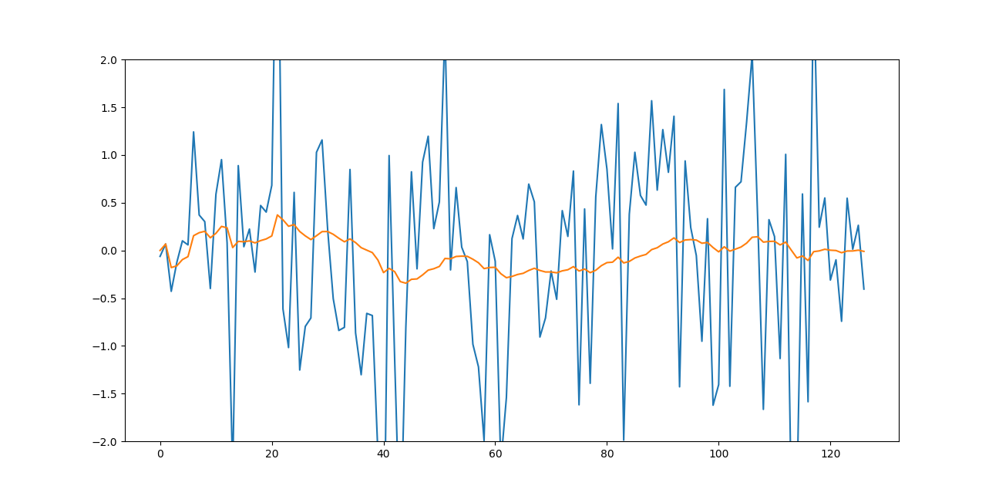
Left Right Left Left turn :(means we first took left turn then after some time we took right turn then left turn then again left turn)
GYROSCOPE Z axis(rad/s)
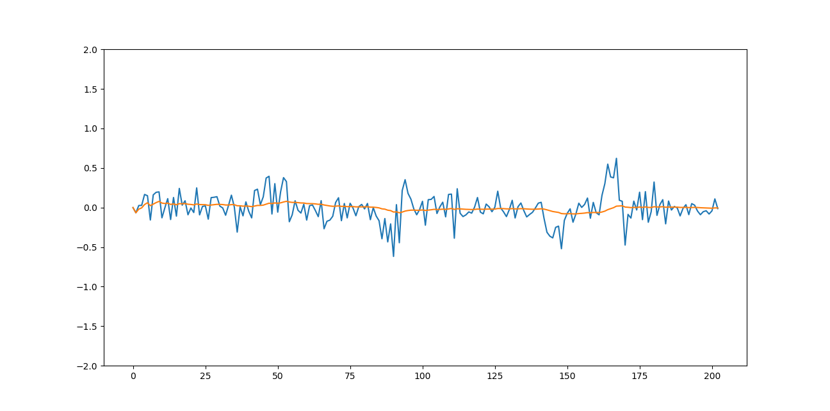
LINEAR ACCELERATION X axis(m/s²)
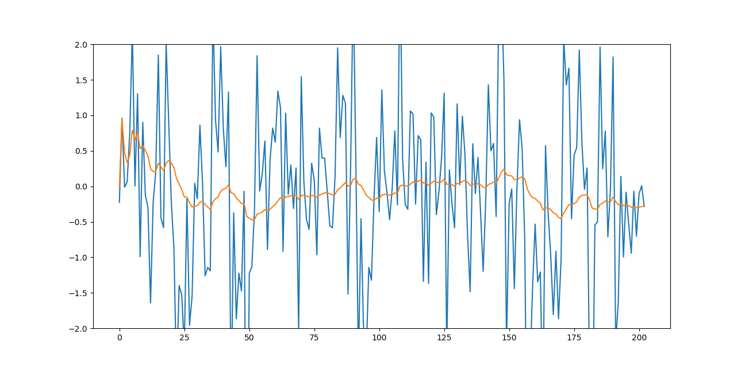

Left Right Right Left : (means we first took left turn then after some time right turn then after a while again right then left then after some time stoped the vehicle)
GYROSCOPE Z axis(rad/s)
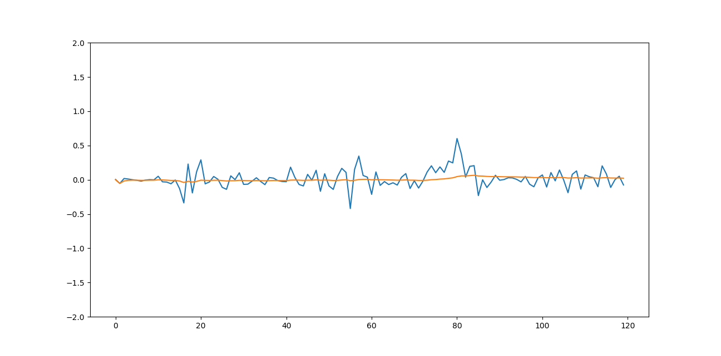
LINEAR ACCELERATION X axis(m/s²)
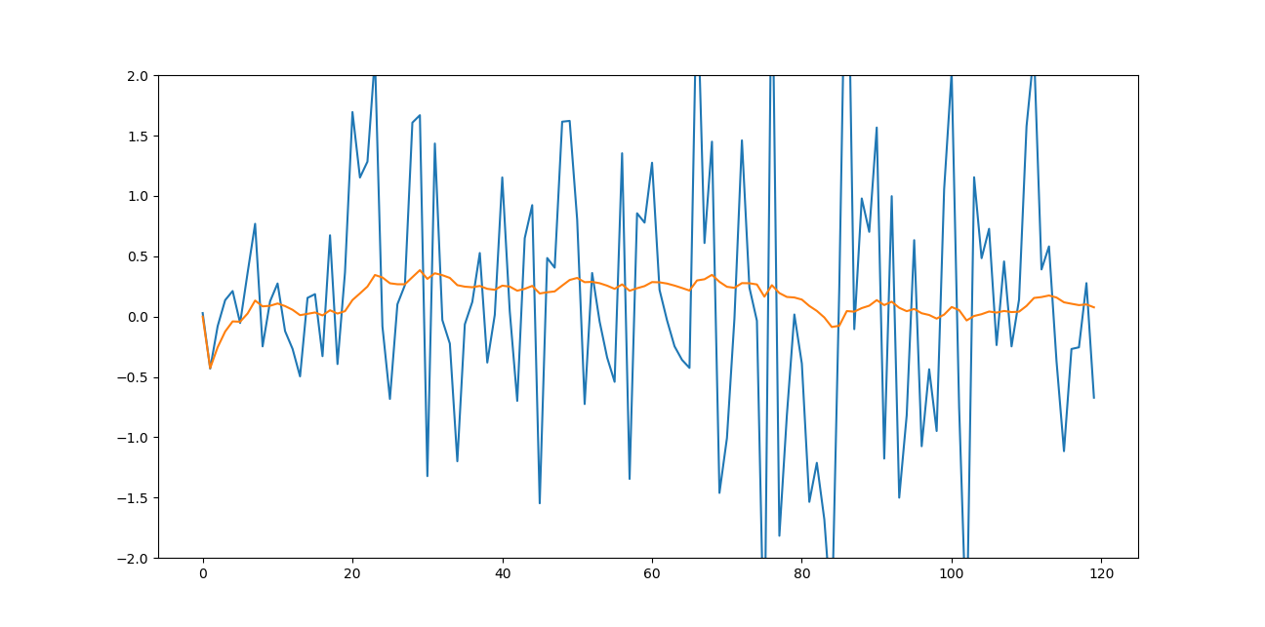
Right Left turn : (means we first took right turn then after some time left turn then after some time stoped the vehicle)
GYROSCOPE Z axis(rad/s)
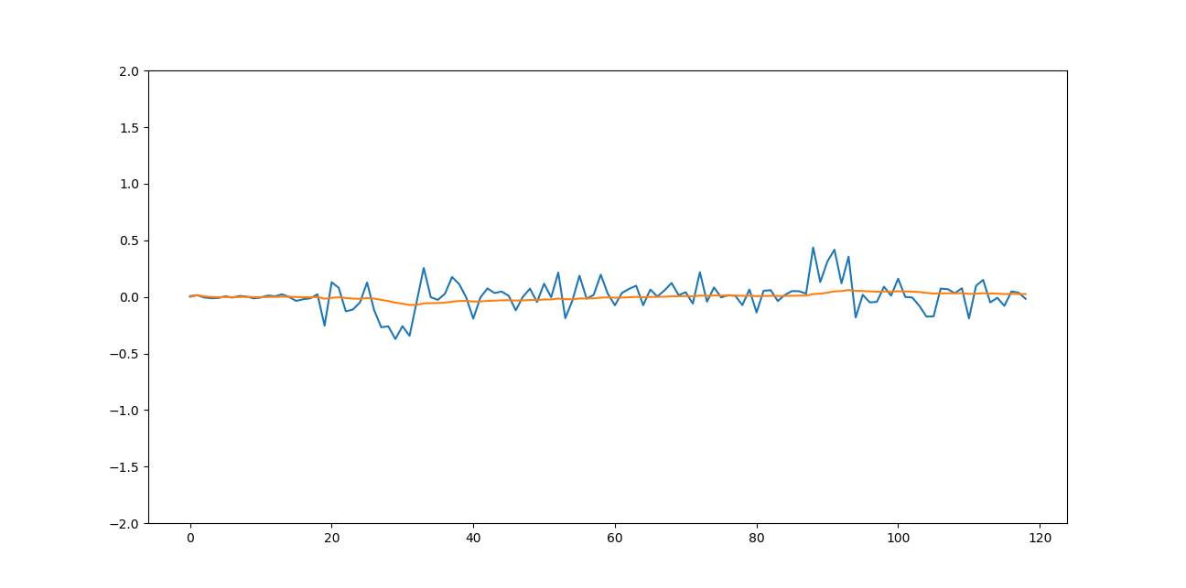
LINEAR ACCELERATION X axis(m/s²)
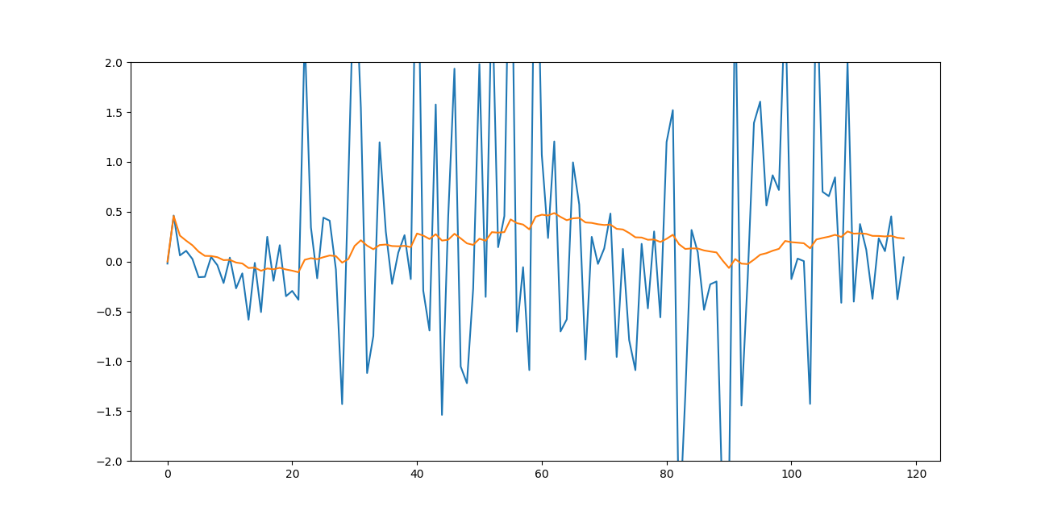
Right Right Turn :
GYROSCOPE Z axis(rad/s)
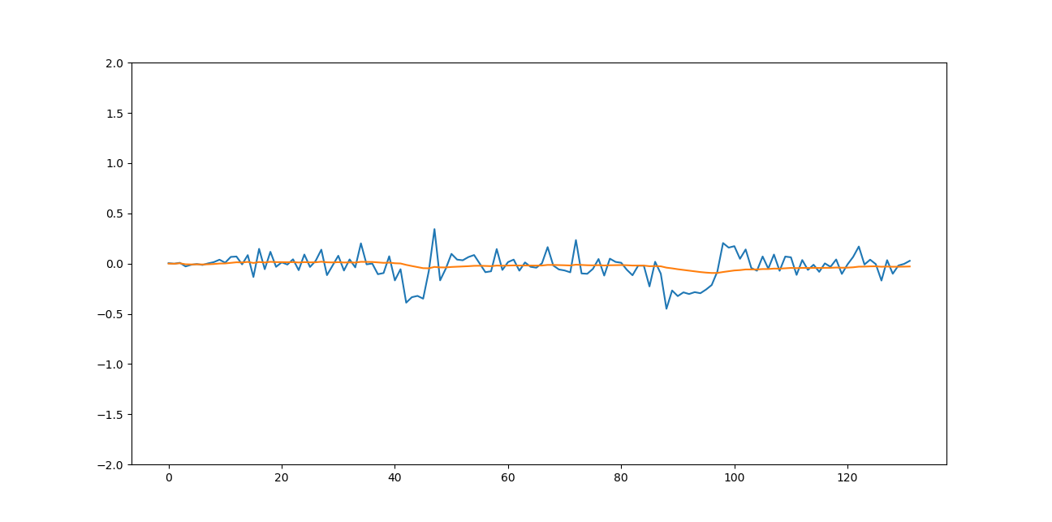
LINEAR ACCELERATION X axis(m/s²)
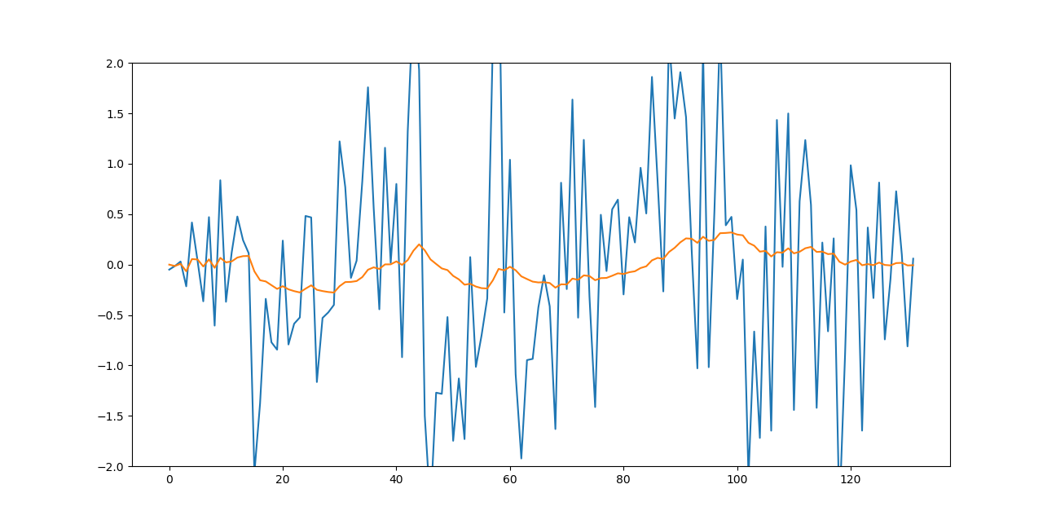
Right Right Left Right :
GYROSCOPE Z axis(rad/s)
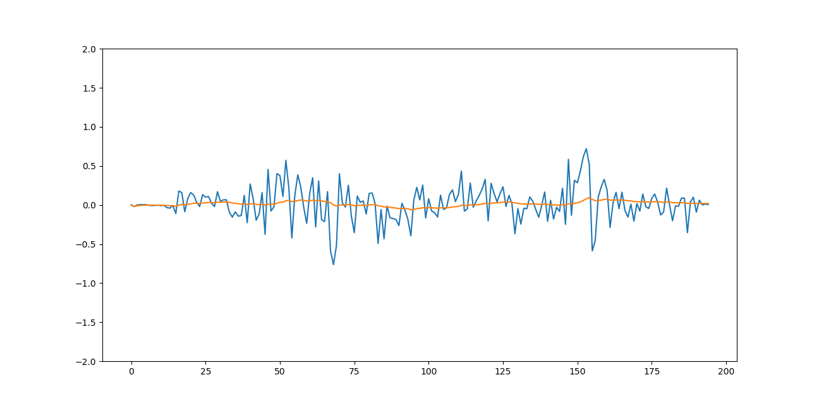

LINEAR ACCELERATION X axis(m/s²)
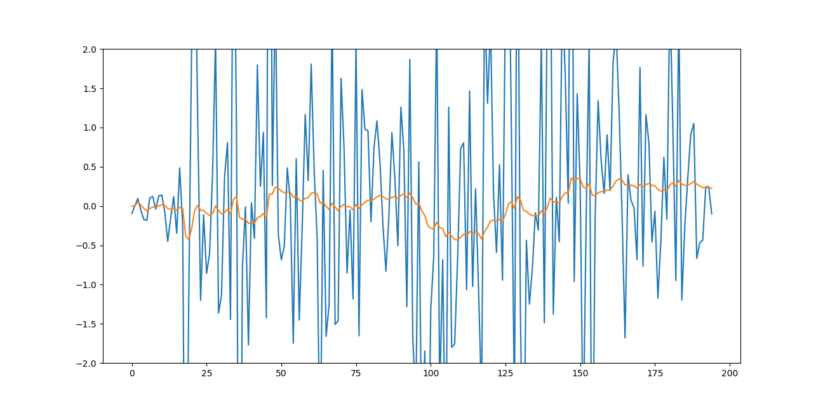
Normal : (No any turn taken in this data)

Data sample 1:
GYROSCOPE Z axis(rad/s)
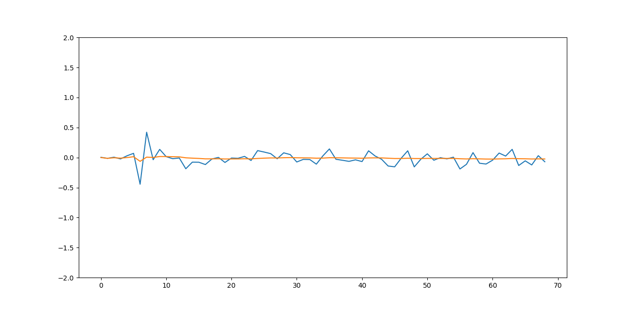
LINEAR ACCELERATION X axis(m/s²)
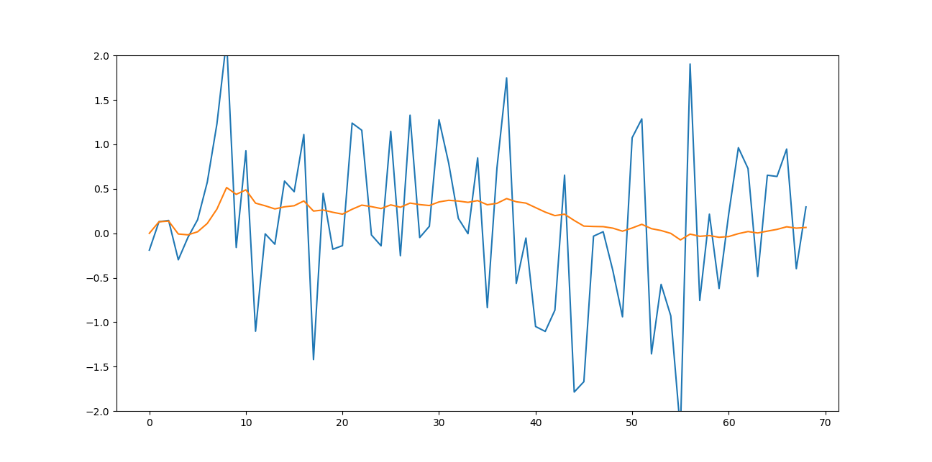

Data sample 2:
GYROSCOPE Z axis(rad/s)
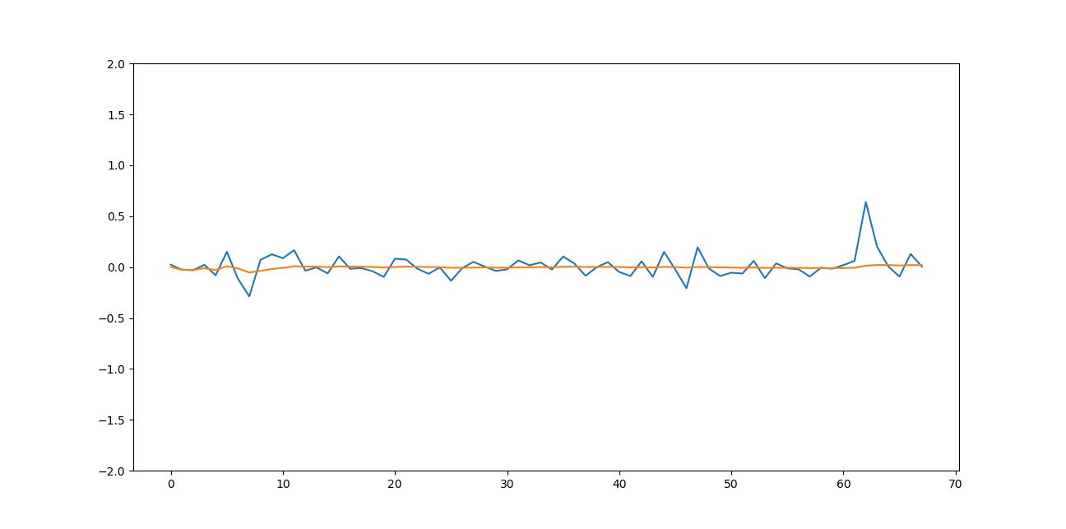
LINEAR ACCELERATION X axis(m/s²)
