Date : 26-11-2019
Time : 6:09:04 pm

Number of driver:
- Driver 1 – yusuf sir
- Driver 2 – Surbhi rani

Position of phone : mounter at vertical position

Vehicle type : 2 wheeler (scooty)

Number of phone : 1
- Oneplus3

Event type:
- Normal
- Break
- Speed breaker (there was 4 speed breaker)

Speed:
- low speed (less than 30)
- high speed (greater than 30)

Map:

For collecting data of break and normal event
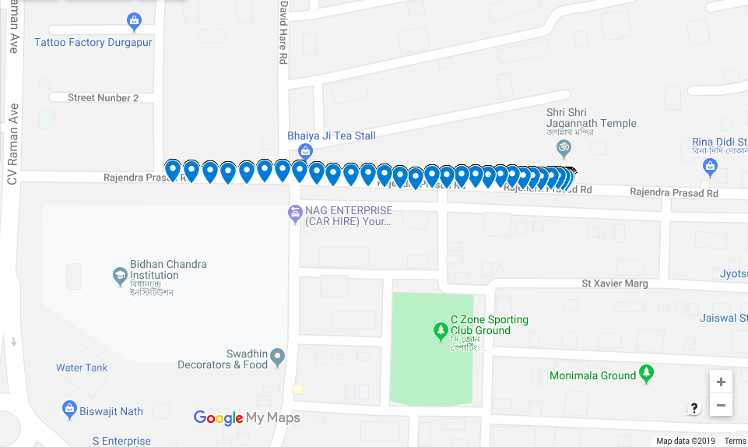

For collecting data of speed breaker event
