Trade Fair Stall Booking System

A PROJECT REPORT
Submitted by
Thakur Prince
Patel Keval
Under the Guidance of
Dr. Saziya Saiyed
In Partial fulfillment for the award of the degree Of

Master of Computer Applications – Sem 4



S.S. Agrawal Institute of Management and Technology

S. S. Agrawal College Campus, Agrawal Road, Navsari - 396445

Affiliated Under

Gujarat Technological University, Ahmedabad April 2026

S.S. Agrawal Institute of Management and Technology

Master of Computer Application Department
CERTIFICATE

This is to certify that the project entitled Trade Fair Stall Booking System
has been carried out by Thakur Prince (248060694110), Patel Keval (248060694060) under my guidance in partial fulfilment of the degree of Master of Computer Applications (MCA 4th Semester) in Gujarat Technological University, Ahmedabad during the academic year 2025-26.

Date:

Guide Name & Signature: Prof.

Examiners’ Signature:

1.
2.
3.

Dr Jinal Tailor Head of Department SSAIMT, Navsari

INDEX

TABLE OF CONTENTS
Index | Section | Page No.
1 | Introduction (Basic overview of System)
1.1 | Existing System (Manual or Automated System working)
1.2 | Need for the New System (disadvantages of existing system)
1.3 | Objectives of the New System (Main goal/objective of system)
1.4 | Problem Definition (2–3 lines about project definition)
1.5 | Core Components (platform, prg language, framework, QA)
1.6 | Project Profile (total activities in system development)
1.7 | Assumptions and Constraints
1.8 | Advantages and Limitations of the Proposed System
2 | Requirement Determination & Analysis
2.1 | Requirement Determination (anticipation, investigation, specification & feasibility)
2.2 | Targeted Users (end users)
3 | System Design
3.1 | Use Case Diagram
3.2 | Class Diagram
3.3 | Interaction Diagram
3.4 | Activity Diagram
3.5 | Data Dictionary (all database tables with description)
4 | Development
4.1 | Coding Standards
4.2 | Screen Shots
5 | Proposed Enhancements
6 | Conclusion
7 | Bibliography (web and book references)

Introduction (Basic Overview of System)

TradeFairBook is a web-based stall booking and management system developed to simplify the process of booking stalls in a trade fair. The system allows users to register, browse domes and stalls, upload Aadhaar details for verification, book stalls, make payments and track their bookings. It also provides an admin panel to manage domes, stalls, materials, bookings, approvals and reports.

Existing System (Manual or Automated System Working)

In the existing system, stall allocation and booking activities are generally handled manually or with limited record-keeping methods. Organizers maintain booking details, customer verification, stall status and payment information through paper records, phone calls, spreadsheets or separate files. This process consumes time and increases dependency on human effort.

Need for the New System (Disadvantages of Existing System)

The existing system has several drawbacks such as delayed booking confirmation, chances of duplicate stall allocation, poor record management, difficulty in tracking customer details and lack of centralized reporting. Manual handling also makes Aadhaar verification, payment tracking and admin monitoring less efficient. Therefore, a computerized system is needed to improve speed, accuracy, transparency and security.

Objectives of the New System (Main Goal/Objective of System)

The main objective of TradeFairBook is to automate the trade fair stall booking process and provide an easy-to-use digital platform for both users and administrators. It aims to manage stall availability, booking approval, document verification, payment processing, extra material selection and report generation in a centralized manner. The system also helps reduce manual errors and improve overall operational efficiency.

Problem Definition (2-3 Lines About Project Definition)

Trade fair organizers face difficulty in managing stall bookings, customer verification, and payment records through manual methods. TradeFairBook is designed to solve this problem by offering an integrated online system for stall booking, Aadhaar submission, booking approval and administrative control. The project ensures better data management and smoother coordination between users and organizers.

Core Components (Platform, Programming Language, Framework, QA)

- Platform: Web-based application
- Programming Languages: JavaScript, HTML, CSS
- Frontend Framework: React with Vite
- Backend Framework: Node.js with Express.js
- Database: MongoDB with Mongoose
- Authentication and Security: JWT, password hashing, Aadhaar data encryption
- File Upload: Multer
- QA and Testing: Node.js unit testing, Postman API testing, and manual functional testing

Project Profile (Total Activities in System Development)

The project includes requirement analysis, system design, database design, frontend development, backend API development, authentication and authorization, stall and dome management, booking workflow implementation, Aadhaar upload and verification, payment integration, report generation, testing, and maintenance. It covers both user-side and admin-side activities in a single system. The development follows a structured approach from planning to implementation and testing.

Assumptions and Constraints

Assumptions: Users have internet access, valid login credentials, and valid Aadhaar details for verification. Admins are responsible for approving or rejecting bookings and maintaining dome, stall, and material data.

Constraints: The system depends on internet connectivity, server availability, and database access. Payment processing depends on external gateway configuration. The system is mainly designed for trade fair stall booking and may require further customization for other domains.

Advantages and Limitations of the Proposed System

Advantages: The proposed system provides faster booking, centralized data storage, better security, reduced paperwork, improved accuracy, online verification, payment support, booking tracking, and admin reporting features. It improves transparency and saves time for both users and organizers.

Limitations: The system requires technical infrastructure, internet access, and proper admin monitoring. If the server, database, or payment service is unavailable, some operations may be affected. Users with limited digital knowledge may require basic guidance.

Requirement Determination and Analysis

Requirement determination and analysis is an important stage in the development of TradeFairBook. In this phase, the system requirements were identified, examined, and structured so that the proposed solution could satisfy both user needs and administrative needs. This phase helped define the project scope, system features, and technical feasibility.

Requirement Determination (Anticipation, Investigation, Specification and Feasibility)

Anticipation: At the initial stage, the expected needs of the system were identified by understanding the common issues faced in manual trade fair stall booking. It was anticipated that the new system should support online registration, dome and stall viewing, stall booking, Aadhaar submission, payment handling, booking approval, and report generation.

Investigation: The investigation stage focused on studying how the current booking process works and what problems exist in practice. The existing manual process was analyzed to identify delays, duplicate bookings, poor record maintenance, lack of proper verification, and difficulty in tracking booking status and payments. Based on this study, the major user and admin requirements were collected.

Specification: After gathering the requirements, they were clearly specified in the form of functional and non-functional requirements. Functional requirements include user registration and login, dome management, stall management, booking creation, Aadhaar upload, payment verification, admin approval or rejection, and report generation. Non-functional requirements include security, accuracy, usability, data consistency, performance, and easy maintenance.

Feasibility: The project was found to be feasible from technical, operational, and economic perspectives. Technically, the system can be developed using React, Node.js, Express.js, MongoDB, and related web technologies. Operationally, it is suitable for organizers and users because it reduces manual effort and improves workflow. Economically, it is cost-effective because it uses widely available tools and minimizes paperwork and repetitive manual tasks.

Targeted Users (End Users)

The targeted users of TradeFairBook are mainly exhibitors or business participants who want to book stalls in a trade fair through an online platform. These users can register in the system, view available domes and stalls, upload Aadhaar details, complete bookings, make payments, and check their booking history.
Another important group of targeted users is the trade fair administration team. Admin users manage domes, stalls, materials, booking requests, approvals, cancellations, and reports through the admin dashboard. In some cases, a super admin can also access higher-level controls such as sensitive booking verification details. Thus, the system is designed for both general users and authorized administrative users.

3 . System Design

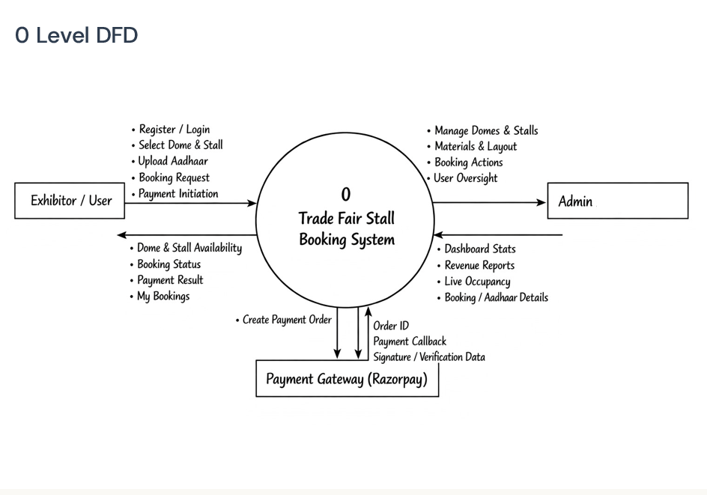

First Level (User)

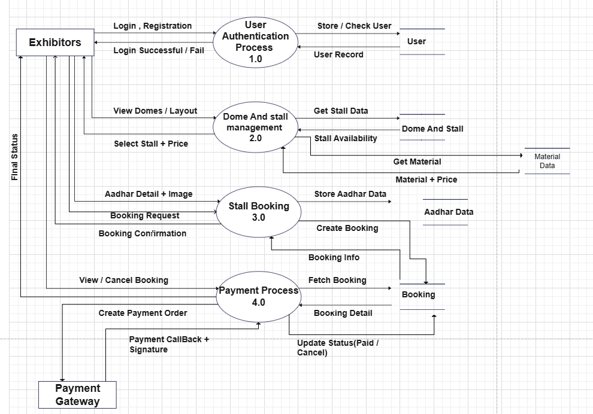

First Level (Admin)

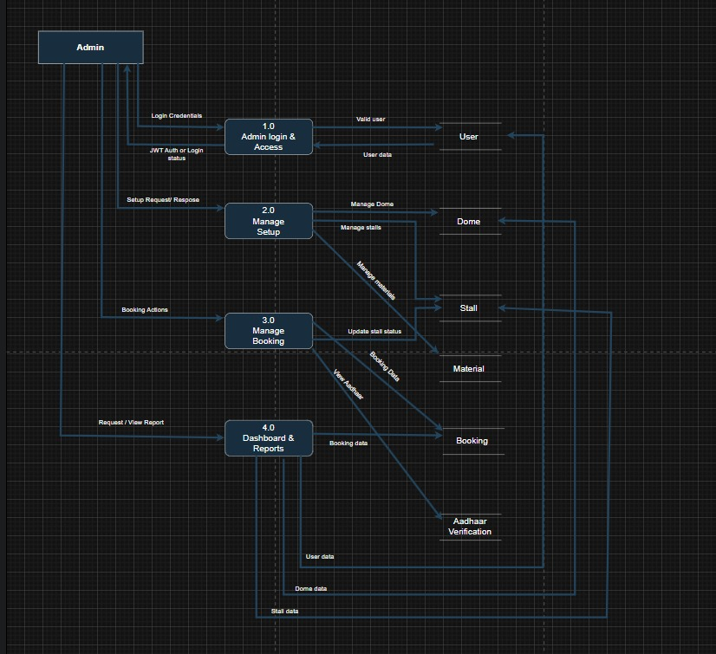

Second Level (Stall Booking)

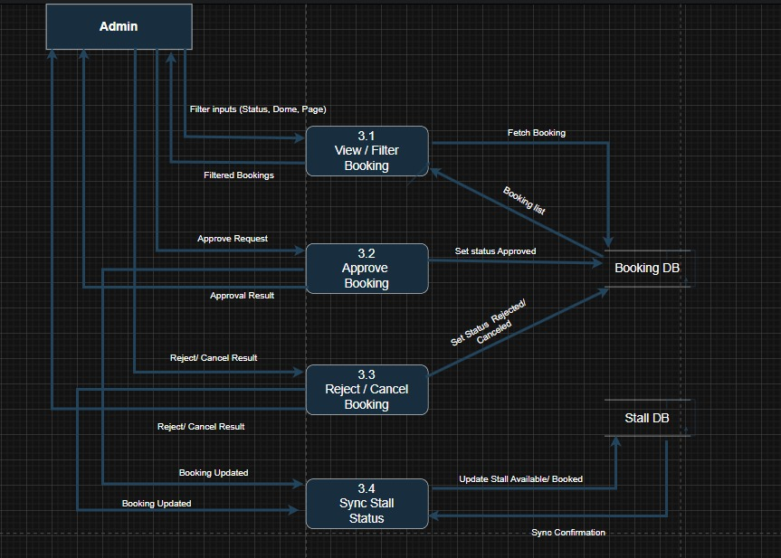

Second Level (Payment)

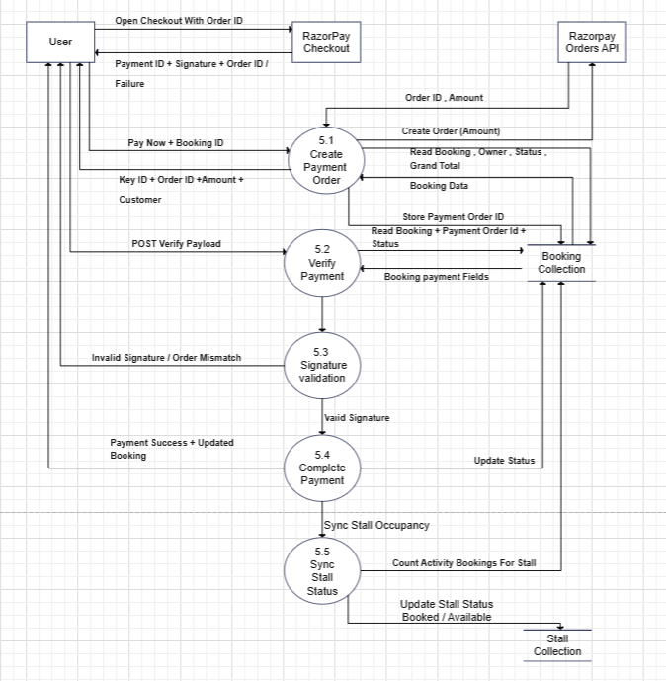

ER Diagram

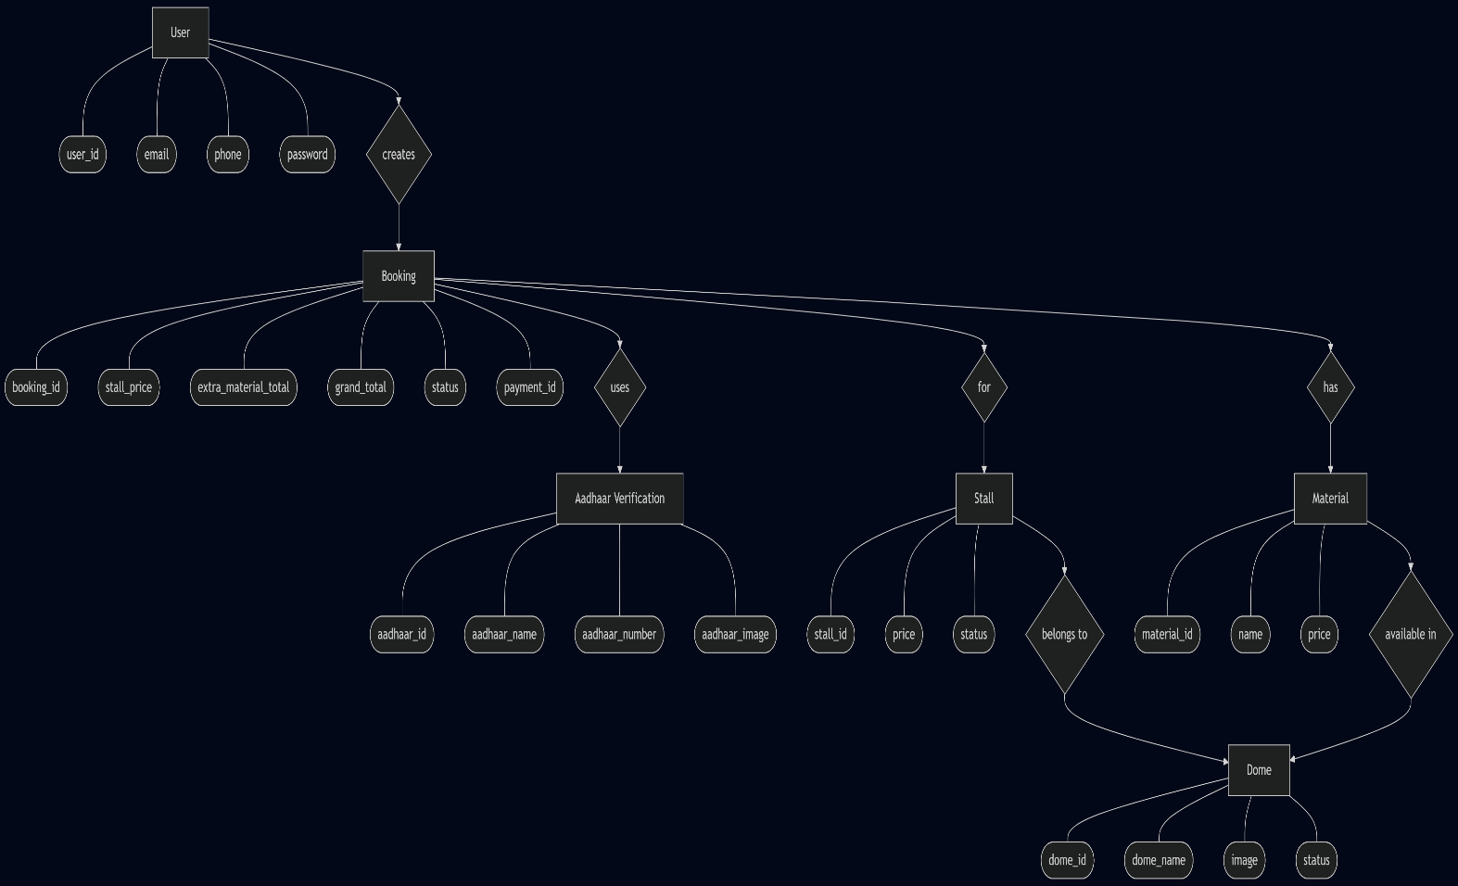

3.1 .Use Case Diagram

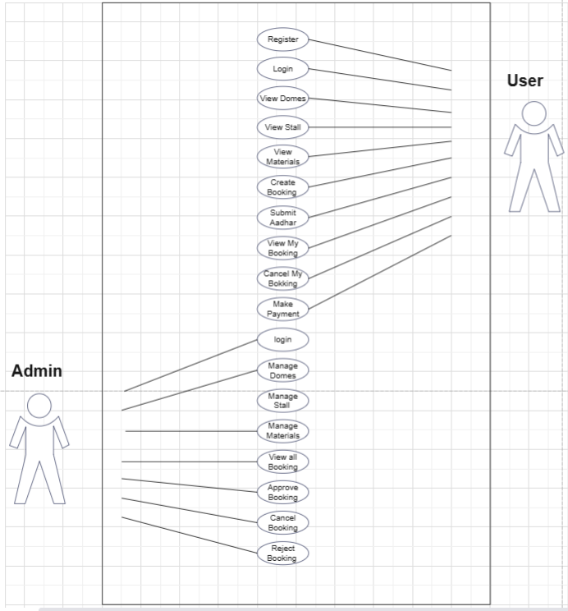

3.2 Class Diagram

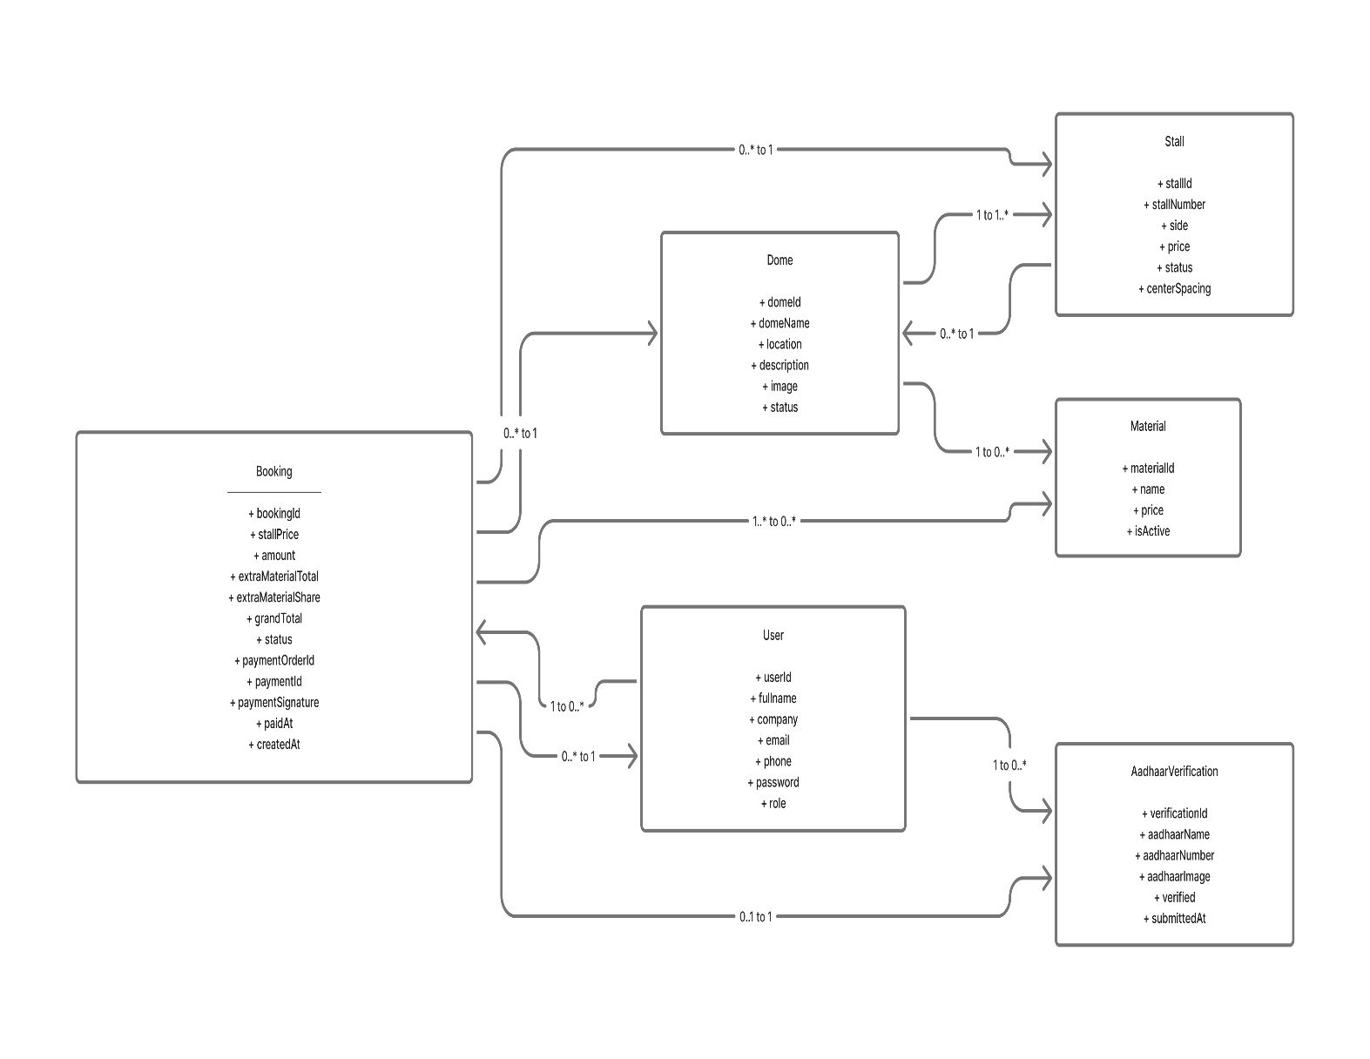

3.3 Interaction Diagram

3.4 Activity Diagram

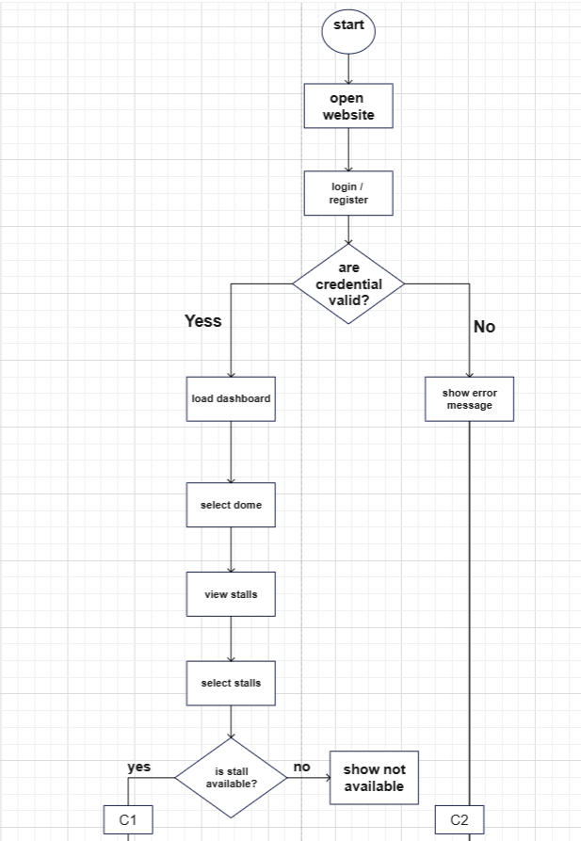

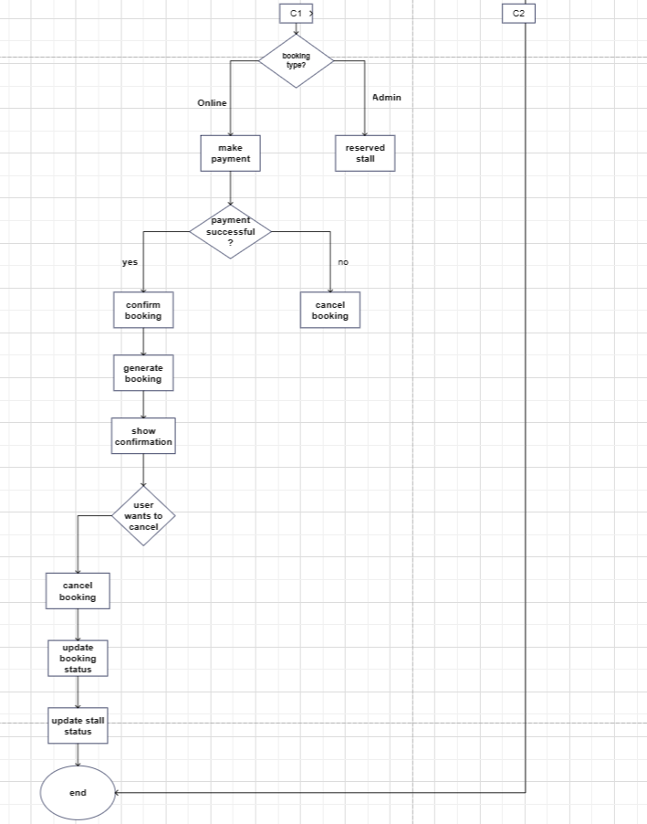

3.5 Data Dictionary (all database tables with description)
users Collection :
Contains account and identity details for all system actors. It is used for login/authentication, role-based authorization, and profile display. email is unique, password is stored as bcrypt hash, and role controls access (USER, ADMIN, SUPER_ADMIN).

SR.No | Column Name | Data type | Size | Constrain | Description
1 | _id | ObjectId | 24 hex chars | PK, Auto-generated | Unique user identifier
2 | fullname | String | Variable | Required | User full name
3 | company | String | Variable | Required | Company or organization name
4 | email | String | Variable | Required, Unique | User login email
5 | phone | String | Variable | Required | User phone number
6 | password | String | About 60 chars | Required | Bcrypt password hash
7 | role | String | Up to 11 chars | Enum: USER,ADMIN,SUPER_ADMIN; Default USER | Access control role
8 | createdAt | Date | 8 bytes | Auto (timestamps) | Record creation time
9 | updatedAt | Date | 8 bytes | Auto (timestamps) | Record last update time

domes Collection :
Master collection for exhibition halls/areas. Each dome acts as a parent entity for stalls and materials. Admin manages dome metadata (domeName, location, status, image), and dome status helps control whether a dome is active for operations.

SR.No | Column Name | Data type | Size | Constrain | Description
1 | _id | ObjectId | 24 hex chars | PK, Auto-generated | Unique dome identifier
2 | domeName | String | Variable | Required | Dome name
3 | location | String | Variable | Required | Dome location
4 | description | String | Variable | Optional | Dome description
5 | image | String | Variable | Optional | Dome image URL or path
6 | status | String | Up to 8 chars | Enum: ACTIVE,INACTIVE; Default ACTIVE | Dome status
7 | createdAt | Date | 8 bytes | Auto (timestamps) | Record creation time
8 | updatedAt | Date | 8 bytes | Auto (timestamps) | Record last update time

Stalls Collection:
Represents individual bookable units inside a dome. Each stall stores layout position (side), pricing, and real-time availability state. A unique composite rule (stallNumber + dome) prevents duplicate stall numbers within the same dome. Stall status is updated based on active bookings.

SR.No | Column Name | Data type | Size | Constrain | Description
1 | _id | ObjectId | 24 hex chars | PK, Auto-generated | Unique stall identifier
2 | stallNumber | String | Variable | Required, Trim, Unique with dome | Stall number or code
3 | dome | ObjectId | 24 hex chars | Required, FK -> domes._id | Dome reference
4 | side | String | Up to 6 chars | Required, Enum: LEFT,RIGHT,TOP,BOTTOM,CENTER | Stall side in layout
5 | price | Number | 8 bytes | Required, Min 0 | Stall price
6 | status | String | Up to 9 chars | Enum: AVAILABLE,BOOKED,HOLD,BLOCKED; Default AVAILABLE | Availability status
7 | centerSpacing | String | Up to 10 chars | Enum: with-space,no-space; Default with-space | Center layout spacing flag
8 | createdAt | Date | 8 bytes | Auto (timestamps) | Record creation time
9 | updatedAt | Date | 8 bytes | Auto (timestamps) | Record last update time
Bookings Collection :
Main transactional collection of the system. Each document links user, stall, dome, Aadhaar verification, pricing, selected materials, and payment details. Booking lifecycle is managed using status values (PENDING, APPROVED, PAID, REJECTED, CANCELLED). Payment metadata (paymentOrderId, paymentId, paymentSignature, paidAt) tracks payment completion.

SR.No | Column Name | Data type | Size | Constrain | Description
1 | _id | ObjectId | 24 hex chars | PK, Auto-generated | Unique booking identifier
2 | user | ObjectId | 24 hex chars | FK -> users._id | User reference
3 | stall | ObjectId | 24 hex chars | FK -> stalls._id | Stall reference
4 | dome | ObjectId | 24 hex chars | FK -> domes._id | Dome reference
5 | stallPrice | Number | 8 bytes | Default 0 | Base stall price
6 | amount | Number | 8 bytes | Optional | Booking amount
7 | defaultMaterials | Array<Object> | Variable | Default [] | Included material snapshot
8 | extraMaterials | Array<Object> | Variable | Default [] | Extra material snapshot
9 | extraMaterialTotal | Number | 8 bytes | Default 0 | Total extra material cost
10 | extraMaterialShare | Number | 8 bytes | Default 0 | Per booking distributed share
11 | grandTotal | Number | 8 bytes | Default 0 | Final total amount
12 | aadhaarVerification | ObjectId | 24 hex chars | Required, FK -> aadhaarverifications._id | Aadhaar verification reference

Aadhaar Verifications Collection:

Stores KYC/identity verification submitted before booking confirmation. Linked to a user and includes Aadhaar name, encrypted Aadhaar number, uploaded image path, verification flag, and submission time. Sensitive Aadhaar number is encrypted before save and hidden from normal API responses.

SR.No | Column Name | Data type | Size | Constrain | Description
1 | _id | ObjectId | 24 hex chars | PK, Auto-generated | Unique verification identifier
2 | user | ObjectId | 24 hex chars | Required, FK -> users._id | User reference
3 | aadhaarName | String | Variable | Required, Trim | Name as on Aadhaar
4 | aadhaarNumber | String | Encrypted variable text | Required, select:false, API expects 12 digits | Encrypted Aadhaar number
5 | aadhaarImage | String | Variable | Required, Trim | Uploaded image path
6 | verified | Boolean | 1 byte | Default false | Verification status
7 | submittedAt | Date | 8 bytes | Default Date.now | Submission timestamp
8 | createdAt | Date | 8 bytes | Auto (timestamps) | Record creation time
9 | updatedAt | Date | 8 bytes | Auto (timestamps) | Record last update time

Payments Collection :

SR.No | Column Name | Data type | Size | Constrain | Description
13 | status | String | Up to 9 chars | Enum: PENDING,APPROVED,PAID,REJECTED,CANCELLED; Default PENDING | Booking lifecycle status
14 | paymentOrderId | String | Variable | Trim, Default empty | Razorpay order ID
15 | paymentId | String | Variable | Trim, Default empty | Razorpay payment ID
16 | paymentSignature | String | Variable | Trim, Default empty | Payment signature
17 | paidAt | Date | 8 bytes | Default null | Payment timestamp
18 | createdAt | Date | 8 bytes | Auto (timestamps) | Record creation time
19 | updatedAt | Date | 8 bytes | Auto (timestamps) | Record last update time

defaultMaterials[] (embedded):-Stores included/free materials as a booking-time snapshot, so future catalog changes do not affect old bookings. Contains fields like name, quantity, price, and subtotal.

extraMaterials[] (embedded):-Stores selected paid extra materials as a booking-time snapshot, including materialId, name, price, quantity, and subtotal. Preserves historical price/quantity for auditing and billing.

SR.No | Column Name | Data type | Size | Constrain | Description
1 | _id | ObjectId | 24 hex chars | PK, Auto-generated | Unique material identifier
2 | dome | ObjectId | 24 hex chars | Required, FK -> domes._id | Dome reference
3 | name | String | Variable | Required, Trim, Unique with dome | Material name
4 | price | Number | 8 bytes | Required, Min 0 | Material price
5 | description | String | Variable | Default empty, Trim | Material description
6 | isActive | Boolean | 1 byte | Default true | Material active flag
7 | createdAt | Date | 8 bytes | Auto (timestamps) | Record creation time
8 | updatedAt | Date | 8 bytes | Auto (timestamps) | Record last update time
- Development

The development phase of TradeFairBook focused on converting the system design into a working web application for trade fair stall booking and management. The project was developed as a full-stack application with separate frontend and backend modules to handle user operations, admin controls, and database processing.

The frontend was developed using React and Vite. It provides interfaces for user registration, login, dome selection, stall viewing, Aadhaar upload, booking management, and profile-related activities. Separate admin pages were also created for dashboard access, booking approval, dome and stall management, material management, and report viewing.

The backend was developed using Node.js and Express.js. It handles authentication, booking creation, stall and dome management, Aadhaar verification, payment processing, and report generation. MongoDB was used as the database, and Mongoose was used to define and manage the collections such as User, Dome, Stall, Booking, Material, and AadhaarVerification.

During development, security and modularity were given importance. JWT was used for authentication, environment variables were used for sensitive configuration, and middleware was used for authorization and file upload handling. Testing was also carried out using Node.js test cases, Postman API validation, and manual functional testing. Thus, the development phase helped build a complete and organized system for both users and administrators.

  - Coding Standards
Coding standards are a set of rules followed during software development to maintain uniformity, readability, and quality of code. In the TradeFairBook project, coding standards were followed to make the source code easy to understand, test, debug, and maintain.
The following coding practices were used in the project:
- Meaningful names were used for variables, functions, components, and files.
- Proper indentation and spacing were maintained throughout the frontend and backend code.
- The code was divided into modules such as controllers, routes, models, middleware, services, and components.
- Reusable functions and components were preferred to avoid duplicate code.
- Error handling and validation were added in APIs for safer execution.
- Sensitive values such as database URL, JWT secret, and payment keys were stored in environment variables.
- Comments were added only where necessary to improve understanding.
- Consistent naming conventions were followed across the project.
- Small and focused functions were used to improve readability and maintenance.
- Database models and API routes were organized clearly to support future enhancements.
According to GeeksforGeeks, coding standards improve readability, maintainability, code reuse, and error detection. Following these standards in TradeFairBook helped in building a cleaner and more reliable system.

  - Screen Shots

- Home page

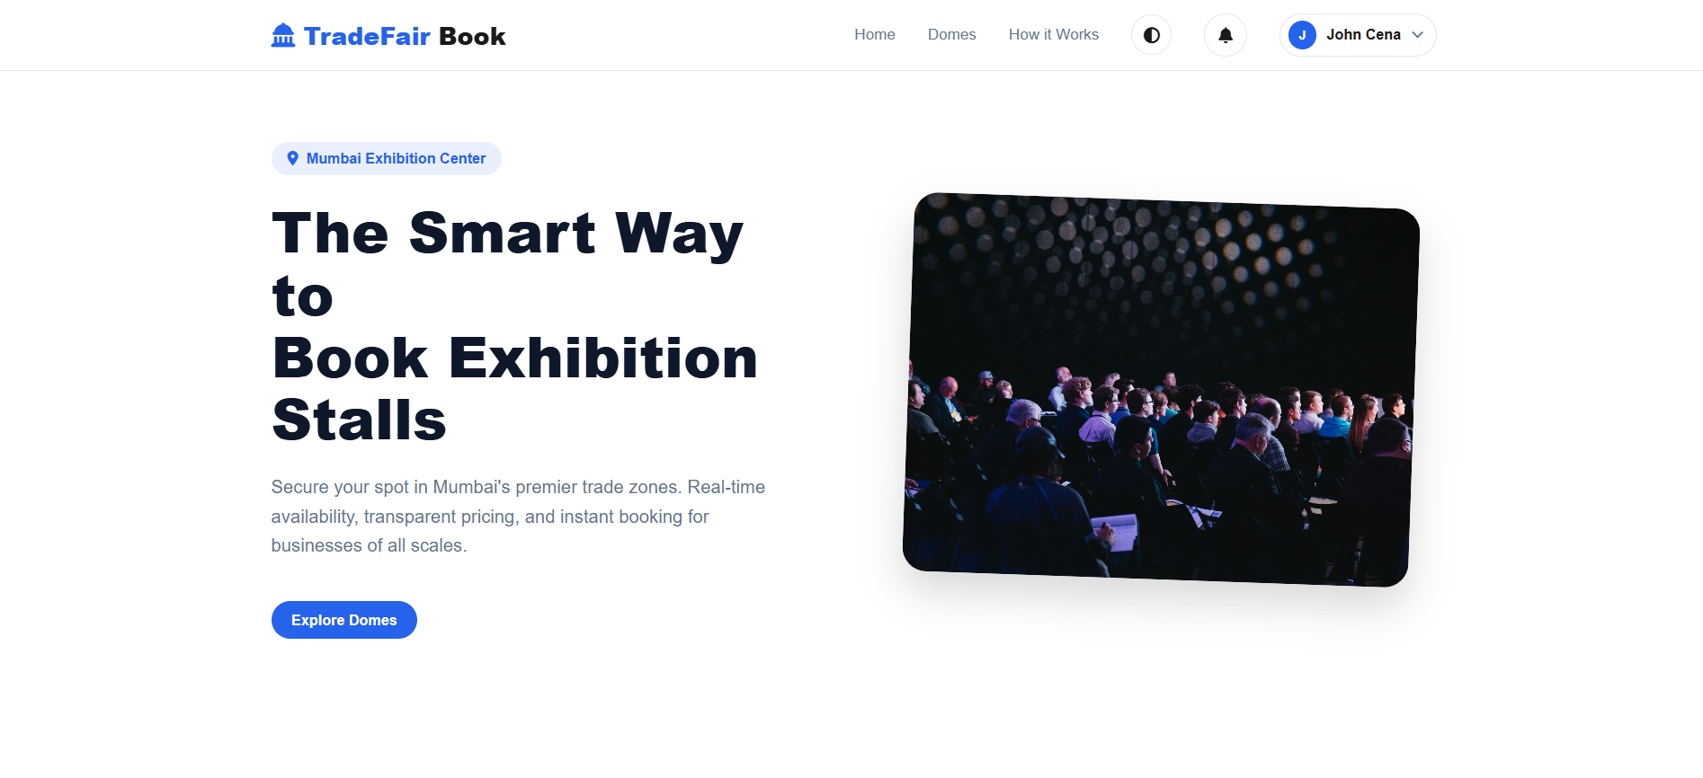

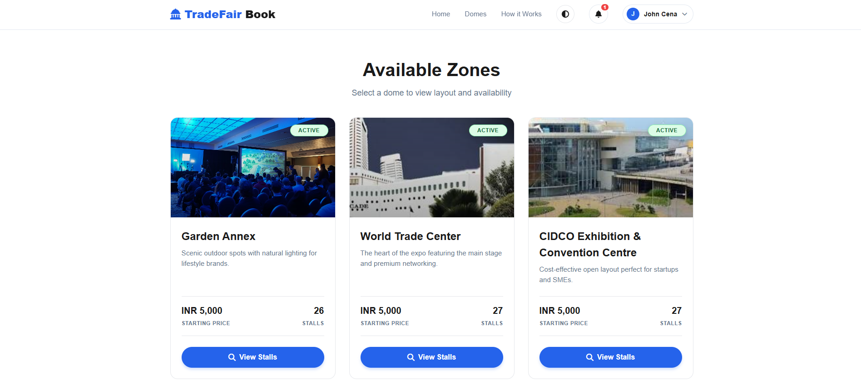

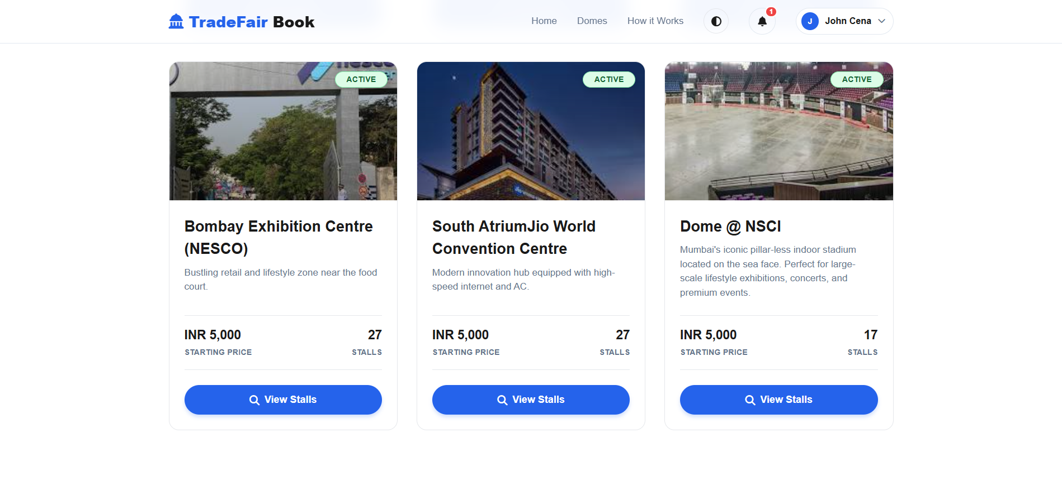

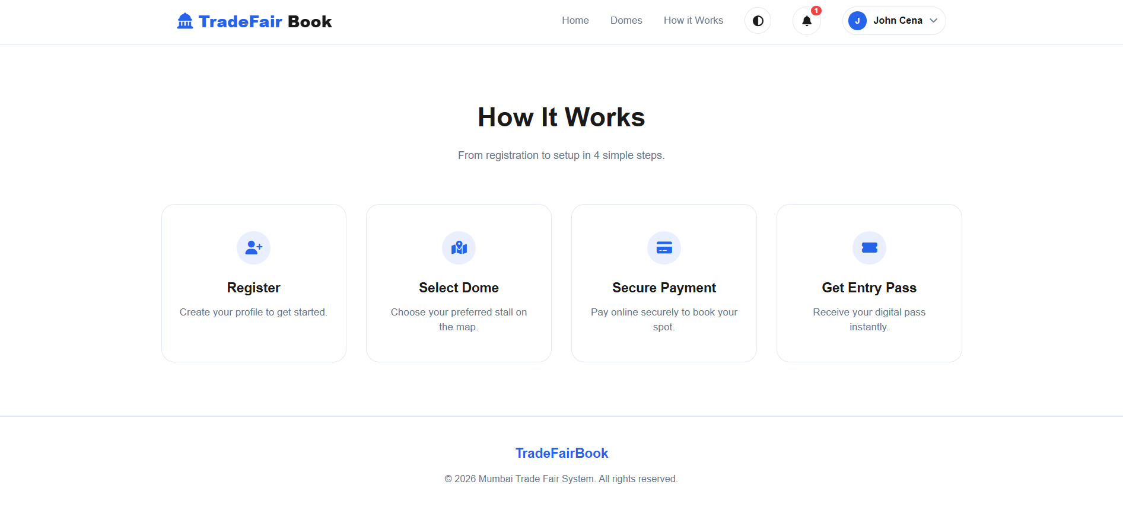

- Register page

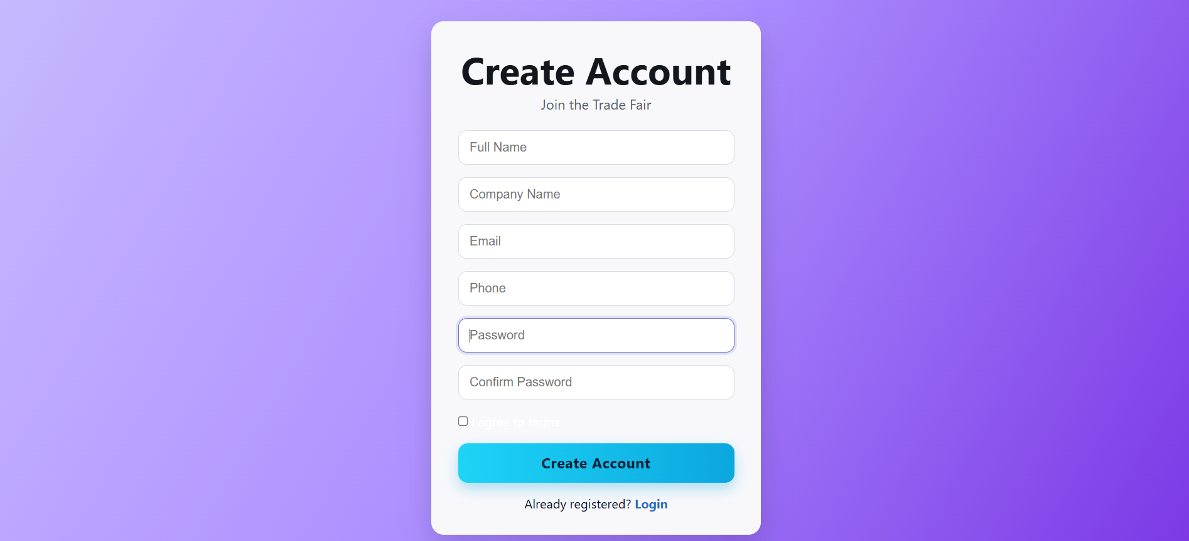

- Login page

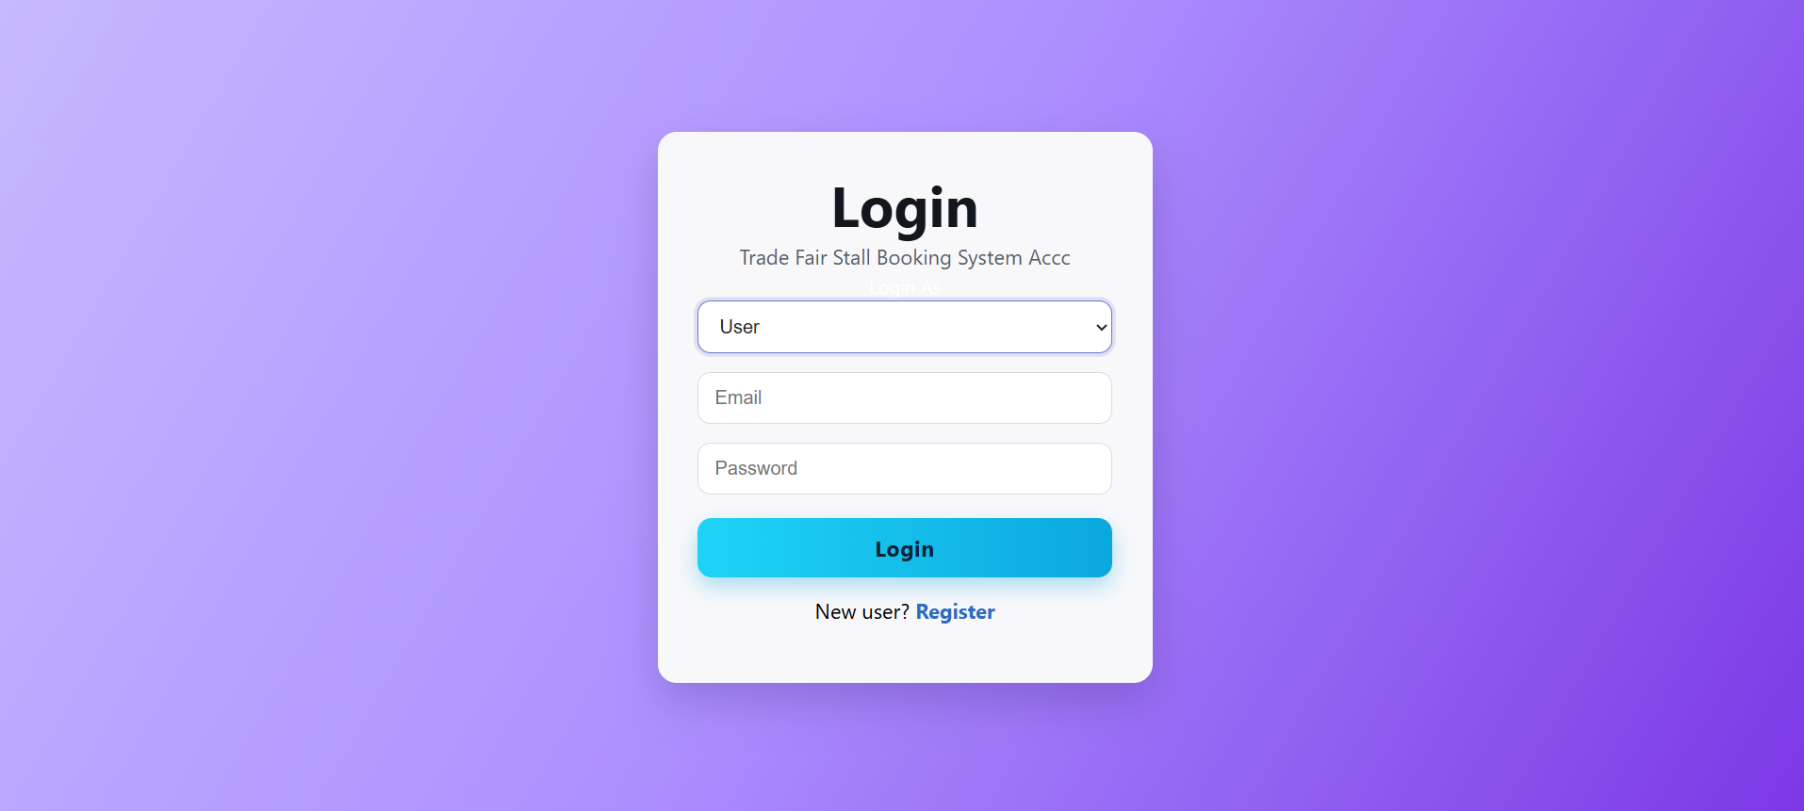

- Dome selection page

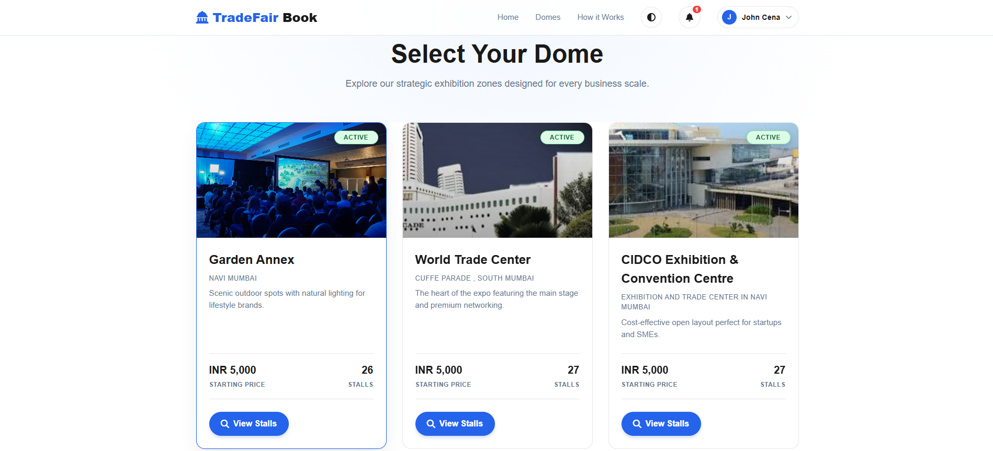

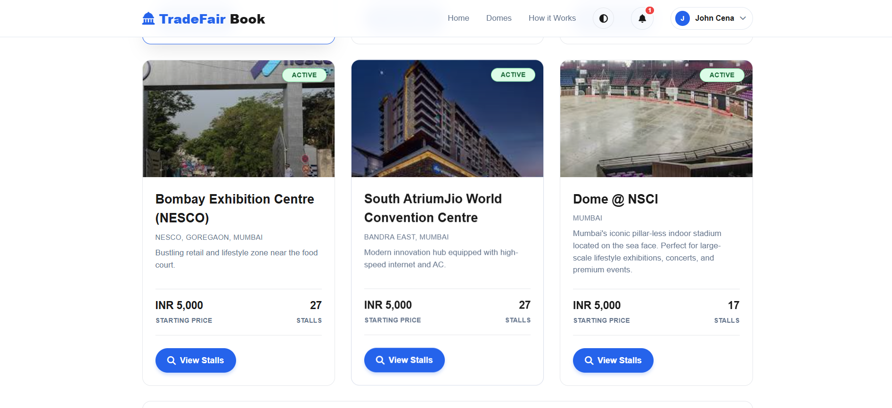

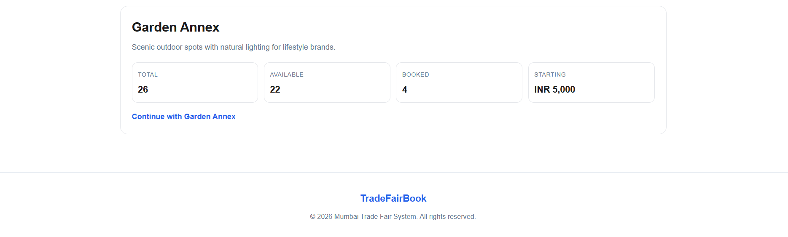

- Stall display page

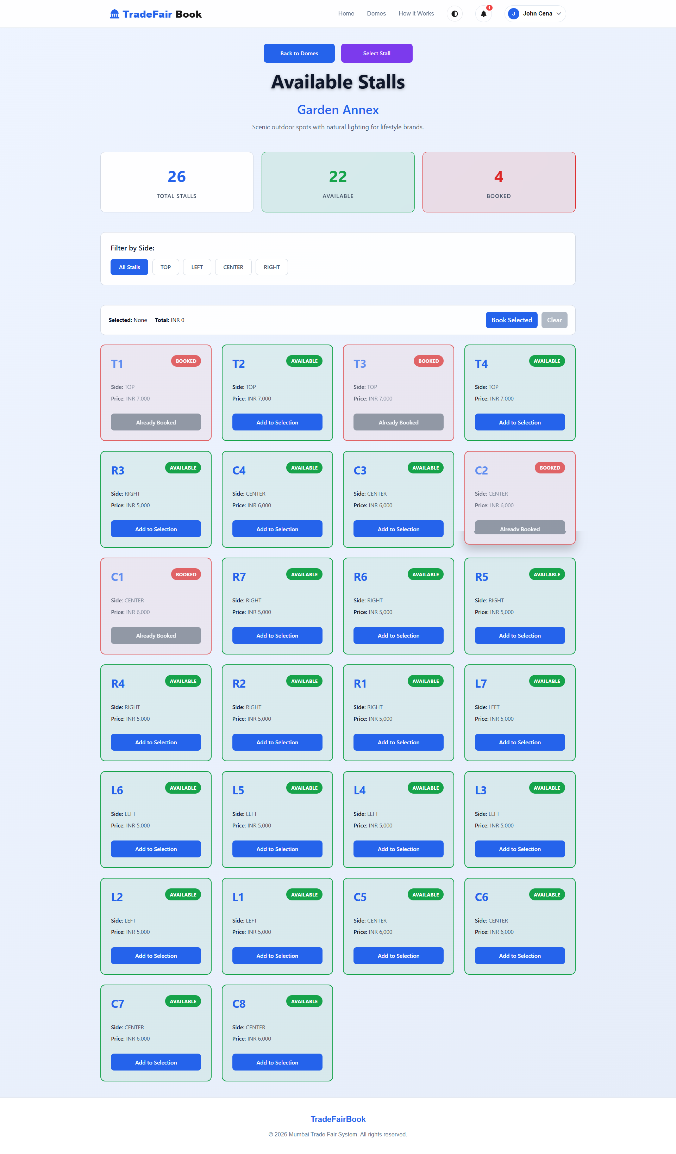

- Stall layout page

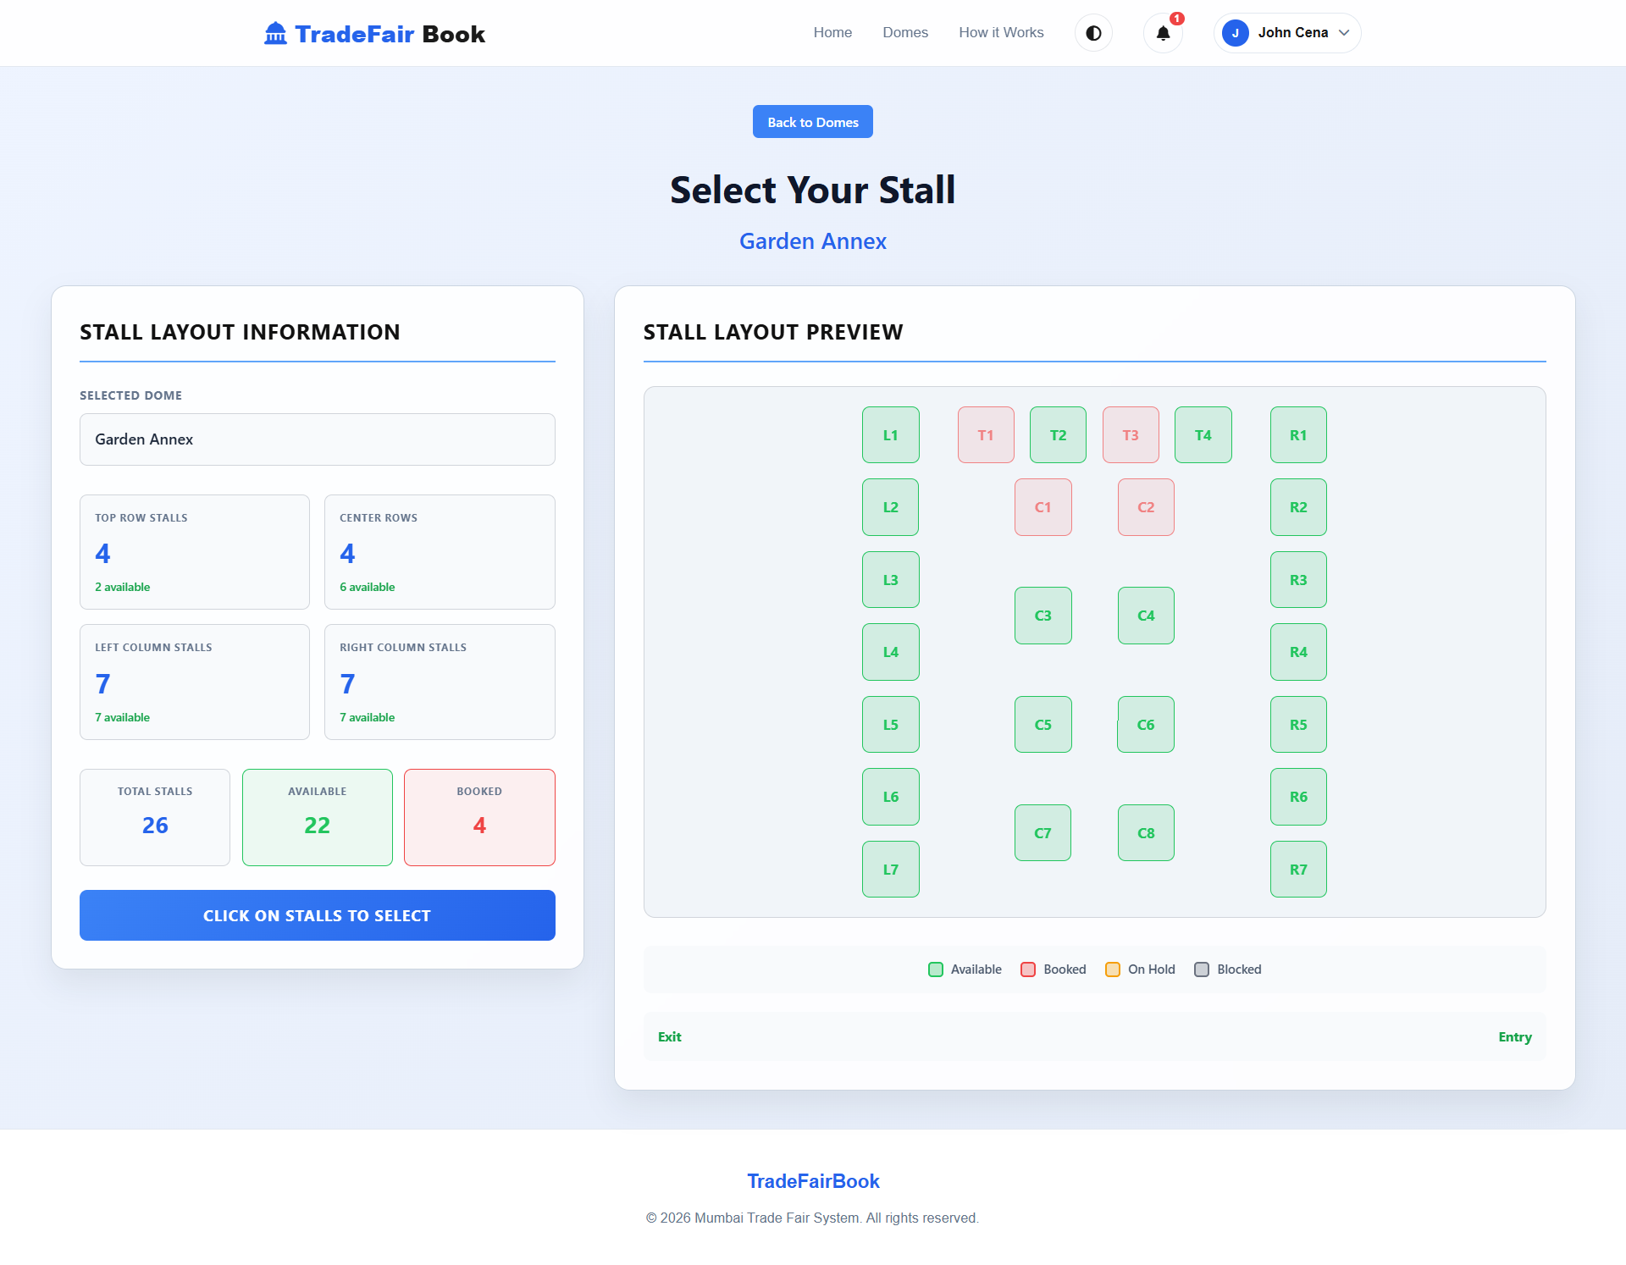

- Aadhaar upload page

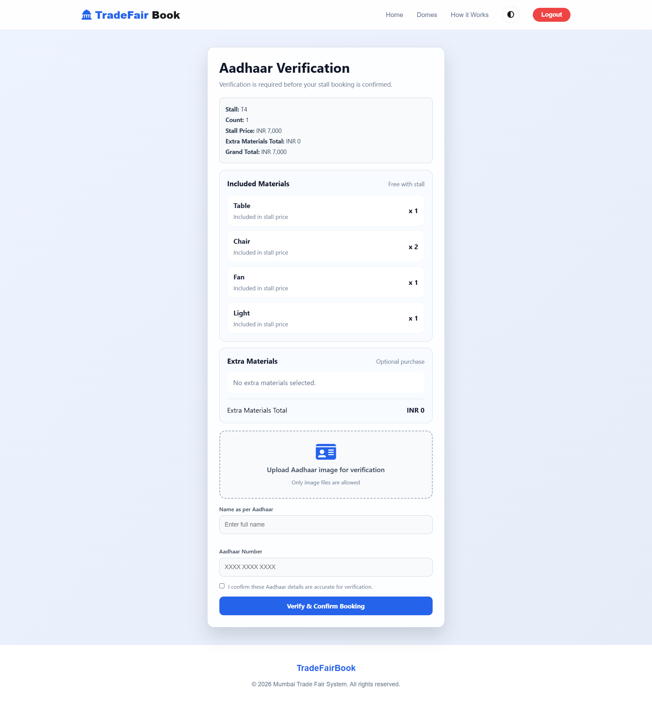

- Admin dashboard Page

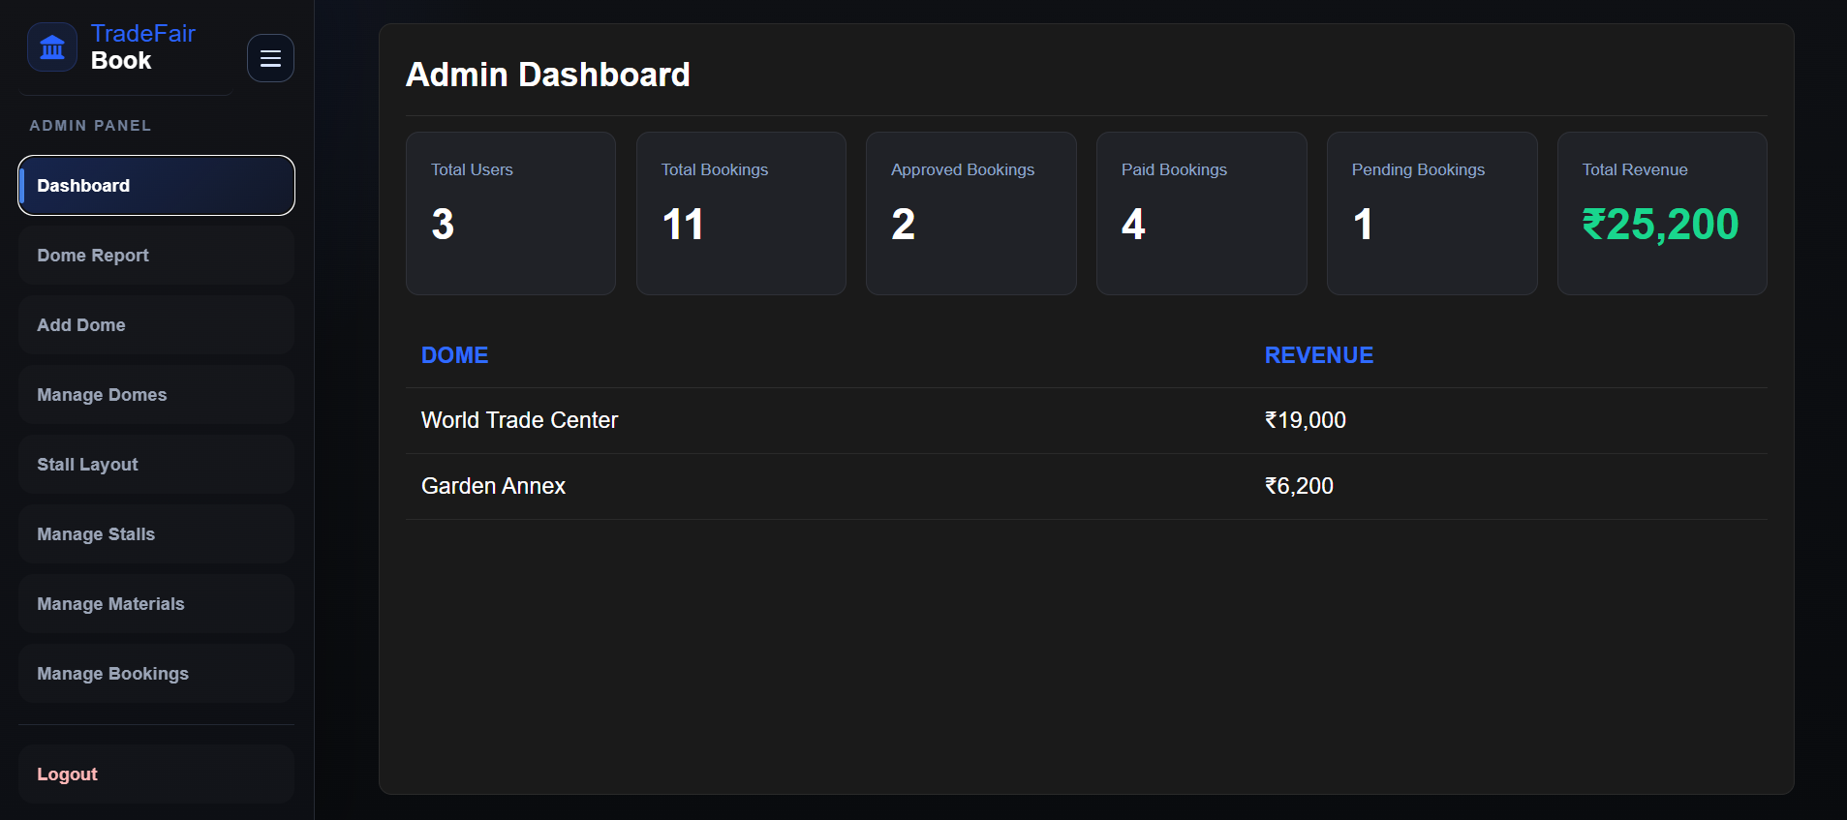

- Dome Report Page

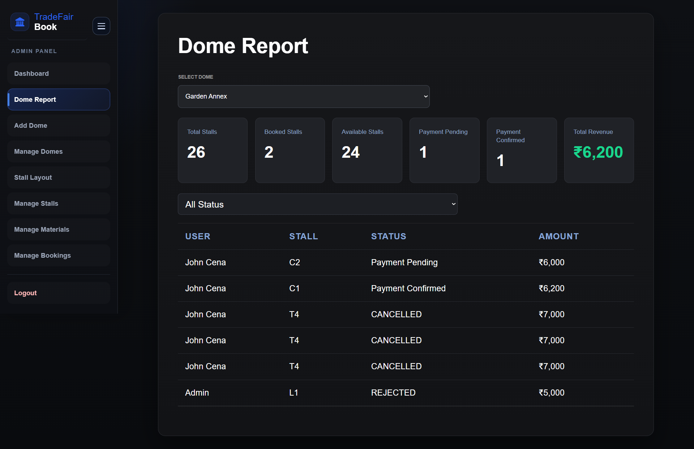

- Add Dome Page

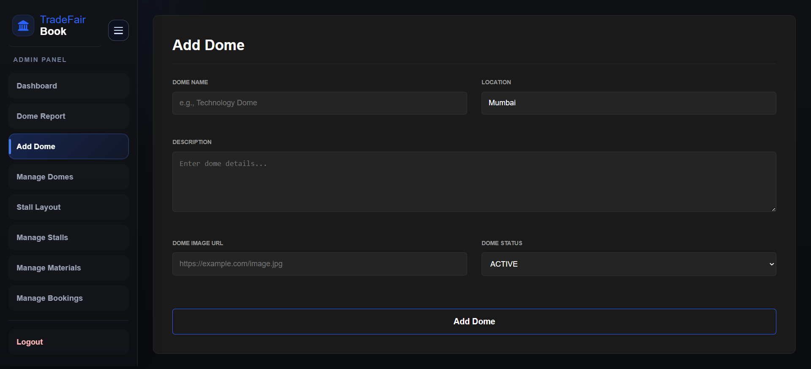

- Manage Dome Page

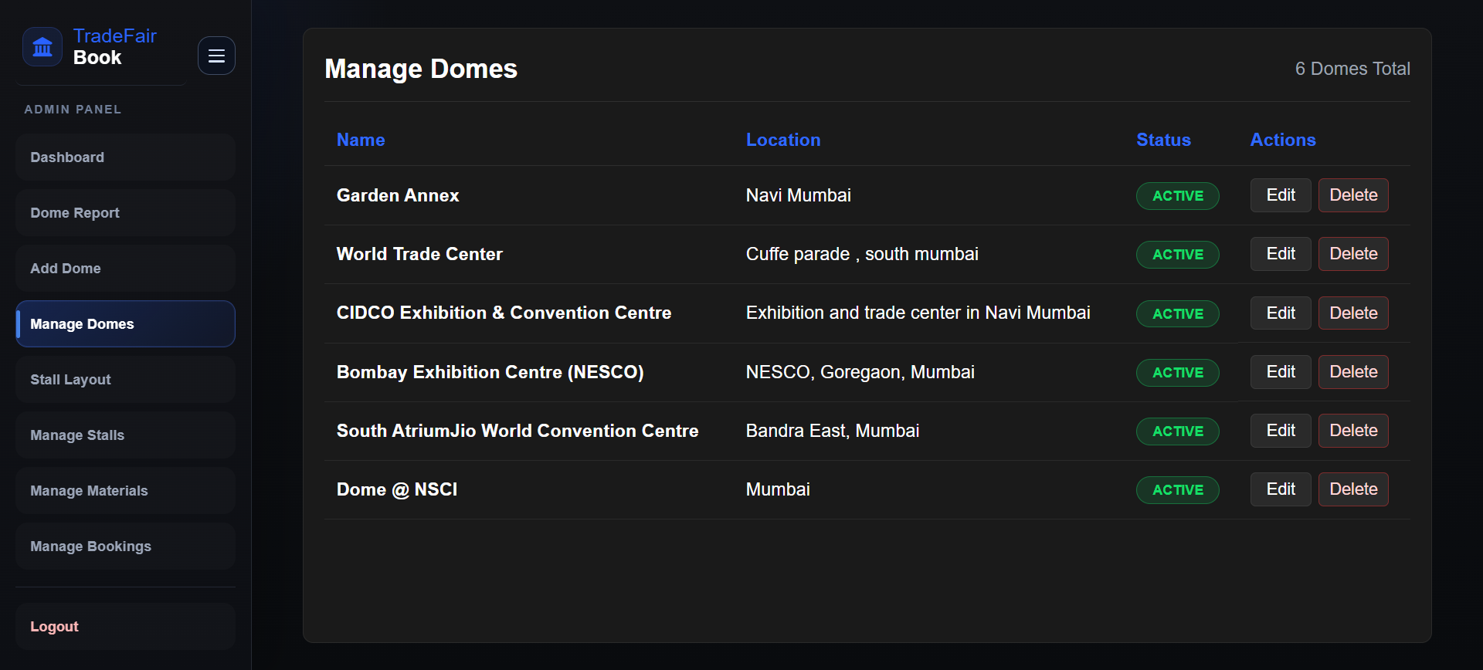

- Stall Layout Page

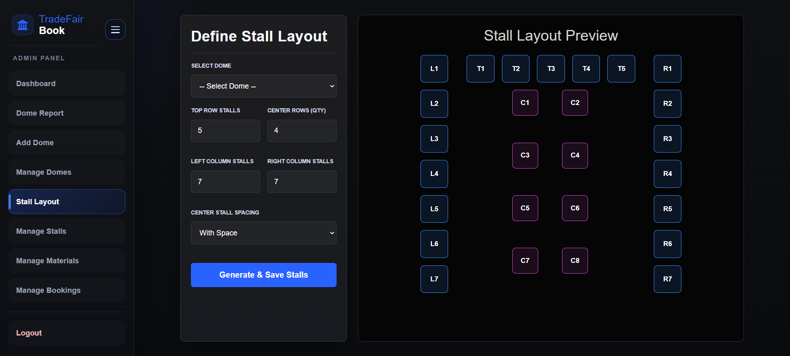

- Manage Stall Page

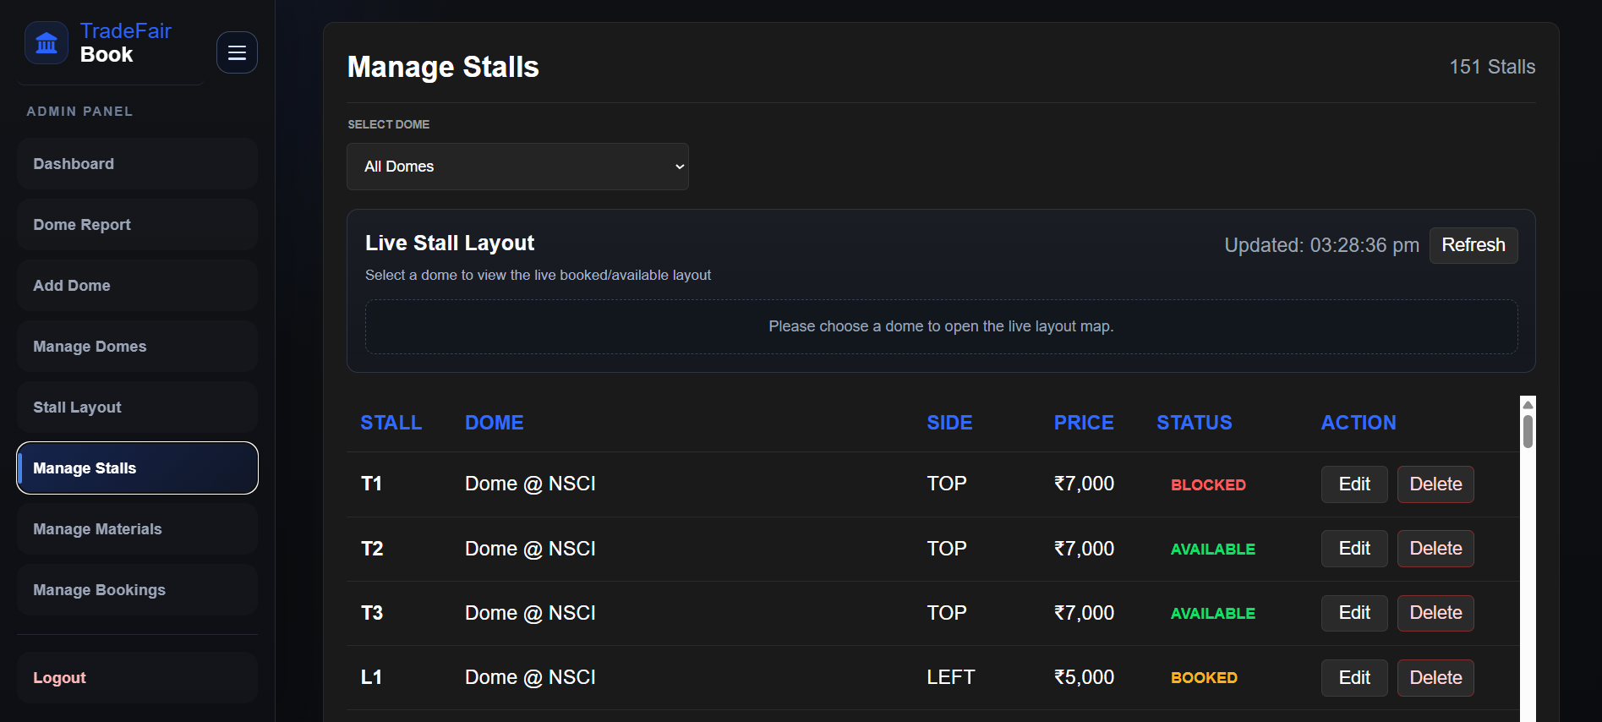

- Manage Materials Page

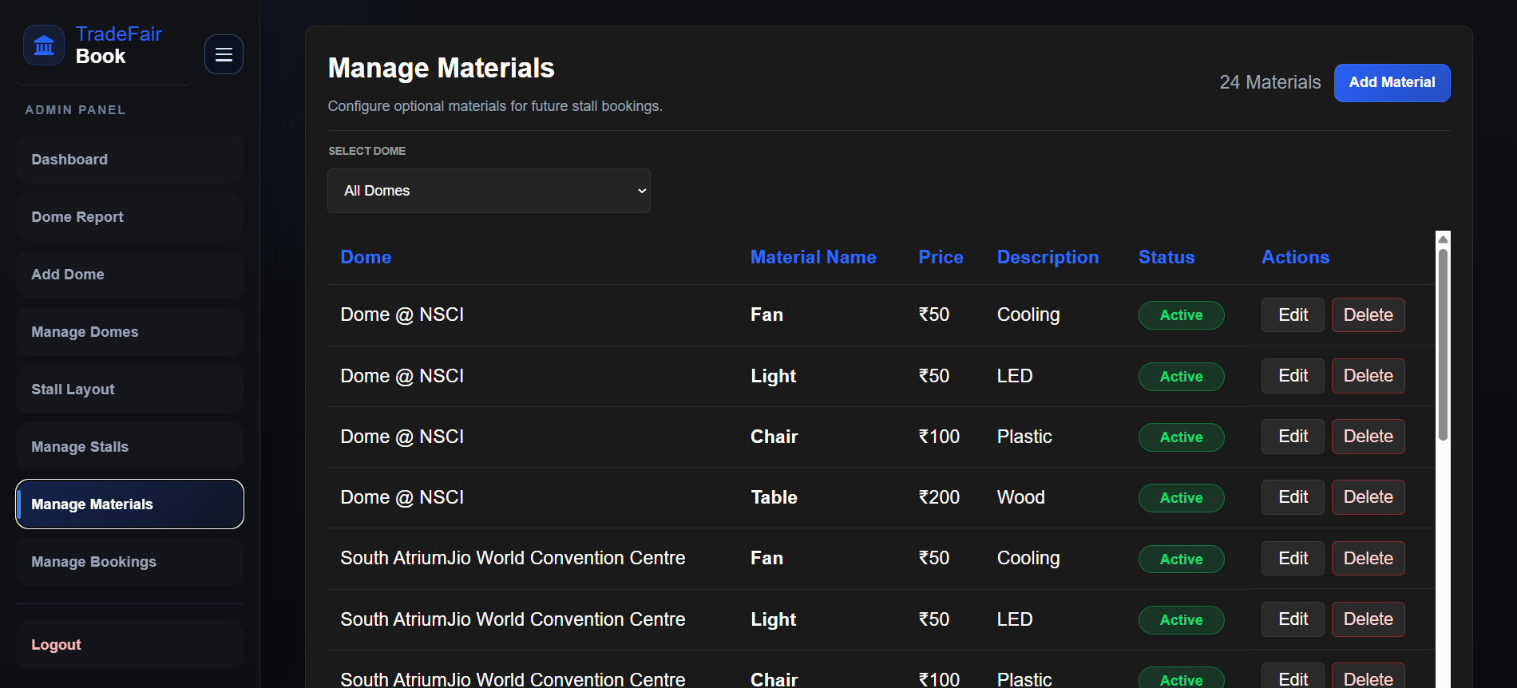

- Manage Booking Page

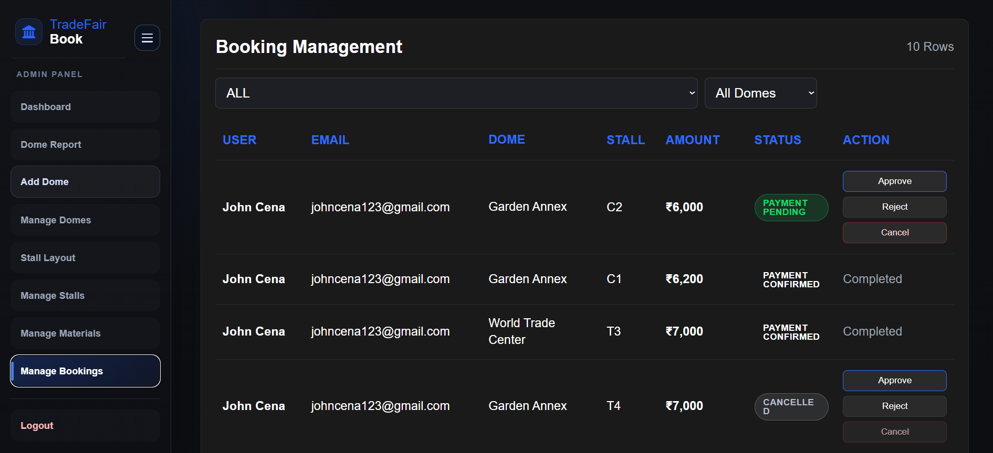

- Proposed Enhancements
In future, TradeFairBook can be enhanced by adding more advanced features to improve user convenience and system efficiency. Email and SMS notifications can be integrated to inform users about booking confirmation, approval, rejection, and payment updates. A real-time availability feature can also be added so that users can instantly view the latest stall status without delay. The system can be further improved by generating downloadable invoices and payment receipts for users after successful booking and payment.
Another useful enhancement would be the addition of advanced search and filter options for domes, stalls, and materials. A mobile application version of the system can also be developed for better accessibility. Multi-language support may be included to make the system easier to use for a wider range of users. In the future, Aadhaar verification can be strengthened further by using OCR or AI-based document validation. Analytical charts and graphical reports may also be added in the admin dashboard for better decision-making and system monitoring.

6. Conclusion
TradeFairBook is a useful web-based system developed for automating the trade fair stall booking process. The project reduces the difficulties of manual booking methods by providing a centralized platform for user registration, dome and stall viewing, Aadhaar submission, booking management, payment handling, and administrative control. It improves accuracy, saves time, reduces paperwork, and helps in maintaining proper records.
The system is beneficial for both users and administrators because it offers transparency, security, and better management of trade fair activities. Through this project, the stall booking process becomes more organized and efficient. Thus, TradeFairBook successfully meets the main objective of providing a digital solution for trade fair booking and management, and it also has scope for further enhancement in the future.

7. Bibliography
Web References

- GeeksforGeeks, “Coding Standards and Guidelines.” Available at: https://www.geeksforgeeks.org/software-engineering/coding-standards-and-guidelines/
- React Official Documentation. Available at: https://react.dev/
- Node.js Official Documentation. Available at: https://nodejs.org/
- Express.js Official Documentation. Available at: https://expressjs.com/
- MongoDB Official Documentation. Available at: https://www.mongodb.com/docs/
- Mongoose Official Documentation. Available at: https://mongoosejs.com/docs/
- Razorpay Developer Documentation. Available at: https://razorpay.com/docs/

Book References
- Roger S. Pressman, Software Engineering: A Practitioner’s Approach.
- Ian Sommerville, Software Engineering.
- Korth, Silberschatz and Sudarshan, Database System Concepts.

