E-COMMERCE PROFIT ANALYSIS
Presentation Report
Prepared for GitHub portfolio submission and presentation defense.
Executive Summary
This analysis reviews 3,500 e-commerce records collected between 2022-01-01 and 2024-12-31. The business generated total sales of $10,667,881 and total profit of $1,844,655, with an average profit margin of 17.37%. The main issue is margin compression: sales are strong, but some products and categories convert revenue into profit less efficiently than others.
The project therefore focuses on profitability quality rather than sales volume alone. That makes the analysis useful for identifying where revenue growth is not translating into the best possible business return.
Introduction
The purpose of this project is to examine sales and profitability patterns, identify the most important business problem, and recommend actions that improve profit efficiency rather than sales alone. A strong sales figure does not always mean strong profitability, so the analysis looks beyond revenue and evaluates margin performance across time, products, categories, and regions.
Dataset Overview
The dataset contains 3,500 rows and 9 columns. The main fields are Order Date, Product Name, Products, Category, Product_Category, Region, Quantity, Sales, and Profit. The date range spans from 2022-01-01 to 2024-12-31, allowing a three-year comparison of business performance.
The dataset is well suited for exploratory analysis because it contains both transactional values and categorical business dimensions that can be compared against one another.
Methodology
- Load the CSV file into pandas.
- Inspect the first and last rows, shape, columns, data types, missing values, and duplicates.
- Clean the date and currency fields.
- Create a profit margin metric.
- Analyze performance by year, category, region, and product.
- Identify the key business problem and explain the root cause.
Data Cleaning
The dataset was first checked for structural issues. No missing values were found and no duplicate rows were detected. The Order Date column was converted to datetime format so that time-based analysis could be performed correctly.
df['Order Date'] = pd.to_datetime(df['Order Date'], errors='coerce')
for col in ['Sales', 'Profit']:
df[col] = pd.to_numeric(df[col].astype(str).str.replace(r'[\$,]', '', regex=True).str.strip(), errors='coerce')
df['Profit Margin'] = df['Profit'] / df['Sales']
Sales and Profit contained currency symbols and commas, so they were cleaned and converted into numeric values. This step was essential because mathematical analysis cannot be performed on text fields. Profit Margin was then calculated as Profit divided by Sales.
Exploratory Data Analysis
The analysis used correlation heatmaps, yearly trend charts, and grouped comparisons across category, region, and product.
1 Yearly Sales and Profit Trend
- 2022: Sales = $3,255,970, Profit = $572,853, Margin = 17.59%
- 2023: Sales = $3,786,592, Profit = $666,860, Margin = 17.61%
- 2024: Sales = $3,625,319, Profit = $604,942, Margin = 16.69%
Profit margin was fairly stable in 2022 and 2023 but declined in 2024. That suggests a shift in the product mix, cost pressure, or a change in the profitability of the sales being made.
2 Profit Margin by Category
- Office: Sales = $1,094,216, Profit = $185,395, Margin = 16.94%
- Accessories: Sales = $4,247,591, Profit = $736,085, Margin = 17.33%
- Electronics: Sales = $5,326,074, Profit = $923,175, Margin = 17.33%
3 Profit Margin by Region
- North: Sales = $2,488,773, Profit = $426,311, Margin = 17.13%
- South: Sales = $2,659,548, Profit = $458,091, Margin = 17.22%
- East: Sales = $2,675,110, Profit = $464,888, Margin = 17.38%
- West: Sales = $2,844,450, Profit = $495,365, Margin = 17.42%
4 Profit Margin by Product
- Tablet: Sales = $1,023,928, Profit = $167,500, Margin = 16.36%
- Printer: Sales = $1,094,216, Profit = $185,395, Margin = 16.94%
- Smartwatch: Sales = $1,049,211, Profit = $179,001, Margin = 17.06%
- Smartphone: Sales = $1,069,681, Profit = $183,299, Margin = 17.14%
- Keyboard: Sales = $1,024,507, Profit = $175,808, Margin = 17.16%
- Mouse: Sales = $1,074,398, Profit = $185,764, Margin = 17.29%
- Monitor: Sales = $1,160,048, Profit = $202,036, Margin = 17.42%
- Headphones: Sales = $988,638, Profit = $172,477, Margin = 17.45%
- Camera: Sales = $1,177,381, Profit = $207,620, Margin = 17.63%
- Laptop: Sales = $1,005,873, Profit = $185,755, Margin = 18.47%
Key Findings
- Sales and Profit show a strong correlation of 0.833.
- The highest product margin is Laptop at 18.47%.
- The lowest product margin is Tablet at 16.36%.
- The weakest category is Office at 16.94%.
- Profit margin declined in 2024 to 16.69%, compared with 17.59% in 2022 and 17.61% in 2023.
Problem Identification
The major problem is that strong sales do not always produce equally strong profit. Some products and categories have weaker margins, which means the business may be earning revenue efficiently in some areas but not in others.
Root Cause Analysis
- Tablet and Office show lower margins than the strongest performers.
- The 2024 margin drop suggests a shift in product mix or cost pressure.
- The business appears to have a profitability imbalance rather than a demand problem.
In practical terms, the business is not struggling to sell; it is struggling to keep every sale equally profitable. That points to a margin management issue, not a sales volume issue.
Recommendations
- Review pricing and cost structure for low-margin products.
- Prioritize higher-margin products in promotions and bundles.
- Track profit margin monthly and by product.
- Compare yearly performance so margin decline is caught early.
- Use margin, not sales alone, as a decision metric.
Conclusion
This project shows that the business is generating strong revenue, but profitability is uneven. Focusing on margin improvement will help turn good sales into better profit outcomes.
The final recommendation is to treat profit margin as a core management metric, because it shows which sales actually create business value.
Correlation Heatmap
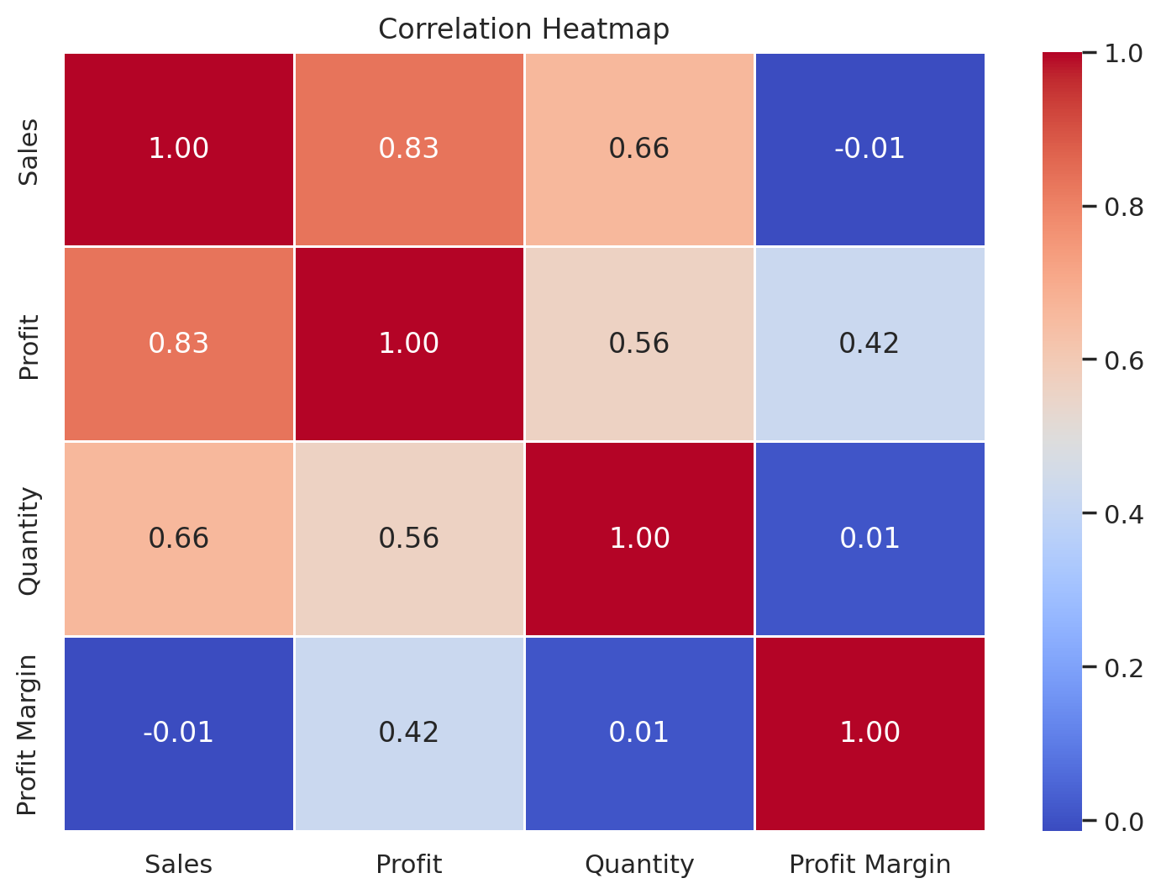
Yearly Sales and Profit Trend
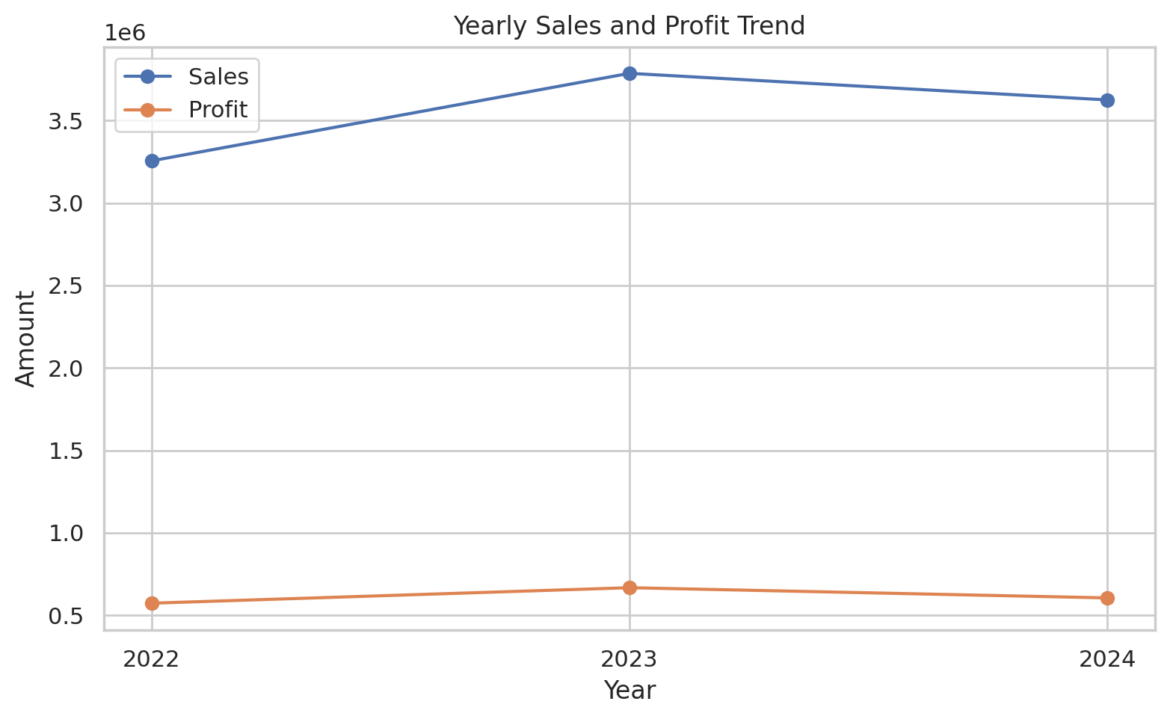
Profit Margin by Category
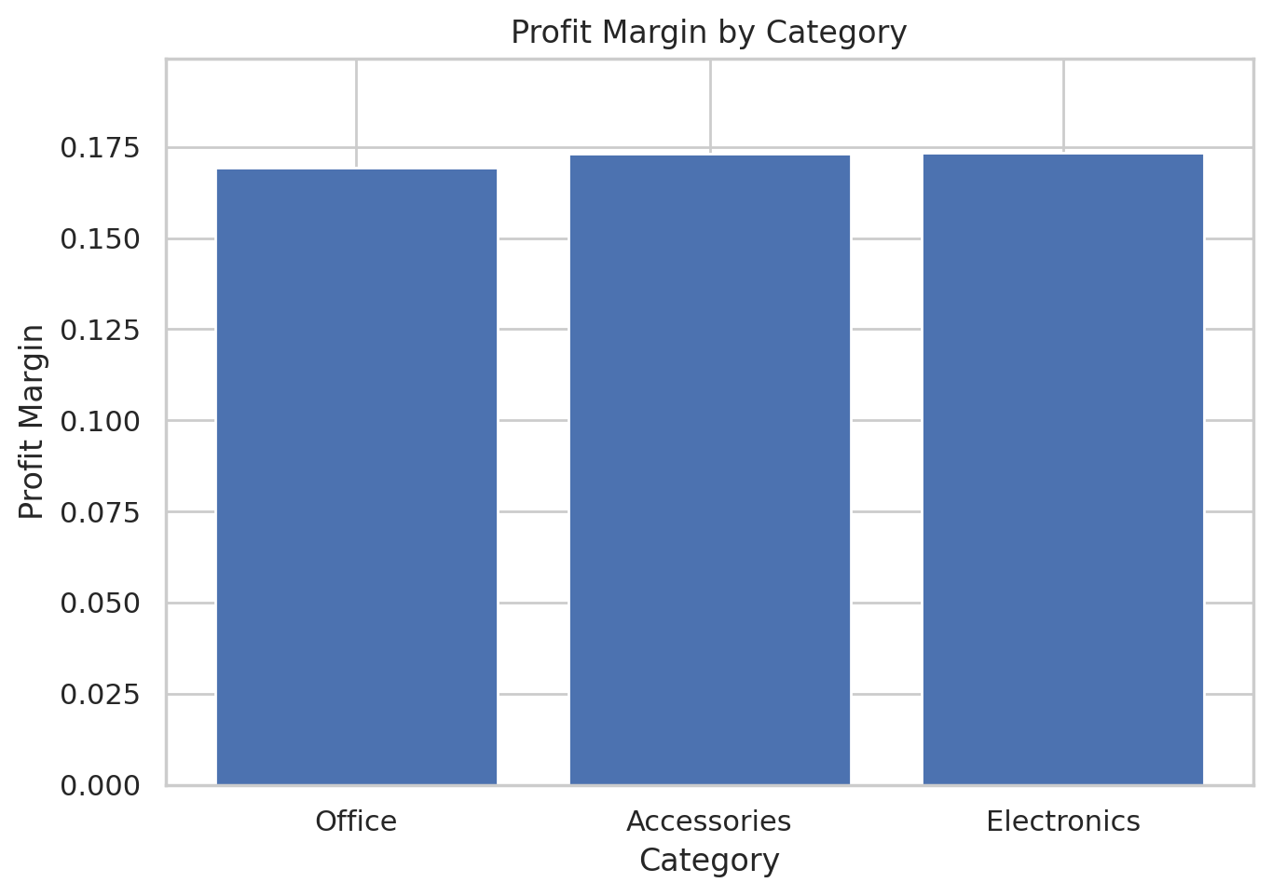
Profit Margin by Region
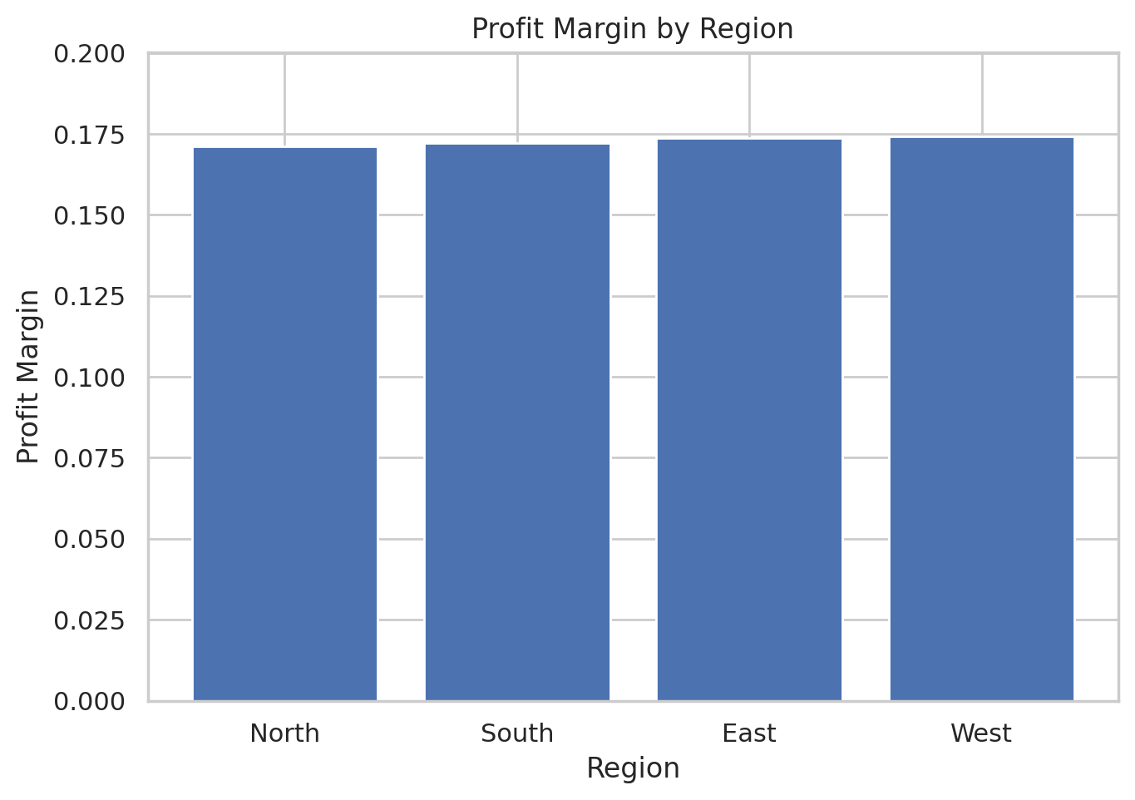
Profit Margin by Product
