BKB Water Quality Analysis
Exploratory analysis of water quality trends, site variation, and environmental indicators

Records analyzed: 2,371
Columns: 17
Years covered: 1989–2019
Unique sites: 6
Mean dissolved oxygen: 6.65 mg/L

1. Executive Summary
This project analyzed 2,371 water-quality records collected across 6 sites between 1989 and 2019. The main finding is that dissolved oxygen has declined over time, with the average falling from 8.91 mg/L in the 1990s to 6.10 mg/L in the 2010s. Water temperature shows the strongest inverse relationship with dissolved oxygen (correlation = -0.51), which suggests thermal stress may be an important factor in water quality decline.
The dataset also contains 9,981 missing cells, including substantial missingness in dissolved oxygen and verification fields. These gaps do not prevent analysis, but they indicate that monitoring coverage can be improved.

2. Introduction
The purpose of this project is to examine whether water quality conditions are changing over time and to identify the strongest observable relationships among the measured variables. The analysis focuses on dissolved oxygen, water temperature, salinity, pH, water depth, Secchi depth, and site-level differences.

3. Dataset Overview
The dataset contains 2,371 observations and 17 variables. It includes site identifiers, dates, location details, and several physical and chemical water measurements. The water-quality records cover 1989–2019, although five rows contain invalid year information and were excluded from time-based analysis.
Metric | Value
Records | 2,371
Columns | 17
Missing cells | 9,981
Duplicate rows | 0
Unique sites | 6
Years covered | 1989–2019
Mean dissolved oxygen | 6.65 mg/L
Mean water temperature | 18.06 °C
Mean pH | 7.17
Mean salinity | 0.72 ppt
Mean Secchi depth | 0.52 m

4. Methodology
- Load the CSV file into pandas.
- Inspect the first and last rows, data types, missing values, and duplicates.
- Convert the date field to datetime and create a clean analysis year.
- Exclude invalid year entries from time-based analysis.
- Compute summary statistics by year and by site.
- Use charts to examine trend, relationship, and distribution patterns.

5. Data Cleaning
The dataset required light cleaning rather than heavy transformation. The Read_Date column was converted to datetime format, and a new AnalysisYear field was created to support time-series analysis. Five records with an invalid year code (1899) and no usable date were excluded from trend calculations. Duplicate rows were not present.
- Converted Read_Date to datetime.
- Created AnalysisYear for consistent trend analysis.
- Excluded invalid year entries from temporal charts.
- Confirmed that no duplicate rows were present.

6. Exploratory Data Analysis
The exploratory analysis focuses on yearly trends, correlations, site comparisons, and missing data patterns.
Figure 1. Yearly trends in dissolved oxygen and water temperature.
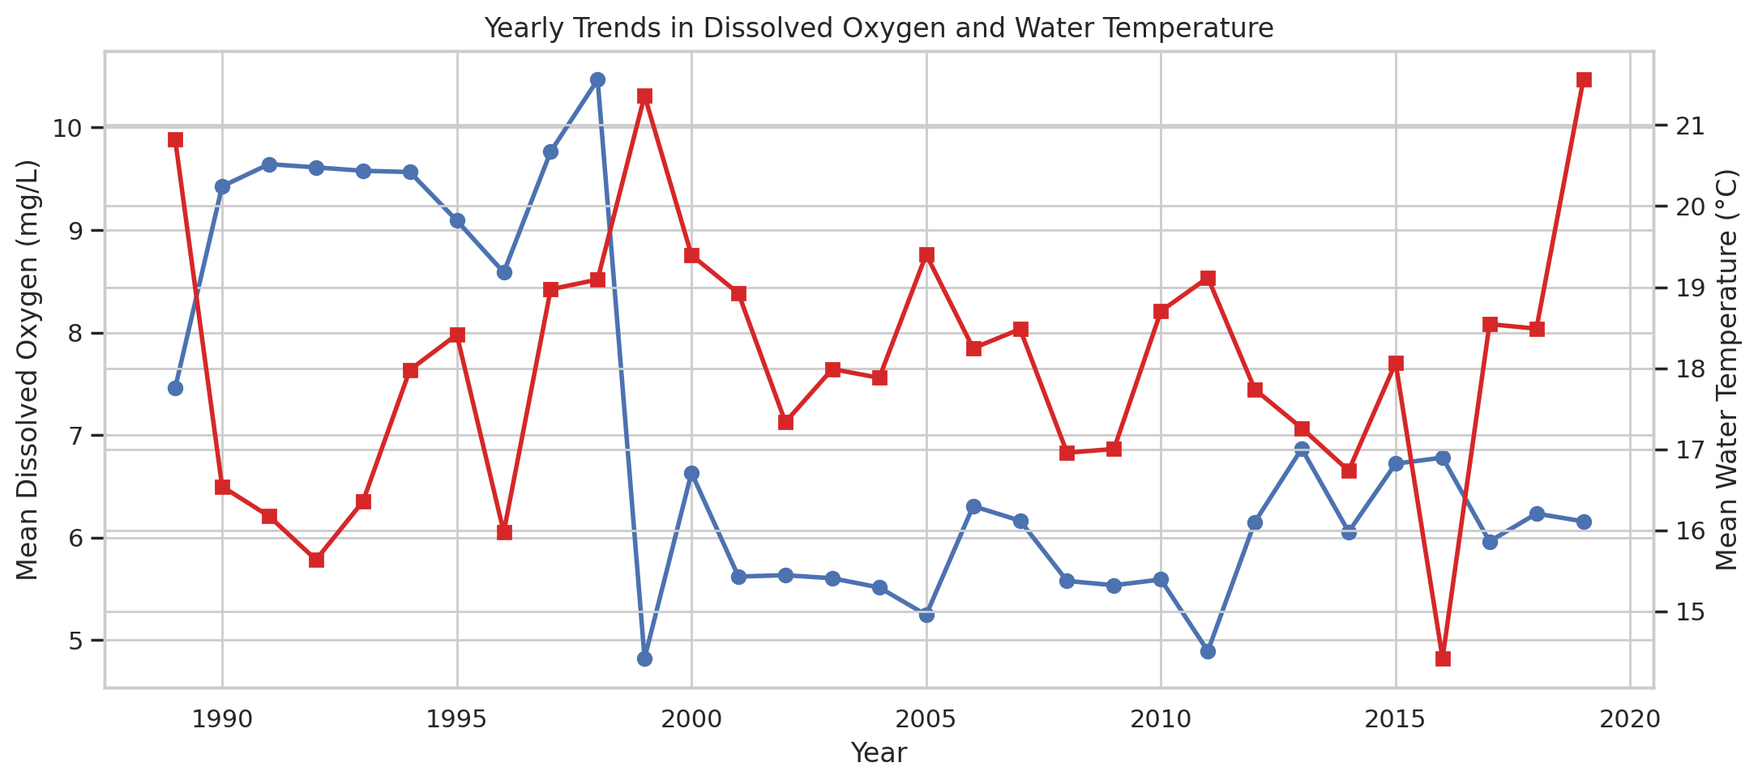
Observation: Dissolved oxygen is lower in the later years, while water temperature remains an important opposing factor.
Figure 2. Correlation heatmap.
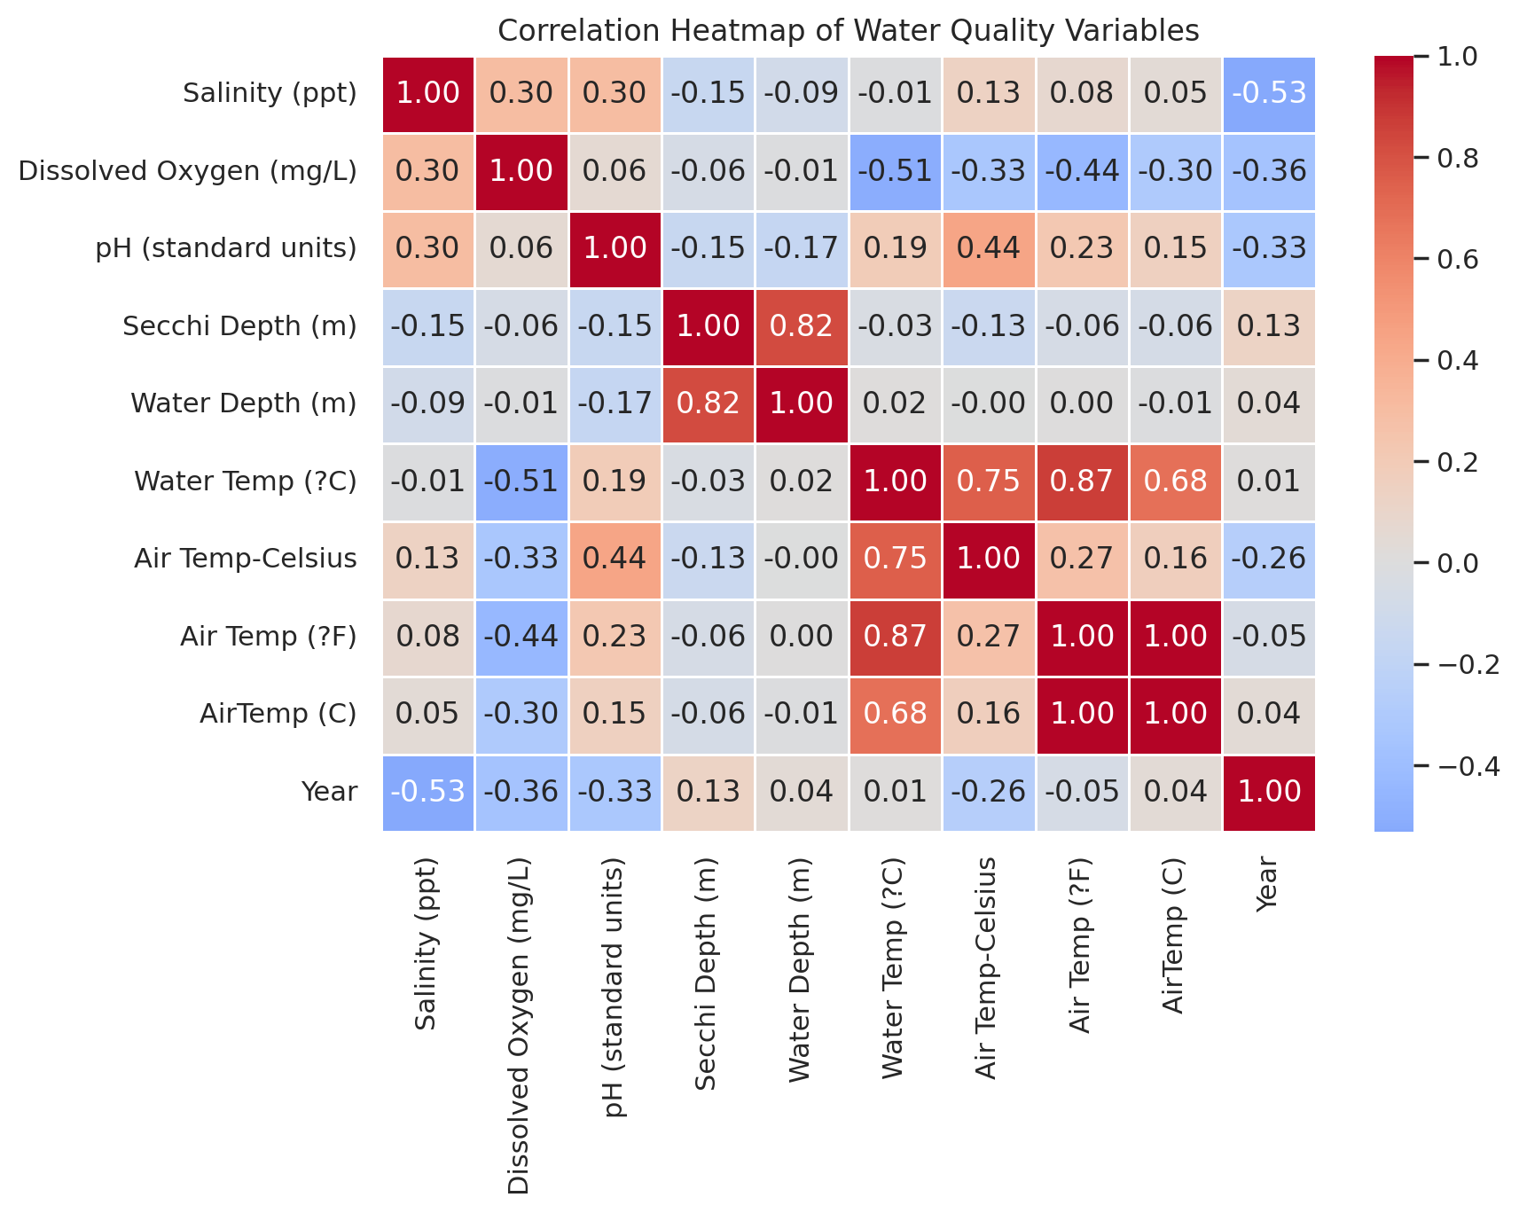
Observation: Dissolved oxygen is most strongly and negatively associated with water temperature.
Figure 3. Dissolved oxygen versus water temperature.
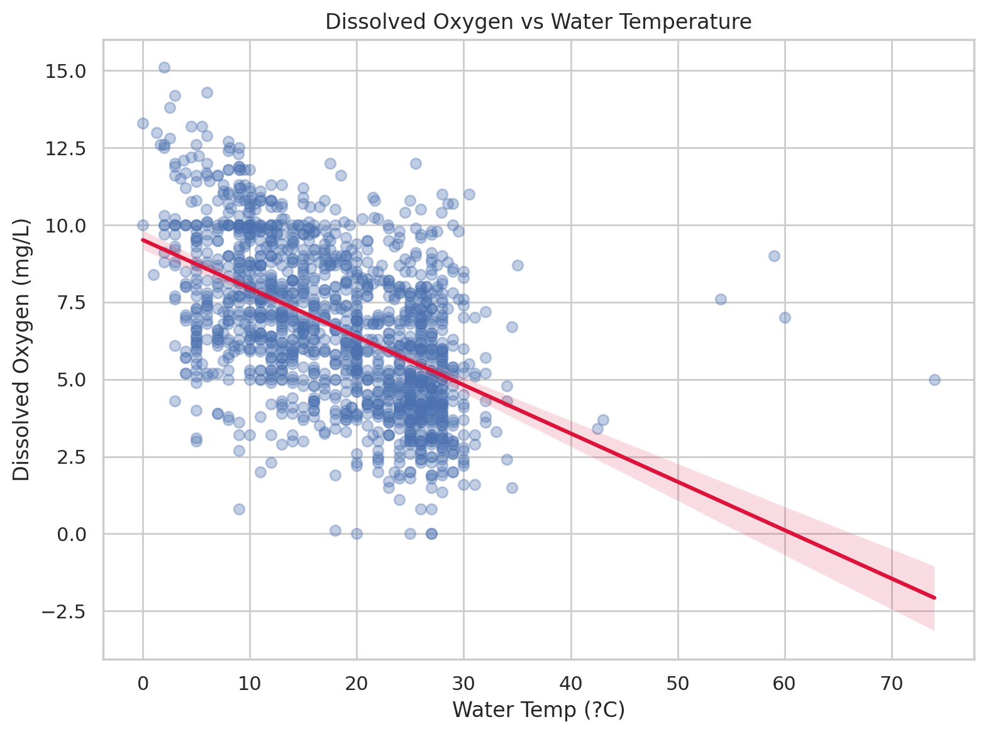
Observation: The regression line slopes downward, confirming an inverse relationship between temperature and dissolved oxygen.
Figure 4. Average dissolved oxygen by site.
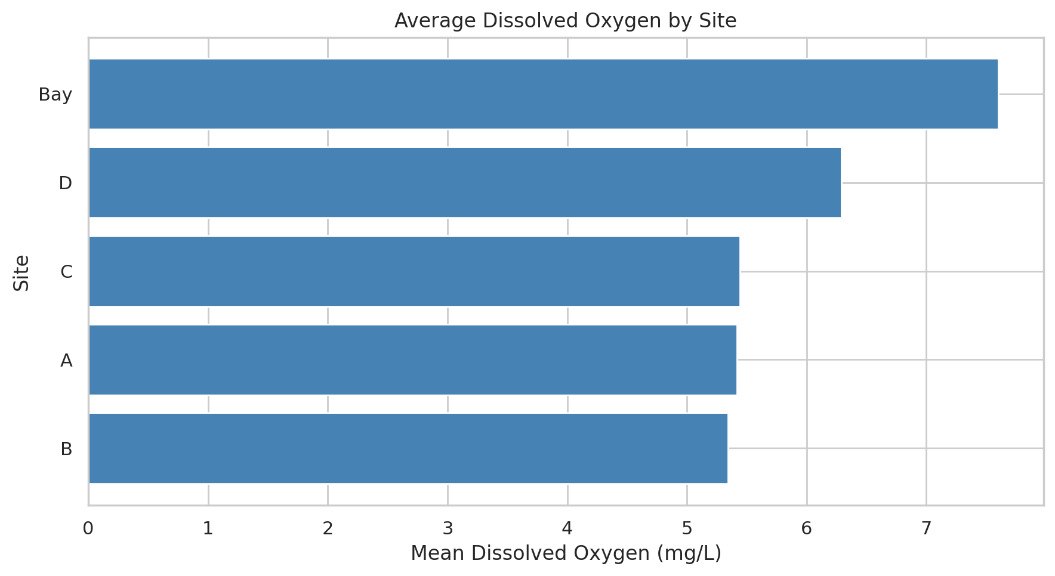
Observation: Site-level averages differ noticeably, indicating localized environmental conditions.
Figure 5. Dissolved oxygen by decade.
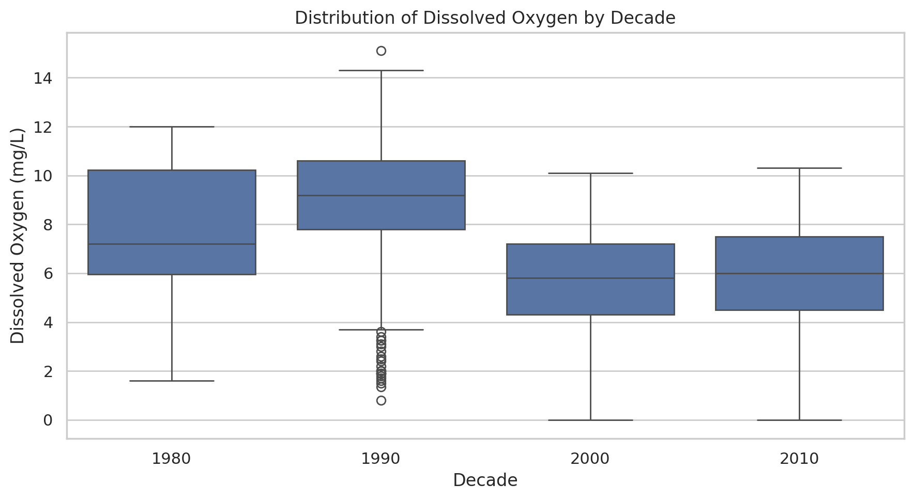
Observation: Later decades generally show lower oxygen distributions than earlier decades.
Figure 6. Missing values by column.
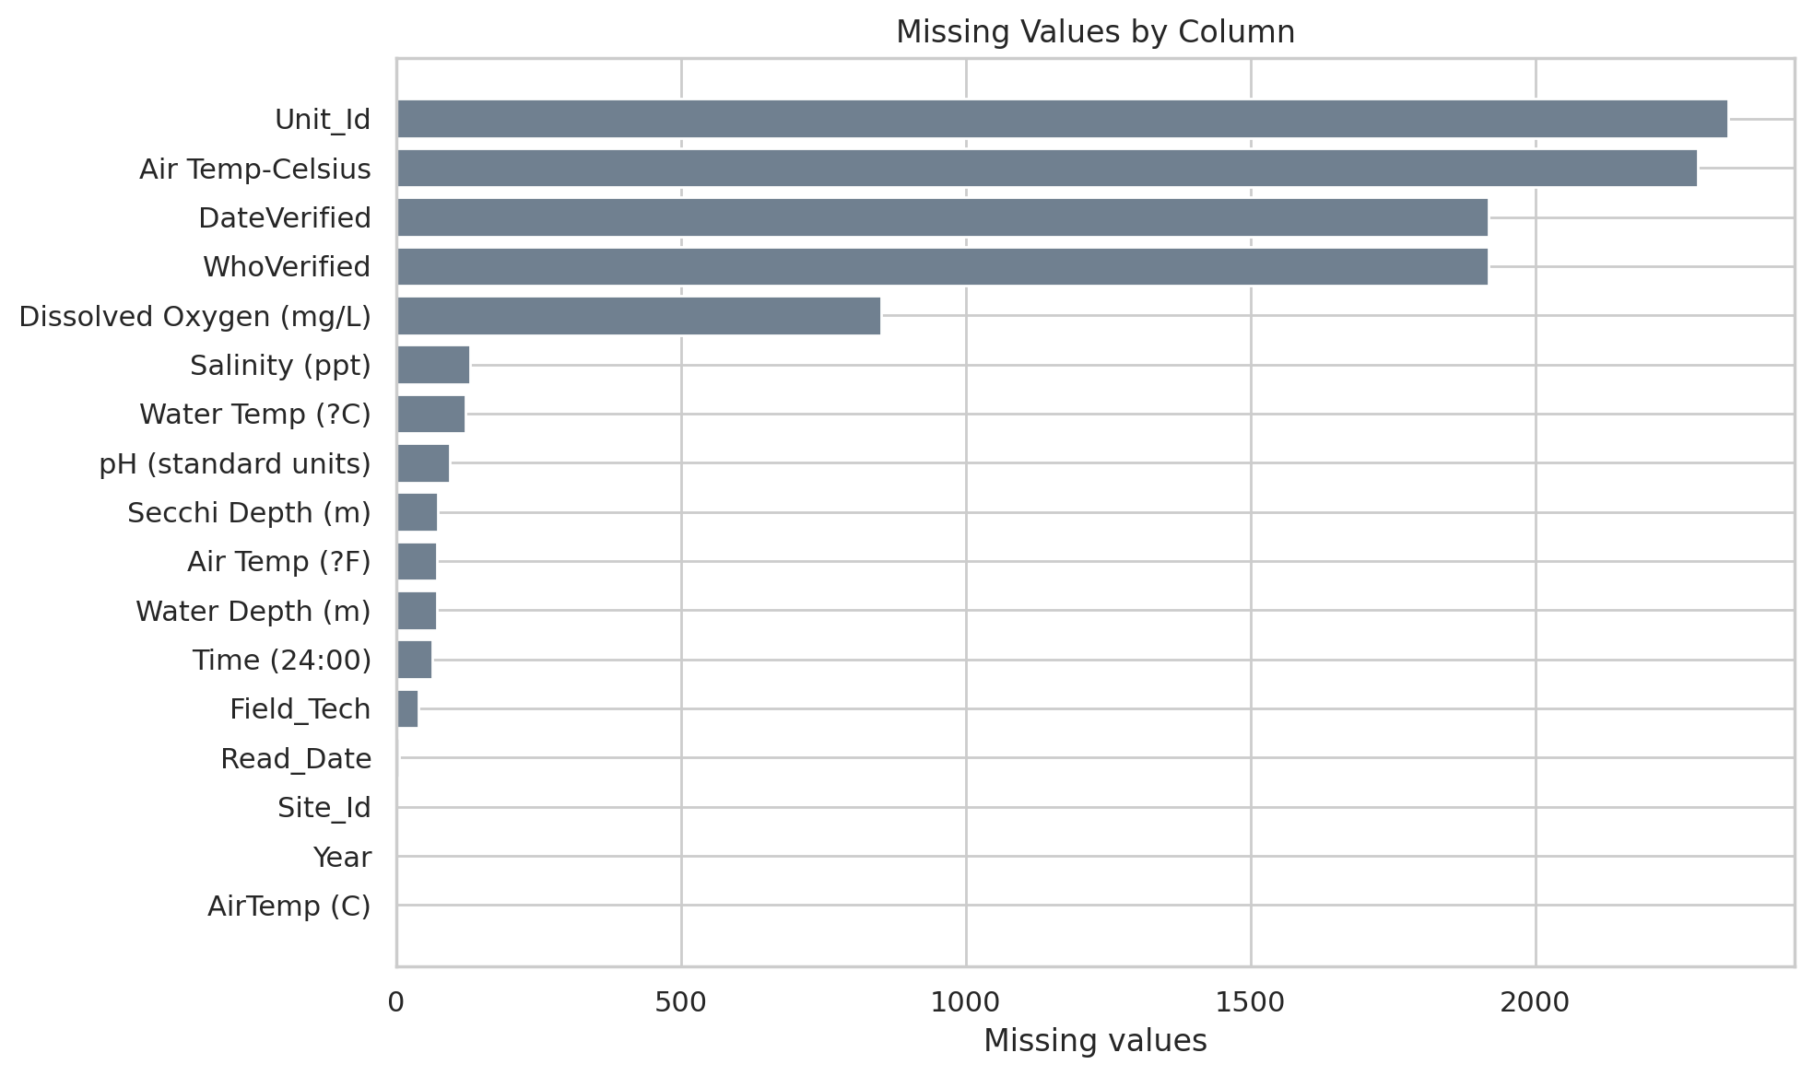
Observation: Missingness is concentrated in dissolved oxygen and verification-related fields.

7. Key Findings
- Dissolved oxygen averages 6.65 mg/L overall, but it declines from 8.91 mg/L in the 1990s to 6.10 mg/L in the 2010s.
- The correlation between dissolved oxygen and water temperature is -0.51, the strongest relationship in the numeric data.
- About 27.0% of observed dissolved oxygen readings are below 5 mg/L.
- Site-level averages show that the highest-oxygen site averages 7.60 mg/L and the lowest-oxygen site averages 5.34 mg/L.

8. Problem Identification
The main problem is a decline in dissolved oxygen over time. Lower oxygen levels can be a warning sign of environmental stress and may indicate less favorable conditions for aquatic life.

9. Root Cause Analysis
- Water temperature has the strongest inverse relationship with dissolved oxygen (r = -0.51).
- Dissolved oxygen also declines with year (r = -0.36), reinforcing the trend-based evidence.
- Some sites consistently perform better than others, suggesting localized environmental variation rather than a single uniform condition across all waters.
- Missing values in key monitoring fields show that data completeness can be improved alongside environmental management.

10. Recommendations
- Increase monitoring during warm periods and at low-oxygen sites.
- Investigate site-specific drivers such as runoff, circulation, or local habitat conditions.
- Improve completeness and consistency of measurement records.
- Track dissolved oxygen and temperature together over time for early warning signals.
- Prioritize restoration or mitigation actions where low oxygen persists.

11. Conclusion
The analysis indicates that water quality has weakened over time, primarily through a decline in dissolved oxygen. Because dissolved oxygen is negatively associated with water temperature, thermal stress is a likely contributor to the observed pattern. Better monitoring and targeted management can help address the problem.

