Credit Card Fraud Analysis
Project Report
Exploratory analysis of transaction risk, card-not-present fraud, and fraud concentration using Python

Prepared for GitHub portfolio presentation

1. Executive Summary
This report presents a complete exploratory analysis of a realistic synthetic credit card transaction dataset containing 50,500 raw records. After cleaning, 50,000 records remained for analysis, with 500 duplicate rows removed and 7,284 missing cells imputed or resolved.
The overall fraud rate is 3.12%, but fraud is not evenly distributed across the portfolio. Online transactions, card-not-present transactions, and high-velocity transactions are significantly more likely to be fraudulent. A targeted high-risk segment accounts for only 19.06% of all transactions but 52.72% of fraud cases.
The main business conclusion is that fraud prevention should focus on transaction context, channel risk, merchant category, and velocity-based monitoring rather than relying only on transaction amount.

2. Dataset Overview
The dataset simulates common fraud-detection functions in a financial organization and includes transaction-level, customer-level, and channel-level attributes.
- TransactionID, TransactionDate, TransactionHour
- CardType, MerchantCategory, TransactionChannel, Country, DeviceType
- Amount, CreditLimit, UtilizationRatio, AvgTxnAmount30d
- CustomerAge, CustomerTenureMonths, TransactionsLast24h
- IsInternational, IsWeekend, CardPresent, FraudFlag
The analysis spans the years 2021–2024 and includes 4 transaction channels, 12 merchant categories, 10 transaction countries, and 4 card types.

3. Methodology
- Load the raw CSV dataset.
- Inspect the structure, missing values, and duplicate rows.
- Convert transaction dates to datetime format.
- Impute missing categorical values with the mode and missing numeric values with the median.
- Remove duplicate rows.
- Create derived fields such as fraud labels, age bands, amount bands, and high-risk segment flags.
- Perform exploratory analysis using tables and charts.
- Interpret the results and develop practical recommendations.

4. Data Cleaning
The cleaning process improved data quality without changing the core business meaning of the dataset.
- TransactionDate was converted to datetime.
- Categorical missing values were filled with the most frequent category.
- Numeric missing values were filled with the median value.
- 500 duplicate rows were removed.
- Derived fields were created to support segmentation and interpretation.
The final cleaned dataset contains 50,000 unique records and no duplicate rows.

5. Key Project Statistics
Metric | Value
Raw records | 50,500
Cleaned records | 50,000
Duplicates removed | 500
Missing cells in raw data | 7,284
Overall fraud rate | 3.12%
Online fraud rate | 7.31%
Card-not-present fraud rate | 5.36%
High-risk share of transactions | 19.06%
High-risk share of fraud | 52.72%
Average amount | $38.06
Average credit limit | $9,193.69
Average tenure | 47.38 months
Average age | 48.94 years

6. Exploratory Data Analysis
The EDA focused on understanding how fraud varies by channel, merchant category, card presence, transaction velocity, amount, and time of day.
Transaction outcome distribution
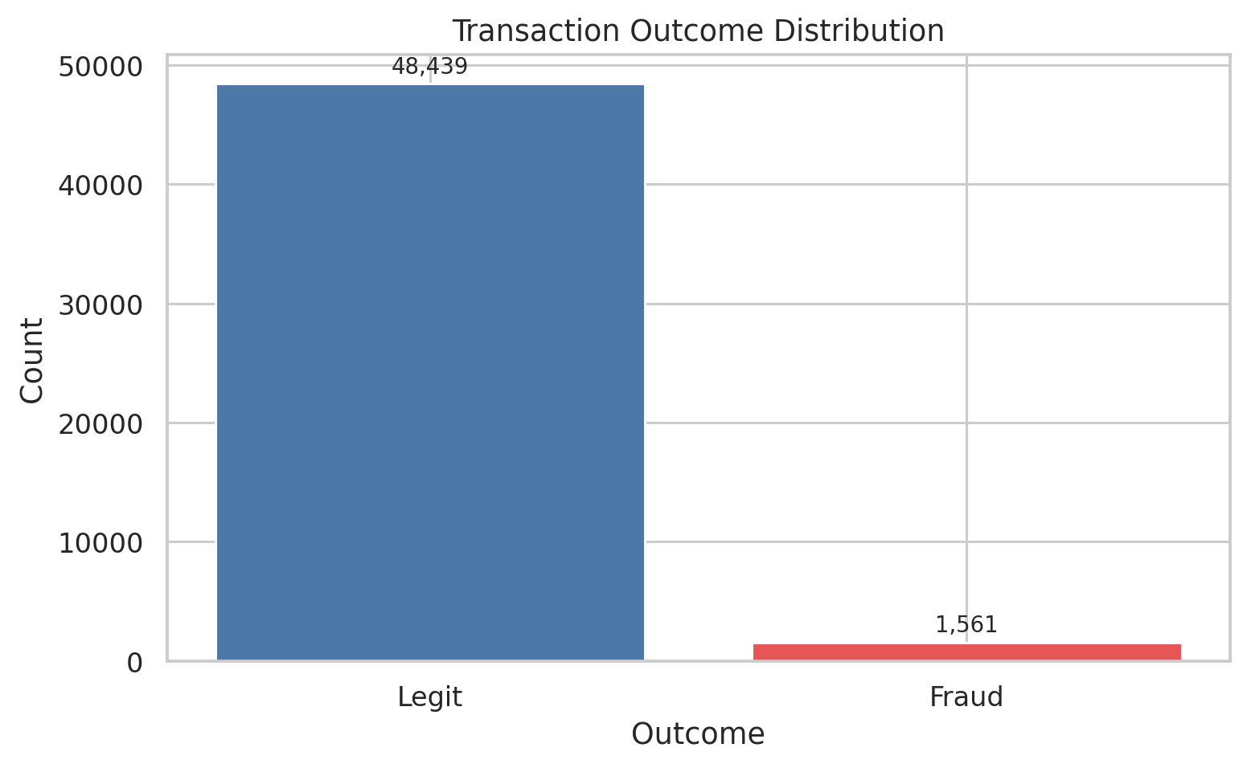

Fraud rate by transaction channel
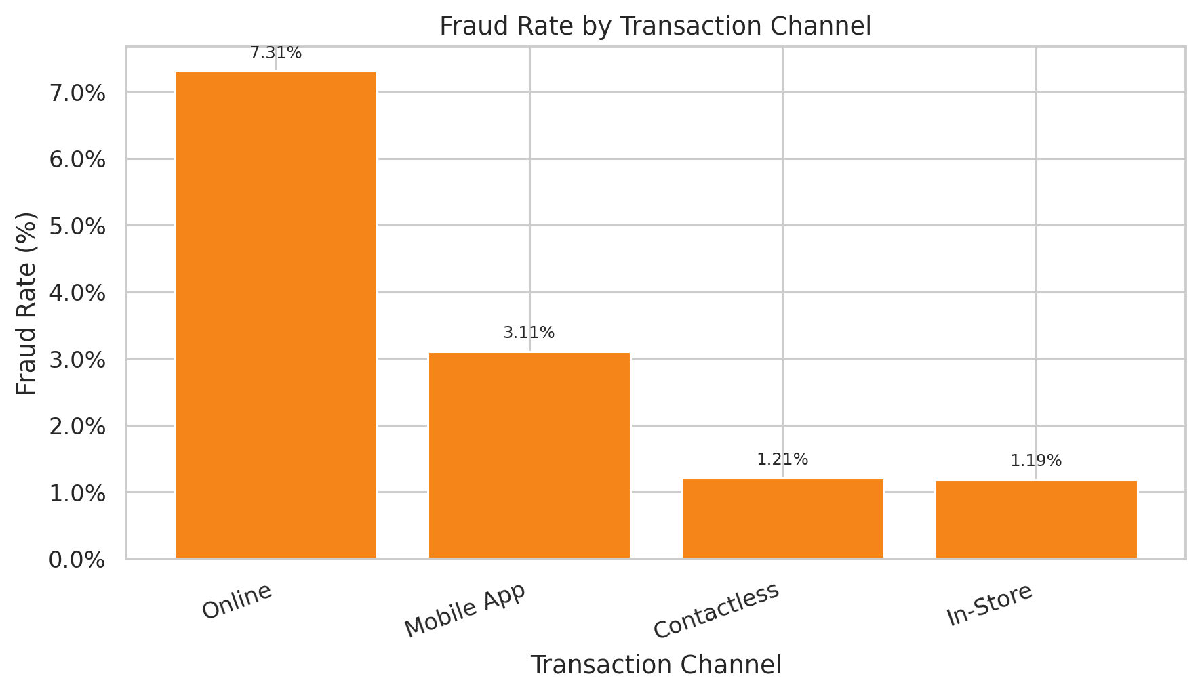

Fraud rate by merchant category
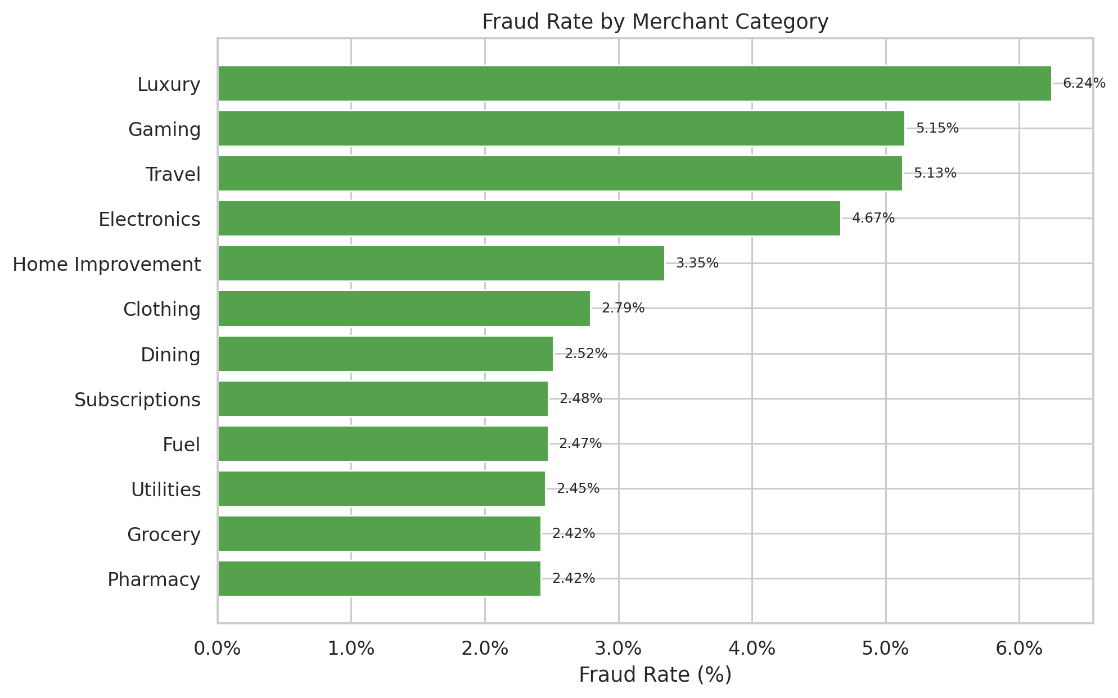

Fraud rate by card presence
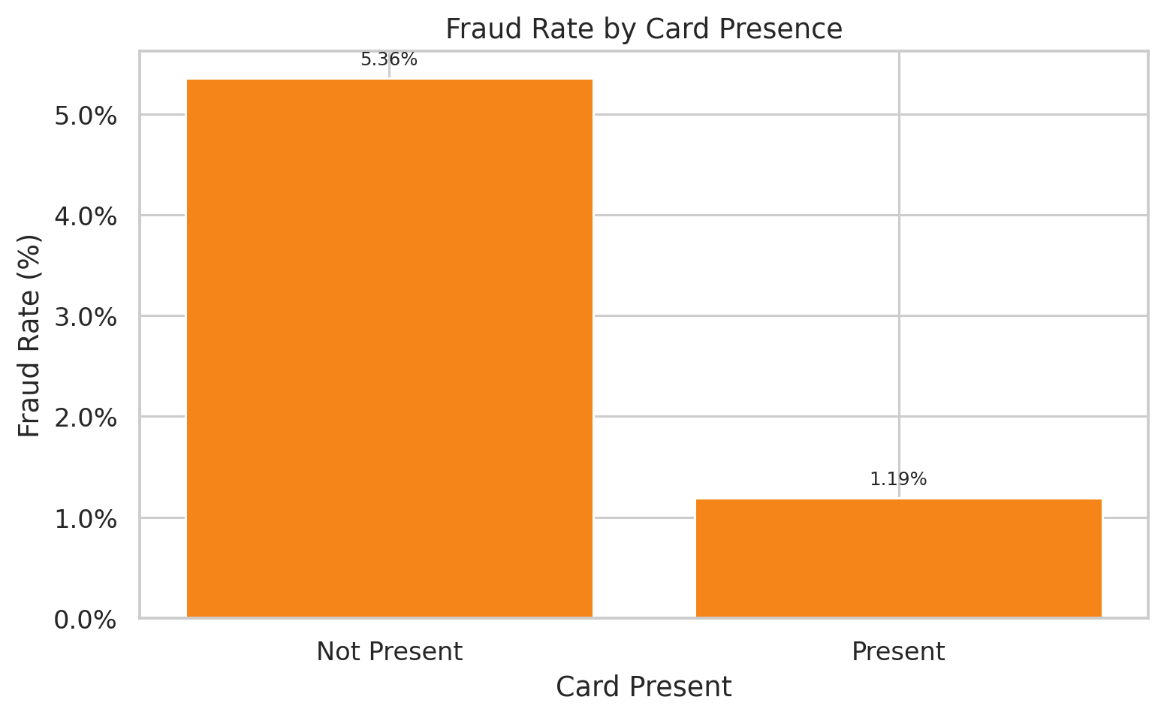

Fraud rate by transaction velocity
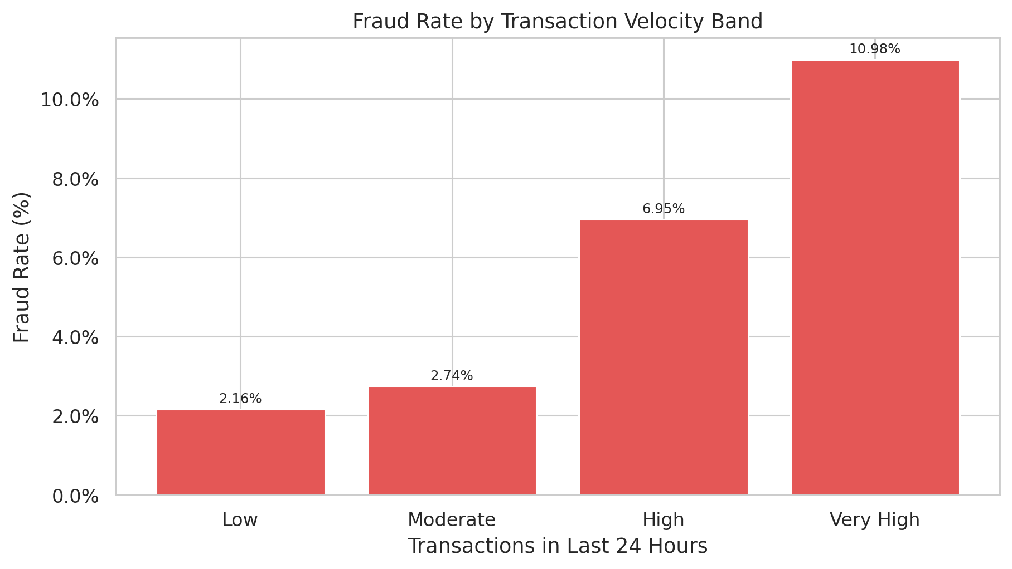

Fraud rate by amount band
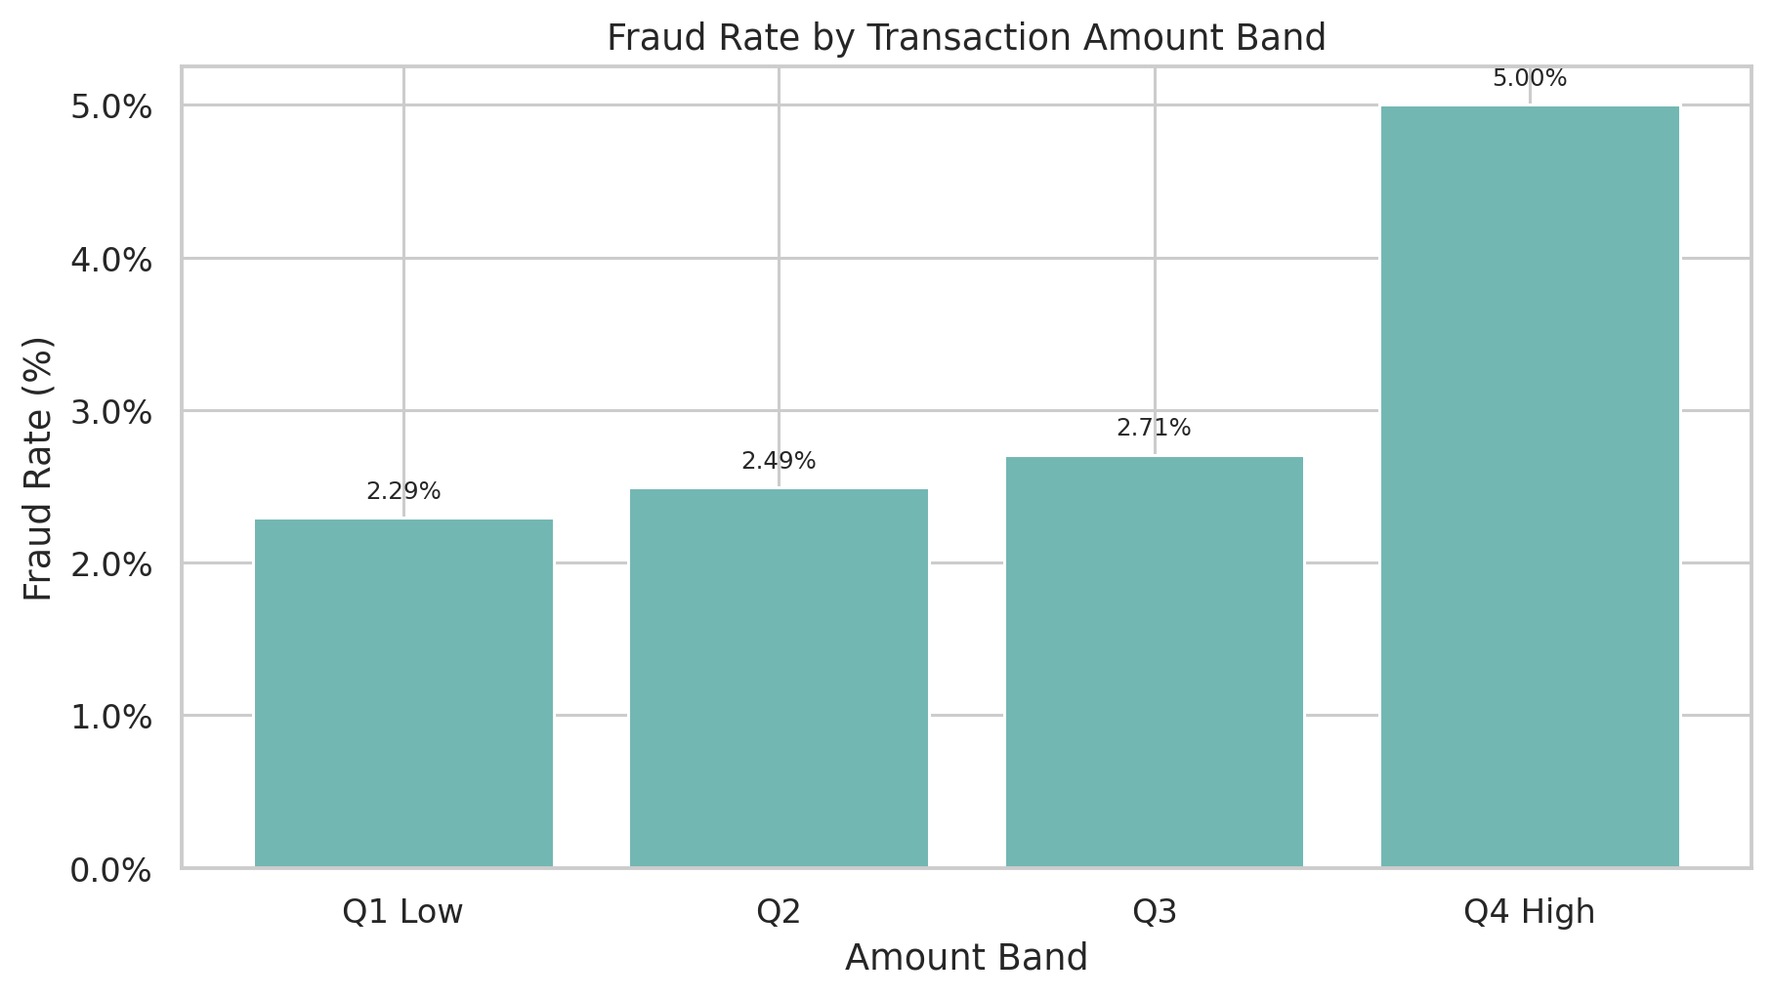

Correlation heatmap
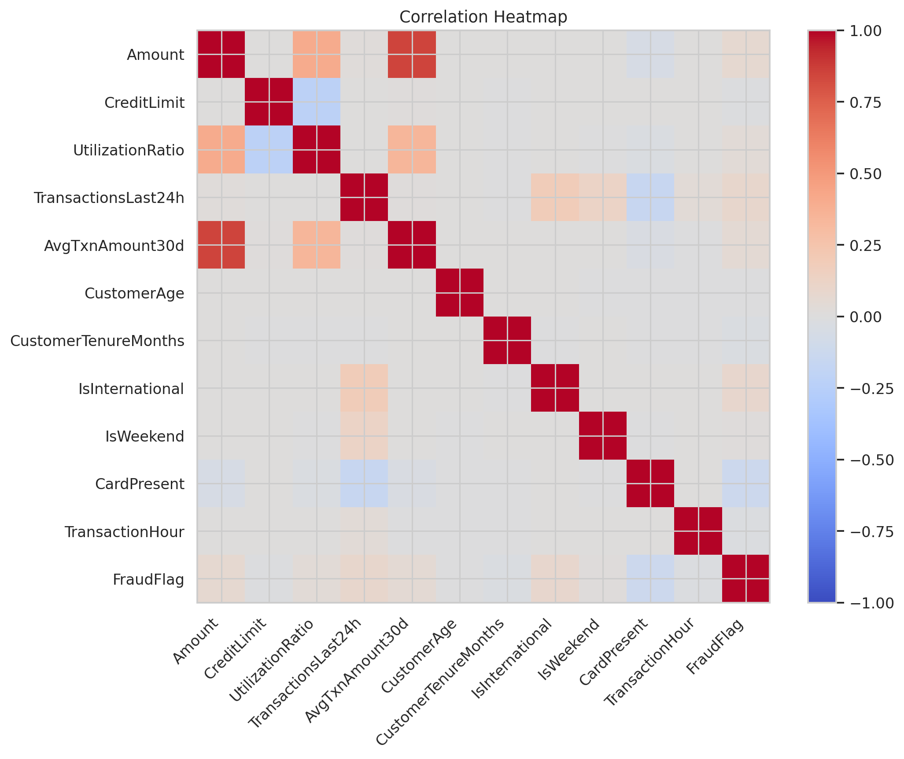

Monthly fraud rate trend
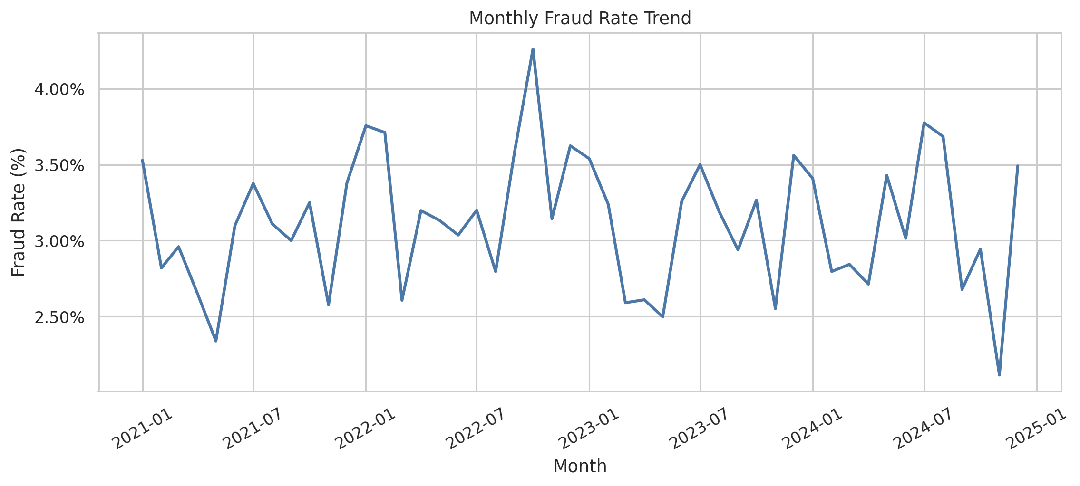

Top fraud drivers
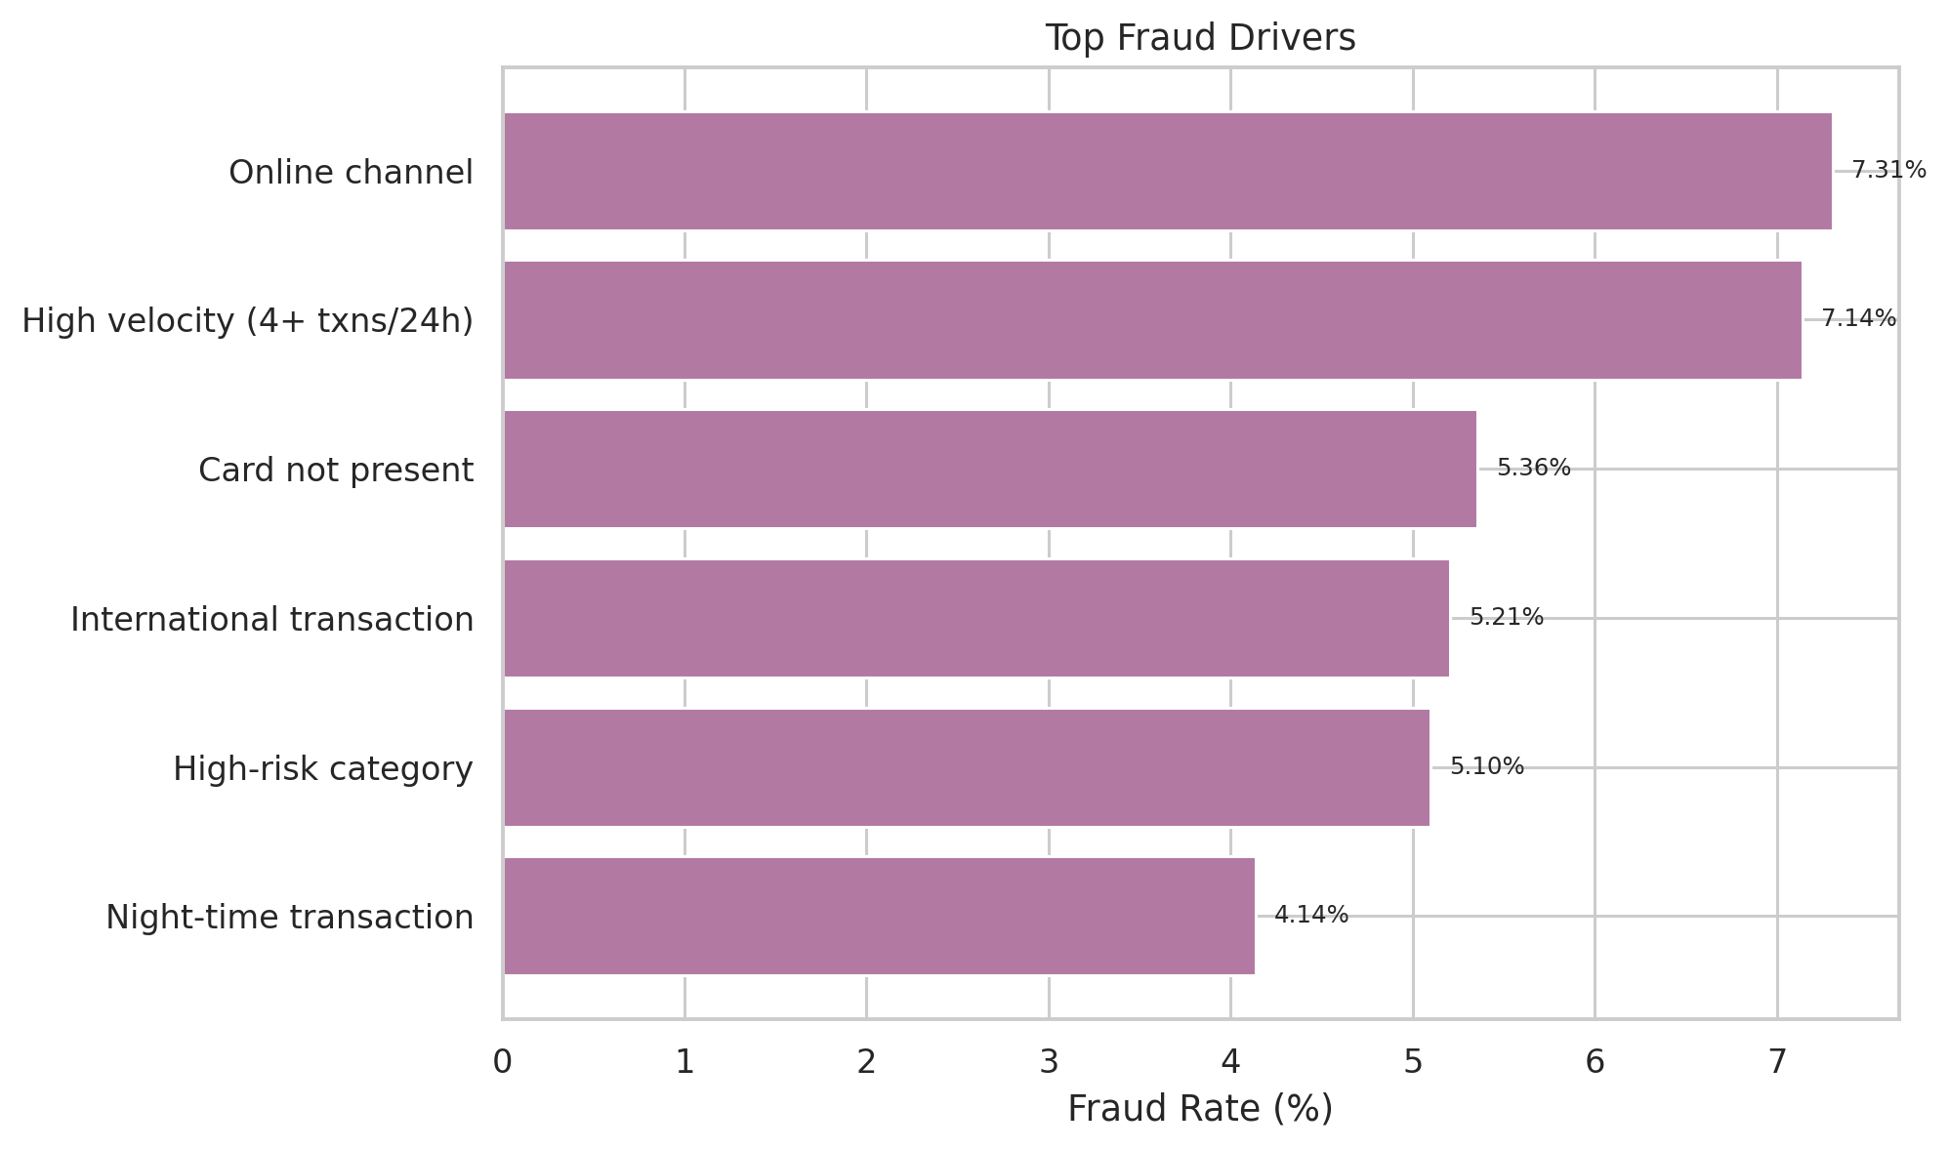

7. Key Findings
- Overall fraud rate is 3.12%.
- Online transactions have a fraud rate of 7.31%.
- Card-not-present transactions have a fraud rate of 5.36%.
- High-risk transactions account for 19.06% of transactions but 52.72% of fraud.
- Fraud rises sharply with transaction velocity.
- High-risk merchant categories include electronics, travel, gaming, and luxury.

8. Problem Identification
Fraud is concentrated in online, card-not-present, international, and high-velocity transactions. This indicates that the organization is exposed to a concentrated risk segment that requires stronger real-time monitoring and step-up controls.

9. Root Cause Analysis
- Online and mobile channels are more exposed to fraud than in-store transactions.
- Card-not-present transactions have substantially higher fraud rates.
- International transactions increase fraud risk.
- Multiple transactions in a short window are a strong warning sign.
- High-risk merchant categories such as travel, gaming, electronics, and luxury contribute disproportionately to fraud.

10. Recommendations
- Tighten controls for card-not-present and international transactions.
- Add step-up authentication for high-risk online and mobile purchases.
- Monitor velocity spikes and repeated attempts in short time windows.
- Apply stricter rules for high-risk merchant categories.
- Increase alerts for night-time and foreign card activity.

11. Conclusion
This project shows that credit card fraud is not evenly distributed across the portfolio. The most effective response is a targeted fraud strategy focused on transaction context, channel risk, merchant category, and transaction velocity.

