App Dev Analytics

EduPulse AI
Github: https://github.com/princeusf13/EduPulseApp
MyWeb:

Prince Praveen – U62327509
EduPulse AI
EduPulse AI is an intelligent academic management and tutoring platform designed specifically for students navigating the rigors of modern analytical and technical coursework. In an era where students are overwhelmed by fragmented information across multiple learning systems, EduPulse AI serves as a centralized, data-driven "Smart Learning Companion."
The Problem
University students often face several critical hurdles that hinder their academic success:
- Information Overload: Vital assignment details, deadlines, and learning materials are often scattered, making it difficult to maintain a clear organizational structure.
- The "Support Gap": When struggling with complex technical topics like Machine Learning or Advanced SQL late at night, students often have no immediate access to academic support or clarification.
- Static Feedback: Traditional systems tell students what their grades are, but they rarely provide the predictive insights or visualizations needed to understand what their grades could be based on current effort and trends.

The Solution
EduPulse AI solves these challenges by integrating organization, analytics, and artificial intelligence into a single, cohesive interface:
- AI-Driven Tutoring: By utilizing a custom-built Knowledge Base, the platform provides immediate, context-aware support for specific assignments, acting as a 24/7 teaching assistant.
- Centralized Management: A robust CRUD (Create, Read, Update, Delete) architecture allows students and professors to manage deliverables with high integrity and transparency.
- Actionable Analytics: Through interactive data visualizations, the platform transforms raw academic data into visual stories, helping students identify risks and optimize their study habits before the final exam.

Why It’s Needed
As academic curricula become increasingly complex, students need more than just a repository for files; they need an ecosystem that supports proactive learning. EduPulse AI is needed to reduce administrative stress and provide the high-level cognitive support required for students to master high-dimensional data and complex architectures, ultimately driving better academic outcomes.

The Home Page
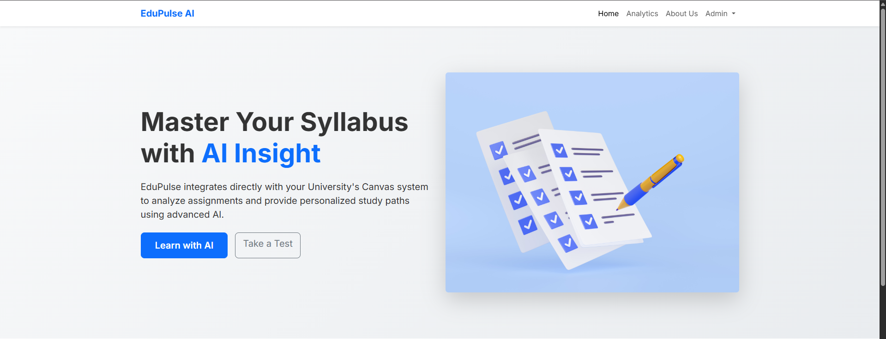
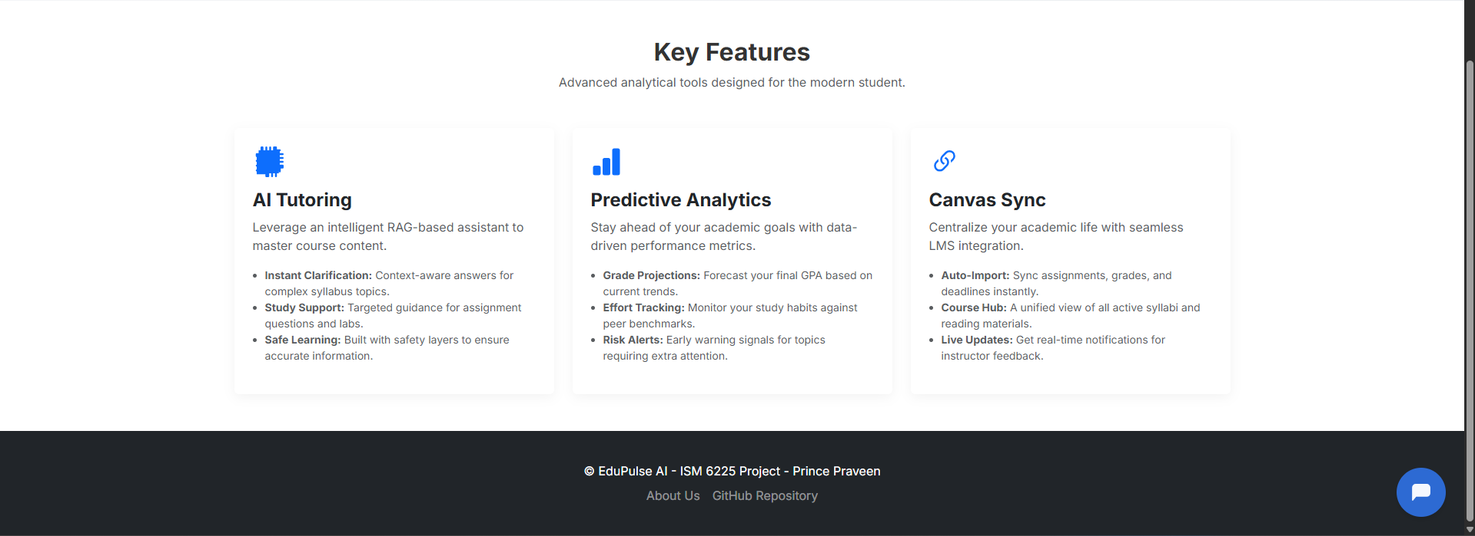

The Home Page serves as the primary entry point for EduPulse AI, immediately establishing its value proposition as a smart learning companion that integrates with university systems. It features a modern, clean interface with a hero section that introduces the project’s mission, high-level Key Feature cards (AI Tutoring, Predictive Analytics, and Canvas Sync) to guide user exploration, and a professional navigation bar for seamless access to the app's analytical and administrative tools.

Manage Assignments: The CRUD Page
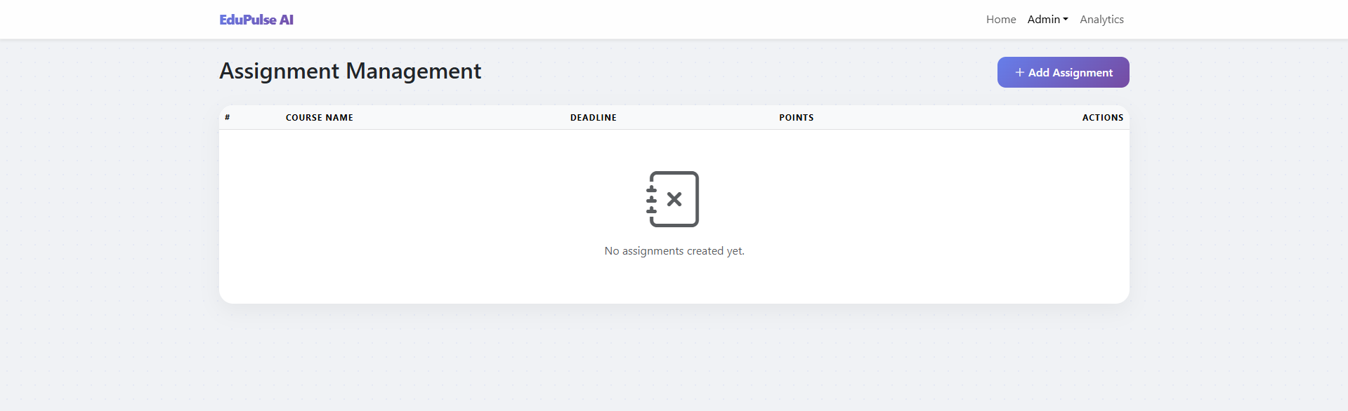
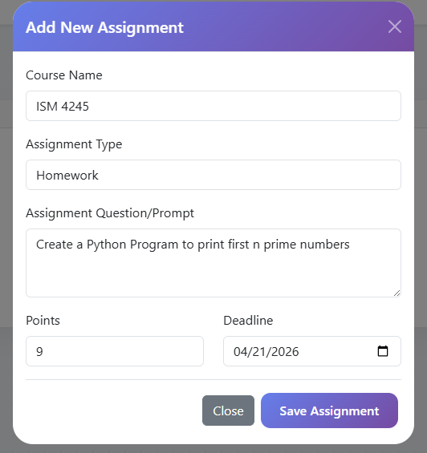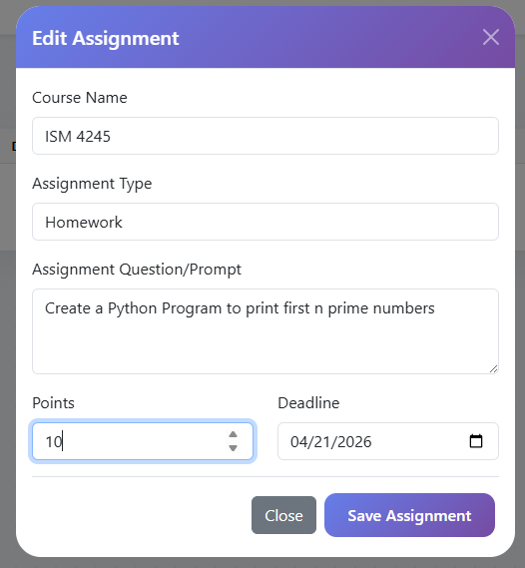
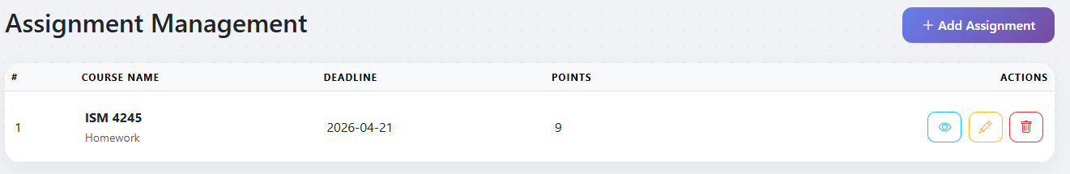

The Assignment Management page serves as the core administrative hub, showcasing a full CRUD (Create, Read, Update, Delete) lifecycle. It features a streamlined interface where admins can view an organized list of deliverables or access a dynamic modal form to add and edit assignment details, such as course names, prompts, points, and deadlines, ensuring the system maintains a high level of data integrity and transparency.
Analytics Page: Chart Js
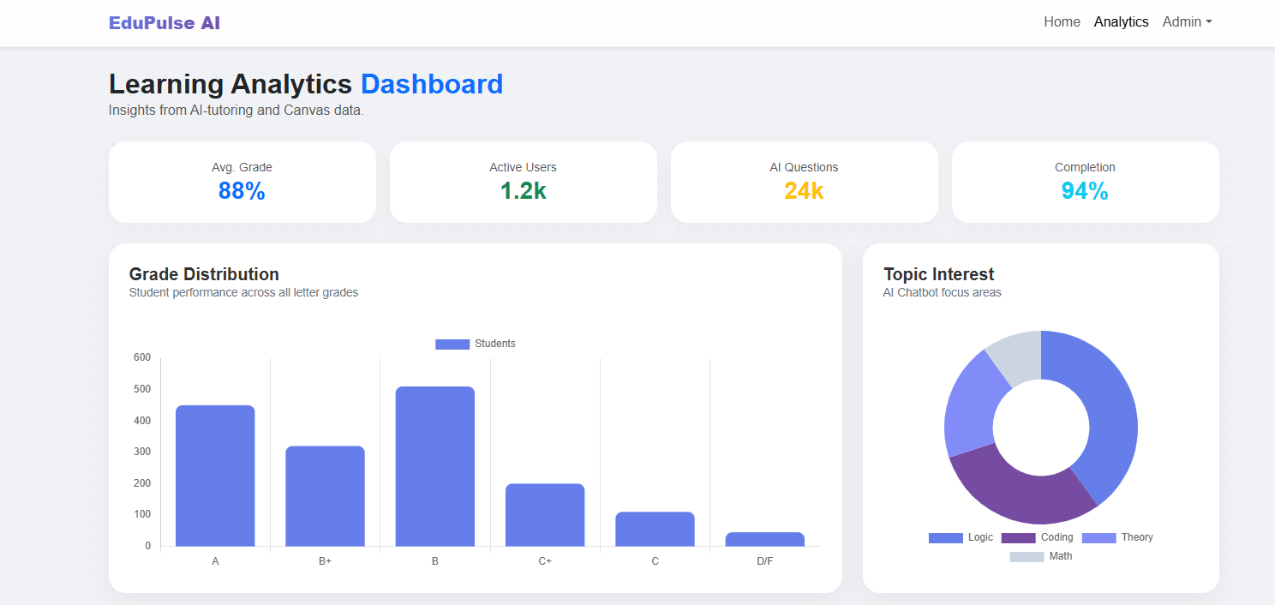
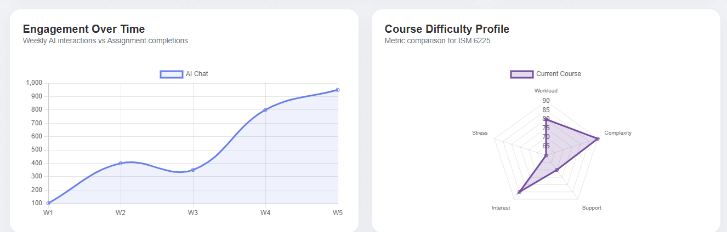
The Learning Analytics Dashboard provides a high-level overview of academic health and system engagement through four key interactive visualizations:
- Grade Distribution: This bar chart illustrates student performance across various letter grades, allowing instructors to identify overall class success and specific areas where students may be falling behind.
- Topic Interest: A doughnut chart that categorizes AI chatbot interactions by subject area, such as Logic and Coding, surfacing the specific curriculum topics where students most frequently seek automated tutoring support.
- Engagement Over Time: This line graph tracks weekly AI chat interactions, providing a longitudinal view of student activity and identifying periods of high demand that typically correlate with major assignment deadlines.
- Course Difficulty Profile: A radar chart that maps several qualitative metrics, including workload, complexity, and stress, offering a multidimensional "signature" of the course's rigor to help manage student expectations and instructional support.
The About Us Page
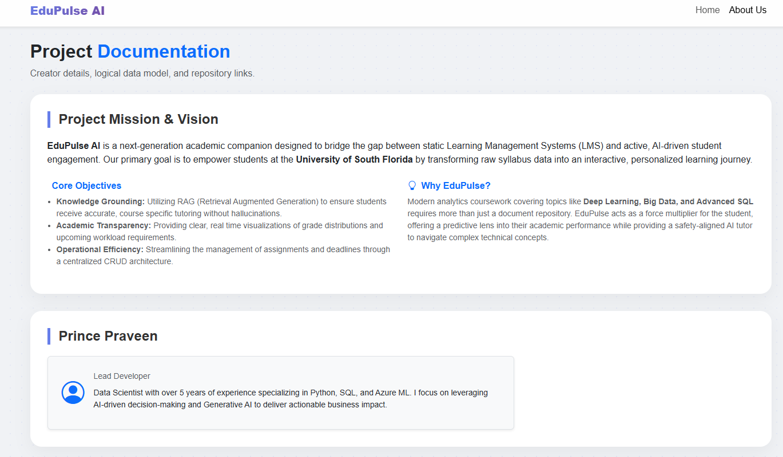
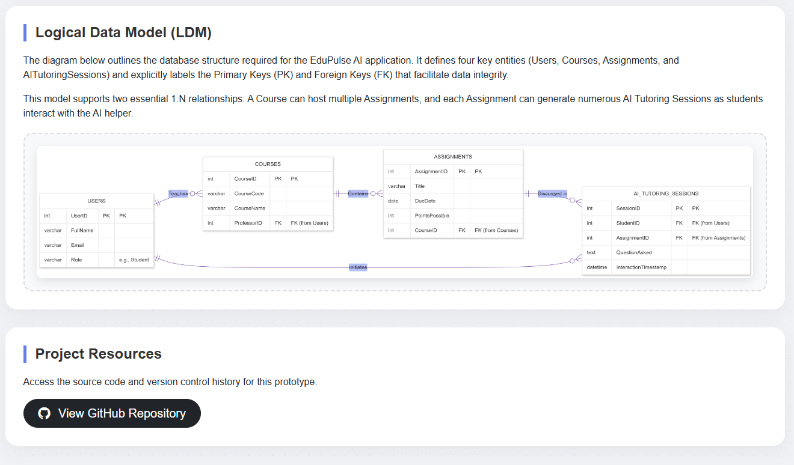

The Data Model
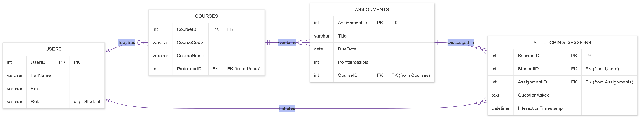

About Us & Documentation
The About Us page provides a comprehensive look at the mission, leadership, and technical foundation of EduPulse AI. It serves as the project's documentation hub, detailing the project's vision to bridge the gap between static Learning Management Systems and active, AI-driven student engagement.

Logical Data Model
The technical core of the application is represented by a Logical Data Model that establishes the structural framework for data integrity and relationship management:
- User & Course Management: The model begins with a USERS table containing unique UserID primary keys. It establishes a one-to-many relationship with the COURSES table, where one user (typically a professor) can teach multiple courses.
- Course Content: The COURSES table connects to the ASSIGNMENTS table through a CourseID foreign key, allowing each individual course to contain multiple specific assignments.
- Interactive Sessions: The model further tracks student engagement through the AI_TUTORING_SESSIONS table. This table utilizes foreign keys to link back to both USERS (initiating students) and ASSIGNMENTS (the specific subject of the tutoring session), facilitating granular tracking of how students interact with the AI assistant for each task.
- Data Integrity: All tables include clearly defined primary keys (PK) and foreign keys (FK) to support relational integrity and future dynamic functionality.

The Bot Press Integration

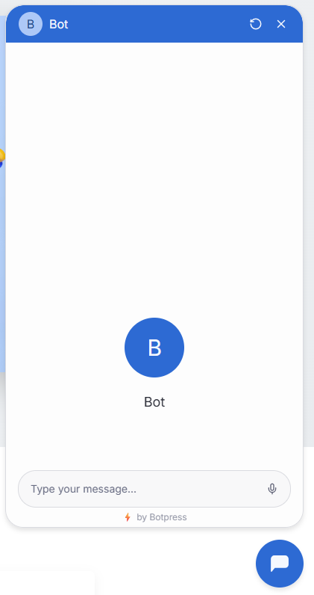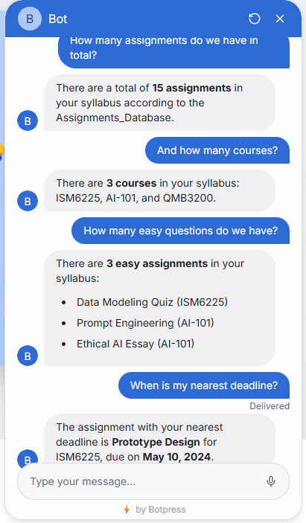

The EduPulse AI Assistant is an interactive chatbot designed to provide real-time, context-aware support by leveraging a custom-built knowledge base. This integration demonstrates how modern conversational AI can be grounded in structured data to deliver accurate academic information to students.

The Knowledge Base: Assignments Database
The chatbot's "intelligence" is derived from a structured Botpress Table that serves as its primary source of truth. This database was engineered with multiple dimensions to ensure the bot could handle diverse student inquiries:
- Identifier & Classification: Includes unique Assignment_ID and Course_Code columns to distinguish between different academic requirements across multiple classes.
- Content Details: Features Title, Category (e.g., Homework, Project, Exam), and Topics_Covered to help students understand the scope of their work.
- Analytical Metrics: Includes Difficulty levels, Points possible, and Estimated_Hours required, allowing the AI to offer strategic study advice.
- Logistics: Tracks Due_Date to provide immediate deadline reminders and prioritization assistance.

Conversational Capability & Testing
The bot uses an Autonomous Node and RAG-based grounding to answer specific questions based on the 15-row dataset provided. As shown in the interaction samples, the bot successfully handles various query types:
- Quantitative Summaries: Accurately identifies the total number of assignments (15) and courses (3) present in the syllabus.
- Attribute Filtering: Successfully filters the database to list "easy" assignments and identifies the courses they belong to.
- Time-Sensitive Logic: Analyzes the Due_Date column to identify the "nearest deadline," providing both the assignment title and the specific date.

By integrating this bot, EduPulse AI moves beyond a static dashboard, offering an active safety net that helps students master high-dimensional data and complex course architectures with 24/7 support.

The API Integration
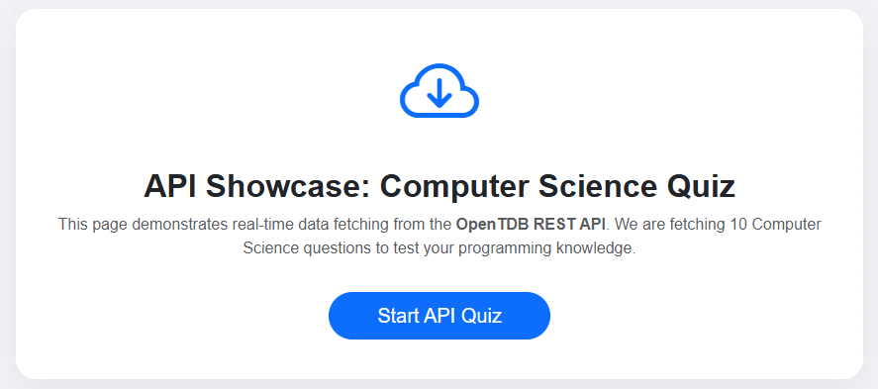
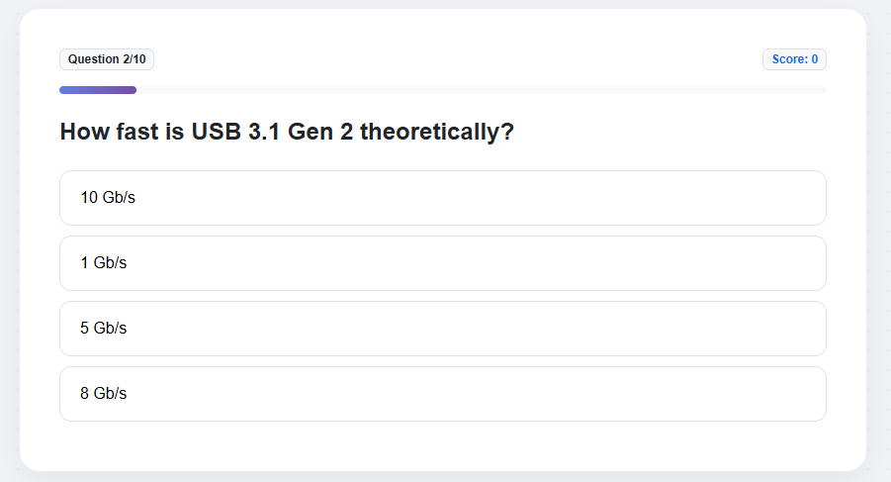

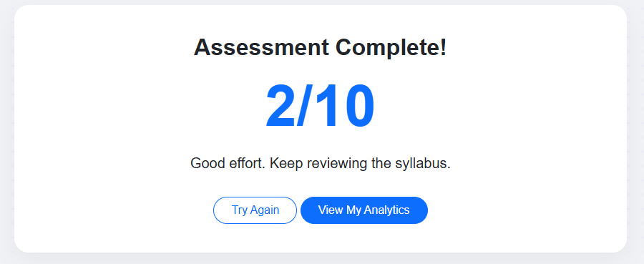

API Integration: External Quiz Showcase
The Syllabus Quiz page demonstrates the application’s capability to integrate with external data sources through REST APIs. This feature serves as a technical proof-of-concept for the final project's requirement to fetch and manipulate real-time data.

Reflections
Name: Prince Praveen
Project Role: Lead Developer & Analytics Specialist
Total Time Spent: Approximately 12 Hours
Project Rationale & Tech Stack
The objective of this assignment was to architect a high-fidelity static prototype for EduPulse AI, a smart learning companion designed to bridge the gap between static syllabi and active student engagement. Leveraging my background in Data Science and AI/ML Research, I selected a modern tech stack to ensure the prototype was both visually premium and technically robust:
Frontend: HTML5 and CSS3 utilizing Bootstrap 5 for a responsive, mobile-first design. I implemented a "Glassmorphism" aesthetic to ensure the UI felt like a high-end SaaS product.
Interactivity: Vanilla JavaScript was used to simulate dynamic behavior, including the use of LocalStorage for the Assignment Management CRUD operations to persist data during sessions.
Data Visualization: Chart.js was integrated to transform raw academic data into actionable insights through four distinct chart types (Bar, Doughnut, Line, and Radar).
AI Integration: Botpress was utilized to deploy a RAG-grounded chatbot capable of answering complex student queries from a custom knowledge base.
External Integration: The OpenTDB API was used to demonstrate real-time data fetching and asynchronous processing via fetch and async/await.
Challenges & Problem Solving
- UI/UX Stability: One major challenge was the Chart.js "infinite growth" bug, where charts would expand vertically and break the page layout. I resolved this by wrapping canvases in relative containers with fixed height caps and disabling the default aspect ratio maintenance.
- Data Persistence on a Static Site: To fulfill the CRUD requirements without a backend, I utilized LocalStorage. This allowed for a realistic demonstration of creating, updating, and deleting assignments that "stayed" on the page even after a refresh.
- API Cleaning: Data retrieved from the OpenTDB API often contained HTML entities. I wrote a custom decoding helper function to ensure the text rendered cleanly in the UI, demonstrating proper data pre-processing.

Key Learnings & Future Vision
This project reinforced the importance of Logical Data Modeling in the early stages of application development. By defining the 1:N relationships between Users, Courses, and Assignments early on, the subsequent UI development became more intuitive. Moving forward into the final project phase, I plan to transition this static data into a live MVC architecture on DOT NET CORE.

