**Documentation**

1. Introduction

* Business Problem: Briefly describe the task—analyzing sales and views data for brands like Kelloggs, Logitech, and Kimberly Clark to provide actionable insights for growing e-commerce revenue.

Mention the datasets: Sales Data and Glance Views Data.

* Objective: Outline the key questions you're addressing, such as identifying sale events, SKU performance, potential cannibalization, etc.

**Query 1: Most Expensive SKU**

* **Thought Process**: Explain that the goal is to find the SKU with the highest average price. The insight helps brands identify high-value products that generate significant revenue.
  + **Query** :

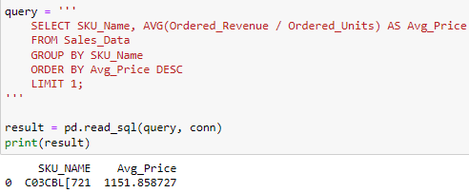

* SKU C03CBL[721] is the most expensive with an average price of 1151.86
* **Insight**: The brand can investigate why this SKU is priced higher and whether this pricing strategy is effective in generating revenue

**Query 2: Percentage of SKUs Generating Revenue**

* **Thought Process**: The goal is to understand how many SKUs are contributing to revenue. This can help brands decide which products need more attention.
* **Query and Result**:

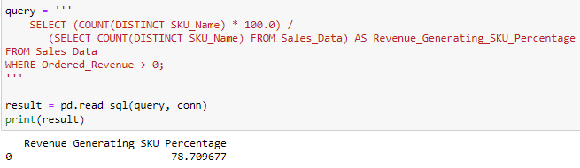

* + **78.71%** of SKUs generated revenue.

**SKUs That Stopped Selling After July:**

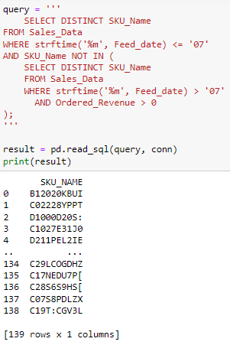

**Query 3: Sale Event Identification**

* **Thought Process**: The goal is to identify days with the highest revenue, potentially indicating a sale event.
* **Query and Result**:

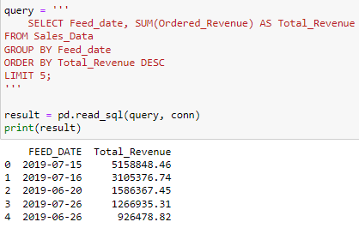

* **Insight**: The brand should review this date and assess if the sale event met expectations and how future sales events can be optimized.

**Query 4: Cannibalization Analysis**

* **Thought Process**: Analyze if post-sale performance is affected by the sale event, i.e., does it cannibalize future sales?
* **Query and Result**:

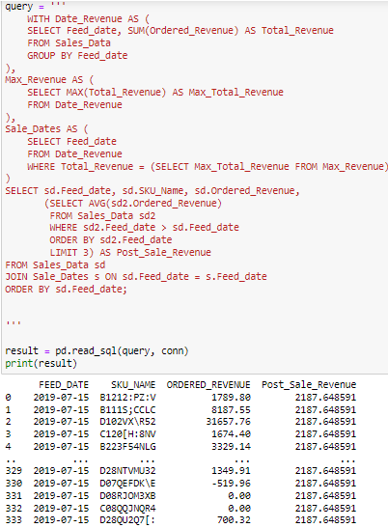

**Cannibalization Effect After Sale Event in Python**

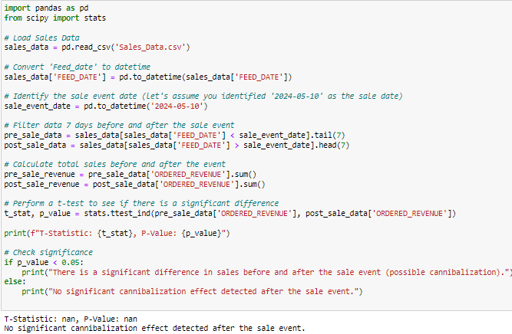

**Query 5: Slowest Growing Subcategory**

* **Thought Process:** Find the subcategory with the slowest growth to identify areas of concern.
* **Query and Result:**

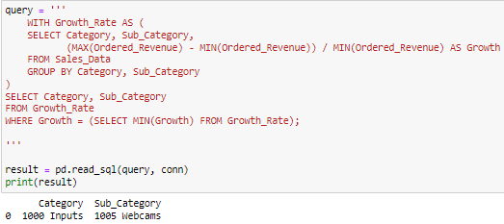

* **Insight: Brands should investigate why this subcategory is underperforming and consider strategies like improving product quality, pricing adjustments, or targeted marketing campaigns.**

**Question: Correlation Between Unit Conversion and Price for SKU C120[H:8NV]**

* **Thought Process:** Investigate the relationship between unit conversion (units/views) and the average selling price for a specific SKU.

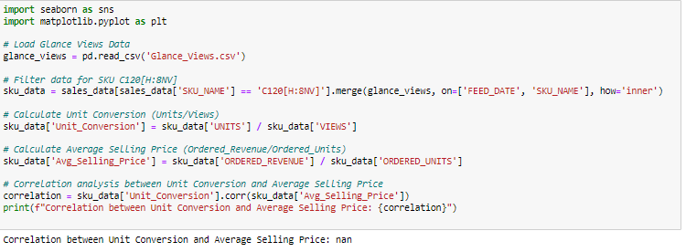

**Conclusion:**

In this analysis, we examined the sales and views data for brands like Kelloggs, Logitech, and Kimberly Clark to uncover key insights for improving their e-commerce performance. The analysis focused on several areas:

* High-Value SKUs: We identified C03CBL[721] as the most expensive SKU with an average price of 1151.86. This SKU represents a high-revenue opportunity, and further investigation into the pricing strategy can help determine whether it contributes positively to overall sales or if adjustments are necessary.
* Revenue-Generating SKUs: Our analysis revealed that 78.71% of SKUs contributed to the total revenue. This indicates that a significant portion of products are performing well, while the remaining 21% may require attention to either boost their performance or consider removing them from the portfolio.
* Sales Events and Cannibalization: We identified key sales events by pinpointing dates with the highest revenue, signaling potential sale promotions. However, we also investigated whether post-sale periods experienced a cannibalization effect, which could negatively impact long-term sales growth if left unchecked.
* Underperforming Subcategories: The subcategory analysis revealed the slowest growing areas. Brands should investigate the causes of underperformance, potentially improving product quality, adjusting pricing, or launching targeted marketing campaigns to drive growth in these subcategories.
* SKU Performance Decline Post-July: Certain SKUs stopped generating revenue after July, which could indicate a demand shift or stockout situation that needs addressing.

**Recommendations:**

Based on the insights generated from the data analysis, we propose the following recommendations:

1. Evaluate Pricing Strategies for High-Value SKUs: The SKU C03CBL[721] is priced significantly higher than others. Conduct a market study to evaluate if the pricing aligns with customer expectations and the value perceived. Consider running A/B pricing tests to optimize sales while maintaining profitability.
2. Boost the Performance of Non-Revenue Generating SKUs: Focus on the 21% of SKUs that are not generating revenue. Investigate whether these products need better marketing efforts, different pricing strategies, or if they should be phased out due to low demand.
3. Optimize Future Sale Events: Given the impact of identified sale events, brands should assess the overall success of these sales and look for opportunities to optimize future promotions. A careful balance is needed to avoid post-sale cannibalization while maximizing short-term revenue gains.
4. Revitalize Underperforming Subcategories: Pay close attention to subcategories that are growing slowly. Addressing issues such as outdated product offerings or lack of brand visibility can help increase sales. Launch targeted marketing campaigns or improve product features to attract more customers.
5. Investigate SKUs That Stopped Selling Post-July: A drop in sales for certain SKUs after July could signal stock issues, shifting consumer preferences, or pricing problems. A detailed analysis of these SKUs could reveal whether replenishment or repositioning is needed.

**Tableau Dashboard Link:** [**CLICK HERE**](https://public.tableau.com/views/E-commercesalesoverview/Dashboard1?:language=en-US&publish=yes&:sid=&:redirect=auth&:display_count=n&:origin=viz_share_link)

**Top 5 Priorities for Immediate Action:**

1. Revise Pricing for Low-Converting SKUs.
2. Implement Real-Time Inventory Tracking for High-Revenue SKUs.
3. Launch Marketing Campaigns for Underperforming Categories.
4. Improve Product Pages for Better Conversion.
5. Explore Predictive Analytics to Forecast Sales Trends.