Advanced Artificial Intelligence B.Tech. (Third Year)- Semester-V D.Y.P.I.U, Pune

Practical 03

Student Name: Vaishnavi Sandesh Gawade
Date of Experiment:
Date of Submission:
PRN No: 20230802073

Aim: Implement a basic Artificial Neural Network (ANN) from scratch.

Software/Tool: Python/Jupyter/Colab

Objectives:
- To understand the working of a simple feed-forward neural network.
- To learn the concept of forward and backward propagation.
- To implement ANN training using weight updates and activation functions.
- To classify the Iris dataset using a single hidden-layer ANN.
- To visualize the loss curve during model training

Prerequisites:
  - Basics of Machine Learning

Theory:

An Artificial Neural Network (ANN) is a computational model inspired by the structure and functioning of the human brain. It consists of interconnected units called neurons, arranged in layers—an input layer, one or more hidden layers, and an output layer.
Each connection between neurons carries a weight that determines how strongly one neuron influences another. During learning, these weights are adjusted to minimize the difference between predicted and actual outputs.

1. Feed-Forward Neural Network:
In a feed-forward network, the data flows only in one direction — from the input layer, through the hidden layers, to the output layer. There are no feedback connections. Each neuron computes a weighted sum of its inputs and passes the result through an activation function such as:
- Sigmoid: $f(x)=\frac{1}{1+e^{-x}}$
- ReLU (Rectified Linear Unit): $f(x)=max⁡(0,x)$
- Tanh: $f(x)=\frac{e^{x}-e^{-x}}{e^{x}+e^{-x}}$
These activation functions introduce non-linearity, enabling the network to learn complex patterns.

2. Forward Propagation:
In forward propagation, input data is passed through the network layer by layer to generate output predictions.
For each neuron:
$$z=W⋅x+b \\ a=f(z)$$
where,
- $x$= input vector
- $W$= weights
- $b$= bias
- $f(z)$= activation function output

3. Backward Propagation:
Backpropagation is the process of updating weights based on the error between predicted and actual output.
The steps are:
- Compute the loss (error) using a loss function, e.g. Mean Squared Error (MSE).
- Calculate the gradient of the loss with respect to weights.
- Update the weights using Gradient Descent:
$$W_{new}=W_{old}-η\frac{∂L}{∂W}$$
where $η$is the learning rate.

4. ANN for Iris Classification:
The Iris dataset contains 150 samples of flowers belonging to three species: Setosa, Versicolor, and Virginica.
Each sample has four features:
- Sepal length
- Sepal width
- Petal length
- Petal width
A simple feed-forward ANN with one hidden layer can be trained to classify these species. The output layer uses Softmax activation to predict the probability of each class.

5. Visualization of Loss Curve:
During training, the loss value decreases as the model learns. Plotting the loss curve (loss vs. epochs) helps visualize the training progress and check whether the model is converging.

Code:
To implement a simple feed-forward Artificial Neural Network (ANN) using NumPy for classification on the dataset.
• Import necessary libraries (numpy, pandas, sklearn)
• Load and preprocess the Iris dataset
• Initialize weights and biases randomly
• Perform Forward Propagation (compute predictions)
• Compute Loss (Cross Entropy)
• Perform Backward Propagation to adjust weights
• Repeat for multiple epochs
• Evaluate the model accuracy
• Plot loss curve

To implement a deeper Artificial Neural Network with multiple layers, ReLU activation, dropout, and adaptive learning rate, trained on MNIST handwritten digits dataset for image classification.-
• Load the MNIST dataset
• Normalize input values (0–255 → 0–1)
• Flatten images into 1D array (784 features)
• One-hot encode output labels
• Define neural network architecture
- Input layer: 784 neurons
- Hidden layers: 128 and 64 neurons (ReLU)
- Output layer: 10 neurons (Softmax)
• Implement forward and backward propagation
• Use Adam optimizer
• Include dropout and L2 regularization
• Implement early stopping
• Plot accuracy and loss curves
• Display confusion matrix and sample predictions

Output :
To implement a simple feed-forward Artificial Neural Network (ANN) using NumPy for classification on the dataset.

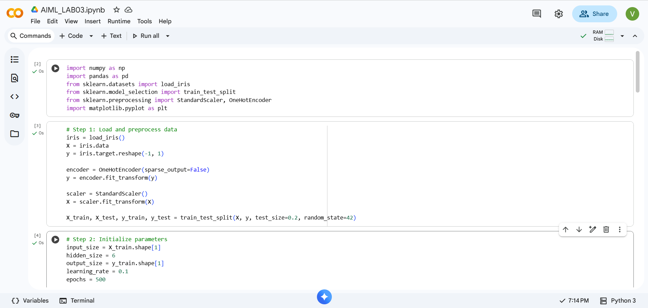

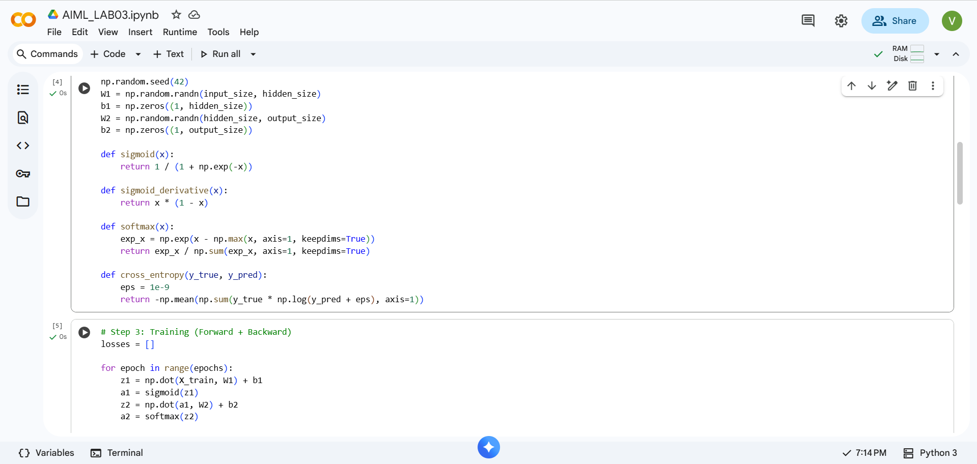
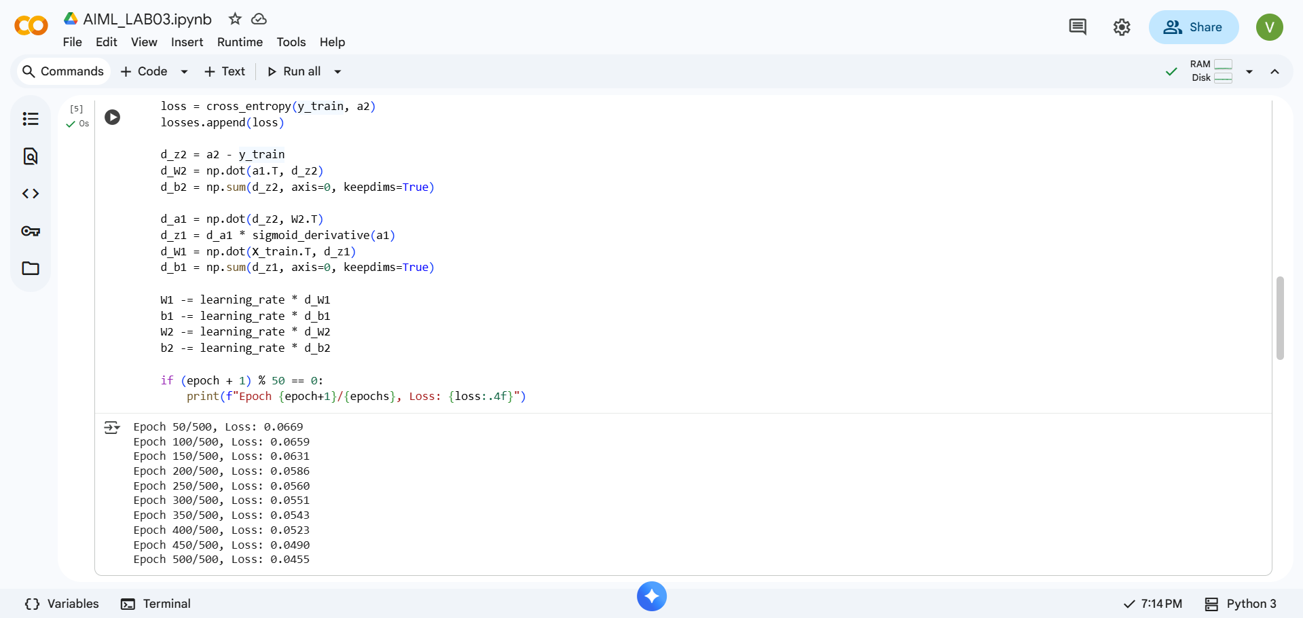

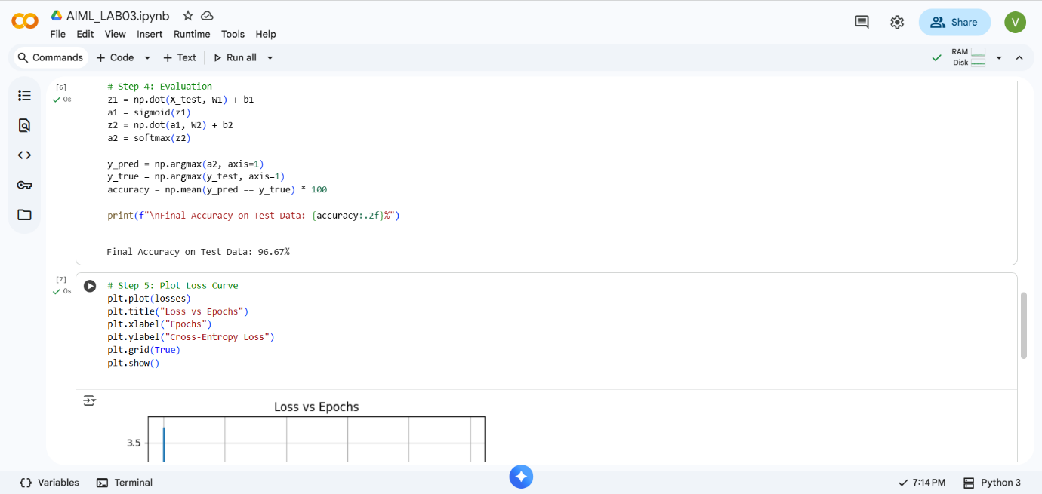

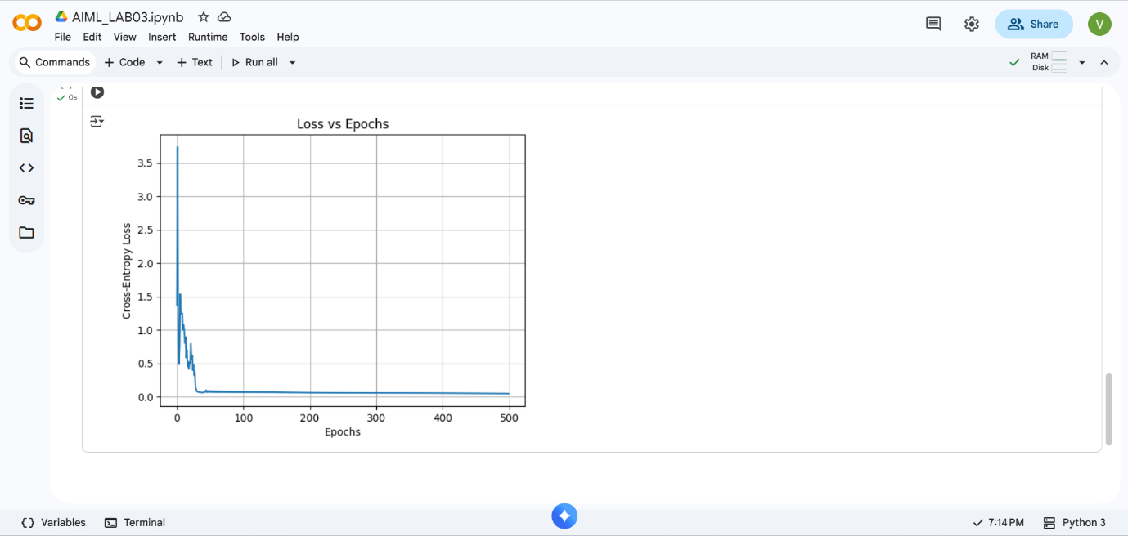

To implement a deeper Artificial Neural Network with multiple layers, ReLU activation, dropout, and adaptive learning rate, trained on MNIST handwritten digits dataset for image classification:
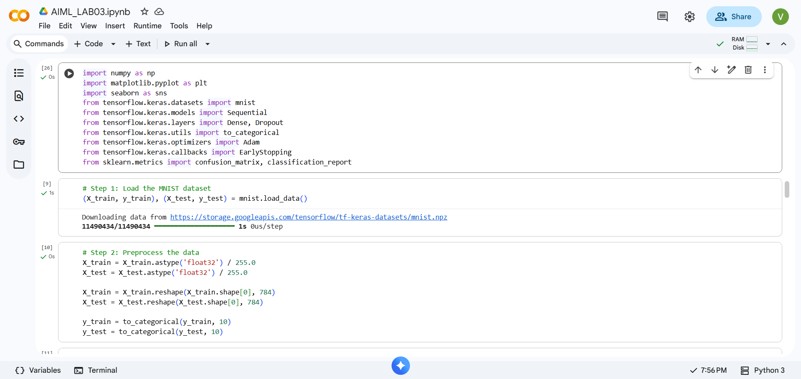
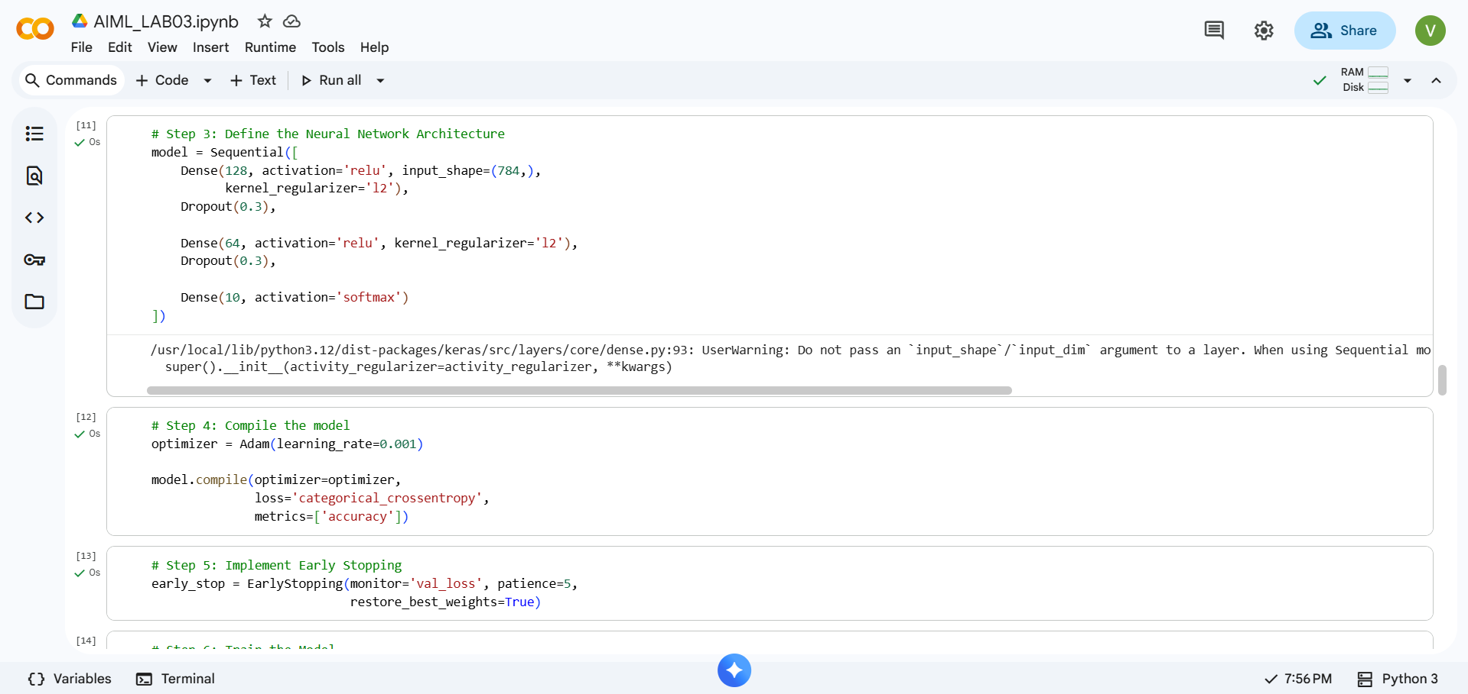
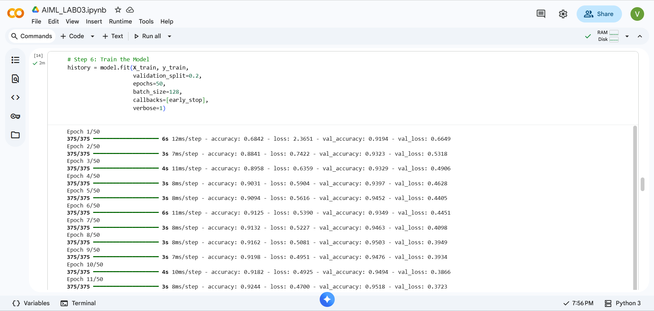
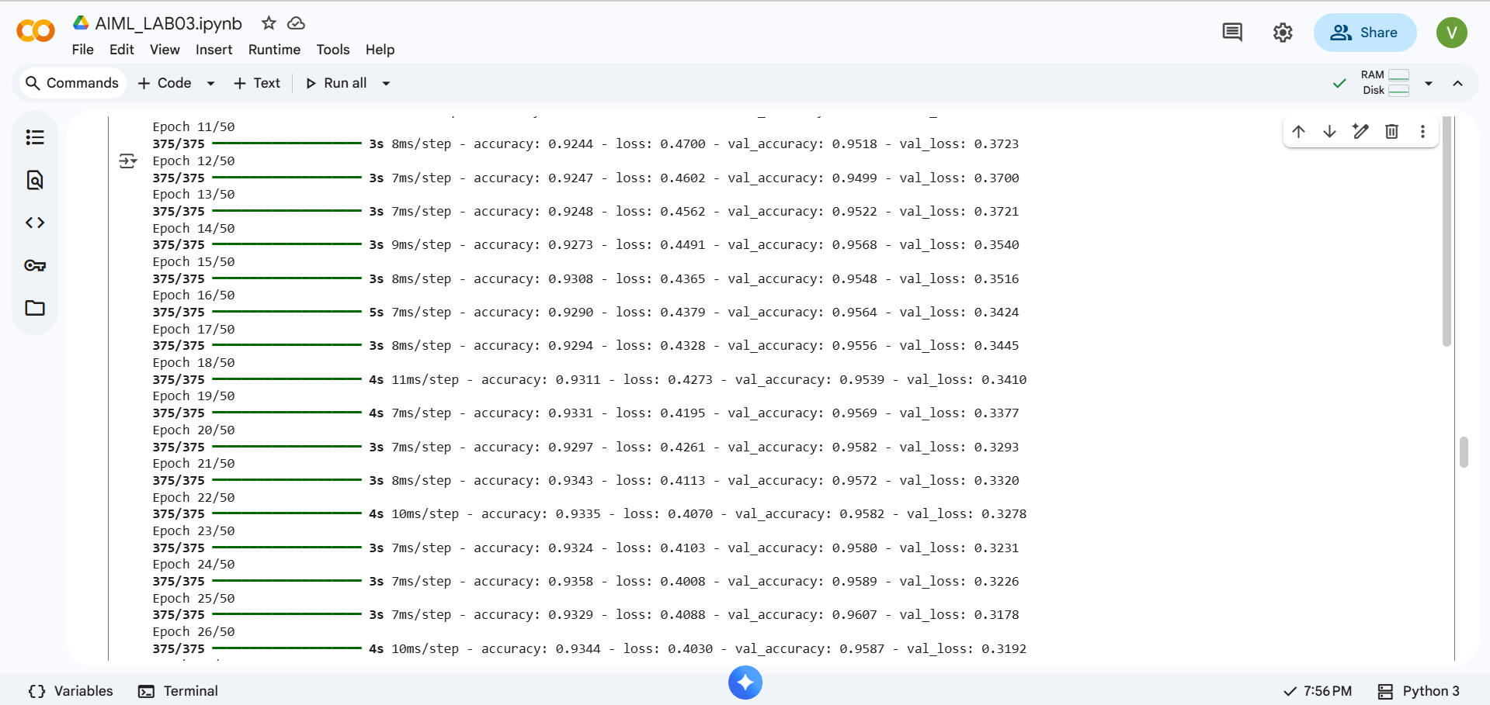
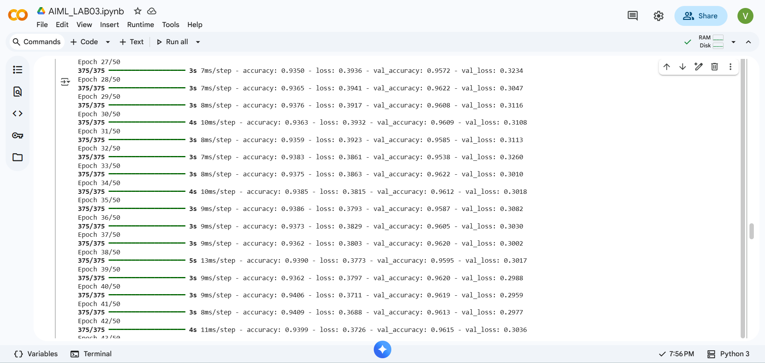
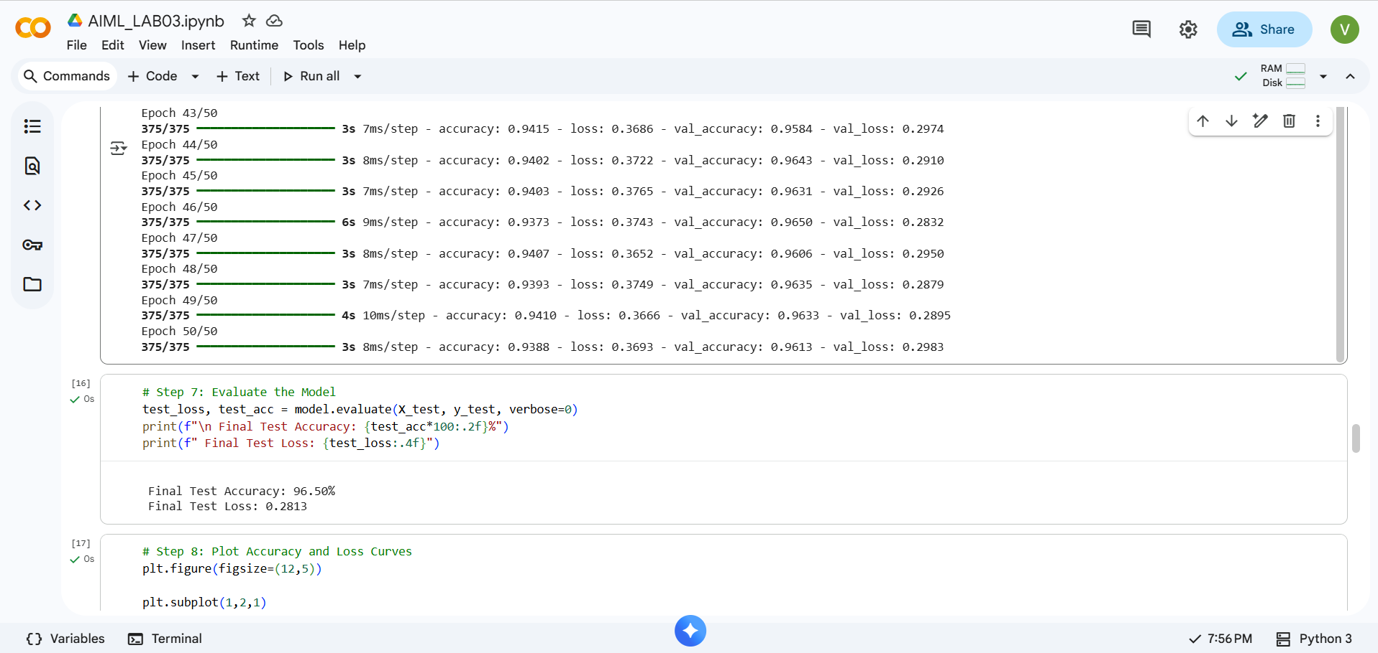
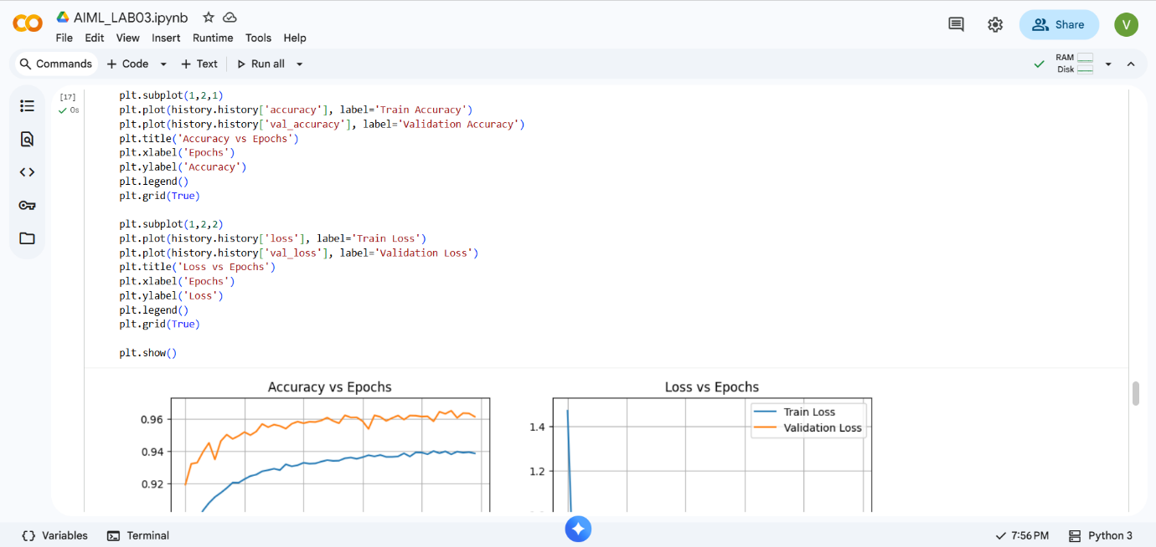
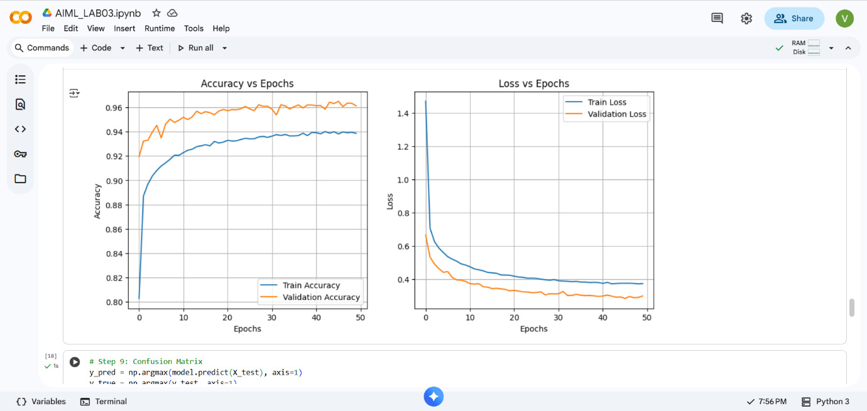
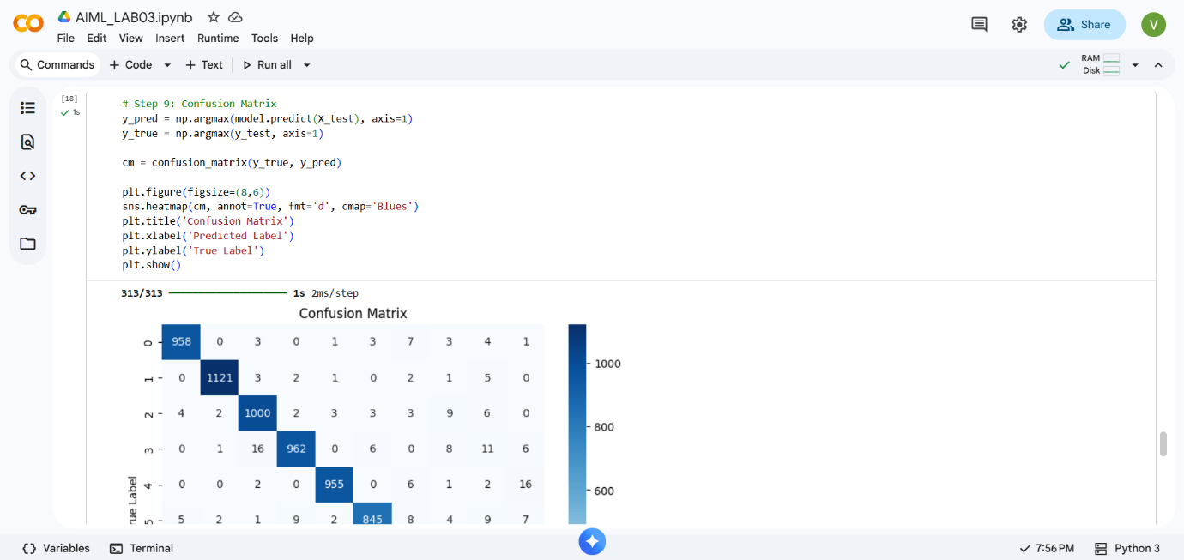
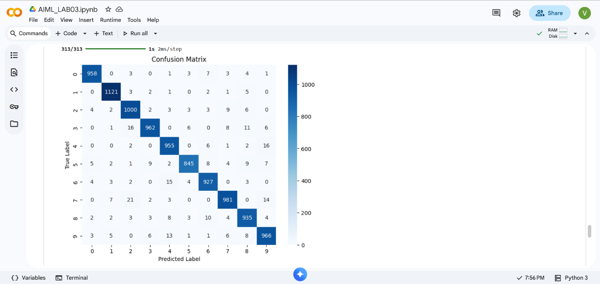
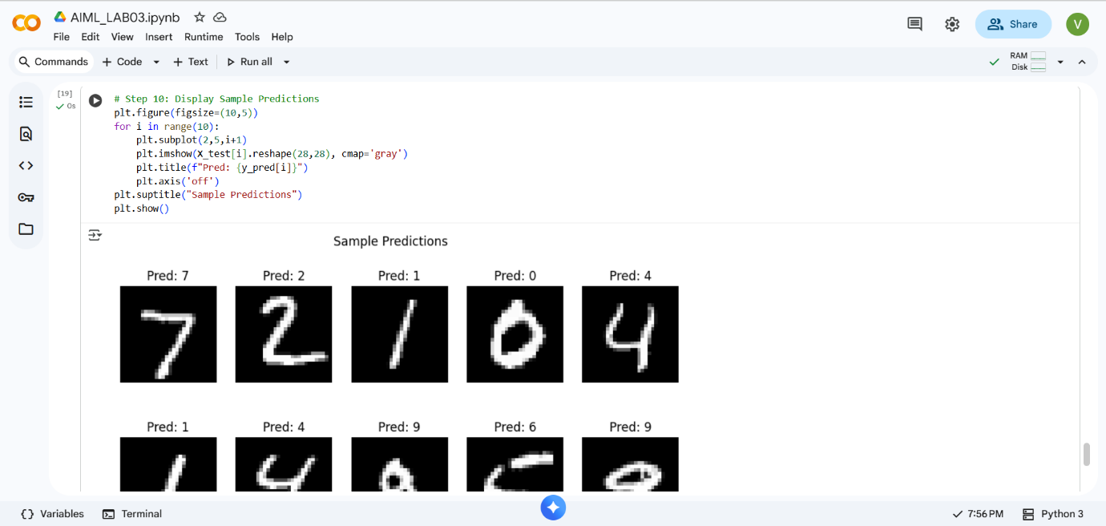
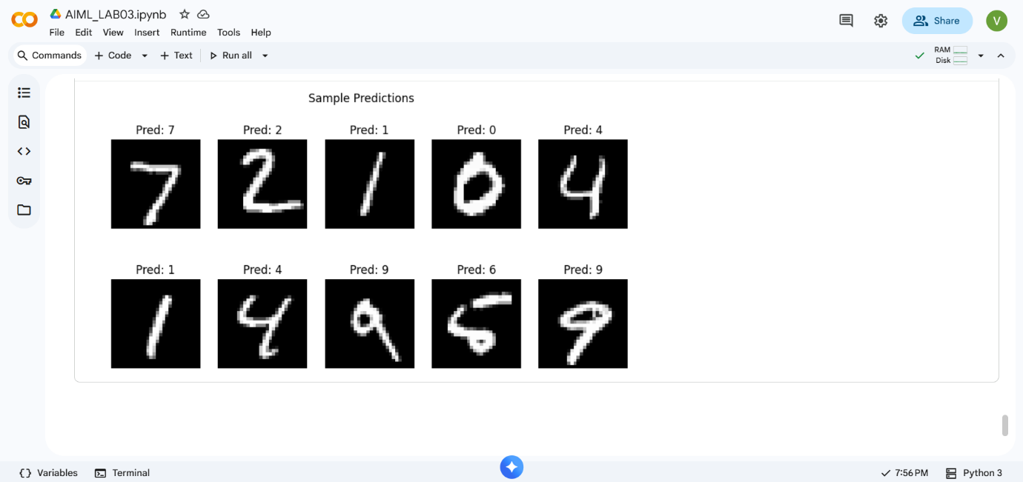

Conclusion:
A simple feed-forward Artificial Neural Network (ANN) was implemented from scratch to classify the Iris dataset. The model successfully learned using forward and backward propagation, showing decreasing loss and good accuracy. This experiment helped in understanding the basic working and training process of an ANN.

