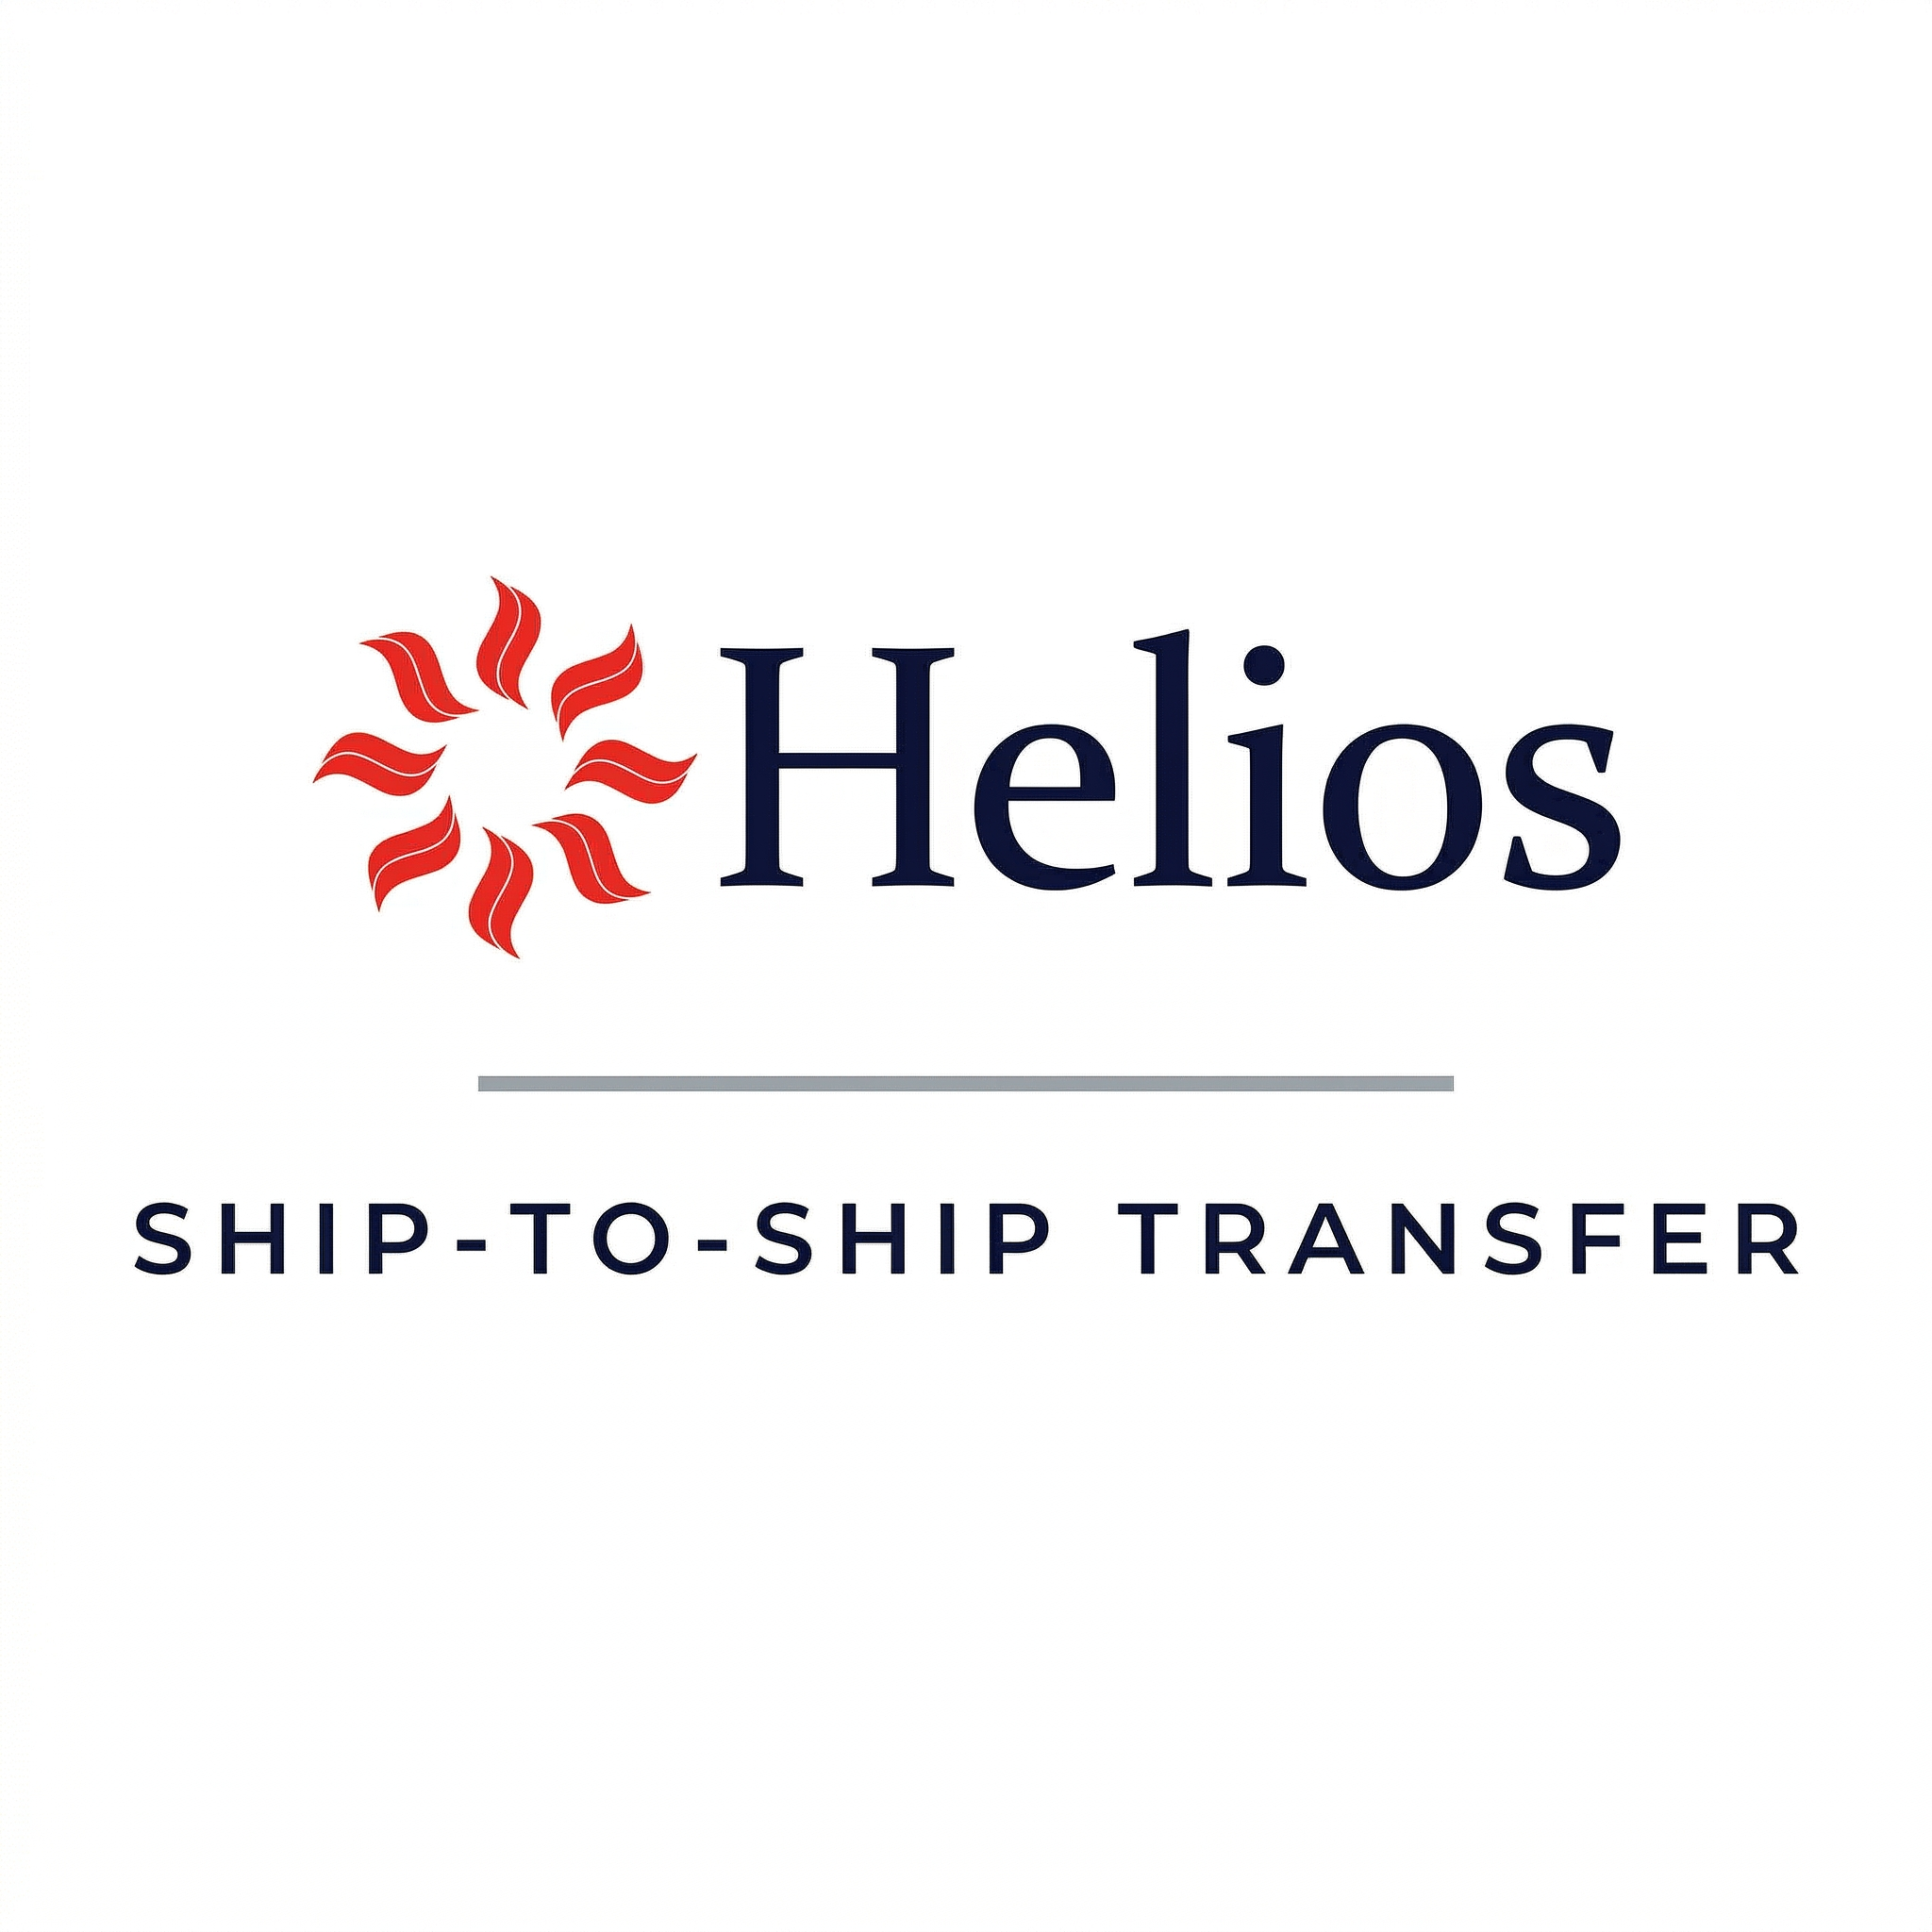 | AT SEA SHIP TO SHIP TRANSFER  CHECKLIST 1 – BEFORE OPERATION COMMENCE | Form No: OPS-OFD-001  Rev No: 2.0  Rev Date: 04 Aug 2026, 05:30  Approved By: JS  Page: 1 of 2

Vessel Name | Rama Arnold
Ship Operator | Voluptate commodi co
Charterer | Deserunt consequatur
STS Organizer | Magnam et dolor ut v
Planned Transfer Date | 11 Jan 1976, 05:30
Transfer Location | Ipsum est dolorum q
Cargo | Cum quae omnis quis
Constant Heading Ship | Cupidatat sed qui am
Manoeuvring Ship | Inventore consectetu
POAC / STS Superintendent | Ipsam lorem totam si
Applicable Joint Plan Operation | Sunt commodo magna n

CL | Generic Checks | Status | Remarks
1 | A copy of the JPO has been received | YES | Ad iure corrupti co
2 | Effective communications are established | YES | Sunt at harum enim e
3 | Ship handling characteristics exchanged | YES | Quaerat temporibus q
4 | The ship is upright at a suitable trim, without any overhanging projections | YES | Sit labore ab expedi
5 | Maneuvering, mooring and navigational equipment has been tested and found in good order | YES | Minim lorem rerum om
6 | Engineers have been briefed on engine speed (and speed adjustment) requirements | YES | Rerum in sapiente qu
7 | Main engine(s) are available without any power limitations | YES | Ullamco dolorum ea n
8 | Weather forecasts have been reviewed and will be monitored | YES | Ut repellendus Et e
9 | Crew briefed on the mooring procedure and JPO | YES | Non non consequatur
10 | STS contingency plan agreed and an appropriate emergency drill has been conducted | YES | Aspernatur eum omnis
11 | Notifications required by local regulations are sent | YES | Qui quidem dolor mai

Name: Yoko Anderson  Rank: Deleniti magna expli | Date: 01 Oct 1970, 05:30 | Signature

