JOB REFERNCE:
OPS-2026-001
MT BLUE WHALE
MT OCEAN PIONEER
SS: STBL :
*All calculations are in Meters

- HOSE CALCULATIONS

POINT A
POINT B
12.5
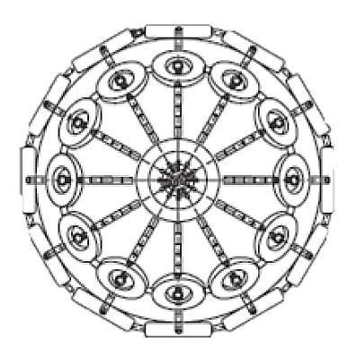
STBL -MIN Freeboard
49
HOSE LENGTH REQUIRED:
9
18
STBL -MAX Freeboard
8
15
SS -MIN Freeboard
SS -MAX Freeboard
POINT C
STBL -Distance manifold to ship rail
SS -Distance manifold to ship rail
3.5
10

- FENDER CALCULATIONS
STBL DWT
80000
50000
SS DWT
40
SS BEAM
32
SS BEAM
SS DISP
95000
60000
SS DISP
SS DRAFT
14
SS DRAFT
12
Equivalent Disp. Coefficient Combined virtual displacement
STBL Mass Coefficient Energy Coefficient Calm
SS Mass Coefficient Energy Coefficient Moderate
Virtual Displacement STBL Energy Coefficient Rough
Virtual Displacement SS
38274.71
52186.18
1199.21
1.66
2026.66
1.38
3069.98
56472.92
119742.88

4Nos x 3.3M x 6.5M
FENDERS REQUIRED FOR CALM WEATHER

4Nos x 3.3M x 6.5M
FENDERS REQUIRED FOR MODERATE WEATHER

FENDERS REQUIRED FOR ROUGH WEATHER
5Nos x 4.5M x 9.0M

