Oceane Marine

Table of contents

1. What this app is?
2. System architecture
3. Tech stack
4. Repository layout
5. Module deep dive
6. API surface
7. Database & Mongoose models
8. Authentication and RBAC
9. Background jobs & document generation
10. External app integrations
11. Environment Variables
12. Scripts & cron
13. Local development
14. Run the app

1. What this app is?

Oceane-Marine is the central back-office. Internal users sign in here to:

- Plan and manage STS (Ship-to-Ship) operations end-to-end — documentation, locations, vessels, clients/agents, mooring masters, cargos, compatibility, quotations, JPO, manuals, inspection checklists, and the entire OPS-OFD checklist family.
- Run QHSE workflows — training & drills, KPIs, MOC, risk assessments, near-miss reports, defects, audits, due diligence, POAC cross-competency, and the Controlled Document Register.
- Run PMS (Plant Maintenance) — equipment inventory, accessories, testing, certificates and warehouse.
- Run HR — POAC matrix, oil majors, statutory certificates and CID.

Receive submissions from two **external public apps**:
- OPERATIONS-STS-CHECKLIST => anonymous OPS-OFD checklist forms filled at sea / on board.
- QHSE-FORMS => anonymous QHSE forms (audits, near-miss, induction, supplier questionnaire ).

2. System architecture

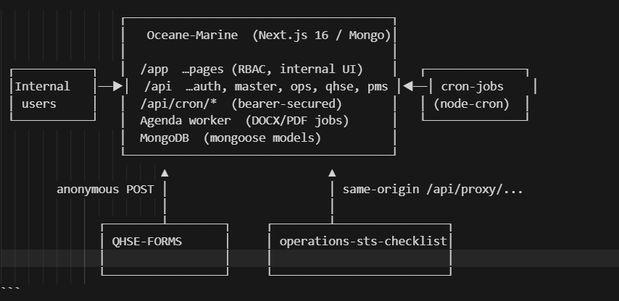

External submissions land via two patterns:
- QHSE-FORMS posts JSON through its own `/api/proxy/...` to the Oceane-Marine `/api/qhse/.../create` and `/api/near-miss-form/create` endpoints, which are explicitly allowlisted in `middleware.js`.
- operations-sts-checklist uses the Oceane-side `/api/sts-proxy/...` (CORS-friendly forward) into `/api/operations/sts-checklist/...`, with anonymous create , read , update permitted by `isPublicOperationsStsChecklistRoute`.

DOCX/PDF generation, notifications and the document register are asynchronous— handled by an Agenda worker (`npm run worker`).

3. Tech stack
- Framework => Next.js 16 (App Router)
- Database = > MongoDB mongoose 9
- Auth | Custom => JWT (jsonwebtoken) + bcryptjs in an HttpOnly access_token cookie.
- State => Zustand (`src/store/authStore.js`)
- UI => Tailwind CSS v4
- Charts =>Chart.js + react-chartjs-2
- Maps =>Leaflet + react-leaflet** |
- Email =>Resend
- Documents =>docx, jspdf + jspdf-autotable (QHSE / HR / bulk PDF), puppeteer (STS quotation PDF), file-saver
- Background jobs => Agenda 5 (Mongo collection agendaJobs
- Other dotenv, node-cron (declared but the in-repo cron lives in workspace `cron-jobs/’)

4. Repository layout

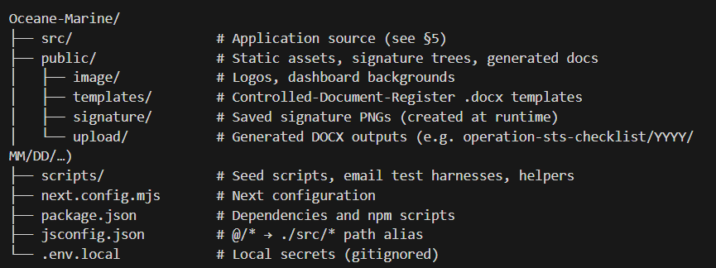

5. Module deep dive

5.1 Operations
Operations module — workflow overview
The Operations module is organised around a single concept: every Ship-to-Ship (STS) operation has a unique Operation Reference Number (e.g. 2026-001). This reference is the thread that ties every document, checklist, calculation and uploaded file to the same operation throughout its lifecycle.
1. Documentation — starting a new operation (Admin)
When a new STS operation is confirmed, an Admin opens the Documentation form inside the Operations module and:
- Generates a fresh Operation Reference Number (the system creates a unique reference automatically).
- Fills in the basic information for the operation — client, vessels involved, planned location, dates, cargo, agents, mooring master assigned, and any supporting documents.
- Saves the record as a Draft. The operation is now registered in the system but not yet locked, so the Admin can come back any time to update missing details before the operation actually starts.
This step creates the operation record that everything else in the module attaches to.
2. Form & Checklist → STS Checklist (Admin → Mooring Master)
Once the operation is on the calendar and a Mooring Master has been assigned, the Admin moves to Form & Checklist → STS Checklist:
- The Admin selects the relevant Operation Reference Number from a dropdown (only operations created in step 1 appear here).
- The system displays the full set of OPS-OFD checklist links (Before Operation, Before Run-in & Mooring, Before Cargo Transfer, During Transfer, Equipment Checklist, Hourly Quantity Log, Master's Feedback, Declarations, etc.) — each link is pre-populated with the operation reference.
- The admin copies these links and shares them with the assigned Mooring Master (typically by email or messaging).
The Mooring Master, working from the vessel, opens each link in turn on a phone, tablet or laptop. Because each link already contains the Operation Reference Number, the Mooring Master does not need any login or any internal access — they simply:
- Open one form at a time (e.g. Before Run-in & Mooring).
- Fill it out, sign where required, and Submit.
- Move on to the next form, in the order the operation requires.
When a form is submitted, the back-office (Oceane-Marine) does the following automatically:
- Saves the submission to the database under the same Operation Reference Number.
- Generates the official DOCX document in the background (e.g. OPS-OFD-002.docx) using the data that was just submitted.
- Attaches the generated DOCX to that specific operation record, so when the Admin opens the operation later, the completed form is available as a downloadable document — no manual upload needed.
This means the Admin always has a single, up-to-date record per operation, with every Mooring Master submission filed under the same reference.
3. Compatibility — Hose & Fender calculation (Admin)
The Compatibility sub-module is used for technical sizing of the operation:
- The Admin selects the relevant Operation Reference Number from a dropdown (the same list of operations from step 1).
- The Admin enters the vessels' particulars and performs the Hose and Fender compatibility calculations.
- On save, the resulting calculation is stored against that specific Operation Reference Number.
This keeps the technical assessment for an operation in the same record as its documentation and checklists, so the full picture for any operation can be retrieved by reference number alone.
4. Manual — managing operating manuals (Admin)
The Manual sub-module gives the Admin a dedicated tab to add and manage operating manuals over time. New manuals (procedures, technical references, etc.) can be uploaded as the company grows or as procedures are updated, without needing developer support.
5. Master data — Locations, Mooring Masters, Clients, Agents (Admin only)
The Operations module also exposes dedicated Admin-only sub-modules to maintain the master data used throughout STS operations:
- Locations — add and manage the ports / anchorages where operations are conducted.
- Mooring Masters — add and manage the pool of certified Mooring Masters that can be assigned to operations.
- Clients & Agents — add and manage the client companies and their agents.
These sub-modules are visible only to Admin users. Other roles (editor, approver, viewer) can use the master data inside their own forms (for example, picking a Location or a Mooring Master from a dropdown) but cannot create, edit or delete master records themselves. This keeps the master data clean and consistent across every operation.

The largest module. Subtree:

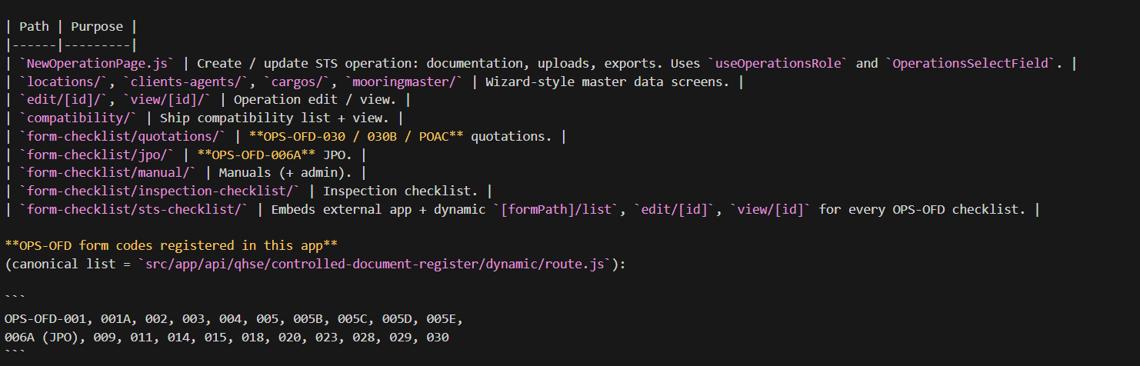

5.2 QHSE

1. Internal hub — how staff use QHSE day to day
Signed-in users open the QHSE area from the main navigation. Depending on their role (Admin, Editor, Approver, Viewer), they can:
- Create and maintain records — training plans and attendance, drill plans and reports, KPI uploads and targets, risk assessments, MOC requests, audit schedules, equipment defects, best-practice entries, and more.
- Review and approve — Approvers can move items through workflow states (for example MOC approval/rejection/closure, audit findings, defect closure) where your process requires it.
- Search and report — Lists and dashboards give leadership and auditors a single place to see status, overdue items, and history.
Admin users have the broadest access: they configure how the module is used and maintain anything that must stay consistent across the whole company (see §5).

2. Controlled Document Register — single catalogue of “official” documents
The Controlled Document Register is the central catalogue of approved QHSE and related procedure documents (with form codes such as QAF-OFD-* and others). It answers three questions for auditors and management:
- Which document types exist?
- How many records exist per type / period?
- Where do you open the template or the live form in the system?
So “what we officially use” is visible in one place, instead of scattered files or spreadsheets.

3. Forms & external portal — internal lists + anonymous submissions
Many QHSE processes use structured forms (audits, inductions, transfer audits, supplier questionnaires, POAC cross-competency, etc.).
Inside Oceane-Marine, your team can create, edit, approve and archive records as usual — full audit trail and role-based access.
For people who do not have an account (subcontractors, suppliers, vessel crew, induction attendees), your organisation shares short links from the separate QHSE-FORMS web app. Those users:
- Open the link on any device.
- Fill the form (sometimes with signatures or attachments).
- Submit once.
Behind the scenes:
- The submission is sent securely to Oceane-Marine and stored in the same database as internally created records.
- It appears in the matching list screen inside QHSE (for example Near Miss list, Subcontractor Audit admin list, Supplier Questionnaire admin list), so one team owns all submissions — whether they started inside the office or from an external link.
So you get one source of truth: external convenience without giving strangers access to your CRM.

4. Near miss / incident reporting
Near miss and related incident-style reports can be captured through the external Near Miss form (anonymous-friendly flow) as well as managed internally. Each submission gets a reference / serial so the reporter can be acknowledged and the safety team can track review, corrective actions and closure inside QHSE — aligned with how you want to run investigations and notifications.

5. Due diligence — subcontractors and suppliers
Due diligence covers:
- Subcontractor audits — structured assessments of contractors working with or for you.
- Supplier questionnaires — extensive questionnaires (legal, insurance, compliance, ethics, banking, etc.), sometimes with supporting documents.
Typically:
- Admin / procurement / QHSE initiates the process and shares the correct external link with the counterparty.
- The counterparty completes the questionnaire or audit form online.
- Your team reviews the submission inside Oceane-Marine, follows up, and keeps the evidence attached to that supplier/subcontractor record for future audits.

6. Training, drills and KPIs
- Training — plan sessions, record attendance, and maintain evidence for certifications and competence requirements.
- Drills — plan emergency/security drills, capture outcomes and lessons learned.
- KPIs — upload targets and actuals so leadership can see trends (for example lagging/leading indicators you define).
Together, these give demonstrable compliance for regulators and clients rather than ad hoc folders.

7. Risk and Management of Change (MOC)
- Risk assessments — identify hazards, controls and residual risk for activities or changes.
- MOC — when something significant changes (procedure, equipment, organisation), a controlled change process captures impact assessment, approvals and closure so unapproved change does not slip through.
Workflow steps (who must approve, when something is closed) respect QHSE roles (Approver vs Editor vs Viewer).

8. Audits, defects and continuous improvement
- Audit / inspection planner — schedule internal or external audits and track findings.
- Equipment defects — log defects, assign ownership and track closure (often linked to corrective/preventive actions).
- Best practices — capture positive findings and lessons learned so good behaviour is repeatable.
These areas support Plan–Do–Check–Act: record → fix → verify → improve.

9. POAC cross-competency
The POAC cross-competency process evaluates competence against your POAC criteria (scores, mandatory remarks where scores are low, signatures). It can be filled via the external portal where appropriate, with completed evaluations visible in the internal POAC list for HR/QHSE oversight.

10. Archive and retention
Where your process requires long-term retention or controlled archiving of QHSE records, the module supports archive-oriented utilities so documents are not deleted casually and remain retrievable for audits.
(Exact retention rules should match your company policy and legal requirements.)

11. Who sees what — Admin-only maintenance
As in Operations, not everyone should edit master setup. QHSE Admin users typically:
- Control who can create vs approve vs only view QHSE records (through role assignment on user accounts).
- Manage catalogues and configuration that must stay consistent company-wide (depending on how your deployment is set up — seed data, controlled templates, notification recipients, etc.).
Editors create and update day-to-day records; Approvers sign off critical steps; Viewers read without changing data — protecting integrity while keeping transparency.

5.3 PMS module — workflow overview
The PMS module is your equipment and maintenance control centre. It helps you keep track of what equipment you own, where it is, whether it is fit for service, when it must be tested or renewed, and how stock moves through your warehouse. Everything is designed so Operations and technical teams can rely on accurate, up-to-date equipment status — especially for marine STS operations where wrong or overdue gear directly affects safety and compliance.

1. Equipment register — primary equipment and accessories
At the core of PMS is the equipment register:
- Primary equipment — main assets (for example fenders, hoses, baskets, winches, or other classified plant items your organisation defines).
- Accessories / linked items — smaller parts or attachments tied to primary equipment where your process requires separate tracking.
Staff can create, update, search and view equipment records depending on their role. Each record holds the identity of the asset (what it is, serial numbers, location, status, links to certificates or tests, etc.) so everyone works from one source of truth instead of spreadsheets.

2. Testing and compliance — knowing equipment is safe to use
Equipment must be tested on schedule (pressure tests, inspections, load tests — whatever your procedures require). PMS supports:
- Recording tests — when a test was done, results, next due date, and evidence as needed.
- Tracking overdue or upcoming tests — so nothing goes into service past its validity window without a conscious decision.
This gives demonstrable maintenance discipline for internal audits and client vetting: you can show which asset was tested, when, and what happens next.

3. Certificates — validity and renewal
Many assets carry certificates (manufacturer certificates, third-party inspection reports, class documents, etc.). PMS ties certificate metadata (and where applicable, documents) to equipment so:
- Validity periods are visible.
- Renewal actions can be planned before expiry.
Together with testing, this answers the question: “Is this piece of equipment legally and technically acceptable for the next job?”

4. Warehouse management — stock and movement
The warehouse sub-module supports controlled movement of parts and consumables (and, depending on how you configure use, spare gear):
- Receipts, issues, transfers — who moved what, when, and between which locations or jobs.
- Stock visibility — reducing duplicate purchases and avoiding “we thought we had it on shelf” situations during urgent mobilisations.
Warehouse discipline supports cost control and traceability when something must be recalled or attributed to a specific operation.

5. Role-based access — who can change master data
As in Operations and QHSE, not everyone should edit equipment master records:
- Admin / privileged roles can typically maintain categories, critical master settings, and sensitive corrections (exact behaviour follows your role setup in Oceane-Marine).
- Editors update day-to-day records (tests, movements, equipment updates).
- Approvers may be required where your process mandates sign-off on critical changes or exceptions.
- Viewers can see status for planning and verification without changing data.
This protects data integrity while keeping transparency for supervisors and planners.

6. Reminders and operational hygiene (high level)
Where configured, the platform can support scheduled reminders (for example testing due dates or warehouse situations that need attention), routed to the PMS team email addresses defined in your environment. That turns PMS from a passive database into an active compliance tool — fewer surprises when mobilising for the next STS operation.
(Exact reminder rules and schedules depend on your deployment and cron setup.)

7. How PMS connects to the rest of Oceane-Marine
- Operations relies on correct equipment status — PMS is where technical readiness is recorded.
- Controlled Document Register and reporting layers can reference equipment-related document types where your organisation has mapped them, so equipment evidence stays aligned with your document control story.

6. API surface (`src/app/api/`)

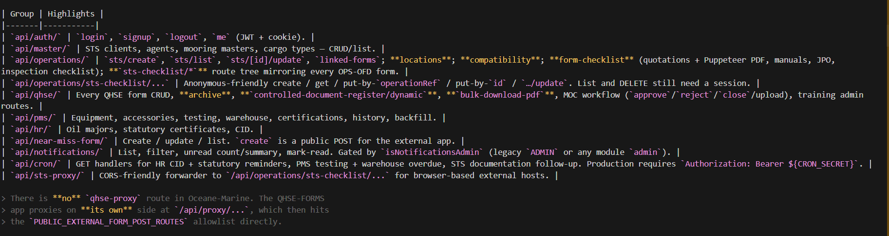

7. Database & Mongoose models
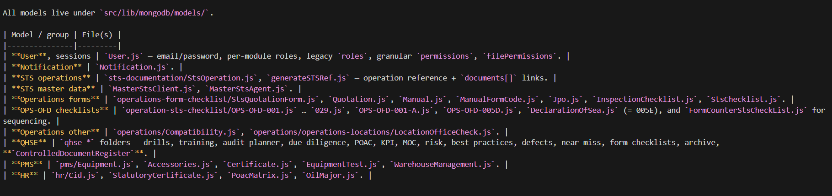

8. Authentication and RBAC
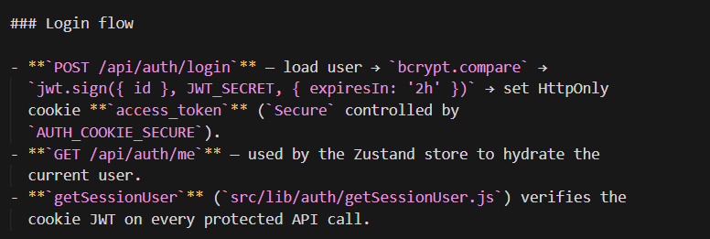
  - Login flow
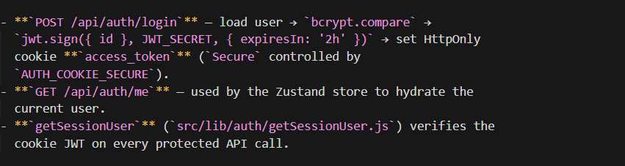
  - Middleware
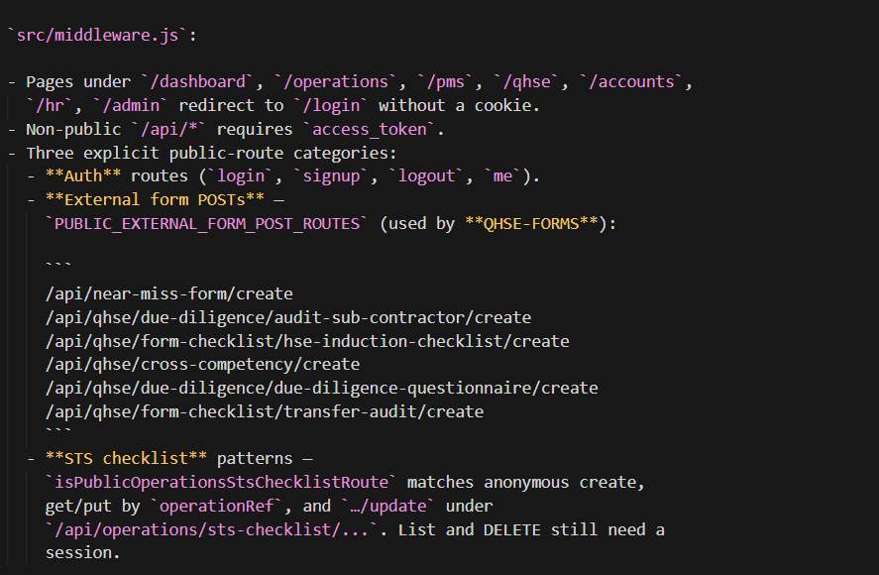

  - Per-module RBAC:-
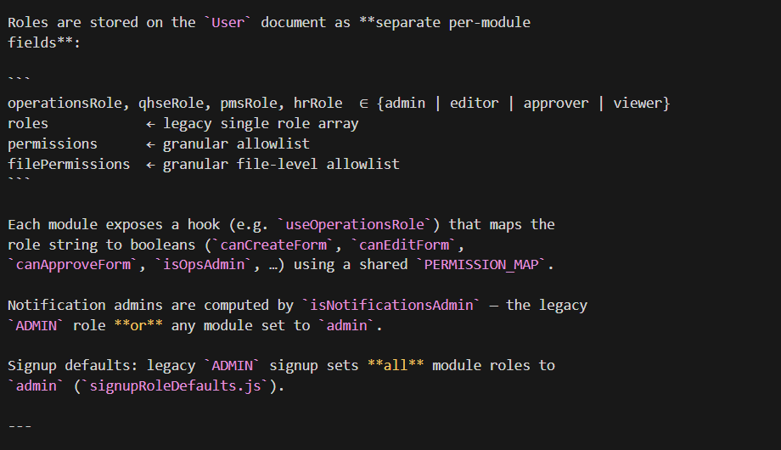
9. Background jobs & document generation
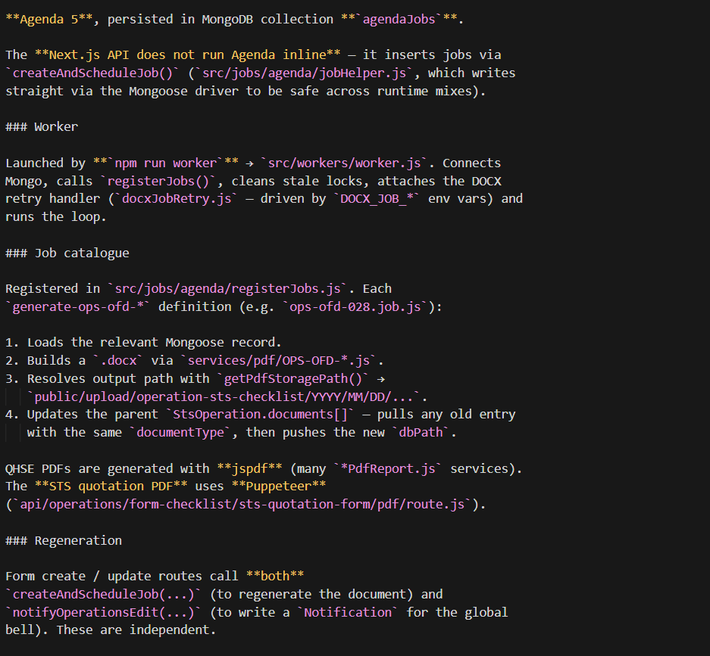

10. External app integrations
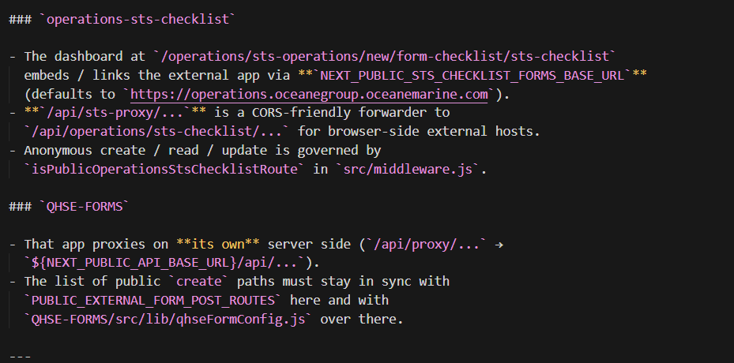

11. Environment variables
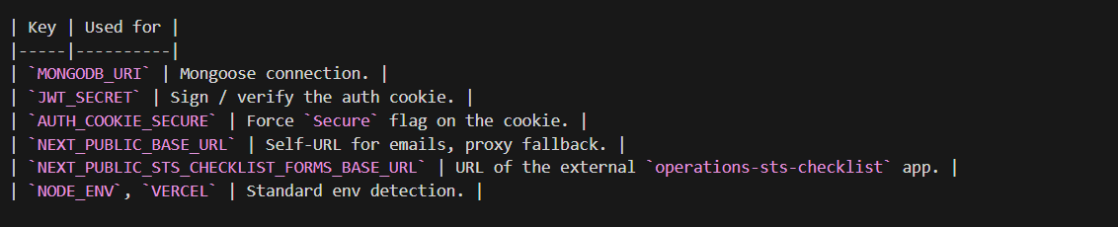
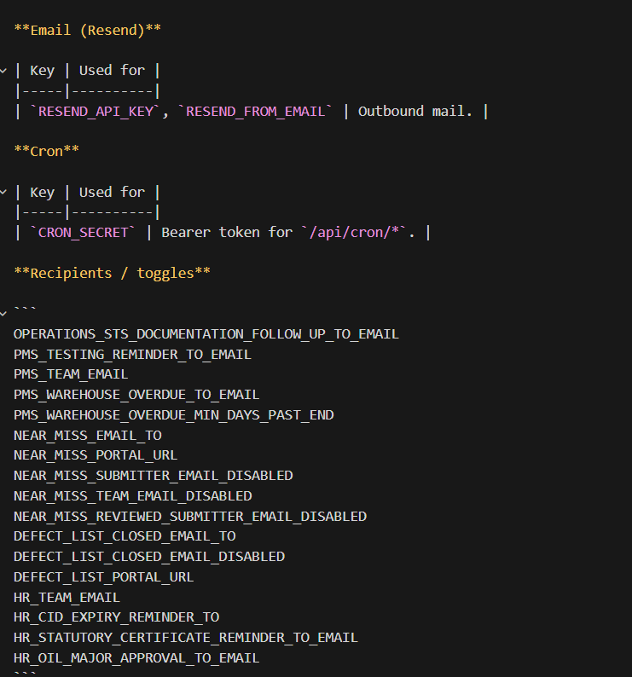

12. Scripts & cron:-
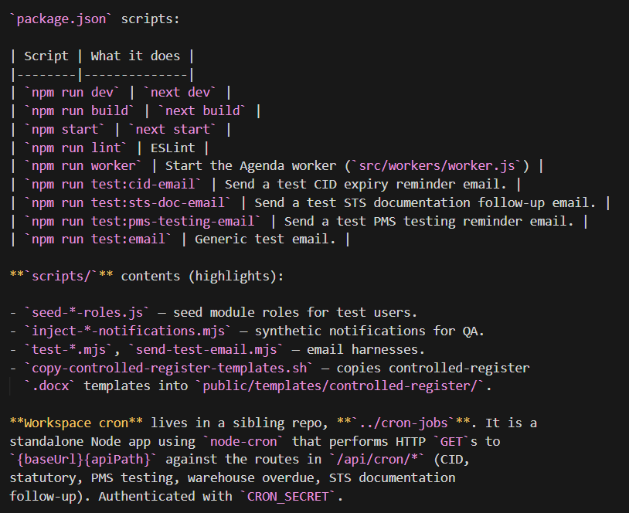
13. Local development
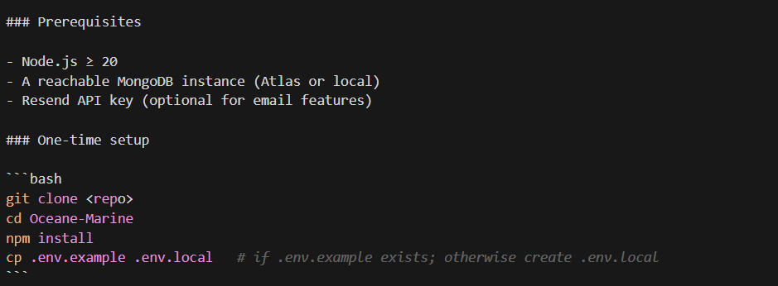
14. Run the app 