JOB REFERNCE:
{{JOB_REF}}
{{STBL_NAME}}
{{SS_NAME}}
SS: STBL :
*All calculations are in Meters

- HOSE CALCULATIONS

POINT A
POINT B
{{POINT_A}}
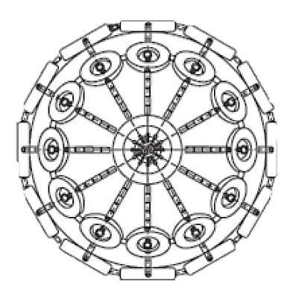
STBL -MIN Freeboard
{{HOSE_LEN}}
HOSE LENGTH REQUIRED:
{{STBL_MINFB}}
{{STBL_MAXFB}}
STBL -MAX Freeboard
{{SS_MINFB}}
{{SS_MAXFB}}
SS -MIN Freeboard
SS -MAX Freeboard
POINT C
STBL -Distance manifold to ship rail
SS -Distance manifold to ship rail
{{POINT_C}}
{{POINT_B}}

- FENDER CALCULATIONS
STBL DWT
{{STBL_DWT}}
{{SS_DWT}}
SS DWT
{{STBL_BEAM}}
SS BEAM
{{SS_BEAM}}
SS BEAM
SS DISP
{{STBL_DISP}}
{{SS_DISP}}
SS DISP
SS DRAFT
{{STBL_DRAFT}}
SS DRAFT
{{SS_DRAFT}}
Equivalent Disp. Coefficient Combined virtual displacement
STBL Mass Coefficient Energy Coefficient Calm
SS Mass Coefficient Energy Coefficient Moderate
Virtual Displacement STBL Energy Coefficient Rough
Virtual Displacement SS
{{CVD}}
{{EDC}}
{{E_CALM}}
{{STBL_MASS}}
{{E_MOD}}
{{SS_MASS}}
{{E_ROUGH}}
{{VDISP_STBL}}
{{VDISP_SS}}

{{F_CALM}}
FENDERS REQUIRED FOR CALM WEATHER

{{F_MOD}}
FENDERS REQUIRED FOR MODERATE WEATHER

FENDERS REQUIRED FOR ROUGH WEATHER
{{F_ROUGH}}

