Computer organization architecture
Innovative Internal Test

•Name: Prince Yadav
• ROLL: 202410101150212
• Group: 47,48
• Submitted to : Dr. Akhilesh Kumar Gupta

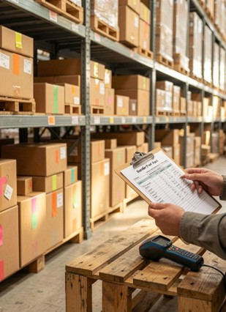

Sales Analytics & Inventory Optimization System

Sales Analytics & Inventory Optimization System
Abstract:
In the present business environment, companies generate a large amount of sales data on a daily basis. This data contains valuable information related to revenue, cost, profit, customer demand, and product movement. However, without proper analysis, raw data cannot be effectively used for decision-making. Therefore, businesses require a systematic approach to convert sales records into meaningful insights.
The main purpose of this project is to design and develop a Sales Analytics and Inventory Optimization System using Scilab. The system imports a CSV sales dataset and performs multiple analytical operations such as total revenue calculation, total cost evaluation, profit analysis, units sold comparison, and reorder level estimation. In addition, the project generates graphical dashboards that visually represent trends and patterns.
This project is highly useful for improving business performance, reducing stock-related problems, and supporting better management decisions. It also demonstrates the practical application of Scilab in data analytics and optimization.

Objectives:
The major objectives of this project are as follows:
- To analyze historical sales records stored in a CSV file.
- To calculate total revenue, total cost, and total profit.
- To identify trends in sales and profit performance.
- To generate understandable graphical dashboards.
- To calculate reorder level for inventory management.
- To reduce stock shortages and excess inventory.
- To improve business decision-making using data analytics.
- To demonstrate practical use of Scilab in real-world problems.

Problem Statement:
Many organizations still rely on manual systems or traditional spreadsheet methods for monitoring sales and stock availability. Such approaches are time-consuming and often lead to errors. Delays in report generation can slow down important decisions.
Businesses also face challenges such as inaccurate forecasting, excessive inventory holding cost, low product availability, and lack of visibility into profit margins. Without proper analytics, it becomes difficult to identify high-performing products and future demand patterns.
Hence, there is a need for an automated system that can quickly analyze sales data, provide useful visual insights, and recommend reorder levels for inventory optimization.

Software Requirements:
The following software and hardware components are required for this project:
Software Requirements:
- Scilab 6.x or above
- Windows Operating System
- CSV Data File
- Spreadsheet Software (optional)
Hardware Requirements:
- Computer or Laptop
- Minimum 4 GB RAM
- Intel Processor or equivalent
- Storage Space for project files
Dataset Description
The dataset used in this project is named Sales.csv. It contains sales transactions from multiple regions and countries. The dataset includes numerical as well as categorical information.
Main Columns Used:
- Region
- Country
- Item Type
- Sales Channel
- Order Priority
- Order Date
- Units Sold
- Unit Price
- Unit Cost
- Total Revenue
- Total Cost
- Total Profit
The dataset contains 100 records and 14 columns, which are sufficient for performing sales analytics and inventory calculations.

Methodology:
The system follows a structured procedure for processing and analyzing the dataset.
- Import the CSV file into Scilab.
- Read required numerical columns such as Units Sold, Revenue, Cost, and Profit.
- Perform calculations for totals, averages, and trends.
- Create multiple graphs for visualization.
- Compute reorder level using inventory formula.
- Generate final report and dashboard.
This step-by-step methodology ensures accuracy and fast execution.

Formulas Used:
Profit Formula:
Profit = Total Revenue – Total Cost
Average Profit Formula:
Average Profit = Total Profit / Number of Orders
Reorder Level Formula:
Reorder Level = (Daily Demand × Lead Time) + Safety Stock
Where:
- Daily Demand = Average units sold per day
- Lead Time = Delivery waiting period
- Safety Stock = Extra reserve stock

Graphical Analysis:
The system generates a dashboard containing nine graphs for easy understanding:
- Revenue Trend Graph
- Profit Trend Graph
- Cost Trend Graph
- Units Sold Graph
- Profit Distribution Histogram
- Cumulative Profit Graph
- Revenue vs Cost Comparison
- Units Sold vs Profit Scatter Plot
- KPI Summary Graph
These visual reports help management quickly understand sales performance and business health.

Advantages:
The proposed system offers several advantages:
- Fast and automated sales analysis
- Better inventory planning
- Accurate profit monitoring
- Easy interpretation using graphs
- Reduction in stock shortage risk
- Improved business efficiency
- Better decision support system

Applications:
This project can be used in various sectors such as:
- Retail Stores
- Supermarkets
- Warehouses
- E-commerce Platforms
- Manufacturing Companies
- Supply Chain Industry
- Distribution Networks

Result:
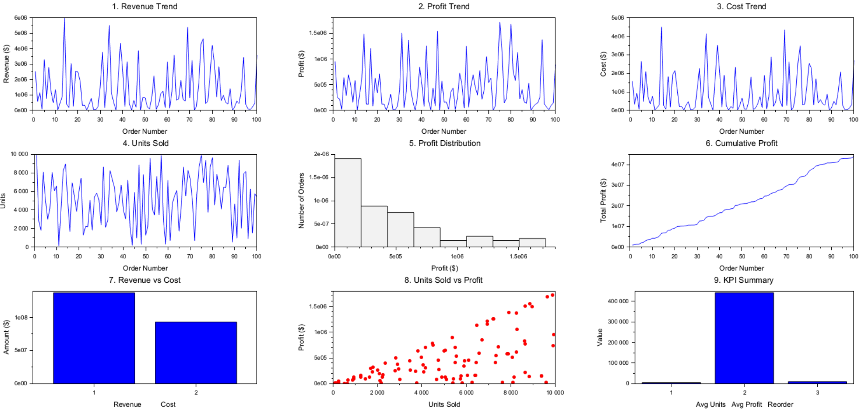
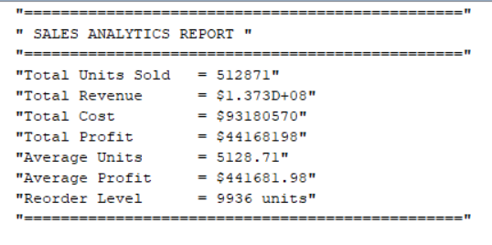
Conclusion:
The Sales Analytics & Inventory Optimization System using Scilab successfully demonstrates how business data can be converted into valuable insights. The system analyzes sales performance, calculates profitability, and provides graphical dashboards for management review.
It also calculates reorder levels to maintain proper inventory stock. This helps organizations reduce losses, improve customer satisfaction, and make faster strategic decisions.
Therefore, the project proves that Scilab is an effective tool for business analytics and optimization.

