**SETUP**

* Setup to Run application on Local Machine [ Eclipse/Intellij ]
* Download Eclipse JEE
* Install spring tool suite and cucumber plugin from eclipse marketplace
* Import unzipped application into eclipse (File -> Import -> Import Existing Maven Project -> select Project folder)
* Run project as spring boot app
* Setup to Run application on Local Machine [ Docker Image ]
* Pull Docker images
* sgdockerprivate/registration-login-update-service.jar
* sgdockerprivate/loan -service.jar
* Run docker images

**How to Run**

* After setup Go to postman
* **REGISTER**: localhost:8083/register (postmapping)

Enter JSON data in following format in the Body

{

        "userid": 103,

        "pan": "BYAPG1290J",

        "name": "TestName",

        "password": "password",

        "address": "411 ABC Building",

        "state": "Arizona",

        "country": "USA",

        "email": "testname123@gmail.com",

        "contactNo": "4588963781",

        "accountType": "Savings"

    }

* **LOGIN:** localhost:8083/login (postmapping)

Enter JSON data in following format in the Body

    {

        "userid": 103,

        "password": "password"

    }

* **UPDATE (ADDRESS):** localhost:8083/update/address (postmapping)

Enter JSON data in following format in the Body

    {

        "Address":"22!1B Main Street",

        "state":"New York",

        "country":"USA"

    }

* **UPDATE (CONTACT DETAILS):** localhost:8083/update/contact (postmapping)

Enter JSON data in following format in the Body

    {

        "contactNo":"411786009"

    }

* **UPDATE (EMAIL):** localhost:8083/update/email (postmapping)

Enter JSON data in following format in the Body

    {

        "email":"test2Name@gmail.com"

    }

* **APPLY LOAN:** localhost:8082/applyloan (postmapping)

Enter JSON data in following format in the Body

 {

     "loanId":9003,

     "pan":"BYAPG1352M",

     "loanType":"Education",

     "loanAmount":150000,

     "monthlyIncome":40000,

     "roi":6,

     "duration":4

 }

APPLICATION DEPLOYED ON GOOGLE KUBERNETES ENGINE

[ To run the deployed applications change “ **localhost** ” in URL of /register/login/update to “ **35.226.5.78:8083** “ ]

[ To run the deployed applications change “ **localhost** ” in URL of /applyloan to

“ **35.194.8.4:808** “ ]

**SNAPSHOTS**

(Register)

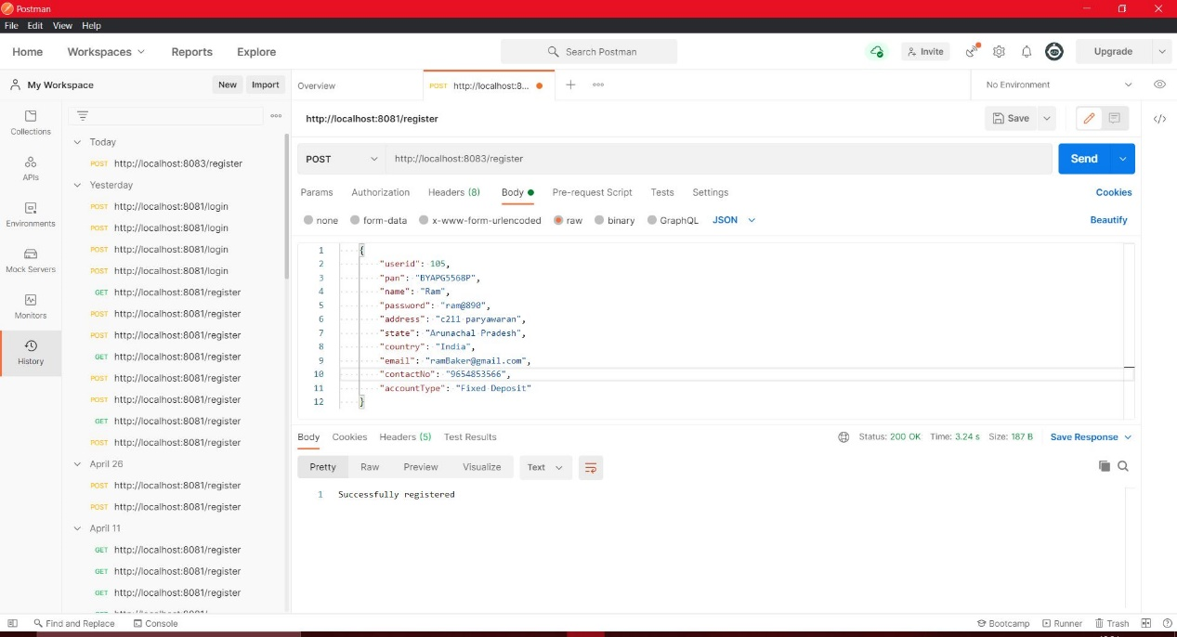

(Login)

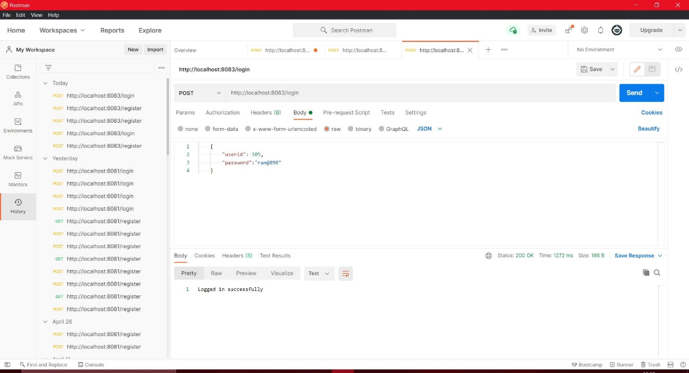

(Update)

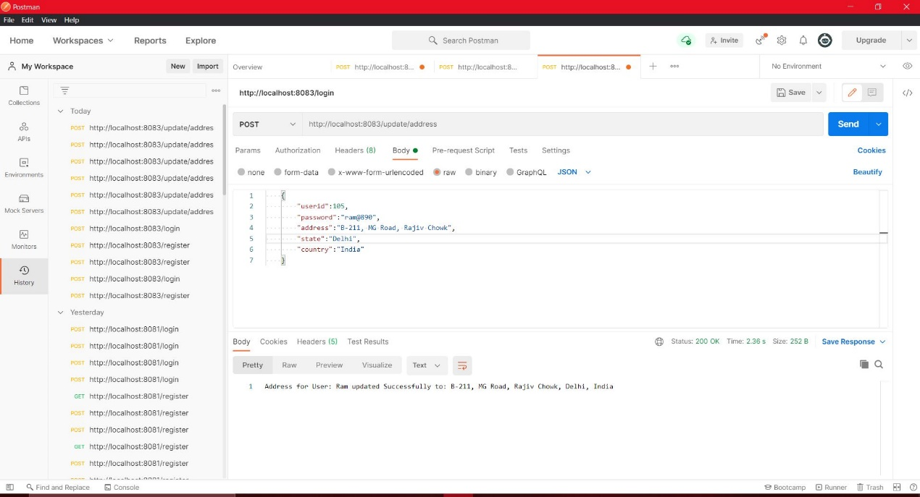

(Apply Loan)

