-- Objective Questions --

**Q.1) Does any table have missing values or duplicates? If yes how would you handle it ?**

Ans – **MYSQL QUERY**

select * from album;

select distinct * from album; -- no duplicate

select * from artist;

select distinct * from artist; -- no duplicate

select * from customer;

select distinct * from customer; -- no duplicate

select count(*) from customer

where company is null; -- count of null in company 49

select count(*) from customer

where state is null; -- count of null in state 29

select count(*) from customer

where fax is null; -- count of null in fax 47

select * from employee; -- there is 1 null value in report_to for employee_id = 1

select distinct * from employee; -- no duplicate

select * from genre;

select distinct * from genre; -- no duplicate

select * from invoice;

select distinct * from invoice; -- no duplicate

select * from invoice_line;

select distinct * from invoice_line; -- no duplicate

select * from media_type;

select distinct * from media_type; -- no duplicate

select * from playlist;

select distinct * from playlist; -- no duplicate

select * from playlist_track;

select distinct * from playlist_track; -- no duplicate

select * from track;

select distinct * from track; -- no duplicate

select count(*) from track

where composer is null; -- 978 null value in composer

The dataset contains no duplicate values across any tables. However, some fields have missing values:

* The **customer table** has 49 null entries for company, 29 for state, and 47 for fax.
* The **employee table** has 1 null entry in the reports_to column.
* The **track table** has 978 null entries in the composer column.

To manage these missing values, I will use the **COALESCE** function.

**Q.2) Find the top-selling tracks and top artist in the USA and identify their most famous genres.**

Ans – **MYSQL QUERY**

select Top_selling_tracks , Top_artist , Most_famous_genres

from (

select t.name as Top_selling_tracks , ar.name as Top_artist , g.name as Most_famous_genres ,

sum(t.unit_price * il.quantity) as total_sales from track t

left join invoice_line il on t.track_id = il.track_id

left join invoice i on i.invoice_id = il.invoice_id

left join album a on a.album_id = t.album_id

left join artist ar on ar.artist_id = a.artist_id

left join genre g on g.genre_id = t.genre_id

where billing_country = "USA"

group by t.name , ar.name , g.name

order by total_sales desc

limit 15

) Top_Track_Artist_Genre;

-- For top selling genre

select Top_Genre from (

select g.name as Top_Genre

from track t

left join invoice_line il on il.track_id = t.track_id

left join invoice i on i.invoice_id = il.invoice_id

left join genre g on t.genre_id = g.genre_id

where i.billing_country = 'USA'

group by g.name

order by sum(il.quantity) desc

limit 15 ) Most_Famous_genre;

Top selling tracks , top artist and top genre in USA

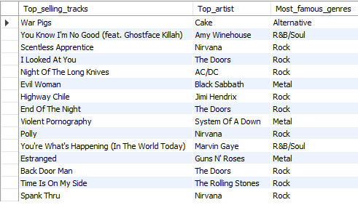

Top top-selling genre in USA :

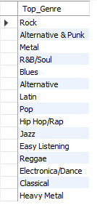

**Insights:**

* Jimi Hendrix appears most frequently among the top tracks.
* "War Pigs" by Cake ranks as the highest-performing track.
* Rock leads in U.S. music sales.

**Recommendations:**

* Focus on Rock for inventory, marketing, and promotions.
* Alongside Rock, R&B should also be emphasized in genre-specific campaigns.
* Jimi Hendrix could be a strong candidate for brand partnerships.

**Q.3) What is the customer demographic breakdown (age, gender, location) of Chinook's customer base?**

Ans – **MYSQL QUERY**

select count(distinct country) from customer ; -- total country 24

select country , count(customer_id) as customer_count

from customer

group by country

order by customer_count desc;

-- USA : 13 , Canada : 8 , Brazil : 5 , France : 5 , Germany : 4 , United Kingdom : 3 ,

-- Czech Republic : 2 , Pourtgal : 2, India :2 , and from remaining all country 1 customer each

The Chinook music store serves customers in 24 countries. Based on the data, the USA has the highest number of customers, totaling 13. However, the customer table does not include age or gender details, making it difficult to analyze the customer demographics.

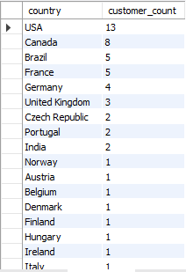

**Insights:**

* Customers are distributed across 24 countries.
* The USA has the highest number of customers.

**Recommendations:**

* Prioritize the US market due to its strong customer presence.
* Focus on expanding the customer base in Canada, Brazil, France, and Germany to drive growth.

**Q.4) Calculate the total revenue and number of invoices for each country, state, and city:**

Ans – **MYSQL QUERY**

select billing_country , billing_state , billing_city , count(*) as number_of_invoice , sum(total) as total_revenue

from invoice

group by billing_country , billing_state , billing_city

order by number_of_invoice desc , total_revenue desc;

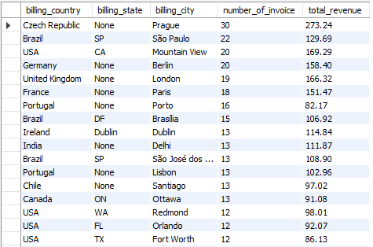

**Insights:**

* Prague (Czech Republic) records the highest revenue.
* São Paulo (Brazil) has a high invoice count but generates lower revenue compared to other locations.

**Recommendations:**

* Investigate Prague’s success in revenue per invoice and apply similar strategies in other cities.
* Assess revenue per invoice across all locations to refine pricing strategies and identify areas for improvement.
* Analyze underperforming cities like Copenhagen, Buenos Aires, and Edmonton to understand and address revenue challenges.

**Q.5) Find the top 5 customers by total revenue in each country**

Ans – **MYSQL QUERY**

with customer_wise_total_revenue as (

select customer_id , sum(total) as total_revenue

from invoice

group by customer_id ) ,

Customer_ranking as (

select concat(c.first_name , ' ' , c.last_name) as Customer_Name , c.country ,

dense_rank() over (partition by c.country order by cr.total_revenue desc) as ranking

from customer c

right join customer_wise_total_revenue cr on cr.customer_id = c.customer_id)

select Customer_name, country, ranking from Customer_ranking where ranking <=5

order by country;

|  |  |  |
| --- | --- | --- |
| **Customer_name** | **country** | **ranking** |
| Diego Gutiérrez | Argentina | 1 |
| Mark Taylor | Australia | 1 |
| Astrid Gruber | Austria | 1 |
| Daan Peeters | Belgium | 1 |
| Luís Gonçalves | Brazil | 1 |
| Fernanda Ramos | Brazil | 2 |
| Roberto Almeida | Brazil | 3 |
| Alexandre Rocha | Brazil | 4 |
| Eduardo Martins | Brazil | 5 |
| François Tremblay | Canada | 1 |
| Edward Francis | Canada | 2 |
| Ellie Sullivan | Canada | 3 |
| Aaron Mitchell | Canada | 4 |
| Jennifer Peterson | Canada | 5 |
| Luis Rojas | Chile | 1 |
| František Wichterlová | Czech Republic | 1 |
| Helena Holý | Czech Republic | 2 |
| Kara Nielsen | Denmark | 1 |
| Terhi Hämäläinen | Finland | 1 |
| Wyatt Girard | France | 1 |
| Camille Bernard | France | 2 |
| Isabelle Mercier | France | 3 |
| Dominique Lefebvre | France | 4 |
| Marc Dubois | France | 5 |
| Fynn Zimmermann | Germany | 1 |
| Hannah Schneider | Germany | 2 |
| Leonie Köhler | Germany | 3 |
| Niklas Schröder | Germany | 4 |
| Ladislav Kovács | Hungary | 1 |
| Manoj Pareek | India | 1 |
| Puja Srivastava | India | 2 |
| Hugh O'Reilly | Ireland | 1 |
| Lucas Mancini | Italy | 1 |
| Johannes Van der Berg | Netherlands | 1 |
| Bjørn Hansen | Norway | 1 |
| Stanisław Wójcik | Poland | 1 |
| João Fernandes | Portugal | 1 |
| Madalena Sampaio | Portugal | 2 |
| Enrique Muñoz | Spain | 1 |
| Joakim Johansson | Sweden | 1 |
| Phil Hughes | United Kingdom | 1 |
| Steve Murray | United Kingdom | 2 |
| Emma Jones | United Kingdom | 3 |
| Jack Smith | USA | 1 |
| Dan Miller | USA | 2 |
| Heather Leacock | USA | 3 |
| Kathy Chase | USA | 4 |
| Richard Cunningham | USA | 5 |

**Insights:**

* The number of customers is evenly distributed across ranks in different countries.
* The USA, Brazil, Canada, and France have customers consistently ranked in the top five.

**Recommendations:**

* Develop targeted marketing campaigns for top customers in each country.
* Introduce tiered loyalty programs based on spending levels.
* Segment customers by value and location for customized engagement.
* Analyze purchasing patterns of high-value customers to identify key drivers of their spending.

**Q.6) Identify the top-selling track for each customer**

Ans – **MYSQL QUERY**

with Top_selling_Rank as (select c.customer_id, concat(c.first_name, ' ', c.last_name) as customer_name, t.name as track_name, sum(il.quantity) as total_sales,

row_number() over (partition by c.customer_id order by sum(il.quantity) desc) as ranking

from customer c

left join invoice i on i.customer_id = c.customer_id

left join invoice_line il on i.invoice_id = il.invoice_id

left join track t on il.track_id = t.track_id

group by c.customer_id, concat(c.first_name, ' ', c.last_name), t.name)

select customer_name, track_name, total_sales

from Top_selling_Rank

where ranking = 1;

Top selling track for each customer grouping by customer_id , customer_name and track_name

|  |  |  |
| --- | --- | --- |
| customer_name | track_name | total_sales |
| Luís Gonçalves | Message in a Bottle | 1 |
| Leonie Köhler | When Evening Falls | 1 |
| François Tremblay | Sting Me | 2 |
| Bjørn Hansen | Animal | 1 |
| František Wichterlová | Bad Boy Boogie | 1 |
| Helena Holý | Summer Love | 1 |
| Astrid Gruber | Be Mine | 1 |
| Daan Peeters | Blow Your Mind | 1 |
| Kara Nielsen | Hypnotize | 1 |
| Eduardo Martins | Like A Bird | 2 |
| Alexandre Rocha | Inside Job | 1 |
| Roberto Almeida | Love And Marriage | 2 |
| Fernanda Ramos | 24 Caprices, Op. 1, No. 24, for Solo Violin, in A Minor | 2 |
| Mark Philips | Immigrant Song | 1 |
| Jennifer Peterson | Something In The Way | 1 |
| Frank Harris | Posso Perder Minha Mulher, Minha Mãe, Desde Que Eu Tenha O Rock And Roll | 1 |
| Jack Smith | Just Friends | 1 |
| Michelle Brooks | Suite for Solo Cello No. 1 in G Major, BWV 1007: I. Prélude | 1 |
| Tim Goyer | Turandot, Act III, Nessun dorma! | 1 |
| Dan Miller | I Don't Wanna Be Kissed (By Anyone But You) (Alternate Take) | 1 |
| Kathy Chase | The Worst | 1 |
| Heather Leacock | Amy Amy Amy (Outro) | 1 |
| John Gordon | My Time After Awhile | 1 |
| Frank Ralston | Who Wants To Live Forever | 1 |
| Victor Stevens | Untitled | 2 |
| Richard Cunningham | Hitchin' A Ride | 1 |
| Patrick Gray | War Pigs | 2 |
| Julia Barnett | Get What You Need | 2 |
| Robert Brown | Virginia Moon | 1 |
| Edward Francis | A Room At The Heartbreak Hotel | 1 |
| Martha Silk | She's A Rebel | 1 |
| Aaron Mitchell | You Know My Name | 1 |
| Ellie Sullivan | Indifference | 1 |
| João Fernandes | Train In Vain | 2 |
| Madalena Sampaio | Get In The Ring | 1 |
| Hannah Schneider | I Can't Explain | 2 |
| Fynn Zimmermann | Radio/Video | 2 |
| Niklas Schröder | Take the Box | 1 |
| Camille Bernard | Midnight | 1 |
| Dominique Lefebvre | Tomorrow's Dream | 1 |
| Marc Dubois | My Melancholy Blues | 1 |
| Wyatt Girard | Changes | 2 |
| Isabelle Mercier | Tease Me Please Me | 2 |
| Terhi Hämäläinen | Compulsion | 1 |
| Ladislav Kovács | Smoke On The Water | 1 |
| Hugh O'Reilly | Drain You | 2 |
| Lucas Mancini | Put The Finger On You | 1 |
| Johannes Van der Berg | Confusion | 2 |
| Stanisław Wójcik | Faceless | 2 |
| Enrique Muñoz | Highway Chile | 1 |
| Joakim Johansson | Run To The Hills | 1 |
| Emma Jones | It Ain't Like That | 1 |
| Phil Hughes | Message in a Bottle (new classic rock mix) | 1 |
| Steve Murray | Baby | 1 |
| Mark Taylor | Kayleigh | 1 |
| Diego Gutiérrez | My Way | 1 |
| Luis Rojas | Odara | 1 |
| Manoj Pareek | Who Wants To Live Forever | 1 |
| Puja Srivastava | Question! | 1 |

**Q.7) Are there any patterns or trends in customer purchasing behavior (e.g., frequency of purchases, preferred payment methods, average order value)?**

Ans – **MYSQL QUERY**

select customer_id , avg(total) as average_total_value , count(invoice_id) as number_of_ordder

from invoice

group by customer_id

order by count(invoice_id) ;

select count(invoice_id) as monthly_invoice_count , date_format(invoice_date , '%m-%Y') as Month_Year ,

round(avg(total),2) as Monthly_average_total , sum(total) as Monthly_sum_total

from invoice

group by Month_Year

order by Month_Year;

|  |  |  |
| --- | --- | --- |
| customer_id | average_total_value | number_of_ordder |
| 29 | 10.15 | 4 |
| 56 | 7.92 | 5 |
| 8 | 8.63 | 7 |
| 18 | 9.9 | 8 |
| 52 | 8.54 | 8 |
| 59 | 8.91 | 8 |
| 24 | 8.91 | 8 |
| 32 | 8.79 | 8 |
| 16 | 9.28 | 8 |
| 40 | 8.03 | 9 |
| 27 | 9.35 | 9 |
| 15 | 7.37 | 9 |
| 19 | 6.05 | 9 |
| 41 | 7.15 | 9 |
| 7 | 7.7 | 9 |
| 47 | 5.61 | 9 |
| 54 | 8.8 | 9 |
| 38 | 8.14 | 9 |
| 3 | 11.11 | 9 |
| 4 | 8.03 | 9 |
| 39 | 8.8 | 9 |
| 11 | 6.93 | 10 |
| 23 | 6.63 | 10 |
| 49 | 7.62 | 10 |
| 25 | 7.62 | 10 |
| 9 | 3.76 | 10 |
| 55 | 8.12 | 10 |
| 51 | 7.52 | 10 |
| 45 | 7.82 | 10 |
| 28 | 7.23 | 10 |
| 37 | 9.41 | 10 |
| 48 | 6.53 | 10 |
| 14 | 2.97 | 10 |
| 31 | 5.67 | 11 |
| 36 | 7.74 | 11 |
| 53 | 8.91 | 11 |
| 2 | 7.47 | 11 |
| 50 | 8.91 | 11 |
| 12 | 7.47 | 11 |
| 44 | 7.2 | 11 |
| 21 | 8.28 | 11 |
| 42 | 9.09 | 11 |
| 26 | 7.18 | 12 |
| 33 | 6.27 | 12 |
| 43 | 6.11 | 12 |
| 10 | 5.03 | 12 |
| 20 | 7.92 | 12 |
| 17 | 8.17 | 12 |
| 6 | 10.73 | 12 |
| 22 | 7.67 | 12 |
| 30 | 7.01 | 13 |
| 57 | 7.46 | 13 |
| 58 | 8.61 | 13 |
| 46 | 8.83 | 13 |
| 1 | 8.38 | 13 |
| 34 | 7.92 | 13 |
| 13 | 7.13 | 15 |
| 35 | 5.14 | 16 |
| 5 | 8.03 | 18 |

|  |  |  |  |
| --- | --- | --- | --- |
| monthly_invoice_count | Month_Year | Monthly_average_total | Monthly_sum_total |
| 17 | 01-2017 | 7.45 | 126.72 |
| 22 | 01-2018 | 8.33 | 183.15 |
| 10 | 01-2019 | 8.51 | 85.14 |
| 8 | 01-2020 | 5.45 | 43.56 |
| 19 | 02-2017 | 7.45 | 141.57 |
| 18 | 02-2018 | 6.49 | 116.82 |
| 7 | 02-2019 | 8.49 | 59.4 |
| 11 | 02-2020 | 8.82 | 97.02 |
| 13 | 03-2017 | 8 | 103.95 |
| 18 | 03-2018 | 8.25 | 148.5 |
| 14 | 03-2019 | 8.98 | 125.73 |
| 11 | 03-2020 | 7.11 | 78.21 |
| 17 | 04-2017 | 8.39 | 142.56 |
| 10 | 04-2018 | 6.34 | 63.36 |
| 17 | 04-2019 | 6.87 | 116.82 |
| 16 | 04-2020 | 7.49 | 119.79 |
| 12 | 05-2017 | 8.75 | 104.94 |
| 10 | 05-2018 | 7.62 | 76.23 |
| 16 | 05-2019 | 6.56 | 104.94 |
| 13 | 05-2020 | 6.32 | 82.17 |
| 12 | 06-2017 | 6.27 | 75.24 |
| 13 | 06-2018 | 7.08 | 92.07 |
| 13 | 06-2019 | 7.08 | 92.07 |
| 11 | 06-2020 | 10.98 | 120.78 |
| 11 | 07-2017 | 9.9 | 108.9 |
| 11 | 07-2018 | 7.74 | 85.14 |
| 15 | 07-2019 | 8.32 | 124.74 |
| 12 | 07-2020 | 6.35 | 76.23 |
| 11 | 08-2017 | 8.01 | 88.11 |
| 16 | 08-2018 | 6.68 | 106.92 |
| 19 | 08-2019 | 8.39 | 159.39 |
| 8 | 08-2020 | 9.03 | 72.27 |
| 13 | 09-2017 | 8.3 | 107.91 |
| 6 | 09-2018 | 9.41 | 56.43 |
| 19 | 09-2019 | 6.67 | 126.72 |
| 13 | 09-2020 | 7.31 | 95.04 |
| 13 | 10-2017 | 6.09 | 79.2 |
| 8 | 10-2018 | 9.78 | 78.21 |
| 6 | 10-2019 | 7.26 | 43.56 |
| 18 | 10-2020 | 8.03 | 144.54 |
| 11 | 11-2017 | 8.55 | 94.05 |
| 7 | 11-2018 | 6.08 | 42.57 |
| 8 | 11-2019 | 8.91 | 71.28 |
| 12 | 11-2020 | 6.93 | 83.16 |
| 5 | 12-2017 | 5.74 | 28.71 |
| 12 | 12-2018 | 8.17 | 98.01 |
| 15 | 12-2019 | 7.46 | 111.87 |
| 17 | 12-2020 | 7.4 | 125.73 |

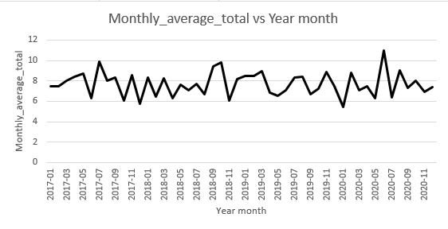

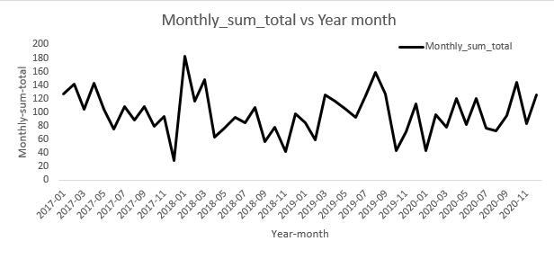

**Insights:**

* **Seasonal Trends:** High sales activity is observed in January, April, and August, reflecting seasonal demand.
* **Customer Purchase Patterns:** Fluctuations in monthly sales create challenges in analyzing buying behavior.
* **Average Order Value (AOV):** Revenue per order remains relatively stable (~6-10) but sees occasional spikes, such as in November 2020.
* **Annual Growth:** A steady increase in yearly totals suggests rising customer spending or improved business efficiency.

**Recommendations:**

* **Leverage Peak Months:** Align marketing efforts with high-demand periods in January, April, and August to maximize seasonal sales.
* **Address Low-Performing Months:** Offer discounts or loyalty programs to stimulate sales during slower periods like December and February.
* **Increase AOV:** Implement upselling strategies or bundle products to enhance the average order value.
* **Enhance Customer Retention:** Analyze purchasing behavior to tailor strategies for repeat and one-time buyers.
* **Data-Driven Strategies:** Continuously monitor invoice trends and customer preferences to optimize inventory and pricing.

**Q.8) What is the customer churn rate?**

Ans – **MYSQL QUERY**

with number_of_customer_in_1st_3months as (

select count(customer_id) as customer_1st_3months

from invoice

where invoice_date between '2017-01-01' and '2017-03-31') ,

-- I assume that the initial customer count is equivalent to the number of customers who joined in the first three months.

-- A total of 49 customers joined during this period.

number_of_customer_in_last_2months as (select count(customer_id) as customer_in_last_2months

from invoice

where invoice_date between '2020-11-01' and '2020-12-31' )

-- I assume the churn rate is determined based on the number of customers who left in the last two months.

-- A total of 29 customers churned during this period.

select round((((select customer_1st_3months from number_of_customer_in_1st_3months) - (select customer_in_last_2months

from number_of_customer_in_last_2months))/(select customer_1st_3months

from number_of_customer_in_1st_3months)* 100),2) as churn_rate;

/*

Based on the provided data, the company's customer churn rate is **40.82%**. This is calculated using the initial customer count of **49** in the first three months and the remaining **29** customers in the last two months.

**Customers lost:** 49 - 29 = **20**  
**Churn rate:** (20 / 49) * 100 = **40.82%**

*/

**Insights from Churn Rate Analysis:**

* **Churn Rate:** A 40.82% churn rate indicates significant customer attrition between the start of the period (Q1 2017) and the final two months (Nov-Dec 2020).
* **Customer Base Decline:** Out of the initial 49 customers, 20 discontinued the service, highlighting a challenge in retention.

**Recommendations:**

* **Retention Strategies:** Implement loyalty programs, discounts, and customer feedback surveys to reduce churn.
* **Customer Engagement:** Strengthen communication through emails, promotions, and targeted campaigns, especially in later stages of the customer lifecycle.
* **Identify At-Risk Customers:** Analyze customer behavior to detect those likely to leave and take proactive measures to retain them.
* **Enhance Onboarding:** Improve the onboarding process to boost customer satisfaction and long-term retention.
* **Analyze Exit Trends:** Conduct surveys with churned customers to understand and address key reasons for their departure.

**Q.9) Calculate the percentage of total sales contributed by each genre in the USA and identify the best-selling genres and artists.**

Ans – **MYSQL QUERY**

with Total_USA_Revenue as ( select sum(total) as total_rev

from invoice

where billing_country = 'USA' ),

Genre_wise_total_revenue as ( select g.name as genre_name, sum(t.unit_price * il.quantity) as total_genre_revenue

from genre g

right join track t on g.genre_id = t.genre_id

left join invoice_line il on il.track_id = t.track_id

left join invoice i on i.invoice_id = il.invoice_id

where billing_country = 'USA'

group by g.name

order by total_genre_revenue desc ),

Genre_Ranking as ( select genre_name, round(total_genre_revenue *100/(select total_rev from Total_USA_Revenue),2) percentage_contribution,

dense_rank() over(order by round(total_genre_revenue *100/(select total_rev from Total_USA_Revenue),2) desc) Ranking

from Genre_wise_total_revenue )

select genre_name, percentage_contribution, Ranking from Genre_Ranking ;

-- Best selling genre

/* genre_name, percentage_contribution, Ranking

Rock 53.38 1

Alternative & Punk 12.37 2

Metal 11.80 3

R&B/Soul 5.04 4

Blues 3.43 5

Alternative 3.33 6

Latin 2.09 7

Pop 2.09 7

Hip Hop/Rap 1.90 8

Jazz 1.33 9

Easy Listening 1.24 10

Reggae 0.57 11

Electronica/Dance 0.48 12

Classical 0.38 13

Heavy Metal 0.29 14

TV Shows 0.19 15

Soundtrack 0.19 15

*/

**Best selling Artist wise**

with Total_USA_Revenue as ( select sum(total) as total_rev

from invoice

where billing_country = 'USA' ),

Artist_wise_total_revenue as ( select a.name as Artist_name, sum(t.unit_price * il.quantity) as total_revenue_Artist_wise

from artist a

left join album al on a.artist_id = al.artist_id

right join track t on al.album_id = t.album_id

left join invoice_line il on il.track_id = t.track_id

left join invoice i on i.invoice_id = il.invoice_id

where billing_country = 'USA'

group by a.name

order by total_revenue_Artist_wise desc ),

Artist_Ranking as ( select Artist_name, round(total_revenue_Artist_wise *100/(select total_rev from Total_USA_Revenue),2) percentage_contribution,

dense_rank() over(order by round(total_revenue_Artist_wise *100/(select total_rev from Total_USA_Revenue),2) desc) Ranking

from Artist_wise_total_revenue )

select Artist_name, percentage_contribution, Ranking

from Artist_Ranking

limit 10 ;

-- Top 10 selling Artist wise

/* Artist_name, percentage_contribution, Ranking

Van Halen 4.09 1

R.E.M. 3.62 2

The Rolling Stones 3.52 3

Nirvana 3.33 4

Foo Fighters 3.24 5

Eric Clapton 3.24 5

Guns N' Roses 3.04 6

Green Day 3.04 6

Pearl Jam 2.95 7

Amy Winehouse 2.85 8

*/

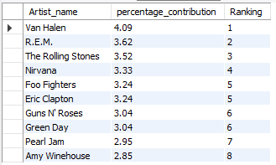

|  |  |  |
| --- | --- | --- |
| genre_name | percentage_contribution | Ranking |
| Rock | 53.38 | 1 |
| Alternative & Punk | 12.37 | 2 |
| Metal | 11.8 | 3 |
| R&B/Soul | 5.04 | 4 |
| Blues | 3.43 | 5 |
| Alternative | 3.33 | 6 |
| Latin | 2.09 | 7 |
| Pop | 2.09 | 7 |
| Hip Hop/Rap | 1.9 | 8 |
| Jazz | 1.33 | 9 |
| Easy Listening | 1.24 | 10 |
| Reggae | 0.57 | 11 |
| Electronica/Dance | 0.48 | 12 |
| Classical | 0.38 | 13 |
| Heavy Metal | 0.29 | 14 |
| TV Shows | 0.19 | 15 |
| Soundtrack | 0.19 | 15 |

**Insights:**

* **Top Genres:** R&B/Soul/Blues is the most represented genre, followed by Blues and Alternative, making up 5.04% of the total.
* **Least Popular Genres:** Heavy Metal (0.29%), Classical (0.38%), and TV Shows/Soundtracks (0.19%) contribute the least.
* **Equal Market Share:** Pop and Latin each hold 2.09%, indicating equal popularity.
* **Niche Preferences:** Jazz, Easy Listening, and Reggae have moderate to low representation.

**Recommendations:**

* **Prioritize Leading Genres:** Invest in marketing and playlist curation for R&B/Soul, Blues, and Alternative to maximize engagement.
* **Support Lesser-Known Genres:** Increase awareness and promotion for Classical and Heavy Metal to grow their audience.
* **Capitalize on Equal Market Share:** Bundle Pop and Latin in promotional efforts since both have similar appeal.
* **Enhance Niche Genre Engagement:** Highlight Jazz and Easy Listening through curated playlists and collaborations to attract dedicated listeners.
* **Data-Driven Strategy:** Continuously analyze trends to allocate resources effectively across genres and maximize potential.

**Q.10) Find customers who have purchased tracks from at least 3 different genres**

Ans – **MYSQL QUERY**

select Customer_Name , Total

from ( select concat(first_name, ' ', last_name) as Customer_Name , count(distinct g.name) as Total

from customer c

left join invoice i on i.customer_id = c.customer_id

left join invoice_line il on il.invoice_id = i.invoice_id

left join track t on t.track_id = il.track_id

left join genre g on g.genre_id = t.genre_id

group by 1

having count(distinct g.name) >= 3

order by count(distinct g.name) desc

) as Customer_Total_Purchase ;

|  |  |
| --- | --- |
| Customer_Name | Total |
| Leonie Köhler | 14 |
| Terhi Hämäläinen | 13 |
| Edward Francis | 13 |
| Madalena Sampaio | 13 |
| František Wichterlová | 13 |
| Heather Leacock | 13 |
| Fernanda Ramos | 12 |
| John Gordon | 12 |
| Jack Smith | 12 |
| Niklas Schröder | 12 |
| Michelle Brooks | 12 |
| Wyatt Girard | 12 |
| Marc Dubois | 12 |
| Julia Barnett | 12 |
| Hugh O'Reilly | 12 |
| Steve Murray | 11 |
| Camille Bernard | 11 |
| Johannes Van der Berg | 11 |
| Ellie Sullivan | 11 |
| Mark Taylor | 11 |
| Enrique Muñoz | 11 |
| Luis Rojas | 11 |
| Ladislav Kovács | 11 |
| Helena Holý | 11 |
| Tim Goyer | 10 |
| Daan Peeters | 10 |
| Hannah Schneider | 10 |
| Isabelle Mercier | 10 |
| João Fernandes | 10 |
| Diego Gutiérrez | 10 |
| Kathy Chase | 10 |
| Lucas Mancini | 10 |
| Luís Gonçalves | 10 |
| Manoj Pareek | 10 |
| Richard Cunningham | 10 |
| Joakim Johansson | 9 |
| Aaron Mitchell | 9 |
| Mark Philips | 9 |
| Eduardo Martins | 9 |
| Dan Miller | 9 |
| Patrick Gray | 9 |
| Stanisław Wójcik | 9 |
| Bjørn Hansen | 9 |
| Alexandre Rocha | 8 |
| Frank Harris | 8 |
| François Tremblay | 8 |
| Dominique Lefebvre | 8 |
| Phil Hughes | 8 |
| Puja Srivastava | 8 |
| Martha Silk | 8 |
| Roberto Almeida | 8 |
| Astrid Gruber | 8 |
| Frank Ralston | 8 |
| Emma Jones | 7 |
| Jennifer Peterson | 6 |
| Kara Nielsen | 6 |
| Fynn Zimmermann | 6 |
| Victor Stevens | 6 |
| Robert Brown | 5 |

**Insights:**

* **Top Customers:** Leonie Köhler leads with 14 transactions, followed by Terhi Hämäläinen and others with 13 transactions each.
* **Low Engagement Customers:** Some customers, including Robert Brown, Victor Stevens, and Kara Nielsen, have 6 or fewer transactions, indicating low interaction.
* **Customer Distribution:** Transaction numbers drop significantly beyond the top 15 customers, highlighting an opportunity for improved retention strategies.

**Recommendations:**

* **Reward High-Value Customers:** Offer incentives, discounts, or exclusive benefits to top buyers like Leonie Köhler and Terhi Hämäläinen to encourage continued engagement.
* **Re-Engage Low-Spending Customers**: Target less active users (e.g., Robert Brown) with special promotions or personalized offers to increase transaction frequency.
* **Identify Retention Drivers:** Analyze purchasing behaviors of loyal customers and apply successful strategies to other segments.
* **Increase Engagement:** Encourage infrequent buyers to transact more often by addressing potential barriers such as pricing, product variety, or communication gaps.

**Q.11) Rank genres based on their sales performance in the USA**

Ans – **MYSQL QUERY**

with Sales_Genre as (

select t.genre_id , g.name , sum(t.unit_price * il.quantity) sales_performance

from track t

left join genre g on g.genre_id = t.genre_id

left join invoice_line il on il.track_id = t.track_id

left join invoice i on i.invoice_id = il.invoice_id

where billing_country = 'USA'

group by 1, 2 )

select name , sales_performance ,

dense_rank() over (order by sales_performance desc) `Rank`

from Sales_Genre;

|  |  |  |
| --- | --- | --- |
| name | sales_performance | Rank |
| Rock | 555.39 | 1 |
| Alternative & Punk | 128.7 | 2 |
| Metal | 122.76 | 3 |
| R&B/Soul | 52.47 | 4 |
| Blues | 35.64 | 5 |
| Alternative | 34.65 | 6 |
| Latin | 21.78 | 7 |
| Pop | 21.78 | 7 |
| Hip Hop/Rap | 19.8 | 8 |
| Jazz | 13.86 | 9 |
| Easy Listening | 12.87 | 10 |
| Reggae | 5.94 | 11 |
| Electronica/Dance | 4.95 | 12 |
| Classical | 3.96 | 13 |
| Heavy Metal | 2.97 | 14 |
| TV Shows | 1.99 | 15 |
| Soundtrack | 1.98 | 16 |

**Insights:**

* **Rock Leads in Sales:** Rock dominates with $555.39 in sales, significantly outperforming other genres.
* **Strong Performers:** Alternative & Punk ($128.7) and Metal ($122.76) rank second and third but remain far behind Rock.
* **Minimal Contribution:** Soundtrack ($1.98) and TV Shows ($1.99) generate low sales, indicating a niche market.
* **Equal Sales Performance:** Pop and Latin both achieve $21.78, suggesting similar audience appeal.
* **Limited Engagement:** Genres like Classical, Heavy Metal, and Electronica/Dance have low sales but cater to a specific audience.

**Recommendations:**

* **Strengthen Rock’s Market Presence:** Enhance Rock-related content, merchandise, and curated playlists to maintain its dominance.
* **Expand Reach for Alternative & Punk and Metal**: Implement targeted marketing strategies to attract a broader audience.
* **Optimize Niche Genres:** Use specialized marketing or bundle Soundtrack and TV Shows with popular genres to increase visibility.
* **Leverage Pop and Latin Synergy:** Promote both genres together to capitalize on shared audience interest and expand reach.
* **Boost Targeted Genre Engagement:** Organize exclusive events or offer premium content for niche genres like Classical and Jazz.
* **Data-Driven Strategy:** Continuously monitor sales trends and adjust marketing efforts to maximize revenue across all genres.

**Q.12) Identify customers who have not made a purchase in the last 3 months**

Ans – **MYSQL QUERY**

select c.customer_id , concat(c.first_name , ' ' , c.last_name) as customer_name

from customer c

where c.customer_id not in ( select distinct i.customer_id

from invoice i

where i.invoice_date >= date_sub('2020-12-31', interval 3 month ) );

|  |  |
| --- | --- |
| customer_id | customer_name |
| 1 | LuÃ­s GonÃ§alves |
| 3 | FranÃ§ois Tremblay |
| 4 | BjÃ¸rn Hansen |
| 7 | Astrid Gruber |
| 8 | Daan Peeters |
| 9 | Kara Nielsen |
| 10 | Eduardo Martins |
| 11 | Alexandre Rocha |
| 17 | Jack Smith |
| 18 | Michelle Brooks |
| 19 | Tim Goyer |
| 36 | Hannah Schneider |
| 37 | Fynn Zimmermann |
| 38 | Niklas SchrÃ¶der |
| 39 | Camille Bernard |
| 43 | Isabelle Mercier |
| 48 | Johannes Van der Berg |
| 50 | Enrique MuÃ±oz |
| 54 | Steve Murray |
| 56 | Diego GutiÃ©rrez |
| 57 | Luis Rojas |
| 58 | Manoj Pareek |

**Insights:**

* **Regional and Cultural Segmentation:** Customers can be categorized by region or culture to tailor product marketing.
* **Re-Engagement Strategy:** Analyzing recent activity helps identify inactive customers who may need targeted re-engagement efforts.

**Recommendations:**

* **Personalized Communication:** Address customers by name to enhance engagement and build loyalty.
* **Culturally and Regionally Tailored Promotions:** Develop marketing campaigns that align with specific cultural or regional preferences.
* **Re-Engage Inactive Customers:** Offer special deals or targeted campaigns to those who haven't made recent purchases.
* **Replicate Success with High-Value Customers:** Study the behaviors of loyal customers like Leonie Köhler and Luís Gonçalves to refine and expand customer retention strategies.

-- **Subjective Questions** –

**Q.1) Recommend the three albums from the new record label that should be prioritised for advertising and promotion in the USA**

**based on genre sales analysis.**

Ans – **MYSQL QUERY**

select * from track

order by album_id , genre_id ;

select genre_id , name from genre ;

with Sales as ( select g.name as genre_name, sum(il.quantity * il.unit_price) as total_sales

from invoice i

join invoice_line il on i.invoice_id = il.invoice_id

join track t on il.track_id = t.track_id

join genre g on t.genre_id = g.genre_id

where i.billing_country = 'usa'

group by g.name

order by total_sales desc ),

Top_Albums as ( select al.title as album_title, ar.name as artist_name, g.name as genre_name, sum(il.quantity * il.unit_price) as album_sales

from invoice i

join invoice_line il on i.invoice_id = il.invoice_id

join track t on il.track_id = t.track_id

join album al on t.album_id = al.album_id

join artist ar on al.artist_id = ar.artist_id

join genre g on t.genre_id = g.genre_id

where i.billing_country = 'USA'

group by al.title, ar.name, g.name

order by album_sales desc )

select album_title, artist_name, genre_name, album_sales

from Top_Albums

limit 3;

/*

Following albums should be prioritised for advertisement and promotion:

album_title artist_name genre_name

From The Muddy Banks Of The Wishkah [live] Nirvana Rock

Are You Experienced? Jimi Hendrix Rock

The Doors The Doors Rock

*/

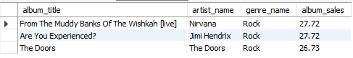

**Approach:**

* **Data Collection:** Extract sales information from invoices, invoice lines, tracks, albums, artists, and genres to assess sales performance.
* **Sales Analysis by Genre:** Use a Common Table Expression (CTE) named Sales to compute total sales for each genre in the USA, helping identify top-performing genres.
* **Identifying Top Albums:** Create a CTE called Top_Albums to calculate total sales for each album, along with their respective artists and genres.
* **Final Selection:** Retrieve the top three albums based on total sales from the Top_Albums CTE to determine which should be prioritized for promotions.

**Insights:**

* From The Muddy Banks Of The Wishkah [Live] is the best-selling Rock album in the USA.
* Are You Experienced? and The Best of Van Halen, Vol. Next are the next top-performing albums.

**Recommendations:**

* **Increase Promotional Efforts:** Focus marketing campaigns on the three best-selling albums to further boost sales.
* **Leverage Nostalgia:** Utilize the strong nostalgic appeal of these albums to drive engagement through bundled offers and targeted promotions.

**Q.2) Determine the top-selling genres in countries other than the USA and identify any commonalities or differences.**

Ans – **MYSQL QUERY**

select g.genre_id , g.name , sum(t.unit_price * il.quantity) as Total_Revenue_Each_Genre

from track t

left join genre g on g.genre_id = t.genre_id

left join invoice_line il on il.track_id = t.track_id

left join invoice i on i.invoice_id = t.track_id

where billing_country != 'USA'

group by 1,2

order by Total_Revenue_Each_Genre desc ;

/* Rock genre is on Top ,

Metal is 2nd & Alternative and Punk on 3rd.

*/

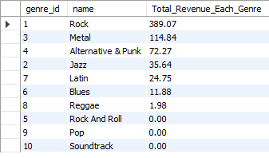

### **Approach:**

### **Data Collection:** Collect sales data from tracks, genres, invoice lines, and invoices to analyze genre performance in countries outside the USA.

### **Sales Analysis by Genre:**

### Write a SQL query to calculate total revenue for each genre by multiplying unit price by quantity sold.

### Exclude records where the billing country is the USA.

### **Grouping and Ordering:**

### Group the data by genre to aggregate total revenue for each genre.

### Order the results by total revenue in descending order to identify the top-performing genres.

### **Insights:**

### Rock consistently leads as the top-selling genre.

### Metal ranks second, followed by Alternative and Punk in third.

### **Recommendations:**

### **Global Campaign Focus:** Prioritize global marketing efforts on Rock, Metal, and Alternative & Punk to drive higher sales.

### **Regional Promotions:** Tailor campaigns to specific regions for genres like Latin, Jazz, and other mid-tier genres to enhance their performance.

**Q.3) Customer Purchasing Behavior Analysis: How do the purchasing habits (frequency, basket size, spending amount) of long-term**

**customers differ from those of new customers? What insights can these patterns provide about customer loyalty and retention strategies?**

Ans – **MYSQL QUERY**

with Purchase_freq as ( select i.customer_id , max(invoice_date) , min(invoice_date) ,

abs(timestampdiff(month , max(invoice_date) , min(invoice_date))) as each_cust_time ,

sum(total) as sales , sum(quantity) as item_count , count(invoice_date) as frequency

from invoice i

left join customer c on c.customer_id = i.customer_id

left join invoice_line il on il.invoice_id = i.invoice_id

group by i.customer_id

order by each_cust_time desc ) ,

average_time as ( select round(avg(each_cust_time),2) as average

from Purchase_freq ) , -- 40.36 Months

Category_Define as (select * , case

when each_cust_time > ( select average from average_time)

then "Long-term Customer" else "Short-term Customer"

end as category

from Purchase_freq )

select category , sum(sales) as Total_spent , sum(item_count) as basket_size , count(frequency) as frequency

from Category_Define

group by category ;



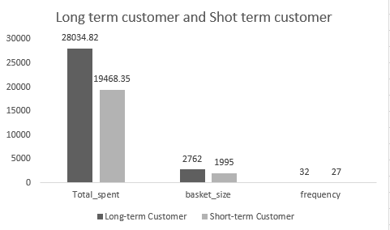

**Approach:**

* **Data Collection:** Collect data from invoices, customers, and invoice lines to analyze customer purchasing behavior.
* **Purchase Frequency Calculation:** Create a Common Table Expression (CTE) named Purchase_freq to calculate metrics for each customer, such as the maximum and minimum invoice dates, time span between purchases, total sales, item count, and purchase frequency.
* **Average Time Calculation:** Create another CTE, average_time, to calculate the average time span of customer purchases across all customers.
* **Customer Categorization:** Define a CTE named Category_Define to categorize customers into "Long-term" or "Short-term" based on whether their purchase time span exceeds the average calculated in the previous step.
* **Final Aggregation:** Aggregate total spending, basket size, and purchase frequency for each customer category.

**Insights:**

* Long-term customers spend more, have larger basket sizes, and shop more frequently compared to short-term customers.

**Recommendations:**

* **Focus on Long-term Customers:** Offer a wider variety of genres that align with the preferences of long-term customers, as they contribute significantly more to revenue.
* **Leverage Customer Loyalty:** Foster stronger relationships with long-term customers, as their repeat purchases over time can drive sustained sales.
* **Enhance Engagement:** Tailor offerings and incentives to retain and nurture long-term customers, making them feel valued to encourage continued loyalty.

**Q.4) Product Affinity Analysis: Which music genres, artists, or albums are frequently purchased together by customers?**

**How can this information guide product recommendations and cross-selling initiatives?**

Ans – **MYSQL QUERY**

-- ( select * from invoice_line ; )

-- Purchase by customer over an invoice but different genre

select il.invoice_id , g.name

from invoice_line il

left join track t on t.track_id = il.track_id

left join genre g on g.genre_id = t.genre_id

group by 1 , 2 ;

-- Different Artists prefered in single invoice

select il.invoice_id, ar.name

from invoice_line il

left join track t on t.track_id = il.track_id

left join album a on a.album_id = t.album_id

left join artist ar on ar.artist_id = a.artist_id

group by 1 , 2 ;

-- Different Albums purchased over an invoice

select il.invoice_id, al.title

from invoice_line il

left join track t on t.track_id = il.track_id

left join album al on al.album_id = t.album_id

group by 1 , 2 ;

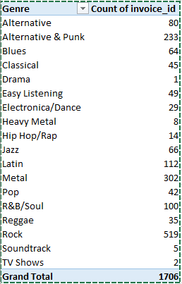

**Genre Preferences:**

* **Most Popular Genres:** Rock, Metal, and Alternative & Punk are the top genres preferred by users.
* **Cross-Selling Potential:** Sales staff can suggest users explore the other two genres when they purchase one, increasing overall sales.

**Top-Selling Artists:**

* **Leading Artists:** Green Day, U2, Foo Fighters, Nirvana, The Rolling Stones, Queens, and System of a Down are among the top sellers.
* **Recommendation Approach:** Use this data to recommend tracks or albums from these prominent artists to enhance customer experience and boost sales.

**Top Albums:**

* **Best-Selling Albums:** Mesmerize, Are You Experienced?, and The Doors are the highest performers.
* **Promotion Strategy:** Feature these albums in promotions or bundle offers to drive further sales.

**Q.5) Regional Market Analysis: Do customer purchasing behaviors and churn rates vary across different geographic regions or store locations?**

**How might these correlate with local demographic or economic factors?**

Ans – **MYSQL QUERY**

with first_six_months as (select billing_country, count(customer_id) count_of_cust from invoice

where invoice_date between '2017-01-01' and '2017-06-30'

group by billing_country ),

last_six_months as ( select billing_country, count(customer_id) count_of_cust from invoice

where invoice_date between '2020-07-01' and '2020-12-31'

group by billing_country )

select f6.billing_country, round((f6.count_of_cust - coalesce(l6.count_of_cust,0))/f6.count_of_cust * 100 , 2) churn_rate

from first_six_months f6

left join last_six_months l6 on f6.billing_country = l6.billing_country

order by churn_rate desc ;

|  |  |
| --- | --- |
| billing_country | churn_rate |
| Denmark | 100 |
| Norway | 100 |
| Spain | 100 |
| Chile | 100 |
| Netherlands | 100 |
| Finland | 50 |
| Italy | 50 |
| India | 40 |
| France | 37.5 |
| Portugal | 20 |
| Germany | 16.67 |
| USA | 15 |
| Brazil | 14.29 |
| Poland | 0 |
| Hungary | 0 |
| Ireland | 0 |
| Canada | -21.43 |
| Australia | -50 |
| United Kingdom | -100 |
| Sweden | -100 |
| Czech Republic | -400 |

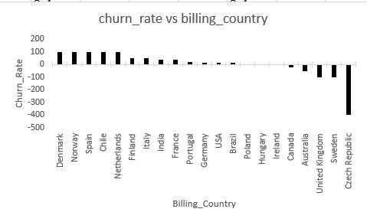

**Approach:**

* **Data Collection:.** Gather invoice data to analyze customer counts in various billing countries over specified time periods
* **Customer Count for the First Six Months:** Create a Common Table Expression (CTE) named *first_six_months* to calculate the number of unique customers in each billing country during the first half of 2017.
* **Customer Count for the Last Six Months:** Create another CTE named *last_six_months* to count the number of unique customers in each billing country during the last half of 2020.
* **Churn Rate Calculation:** Calculate the churn rate for each country by comparing the customer counts from the two periods, using the percentage change in the number of customers as the churn rate.
* **Final Selection:** Select the billing country and its corresponding churn rate, ordering the results by churn rate in descending order.

**Insights:**

* **High Churn Rates**: Finland experienced the highest churn rate at 50%, followed by India at 40%, and France at 37.5%.
* **Zero Churn:** Spain, Denmark, and Norway reported no churn, indicating full customer attrition during the period.
* **Growth Regions:** Canada and Australia showed positive growth, with Canada experiencing a 21.43% increase and Australia a 50% increase, suggesting successful retention or customer acquisition strategies.
* **Stable Loyalty:** Poland, Hungary, and Ireland demonstrated zero churn, reflecting strong customer loyalty in these regions.

**Recommendations:**

* **Focus on High Churn Regions:** Develop loyalty programs and localized campaigns in Finland, India, and France to regain customer loyalty and reduce churn.
* **Leverage Growth in Canada and Australia:** Build on the positive growth in these regions by enhancing marketing strategies and improving customer engagement with Priority’s services.
* **Maintain Customer Loyalty in Stable Regions:** Sustain customer loyalty in Poland, Hungary, and Ireland through consistent engagement and maintaining service quality.

**Q.6) Customer Risk Profiling: Based on customer profiles (age, gender, location, purchase history), which customer segments are more**

**likely to churn or pose a higher risk of reduced spending? What factors contribute to this risk?**

Ans – **MYSQL QUERY**

First trying to find customer Days_Since_Last_Purchase

select customer_id , datediff('2020-12-31' , max(invoice_date)) as Days_Since_Last_Purchase

from invoice

group by customer_id;

Assume a customer is at risk if they haven't purchased in the last 90 days.

with Risk_Status as ( select customer_id ,

case

when datediff('2020-12-31' , max(invoice_date)) > 90 then 'At Risk'

else 'Active'

end as Customer_Risk_Status

from invoice

group by customer_id )

select Customer_Risk_Status , count(*) as Total_Count

from Risk_Status

group by Customer_Risk_Status;

Calculate Total Spending and Average Spending per Customer

select customer_id , count(invoice_id) as Total_Invoice ,

sum(total) as Total_Spent , round(avg(total),2) as Avg_Spent_Per_invoice

from invoice

group by customer_id ;

Compare spending across year by year

select customer_id , year(invoice_date) as Year , sum(total) as Yearly_Spending

from invoice

group by customer_id, year(invoice_date)

order by customer_id, Year;

Analyze Spending by Location (City , State and Country)

select billing_city , billing_state , billing_country ,

count(distinct customer_id) as Customer_Count , sum(total) as Total_Spent , round(avg(total),2) as Avg_Spent

from invoice

group by billing_city , billing_state , billing_country

order by total_spent desc ;

**Factors Contributing to Risk**

High Recency (Days Since Last Purchase): Customers who haven’t purchased in a long time.

Low Frequency (Total Invoices): Customers with infrequent transactions.

Declining Spending Trends: Customers whose spending decreases over time.

Demographic Location: Customers in regions with lower average spending or higher churn.



|  |  |  |  |
| --- | --- | --- | --- |
| customer_id | Total_Invoice | Total_Spent | Avg_Spent_Per_invoice |
| 18 | 8 | 79.2 | 9.9 |
| 30 | 13 | 91.08 | 7.01 |
| 40 | 9 | 72.27 | 8.03 |
| 27 | 9 | 84.15 | 9.35 |
| 31 | 11 | 62.37 | 5.67 |
| 49 | 10 | 76.23 | 7.62 |
| 59 | 8 | 71.28 | 8.91 |
| 38 | 9 | 73.26 | 8.14 |
| 42 | 11 | 99.99 | 9.09 |
| 35 | 16 | 82.17 | 5.14 |
| 25 | 10 | 76.23 | 7.62 |
| 44 | 11 | 79.2 | 7.2 |
| 1 | 13 | 108.9 | 8.38 |
| 20 | 12 | 95.04 | 7.92 |
| 24 | 8 | 71.28 | 8.91 |
| 10 | 12 | 60.39 | 5.03 |
| 43 | 12 | 73.26 | 6.11 |
| 9 | 10 | 37.62 | 3.76 |
| 53 | 11 | 98.01 | 8.91 |
| 4 | 9 | 72.27 | 8.03 |
| 39 | 9 | 79.2 | 8.8 |
| 55 | 10 | 81.18 | 8.12 |
| 12 | 11 | 82.17 | 7.47 |
| 45 | 10 | 78.21 | 7.82 |
| 46 | 13 | 114.84 | 8.83 |
| 3 | 9 | 99.99 | 11.11 |
| 58 | 13 | 111.87 | 8.61 |
| 33 | 12 | 75.24 | 6.27 |
| 34 | 13 | 102.96 | 7.92 |
| 51 | 10 | 75.24 | 7.52 |
| 37 | 10 | 94.05 | 9.41 |
| 50 | 11 | 98.01 | 8.91 |
| 19 | 9 | 54.45 | 6.05 |
| 22 | 12 | 92.07 | 7.67 |
| 21 | 11 | 91.08 | 8.28 |
| 36 | 11 | 85.14 | 7.74 |
| 57 | 13 | 97.02 | 7.46 |
| 26 | 12 | 86.13 | 7.18 |
| 15 | 9 | 66.33 | 7.37 |
| 52 | 8 | 68.31 | 8.54 |
| 47 | 9 | 50.49 | 5.61 |
| 16 | 8 | 74.25 | 9.28 |
| 2 | 11 | 82.17 | 7.47 |
| 13 | 15 | 106.92 | 7.13 |
| 5 | 18 | 144.54 | 8.03 |
| 48 | 10 | 65.34 | 6.53 |
| 32 | 8 | 70.29 | 8.79 |
| 8 | 7 | 60.39 | 8.63 |
| 17 | 12 | 98.01 | 8.17 |
| 54 | 9 | 79.2 | 8.8 |
| 6 | 12 | 128.7 | 10.73 |
| 28 | 10 | 72.27 | 7.23 |
| 29 | 4 | 40.59 | 10.15 |
| 7 | 9 | 69.3 | 7.7 |
| 14 | 10 | 29.7 | 2.97 |
| 11 | 10 | 69.3 | 6.93 |
| 23 | 10 | 66.33 | 6.63 |
| 41 | 9 | 64.35 | 7.15 |
| 56 | 5 | 39.6 | 7.92 |

|  |  |  |  |
| --- | --- | --- | --- |
| **Billing_county** | **Count of Customer_Count** | **Sum of Avg_Spent** | **Sum of Total_Spent** |
| Argentina | 1 | 7.92 | 39.6 |
| Australia | 1 | 8.12 | 81.18 |
| Austria | 1 | 7.7 | 69.3 |
| Belgium | 1 | 8.63 | 60.39 |
| Brazil | 4 | 28.88 | 427.68 |
| Canada | 8 | 59.34 | 535.59 |
| Chile | 1 | 7.46 | 97.02 |
| Czech Republic | 1 | 9.11 | 273.24 |
| Denmark | 1 | 3.76 | 37.62 |
| Finland | 1 | 7.2 | 79.2 |
| France | 4 | 30.77 | 389.07 |
| Germany | 3 | 24.8 | 334.62 |
| Hungary | 1 | 7.82 | 78.21 |
| India | 2 | 17.52 | 183.15 |
| Ireland | 1 | 8.83 | 114.84 |
| Italy | 1 | 5.61 | 50.49 |
| Netherlands | 1 | 6.53 | 65.34 |
| Norway | 1 | 8.03 | 72.27 |
| Poland | 1 | 7.62 | 76.23 |
| Portugal | 2 | 13.06 | 185.13 |
| Spain | 1 | 8.91 | 98.01 |
| Sweden | 1 | 7.52 | 75.24 |
| United Kingdom | 2 | 17.55 | 245.52 |
| USA | 12 | 95.45 | 1040.49 |
| **Grand Total** | **53** | **408.14** | **4709.43** |

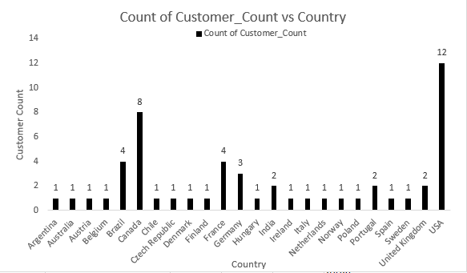

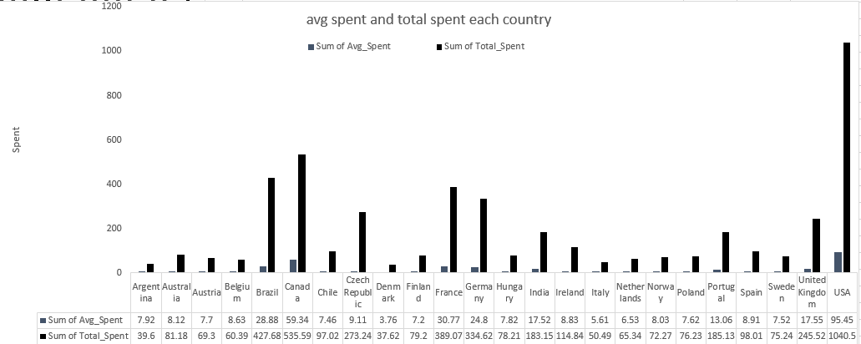

|  |  |  |
| --- | --- | --- |
| **Year** | **Count of customer_id** | **Sum of Yearly_Spending** |
| 2017 | 57 | 1201.86 |
| 2018 | 55 | 1147.41 |
| 2019 | 54 | 1221.66 |
| 2020 | 58 | 1138.5 |
| **Grand Total** | **224** | **4709.43** |

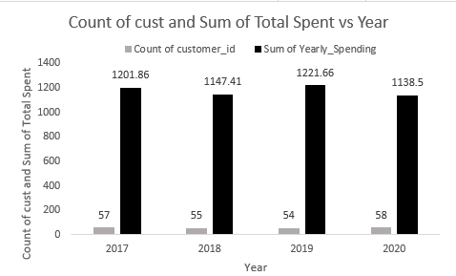

### **Approach:**

* **Days Since Last Purchase**:
  + Calculate the number of days since the last purchase for each customer to identify those who may be at risk of churning.
* **Risk Status Classification**:
  + Classify customers as "At Risk" if they haven't made a purchase in the last 90 days, and "Active" otherwise.
* **Total and Average Spending Calculation**:
  + Calculate total spending and average spending per customer to understand their purchasing behavior.
* **Yearly Spending Comparison**:
  + Analyze spending patterns year over year to identify trends in customer spending.
* **Spending Analysis by Location**:
  + Analyze spending by geographic location (city, state, country) to identify regional differences in customer behavior.

**Insights:**

* Inactivity: Prolonged periods between purchases boost the risk of churn, the study reveals.
* Low Purchase Frequency & Spending: Less often purchases along with the overall spendings indicate lesser interaction with the brands and the products.
* Demographics: Churn rates and spending may differ based on age and gender but beyond that, the data constraints make it difficult to go deeper on preferences and behaviour.

**Recommendations**:

As customer loyalty is crucial in any business and word of mouth play a significant role in assessing the business’ health therefore, such customers should be dealt with utmost care and specialised offers or campaigns should be launched to keep them loyal.

**Q.7) Customer Lifetime Value Modeling: How can you leverage customer data (tenure, purchase history, engagement) to predict the**

**lifetime value of different customer segments? This could inform targeted marketing and loyalty program strategies.**

**Can you observe any common characteristics or purchase patterns among customers who have stopped purchasing?**

Ans – **MYSQL QUERY**

with purchase_history as ( select i.customer_id , i.billing_country , i.invoice_date ,

concat(c.first_name , ' ' , c.last_name) as customer_name , i.total

from invoice i

left join customer c on i.customer_id = c.customer_id

group by i.customer_id , i.billing_country , i.invoice_date , i.total

order by customer_name ) ,

Lifetime_purchase as (select customer_id , sum(total) as Lifetime_value

from invoice

group by customer_id )

select ph.customer_id , ph.billing_country , ph.invoice_date ,

ph.customer_name , ph.total , lp.Lifetime_value

from purchase_history ph

left join Lifetime_purchase lp on lp.customer_id = ph.customer_id

order by lp.Lifetime_value desc , ph.customer_name , ph.invoice_date ;

|  |  |  |  |
| --- | --- | --- | --- |
| **Country** | **Sum of Lifetime_value** | **Count of invoice_date** | **Sum of total** |
| Argentina | 198 | 5 | 39.6 |
| Australia | 811.8 | 10 | 81.18 |
| Austria | 623.7 | 9 | 69.3 |
| Belgium | 422.73 | 7 | 60.39 |
| Brazil | 5341.05 | 61 | 427.68 |
| Canada | 5291.55 | 76 | 535.59 |
| Chile | 1261.26 | 13 | 97.02 |
| Czech Republic | 4146.12 | 30 | 273.24 |
| Denmark | 376.2 | 10 | 37.62 |
| Finland | 871.2 | 11 | 79.2 |
| France | 3921.39 | 50 | 389.07 |
| Germany | 3440.25 | 41 | 334.62 |
| Hungary | 782.1 | 10 | 78.21 |
| India | 2024.55 | 21 | 183.15 |
| Ireland | 1492.92 | 13 | 114.84 |
| Italy | 454.41 | 9 | 50.49 |
| Netherlands | 653.4 | 10 | 65.34 |
| Norway | 650.43 | 9 | 72.27 |
| Poland | 762.3 | 10 | 76.23 |
| Portugal | 2653.2 | 29 | 185.13 |
| Spain | 1078.11 | 11 | 98.01 |
| Sweden | 752.4 | 10 | 75.24 |
| United Kingdom | 2337.39 | 28 | 245.52 |
| USA | 10650.42 | 131 | 1040.49 |

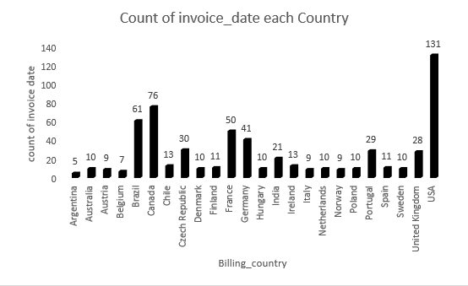

### **Approach:**

* **Purchase History Collection**:
  + Create a Common Table Expression (CTE) named purchase_history to gather relevant customer data, including customer ID, billing country, invoice date, customer name, and total purchase amount.
* **Lifetime Value Calculation**:
  + Create another CTE named Lifetime_purchase to calculate the total lifetime value for each customer by summing their total purchases.
* **Final Selection**:
  + Join the two CTEs to combine purchase history with lifetime value, allowing for a comprehensive view of each customer's purchasing behavior and their overall lifetime value.
* **Ordering Results**:
  + Order the results by lifetime value in descending order, followed by customer name and invoice date for better readability.

### **Insights from Customer Lifetime Value Modeling**

* **Identifying High-Value Customers**:
  + By calculating the lifetime value of customers, businesses can identify which segments contribute the most to revenue. This allows for targeted marketing efforts aimed at retaining these high-value customers.
* **Segmentation for Targeted Marketing**:
  + The analysis can reveal distinct customer segments based on their purchasing behavior, such as frequent buyers, high spenders, and occasional purchasers. Tailoring marketing strategies to these segments can improve engagement and conversion rates.
* **Churn Prediction**:
  + Customers with low or declining lifetime values may be at risk of churning. By identifying these customers early, businesses can implement retention strategies, such as personalized offers or loyalty programs, to encourage continued spending.
* **Understanding Purchase Patterns**:
  + Analyzing the purchase history can uncover trends in customer behavior, such as seasonal buying patterns or preferences for specific product categories. This information can inform inventory management and promotional strategies.
* **Impact of Engagement**:
  + Customers who engage with the brand through loyalty programs, newsletters, or social media may show higher lifetime values. Understanding the correlation between engagement and spending can help businesses design more effective engagement strategies.
* **Geographic Insights**:
  + The analysis of customer data by location can reveal regional differences in purchasing behavior. This can inform localized marketing strategies and help businesses allocate resources more effectively.

**Recommendations:**

**Customer Data Utilization:**

* Purchase History, Tenure, Engagement: These points of data can be used to calculate aspects about customers which include loyalty, value – high or low, and frequency of purchases.
* Recent High-Value Customers: Such customers may well become loyal in future and, therefore, represent potential for marketing or promotion.

**Segmentation & Targeted Marketing:**

Customer Segmentation: Due to the data processing techniques, customers can be divided into groups depending on their buying behavior, and the company can send targeted marketing messages to those groups.

**Churn in Less Developed Countries:**

* Higher Churn Rates: Mobile customers in LDCs have a higher churn rate possibly because of aspects such as product-market alignment or cost.

Addressing Issues: There are topics such as Product Market Fit and Pricing that need to be resolved to hack growth and minimize churn.

**Q.8) If data on promotional campaigns (discounts, events, email marketing) is available, how could you measure their impact on customer acquisition, retention, and overall sales?**

Ans – **MYSQL QUERY**

select count(*) from track ; -- total available tracks according to our data

select distinct t.name

from track t

where t.track_id not in ( select il.track_id

from invoice_line il

left join invoice i on i.invoice_id = il.invoice_id

where i.invoice_date between '2020-07-01' and '2020-12-31') ;

Identifying songs that were not Purchased by any customer in previous 6 months.

So promotions campaigns can applied over them to promote their sales.

select c.email , concat(c.first_name, ' ', c.last_name) as Customer_Full_Name

from customer c

where c.customer_id not in (select distinct customer_id

from invoice

where invoice_date between '2020-07-01' and '2020-12-31' ) ;

Identifying those customer they have not made any purchase in previous 6 months.

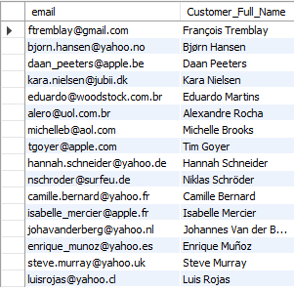

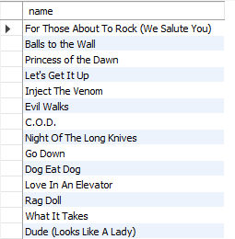

* Identifying the tracks that have not been sold in last 6 months(i.e. Between 01 July 2020 and 31 Dec 2020)
* 3006 such songs/tracks were Identified out of 3503 total songs/tracks.
* Identifying customers that haven’t made any purchase in last 6 months.
  + 16 such customers out of 59 were identified that haven’t made any purchase in last 6 months.

### **Approach:**

* **Total Tracks Available**:
  + First, determine the total number of tracks available in the database. This provides a baseline for understanding the inventory.
* **Identifying Unpurchased Tracks**:
  + Identify tracks that have not been purchased by any customer in the last six months. This information can help target promotional campaigns to boost sales of these tracks.
* **Identifying Inactive Customers**:
  + Find customers who have not made any purchases in the last six months. This information can be used to target these customers with re-engagement campaigns, such as email marketing or special offers.

### **Insights from Promotional Campaign Analysis**

* **Targeted Marketing Effectiveness**:
  + By identifying tracks that have not been purchased recently, businesses can tailor promotional campaigns specifically to these products. This targeted approach can lead to increased sales for underperforming items, demonstrating the effectiveness of focused marketing efforts.
* **Re-engagement of Inactive Customers**:
  + Promotional campaigns aimed at inactive customers can significantly improve retention rates. If a notable percentage of these customers return to make purchases after receiving targeted promotions, it indicates that the campaigns are effective in re-engaging lapsed customers.
* **Customer Segmentation**:
  + Analyzing the response to promotional campaigns can reveal distinct customer segments that are more responsive to certain types of promotions (e.g., discounts, exclusive events). This insight allows businesses to refine their marketing strategies and tailor future campaigns to specific segments for better results.
* **Sales Growth from Promotions**:
  + By comparing sales data before and after promotional campaigns, businesses can quantify the impact of these initiatives. A significant increase in sales, particularly for previously unpurchased tracks, indicates that the promotions successfully stimulated demand.
* **Return on Investment (ROI)**:
  + Calculating the ROI of promotional campaigns provides insights into their financial effectiveness. If the revenue generated from increased sales exceeds the costs of the campaigns, it validates the investment in marketing efforts and can guide future budget allocations.
* **Customer Lifetime Value (CLV) Enhancement**:
  + Successful promotional campaigns that lead to repeat purchases from previously inactive customers can enhance their lifetime value. Understanding how promotions affect CLV can help businesses prioritize customer retention strategies that yield long-term benefits.
* **Feedback and Improvement**:
  + Gathering customer feedback on promotional campaigns can provide insights into customer preferences and perceptions. This qualitative data can inform future campaigns, helping businesses understand what types of promotions resonate most with their audience.
* **Seasonal Trends and Timing**:
  + Analyzing the timing of promotional campaigns in relation to sales spikes or declines can reveal seasonal trends. This insight can help businesses plan future promotions to align with peak purchasing periods, maximizing their impact.

**Recommendations:**

* Promote attractive with high profit margins to customers, who are long-term inactive, in order to reactivate them.
* Use promotions – coupons or bundles – on tracks that did not sell in the previous months.
* Monitor Customer Acquisition Cost (CAC) to know which campaigns are inexpensive and assign new customers to a particular campaign by codes or URLs.
* Establish the extent of how churn rate has changed over a period of time, and how repeat purchases have taken place and compare this with the same situation during or after a promotion in a bid to establishing how effective they are in growing long-term customer relations.
* Measure the performance of a campaign by comparing the number of items sold or revenue generated and the AOV during the promotion period against those of a normal period.

**Q.9) How would you approach this problem, if the objective and subjective questions weren't given?**

Ans – **MYSQL QUERY**

If objective and subjective questions weren't given . then first I'll try to approach for finding

Duplicate and null value in each table , also year and country wise revenue

select * from album ;

select distinct * from album ; -- No any Duplicate

select * from artist ;

select distinct * from artist ; -- No any Duplicate

select * from customer ;

select distinct * from customer ; -- No any Duplicate

select count(*) from customer

where company is null ; -- 49 Null value

select count(*) from customer

where state is null ; -- 29 Null value

select count(*) from customer

where fax is null ; -- 47 Null value

select * from employee ; -- employee_id 1 report_to is null

select distinct * from employee ; -- No any Duplicate

select * from genre ;

select distinct * from genre ; -- No any Duplicate

select * from invoice ;

select distinct * from invoice ; -- No any Duplicate

select * from invoice_line ;

select distinct * from invoice_line ; -- No any Duplicate

select * from media_type ;

select distinct * from media_type ; -- No any Duplicate

select * from playlist ;

select distinct * from playlist ; -- No any Duplicate

select * from playlist_track ;

select distinct * from playlist_track ; -- No any Duplicate

select * from track ;

select distinct * from track ; -- No any Duplicate

select sum(total) as Yearly_Revenue , extract(year from invoice_date) as Year

from invoice

group by 2;

/* Yearly revenue

1201.86 2017

1147.41 2018

1221.66 2019

1138.50 2020

*/

select billing_country , sum(total) as Total_Revenue

from invoice

group by billing_country

order by Total_Revenue desc ;

select customer_id , sum(total) as Lifetime_Purchase

from invoice

group by customer_id

order by sum(total) desc ;

**Understand the Problem Context:**

**Identify Chinook's primary business goals such as :**

· Increasing revenue.

· Improving customer retention.

· Enhancing customer acquisition.

**Define the Core Business Questions:**

· "Which geographical regions generate the most revenue?"

· "What is the average purchase behaviour of customers across countries?"

· "What drives customer retention, and where are we losing customers?"

· "Which products or services contribute the most to revenue?"

**Explore and Understand the Data**

· Review the available tables in the Chinook database (e.g., Customer, Invoice, Invoice Line, Track, Genre, etc.).

· Understand the relationships between these tables (e.g., how customers link to invoices, how tracks contribute to purchases).

**Identify Key Metrics**

**Customer Insights:**

· Total customers by country.

· Average spending per customer.

· Churn rate and retention rate.

· Average number of tracks purchased.

**Sales Insights:**

· Total revenue by country.

· Most purchased genres or tracks.

**Geographical Trends:**

· Which countries contribute most to revenue?

· Identify high-value and low-value regions.

**Conclusion**

Without predefined questions, the approach revolves around exploring the data, getting insights and aligning analysis with business goals.

**Q.10) How can you alter the "Albums" table to add a new column named "ReleaseYear" of type INTEGER to store the release year of each album?**

Ans – **MYSQL QUERY**

alter table album

add column ReleaseYear int;

select *

from album;

**Q.11) Chinook is interested in understanding the purchasing behavior of customers based on their geographical location. They want to know the average total amount spent by customers from each country, along with the number of customers and the average number of tracks purchased per customer. Write an SQL query to provide this information.**

Ans – **MYSQL QUERY**

with average_spent as( select round(avg(total),2) as avg_total_amount_spent,

count(distinct customer_id) as num_of_customer , billing_country

from invoice i

left join invoice_line il on il.invoice_id = i.invoice_id

group by billing_country ),

Purchase_qty as (select i.customer_id, sum(quantity) as quantity_purchased from invoice i

left join invoice_line il on il.invoice_id = i.invoice_id

group by i.customer_id ),

average_by_country as ( select billing_country, round(avg(quantity_purchased),2) as avg_tracks_per_country

from invoice i

left join Purchase_qty pq on pq.customer_id = i.customer_id

group by billing_country )

select * from average_spent

left join average_by_country ac on ac.billing_country = average_spent.billing_country ;

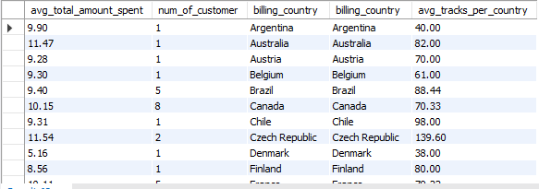

### **Approach**

* **Define Objectives**:
  + Determine the key metrics to analyze:
    - Average total amount spent by customers from each country.
    - Number of distinct customers in each country.
    - Average number of tracks purchased per customer in each country.
* **Data Sources**:
  + Identify the relevant tables in the database:
    - **Invoice Table**: Contains information about customer purchases, including total amounts and billing country.
    - **Invoice Line Table**: Contains details about individual items purchased in each invoice, including quantities and track IDs.
* **Calculate Average Total Amount Spent**:
  + Create a Common Table Expression (CTE) to calculate the average total amount spent by customers in each country:
    - Use the AVG() function to compute the average total from the invoice table.
    - Count distinct customers using COUNT(DISTINCT customer_id) to get the number of customers per country.
    - Group the results by billing_country.
* **Calculate Total Tracks Purchased**:
  + Create another CTE to calculate the total number of tracks purchased by each customer:
    - Sum the quantities from the invoice_line table, grouping by customer_id.
* **Calculate Average Tracks Purchased per Country**:
  + Create a third CTE to calculate the average number of tracks purchased per customer for each country:
    - Join the invoice table with the previous CTE (total tracks purchased) to compute the average number of tracks per country.
    - Use the AVG() function on the total quantities purchased, grouping by billing_country.
* **Combine Results**:
  + Use a final SELECT statement to combine the results from the CTEs:
    - Perform a LEFT JOIN between the CTEs that calculate average spending and average tracks purchased, matching on billing_country.
    - Select the relevant columns: average total amount spent, number of customers, billing country, and average tracks purchased.

**Insights:**

* The average total amount spent per customer seems to be in the range of 8 to 12 approximately with an outlier of 5.158 in Denmark.
* The number of customers are very few (single digits) in most of the countries.
* USA is the country with highest number of customers.

**Recommendations:**

* Focus on the USA: The US market has a good number of customers and therefore should be a top priority.
* Increase Penetration: Find ways to make your customer base bigger in other countries.
* Tailor Marketing: Looking at the types of genres, develop region specific marketing campaigns for each of them based on the genre preferences and spendings average.
* Address Low Spending: Check out the average spending of certain regions and countries and experiment with targeted promotions or product adjustment.
* Encourage Higher Spending: Offer customers with loyalty programs or personalised recommendations to encourage them to purchase more tracks.