Republic of the Philippines
Laguna State Polytechnic University
Province of Laguna
College of Computer Studies
ITEC 204 - Data Structures and Algorithms
Laboratory Activity 1 - Documentation
Name: | Zenrik Principe
Section: | BSIT-2A
Date: | September 24, 2026
Instructor: | Maxyne Nuela Ignacio

I. Program Title
IT Automation Incident Ticket Manager

II. Objective
This program is designed to simulate an IT Automation Incident Ticket Manager, which helps support teams organize and manage incident tickets generated by automation bots. It applies the concepts of a linear data structure, specifically a list of dictionaries, to store and manipulate ticket records. Through this program, basic data structure operations such as adding, displaying, searching, removing, and counting records are demonstrated in a practical, menu-driven application.

III. Scenario
Automation bots running in an IT environment (such as BOT-Inventory, BOT-Email, and BOT-DataSync) occasionally encounter errors or failures during their scheduled tasks. When this happens, an incident ticket is automatically generated and needs to be tracked by the support team until it is resolved. This program simulates the ticket-tracking system used by the support team to add new incidents, view active tickets, search for specific tickets, remove resolved ones, and monitor how many incidents are still active.

IV. Data Structure Used
A List of Dictionaries was used as the linear data structure for this program. Each incident ticket is represented as a dictionary containing three key-value pairs: id (Incident ID), bot (the automation bot involved), and description (short description of the issue). All ticket dictionaries are stored inside a single list named incident_tickets. A list was chosen because it naturally supports sequential (linear) storage of records and provides built-in operations such as append() and remove() that map directly to the required Add and Remove operations, while allowing simple iteration for Display, Search, and Count.

V. Program Operations
Add Incident - Appends a new ticket (as a dictionary) to the end of the list.
Code: incident_tickets.append(ticket)
When the user chooses to add a ticket, the program collects the Incident ID, Bot name, and Short Description, packages them into a dictionary, and appends this dictionary to the incident_tickets list using Python's built-in append() method.
Display Incidents - Iterates through the list and prints each ticket's details.
Code: for ticket in incident_tickets:
The program loops through every dictionary currently stored in incident_tickets and prints the Incident ID, Bot, and Description of each one in a formatted table, allowing the user to view all active tickets at once.
Search Incident - Performs a linear search for a matching Incident ID.
Code: if ticket["id"] == incident_id:
The program checks each ticket in the list one by one, comparing its id field against the Incident ID entered by the user. Once a match is found, the ticket's details are displayed; if no match is found after checking the entire list, a not-found message is shown.
Remove Resolved Incident - Deletes a specific ticket dictionary from the list.
Code: incident_tickets.remove(ticket)
After locating the ticket that matches the given Incident ID (using the same linear search logic), the program calls remove() to delete that specific dictionary from the incident_tickets list, effectively marking the incident as resolved and removing it from the active list.
Count Active Incidents - Returns the current number of tickets in the list.
Code: len(incident_tickets)
The program uses Python's built-in len() function to count how many dictionaries currently exist in the incident_tickets list, giving the total number of active (unresolved) incident tickets at any point in time.

VI. Source Code
"""
IT Automation Incident Ticket Manager
ITEC 204 - Data Structures and Algorithms
Laboratory Activity 1

Linear Data Structure Used: List of Dictionaries
"""

incident_tickets = [] # main linear data structure (list)

def add_ticket(incident_id, bot, description):
"""Add a new incident ticket to the list."""
ticket = {"id": incident_id, "bot": bot, "description": description}
incident_tickets.append(ticket)
print(f"\nTicket {incident_id} added successfully.")

def display_tickets():
"""Display all active incident tickets."""
if not incident_tickets:
print("\nNo active incident tickets.")
return
print("\n" + "-" * 75)
print(f"{'Incident ID':<15}{'Bot':<20}{'Short Description'}")
print("-" * 75)
for ticket in incident_tickets:
print(f"{ticket['id']:<15}{ticket['bot']:<20}{ticket['description']}")
print("-" * 75)

def search_ticket(incident_id):
"""Search for a specific incident ticket using its Incident ID."""
for ticket in incident_tickets:
if ticket["id"] == incident_id:
print("\nTicket Found:")
print(f"Incident ID : {ticket['id']}")
print(f"Bot : {ticket['bot']}")
print(f"Description : {ticket['description']}")
return ticket
print(f"\nTicket {incident_id} not found.")
return None

def remove_ticket(incident_id):
"""Remove a resolved incident ticket from the list."""
for ticket in incident_tickets:
if ticket["id"] == incident_id:
incident_tickets.remove(ticket)
print(f"\nTicket {incident_id} has been marked resolved and removed.")
return
print(f"\nTicket {incident_id} not found.")

def count_active_tickets():
"""Display the total number of active incident tickets."""
print(f"\nTotal active incident tickets: {len(incident_tickets)}")

def load_sample_data():
"""Pre-load the 10 sample incident tickets for testing."""
sample_data = [
("INC1392939", "BOT-Inventory", "Failed to generate the daily report"),
("INC1392940", "BOT-Email", "Failed to send the scheduled notification"),
("INC1392941", "BOT-DataSync", "Encountered an error during data transfer"),
("INC1392942", "BOT-Invoice", "Failed to process an invoice"),
("INC1392943", "BOT-Report", "Failed to generate the weekly report"),
("INC1392944", "BOT-FileTransfer", "Failed to upload the required file"),
("INC1392945", "BOT-DataEntry", "Encountered an error while entering records"),
("INC1392946", "BOT-Backup", "Failed to complete the scheduled backup"),
("INC1392947", "BOT-Validation", "Failed to validate the submitted records"),
("INC1392948", "BOT-Notification", "Failed to send the system alert"),
]
for incident_id, bot, description in sample_data:
add_ticket(incident_id, bot, description)

def main():
print("=" * 75)
print(" IT AUTOMATION INCIDENT TICKET MANAGER")
print("=" * 75)
load_sample_data()
print("\n10 sample incident tickets have been loaded for testing.")

while True:
print("\n--------- MENU ---------")
print("1. Add Incident Ticket")
print("2. Display All Active Incident Tickets")
print("3. Search Incident Ticket")
print("4. Remove Resolved Incident Ticket")
print("5. Count Active Incident Tickets")
print("6. Exit")

choice = input("Enter your choice (1-6): ").strip()

if choice == "1":
incident_id = input("Enter Incident ID: ").strip()
bot = input("Enter Bot Name: ").strip()
description = input("Enter Short Description: ").strip()
add_ticket(incident_id, bot, description)

elif choice == "2":
display_tickets()

elif choice == "3":
incident_id = input("Enter Incident ID to search: ").strip()
search_ticket(incident_id)

elif choice == "4":
incident_id = input("Enter Incident ID to remove: ").strip()
remove_ticket(incident_id)

elif choice == "5":
count_active_tickets()

elif choice == "6":
print("\nExiting program. Goodbye!")
break

else:
print("\nInvalid choice. Please try again.")

if __name__ == "__main__":
main()

VII. Program Output
Below are the program outputs demonstrating each required operation, tested using the 10 sample incident tickets.
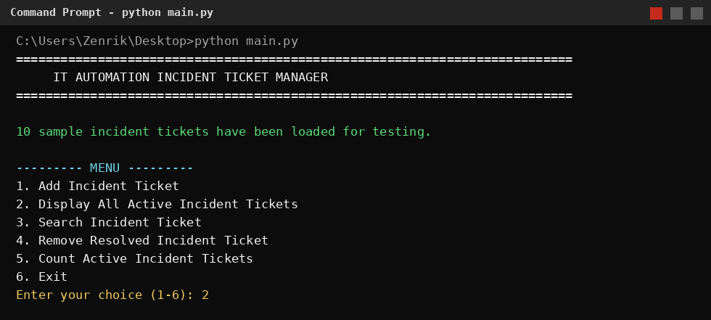
Figure 1. Program menu after loading the 10 sample incident tickets.
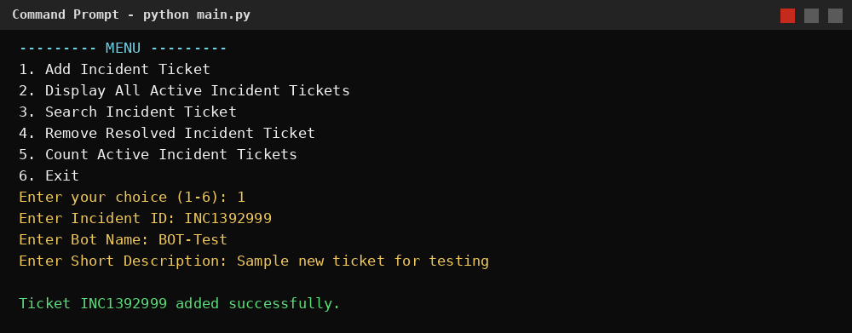
Figure 2. Add Incident Ticket operation.
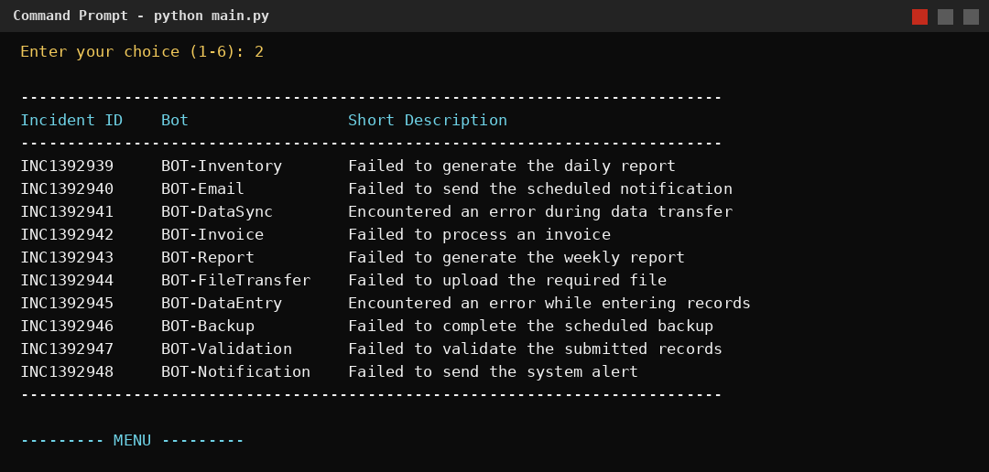
Figure 3. Display All Active Incident Tickets operation.
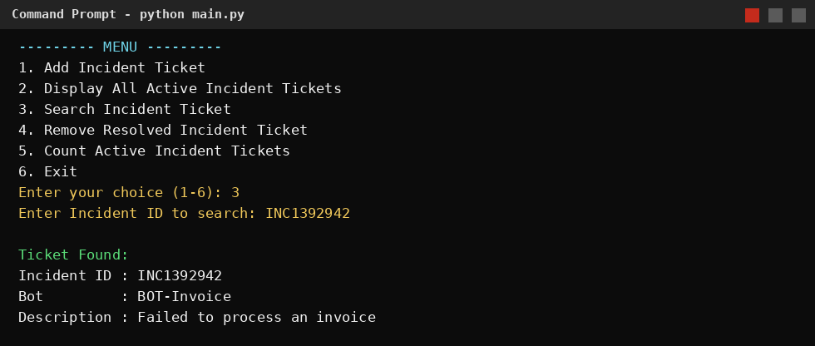
Figure 4. Search Incident Ticket operation.
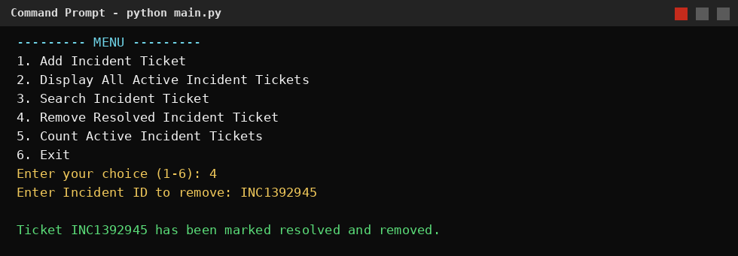
Figure 5. Remove Resolved Incident Ticket operation.
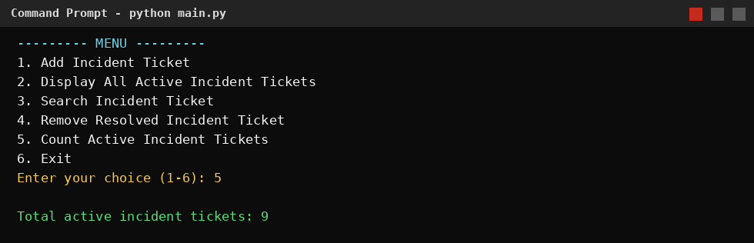
Figure 6. Count Active Incident Tickets operation.

VIII. Conclusion
Through this activity, I learned that a linear data structure such as a list is an efficient way to organize records that need to be added, searched, and removed individually, since it allows straightforward sequential access to each element. I was also able to apply core list operations - append(), remove(), iteration, and len() - to a practical, real-world scenario involving the management of incident tickets generated by automation bots. This exercise strengthened my understanding of how linear data structures serve as the foundation for building simple, functional record-management systems.

