week1 Assignment

1. Write hello world python program using any five methods which we have learned in week-1 class

1-

Anaconda

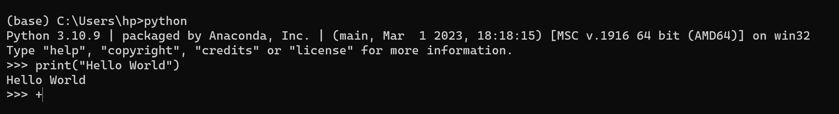

cmd

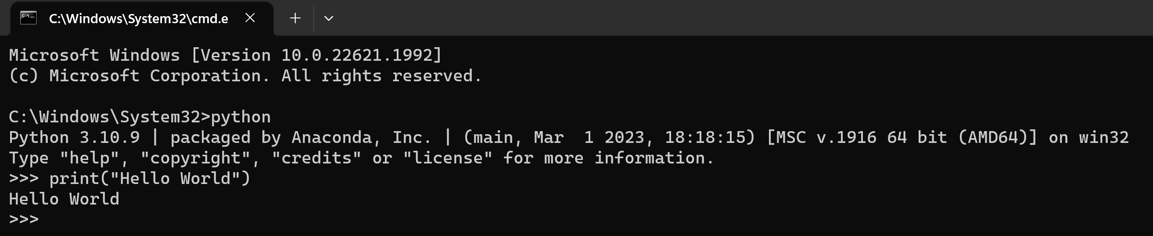

2- Running .py file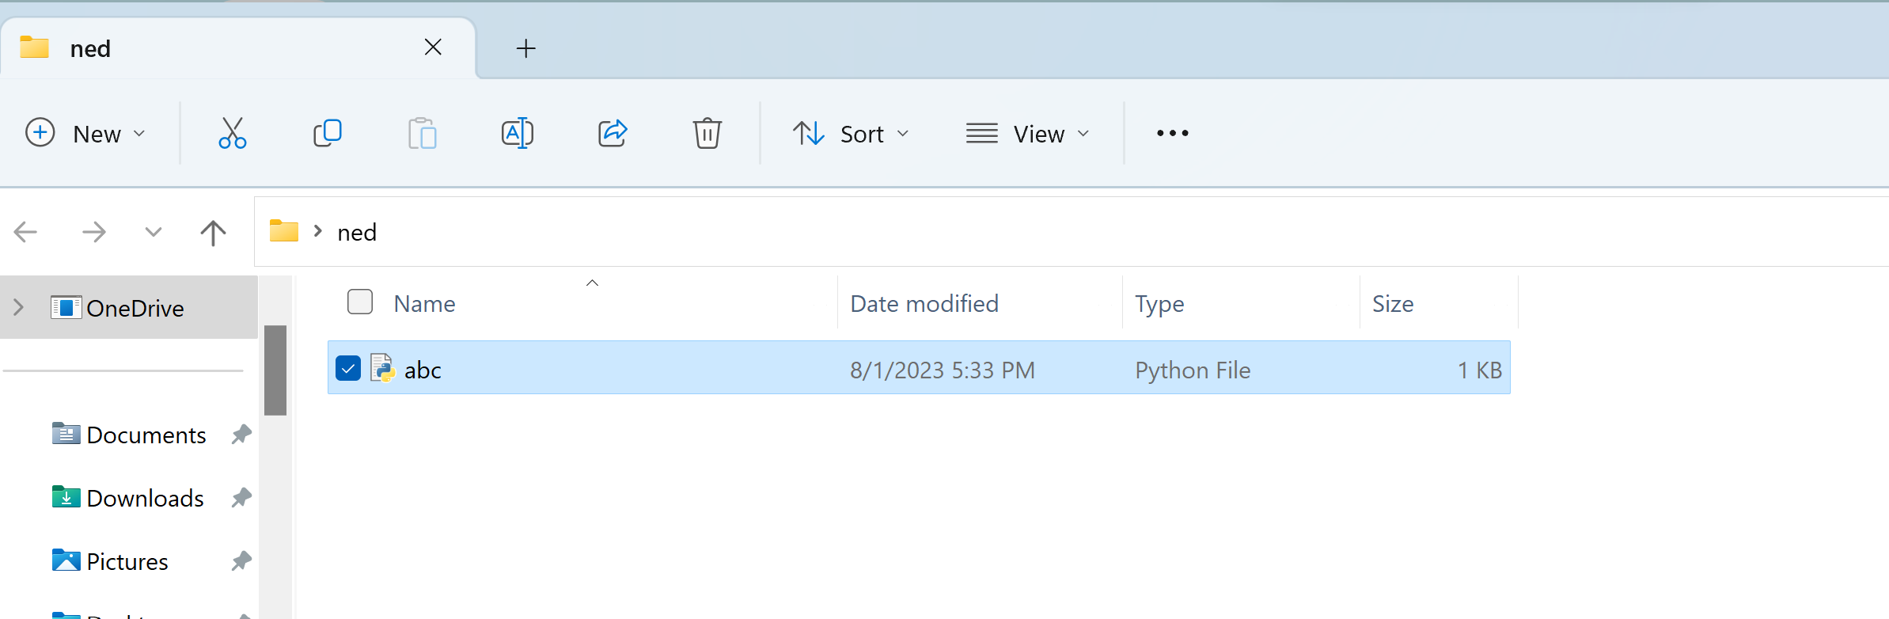

Anaconda

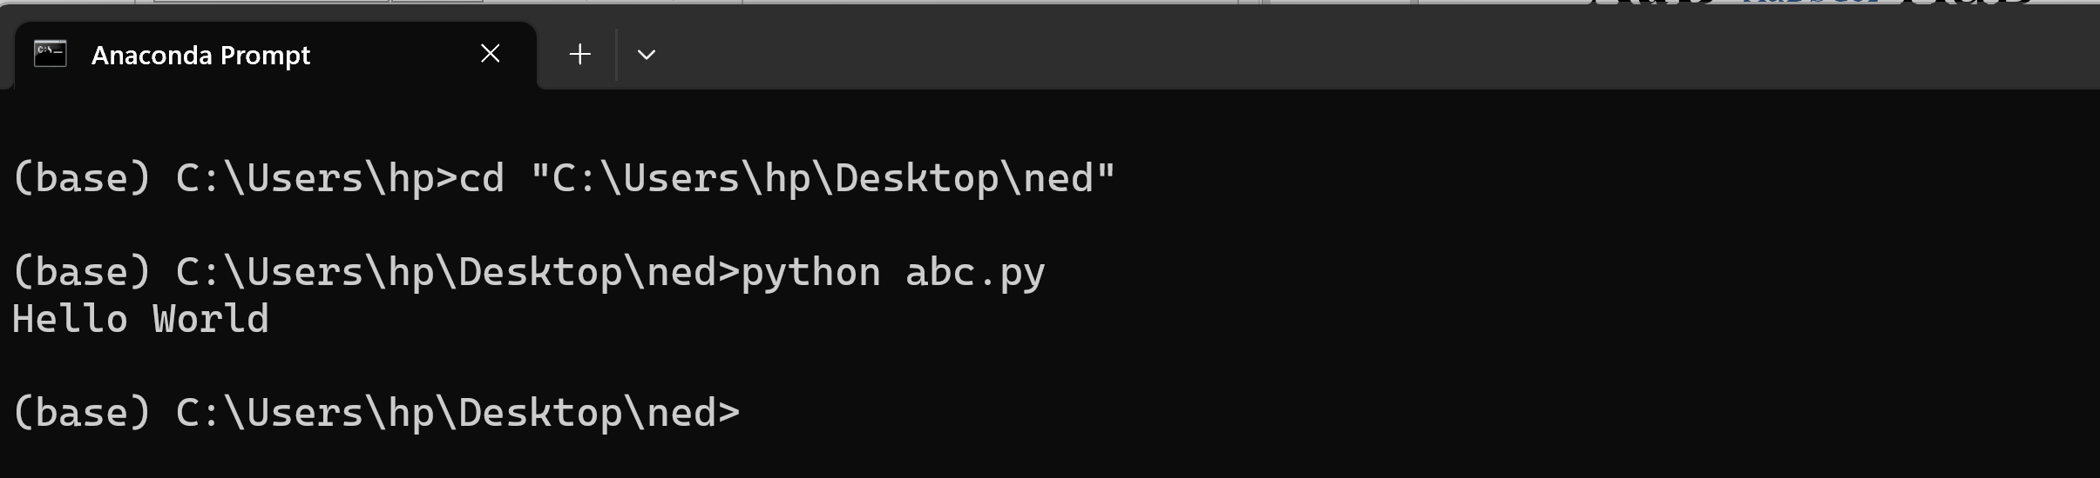

cmd

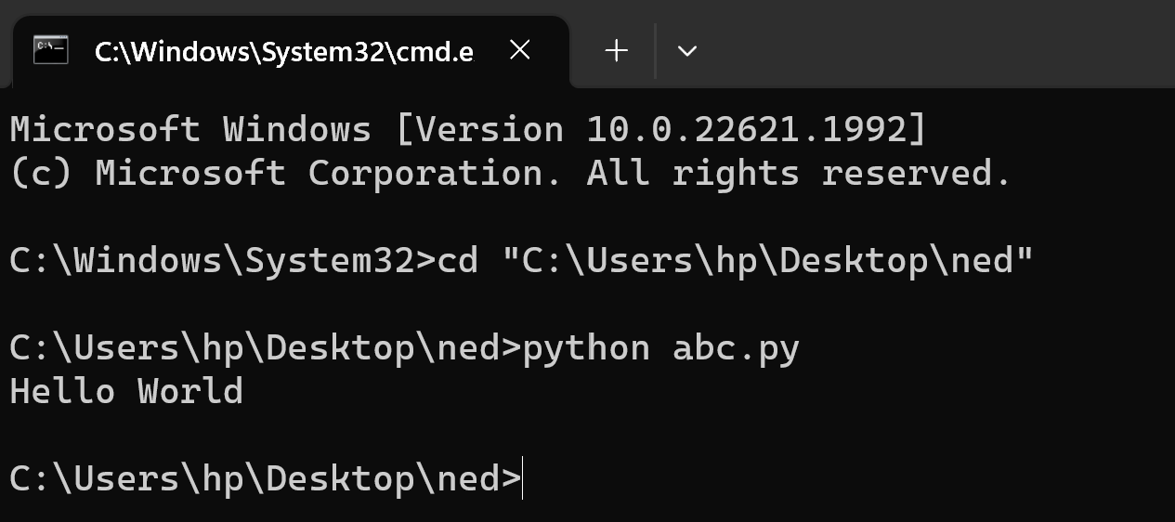

3-

Visual Studio code

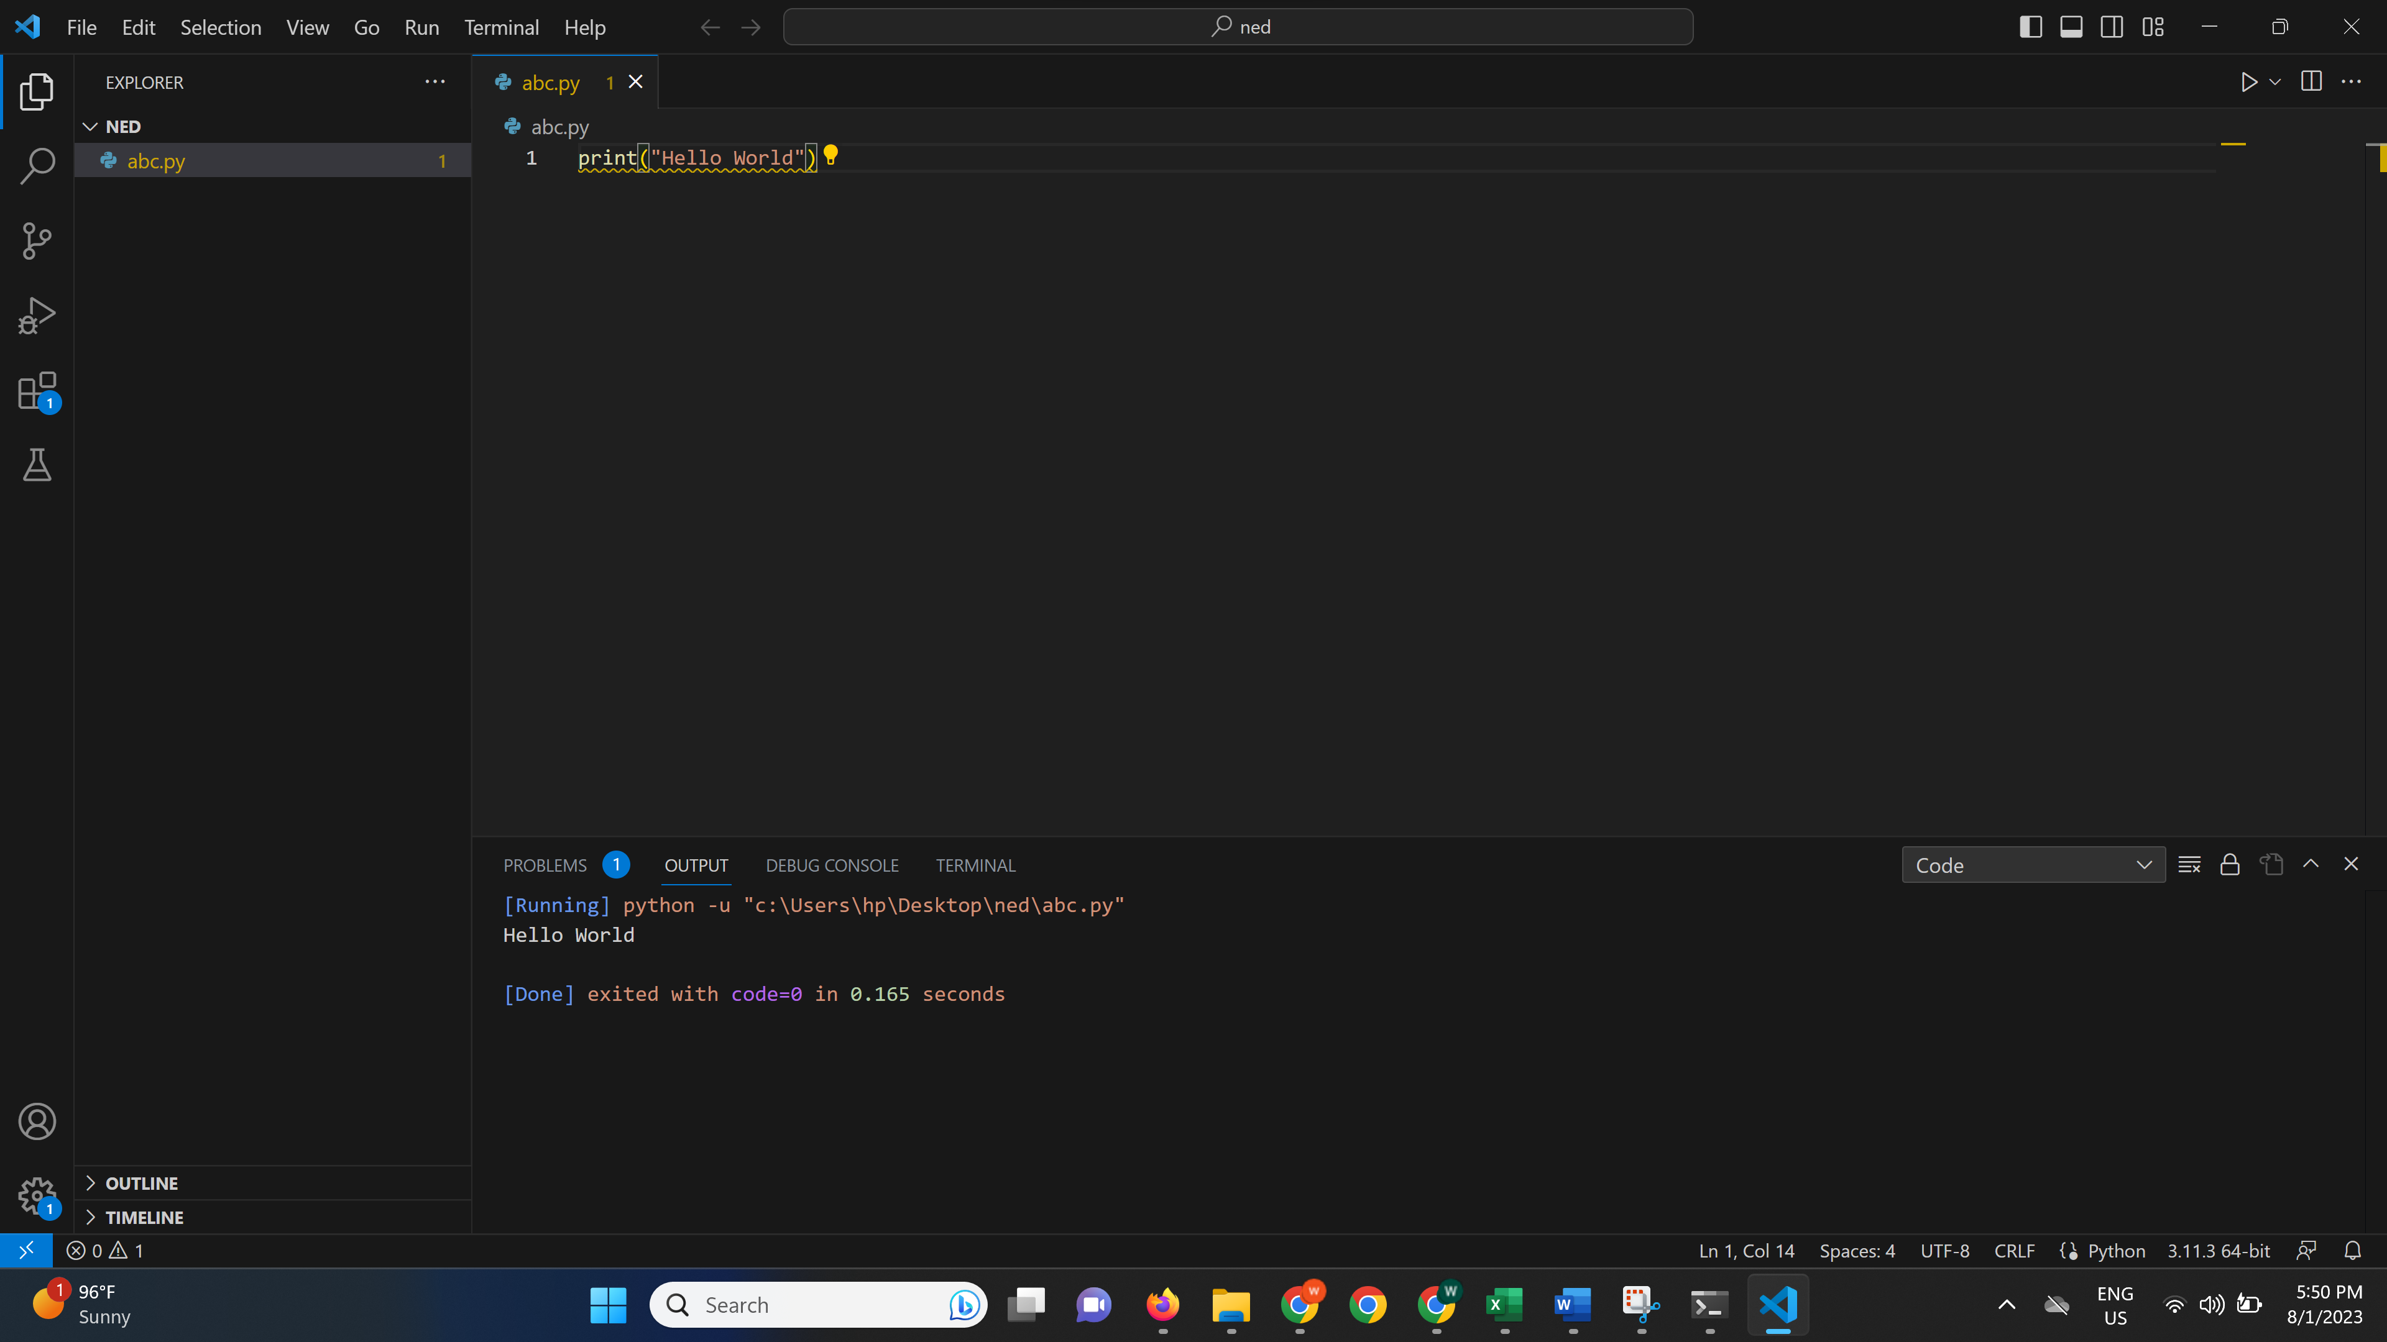

4-

Visual code .ipynb

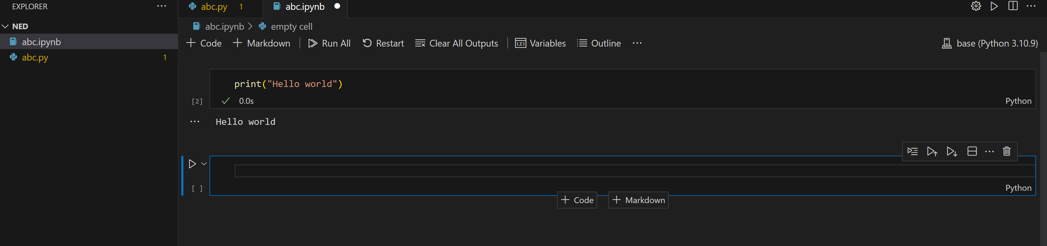

5-

Jupyter Notebook

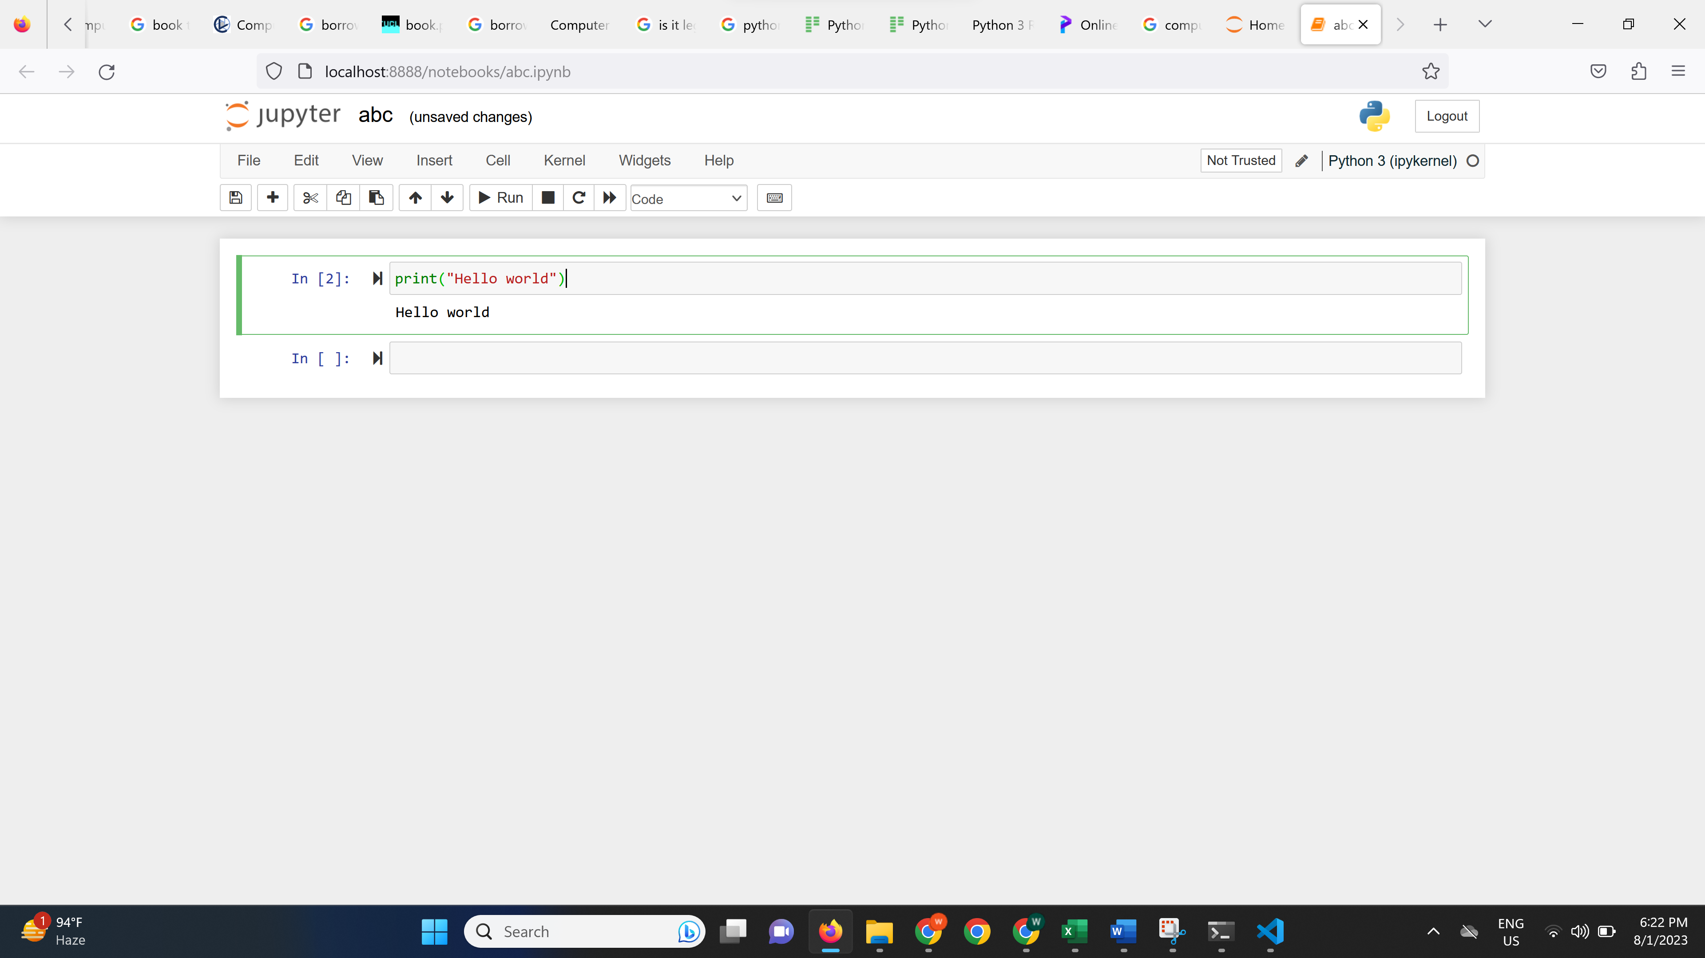

Google colab

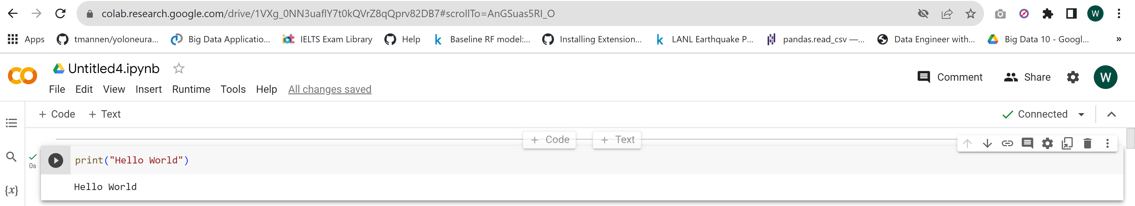

1. upload your own GitHub repository

https://github.com/princit/helloworld

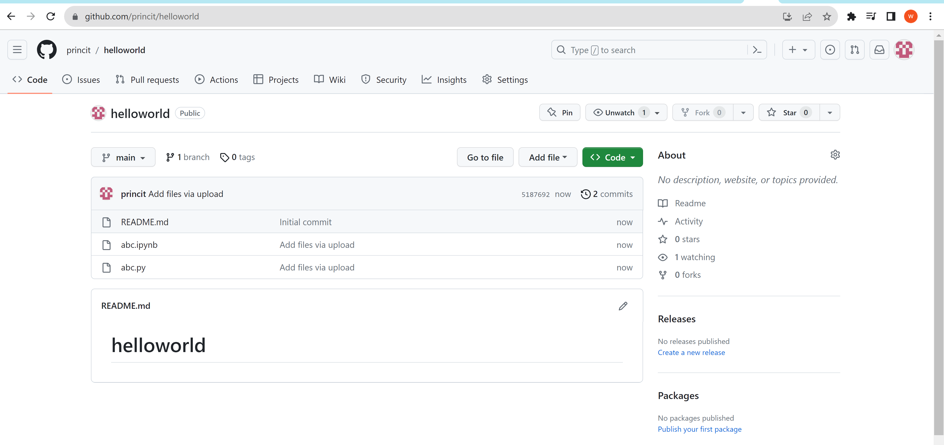

1. create 30 to 60 seconds video above program result and upload on LinkedIn

<https://www.linkedin.com/posts/waqar-saleem-006555286_activity-7092164159823327232-nwj2?utm_source=share&utm_medium=member_desktop>

4) create one assignment1.txt and paste all links in this file and upload here