Lab Sheet: 2

Objective:
• To understand and implement SQL transactions using COMMIT, SAVEPOINT, and ROLLBACK, retrieve records using SELECT queries, and perform INSERT, UPDATE, and ALTER operations on tables.

Instructions:
- Open your preferred Database Management System (DBMS) tool.
- Create the required tables: CLASS, EMPLOYEES, and Client_master.
- Insert the given/suitable records into each table.
- Execute the SQL scripts and queries step by step.
- Observe the output carefully after each operation, especially after ROLLBACK and UPDATE commands.

Table Structures:

CLASS
D (NUMBER) and Name (VARCHAR).
The initial records in the table are (1, 'Bravo'), (2, 'Alex'), and (4, 'Cheng').

EMPLOYEES
Employee_Id (NUMBER), First_Name (VARCHAR), Last_Name (VARCHAR), Email (VARCHAR), Phone_Number (VARCHAR), Hire_Date (DATE), Job_Id (VARCHAR), Salary (NUMBER), Commission_Pct (NUMBER), Manager_Id (NUMBER), and Department_Id (NUMBER).

DDL Questions (Data Definition Language) :

- How do you create a table named CLASS with appropriate data types?
- How do you create a table named EMPLOYEES with the specified attributes?
- How do you create a table named Client_master with the specified attributes?
- What SQL statement would you use to rename the table Client_master to Client12?
- How do you display the bal_due column heading as “BALANCE”?

DML Questions (Data Manipulation Language) :

Part A: Transactions and Savepoints (CLASS Table)
Give the output of the following SQL script:
  - INSERT INTO class VALUES (5,’Rahul’);
  - COMMIT;
  - UPDATE class SET name = ‘Abhijeet’ WHERE id=’5’;
  - SAVEPOINT A;
  - INSERT INTO class VALUES (6,’Chris’);
  - SAVEPOINT B;
  - INSERT INTO class VALUES (7,’Bravo’);
  - SAVEPOINT C;
  - SELECT * FROM class;
  - ROLLBACK TO B;
  - SELECT * FROM class;
  - ROLLBACK TO A;

Part B: Retrieving Records (EMPLOYEES Table)

- Find out the employee id, names, and salaries of all the employees.
- List out the employees who work under manager 100.
- Find the names of the employees who have a salary greater than or equal to 4800.
- List out the employees whose last name is ‘AUSTIN’.
- Find the names of the employees who work in departments 60, 70, and 80.
- Display the unique Manager_Id.

Part C: Updating Records (Client_master Table)
- Insert five records into the Client_master table.
- Find the names of clients whose bal_due > 5000.
- Change the bal_due of ClientNO "C123" to Rs. 5100.

DDL QUESTIONS:

Q1. How do you create a table named CLASS with appropriate data types?

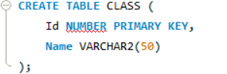

Insert initial records:
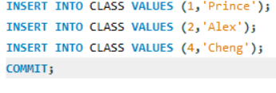

Q2. How do you create a table named EMPLOYEES with the specified attributes?
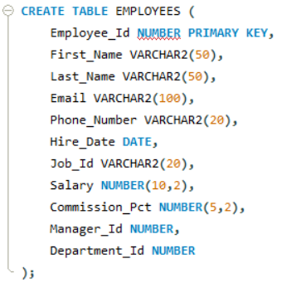

Q3. How do you create a table named Client_master with the specified attributes?
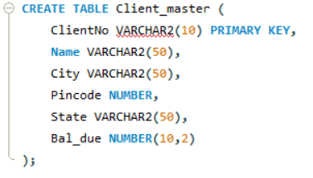

Q4. What SQL statement would you use to rename the table Client_master to Client12?

Q5. How do you display the bal_due column heading as “BALANCE”?


DML QUESTIONS:

PART A: Transactions and Savepoints (CLASS Table)

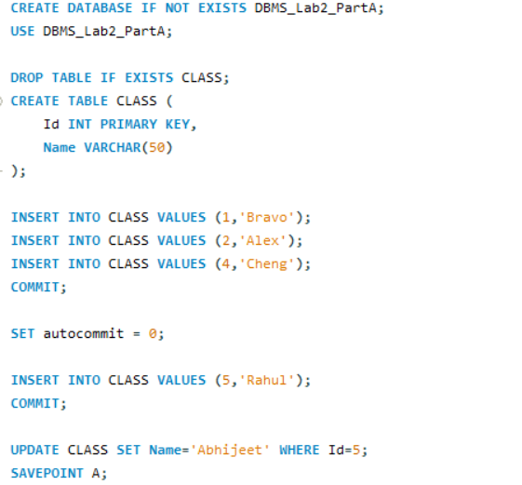
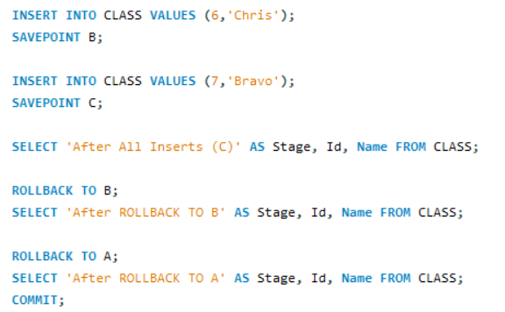
Output:

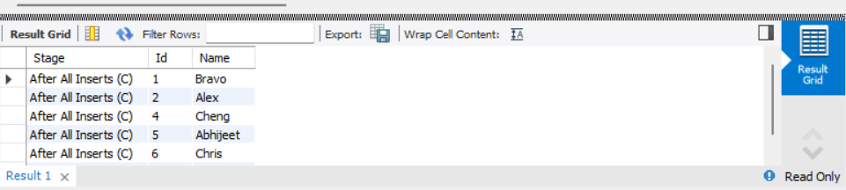

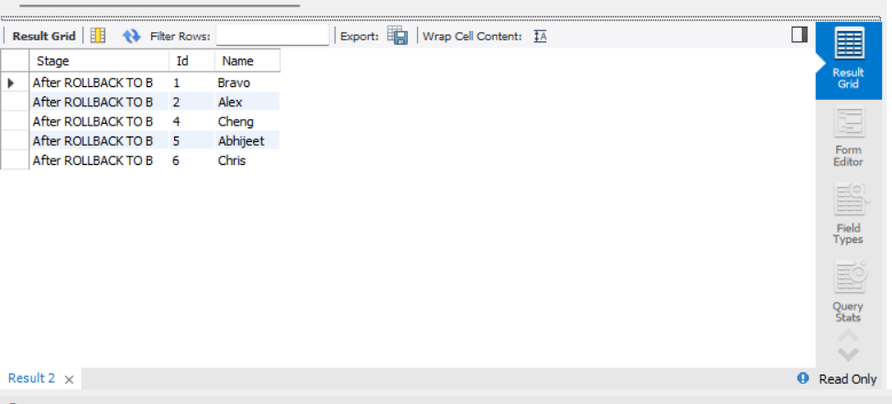

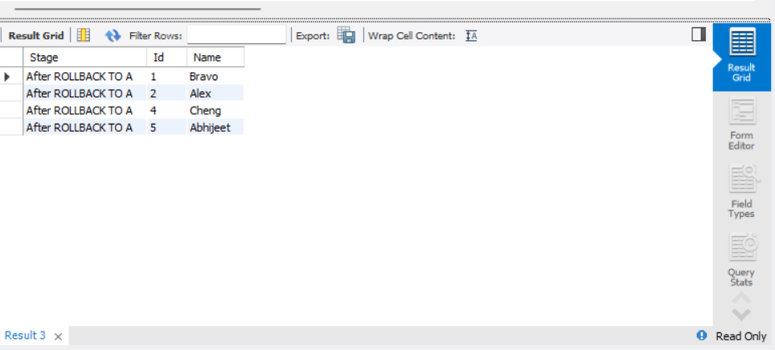

PART B – RETRIEVING RECORDS (EMPLOYEES Table)
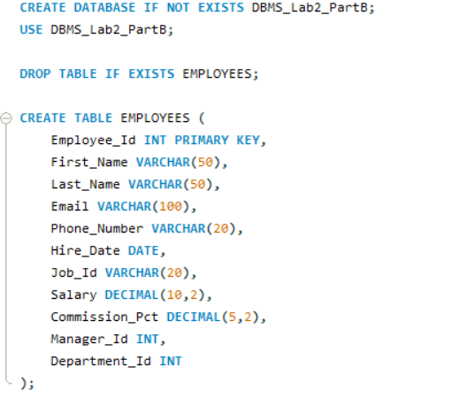
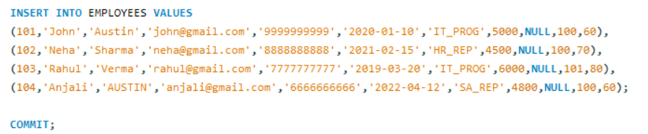

1. Find out the employee id, names, and salaries of all the employees.

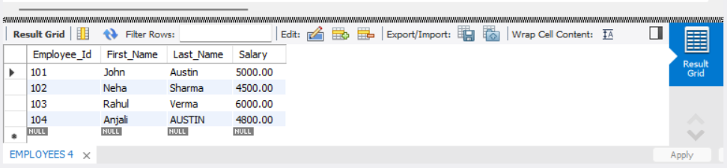

2. List out the employees who work under manager 100.
SELECT First_Name, Last_Name FROM EMPLOYEES WHERE Manager_Id = 100;
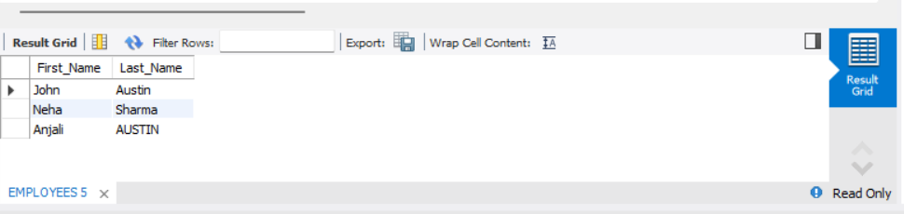

- Find the names of the employees who have a salary greater than or equal to 4800.
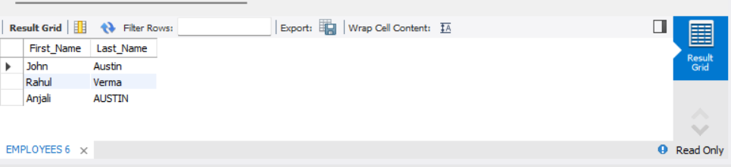

- List out the employees whose last name is ‘AUSTIN’.

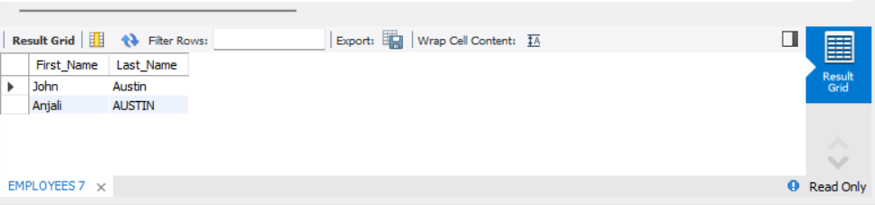

5. Find the names of the employees who work in departments 60, 70, and 80.

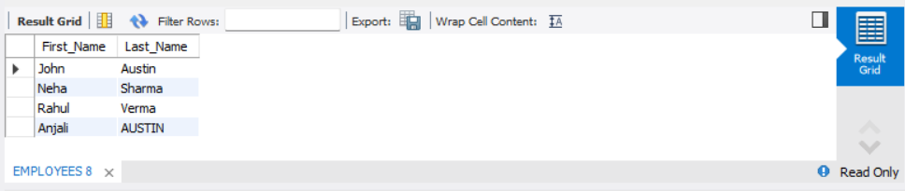

- Display the unique Manager_Id. give for part b answers.

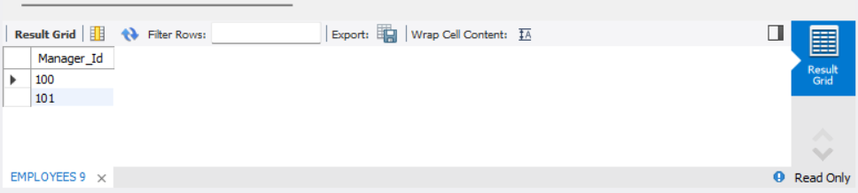

PART C – CLIENT_MASTER TABLE
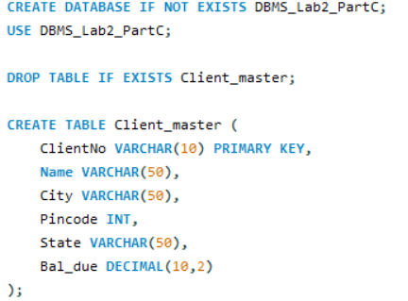

1. Insert five records into the Client_master table.
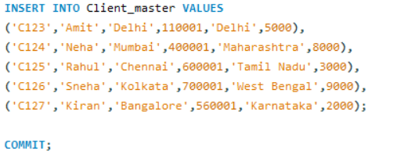
2. Find the names of clients whose bal_due > 5000.
SELECT Name, Bal_due FROM Client_master WHERE Bal_due > 5000;
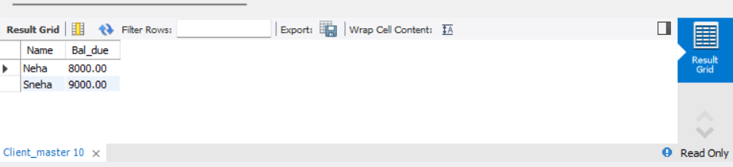

3. Change the bal_due of ClientNO "C123" to Rs. 5100. gave answers for part c.
