Lab Sheet: 3

Objectives

- To understand the use of COMMIT and ROLLBACK commands in transaction control.
- To use ORDER BY and GROUP BY clauses in SQL queries.
- To understand DCL commands (GRANT, REVOKE) and the use of SAVEPOINT.
- To understand and implement JOIN operations in SQL.

Instructions

Open your preferred Database Management System (DBMS) tool.

- Create the required tables: TEACHER, SALES, DEPARTMENTS, and EMPLOYEES.
- Insert suitable records into each table.
- Execute the SQL commands for transaction control, privilege control, grouping, sorting, and joins.
- Observe the output after each operation such as ROLLBACK, COMMIT, SAVEPOINT, GRANT, and REVOKE.

DDL Questions (Data Definition Language)

- Create the TEACHER table with the following attributes:
(Name, DeptNo, Date_of_Joining, DeptName, Location, Salary).
- Create the SALES table with the following attributes:
(Sales_No, Salesname, Branch, Salesamount, DOB).
- Create the DEPARTMENTS table with the following attributes:
(dept_no, dept_name, dept_location).
- Create the EMPLOYEES table with the following attributes:
(emp_id, emp_name, emp_salary, dept_no).

DML Questions (Data Manipulation Language)

From TEACHER Table

- Insert five records into the TEACHER table.
- Give an increment of 25% salary to teachers working in the Mathematics department.
- Give an increment of 15% salary to teachers working in the Commerce department.

From SALES Table

- Insert five records into the SALES table.
- Calculate the total sales amount in each branch.
- Calculate the average sales amount in each branch.
- Display the Salesname and DOB of salesmen born in the month of December with date format like 21-Dec-09.
- Display the Salesname and DOB of salesmen in alphabetical order of the month.

From JOIN Operations

- Display employee details and department details where the department numbers are the same in both tables.
- Display the employee name and department name using a LEFT OUTER JOIN.
- Display the employee name and department name using a RIGHT OUTER JOIN.
- Display the details of employees who draw a salary greater than the average salary.

TCL Questions (Transaction Control Language)

- Perform the ROLLBACK command on the TEACHER
- Perform the COMMIT command on the TEACHER table.
- Write a query to implement a SAVEPOINT.

DCL Questions (Data Control Language)

- Write a query to grant all privileges on the EMPLOYEES table to DEPARTMENTS.
- Write a query to grant selected privileges on the EMPLOYEES table to DEPARTMENTS.
- Write a query to revoke all privileges on the EMPLOYEES table from DEPARTMENTS.
- Write a query to revoke selected privileges on the EMPLOYEES table from DEPARTMENTS.

Solutions
DDL Questions (Data Definition Language)

1. Create the TEACHER table with the following attributes: (Name, DeptNo, Date_of_Joining, DeptName, Location, Salary).
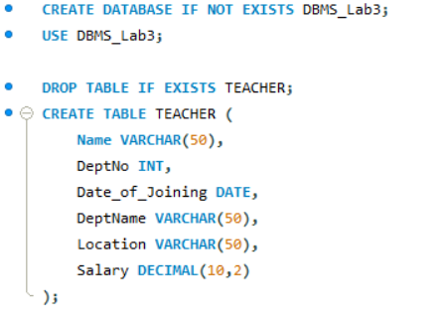
2. Create the SALES table with the following attributes: (Sales_No, Salesname, Branch, Salesamount, DOB).
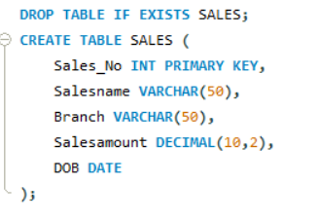
3. Create the DEPARTMENTS table with the following attributes: (dept_no, dept_name, dept_location).
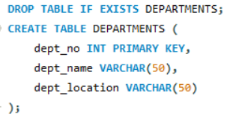

- Create the EMPLOYEES table with the following attributes: (emp_id, emp_name, emp_salary, dept_no).
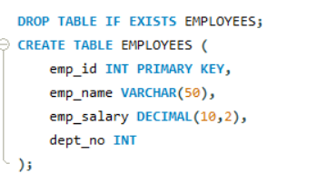
DML – TEACHER Table Operations

From TEACHER Table
1. Insert five records into the TEACHER table.
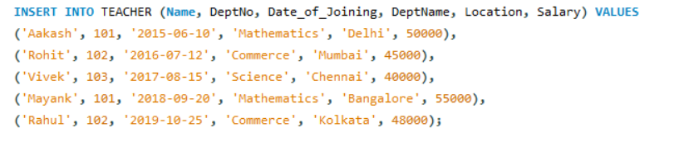
2. Give an increment of 25% salary to teachers working in the Mathematics department.
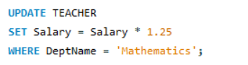
3. Give an increment of 15% salary to teachers working in the Commerce department.
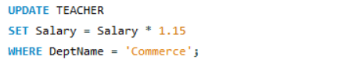

From SALES Table
Q1. Insert five records into the SALES table.
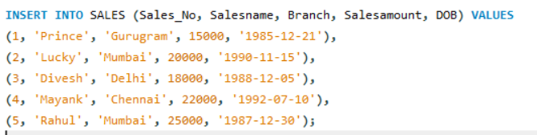

Q2. Calculate the total sales amount in each branch.
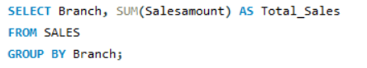
Q3. Calculate the average sales amount in each branch.
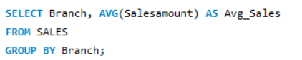
Q4. Display the Salesname and DOB of salesmen born in December (format: 21-Dec-09).
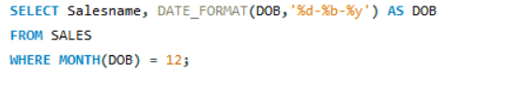
Q5. Display the Salesname and DOB of salesmen in alphabetical order of the month.
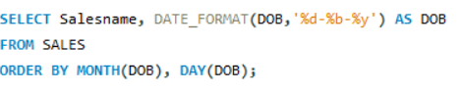

From JOIN Operations

Q1. Display employee details and department details where the department numbers are the same.
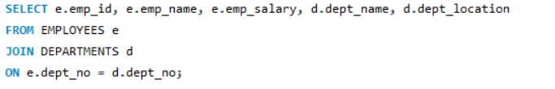
Q2. Display employee name and department name using LEFT OUTER JOIN.
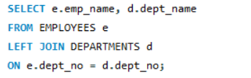
Q3. Display employee name and department name using RIGHT OUTER JOIN.
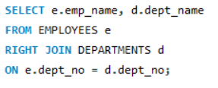

Q4. Display details of employees who draw a salary greater than the average salary.
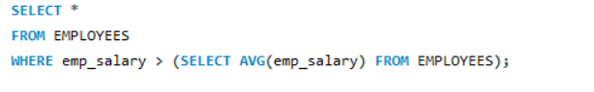

TCL Questions (Transaction Control Language)

Q1. Perform the ROLLBACK command on the TEACHER table.
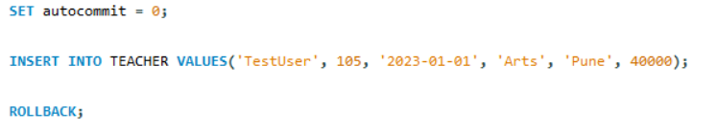
Q2. Perform the COMMIT command on the TEACHER table.
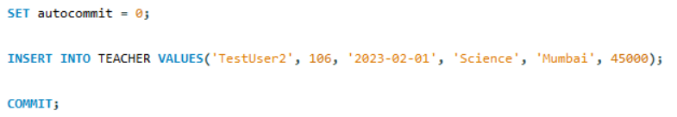
Q3. Write a query to implement a SAVEPOINT.
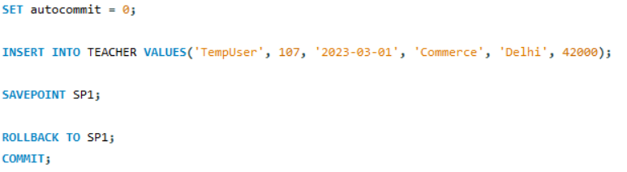

DCL Questions (Data Control Language)

Q1. Grant all privileges on EMPLOYEES table to DEPARTMENTS.

Q2. Grant selected privileges (SELECT, INSERT) on EMPLOYEES table to DEPARTMENTS.

Q3. Revoke all privileges on EMPLOYEES table from DEPARTMENTS.

Q4. Revoke selected privileges (INSERT) on EMPLOYEES table from DEPARTMENTS.

