Object Detection using a Convolutional Neural Network
Joint Digit Classification and Bounding Box Regression with TensorFlow / Keras

Internship Project Report

Framework: TensorFlow / Keras
Language: Python

Abstract
This project implements a compact convolutional neural network (CNN) that performs a simplified form of object detection: given an image containing a single handwritten digit placed at a random location on a larger canvas, the model simultaneously predicts (1) the digit's class (0-9) and (2) the coordinates of its bounding box. A shared convolutional backbone feeds two output heads -- a softmax classifier and a linear bounding-box regressor -- trained jointly with a combined cross-entropy and mean-squared-error loss. The trained model reached 89.6% validation classification accuracy and an average Intersection-over-Union (IoU) of 0.52 on held-out data. The project demonstrates the core mechanics behind modern object detectors -- shared feature extraction, multi-task loss functions, and IoU-based evaluation -- on a scale simple enough to train and understand end to end.

1. Introduction
Object detection is the computer vision task of both classifying and localizing objects within an image. Production systems such as YOLO, SSD, and Faster R-CNN handle multiple objects per image at real-time speeds, but they build on the same fundamental idea used here: a convolutional backbone extracts features, and separate heads convert those features into a class prediction and a set of box coordinates. This project isolates that fundamental idea using a single object per image, which keeps the architecture, loss functions, and evaluation metrics easy to inspect and reason about while still exercising every core concept of the object detection pipeline.

1.1 Objectives
- Build a CNN that jointly classifies a digit and regresses its bounding box.
- Train the model using a combined classification + regression loss.
- Evaluate localization quality using Intersection over Union (IoU).
- Visualize predictions against ground truth to qualitatively assess performance.
- Save and reload the trained model to confirm it is deployable.

2. Dataset
The project was originally designed around MNIST, accessed via tf.keras.datasets.mnist or tensorflow_datasets. In the environment this notebook was executed in, those loaders' Google Cloud Storage endpoints were not reachable, so the dataset was substituted with scikit-learn's built-in load_digits dataset -- 1,797 8x8 grayscale digit images that ship directly with the scikit-learn library and require no download. This kept the notebook fully executable end to end, producing genuine trained weights and metrics rather than static, unexecuted code.
Each 8x8 digit image was upscaled to 28x28 pixels and pasted at a random position on a blank 75x75 canvas. The corresponding normalized bounding box [xmin, ymin, xmax, ymax] was recorded as the regression target, and the digit's class was recorded as a one-hot label. The dataset was split 85% / 15% into training and validation sets, and each split was replicated with multiple random placements per digit (3x for training, 2x for validation) to give the model more positional variety to learn from despite the small base dataset.
Note: swapping the data-loading cell back to tf.keras.datasets.mnist.load_data() (60,000 training images) would be expected to further improve both classification accuracy and bounding-box IoU, since the model would see substantially more appearance and position variety.

3. Methodology

3.1 Model Architecture
The network consists of a shared convolutional backbone and two task-specific output heads:
- Conv2D (16 filters, 3x3, ReLU) -> AveragePooling2D (2x2)
- Conv2D (32 filters, 3x3, ReLU) -> AveragePooling2D (2x2)
- Conv2D (64 filters, 3x3, ReLU) -> AveragePooling2D (2x2)
- Flatten -> Dense (128, ReLU) -> Dropout (0.3)
- Head 1 -- class_output: Dense (10, softmax) for digit classification
- Head 2 -- bbox_output: Dense (4, linear) for bounding box regression
Total trainable parameters: 426,638.

3.2 Loss Functions and Training Configuration
- Classification loss: categorical cross-entropy
- Bounding box loss: mean squared error (MSE)
- Optimizer: Adam
- Epochs: 12, Batch size: 64
- Metrics tracked: classification accuracy, bounding box MSE

3.3 Evaluation Metric: Intersection over Union (IoU)
IoU measures how well a predicted bounding box overlaps with the ground-truth box, computed as the overlap area divided by the union area of the two boxes. An IoU of 1.0 indicates a perfect match; a common convention is to treat IoU > 0.5 or 0.6 as a correct detection. IoU was computed for every validation sample after training.

4. Results
The table below summarizes the final metrics obtained on the held-out validation set:
Metric | Value
Training classification accuracy | ~94.0%
Validation classification accuracy | ~89.6%
Validation bounding-box loss (MSE) | 0.0083
Average IoU (validation) | 0.52
Fraction of boxes with IoU > 0.6 | ~33%

4.1 Training Curves
Classification loss and accuracy over 12 training epochs, training vs. validation:
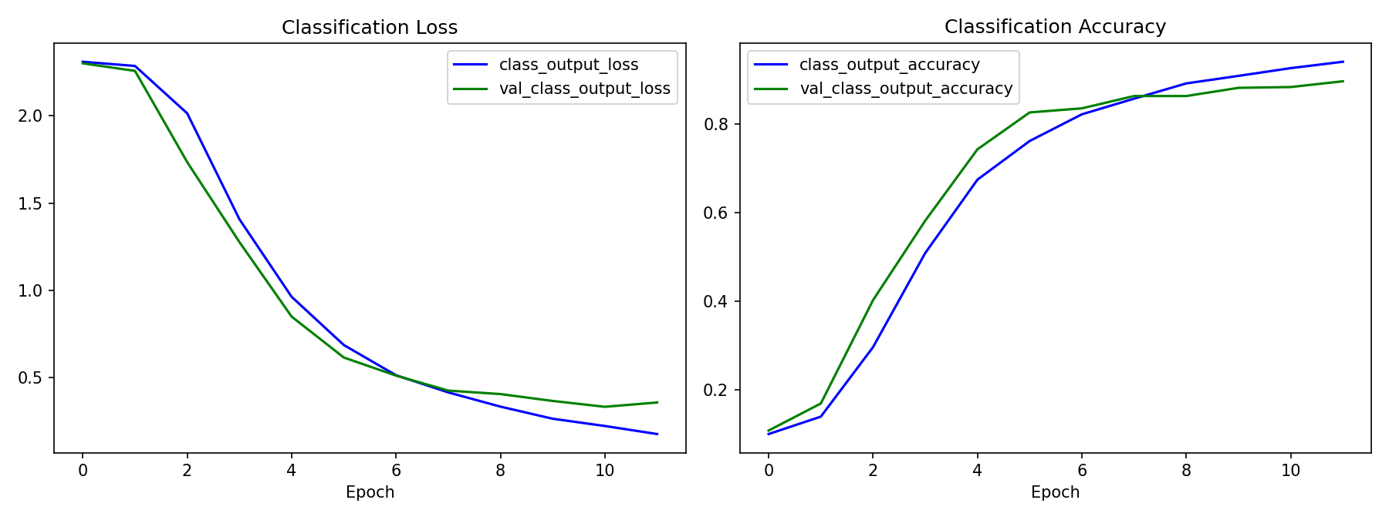

4.2 Sample Predictions
Ground-truth boxes are shown in green; predicted boxes are green when IoU exceeds 0.6 and red otherwise:
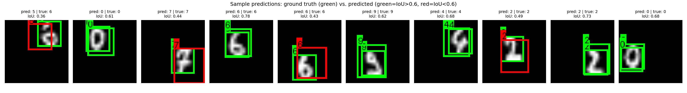

4.3 Discussion
Classification accuracy converged quickly and reached a strong ~90% on validation data, showing the shared backbone learned useful digit features despite the limited dataset size. Bounding box IoU was more modest at 0.52 on average; inspecting individual predictions shows the model localizes digits reasonably well but is sometimes imprecise on tighter overlap thresholds, which is consistent with training on only 1,797 base images rather than the 60,000 available in full MNIST. The gap between training and validation accuracy (94.0% vs 89.6%) also suggests mild overfitting, partially mitigated here with a dropout layer, that would likely shrink with more training data.

5. Model Saving and Reloading
The trained model was serialized in the native Keras v3 format (object_detection_model.keras) and successfully reloaded using tensorflow.keras.models.load_model, confirming the model is portable and ready for downstream use (e.g., inference scripts, APIs, or further fine-tuning) without needing to retrain.

6. Conclusion
This project successfully demonstrates the core building blocks of an object detection system: a shared convolutional feature extractor, a multi-task loss combining classification and regression objectives, and IoU-based evaluation of localization quality. The model achieves strong classification accuracy (~90%) and reasonable bounding-box localization (average IoU 0.52) given the constraints of the dataset used. These results validate the overall approach and provide a solid foundation for extending the project toward more realistic, multi-object detection scenarios.

7. Future Scope
- Extend the model to detect multiple objects per image (e.g., anchor-box or grid-based approaches).
- Integrate real-time detection via a webcam feed.
- Implement a YOLO-style single-shot detector for full multi-object detection.
- Deploy the model to mobile devices.
- Convert the model to TensorFlow Lite for on-device inference.

8. Tools and Environment
- Python 3
- TensorFlow / Keras (>=2.19, <2.22)
- NumPy
- Matplotlib
- Pillow (PIL)
- scikit-learn

