Name : Princy Bhalu

Roll No : CE018

ID : 20CEUOS097

Subject : SDP

Lab-9

//Tutorial-1  
import 'package:flutter/material.dart';  
import 'quote_card.dart'; // Absolute path  
import 'quote.dart'; // due to same directory file relative path will work  
//import 'quote_card.dart'; // Relative path  
void main() => runApp(MaterialApp(  
 home: EchoList(),  
));  
class EchoList extends StatefulWidget {  
 @override  
 State<EchoList> createState() => _EchoListState();  
}  
class _EchoListState extends State<EchoList> {  
/*  
List<String> quotes = [  
'The truth is realy pure and never simple',  
'I see humans but no humanity',  
'The time is always right to do what is right'  
];  
// List<String> author = [];  
*/  
/* this will create error..because list is now not of string....  
List<String> quotes = [  
Quote(text: 'The truth is realy pure and never simple',author:  
'Princy'),  
];  
*/  
 List<Quote> quotes = [  
 Quote(text: 'The truth is realy pure and never simple',author:  
 'Princy'),  
 Quote(author: 'Princy', text: 'I see humans but no humanity'),  
 Quote(text: 'The time is always right to do what is right',author:  
 'Princy'),  
 ];  
/*  
Widget quoteTemplate(quote){  
return QuoteCard(quote: quote,);  
}  
*/  
 @override  
 Widget build(BuildContext context) {  
 return Scaffold(  
 backgroundColor: Colors.*lightBlueAccent*[100],  
 appBar: AppBar(  
 title: Text('Quotes'),  
 centerTitle: true,  
 backgroundColor: Colors.*orangeAccent*,  
 ),  
 body: Column(  
// mainAxisAlignment: MainAxisAlignment.center,  
// crossAxisAlignment: CrossAxisAlignment.center,  
// children: quotes.map((quote) => quoteTemplate(quote)).toList(),  
 children: quotes.map((quote) => QuoteCard(  
 quote: quote,  
 delete: () {  
 setState(() {  
 quotes.remove(quote);  
 });  
 },  
 )).toList(),  
 ),  
 );  
 }  
}

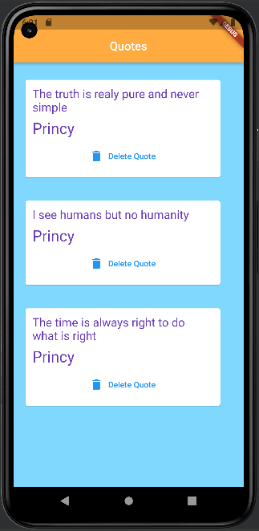

//Tutorial-2  
import 'package:flutter/material.dart';  
import 'choose_location.dart';  
import 'home.dart';  
import 'loading.dart';  
//  
// void main() => runApp(MaterialApp(  
// // home: Home(),  
// routes: { // routes is Map variable with 'key:value' pairs  
// // '/about' ....eg.....routes the screen through 'about' widgets  
// // '/contact'....  
// '/': (context) => Loading(), // base routes....base widget file...main  
// file of project  
// // above statement will creates error...because it conflict with 'home:  
// Home(),  
// // because both statements tell flutter to initialize the app from their  
// given location  
// '/home': (context) => Home(),  
// '/location': (context) => ChooseLocation(),  
// }  
// ));  
  
void main() => runApp(MaterialApp(  
// home: Home(),  
// instead of making home: property to make any page to initialize at beginning...  
// we can use following code ....  
 initialRoute: '/home',  
 //The application's top-level routing table.  
 // When a named route is pushed with Navigator.pushNamed, the route name is looked up in this map.  
 // If the name is present, the associated widgets.WidgetBuilder is used to construct a  
 // CupertinoPageRoute that performs an appropriate transition, including Hero animations, to the new route.  
 routes: {  
 '/': (context) => Loading(),  
 '/home': (context) => Home(),  
 '/location': (context) => ChooseLocation(),  
 }  
));

