

Software

Engineering

Exam

2018


April 189

DSTI – A19
Authored by: Princy Pappachan

We are trying to replicate the “always fresh” data policy in the view vw_AllSurveyData.

- Here I am trying to replicate the function dbo.fn_GetAllSurveyDataSQL which fetches the entire survey data and dbo.trg_refreshSurveyView which creates a view and keeps it updated on every create, update or insert .

- In Real world scenarios where Data scientists don’t have privileges for creating stored procedures/functions and triggers but only select query option available.

- This code is created to handle such scenarios.

Pre-Requisites:
1.Database User should have CREATE/ALTER access
2.Proper User credentials are updated in the YAML File available in the zip file
3.The YAML File should be placed in your current working directory

Highlights:
- I didn’t want crucial information like DB credentials to be visible in the code. So I created a YAML File to store the database details

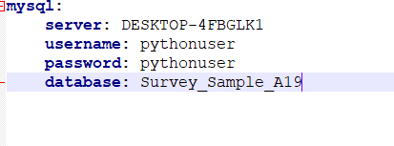

- User is reminded about the YAML File as soon as the code is executed
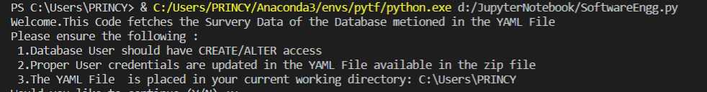

- I have implemented a class
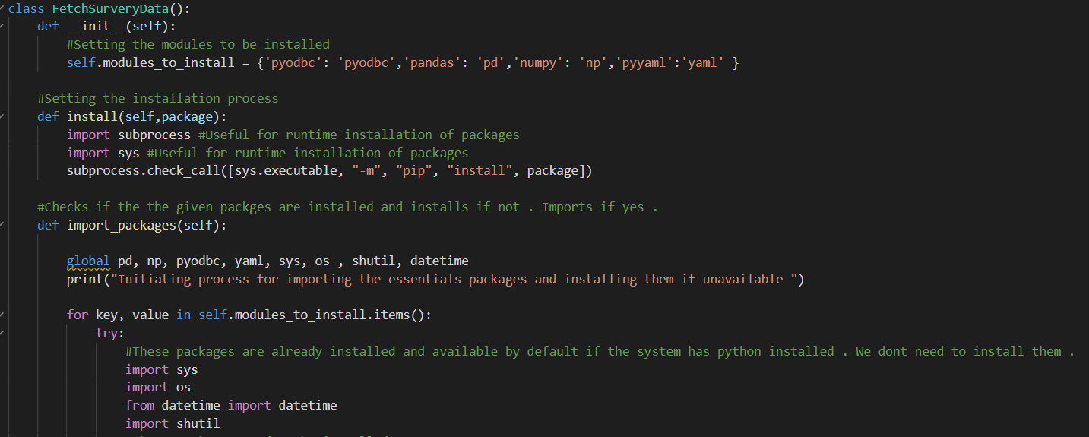

- Created function for the purpose of reusability
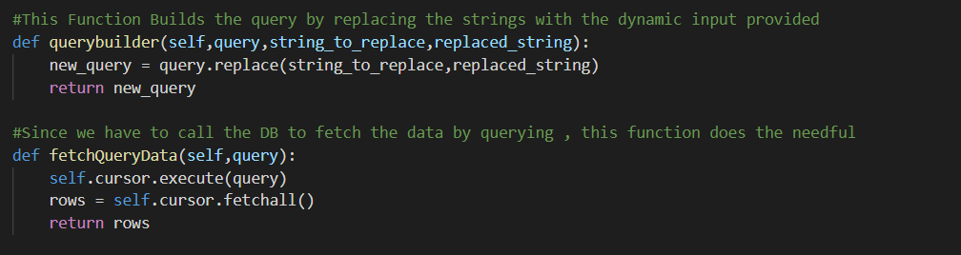

- Created a main function for calling the class and the objects
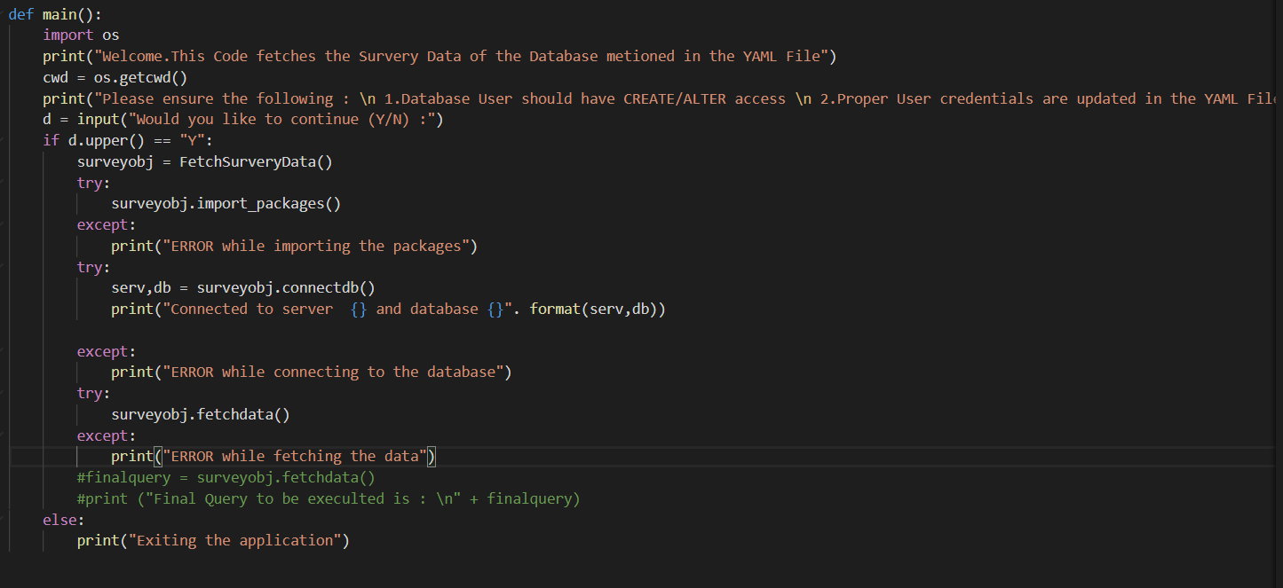

- All the packages will be automatically imported if present in the environment else installed and then imported.
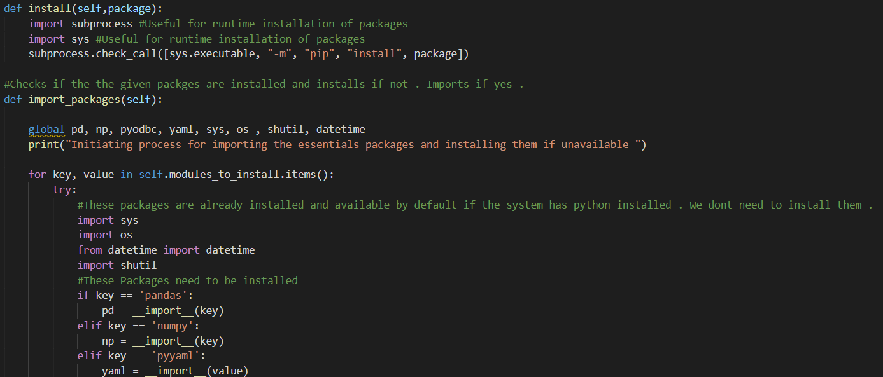

- If the code is being run for the first time, Survey Structure, All Survery data and the view in DB will be created and the following message will be displayed

- The survey structure and AllSurveryData will be stored in a csv in the current working directory.
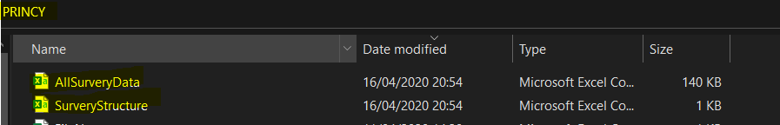

- If the survey structure is updated, a new folder called archive will be created in the same directory and the code will display the following message
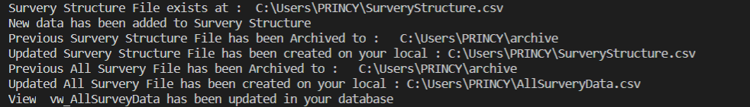

- Previous file will be archived in the folder with the name appended with the current date and time in milliseconds

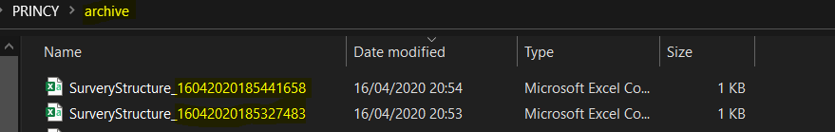

- If the code is called again and there is no update in the Survery Structure, the following will be displayed

- I have commented for every function stating their use and expected input and results

- Implemented try and catch for handling the error scenarios gracefully. Generating specific Error Messages for special scenarios
