**Encapsulation, Observer and Template Method Assignment Report** -Princy Jain

Introduction:

This assignment mainly focuses on learning **Observer Pattern** along with **Encapsulation** and **Template method pattern.** According to Observer Pattern, the observer will not ask for the current state of observable (one who is observed), instead the observable will update the observer every time there is a change in state. Here, in this project the observer is **Flier** and the observable is **Drone/Simulator.**

Project Design:

I started my design by making the communication diagram to have a clear understanding of how the communication is taking place between the flier and simulator.

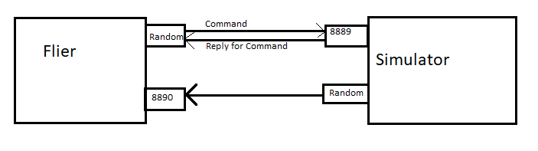

Points Covered:

1. Both the flier and the simulator checks if the drone is in command mode or not. If the drone/simulator is in command mode, then only the simulator will send status messages to the flier and also the flier will only receive the status messages when the drone is in command mode. The port used at the flier end to receive status message is 8890. This is executed at Flier side in **FlierStatusThread** class and on the simulator side in **SimulatorStatusThread** class.

The Flier irrespective of the ongoing Mission will use this status message to get a clear picture of the drone’s state.